Victorian Pest Plant Prioritisation Process: Methodology
Table of Contents
Methodology 3
2.1 Decision Support Systems 4
2.2 Applying the Analytical Hierarchical Process to weed risk assessment 5
2.3 Pest Plant Risk Assessment in Victoria 6
2.3.1 Assumptions 7
2.3.2 Rationale in weighting Invasiveness, Distribution and Impact 8
2.3.3 Confidence 8
2.4 Invasiveness Potential of Pest Plants 9
2.5 Present and Potential Distribution of Pest Plants 14
2.5.1 Present Distribution 14
2.5.2 Potential Distribution 17
2.5.3 Ratio of present to potential distribution 19
2.5.4 Limitations of Present and Potential Distribution Maps 21
2.6 Impacts 22
2.6.1 Developing a process to measure impacts of weeds 22
2.7 Calculating a Pest Plant Score 23
References 30
Annex 1 Invasiveness criteria and intensity ratings 32
Annex 2 Impact criteria and intensity ratings 35
Figures
Figure 1. Hierarchy illustrating components of the Pest Plant Prioritisation Process (PPPP). 6
Figure 2. Group weightings of invasiveness. 10
Figure 3. Criteria (intra-group) weightings of invasiveness 12
Figure 4. Total criteria weightings of invasiveness 12
Figure 5. Distribution of serrated tussock in countries of origin 15
Figure 6. Distribution of serrated tussock worldwide- except Australia. 15
Figure 7. Distribution of serrated tussock in Australia. 16
Figure 8. Known naturalisations of serrated tussock in Victoria (From DPI and DSE’s IPMS).16
Figure 9. Potential distribution of serrated tussock in Australia, according to climatic parameters
(Areas in red indicate a 80%+ match with the preferred climate of the plant species, dark
green 70%, light green 60% and yellow 50%) . 17
Figure 10. Potential distribution of serrated tussock in Victoria, according to climatic parameters
(Areas in red indicate a 80%+ match with the preferred climate of the plant species, yellow
70%, orange 60% and green 50%) . 17
Figure 11. Dialogue box from CLIMATE (Pheloung 1996) showing the climatic parameters
used in terrestrial weed modelling. The eight rainfall parameters are not included when
modelling the potential climatic range of aquatic weeds 18
Figure 12. Potential distribution of serrated tussock in Victoria according to climatic parameters,
susceptible broad vegetation types (BVT's), and susceptible land-uses. (Areas in red
indicate a very high probability that serrated tussock could establish in agricultural or
natural ecosystems within this region, yellow a high, orange a medium, and green a low
probability of establishment. In the non-coloured areas the plant is unlikely to establish as
the climate, soil, or land-use is not presently suitable.) 19
Figure 13. Invasion graph indicating stages of expansion of a new species into a habitat.
(Adapted from Groves (1992) and Hobbs (1991)) . 20
Figure 27. Total cost of plant invasions showing costs of early expenditure (Area A) and the
resulting benefit (Area B) (Adapted from Hobbs and Humphries (1995)) . 21
Figure 29. Total (final) criteria weightings of impact. 25
Figure 31. Total (final) criteria weightings of impact according to importance 26
Tables
Table 1. Analytical hierarchical process steps as described by Saaty (1995) . 4
Table 2. Confidence score intensity ratings ..8
Table 3. Group and criteria weightings for determining invasive potential. 9
Table 4. Comparison of invasiveness assessments for gorse/furze Ulex europaeus and boxthorn
Lycium ferocissimum 13
Table 5. Intensity ratings for evaluating the present compared to potential distribution of a weed.
20
Table 6. Group and criteria ratings for determining impact. 24
Table 7. Example of an impact assessment for serrated tussock according to criteria and intensity ratings. H=1, MH=0.75, M=0.5, ML=0.25, L=0 27
2 Methodology
2.1 Decision Support Systems
Natural resource managers work with complex systems where problem solving and decision-making is based on extensive, but incomplete, uncertain, and even contradictory data and knowledge. There is often no single correct method, or answer, to address problems in these systems. Managers therefore require a decision making process to break down complex systems into simpler steps with defined criteria to allow assessment and prioritisation of issues.
We propose a specific decision support system (DSS) that relies on expert quantitative and qualitative data. This DSS relies on a type of multi-criteria analysis (analytical hierarchical process or AH?) that enables complex issues to be broken down into sets of related criteria. The AH? (Saaty 1995) is a method that assists with decisions about priorities using qualitative and/or quantitative information. It facilitates effective decisions on complex issues by simplifying and expediting the intuitive decision-making process. AH? does this by organising a complex unstructured situation into component parts with similar themes, arranges these parts into a hierarchical order, assigns values relative to each variable, and synthesises these judgements to determine which variables are most important. AH? also provides an effective structure for group decision-making. This is generally based either on already documented scientific information or in workshop sessions with experts.
Because there is often a lack of specific information on land and resource value, and the impact of any particular weed on social, environmental and economic resources, there is a need for a methodology that considers qualitative and quantitative information. The DSS allows for this integration and applies visible weighting to criteria or resources to indicate their importance. A summary of the analytical hierarchical process, as described by Saaty (1995), is presented in Table 1.
The main benefits of using this type of decision support system are that:
- It takes advantage of existing information by integrating it into a system that allows a wide range of users to interpret the data, using a methodology developed by experts.
- It captures the expertise of specialists and makes this expertise available across a wide range of decision-making contexts.
- It provides an explicit method for integrating ecological, social, and economic criteria into the decision-making process.
- It can provide a set of "best practice" decision-making tools to planners and managers.
- It provides a mechanism for identifying information shortfalls.
- It enables a qualitative analysis of the suitability of data and its relevance to the decision-making process.
- It provides a framework for developing sophisticated benchmarks, including identifying the necessary trade-offs between competing value systems.
- It is easily up-dated as research fills knowledge gaps.
Table 1. Analytical hierarchical process steps as described by Saaty (1995).
SAATY
HIERARCHY

1 Define the problem and specify the solution desired
2 Structure the hierarchy
WEIGHTING
3 Construct a pair-wise comparison matrix
4 Obtain all judgements required to develop the set of matrices
5 Test consistency
6 Perform 3 – 5 for all levels and clusters in the hierarchy
7 Use hierarchical composition to weight the vectors of priorities by the weights of the
criteria, and take the sum over all weighted priority entries corresponding to those in the next lower level and so on.
Evaluate the consistency of the entire hierarchy.

Source: “Priority setting Framework for Natural Resources Management – Application of the Analytical Hierarchal Process and Natural Resources Accounting" (Sposito et al 2002)
To be scientifically valid though, any system developed must meet certain criteria:
- "It must be transparent, be open to review, and have been evaluated by peers.
- It must have a logical framework that includes independent factors-identified through critical observation, experimentation, or both-important in the invasion process.
- Use of the framework must be repeatable and lead to the same outcome, regardless of who makes the predictions." (NRC 2002)
Although the US National Research Council (NRC 2002) applied these criteria specifically to systems predicting invasiveness, they should apply equally to all components of a decision support system.
2.2 Applying the Analytical Hierarchical Process to weed risk assessment
The species that are of highest risk are those that have the greatest potential to affect valued resources. However the degree of affect can only be determined if managers responsible for those resources prioritise or value them in relation to each other. This process can be accomplished through workshops using the AHP – DSS to rank the social, environmental and economic resources of the region. Any process developed for a territory or State in Australia though should address the requirements of the draft technical standard for weed risk management (Virtue et. al. 2004); the method described here meets these requirements.
The information that is needed to enable threats to be assessed under this process includes:
- The species that could threaten the region either now or in the future.
- Information about the biology of each species and its potential rate of spread.
• The level of impact that a species could have on social, agricultural and environmental resources.
• The values that land managers assign to affected resources.
With this information, the relative importance of invasive species can be determined by considering:
- How invasive it is, i.e., how fast can the species spread. Generally this relates to the intrinsic biological features of the species (i.e. dispersal, reproductive and competitive rate).
- The present and potential extent of the species.
- And importantly, what social, environmental, and economic impacts the species has and the value of the things that are impacted upon.
2.3 Pest Plant Risk Assessment in Victoria
To make informed decisions about the best way to control weeds on public land in Victoria, it is necessary that the relative importance of each weed be determined. It is essential that this is done prior to the allocation of priority works or funding. The draft national technical specification for weed risk management (Virtue et. al. 2004), for example, states that "a semi-quantitative analysis is the most appropriate for ranking species where there are considerable, long-term financial investments in weed management". Decisions based on limited factual data and emotional reactions will almost certainly result in unnecessary expenditure of resources and damage to the environment through inappropriate use of control measures. Consider the situation in Victoria, where over 1200 plant species are naturalised or incipiently naturalised (Ross and Walsh 2003). It has been estimated that only about ten percent of naturalised plant species become weeds of significant economic and ecological impact (Williamson and Fitter 1996). It is therefore unrealistic and unnecessary to expect that all alien plants can, and should, be controlled.
The Pest Plant Prioritisation Process (PPPP), developed by Primary Industries Research Victoria (PIRVic), is a prioritisation process or risk assessment, based on the AHP, that ranks weeds by:
- Assessing the plant’s invasiveness.
- Comparing the plant’s present and potential distribution; and
- Determining the impacts of the plant on social, economic, and environmental values.
The PPPP is therefore expressed as a hierarchy (Figure 1), the components of which are weighted (using AHP) to allow the determination of a Pest Plant Assessment score for individual species.
The Pest Plant Assessment score (or simply Pest Plant score) is expressed as:
Pest Plant Score = á (Invasiveness score) + â (Present:Potential Distribution) + ä (Impact)
(where á, â and ä are weightings of the subcomponents).
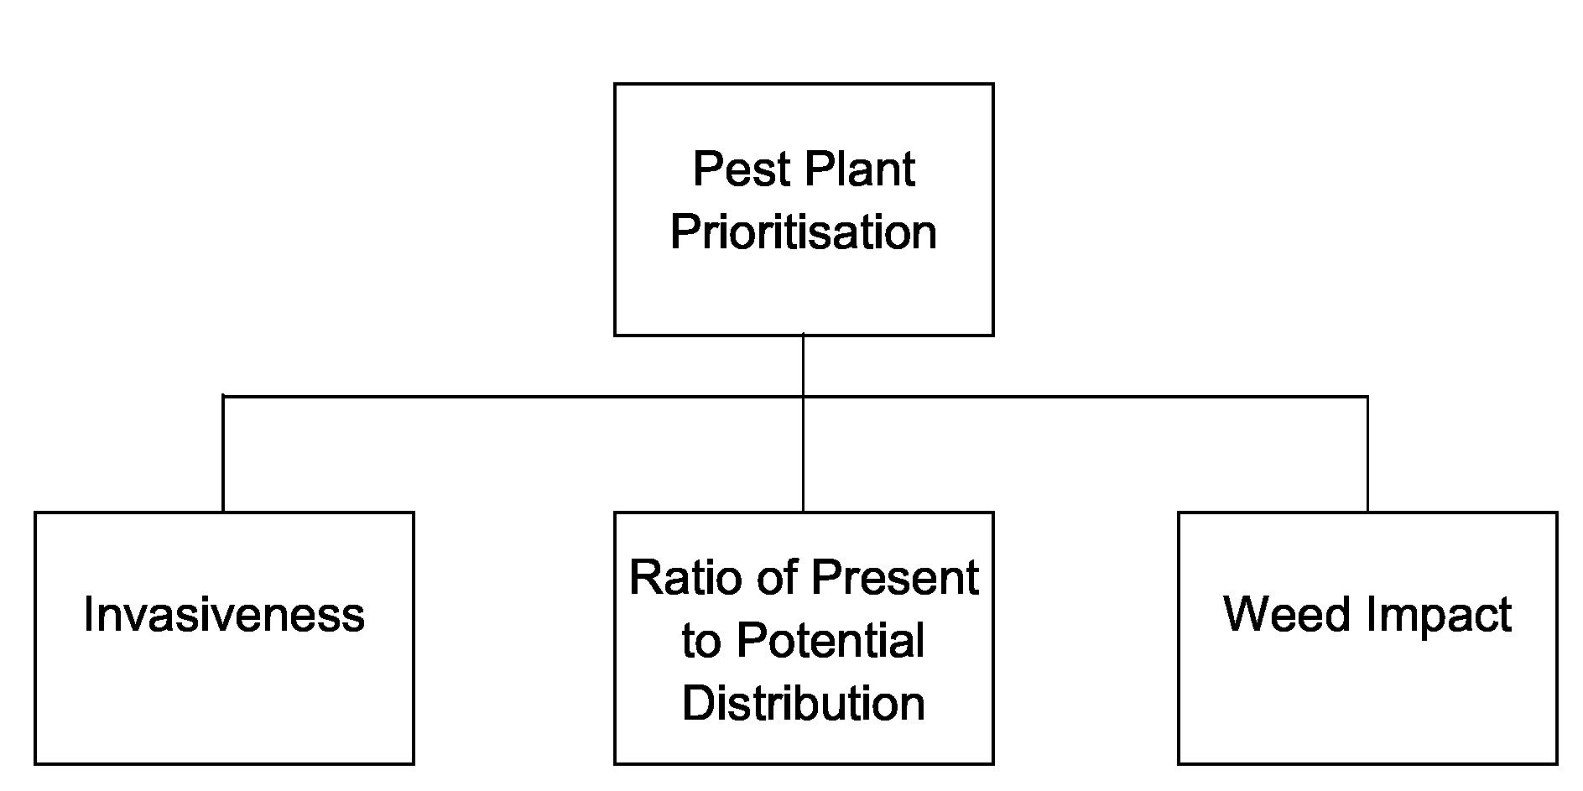
Figure 1. Hierarchy illustrating components of the Pest Plant Prioritisation Process (PPPP).
2.3.1 Assumptions
No specific targeted control
For each criterion (both invasiveness and impact), species are assessed on their potential in the absence of targeted control (e.g., no change in routine herbicide use to specifically target the weed of interest). Targeted control is a consequence of a weed being assessed as a significant threat.
Limited information on species
To assess plants for both invasiveness and impact, information from a variety of sources including databases, journal articles, flora’s of the world (books or articles describing the species of a particular country or region), online information, and other sources was accessed. However, information relating directly to specific criteria is not always available. Where such information is lacking, there are two options; rate the criterion as Medium (M) or, where suitable other information is available, estimate a likely response. By assigning a rating of M the maximum possible error is ±0.5 for that criterion. Assigning a rating of H or L could introduce an error of ±1.
In some cases an answer can be implied from other information about the plant. For example, a weedy grass would be considered to contribute to an increase in fire frequency (though not intensity) due to, say, its documented ability to dominate its environment and suppress (less fire-prone) herbaceous species. There may be no specific mention of the plant’s ability to change the fire regime, but in this case we could confidently score the criterion as Medium Low (ML) rather than applying the Medium score.
Degree of affect
Plants are assessed for their potential to affect natural or agricultural landscapes negatively. The rating chosen is based on the assumption that a plant will achieve its maximum growth and/or
impact. For example, Paterson’s curse (Echium plantagineum L.) is often regarded as non-toxic, yet research has shown that toxic principles within the plant can cause liver damage sometimes leading to animal death (Parsons & Cuthbertson 2001). So, while experience suggests the plant is harmless, there is evidence that indicates otherwise. Accordingly, this species is rated as being toxic to native fauna. It is given a MH rating, rather than H, based on the presumption that native fauna will be able to browse on a variety of species, not solely Paterson’s curse.
We acknowledge that a species will not always find optimal conditions in every situation, but it is the only way of consistently assessing a range of plants.
This risk assessment process is generic. It enables a large number of species to be evaluated in a short time and be ranked according to the score each plant achieves. The assessment of any one plant only has relevance to the other plants assessed, it does not confer any inherent qualities, either good or bad, about the plant. The results are used to compare assessed species and rank them accordingly.
2.3.2 Rationale in weighting Invasiveness, Distribution and Impact
Researchers of the Cooperative Research Centre for Australian Weed Management (Weeds CRC) and Department of Primary Industries (DPI) weed experts determined a preliminary ranking of the three subcomponents of the PPPP. The basis of the weighting was that invasiveness was considered less important than distribution, which in turn was considered less important than impact, with the following ratios:
- Invasiveness is 3 time less important than distribution
- Invasiveness is 4 times less important than impact
- Distribution is half as important than impact
A preliminary AHP pair-wise comparison produced the following weightings (with an acceptable consistency ratio of 0.02) for invasiveness, distribution and impact:
Invasiveness - 12% Distribution - 32% Impact - 56%
Therefore, when calculating a Pest Plant score; á = 0.12, â = 0.32 and ä = 0.56
The method for developing scores for each of the subcomponents; invasiveness, present and potential distribution, and impact, is now outlined (Sections 2.4-2.6).
2.3.3 Confidence
As noted in Assumptions (Section 2.3.1 above) an absence of information can be treated in two ways, either infer from other data or score the criterion as medium. In either case, the lack of absolute information casts immediate doubt on the accuracy of the response. A refinement to that approach, which can be applied to all criteria and thus to the complete assessment, is that of a confidence rating for each answer. The confidence rating is based on the quality of reference material(s) used to answer a question. This approach follows the method used by Robertson et al (2003), which indicates uncertainty and availability of data for each criterion. The lower the confidence score the greater the uncertainty and amount of missing data for that criterion. This
approach has the advantage that it explicitly indicates a level of confidence in the total risk score assigned to a species. That is, it can be used as a measure of how much faith should be placed in a given risk score, and that further research is desirable. In addition, the confidence score can be used as a measure of the state of knowledge of a given species. Intensity ratings (ie. typical
information sources and their relative quality rating) for the confidence scores are listed in Table 2 below.
Table 2. Confidence score intensity ratings
Document type or information source | Confidence  Rating
- Peer reviewed scientific papers | H
- High quality science or plant specific books, non-peer reviewed papers, eg. Conference proceedings  - Industry reports by State government departments  - Internet information from reliable sources  - Industry websites  - Industry papers  - Reports from reliable sources (eg. Honours theses) | MH
- Personal communication with industry experts/practitioners - Unpublished reports from uncertain sources  - Unreferenced papers (eg. CRC Weed Management) | M
- Anecdotal data from non-experts (second-hand experience) | ML
- No supporting data or reference material available | L

The assessment confidence score is the sum of the confidence scores multiplied by the relevant weighting for the criterion, ie.; (confidence score for a criterion x criterion weight) – in the same way as the assessment score is calculated. Where information relating directly to specific criteria is not available, the risk rating assigned is generally medium (M) with a correspondingly low confidence level.
2.4 Invasiveness Potential of Pest Plants
Many researchers have focused on the relative invasiveness of species as an indicator of potential spread rate. Invasiveness can be defined as the ability to establish, reproduce, and disperse within an ecosystem. Plant propagules arrive at a new site with certain inherent characteristics that previously enabled their successful survival and continued reproduction throughout their evolutionary history. There is no single suite of characteristics which make a plant invasive, rather there are several predisposing factors that act either alone or together to increase the chance of a plant becoming invasive.
Many researchers have also agreed that the following biological attributes of a plant species are associated with invasiveness.
- Ecological status; a generalist or specialist plant.
Most common and noxious weeds in southern Australia are generalist and opportunistic rather than requiring specific niches or special habitat requirements.
- ‘Weedy’ phenology and biology; such as competitive growth, seed dispersal mechanisms, seed dormancy and propagule production.
Major weeds can have attributes such as high seed production, rapid vegetative spread, long-lived seeds, staggered germination, competitive growth and long-distance seed dispersal. However, there is no defined group of ecological and biological attributes that can be used to identify all major weeds. Different attributes may be important for different plant families and different ecosystems.
- Wide native range. Within a genus the more important weeds may have a wider native range.
- Taxonomic position; members of generally ‘weedy’ plant families.
Certain plant families such as Poaceae (grasses), Asteraceae (eg. daisies, thistles), Iridaceae (irises) and Brassicaceae (eg. mustards, turnips) are noted for having many ‘weedy’ species.
- Effective modes of reproduction and genetic variation.
Plant species that vegetatively reproduce or self-pollinate have the potential to start new populations from a single, isolated plant. However, high levels of inbreeding in self-pollinators may limit their adaptability compared to cross-pollinators.
Other factors may also favour invading species. For example invading species are generally free of the biotic interactions that occur in their natural range, providing them with a competitive advantage over native species that have many co-evolved predators present (Sax & Brown 2000). As this is not a specific biological attribute of a plant it has not been included in the invasiveness assessment criteria.
Specific criteria for a generic model to assess the potential invasiveness of weeds were determined at two national workshops, held at the Arthur Rylah Institute (ARI), in June 1998 (Table ). A working party at PIRVic's Frankston Centre (previously the Keith Turnbull Research Institute) then used an expert system, relying on multi-criteria analysis/analytical hierarchical process (AHP) (Saaty 1995), to develop a decision-tree that allows groups and criteria to be weighted according to importance (Table 3).
These criteria are echoed in the draft National Technical Specifications for Post Border Weed Risk Management (Virtue et al 2004). The specification was developed to foster the use and further development of decision support systems for prioritising weed species for management at the regional, state/territory and national levels. That document nominates the following attributes as important measures by which to assess invasiveness.
- What is the weed’s ability to establish amongst existing vegetation?
- What is the weed’s reproductive ability? This includes attributes of time to seeding, seed production and vegetative reproduction
- What is the weed’s dispersal ability? This incorporates wind, water, flying animals, ground animals, deliberate human spread, accidental human spread, vehicles and produce or byproduct contaminants.
The criteria used in this process expands upon the attributes nominated in the proposed national specification.
Table 3. Group and criteria weightings for determining invasive potential.
GROUP | CRITERIA | GROUP & CRITERIA WEIGHTINGS | TOTAL CRITERIA WEIGHTINGS
Establishment |  | 0.500
 | Germination requirements? | 0.085 | 0.0425
 | Establishment requirements? | 0.671 | 0.3355
 | Disturbance requirements? | 0.244 | 0.122
Growth/competitive ability |  | 0.096
 | Life form? | 0.060 | 0.00576
 | Allelopathic properties? | 0.090 | 0.00864

GROUP | CRITERIA | GROUP & CRITERIA WEIGHTINGS | TOTAL CRITERIA WEIGHTINGS
 | Tolerates herbivory pressure? | 0.472 | 0.0456
 | Normal growth rate? | 0.192 | 0.018432
 | Stress tolerances? | 0.185 | 0.01776
Reproduction |  | 0.119
 | Reproductive system? | 0.047 | 0.005593
 | Propagule production? | 0.460 | 0.05474
 | Seed longevity? | 0.256 | 0.030464
 | Reproductive period? | 0.101 | 0.012019
 | Time to reproductive maturity? | 0.136 | 0.016184
Dispersal |  | 0.284
 | Number of mechanisms? | 0.333 | 0.094572
 | How far do propagules disperse? | 0.667 | 0.189428

By comparing the major groups (i.e., establishment, growth/competitive ability, reproduction and dispersal), the working party determined the following order of importance of invasiveness indicators:
- the plant’s ability to establish in an ecosystem,
- its ability to disperse,
- its reproduction strategy, and
- its growth/competitive ability.
These group weightings can also be expressed graphically (Figure 2). Within each group, the
individual criterion were compared and weighted against each other (Table ). For instance, within the dispersal group, the working party decided that the question 'how far do propagules
disperse?' was twice as important as the 'number of mechanisms' for dispersal (Table ). The results of the intra-group criteria weightings are also shown graphically (Figure 3).
Figure 2. Group weightings of invasiveness.
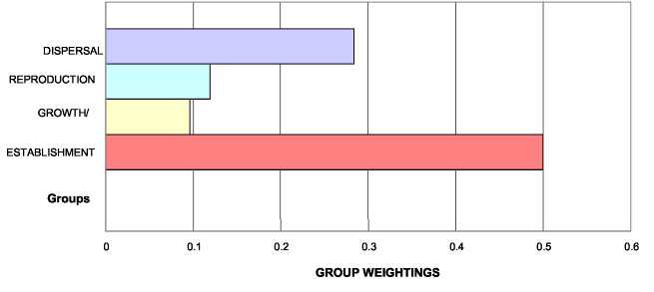
Within the invasiveness hierarchy, the weightings of individual intra-group criterion are multiplied by the group's weighting (eg. 'distance of dispersal' x 'dispersal' => 0.667 x 0.284 = 0.189), to produce a total weighting for each criterion (Figure 4). During the assessment of biological data, criteria are assigned intensity ratings (criteria ratings) of high (H), medium-high (MH), medium (M), medium-low (ML), and low (L), to score each species. (The respective numerical value for each intensity rating is H=1, MH=0.75, M=0.5, ML=0.25 and L=0.) The scored intensity ratings for each criterion and their weightings are then tallied and calculated to produce a final ‘invasiveness score’ for each species, ie.
Invasiveness score = E ((Group weighting x Criterion weighting) x Intensity rating)
The closer the final invasiveness score is to 1, the more invasive the plant is. The invasiveness score for each species is only relative to scores of other plants run through the same process, but can be used to rank species as to their potential invasiveness or rate of spread. An example of this process is shown for gorse/furze and boxthorn (Table 4). A summary of biological data was collated to determine the ‘invasiveness score’ of gorse/furze and boxthorn (Table 4). The information to rate each criterion was obtained from databases, journal articles, flora’s of the world (books or articles describing the species of a particular country or region), online information, and other sources. There is much available information on some species (eg. declared noxious species), and very scant information for others (eg. grasses and new and emerging weed species). Where there is an information ‘gap’ for a particular criterion, a ‘medium’ (M) ranking is given to indicate ‘unknown’. Although the invasiveness assessments are undertaken using the best available information, they are only as accurate as the information that is used. Therefore, as we become more informed about a species, reassessment may be necessary.
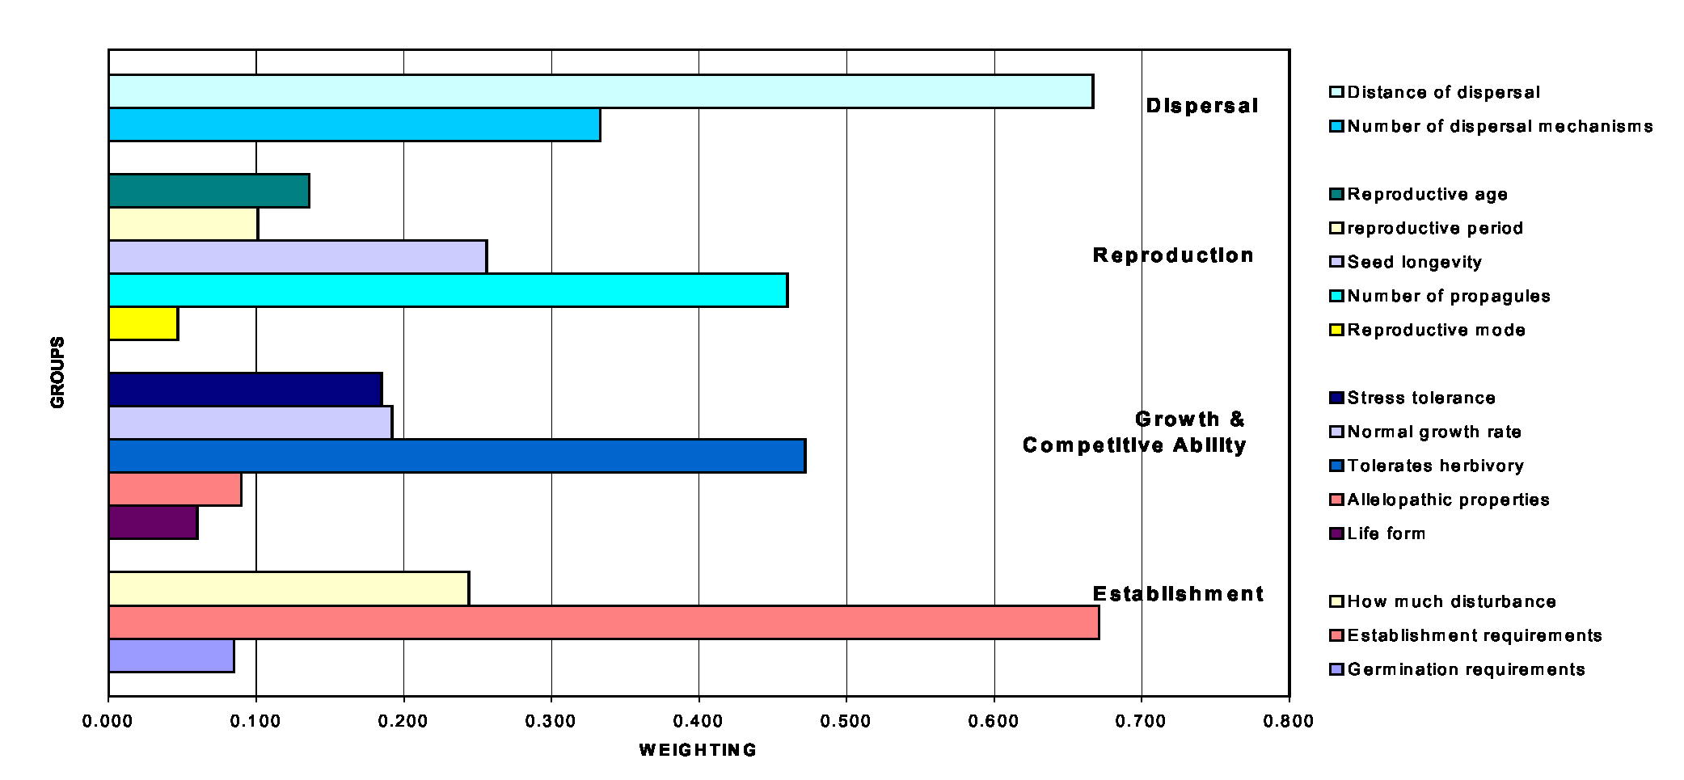
Figure 3. Criteria (intra-group) weightings of invasiveness.
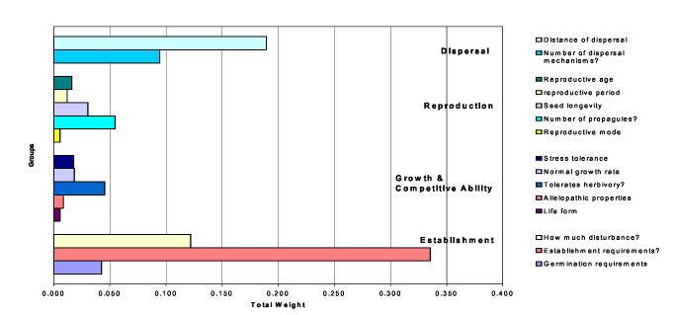
Figure 4. Total criteria weightings of invasiveness.
Table 4. Comparison of invasiveness assessments for gorse/furze Ulex europaeus and boxthorn Lycium ferocissimum.
 | Ulex europaeus |  | Lycium ferocissimum
QUESTION | COMMENTS | RATING | COMMENTS | RATING
Establishment
Germination requirements? | “Most germination occurs in autumn and spring to mid summer”. | MH | Seeds germinate at any time of the year. | H
Establishment  requirements? | Occurs in ecosystems receiving shading e.g. dry and damp sclerophyll forest. | MH | Occurs in open areas. | ML
How much disturbance is required? | Invades undisturbed ecosystems – heathland and heathy woodland. | H | Establishes in pastures. Listed as a ‘problematic weed of agricultural situations’ | MH
Growth/Competitive
Life form? | Fabaceae family: a legume. | MH | Large shrub, other category | L
Allelopathic properties? | No allelopathic properties described. | L | No allelopathic properties described. | L
Tolerates herb pressure? | “Young seedlings, which are not armed with stiff spines, are readily grazed by sheep and rabbits”. | MH | Seldom grazed by stock because of the sharp spines. | MH
Normal growth rate? | “Rapidly growing”. “Control is made difficult by the vigour and comprehensiveness of the plant”. | MH | Early root growth is rapid ensuring young plants are competitive | H
Stress tolerance to frost, drought, w/logg, sal. etc? | “Tolerates many soil types, frost to -20°C (young plants are sensitive), salt laden wind and drought”. Burns readily but not killed – re sprouts and seeds germinate”. | MH | Tolerant of drought and frost. Some water logging (occurs in creek beds and along streams and rivers). | MH
Reproduction
Reproductive system | “Reproducing by seed”. | ML | Reproducing by seed. | ML
Number of propagules produced? | “Seed production is prolific with an annual input of up to 6 million seeds per hectare”. | H | Fruit production has ranged between 0535. Seeds numerous. ˜ 500 fruit x 10 seeds per fruit=5,000 seeds. | H
Propagule longevity? | “Have a high viability and even seeds 25 years old is 85% viable”. | H | No information available. | M
Reproductive period? | “Plants are long lived, producing new growth each spring”.“Living to a maximum life of 29 years”. | H | Large shrub. Produces dense thickets. | H
Time to reproductive maturity? | “Plants may flower first when about 18 months old”. | MH | Plants do not flower until at least 2 years old. | MH
Dispersal
Number of mechanisms? | Refer to ‘dispersal’ in P & C (1992 p. 482) → wind, birds, ant’s etc. | H | The fruit is commonly eaten by birds and foxes and the seeds are viable when excreted. | H
How far do they disperse? | “Birds are important in spreading seeds and patches of weeds are often found under trees or posts where birds have perched”. | H | Above animals could disperse seeds > 1 km as quite mobile. | H
Invasiveness Index (max. = 1, min. = 0) |  | 0.83 |  | 0.67

2.5 Present and Potential Distribution of Pest Plants
Current and potential distributions are another major component required in the decision support system and AHP to predict the status of a weed. The greater the potential distribution of a weed the greater the potential impact and management costs. To ensure the most cost-effective use of weed management resources, invasive species that have the greatest potential range should be targeted. Prioritisation is also important as it is unrealistic to expect that all weeds can be controlled with limited available resources. Knowledge of potential distribution is also necessary for devising management programs. Land managers can be alerted to the risk of weed invasion and measures can be enforced to prevent the introduction of weed propagules into new areas. Low priority can be given to areas where the weed might fail to persist, or be of little economic, environmental or social importance.
In determining the potential distribution of plants, consideration must be given to the environmental conditions that a given genotype is exposed to. The US National Research Council for example, pointed out that;
" simply identifying the traits of a species and ignoring the environmental context in which the species occurs limits the information about whether the species can persist, let alone become invasive " (NRC 2002).
Two of the major environmental factors influencing weed distribution are climate and land-use. Weed species are typically more invasive in regions that are climatically similar to their native environment. Climate limits distribution according to how temperature and moisture stresses affect the weed's life cycle. Different land-uses (eg. cropping, perennial pasture and forestry) have different disturbance regimes that may or may not favour different groups of weeds. Therefore, having determined the climatic preferences of a weed, it is necessary to overlay its potential location on a map of the weed’s associated land-use in Victoria. The areas of the state that are potentially at risk from this weed can then be identified.
2.5.1 Present Distribution
Information on the weed’s present distribution, both overseas and in Australia, is collected from databases, journal articles, floras of the world (books or articles describing the species of a particular country or region), online information, and any other sources. Serrated tussock Nassella trichotoma (Nees) Hack. Ex Archav. is used here as an example to highlight the variety of sources, and the process, used to determine a weed’s present distribution.
Serrated tussock originates from Argentina and surrounding countries (Chile, Peru and Uruguay) in South America (Figure 5). Serrated tussock now occurs in South Africa, New Zealand, occasionally in Europe (eg. Italy) (Figure 6), and in Australia (Figure 7) but has not been reported elsewhere. In Australia it is thought the weed was introduced about 1900, but not recorded until 1935, growing at Yass in NSW. It was first recorded in Victoria in 1954, and Tasmania in 1956, and does not occur in any of the other states. In NSW it is most widespread on the southern and central tablelands but also occurs widely on the New England tablelands. In Victoria it is mainly found on the basalt plains west of Melbourne (Figure 8). Smaller infestations occur in the Western District, in Gippsland, and in a small patch in the north east of the State (Figure 8). A small area of serrated tussock occurs in Tasmania, near Hobart, and on King Island in Bass Strait.
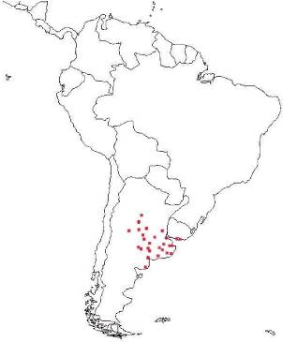
Figure 5. Distribution of serrated tussock in countries of origin.
Figure 6. Distribution of serrated tussock worldwide- except Australia.
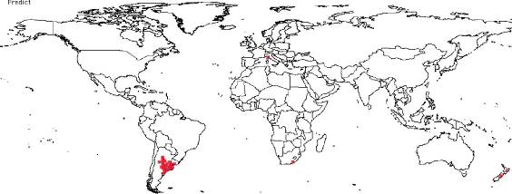
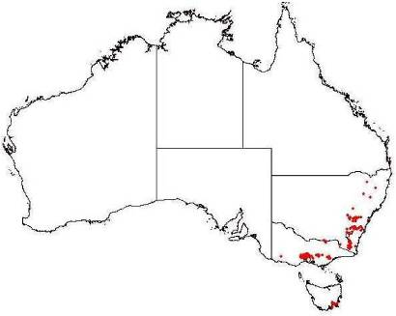
Figure 7. Distribution of serrated tussock in Australia.
Figure 8. Known naturalisations of serrated tussock in Victoria (From DPI and DSE’s IPMS).
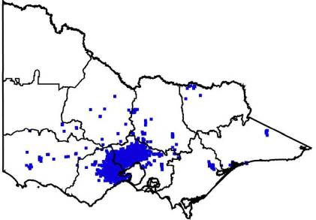
2.5.2 Potential Distribution
Information on Australian and overseas distributions were imported into a climate-matching program, CLIMATE (Pheloung 1996), to predict potential distribution in Australia. Using the localities where a species occurs overseas and within Australia, the potential climatic range of any species can be overlaid upon Australia's climatic regions. The maps below illustrate the climatic regions most suitable for serrated tussock in Australia (Figure 9) and Victoria (Figure 10).

Figure 9. Potential distribution of serrated tussock in Australia, according to climatic parameters (Areas in red indicate a 80%+ match with the preferred climate of the plant species, dark green 70%, light green 60% and yellow 50%).
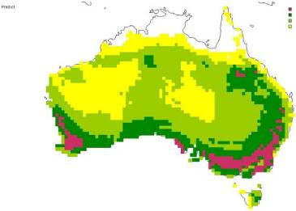
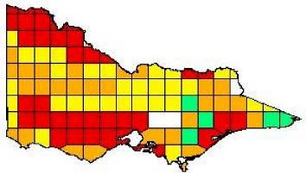
Figure 10. Potential distribution of serrated tussock in Victoria, according to climatic parameters (Areas in red indicate a 80%+ match with the preferred climate of the plant species, yellow 70%, orange 60% and green 50%).

The 16 climatic parameters that are used to determine potential distribution can be grouped according to temperature or rainfall (Figure 11). Aquatic weeds are modelled for potential climatic range differently than terrestrial species. Rainfall is not a major criterion for determining the potential range of aquatic species, especially submergents, although it may play an important role in triggering certain biological properties (eg. freshwater floods appear to stimulate flowering in Spartina) (Strong pers. comm.). Thus rainfall parameters are excluded when predicting the climatic range of aquatic weeds. Water temperature is generally more moderate and has fewer fluctuations than air temperature, and would provide a more accurate prediction for modelling aquatic species, however the necessary data is usually unknown. Therefore, modelling the climatic range of aquatic species has included eight air temperature parameters that provide at least some indication of potential range. The process for aquatic weeds is, consequently, more uncertain and likely to overestimate the species’ actual potential range.
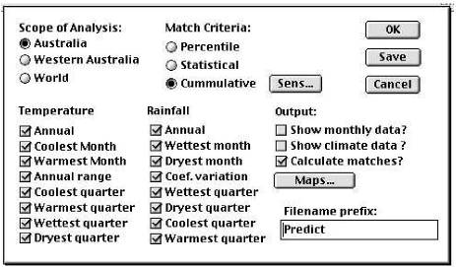
Figure 11. Dialogue box from CLIMATE (Pheloung 1996) showing the climatic parameters used in terrestrial weed modelling. The eight rainfall parameters are not included when modelling the potential climatic range of aquatic weeds.
Climatic overlays are then used to determine the potential range of the plant species by overlaying or intersecting them with susceptible land-uses, and broad vegetation types (BVTs) or wetlands, using ArcView GIS 3.2a software (ESRI Australia Pty Ltd, Melbourne). This refines potential distribution maps by recognising that plants are limited by factors other than climate alone, such as disturbance regimes associated with land-uses.
In the serrated tussock example, the weed is known to prefer sub-humid, subtropical and warm-temperate regions, and to occur as a weed in native and introduced pastures and lightly timbered regions. It is not restricted to any soil type or rainfall pattern and is relatively resistant to drought. In South America it is a minor weed invading cleared woodland, ploughed fields and neglected areas (Parsons and Cuthbertson, 1992). Serrated tussock also invades dry coastal vegetation, lowland grassland & grassy woodlands, dry sclerophyll forests & woodlands, and rock outcrop vegetation (Carr et. al. 1992). From this information one can then use a variety of GIS layers to determine susceptible land-use and broad vegetation types. The susceptible land-use overlays in this case were 'irrigated pasture' and 'dryland pasture', and the susceptible native vegetation corresponded to the following broad vegetation types;
Coastal scrubs and grasslands; dry foothill forests; grasslands; plains grassy woodlands; valley grassy forests; coastal grassy woodlands; montane grassy woodlands; riverine grassy woodlands; rainshadow woodlands; and box-ironbark forests.
The resulting map (Figure 12) illustrates the potential range of this weed in Victoria.
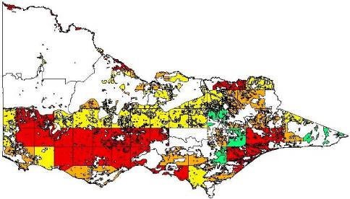
Figure 12. Potential distribution of serrated tussock in Victoria according to climatic parameters, susceptible broad vegetation types (BVT's), and susceptible land-uses. (Areas in red indicate a very high probability that serrated tussock could establish in agricultural or natural ecosystems within this region, yellow a high, orange a medium, and green a low probability of establishment. In the non-coloured areas the plant is unlikely to establish as the climate, soil, or land-use is not presently suitable.)
2.5.3 Ratio of present to potential distribution
The ratio of present to potential distribution provides an indication as to the stage that spread of a weed has reached. Another way of expressing this is the relative position of the species on its invasion graph (Figure 13). Weeds that have reached, or nearly reached, the full limit of their distribution are not a major concern in terms of potential spread and impacts. However weeds currently occupying a small area of their potential range, which are in the ‘lag' or 'sleeper’ phase, should become a management priority. An important outcome of comparing present to potential distribution is the ability to target early intervention actions against weed invasions more effectively. Early intervention not only achieves better results from government and land manager investment (Figure 14), but also reduces costs of control and impact on social, environmental and economic values.
Intensity ratings for evaluating the ratio of present to potential distribution are shown in Table 5. Intensity ratings are subsequently "ground-truthed" to ensure the rating and corresponding descriptors reflect what officers of relevant agencies are seeing in the field.
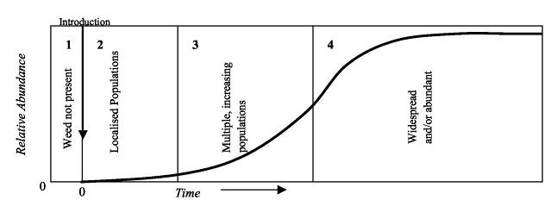
Figure 13. Invasion graph indicating stages of expansion of a new species into a habitat. (Adapted from Groves (1992) and Hobbs (1991)).
Table 5. Intensity ratings for evaluating the present compared to potential distribution of a weed.
Rating | Weight | Pres:Pot  Ratio | Statewide Descriptive | Regional or CMA Descriptive Rating
Very High | 1.00 |  | Infestation(s) that are able to be  eradicated with no chance of reinvasion from outside of area of control (interstate.). | Infestation(s) that are able to be eradicated with no chance of  reinvasion from outside of area of control (interstate/ other region etc.)
High | 0.85 | > 100,000 | Infestation(s) that are able to be eradicated with some chance of reinvasion, less than 1,000ha in Vic. | Infestation(s) that are able to be eradicated with some chance of reinvasion
Medium High | 0.71 | >  1:10,000 | Several or widely scattered small infestations or one large infestation | Several small infestations beyond eradication
Medium | 0.57 | 1:100 -  1:10,000 | Several large infestations or lots of multiple widely scattered infestations or a few combinations of both | A large partially dispersed infestation or few widely scattered small infestations
Medium Low | 0.42 | 1:10 -  1:100 | Multiple large infestations and multiple small infestations. | Numerous large dispersed infestations or lots of scattered small infestations.
Low | 0.28 | 1:2 - 1:10 | The majority of region infested with some large areas still “clean” (more “clean” areas than infested) | The majority of region infested with some large areas still “clean” (more “clean” areas than infested)
Very Low | 0.14 | < 1:2 | The majority of region infested with some smallish areas still “clean” (less “clean” areas than infested) | The majority of region infested with some smallish areas still “clean” (less “clean” areas than infested)
Extremely Low | 0 | 1:1 | Reached full potential – but may increase in density within infested area | Reached full potential – but may increase in density within infested area

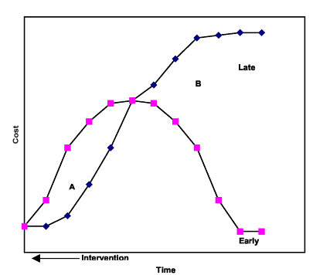
Figure 14. Total cost of plant invasions showing costs of early expenditure (Area A) and the resulting benefit (Area B) (Adapted from Hobbs and Humphries (1995)).
2.5.4 Limitations of Present and Potential Distribution Maps
Potential distribution maps are estimates and are only as reliable as the data they are based on. As more records are collected on where plants occur the predictions will become more accurate. It is expected, consequently, that there are potential distribution maps that do not yet fully represent existing or potential distribution.
For some species there may be insufficient data to undertake potential distribution mapping. For other species, information on present distribution may be under-represented in the databases used, with the exception of priority weeds such as serrated tussock. Conversely, the modelled potential distribution of weeds is likely to be overestimated. This occurs as the broad scale (i.e. 1:250,000) of the statewide databases used merges minor differences into the larger BVT's or land-uses for each grid. Microhabitats within a vegetation or land-use type may be unsuitable for the particular weed species, and microhabitats outside the identified susceptible land-use or vegetation type may be suitable but not recognised (eg. roadsides, small riparian or vegetation corridors). More detailed map layers, such as the soon to be introduced Ecological Vegetation Classes (EVCs), will produce predictions of finer detail.
The many weeds recorded as occurring along roadsides presents another major limitation when predicting potential distribution. Victoria has over 170,000 kilometres of roads, however to include all these roads within the image would not be suitable, as it would be too cluttered and meaningless. Thus, some potential distribution images may not include the occurrence of weeds within a region, if they only occur along roadsides. For example, horehound Marrubium vulgare L. can occur along roadsides within cropping regions, but is unable to withstand cultivation. Similarly, some riparian weeds may occur along small rivers, streams and water channels, but these watercourses are too small or scattered to be detected at a 1:250,000
scale. As they are not included in the riparian or riverine vegetation classes of the BVT GIS layer, they do not appear on the predicted potential distribution maps.
These limitations highlight the need for ongoing action to improve our knowledge of weed distribution. Where information on a weed’s present distribution is known but not recorded, records need to be updated to ensure management and monitoring are effectively undertaken
2.6 Impacts
The next stage of the PPPP, before calculating a Pest Plant Score (Section 2.3 and Section 2.7), is to determine the social, environmental, and economic impacts of pest plants. Some impacts of weeds can be measured in economic terms. These include:
- lost agricultural and horticultural production,
- cost of control of weeds, including fuel reduction activities,
- loss of recreational and tourism income as a result of degraded natural attractions,
- loss of native flora and fauna with potential commercial uses, and
- loss of water quality because of altered hydrological cycles and degraded natural landscapes.
However impacts on many social and environmental values, such as the impact of weeds on cultural sites or biodiversity, can be difficult to measure in dollar terms. Consequently it is yet to be demonstrated that we can credibly evaluate the full effects of weeds in such terms. Alternative assessment procedures have used general questions such as “does the weed have major, positive or negative effects on environmental health” (Virtue, pers comm.). Other procedures have been relatively detailed but lacked the transparency of weightings of questions.
2.6.1 Developing a process to measure impacts of weeds
Specific criteria to assess impacts have now been developed by PIRVic and weighted using a process similar to that for invasiveness (see Section 2.4). The method uses AHP to generate weightings for individual criteria by pair-wise comparisons of criteria within subgroups, and of subgroups, as per the methodology designed by Saaty (1995).
A series of workshops, and surveys of workshop participants, identified the social, environmental and economic values that are, or could be, threatened by weeds. A list of criteria was developed at these workshops, and twenty-six specific criteria were selected as being appropriate to determine the impacts that weeds have on these values in Victoria (Table ).
The draft National Technical Specifications for Post Border Weed Risk Management (Virtue et al 2004) identifies six factors fundamental to determining the impact of weeds. The factors question the degree to which the weed could:
- reduce the establishment of desired plants?
- reduce the biomass/yield of desired plants?
- reduce the quality of products or services?
- restrict physical movement?
- affect human and/or animal health?
- ecological processes?
The impact criteria established for this process reflect those factors and, in fact, expand upon them.
The workshops grouped these criteria according to a basic hierarchy of social, environmental (abiotic and biotic), and economic (principally agricultural) issues. Finally the criteria within groups were allocated weights according to pair-wise comparisons. Subgroups within the same group were also compared and
weighted (ie. Tourism versus Cultural, or Vegetation versus Fauna), as were the major groups; social values (social impacts), natural resources (environmental impacts-abiotic), flora and fauna (environmental impacts-biotic), and agriculture (economic impacts) (Table 6).
The process included a revision of preliminary weightings to identify inconsistencies between perceived values and the weightings that had been assigned. For example, most social criteria were assumed less important than environmental criteria, however criteria such as threatened flora, or high value EVCs were found to be under-weighted, while some of the social criteria were over-weighted. The revision and adjustment of weightings in this fashion is in accordance with Saaty (1995). Final weighted criteria are presented in Figure 15 and, according to importance, in Figure 16.
Once weightings are finalised, individual weeds are subsequently assessed for each criterion according to 'intensity ratings' (Table 7). Each criterion is rated on a common scale (ie. 1 to 0) as H, MH, M, ML, or L (with respective intensity score of 1, 0.75, 0.5, 0.25 and 0). This intensity rating score is then multiplied by the overall weighting for that particular criterion and summed with all the other criteria scores to produce an overall impact score from 1 (scored H for all criteria) to 0 (scored L for all criteria), ie.:
Impact Score = Ó ((Criteria Group Weighting × Criteria Weighting) × Criteria Intensity Rating)
2.7 Calculating a Pest Plant Score
The final stage of the PPPP is to apply the results of invasiveness (Section 2.4), distribution (Section 2.5), and impact (Section 2.6) assessments to determine the relative importance of weeds by calculating a Pest Plant Score. The formula for calculating the Pest Plant Score (introduced in Section 2.3) is:
Pest Plant Score = á (Invasiveness score) + â (Present:Potential Distribution) + ä (Impact)
where á = 0.12, â = 0.32 and ä = 0.56
The application of this formula can be illustrated using the example of serrated tussock in two different catchment management authority (CMA) regions:
Wimmera CMA Port Phillip and Westernport CMA
Pest Plant Score Pest Plant Score
= á (0.7615) + â (0.85) + ä (0.6290) = á (0.7615) + â (0.28) + ä (0.6290)
= 0.12 (0.7615) + 0.32 (0.85) + 0.56 (0.6290) = = 0.12 (0.7615) + 0.32 (0.28) + 0.56 (0.6290)
= 0.7156 = 0.5332
In this example serrated tussock was subsequently ranked as the third highest priority weed in the Wimmera CMA (with a relatively high Pest Plant Score of 0.7156). In the Wimmera CMA serrated tussock currently occupies a small area of its potential range, therefore intervention in this case would optimise government and land manager investment, and reduce costs of control, and impact on social, environmental and economic values. In the Port Phillip and Westernport CMA however, serrated tussock (with a Pest Plant Score of 0.5332) already occupies a large proportion of its potential distribution and was consequently ranked 32 of 101 weeds assessed.
Table 6. Group and criteria ratings for determining impact.
GROUP | SUB GROUP | CRITERIA |  | GROUP  WEIGHTING | SUB GROUP  WEIGHTINGS | CRITERION  WEIGHTING |  | FINAL  CRITERION  WEIGHTS
Social Values 0.1
Tourism |  |  |  |  | 0.875
 |  | Restrict human access? |  |  |  | 0.297 |  | 0.0259875
 |  | Reduce the ‘tourism / aesthetics/ recreational use of the land’? |  |  |  | 0.539 |  | 0.0471625
 |  | Plant injurious, toxic, or spines affect people? |  |  |  | 0.164 |  | 0.01435
Cultural |  | Damage to indigenous or European cultural sites? |  |  | 0.125 |  |  | 0.0125
Natural Resources - soil, water and processes 0.25
Water |  |  |  |  | 0.5
 |  | Impact on water flow within watercourses or water bodies? |  |  |  | 0.333 |  | 0.041625
 |  | Impact on water quality (ie. dissolved 02, water temperature)? |  |  |  | 0.667 |  | 0.083375
 | Soil | Increase soil erosion? |  |  | 0.3 |  |  | 0.075
 | Processes |  |  |  | 0.2
 |  | Reduce the biomass of the community? (nb. biomass acting as a carbon sink). |  |  |  | 0.1 |  | 0.005
 |  | Change the frequency or intensity of fires? |  |  |  | 0.9 |  | 0.045
Flora and Fauna 0.425
Vegetation |  |  |  |  | 0.65
EVCs: Impact on the vegetation composition on the following: |  |  |  |  |  | 0.53
 |  |  | - High value EVCs |  |  |  | 0.56 | 0.081991
 |  |  | - Medium value EVCs |  |  |  | 0.34 | 0.04978025
 |  |  | - Low value EVCs |  |  |  | 0.1 | 0.01464125
 |  | Structure of a vegetation community? |  |  |  | 0.25 |  | 0.0690625
 |  | Threatened flora spp.? |  |  |  | 0.22 |  | 0.060775
Fauna 0.35
 |  | Threatened fauna spp.? |  |  |  | 0.368 |  | 0.05474
 |  | Non-threatened fauna spp.? |  |  |  | 0.177 |  | 0.02632875
 |  | Benefits or facilitates the establishment of indigenous fauna? |  |  |  | 0.155 |  | 0.02305625
 |  | Toxic, its burrs or spines affect indigenous fauna? |  |  |  | 0.112 |  | 0.01666
 |  | Pest Animals |  |  |  | 0.188
 |  |  | Provide a food source to assist in success of pest animals? |  |  |  | 0.4 | 0.011186
 |  |  | Provide important habitat or harbour for serious pests? |  |  |  | 0.6 | 0.016779
Agriculture 0.225
 |  | Quantity or yield of agricultural produce? |  |  |  | 0.084 |  | 0.0189
 |  | Agricultural quality (eg. contamination)? |  |  |  | 0.144 |  | 0.0324
 |  | Affect land value? |  |  |  | 0.243 |  | 0.054675
 |  | Change in priority of land use? |  |  |  | 0.448 |  | 0.1008
 |  | Increases the cost of harvest? |  |  |  | 0.053 |  | 0.011925
 |  | Act as an alternative host or vector for diseases of agriculture? |  |  |  | 0.028 |  | 0.0063

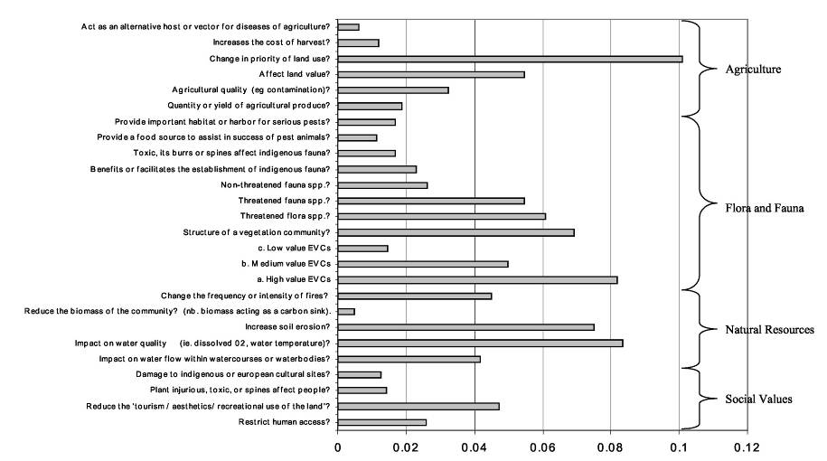

Figure 15. Total (final) criteria weightings of impact.

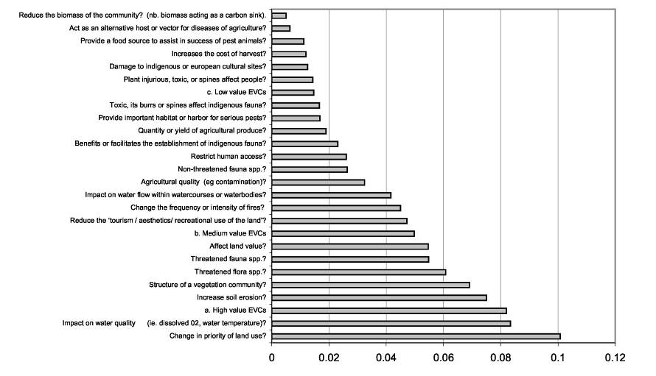
Figure 16. Total (final) criteria weightings of impact according to importance
Table 7. Example of an impact assessment for serrated tussock according to criteria and intensity ratings. H=1, MH=0.75, M=0.5, ML=0.25, L=0
Question | Comments | Rating
- To what extent does the weed restrict human access? | “A perennial tussock-forming grass to 50cm high and 25 cm diameter at the base.” Leaf spread is about 50 cm. Intensity rating: Would not hinder human access. (P & C 2001, Groves et al 1995). | L
- To what level does this weed reduce the ‘tourism / aesthetics/ recreational use of the land? | Tussocks are noticeable, but would not restrict recreational activities. Intensity rating: Weeds not obvious to the average visitor. | L
- To what level is the plant injurious, toxic, or spines affect people? | Not toxic to humans. | L
- How much damage is done to indigenous or European cultural sites? | Dense patches of tussocks likely to create a negative visual impact on cultural sites. | ML
5.To what extent does this weed impact on water flow within watercourses or waterbodies? | Terrestrial sp. (P & C 2001) | L
- To what extent does the weed impact on water quality (ie. dissolved 02, water temperature)? | Terrestrial sp. (P & C 2001) | L
- To what extent does the weed increase soil erosion? | Tussocks persist for many years. Roots are diffuse and fibrous, mostly in top 20 cm of soil, and even seedlings are difficult to pull from the soil. Not likely to contribute to soil erosion.  Intensity rating: Low probability of large scale soil movement. (P & C 2001) | L
- To what extent does this weed reduce the biomass of the community? (n.b. biomass acting as a carbon sink). | “It dominates pastures and invades natural areas forming dense swards.” Intensity rating: Replaces biomass. (Blood 2001) | ML
- To what extent does the weed change the frequency or intensity of fires? | “N. trichotoma burns readily in winter. A dense mature infestation of N. trichotoma generally has 5–20 tussocks per square metre.” “Dense stands produce a serious fire hazard.” CFA trials (at Melton 1998) have indicated serrated tussock burns with an intensity up to seven times greater than grasslands. Seed heads create additional hazards where they build up against housing, sheds, roadsides, fence lines etc. This is a particularly serious hazard in the rural/urban interface areas of outer west Melbourne.  Intensity rating: Dense infestations would moderately change the frequency and intensity of fire risk. (Groves et al 1995, Eurobodalla Shire, David Boyle, pers. comm) | H

10. To what extent does this weed impact on the vegetation composition on the following: | - High value EVCs | EVC=Plains grassland (E); CMA=Corangamite; Bioreg=Victorian Volcanic Plain; VH CLIMATE potential.  Prolific seeder. Each plant can cover a large area leading to almost complete cover in dense infestations and eliminating most other species. Serious impact on grasses/forbs. 3-fold effect: competitiveness, water usage high, and allelopathy. Can form a monoculture if the area of infestation is 20% or greater-cannot save grassland.  Intensity rating: Potential for monoculture within a specific layer. (P & C 2001, Colin Hocking – Pers comm) | H
 | - Medium value EVCs | EVC=Grassy dry forest (E); CMA=Port Phillip; Bioreg=Central Victorian Uplands; VH CLIMATE potential.  Also grows in lightly timbered areas. Impact as in 10(a) above. (P & C 2001) | H
 | - Low value EVCs | EVC=Heathy dry forest (E); CMA=Glenelg Hopkins; Bioreg=Goldfields; VH CLIMATE potential. Impact as in 10(b) above. (P & C 2001) | H
11. To what extent does this weed effect the structure of a vegetation community?  (How many levels within community would be affected; Total of 6 levels – trees> 20m, trees 10–20m, shrubs 2–10m, shrubs<2m, tussock grasses, ground covers & herbs (after Specht, 1970)). |  | “In dense stands foliage of N. trichotoma completely covers the soil surface, thereby suppressing competitors.” “Mature plants develop a drooping, smothering form eventually excluding other ground-flora.” N. trichotoma is most commonly found in grassland/pasture situations, where it would compete strongly with and possibly replace other grasses, and forbs. “...establishing dense tree and shrub cover will, after a number of years, significantly impede Serrated Tussock invasion.”  Intensity rating: Affects the lower two levels only. (P & C 2001, Muyt 2001) | ML
12. What effect does the weed have on threatened flora spp.? |  | From serrated tussock establishment it takes only seven years to dominate a pasture or native grassland. Effects on Danthonia spp. Threatens ANZECC rated rare or threatened native plant species. (Groves et al 2003) | H
13. What effect does the weed have on threatened fauna spp.? |  | Hotter burns impact on striped legless lizard, and other ground dwelling species. Loss of flora biodiversity as serrated tussock displaces desired species impacts on adequate food supply. Golden sun moth, (Synemon plana) are dependant on Austrodanthonia spp., which are displaced by serrated tussock. Intensity rating: Habitat changed leading to possible extinction of a VROT or Bioregional Priority spp. (A review of the conservation status of selected Australian non-marine invertebrates. G Clarke F Spier 2004) | H
14. What effect does the weed have on non-threatened fauna spp.? |  | “Plants are unpalatable and infestations commonly expand as other species are selectively grazed out. The smothering form eventually excludes other ground-flora.” Reduction in habitat for native fauna. Or habitat changed dramatically? Possible local extinction. Wombats foraging in Monaro plains – foraging limited by ST infestations – forced to raid rubbish bins.  Intensity rating: Habitat changed dramatically, leading to possible extinction. (Muyt 2001, David Boyle pers comm) | H
Q15. To what extent does this weed provide benefits or facilitates the establishment of indigenous fauna? |  | No documented benefits for fauna.  Intensity rating: Provides very little support for desirable species. | H

16. To what extent is the plant toxic, its burrs or spines affect indigenous fauna? | “Sheep will not graze it unless forced to and they lose weight and die due to a rumen full of undigested leaves.” May have similar impact on fauna, although they are unlikely to graze.  Intensity rating: May cause fauna to lose condition. (Blood 2001) | ML
17. To what extent does this weed provide a food source to assist in success of pest animals? | Not known as a food source to pests. | L
18. To what extent does this weed provide important habitat or harbour for serious pests (eg. foxes,  rabbits)? | Across the basalt plains rabbits are the greatest vertebrate environmental pest and serrated tussock provides harbour; permanent harbour in Rowsley Valley area.  Intensity rating: Capacity to provide harbour for rabbits throughout the year. (David Boyle pers comm) | H
19. To what extent does this weed impact on the quantity or yield of agricultural produce? | “Even moderate infestations reduce carrying capacity by about 40% and up to 100%.” Serious impact on quantity of produce.  Intensity rating: Serious impact on quantity e.g., >20% reduction. (P & C 2001, David Boyle pers comm) | H
20. To what extent does the weed impact on agricultural quality (eg contamination – lower price)? | Animals forced to eat the plant lose condition. “Even a moderate loss of condition results in lowered wool quality because of loss of crimp and breaks in the fleece. Seeds also contribute to vegetable fault in wool.” Major impact on quality. Canola crop contaminated by seed contaminant by wind, civil court case - $60,000 damage.  Intensity rating: Serious impacts on quality. Produce rejected for sale or export. (P & C 2001, David Boyle pers comm) | H
21. To what extent does this weed affect land value? | As a serious weed of pasture with significant impact on carrying capacity and reduction in agricultural return, its presence would seriously affect land value. Seven (7) Local Govt councils have introduced rebate schemes to arrest the decline in land value.  Intensity rating: Major significance > 10% reduction in land value. (P & C 2001, David Boyle pers comm) | H
22. To what extent does this weed cause a change in priority of land use? | In New Zealand, “considerable effort to control [N. trichotoma], involving government purchase of heavily infested farms, clearing the weed at government expense, and reselling the land for farming, has been expended over many years.” Without government intervention, the land would have had no use for pastoral activities.  Intensity rating: Significant loss of land for agricultural use. (P & C 2001) | H
23. To what extent the presence of the weed increases the cost of harvest. | Not a weed of cropping in Australia. In uncultivated areas serrated tussock dominates but can be controlled with cropping regimes. In very heavy infestation areas continuous cropping is the only control option and creates another set of problems with soil health. However the impact of seeding tussock blown  onto pre-harvested crops has resulted in downgraded quality of produce and has seen one civil case against neighbouring polluters. More seed testing carried out. Time taking in harvest and post harvest testing. Also need to cultivate each year to prevent re-establishment.  Intensity rating: Major increase in time or labour, or machinery in harvesting. (David Boyle pers comm) | H
24. To what extent does this weed act as an alternative host or vector for diseases of agriculture? | None evident. Unknown. | M

References
Carr, G.W., Yugovic, J.V. and Robinson, K.E. (1992) Environmental Weed Invasions in Victoria: Conservation and Management Implications. Department of Conservation and Natural Resources and Ecological Horticulture, Victoria.
Groves, R.H. (1992) Weed ecology and spread. In: Proceedings of the First International Weed Control Congress (Volume 1). Weed Science Society of Victoria, Melbourne.
Hobbs, R.J. (199 1) Disturbance a precursor to weed invasion in native vegetation. Plant Protection Quarterly 6(3): 99-104.
Hobbs, R.J. and Humphries, S.E. (1995) An Integrated Approach to the Ecology and
Management of Plant Invasions. Conservation Biology 9(4): 761-770.
NRC (National Research Council), Committee on the scientific basis for predicting the invasive
potential of non-indigenous plants and plant pests in United States. (2002) Predicting invasions of non-indigenous plants and plant pests. National Academy Press, Washington
Pheloung, P.C. (1996) CLIMATE: a system to predict the distribution of an organism based on climate preferences. Agriculture Western Australia, Perth.
Robertson M.P., Villet M.H., Fairbanks D.H.K., Henderson L., Higgins S.I., Hoffmann J.H., Le Maitre D.C., Palmer A.R., Riggs I.,Shackleton C.M. and H.G. Zimmermann. (2003), A
proposed prioritization system for the management of invasive alien plants in South Africa, South African Journal of Science 99: 1-7
Ross, J. H. and Walsh, N. G. (2003) A census of the vascular plants of Victoria. 7th edition. National Herbarium of Victoria, Royal Botanic Gardens, Melbourne
Saaty, T. (1995) Decision Making for Leaders: The Analytical Hierarchy Process for Decisions in a Complex World. RWS Publications, Pittsburgh.
Sax, D.F. and Brown, J.H. (2000) The paradox of invasion. Global Ecology & Biogeography 9, 363–371
Sposito, V., Thatcher, A., Itami, B., Weiss, J., and Cotter, M. (2002) Priority setting framework for natural resources management - Application of the analytical hierarchy process and natural resources accounting. Department of Natural Resources and Environment, Melbourne
Virtue, J. G., Cunningham, D. C., Hanson, C. S. T., Hosking, J. R., Miller, I. L., Panetta, F. D., Pheloung, P. C., Randall, R. P., Timmins, S. M., Walton, C. S., Weiss, J. E. R., and Williams, P. A. (2004) A national technical specification for post-border weed risk management. CRC Weed Management Systems, Adelaide
Williamson, M. and Fitter, A., (1996) The varying success of invaders. Ecology 77: 1661-1666
Other references
Blood, K. (2001). Environmental Weeds. A Field Guide for SE Australia. CH Jerram, Science Publishers.
Carr, G.W., Yugovic, J.V. and Robinson, K.E. (1992). Environmental Weed Invasions in Victoria. Department of Conservation and Environment Melbourne.
Groves, R.H., Shepherd, R.C.H. and Richardson, R.G. (Eds) (1995). The Biology of AUSTRALIAN WEEDS. Volume 1 R.G. and F.J. Richardson Meredith, Victoria.
Lamp, C. and Collet, F. (1989). Field Guide to Weeds in Australia. Inkata Press Melbourne & Sydney.
Lazarides, M., Cowley, K. and Hohnen, P. (1997). CSIRO Handbook of Australian Weeds. CSIRO Publications Australia.
Muyt, A. (2001). Bush Invaders of South -East Australia. A guide to the identification and control of environmental weeds found in South -East Australia. R.G. & F.J. Richardson Victoria.
Panetta, F.D., Groves, R.H. and Shepherd, R.C.H. (Eds) (1998). The Biology of Australian Weeds. Volume 2 R.G. and F.J. Richardson Meredith, Victoria.
Parsons, W.T. and Cuthbertson, E.G. (2001). Noxious Weeds of Australia, 2nd edn. Inkata Press Melbourne & Sydney. Randall, R.P. (2002). A Global Compendium of Weeds. R.G. and F.J. Richardson, Merredith, Victoria.
Thorpe, J.R. and Lynch, R. (2000). The determination of Weeds of National Significance. National Weeds Strategy Executive Committee, Launceston
Viridans (Biological Databases). 2003. Wild Plants of Victoria CD-ROM. Viridans Pty. Ltd, Melbourne, Victoria.
Databases and websites:
A Global Compendium of Weeds. A web version of the book (Randall 2002 – see references above). Collates weed lists from around the world. The prime source for investigating the weed history of a species.
www.hear.org/gcw/index.html
Australia’s Virtual Herbarium website. This website maps the recorded locations of plant specimens held within Australia’s national and state herbaria, including exotic species.
http://www.chah.gov.au/avh/
GRIN (Germplasm Resources Information Network) database enables users to determine current names and obtain some information on species (and where to go for more information). This database suggests which name should be used and often gives reasons why.
www.ars-grin.gov/npgs/tax/taxgenform.html
The Nature Conservancy website. This website is particularly useful for temperate weeds. tncweeds.ucdavis.edu/esadocs.html
PLANTS database set up by the United States Department of Agriculture. This database covers all species naturalised in the United States of America (USA) and often has links to further information on species.
http://plants.usda.gov/topics.html
W3Tropicos. An internet resource that provides access to the Missouri Botanical Garden's VAST (VAScular Tropicos) nomenclatural database and associated authority files. It provides current information on the name, place of publication, type, and other information about a plant. http://mobot.mobot.org/W3T/Search/vast.html
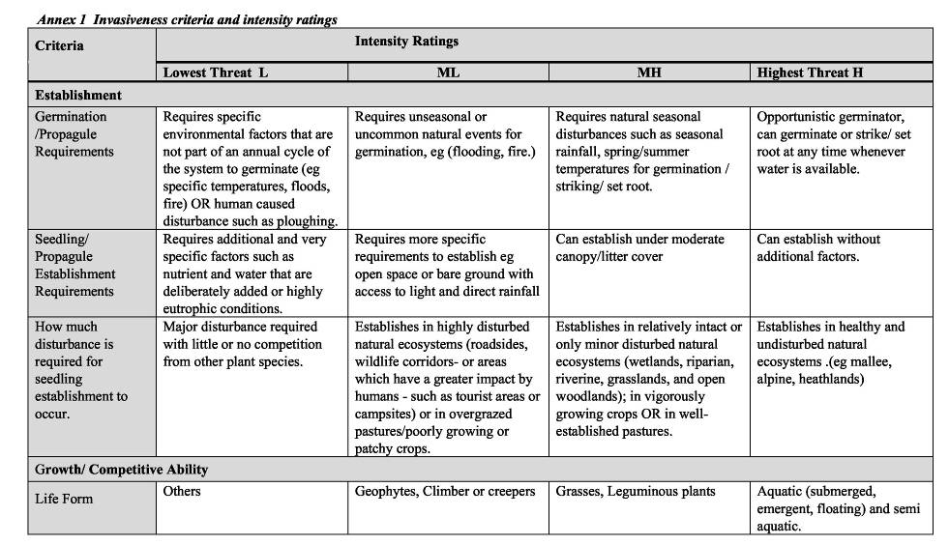
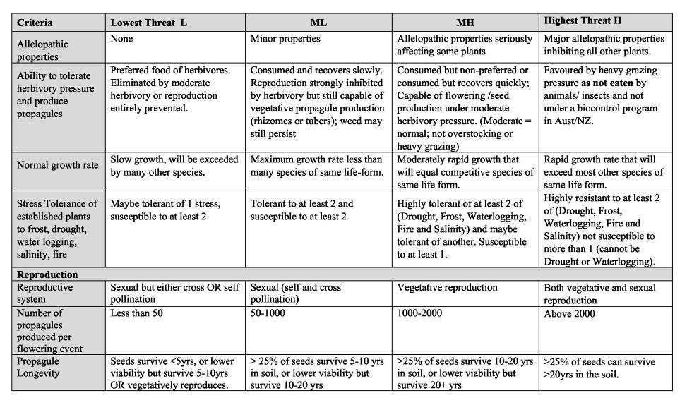
Criteria | Lowest Threat L | ML | MH | Highest Threat H
Reproductive period | Mature plant produces viable propagules for only 1yr. | Mature plant produces viable  propagules for only 1 – 2 yrs. | Mature plant produces viable propagules for 3 –10yrs | Mature plant produces viable propagules for 10yrs or  more, or species forms self-sustaining dense monocultures.
Time to reach reproductive maturity. | Greater than 5yrs to reach sexual maturity. | 2-5yrs | Produces propagules between 1- 2yrs after germination. | Reaches maturity and produces viable propagules in under a year.
Dispersal
Number of dispersal mechanisms? | Propagules mainly spread by gravity | Propagules can also be spread by attaching to humans or animals | Propagules spread by wind, water, animals (not birds) or light vehicular traffic. | Very light, wind dispersed seeds, OR bird dispersed seeds OR has edible fruit that is readily eaten by highly mobile animals.
Probability (or chance) that propagules will disperse to a distance greater than 1 km. | Very unlikely to disperse greater than 200m most will be less than 20m | Very few to none will disperse to 1 km, most 20-200m | Few propagules will disperse greater than 1 km but many will reach 200-1000m | Very likely that some propagules will disperse greater > 1 km

Annex 2 Impact criteria and intensity ratings
Criteria | Intensity Ratings
Criteria | Lowest Threat L | ML | MH | Highest Threat H
SOCIAL ( Tourism, Visual aesthetics, Experience, Cultural sites)
- To what extent does the weed restrict human access? | Minimal or negligible impact (ie. can go anywhere). | Low nuisance value. Impedes individual access; unable to walk to waterways. | High nuisance value. People and/or vehicles access with difficulty. | Major impediment to access waterways or machinery. Significant works required to provide reasonable access, tracks closed or impassable.
- To what level does this weed reduce the ‘tourism / aesthetics/ recreational use of the land? | Weeds not obvious to the ‘average’ visitor. | Minor effects to aesthetics and/or recreational uses (ie. aware but not bothered or activity inhibited). | Some recreational uses affected. | Major impact on recreation. Weeds obvious to most visitors, with visitor response complaints and a major reduction in visitors.
- To what level is the plant injurious, toxic, or spines affect people? | No effect, no prickles, no injuries. | Mildly toxic, may cause some physiological issues (eg. hayfever, minor rashes, minor damage from spines and burrs at certain times of year). | Spines, burrs or toxic properties at most times of the year, or may be a major component in allergies, hayfever and/or asthma. | Large spines or burrs, extremely toxic, and/or cause serious allergies to humans throughout year.
- How much damage is done to indigenous or european cultural sites? | Little or negligible effect on aesthetics or structure of site. | Moderate visual effect. | Moderate structural effect. | Major structural damage to site, and/or obliteration of the historic/cultural feature.
NATURAL RESOURCES – SOIL, WATER & PROCESSES
- To what extent does this weed impact on water flow within watercourses or waterbodies? | Little or negligible affect on water flow. | Minor impact on surface or subsurface flow either by roots or free floating aquatics. | Major impact on either surface or subsurface flow (eg. major root obstructions, submergent aquatics). | Serious impacts both to surface and subsurface water flow (eg. attached emergent aquatics).

Criteria | Lowest Threat L | ML | MH | Highest Threat H
- To what extent does  the weed impact on water quality (ie. dissolved  02, water temperature)? | No noticeable effect on dissolved 02 or light levels. | Noticeable but minor effects in either dissolved 02 or light levels. | Noticeable but moderate effects in both dissolved 02 and light; causing increased algal growth. | High effects in either dissolved 02 and/or light; causing eutrophication.
- To what extent does the weed increase soil erosion? | Low probability of large scale soil movement. | Moderate probability of large scale soil movement. | High probability of large scale soil movement with minor off-site  implications. | High probability of large scale soil movement with major off-site implications.
- To what extent does this weed reduce the biomass of the  community? (nb. biomass acting as a carbon sink). | Biomass may increase. | Direct replacement of biomass by invader. | Biomass slightly decreased. | Biomass significantly decreased (eg. trees replaced by more open community).
- To what extent does the weed change the frequency or intensity of fires? | Small or negligible effect on fire risk. | Minor change to either frequency or intensity of fire risk. | Moderate change to both frequency and intensity of fire risk. | Greatly changes the frequency and/or intensity of fire risk.
Fauna and flora / vegetation & EVCs
- To what extent does this weed impact on the vegetation composition on the following:
- High value EVCs | Very little displacement of any indigenous spp. Sparse/ scattered infestations. | Minor displacement of some dominant or indicator spp. within any one strata/layer (eg. ground cover, forbs, shrubs & trees). | Major displacement of some dominant spp. within a strata/layer (or some dominant spp. within different layers). | Monoculture within a specific layer; displaces all spp. within a strata/layer.
- Medium value EVCs | (as above) | (as above) | (as above) | (as above)
- Low value EVCs | (as above) | (as above) | (as above) | (as above)

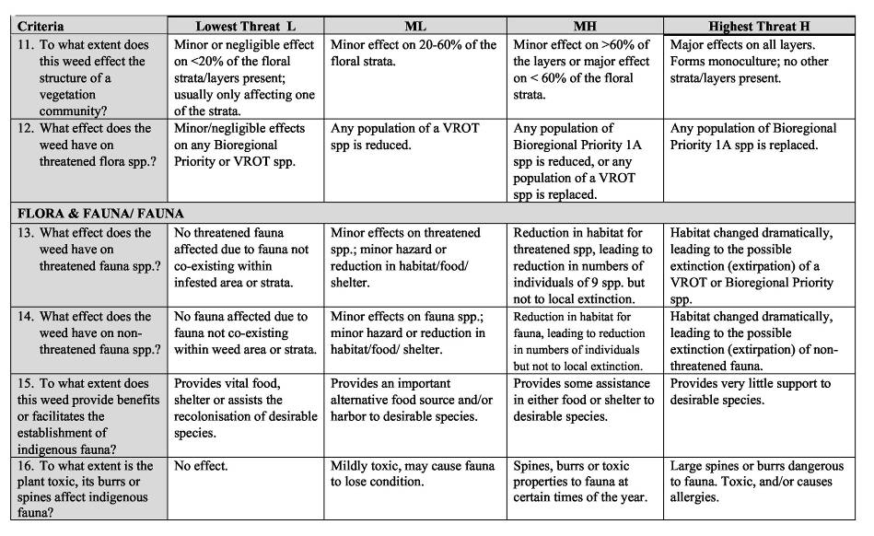

Criteria | Lowest Threat L | ML | MH | Highest Threat H
FLORA AND FAUNA/ FAUNA /Pest Animal
- To what extent does this weed provide a food source to assist in success of pest animals? | Provides minimal food for pest animals. | Supplies food for one or more minor pest spp.  (eg. blackbirds or  environmental insect pests). | Supplies food serious pest (eg. rabbits and foxes), but at low levels (eg. foliage). | Supplies food for > 1 major pest spp at crucial times of the year (heavy berry load or continual food throughout the year).
- To what extent does this weed provide habitat / harbor for serious pests? | No harbour for pest spp. | Doesn’t provide harbor for serious pest spp, but may provide for minor pest spp. | Capacity to harbor rabbits or foxes at low densities or as overnight cover. | Capacity to provide harbor and permanent warrens for foxes and rabbits throughout the year.
AGRICULTURE – Quality, Quantity, Cost to Production, Effect on land use and value
- To what extent does this weed impact on the quantity or yield ^{of}agricultural produce? | Little or negligible affect on quantity of yield. | Minor impact on quantity of produce (eg < 5% reduction). | Major impact on quantity of produce (eg 5-20%). | Serious impacts on quantity (eg >20% reduction) Unviable to  harvest crop/ stock.  p
- To what extent does the weed impact on agriculturalquality (eg contamination - lower price)? | Little or negligible affect on quality of yield. | Minorimpact on quality of produce (eg < 5% reduction). | Major impact on quality of produce (eg 5-20%). | Serious impacts on quality (eg g >20% reduction) Produce  e  rejected for sale or export.
- To what extent does this weed affect land value? | Little or none. |  | Decreases land value <10% | Major significance > 10%
- To what extent does this weed cause a change in priority of land use? | Little or no change | Some change, but no serious alteration of either agricultural return. Affects the visual rather than intrinsic agricultural value | Downgrading of the priority land use, to one with either less  agricultural return. | Major detrimental change and significant loss for agricultural usage (eg complete change to different ag use eg farm forestry.)
- To what extent the presence of the weed  increases the cost of harvest? | Little or none. |  | Minor increase in cost of harvesting–— eg slightly more time or labour is required. | Major increase in time or labour, or machinery in harvesting.
- To what extent does this weed act as an alternative host or vector for diseases of agriculture? | Little or no host |  | Provides host to minor (or common) pests or  diseases | Host to major and severe disease or pest of important agricultural produce.

