adz@work

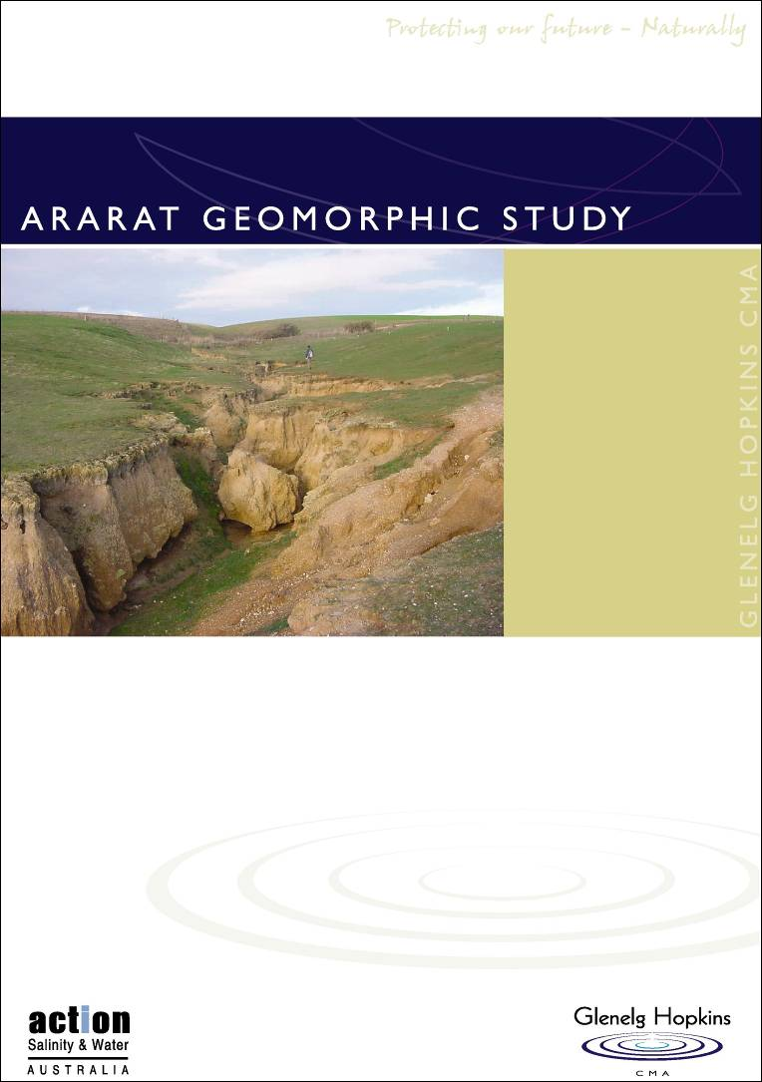

Ararat Geomorphic Study
FINAL REPORT
■ Final
■ 28/10/2003
Sinclair Knight Merz ABN 37 001 024 095 590 Orrong Road, Armadale 3143
PO Box 2500
Malvern VIC 3144 Australia Tel: +61 3 9248 3100 Fax: +61 3 9248 3400
Web: www.skmconsulting.com
COPYRIGHT: The concepts and information contained in this document are the property of Sinclair Knight Merz Pty Ltd. Use or copying of this document in whole or in part without the written permission of Sinclair Knight Merz constitutes an infringement of copyright.
Ararat geomorphic study: final report



Contents
SINCLAIR KNIGHT MERZ
I:\wcros\Wc02550\REP03_06.23\Final Report\R02 PJS Ararat Final Report.doc PAGE i
Executive summary iv
- Introduction 1
1.1 Project objectives 1
1.2 Project approach 1
1.3 Document structure 3
- Model of landscape change 5
- Hopkins River 7
3.1 Climate and hydrology 7
3.2 Environmental condition 7
- Study area 11
4.1 Geology 11
4.2 Landforms and soil types 13
4.3 Gully erosion 15
4.4 Coupling and connectivity of sediment transport processes 17
- Sediment sources and sinks 21
5.1 Field techniques 21
5.2 Terrain analysis 22
5.3 Construction of sediment budgets 26
- Ararat Hills 28
6.1 Gully processes 31
6.2 Floodouts and in-gully storages 35
6.3 Hopkins River 37
- Challicum Hills 39
7.1 Gully processes 42
7.2 Floodouts and in-channel storages 46
7.3 Hopkins River 48
- Skeleton Hills 52
8.1 Gully processes 52
8.2 Floodouts and in-gully storages 59
8.3 Hopkins River 60
- Rehabilitation options 62
9.1 Erosion risk 62
9.2 Monitoring 64

Ararat geomorphic study final report

9.3 Control works 67
SINCLAIR KNIGHT MERZ
I:\wcms\Wc02550\REP03_06.23\Final Report\R02 PJS Ararat Final Report.doc PAGE ii
- Summary and conclusions 71
- References 75
Appendix A Consultation with landholders 78
Appendix B Gully control works 80
B.1 Reclaiming areas affected by surface erosion processes 80
B.2 Reclaiming areas affected by subsurface erosion processes 82
Appendix C Sediment analysis 83

Ararat geomorphic study final report
Document history and status
Revision
Issue | Revision | Date issued | Reviewed by | Approved by | Comment
1 | Draft | 11/09/03 | B. Abernethy | B. Abernethy | Draft for client review
2 | Final | 28/10/03 | L. Smith | B. Abernethy | Final for release

Distribution
Copy | Quantity | Issued to
1 | 2 | Leigh Smith (Glenelg Hopkins CMA)
2 | 1 | File WC02550

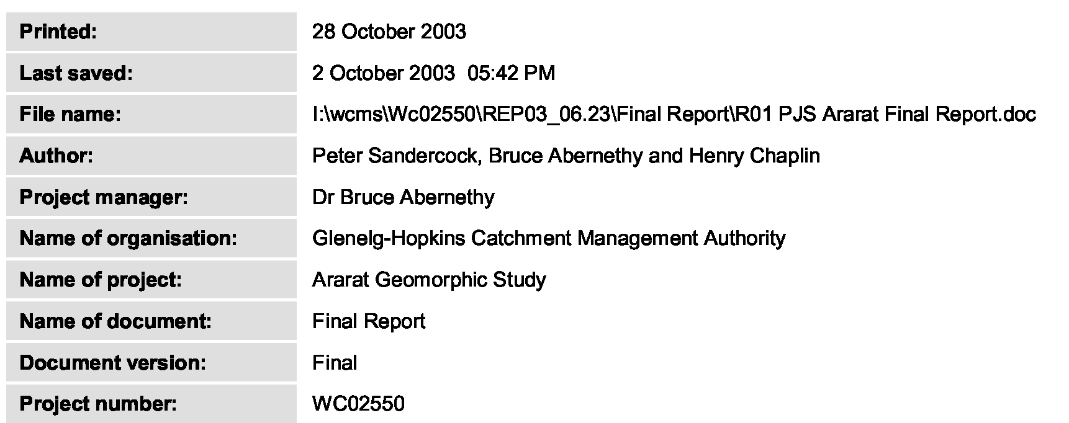
SINCLAIR KNIGHT MERZ
I:\wcms\Wc02550\REP03_06.23\Final Report\R02 PJS Ararat Final Report.doc PAGE iii

Ararat geomorphic study: final report


Executive summary
SINCLAIR KNIGHT MERZ
I:\wcros\Wc02550\REP03_06.23\Final Report\R02 PJS Ararat Final Report.doc PAGE iv
This study arose out of concerns that gullies in the upper Hopkins River catchment are still actively eroding and that the eroded sediments are impacting on the condition of the downstream river system. Gully initiation in the study area was brought about by historic clearing and other catchment disturbances. However, the erodible nature of the soil types, combined with their position in the landscape, is an important factor contributing to the erosional problems in the study area. Once a gully is cut, surface and subsurface flow contribute to the headward extension of the gully. Piping, tunnelling and seepage erosion are accentuated in the three areas by the sodic and dispersive character of the lower clay subsoil (B) horizon and elevated groundwater levels. Sediments eroded from these networks may be transported directly to the river system, or stored in floodouts and in-gully storages. Landholder interviews, field investigations and the construction of sediment budgets provided an assessment of the different sediment sources and sinks in each of the three physiographic units that make up the study area: Ararat Hills; Challicum Hills; and Skeleton Hills.
The sediment budget for Ararat Hills estimates that 71% of the sediments eroded from the gully network has been exported to the Hopkins River, with 13% being stored in floodouts and in-gully storages and 16% stored on the Hopkins River floodplain. However, field investigations indicate that there is now a lower rate of sediment delivery from the gully network.
Gully incision and sidewall processes are still active in the upper parts of gullies and we observed several nickpoints within the network. The migration of nickpoints towards the drainage divide will result in further incision and widening along the gully network. The stabilisation of the lower gully network by Spiny Rush functions as a sediment trap. The current stability of the lower gully network results in sediments being stored within the gully (due in part to the establishment of Spiny Rush on the gully beds).
Gullies in the steep Challicum Hills are very active. Eroded sediments are deposited in large diffuse floodouts at the break of slope; there is no throughput of sediment to the downstream higher-order channels. Incision and channel widening along fifth and sixth order streams has contributed large amounts of sediments to the Hopkins River (72%). The remaining 28% is stored within the gullies and within tributary junction plugs/floodouts. The high sediment transport capacity of the Hopkins River downstream from Jacksons Creek has led to the export of these sediments from the upper Hopkins River catchment study area.
Incision and channel widening process are now largely inactive along the fifth and sixth order streams but some localised channel instability continues to occur, particularly where there is only sparse riparian vegetation. The current low rate of sediment delivery is due to a large tributary junction plug/floodout at the confluence of Jacksons Creek with the Hopkins River. Channel widening and incision in the confined reaches downstream of Jacksons Creek has led to the formation of an erosional nickpoint. Migration of this nickpoint upstream has reworked sediments

Ararat geomorphic study final report



stored in the floodplain. If this erosion continues the Hopkins River may avulse or liberate large quantities of sediment from the tributary junction plug.
SINCLAIR KNIGHT MERZ
I:\wcros\Wc02550\REP03_06.23\Final Report\R02 PJS Ararat Final Report.doc PAGE 5
The Skeleton Hills gullies are actively eroding their beds and sidewalls. Our sediment budget for this area estimates that some 96% of eroded sediments are stored in large floodouts. However, advancing gully heads threaten to rework the sediments stored in the floodouts. The majority of sediment derived from incision and widening of higher order channels below these floodouts is exported to the Hopkins River. Channel incision (to bedrock in places) and widening has occurred along a 9.2 km section of the Hopkins River downstream from the Skeleton Hills drainage area. The lack of sediment stored in Hopkins River, here, indicates that eroded sediments have been transported further downstream.
Monitoring recommendations for the three physiographic units include the establishment of monumented cross-sections for repeat surveys of gully morphology, repeated observations of gully morphology and the measurement of nickpoint location in relation to some permanent datum. In the Challicum Hills, groundwater levels in the upslope contributing areas should also be monitored in conjunction with pipe development and gully head migration.
Gullies in the Ararat and Skeleton Hills may be battered. Construction of diversion banks to divert flow away from gullies and revegetation of these battered areas will reduce the probability of reincision. A combination of structural and non-structural works is recommended to stabilise the gullies that have formed on the steep slopes of Challicum Hills. Diversion banks and deep drainage will be required to divert surface and subsurface flow away from gully heads. Erosional pipes should be ripped followed by battering and recompaction of soils. Planting of deep-rooted vegetation in the contributing area will serve to lower groundwater levels. Efforts are required to improve the condition of vegetation on floodouts, particularly in Ararat and Skeleton Hills where gully heads threaten to rework the stored sediments.

Ararat geomorphic study: final report

1. Introduction
SINCLAIR KNIGHT MERZ
I:\wcros\Wc02550\REP03_06.23\Final Report\R02 PJS Ararat Final Report.doc PAGE 1
Sinclair Knight Merz was engaged by the Glenelg Hopkins Catchment Management Authority to undertake a geomorphic study of the upper Hopkins River catchment, southwestern Victoria (Figure 1). The downstream limit of the study area is the section of the Hopkins River immediately downstream from the junction of Jacksons Creek with the Hopkins River. Within the study area, three physiographic units have been chosen for analysis: Ararat Hills to the west of the study area, Challicum Hills to the south and Skeleton Hills to the north (Figure 1).
The main township in the study area is Ararat, with a population of approximately 7,800 people. Small townships include Maroona and Rossbridge, and the regions of Denicull Creek, Cathcart, Dobie, Langi Logan and Jacksons Creek. The catchment supports a range of agriculture concerns including prime lamb and beef cattle production, sheep grazing for wool, viticulture, and cereal and oilseed cropping.
This report is the final report in a series of three documents submitted to GHCMA. Building on the earlier Background Review and Results of Fieldwork and Sediment Budgets, this report describes the study area, identifies those soil types and locations that are sensitive to gully erosion and assesses the current condition of the drainage network. The processes acting on the catchment to erode and deliver sediments to the Hopkins River are also described. Our understanding of the processes of sediment erosion, transport and storage in the catchment is based on extensive studies completed in the field. The results of field surveys are used to form a sediment budget for each of the three physiographic units. We then recommend a number of rehabilitation options to stabilise and rehabilitate gullies in the three physiographic units. The report concludes with a summary of our findings and recommendations for further work.
1.1 Project objectives
The objective of this project is to complete a geomorphic assessment of the gully networks in the study area. The project requires an understanding of the gully processes and erosion activity along with the processes of sediment transport and storage. The study considers the following four questions.
- Where are the major areas of erosion in the study areas (sediment sources)?
- How is eroded sediment moved through the gully networks (sediment transport)?
- Where is the sediment deposited (sediment sinks)?
- What are the management implications of erosion and deposition in the upper Hopkins River catchment?
1.2 Project approach
Sediment sources, sinks and fluxes can vary widely within a stream basin in space and time (Trimble, 1999). Differences in geology, geomorphology and soils between subcatchment areas, combined with changes in landuse contribute to spatial and temporal variations in sediment yield. In the field, we determined the processes that formed the gully networks assessed, the activity of those processes and determined where the eroded sediments are stored in the landscape.

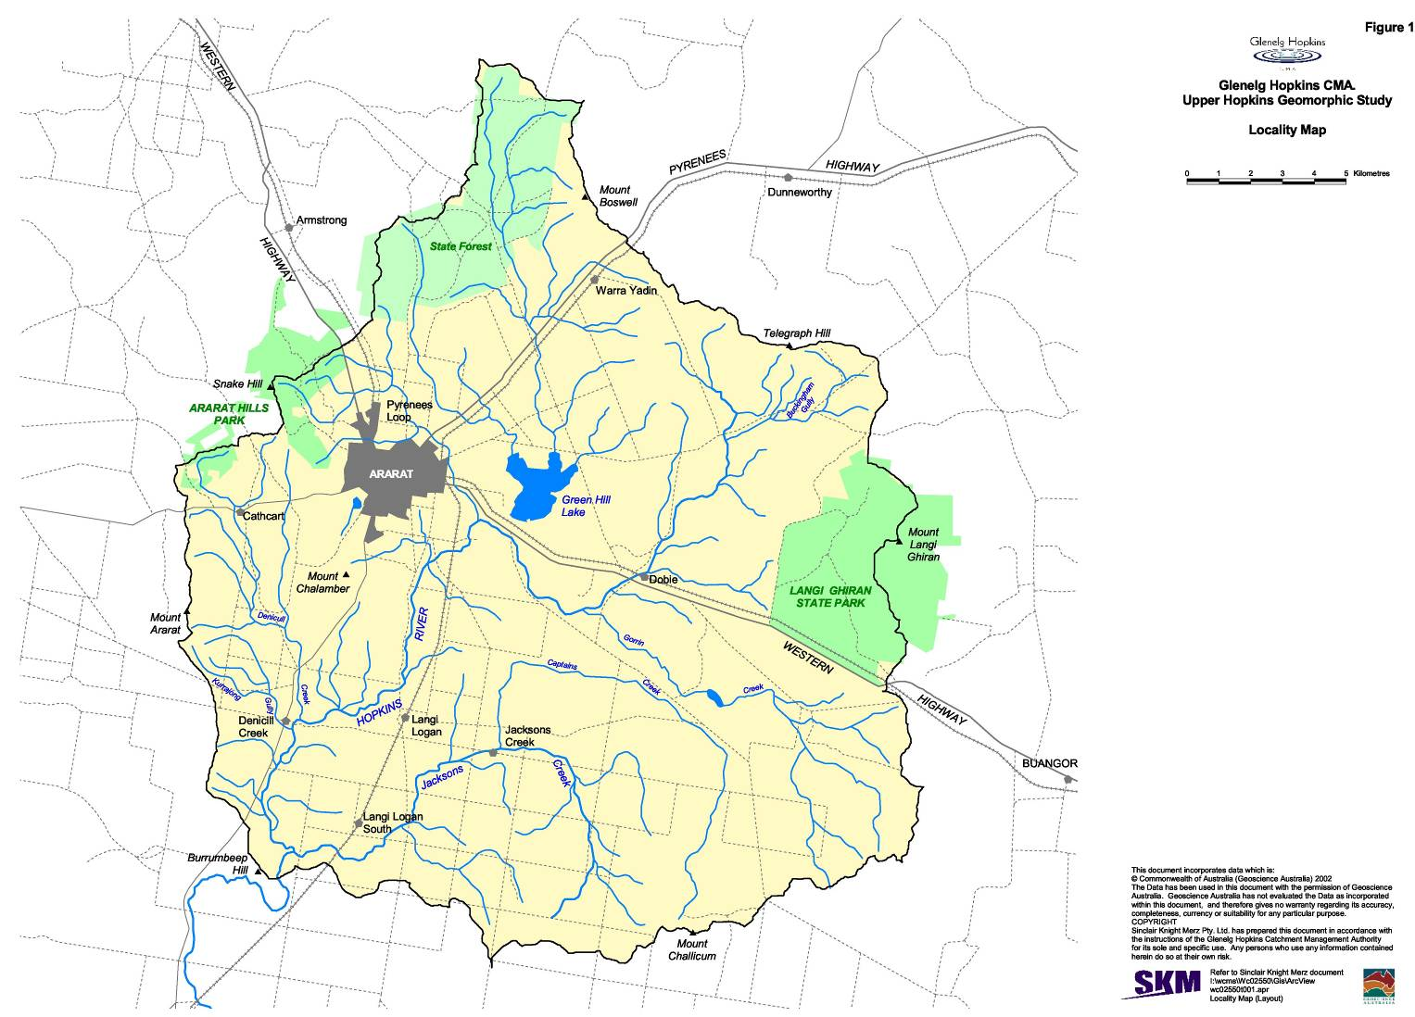
Ararat geomorphic study final report

Geographic information system (GIS) utilities and digital terrain model (DTM) analyses were then used to extrapolate field derived data to characterise entire gully networks (gully density, distance to drainage divide).
SINCLAIR KNIGHT MERZ
I:\wcms\Wc02550\REP03_06.23\Final Report\R02 PJS Ararat Final Report.doc PAGE 3
Of key concern to this study, is the fate of sediment eroded from gullies and what threat, if any, this sediment poses to the Hopkins River. Sediment eroded from gully networks may be deposited downstream as in-gully storages, within floodouts, on the floodplain or exported downstream through the river system. A major outcome of this project will be the formation of a sediment budget for each physiographic unit. A sediment budget considers the processes of sediment transport and deposition by accounting for the sources and stores of sediment as it travels from its point of origin to its eventual exit from a drainage basin (see Reid and Dunne, 1996; Slaymaker, 2003). Information collected as a result of the field investigations on the approximate volume and grain-sizes of sediment in storage along the channel network will be used to construct the sediment budget (Figure 2).
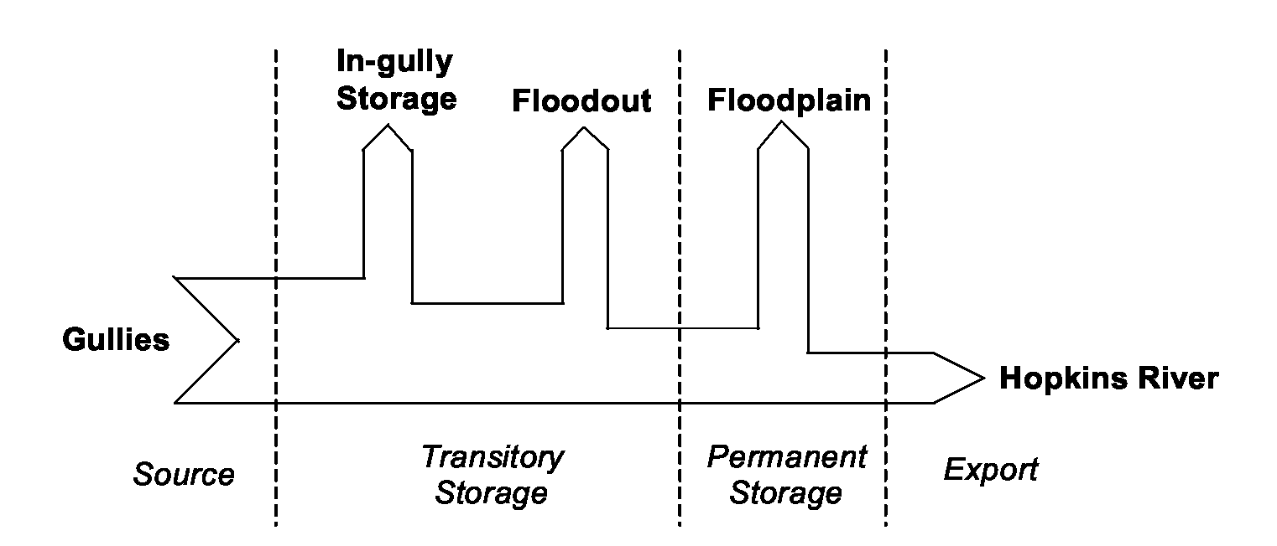
Figure 2: Flowchart illustrating sediment relations between erosion, storage and export to the Hopkins River.
Understanding the contributing factors and likelihood of erosion occurring at locations across the catchment allowed us to develop a series of general rehabilitation options. The rehabilitation options are designed to mitigate any potential threats posed by active gullies. We also recommend a monitoring plan that will allow evaluation of the effectiveness of the rehabilitation options. Monitoring will underpin later adaptive management of the gully works in the catchment.
1.3 Document structure
Section 2 outlines a general model of landscape change that has led to the development of gullies in southeast Australia. A description of the Hopkins River basin, and its environmental condition is outlined in Section 3. Section 4 describes the physical setting of the study area: geology, geomorphology, and soils. The processes of gully erosion in each of the three physiographic units and the historical changes to the landscape, which have contributed to the development of gullies in the region, are also described.
The concept of coupling is then used to discuss the possible effect of gullying on the processes of
sediment transport and storage in the upper Hopkins River. Section 5 outlines the various field and

Ararat geomorphic study final report

analytical techniques used to investigate the processes of gully erosion, sediment transport and storage in the catchment. The results of field investigations and the sediment budgets constructed within each of the three physiographic units are outlined in Section 6, 7 and 8. A monitoring and rehabilitation plan is outlined in Section 9. This is followed by a summary of the outcomes of this report.
SINCLAIR KNIGHT MERZ
I:\wcros\Wc02550\REP03_06.23\Final Report\R02 PJS Ararat Final Report.doc PAGE 4

Ararat geomorphic study final report

2. Model of landscape change
SINCLAIR KNIGHT MERZ
I:\wcros\Wc02550\REP03_06.23\Final Report\R02 PJS Ararat Final Report.doc PAGE 5
Many of the gullies that are now apparent in southeast Australia eroded between 1850 and 1950 when disturbance of valley floor vegetation and the introduction of hoofed stock increased runoff and decreased erosion resistance (Prosser and Slade, 1994). When runoff is concentrated in hillslope hollows, the erosivity of flow increases, sometimes incising gullies into the valley floor. Once initiated, gullies spread at an exponentially declining rate with much of the networks being formed within the first few decades (Graf, 1977). This model of landscape change has been widely used to explain the occurrence of gully erosion (Prosser and Slade, 1994).
Channel initiation by overland flow has been viewed as a threshold phenomenon related to the size of the contributing area and its slope (Horton, 1945). The relationships between source area and slope have been explored in a number of environments to predict the onset and the stable extent of gully networks (e.g. Dietrich et al., 1992; Prosser and Abernethy, 1996; Morgan and Mngomezulu, 2003). Once incision occurs, gully heads typically migrate upslope until some threshold of contributing area and/or slope is met. At this point runoff, capable of further incision, cannot be generated and the gully stabilises in its headward extent. Topographic thresholds are also influenced by vegetation. The loss of groundcover and enhanced runoff results in an increase in the erosiveness of flows on the valley floor. The effect of this is to reduce the critical area/slope required for gully initiation and stabilisation.
The other dimensions of gully networks are gully width and depth. Gullies often continue to incise down to bedrock or until some stable gradient is achieved from the baselevel of the downstream drainage network (see Schumm et al., 1984). After the gully floor has stabilised the gully walls tend to lay back under the influence of water and gravity until they are reduced to relatively stable slopes (Crouch, 1987). As gully floor elevation and sidewall slope stabilise, vegetation is able to colonise the surfaces, further damping the effects of any erosion processes.
Relating gully morphology to erosion process provides a useful field technique to assess gully stability. The further a gully head from a drainage divide the more potential there is for continued headward extension. Secondary nickpoints in gully floors indicate that some change in baselevel has renewed the incision process and that the gullies will continue to deepen (sometimes to bedrock). Deepening gullies will promote sidewall instability and maintain the walls at steep angles. Lower angles on the sidewalls indicate general gully stability. Overtime, with the establishment of vegetation, the gully will begin to infill and begin the process of landscape recovery.
Much of the gully erosion in SE Australia, occurred only after valley floor vegetation had been disturbed (Prosser and Slade, 1994). However, other factors, such as the strength and hydraulic properties of valley-floor soils, also influence erosion processes. Many Australian soils have hard-setting A-horizons, and more clayey sodic B-horizons (Young and Young, 2001). The B-horizon often has a lower permeability and water is forced laterally and moves as throughflow downslope. If the clays in the B-horizon are dispersive, fine soil particles can be carried in suspension in the

Ararat geomorphic study final report

throughflow (Figure 3, overleaf). The transport of clay-sized particles by subsurface water leads to piping, tunnelling and seepage erosion (Young and Young, 2001). While the removal of vegetation has increased runoff rates, the characteristics of the underlying soils can have a strong influence on the potential for gullying to occur.
SINCLAIR KNIGHT MERZ
I:\wcros\Wc02550\REP03_06.23\Fin Report\R02 PJS Ararat Final Report.doc PAGE 6
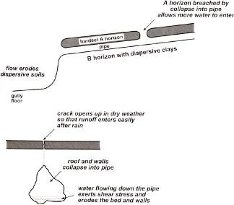
Figure 3: Gullies and seepage flow (from Young and Young, 2001).
An important component of any geomorphic study, is an appreciation of the setting in which the processes of erosion and deposition operate. The potential to misinterpret the natural instability which can exist in a catchment, as simply being a result of human impact, or to exaggerate the human impact, has been recognised as a consistent problem in geomorphic studies (Dollar, 2000). Recognition of the different factors that have contributed to the development of the erosional problem, and the role that subsurface and overland flow paths have in driving the erosional processes is important as a precursor to recommending appropriate rehabilitation options.

Ararat geomorphic study final report

3. Hopkins River
SINCLAIR KNIGHT MERZ
I:\wcros\Wc02550\REP03_06.23\Final Report\R02 PJS Ararat Final Report.doc PAGE 7
The Hopkins River Basin covers a catchment area of 10,096 km². The Hopkins River rises near Ararat and flows into the Southern Ocean at Warrnambool. With the exception of small pockets of remnant forest and grasslands, the catchment has been entirely cleared and supports significant agricultural activity. The river is in poor condition along much of its 259 km length, with little native riparian vegetation remaining (GHCMA, 2002).
3.1 Climate and hydrology
Climate, plays an important role in driving the processes of sediment erosion and transport in fluvial systems. Rainfall in the study area varies from 600 to 1,150 mm annually (Figure 4, overleaf). The majority of the rainfall occurs in winter between April and November. Summer rainfall is in the range 30-36 mm per month, and January and March tend to be drier than February (LCC, 1972). Thunderstorm days average 10-15 per annum. Rainfall in the past seven years has been lower than average due to the occurrence of a drought.
Flow records (Gauging Station 236219) for the upper Hopkins River are available for May 1989 to present (Figure 5). The mean annual daily peak discharge is c.785 ML/Day. The largest flood on record for the 14 year period occurred on 31 July 1989 when the flow peaked at 4,333 ML/Day. The second and third highest discharges were 3,911 and 2,322 ML/Day recorded on 22 December 1992 and 18 July 1990 respectively. The absence of earlier records, does not permit a study of the hydrological changes that have taken place over periods greater than a decade. However, in the past seven years there has been a notable decline in the magnitude of flows (Figure 5 and Figure 6). This is reflective of the low rainfalls that have characterised the recent drought affecting the region.
3.2 Environmental condition
Present understanding of the environmental condition of the upper Hopkins River is largely based on the information provided by the National Land and Water Resources Audit and the Index of Stream Condition (ISC) database.
As part of a larger study conducted by the National Land and Water Resources Audit (2001) for catchments across Australia, sediment budgets have been constructed to represent the erosion of sediment from riverbanks and the propagation of gully, hillslope and riverbank sourced sediment through a river network. Data indicates that in the Hopkins River catchment (Table 1), streambank and gully erosion contributes the largest proportion of sediments to the river system (43% and 53% respectively). This is notably higher than the median Australian-wide value (30% and 32% respectively). Not surprisingly, the Hopkins River basin has been listed as one of the most degraded river systems in Victoria, rating in pooror very poorconditions along 83% of its its stream length (ISC Stream Condition).
There are two ISC sites within the study area. These sites provide some useful information on flow
regime, water quality, condition of the channel and riparian zone and the presence of invertebrate
communities. In the ISC there are five groups of related indicators (sub-indices) calculated from

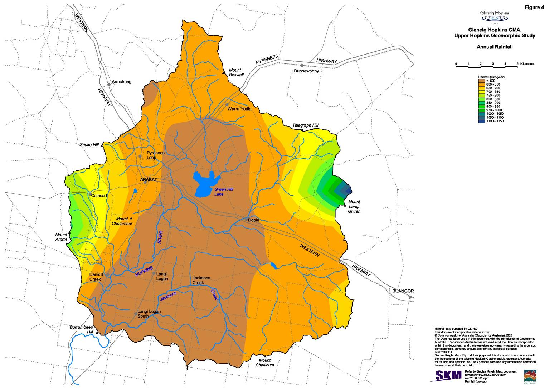
Ararat geomorphic study final report

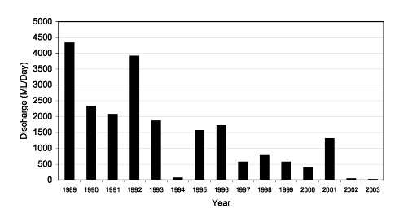
Figure 5: Annual discharge maxima for Ararat gauging station.

¹Source: National Land and Water Resources Audit (NLWRA, 2001). ²Median values.
dimensionless values (ratings) for 19 indicators. These sub-indices are the: Hydrology Sub-index, Streamside Zone Sub-Index, Water Quality Sub-index and Aquatic Life Sub-Index. Each subindex is scored out of ten.
Attribute  Sediment supplied to rivers | Unit  t/yr | Basin value  444,368 | Australia-wide value²  166,621
Sediment supply | t/ha/y | 0.5 | 0.5
Hill slope erosion | % | 2.86 | 14
Streambank erosion | % | 43.97 | 30
Gully erosion | % | 53.17 | 32
Length with riverbed deposition | % | 22 | 0
Sediment export to coast | t/y | 64,382 | 30,062
Contribution of sediment to coast | t/ha/y | 0.07 | 0.1
Sediment delivery | Ratio | 0.14 | 0.34

SINCLAIR KNIGHT MERZ
I:\wcms\Wc02550\REP03_06.23\Final Report\R02 PJS Ararat Final Report.doc PAGE 9
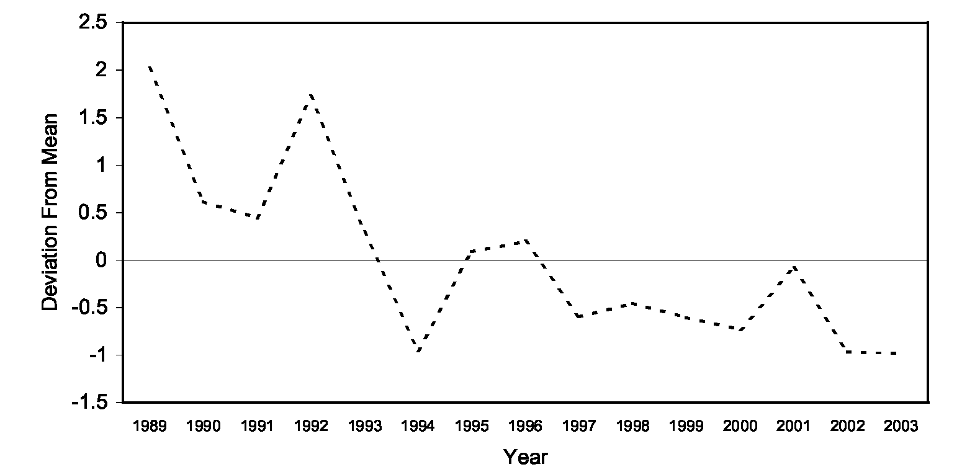
Figure 6: Deviation from the mean annual discharge maxima for Ararat gauging station.
Table 1: Erosion and sediment transport in the Hopkins River¹.

Ararat geomorphic study final report

The first site is located on Gorrin Creek. Its overall condition was rated as marginal. The reach has a hydrology score of ten, and a physical form index of five. Physical habitat was assessed along the reach as ranging from poor to good, with the variation in score being a result of differences in the amount of large woody debris. The bed of the channel was documented as stable, and bank instability was rated as minor to moderate. The streamside vegetation zone varies widely in its structural intactness, has a width of <5-40 m, with 10-40% exotics. No water quality or aquatic life data was available for this site.
SINCLAIR KNIGHT MERZ
I:\wcros\Wc02550\REP03_06.23\Final Report\R02 PJS Ararat Final Report.doc PAGE 10
The second ISC site, located on the Hopkins River c.2 km upstream of the junction of Denicull Creek, is rated as poor. While the reach has a hydrology score of ten, it has a physical form index of four. Physical habitat ranges from very poor to good along the reach, with the variation in score being a result of differences in the amount of large woody debris and available habitat. The bed of the channel was documented as stable, and bank instability was rated as minor to moderate. The streamside vegetation zone varies widely in its longitudinal connectivity and structural intactness. The width of the streamside vegetation zone varies from <5-40 m, with 1-40% exotics. Similarly, no water quality or aquatic life data was available for this site.
The results of the National Land and Water Audit and the ISC indicate that there is likely to have been significant adjustments to the channel characteristics of the Hopkins River. Increased sediment loads from catchments, has been linked with the infilling of pools along rivers, deterioration in habitat conditions, and an overall degradation of aquatic ecosystems (Rutherfurd and Budahazy, 1996). Sediments may be supplied to the river from hillslopes, incised gullies or erosion of the channel bed and banks from incoming tributaries.

Ararat geomorphic study final report

4. Study area
SINCLAIR KNIGHT MERZ
I:\wcros\Wc02550\REP03_06.23\Final Report\R02 PJS Ararat Final Report.doc PAGE 11
The upper Hopkins River Basin as defined for this study has a catchment area of c.426 km² and forms part of the upper Hopkins River subcatchment (H5). The area is bordered by the Ararat Hills to the west, the Challicum Hills to the south and the Skeleton Hills to the north. The downstream limit of the study area is the section of the Hopkins River immediately downstream from the Jacksons Creek confluence (Figure 1).
Prior to agricultural development the upper Hopkins River Basin could be divided into three major morphological zones: unchannelled slopes, terraced floodplains and floodplains. Gullies in the region, have generally developed over the last century in the channelised slopes of the Tertiary and Quaternary deposits that mantle the metamorphic and granitic intrusions. Their presence in the landscape has been a response to a number of factors, which contribute to the erosional setting in which they have developed (geology, landforms, soil types, and historical changes).
4.1 Geology
The geology of the catchment (Figure 7) is fully described by King (1985). The study area forms part of the Stalwell Sedimentary Belt, a thick sequence of unfossiliferous Cambrian and Lower Ordovican sediments including slate, rare carbonaceous slate, siltstone and greywackle. In the western parts, metamorphic rocks and granite intrusions form the steep Ararat Hills (617 m). The Challicum Hills (450-500 m) and Skeleton Hills (500 m) are comprised of tightly folded marine sediments, mostly altered phyllite and low-grade schist. In between the Challicum and Skeleton Hills, the marine sediments are intruded by folded quartz veins and lower Devonian granites. Mount Langi Ghiran forms a large granitic mass in the eastern parts of the study area.
Erosion and dissection of the Stalwell Sedimentary Belt was affected very much by rock type, with broad areas of finer Cambrian and Lower Ordovician Sediments weathering more rapidly to form valleys and plains. The metamorphic and granitic intrusions are more resistant to erosion and these units have formed the topographic high points in the landscape. A general statewide uplift, commonly known as the Kosciusko Uplift commenced during the late Tertiary. Uplift was accompanied by further valley erosion and rejuvenation of streams. In many places, this valley erosion was interrupted by the extrusion of Newer Volcanics, outpouring of fluid lavas which flowed onto the plain during the late Tertiary and early Quaternary, obliterating broad areas of the existing drainage system. The most abundant rock types formed by the extrusion of the Newer Volcanics are the Olivine and Iddingsite Basalts.
The contemporary landscape is characterised by remnant granite and metamorphic ridges, with steep slopes covered by thin skeletal soils. The relatively steep slope and the lack of surficial material gives rise to high runoff coefficients and discharge velocities from this surface: factors that combine to generate high erosion potential. High rates of erosion led to the formation of the wide inter-montane plains between the resistant hills and ridges. Alluvial deposition in the valleys has continued from the Late Tertiary through to the present. Surface and lacustrine outcrops are

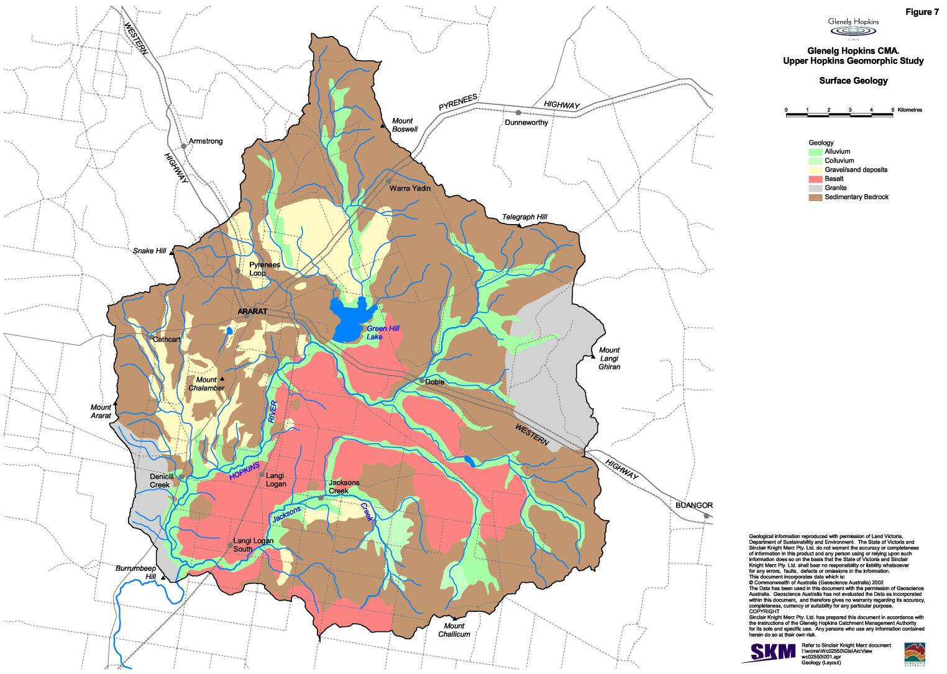
Ararat geomorphic study final report

divided into the older terrace and lake systems located east of Ararat Hills, north of Ararat and south of Jacksons Creek near Challicum Hills. Areas of younger alluvial and lacustrine sediments are established with the indistinct drainage system that has re-established itself on the basalts.
SINCLAIR KNIGHT MERZ
I:\wcms\Wc02550\REP03_06.23\Final Report\R02 PJS Ararat Final Report.doc PAGE 13
4.2 Landforms and soil types
The landforms and soils of the upper Hopkins River catchment correlate closely with the major rock groups. Land units and soil types have been mapped for the entire Glenelg-Hopkins Region (Baxter and Robinson, 2001). The study area can be broken up into five different land units: Ararat Granite, Ararat Marine Siltstone, Ararat Schists, Ararat Alluvial and Ararat Colluvial. There are four different soil types present in the study area: Sodosols, Kurosols, Chromosols (soils have a strong texture contrast between the surface and subsoil horizons), and Vertisols (cracking clay soils). A description of these four different soil types is given in Table 2.
Table 2: Soils of the study area (NLWRA, 2001).
Soil type Kurosols | Description  Soils have a strong texture contrast between the surface (A) horizons and the clay subsoil (B) horizons. The subsoil is strongly acid (i.e. pH is less than 5.5 in water) and non-sodic.
Chromosols | Soils have a strong texture contrast between the surface (A) horizons and the clay subsoil (B) horizons. The subsoil is also not strongly acid (i.e. pH is greater than 5.5 in water).
Sodosols | Soils have a strong texture contrast between the surface (A) horizons and the clay subsoil (B) horizons. The subsoil is sodic and not strongly acid (i.e. pH is greater than 5.5 in water).
Vertisols | Clay soils that shrink and swell, and crack as the soil dries. The soils vary in colour black, brown, grey and red with every gradation in between and range from strongly acid to highly calcareous.

The characteristics of the different soil types and their susceptibility to erosion vary within the different land units. The land units of the study area have been described below (after Baxter and Robinson, 2001).
Ararat Granite
This land unit consists of the granitic hills, low hills and rises to the east and south of Ararat. Mount Langi Ghiran forms a large granitic mass in the eastern parts of the study area. The hillside basalts and rises often have long gentle slopes leading to the plains, commonly coming off a rocky crest. Rock outcrop is common at the break-of-slope, although it is generally absent on the lower slope. Soil depth is variable although soils are generally shallow (less than 50 cm deep), particularly on the crests and steep slopes. There is often a deep C horizon (weathered granite) present. The C horizon tends to act as a barrier for water penetration. The dominant soil types are Grey Sodosols or Brown Chromosols. The subsoil structure tends to be prismatic and angular blocky, and in many cases will be sodic. The steeper slopes and rocky crests have a lower capacity of supporting intensive landuses (compared to the long gentle slopes) due to land and soil limitations.
Ararat Marine Siltstone
The dominant landform of this land unit is dissected undulating rises, although there are also some rolling low hills and some undulating plains that are mainly the footslopes of the rises. The major soil type found on the gentler footslopes of the undulating rises and plains tend to be reddish, strongly structured and well drained soils (Chromosols), although soils with a strongly acidic

Ararat geomorphic study final report

subsoil (Kurosols) can also occur. There is evidence of a bleached horizon, indicative of impeded drainage, in some of the soils, mainly on the lower slopes and drainage depressions where there is more water accumulation. Both the topsoil and subsoils tend to be acidic, sometimes strongly so. The soils on the dissected rolling low hills are generally shallow, although they can be quite strongly structured. They are commonly Sodic Red Chromosols. Cleaved sedimentary rock outcrop is common on this land unit, especially on the exposed westerly aspects. Gully erosion on the plains below these hills and on the drainage depressions can be quite severe.
SINCLAIR KNIGHT MERZ
I:\wcros\Wc02550\REP03_06.23\Final Report\R02 PJS Ararat Final Report.doc PAGE 14
Ararat Schists
These soils have formed in association with the dissected undulating rises and low hills of CambroOrdovician Amphibolite Schist around Ararat. The major soil type is a Bleached-Mottled, Brown Chromosol, although some soils may have a sodic subsoil, particularly at depth. The soil becomes shallower and rock outcrop cleavage (schistosity) becomes more apparent with increased steepness of slope. The capability of the low hills is limited due to slope, frequent rock outcrops and shallow soils. This limitation is also compounded by the susceptibility to water erosion of these soils. The gently undulating plains generally encompasses the lower slopes off the rises and have an increased capacity for landuse options due to formation of deeper soils in a more favourable landscape.
Ararat Alluvial
This land unit consists of the alluvial plains around Ararat and Moyston. The plains are generally quite broad but narrow in the steeper country. They are generally imperfectly drained and have very little slope. The soils tend to be Black or Grey Sodosols, Vertisols or Vertic Chromosols.
Ararat Colluvial
The colluvial slopes around Ararat originate from the hills and rises of Cambro-Ordovician Marine Siltstone, although some colluvial slopes are of granite derivation. Brown Sodosols are the common soil type on the colluvial slopes of both geology types. As the soils are quite dispersive, they can be prone to water erosion if landuse practices are beyond the land's capability.
Review of the landform and soil mapping indicates that the land units in the area are comprised of a number of soil types which have an inherent susceptibility to erosion. Sodosols are particularly sensitive to erosion (NLWRA, 2001). These soils have an abrupt clay increase down the profile and high sodium content, which can lead to clay dispersion and instability. Seasonally perched water tables are common in areas where these soils are distributed because of the structure of the subsoil. Sodosols are usually very hard when dry and are prone to crust formation. The dispersive subsoil makes these soils prone to tunnel and gully erosion. Kurosols are also classified as having a moderate to high wind and water erosion potential due to a deep, loose, sandy surface. Chromosols have a low to moderate erosion hazard depending on slope but increasing with degradation of the A horizons. These soils are susceptible to surface slaking upon rapid wetting, resulting in hardsetting if organic matter content is low. Increased runoff rates can be expected from areas where this soil has been degraded, increasing the potential for erosion to occur.

Ararat geomorphic study final report

4.3 Gully erosion
SINCLAIR KNIGHT MERZ
I:\wcros\Wc02550\REP03_06.23\Final Report\R02 PJS Ararat Final Report.doc PAGE 15
The erodible nature of the soil types combined with their position in the landscape are important factors contributing to the erosional problems in the Ararat, Challicum and Skeleton Hills. It is likely that the gullies developed as a result of erosion by surface flow and throughflow processes. Removal of covering vegetation would have resulted in increased runoff and is likely to have been the cause of initial gully incision on the steep slopes. When the gully is cut, it intercepts surface flow and also subsurface water moving through the soil. As this water in the soil profile interacts with the lower clay subsoil (B) horizons, piping, tunnelling and seepage erosion could then be expected to be increasingly important. We observed many gullies in the area with subsurface pipes leading back from their walls.
The three units demonstrate an inherent sensitivity to erosion. However, historical factors have also been important in the development of an erosional problem in the upper Hopkins River catchment. In the following sections the historical record is explored in an attempt to determine when gullying first commenced in the region. Consultation with landholders helped to provide more localised information on the history of gullying in the three units, and the present condition of the gully networks. Historical aerial photographs were studied to determine whether there have been any significant changes in the extent of the gully networks in the recent past (last c.50 years). Aerial photographs showing the Hopkins River were also compared to determine whether there has been any significant channel changes, which may be linked to the effect of the gullies.
Landuse changes
Prior to the European invasion that followed Major Mitchells exploration in the late 830s, people of the Parn Balug Clan occupied the Ararat region. This was one of over 40 clans comprising the Djab Wurrung Language Group whose territory covered a large part of southwest Victoria, including portions of the Grampians (LCC, 1972).
Gold was discovered in the area in 1857, precipitating an enormous influx of people. Ararat, for example, sustained a population of some 20,000 during the gold rush there and was subject to extensive mining in the 1850s. Mining was primarily focused on shallow alluvial deposits. However, with the exhaustion of surficial sources there was a shift to deep lead mining. Discarded pits and mine workings litter the landscape in the area surrounding Ararat. Following the gold rush, farming enterprises set about clearing the land.
The Land Act 1884 resulted in large-scale tree clearance as settlers had to ring-bark or fell the trees to obtain freehold title of their block (GHCMA, 2002). However, it was the passing of the Closer Settlement Act 1898 that led to the subdivision of larger squatter estates in the region. Smaller farmers were encouraged to clear the land, but soil limitations and the influx of rabbits dramatically affected farming success. Settlement schemes were introduced after both World Wars for return soldiers, further increasing land clearance pressures. Advances in farm machinery, economic pressure to utilise all available land on farms and taxation minimisation schemes advanced the rate of clearing. Between 1972 and 1987, it is estimated that 40% of the remaining vegetation on freehold land was cleared in the Glenelg-Hopkins Catchment (GHCMA, 2002).

Ararat geomorphic study final report

The physiographic response of the study area to clearing and the introduction of European farming systems is likely to have been fairly rapid, given our understanding of the sensitivity of the underlying soils to erosion. The initiation and expansion of gully networks in the landscape was a direct response to the clearing of native vegetation from highly erodible soils. The cumulation of the effects of vegetation loss, droughts, rabbits and fires all contributed to the development of an erosional problem.
SINCLAIR KNIGHT MERZ
I:\wcros\Wc02550\REP03_06.23\Final Report\R02 PJS Ararat Final Report.doc PAGE 16
Placing an absolute time on the commencement of gullying in the study area is difficult due to the limited historical information available for the Hopkins Catchment. However, the Glenelg Catchment experienced a similar landuse history. Historical records for this catchment may provide a best estimate of when erosion commenced and later stabilised. Catchment erosion and gullying was reported in the Glenelg River catchment as early as 1853 (Rutherfurd and Budahazy, 1996). For the most part, the initial phase had largely stabilised by the middle of last century. However, the end of the Second World War and the return of demobilised soldiers to the land, along with improvements in technology saw a second phase of adjustment that for some landscape elements (notably clearing of ground flora) is only now reaching a new equilibrium.
Landholder interviews
As part of this study we completed a number of informal telephone interviews with landholders to gain an appreciation of their attitudes, issues and priorities with respect to gully erosion and sedimentation. A summary of the feedback provided by the landholders is presented in Appendix A. As many of the landholders are descendants of the original settlers, they were also able to communicate anecdotal information on the history of gullying in the region.
Landholders in the Ararat and Skeleton Hills areas cannot recall there being changes in the extent of the gully network in the recent past. The general consensus was that gullies had already reached their current extent prior to the current tenure. While there has not been any notable extension of the gully network in the recent past, a number of landholders were of the opinion that gully incision and sidewall erosion was still active. John Stewart, from Kurrajong remarked that gullies may drop as much as a foot after a large rainfall event.
We also spoke to a number of landholders with properties in the Challicum Hills area. It was stated by Jeff Smart and Eric Carter that gullies were not present prior to the 1940s. Clearing of vegetation off the steep-sided slopes did not take place until the early 1940s. Gullying commenced rapidly after these slopes were cleared of vegetation. The general consensus provided from landholders in the Challicum Hills area was that these gullies are still active.
Aerial photos
Study of past and present aerial photographs for the three priority areas would suggest that the gullies had reached their maximum extent by 1948 in the Ararat Hills and Challicum Hills areas. There is an absence of early aerial photographs for the Skeleton Hills area, however study of the 1972 aerial photographs of this area indicate that the gully networks have not changed significantly

Ararat geomorphic study final report

in the past 30 years. Floodouts could be clearly seen on the earlier aerial photographs, but are less defined in the recent 2002 aerial photography.
SINCLAIR KNIGHT MERZ
I:\wcros\Wc02550\REP03_06.23\Final Report\R02 PJS Ararat Final Report.doc PAGE 17
No significant changes to the characteristics of the Hopkins River, upstream and downstream of Denicull Creek were observed from a study of the 1948 and 2002 aerial photographs. Levee banks have been constructed along a section of the Hopkins River further downstream where the river runs adjacent to Warrnambool Road. These levees have been constructed to prevent the road from flooding. One area where the Hopkins River is in the process of adjusting its course is near the confluence with Jackson Creek. This issue was first recognised in the early 1980s. Levee banks were constructed in an attempt to confine flood flows to the rivers old course. This has been unsuccessful, and the levee banks have since been breached. A large channel has partly incised into the western floodplain and if left alone it is likely that this channel will continue to erode further upstream to form a new course for the Hopkins River. The former channel will then be cutoff from flows, and will form part of the floodplain (Section 7.3).
4.4 Coupling and connectivity of sediment transport processes
The geomorphological characteristics of a river system will respond to variations in the nature and supply of flow and sediments from different subcatchment areas. A large proportion of the tributaries contributing flow and sediments to the upper Hopkins River, have their headwaters draining highly erodible Cambrian and Lower Ordovican sediments. Sediments eroded from gully networks may be transported directly to the river system or stored in floodouts prior to the river.
Whether eroded sediments are stored in floodouts or transported directly to the upper Hopkins River is a function of the efficiency of processes controlling sediment transport and deposition. We refer to the concept of coupling to theorise how the upper Hopkins Catchment, and in particular the Hopkins River may have responded to the effects of gullying. Coupling relates to the connectivity of flow and sediment transport processes that link different components within a catchment. Downstream changes in the rate at which sediments are transferred from hillslopes to channel/floodplain storages are linked to the strength of coupling mechanisms that are established within the fluvial system (Harvey, 2002; Hooke, 2003). Coupling may operate at a range of spatial and temporal scales within a drainage basin.
Local-scale coupling involves coupling within one zone or between two adjacent zones of the fluvial system (Harvey, 2002). For example, the erosion of sediments from gullies and deposition of sediments downstream in floodouts provides an example of coupling between two adjacent zones in a fluvial system. The transfer of sediments downstream along the channel network can be described with reference to a number of local-scale coupling mechanisms.
Studies on the adjacent Avoca River, showed that up to 80% of the sediment eroded from a large gully system is deposited on floodplains as floodouts and does not reach the river system (Rutherfurd and Smith, 1992). In such a system, processes of sediment erosion from the gully network and deposition in the floodout may be described as strongly coupled. Over time, these floodouts may be reworked by gullying processes.

Ararat geomorphic study final report

The stream networks in the upper Hopkins River catchment have developed narrow floodplains that are confined within older river terraces and basalt extrusions (Figure 7). This confined morphology has several implications for sediment transport and deposition. In a confined system, flows are constrained within a deeper narrow cross-section. Confined flows, of a given discharge, exert higher shear stresses on the channel bed and transport relatively more sediment than an unconfined flow of the same discharge. In a confined system, sediment is efficiently transported from the eroded gully network to the river system downstream, with little potential for sediments to be deposited over a broad floodplain. Significant adjustments to the channel morphology of the Hopkins River may be anticipated, in response to a massive increase in sediment supply.
SINCLAIR KNIGHT MERZ
I:\wcros\Wc02550\REP03_06.23\Final Report\R02 PJS Ararat Final Report.doc PAGE 18
The specific channel response is dependent on a number of different variables: the amount and calibre of the material being supplied to the river; the capacity of the river to transport increased sediment loads; and localised factors affecting erosion and deposition at a site (e.g. riparian vegetation). In response to a significant increase in coarse bedload material the channel may aggrade its bed. Alternatively, if there has been a large increase in the supply of sediments of a very fine calibre, aggradation of the floodplains may occur. Sediments eroded from gully networks may be stored in floodouts or along the creek prior to the junction with the Hopkins River. These storages may be temporary or permanent. Hence, the response of the upper Hopkins River to gullying will vary depending on a range of factors. These factors combine together to define the coupling mechanisms that are established within the catchment. The nature of the coupling mechanisms in turn controls the downstream changes in patterns of sediment transport and storage.
Long profiles can be used to elucidate the efficiency of sediment transport processes along the drainage network (Bridge, 2003). Long profiles are illustrated for selected gullies/creeks draining the three eroded areas in the upper Hopkins Catchment and for the Hopkins River (Figure 8, Figure 9, Figure 10 and Figure 11). The long profile illustrates variations in channel slope along the length of the creeks and the Hopkins River. The gully draining Ararat Hills has a fall in bed elevation of some 174 m over a longitudinal distance of 5,200 m, notably greater relief than Challicum Hills (82 m over 16,000 m) and Skeleton Hills gully systems (75 m over 3,680 m).
As slope varies along the course of the creek and river the efficacy of sediment transport processes will change. Floodouts typically occur along the profile at the point where there is a significant break in slope (Rutherfurd and Smith, 1992). Such break points occur within the first kilometre of the longitudinal profiles. At this point sediments eroded from gullies incised on the steep slopes may be deposited. As the length of the drainage network increases, so does the potential for sediments to be deposited prior to the junction with the Hopkins River. Hence, the marked changes in slope evident in the longitudinal profiles and the distances over which sediments must be transported to the Hopkins River (particularly for the creek draining Challicum Hills), suggests that there may be significant storage of sediments in floodouts and along the creek.

Figure 10: Long profile of Buckingham Gully (draining Skeleton Hills), based on digital bed elevation data.

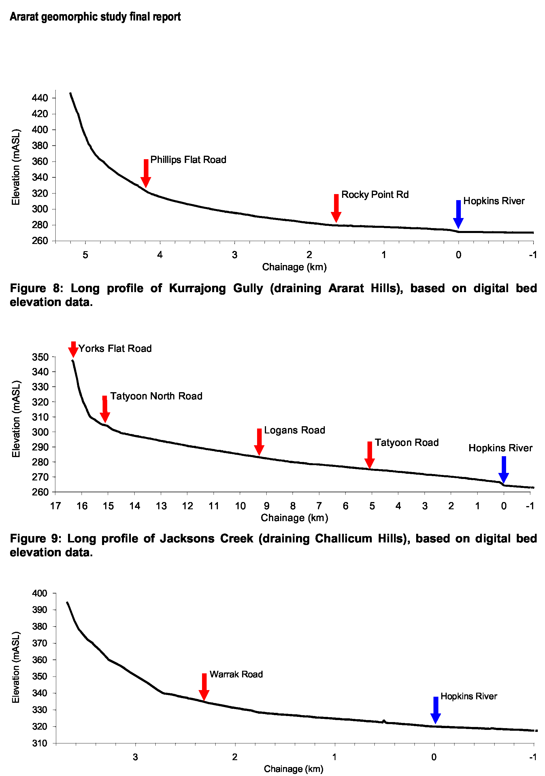
SINCLAIR KNIGHT MERZ
I:\wcms\Wc02550\REP03_06.23\Final Report\R02 PJS Ararat Final Report.doc PAGE 19
Figure 11: Long profile of Hopkins River, based on digital bed elevation data.

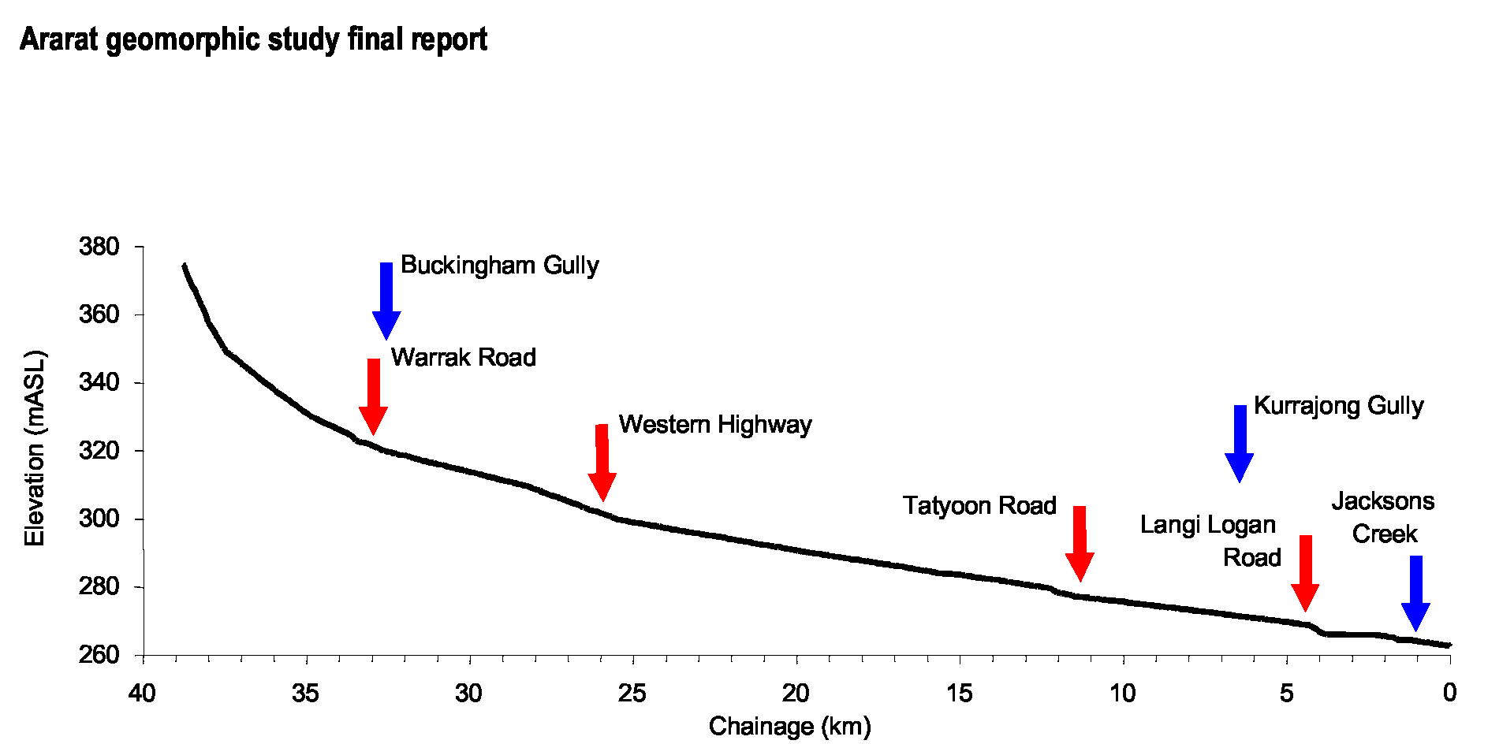
SINCLAIR KNIGHT MERZ
I:\wcms\Wc02550\REP03_06.23\Final Report\R02 PJS Ararat Final Report.doc PAGE 20
Ararat geomorphic study final report

5. Sediment sources and sinks
SINCLAIR KNIGHT MERZ
I:\wcros\Wc02550\REP03_06.23\Final Report\R02 PJS Ararat Final Report.doc PAGE 21
A major objective of this project is to outline the sources and sinks of sediments in the upper Hopkins River catchment. The background review has shown that the gullies are established on soil types that are inherently sensitive to erosion. The fate of eroded sediments depends on an array of factors controlling the efficiency of sediment transport mechanisms (Section 4). Sediments eroded from gully networks may be stored in floodouts, in gully-storages or transported directly to the Hopkins River.
The relative proportion of sediments which are stored in floodouts and in-gully storages, verses that which is lost to the Hopkins River is likely to vary within and between the three areas. To determine where the various sediment sources and sinks are, and the current geomorphic stability of the gully networks and storages, requires an approach that can incorporate any variability that is likely to exist within the three areas. Our balance of field investigations, aerial photograph interpretation and DTM analyses enable us to provide a thorough assessment of past and present processes of erosion, transport and storage in the three areas.
The approach taken in this study relied on detailed field investigations in representative gully systems for each physiographic unit. The information collected in the field from these representative gullies, was then combined with information gathered from aerial photo interpretation and the DTM to provide an overall assessment of the erosion in the three physiographic units. A series of sediment budgets were constructed to quantify the sediment sources and sinks of the study area and the amount of sediment exported via the Hopkins River.
5.1 Field techniques
Gully processes
Surveys of gully morphology were undertaken to provide an insight into the formative processes, and whether these processes are still active in the landscape. Variables documented in the field included: gully width, depth and length; gully head overhang, plunge-pool, tension cracks, piping; secondary nickpoints in gully floor; distance from gully head to drainage divide; hill slope; gully slope; stock damage; and vegetation cover.
The activity of gully heads and sidewalls were assessed using a set of predefined criteria as listed in Table 3. On the basis of this assessment, gully heads were classified as very active, active, or inactive. Photographs were taken to show different categories of gully activity in each of the physiographic units. Inactive gully heads are characterised by rounded walls, partly overgrown with no overland flow marks. Active gully heads have some flow marks, or a small channel through which water flows. If recently deposited sediments were found at the foot of the gully wall, or if the headwall is undercut, it was classified as active. If tension cracks occur at the head due to undercutting they indicate an active gully. Active gully heads have sharp edges and little vegetation below the head. Very active gully heads have very sharp edges, freshly exposed gully head walls, and clear flow marks. Surveys were completed on as many gully networks as possible with the results extrapolated to the rest of the physiographic unit.

Ararat geomorphic study final report

Table 3: Criteria used for classifying gully head and sidewall activity¹.
Active  Sharp edges | Inactive Rounded edges
Plunge pool | No plunge pools
Undercut | Inclined gully head wall
Tension cracks | Vegetation on gully walls and bed
Recently deposited sediment | Extremely small contributing catchment area
Flow marks
after Oostwould Wijdeness et al. (2000).
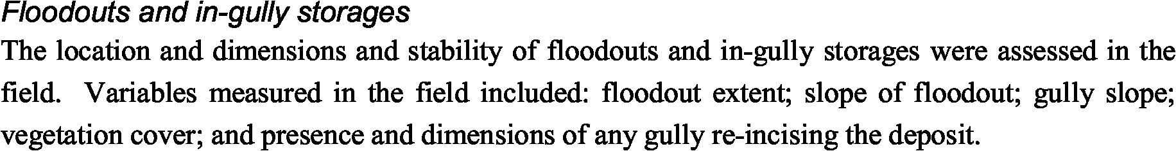
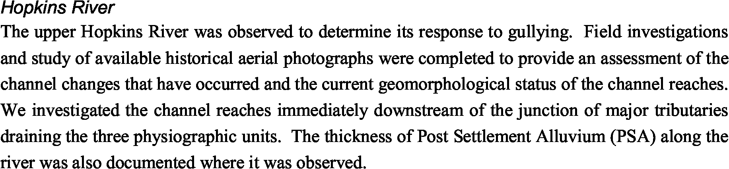
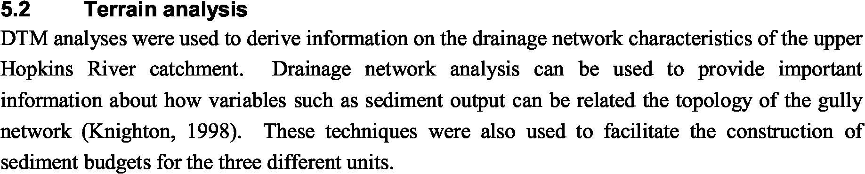
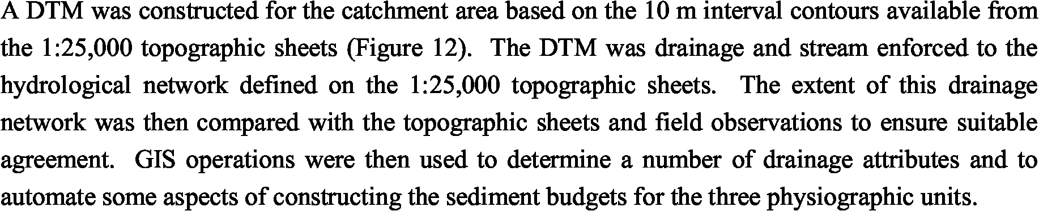

The two variables which are frequently referred to when discussing drainage network structure are stream order and drainage density, which were first introduced by Horton (1945). The intention of these methods was to replace previously qualitiative descriptions of drainage basins with quantitative values in which the hierarchal structure of the drainage netowkr is recognised (Knighton, 1998).
Stream Order
The stream order method which is most frequently used to classify networks is the Horton-Strahler classification system. A first-order stream is the smallest unbranched stream. Two

SINCLAIR KNIGHT MERZ
I:\wcros\Wc02550\REP03_06.23\Final Report\R02 PJS Ararat Final Report.doc PAGE 22

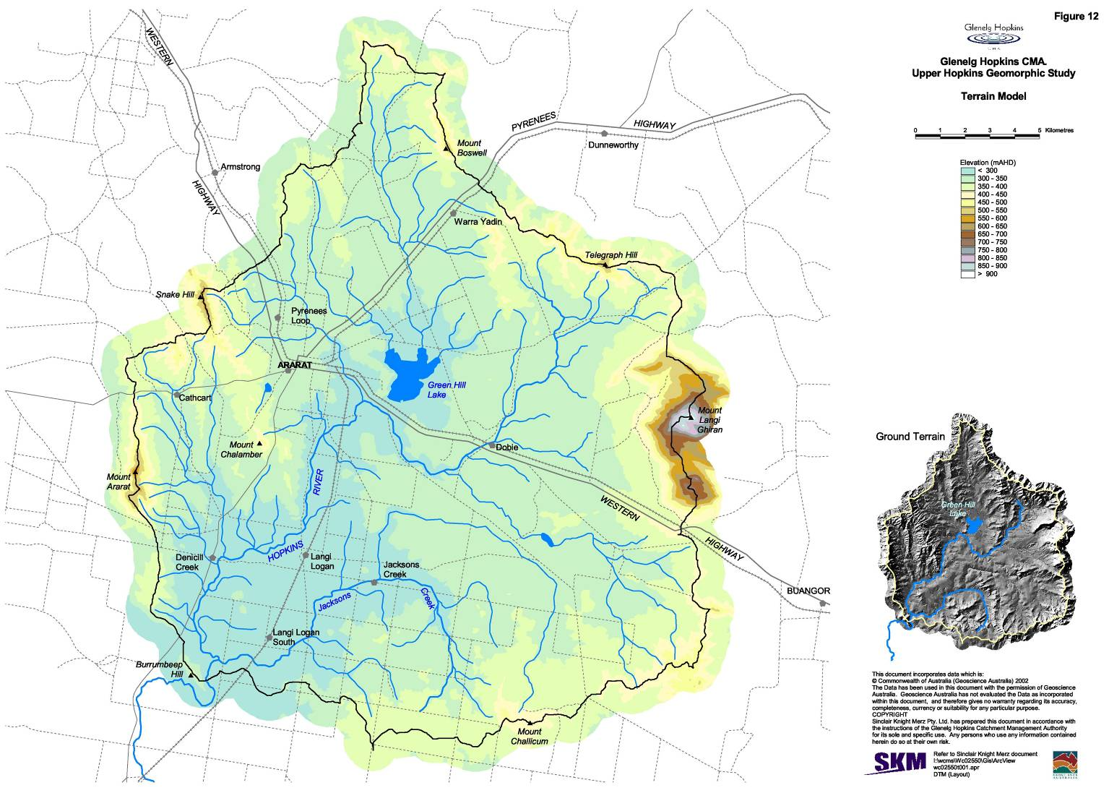
Ararat geomorphic study final report

first-order streams join to form a second order stream. When two streams of order w join, a stream order of w + 1 is created. However, when two segments of different orders, for example w and w + 1, join the stream segment immediately downstream retains the higher of the orders of the two contributing streams, and will have the order w + 1 (Figure 13).
SINCLAIR KNIGHT MERZ
I:\wcros\Wc02550\REP03_06.23\Final Report\R02 PJS Ararat Final Report.doc PAGE 24
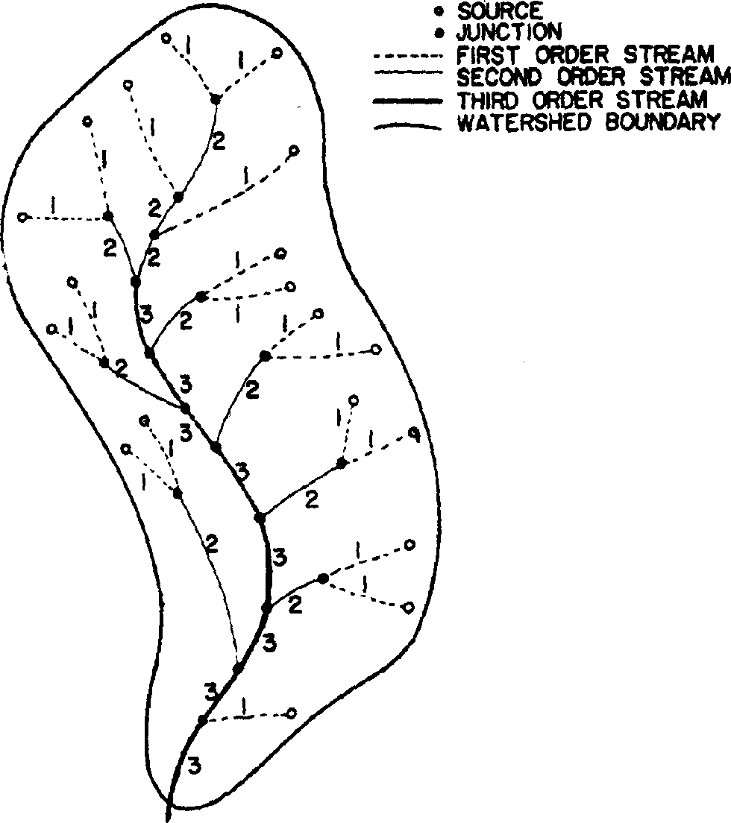
Figure 13: Hypothetical stream network ordered by the Horton-Strahler method (Knighton, 1998).
Use of stream-ordering is based on the principle that order number is directly proportional to size of the contributing drainage area, to channel dimensions, and to stream discharge at that point in the drainage network. Two different drainage networks can be compared with respect to corresponding points in their geometry through the use of order number. In this study, cross-sectional area was measured at selected points along the gully networks. Average values are then determined for each of the different stream orders (Table 4. The stream ordering classification system is used, as a basis for providing information on the cross-sectional area for the rest of the drainage network. The positioning of floodouts and in-gully storages and the amounts of sediment stored in these storages were also linked to stream order. The stream order classification is then used to facilitate the construction of sediment budgets for the three physiographic units (see Section 5.3).
Table 4: Average cross-sectional area of gullies (m²).
Stream order Ararat Hills Challicum Hills¹ Skeleton Hills
1 | 1.0 | 0.6 | 6.8
2 | 3.3 | 10.8 | 12.6
3 | 13.3 | 11.3 | 8.4
4 | 19.0 | 0.0 | 8.4
5 |  | 11.2 | 16.5
6 |  | 6.1

Fourth order gullies in the Challicum Hills area occur as unchannelled floodouts.

Ararat geomorphic study final report
Drainage Density
Drainage density is considered the most important areal measure of network geometry in that it expresses the degree of basin dissection by surface streams. Drainage density (Dd) is defined by:

$D_{d}=\frac{\sum{L}}{A}$ (1)
where L is channel length in a basin of area A. Drainage density is controlled by two sets of factors, those that govern the amount and quality of water received at the surface (climatic factors), and those that control the subsequent distribution of that water and its ability to incise the surface (mix of lithologic, vegetational and topographic factors).
For a given drainage network, the closer the channel head is to the drainage divide, the greater the total length of channel. Drainage density is therefore an indicator of drainage efficiency the relative proportion of overland and channel flows. It therefore can be expected to exert a strong influence on sediment yield and runoff response (Knighton, 1998). Drainage density was determined for each of the three physiographic units through DTM analysis (Table 5).
Table 5: Drainage density.
Physiographic region | Drainage density (km/km²)
Study area | 2.5
Ararat Hills | 4.3
Challicum Hills | 1.9
Skeleton Hills | 2.8

Risk of gully erosion
SINCLAIR KNIGHT MERZ
I:\wcros\Wc02550\REP03_06.23\Final Report\R02 PJS Ararat Final Report.doc PAGE 25
Stable gully heads are located at those points in the landscape where the erosivity of flow is just able to incise the soil surface (Prosser and Abernethy, 1996). Gully heads represent a topographic threshold between the unchannelled and channelled portions of hillslopes. This topographic threshold can be represented by an inverse relationship between drainage basin area and the critical slope for entrenchment (Knighton, 1998; Poeson et al., 2002). The threshold is based on the assumption that in a given landscape with a given climate, there exists for a particular drainage area a critical soil surface slope, necessary for gully incision. As drainage area increases, this critical slope decreases and vice versa (Figure 14).
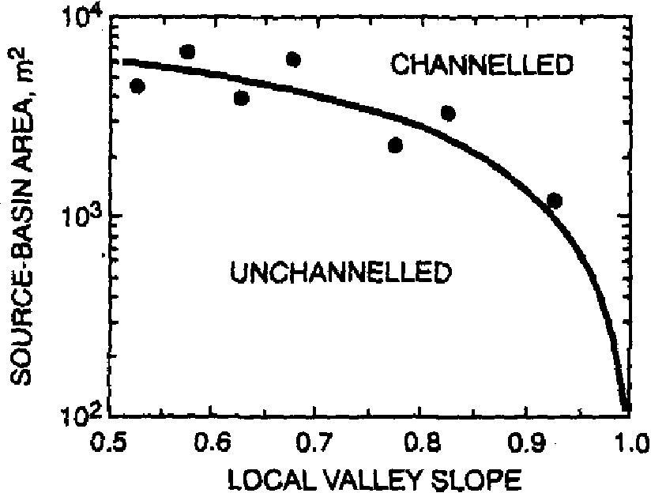
Figure 14: Source-basin area-slope relationships (Knighton, 1998).
Ararat geomorphic study final report

One possible approach to predict locations in the landscape where gully heads might develop is to apply the topographic threshold concept. DTM analysis techniques were used to determine a number of topographic parameters for gully heads in each of the three areas. Calculated topographic parameters include upslope contributing area (A), slope at the gully head (S) and distance from the gully head to the divide (D). If a clear topographic relationship can be developed for each of the areas which explains the location of gully heads in the landscape, then this may be used as a predictor of possible locations where gully heads might develop. This would then form the basis for mapping areas in the upper Hopkins River catchment where there is a high risk of gully erosion.
SINCLAIR KNIGHT MERZ
I:\wcros\Wc02550\REP03_06.23\Final Report\R02 PJS Ararat Final Report.doc PAGE 26
5.3 Construction of sediment budgets
A sediment budget is an accounting of the sources and disposition of sediment as it travels from its point of origin to its eventual exit from a drainage basin (Reid and Dunne, 1996). In this, the various sources of sediment within a drainage basin are defined, and the sediment which is supplied from these sources and routed through the channel system is accounted for by recognition of the various opportunities for sediment storage (Knighton, 1998). If the various sediment sources and storages can be recognised, and it is possible to measure the loss and gain of sediments along the drainage network, a sediment budget may be determined. The constructed sediment budgets can then be used to provide information for the management of these areas (Reid and Dunne, 1996).
The results of field surveys of the volume of sediment eroded from gully networks verses that stored in floodouts and floodplains have been used to form a sediment budget for each of the three units. We have transformed the detailed surveys of cross sectional area (sediment loss) along the gully network to average values for each of the different stream orders. The stream order classification provides a list of the cumulative length of each stream order within a defined drainage area. To calculate sediment loss, we simply multiply the average cross-sectional area by the cumulative length of the stream order. Aerial photos were used to check the veracity of extrapolating individual site information across different drainage systems.
Study of the Ararat and Skeleton Hills gully networks in the field and comparison with the aerial photos, confirmed the validity of extrapolating the field surveys of the chosen gully networks to the entire physiographic unit. However, there was considerable variation in drainage network characteristics in the Challicum Hills unit. There were a number of subcatchments that remain ungullied. In order to calculate a sediment budget for the Challicum Hills unit, the suitability of extrapolating individual site information across different drainage systems was assessed through an interpretation of the aerial photos. Those subcatchments not gullied were excluded from the sediment budget.
The positioning of floodouts and in-gully storages and the amounts of sediment stored along the drainage network as determined from our detailed field surveys are also linked to stream order. A similar relationship is developed between stream order and the volume of sediments stored in floodouts/in-gully storages. This is then extrapolated for other areas of the drainage network to calculate the total volume of sediments stored in the gully network. To calculate the volume of

Ararat geomorphic study final report

sediments which are input to the Hopkins River, we simply subtract the volume of sediments eroded from the gully network from that which is stored in floodouts and in-gully storages.
SINCLAIR KNIGHT MERZ
I:\wcros\Wc02550\REP03_06.23\Final Report\R02 PJS Ararat Final Report.doc PAGE 27
Surveys were completed of the Hopkins River immediately downstream from the junction with the major tributaries. Surveys of cross-sectional area were used to provide an estimate of the volume of sediments which have been eroded along the river. The thickness of post settlement alluvium was also documented where it was observed. The volume of sediment storage/loss for a section of the upper Hopkins River could then be determined by multiplying the information collected at a site by the length of the river. This provided the basis for an assessment of the amount of sediments that has been stored along the Hopkins River verses that which has been exported from the catchment.
Grain-size characteristics of sediments sampled from the channel and floodplain of the upper Hopkins River were also compared with those sampled from gully-heads and floodouts. Comparison of grain-size characteristics reveals further detail about the travel distances of sediments eroded from the gully networks. The results of particle size analysis of different sediment sources and storages are in general agreement with the findings from detailed field investigation and sediment budgets (see Appendix C). Individual sediment budgets for each of the physiographic units are presented in the next three sections.

Ararat geomorphic study final report

6. Ararat Hills
The Ararat Hills physiographic unit drains 36.5 km², or some 8.6 % of the total upper study area (Figure 16, overleaf). The unit has a drainage density of 4.3 km/km² notably higher than the drainage density calculated for the entire study area (2.5 km/km²). The two catchment areas which drain the Ararat Hills are Kurrajong Gully (7.5 km²) and Denicull Creek (29 km²).
Kurrajong Gully was selected as the representative gully network to be studied in the Ararat Hills area (Figure 16 and Figure 17, overleaf). Kurrajong Gully has a catchment area of 7.54 km² and experiences a fall in bed elevation of some 174 m over a longitudinal distance of 5,200 m (Figure 8). With such a high rate of fall over a small distance (in comparison to the Challicum and Skeleton Hills drainage networks) we anticipated that there would be a high rate of transfer of eroded sediments to the Hopkins River.
Comparison of the drainage network depicted by the 1:25,000 topographic data with that surveyed in the field, along with aerial photograph analysis indicates that the 1:25,000 stream network provides an accurate representation of the gully network. Study of the aerial photographs of the Ararat Hills unit confirmed that it was suitable to extrapolate the information collected on sediment loss/storage for Kurrajong Gully to other gully networks in the physiographic unit.
Cross-sectional area was measured for a series of points along the gully network. The dimensions of floodouts and in-gully storages were also measured to provide an assessment of the amount of sediments stored in the gully network, verses that exported to the Hopkins River. Detailed field investigations were completed on Kurrajong Gully, with the information collected, along with aerial photograph analysis, used to formulate a sediment budget for Kurrajong Gully and the Ararat Hills (Figure 15).
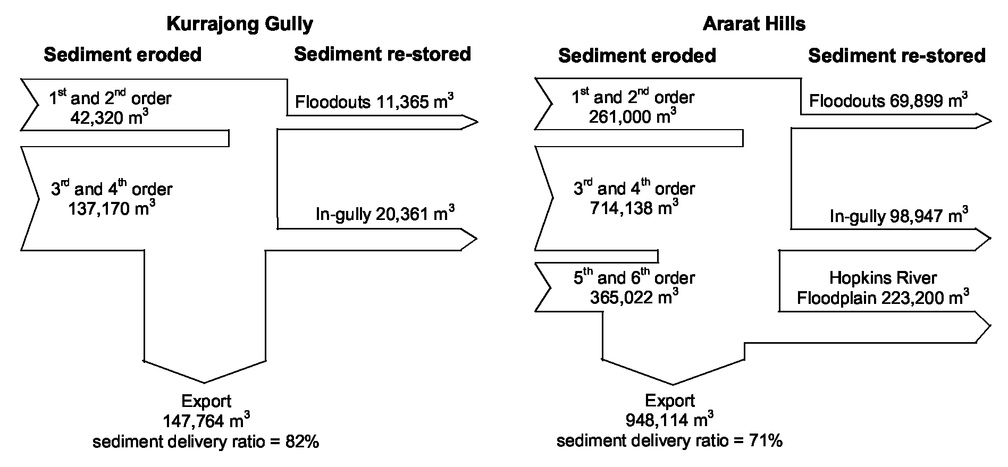
Figure 15: Ararat Hills sediment budgets.
SINCLAIR KNIGHT MERZ
I:\wcms\Wc02550\REP03_06.23\Final Report\R02 PJS Ararat Final Report.doc PAGE 28

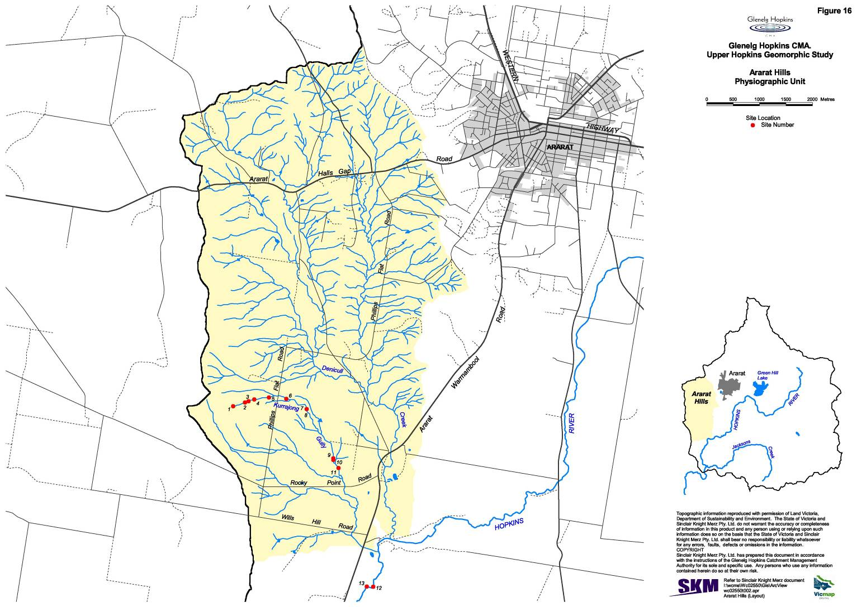
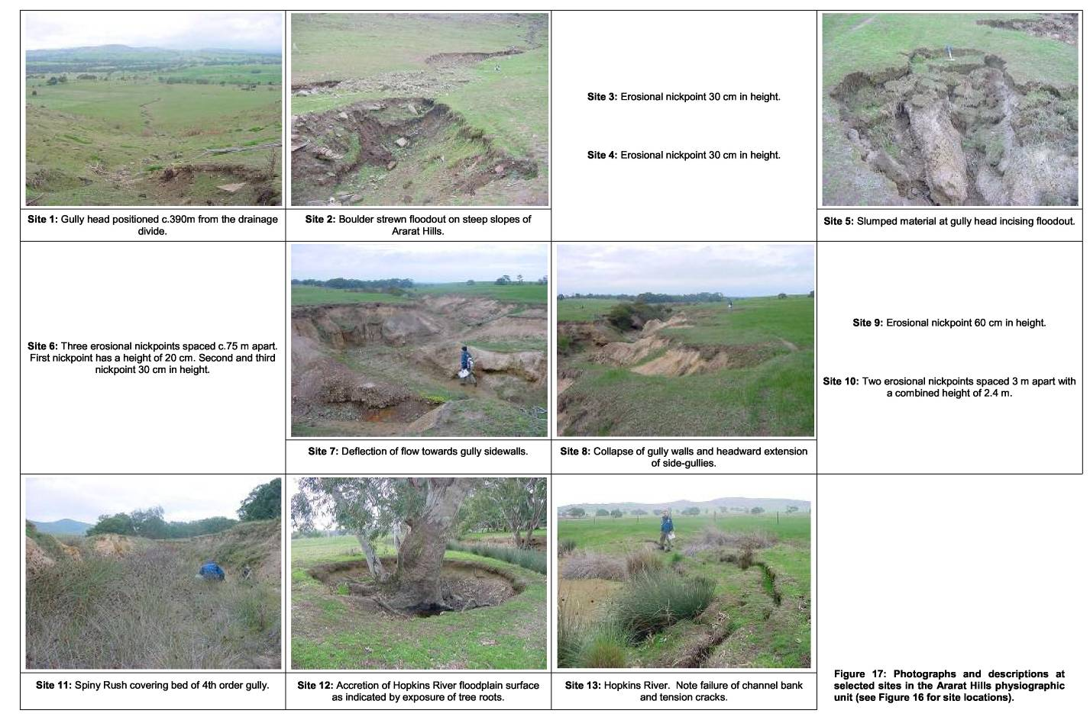
Ararat geomorphic study: final report

6.1 Gully processes
SINCLAIR KNIGHT MERZ
I:\wcros\Wc02550\REP03_06.23\Final Report\R02 PJS Ararat Final Report.doc PAGE 31
The gully network commences in the steep slopes of Ararat Hills west of Phillip Flats road. These steep slopes are comprised of thin skeletal soils that lie above the underlying colluvial boulders and clasts. Burrowing by rabbits has been extensive on these slopes and there is lack of vegetation covering the ground surface, except for a fine grass cover. A series of discontinuous gullies have developed on these steep slopes which end in small floodouts (Figure 18).
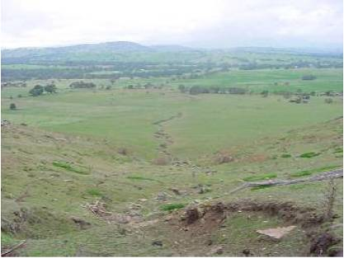
Figure 18: Kurrajong Gully. Photo taken from gully head positioned c.390 m from the drainage divide.
Differences in the dimensions of the gullies that are present in the Ararat Hills are a function of variations in slope, drainage area, and characteristics of the underlying materials (Table 6). The shallow depth of the skeletal soils limits the height and dimensions of the gully heads on the steeper slopes draining Ararat Hills. Seepage at the base of the gully head and sidewalls has contributed to headward erosion, whist the removal of sediments is linked to the high streampower of runoff generated on these steep, bare slopes.
Once the surface is cut, the gully intercepts surface and also subsurface water moving through the soils. Slumping and undercutting of gully head and sidewalls was noted on a gully incising a large floodout positioned on the lower slopes. This shows that subsurface flow is important in driving the erosional processes in this area (Figure 19, overleaf). The sharp edges, presence of undercuts, tension cracks and slumping of material at gully heads and sidewalls provides evidence that these gully networks west of Phillips Flat Road are actively eroding.
We investigated topographic thresholds for gully incision in Ararat Hills (Figure 20, overleaf). GIS operations were used to determine the contributing area, slope and the distance to divide for individual gully heads. There were 271 gully heads documented in the Ararat Hills. Study of the aerial photographs showed that a small proportion of the channel heads depicted by the 1:25,000 topographic data were not gully heads; these were omitted from further analyses.

Ararat geomorphic study final report

Table 6: Gully head dimensions and activity for selected channel heads.
SINCLAIR KNIGHT MERZ
I:\wcms\Wc02550\REP03_06.23\Final Report\R02 PJS Ararat Final Report.doc PAGE 32
Site | Grid ref | Area¹  (m³) | Slope  (º) | Distance ^{1,2}  (m) | Width  (m) | Height  (m) | Status | Description
1 | 0665186  5866502 | 28,450 | 22 | 390 | 2.0 | 0.3 | Inactive | No undercut, or tension cracks grassed face (inclined 90º), bed armoured with boulders.
2 | 0665232  5866520 | 43,500 | 10 | 502 | 1.7 | 0.6 | Active | Undercut (inclined 60º), 10 cm high overhand, tension cracks, bed armoured with boulders.
3 | 0665263  5866535 | 60,700 | 22 | 544 | 2.3 | 0.5 | Active | Transitional gully head (inclined 25º), bed armoured with boulders.
4 | 0665314  5866544 | 72,375 | 13 | 598 | 1.0 | 0.3 | Inactive | Abrupt gully head, bed armoured with boulders.
5 | 0655403  5866586 | 94,350 | 15 | 702 | 0.7 | 1.5 | Active | Undercut, reincised floodout margin.
9 | 0665541  5866636 | 143,825 | 10 | 863 | 1.6 | 0.7 | Active | Undercut, 10 cm high overhand, plunge pool
13 | 0665855  586673 | 227,450 | 3 | 880 | 2.1 | 1.1 | Very active | Abrupt gully head, slumping of sidewalls, reincised floodout

¹From DTM.
²Distance to drainage divide.
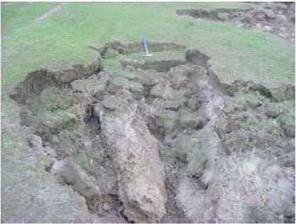
Figure 19: Slumped material at gully head incising floodout.
Study of the histogram frequency plots of the topographic parameters for the gully heads (Figure 20, overleaf) indicates that the majority of the gully heads have catchment areas in the range of 5,000-10,000 m². Many of the gully heads are also positioned between 100 and 300 m from the drainage divide and are located on slopes >10º. It could be argued that gully heads with larger catchment areas have the potential to continue to erode further upslope towards the drainage divide.
There are other factors that also need to be considered in evaluating whether gully heads are likely to continue to erode towards the drainage divide. These include soil depth, the presence/absence of a boulder armour layer over the surface and the density of vegetation cover. Incision would not be anticipated in areas where there are shallow skeletal soils and there is an armour of boulders covering the surface, except perhaps on very steep slopes where high streampower runoff occurs.

Ararat geomorphic study final report

Vegetation can also play an important role in increasing the resistance of the underlying soils to erosion, and thereby preventing further headward extension of the gully head.
SINCLAIR KNIGHT MERZ
I:\wcms\Wc02550\REP03_06.23\Final Report\R02 PJS Ararat Final Report.doc PAGE 33
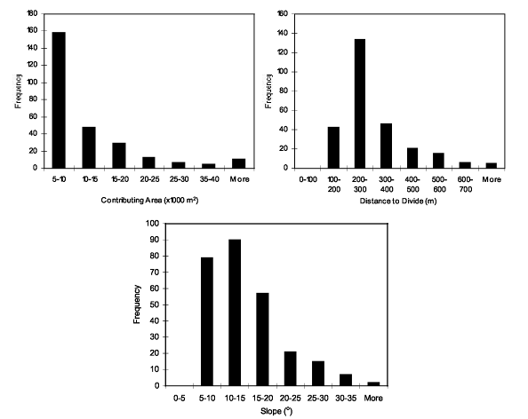
Figure 20: Distribution of topographic parameters for gully heads in the Ararat Hills (all values derived from DTM analysis).
East of Phillips Flat Road the gully network becomes more incised and there has been a significant increase in the amount of sediments that have been eroded along the length of the gully. At this point the gully is now classified a third order stream, has a V-shaped morphology with 2-3 m high sidewalls. Gully sidewalls are typically comprised of a lower gravel/clay colluvial unit and an upper fine silt/clay soil horizon. Angular clasts eroded from the colluvial fill are littered along the floor of the gully. A number of nickpoints along this section and undercut sidewalls indicate that the gully is still actively incising its bed. At one point, there is clear deflection of flow towards the gully sidewalls, which has contributed to the progressive widening of the gully (Figure 21).
As gully sidewalls collapse through mass-failure mechanisms a series of smaller rounded gully heads at the margins of the main gully have formed (Figure 22, overleaf). The presence of clear flow lines along the base of the gully and undercutting of sidewalls suggest that sediments are still being eroded from this section of the gully network. This widening of the gully represents a stage in a sequence of adjustments, similar to that described for incised channels (Schumm and Rea,

Ararat geomorphic study final report

1995). Drainage networks undergo a period of incision followed by widening as they seek to adjust to the effects of a disturbance in the fluvial system.
SINCLAIR KNIGHT MERZ
I:\wcros\Wc02550\REP03_06.23\Final Report\R02 PJS Ararat Final Report.doc PAGE 34
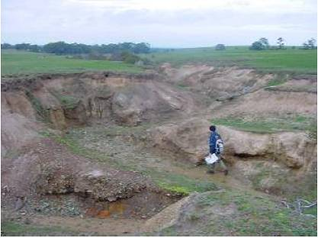
Figure 21: Deflection of flow towards gully sidewalls.
As expected, there has been a progressive increase in the amount of sediment which has been eroded from the gully network with an increase from a third to a fourth order stream. Two nickpoints, 2.4 m in combined height were observed within 5 m of each other (Grid Reference 0667082 5865500). If these nickpoints continue to migrate further upstream, rejuvenation of large proportion of the drainage network is likely to occur. However, the culvert at Phillips Flat Road, acts as a grade control structure that will tend to prevent migrating nickpoints sourced from the lower drainage network continuing to the headwaters of the Kurrajong Gully. From this point downstream to where Kurrajong Creek crosses Wills Hills Road, Spiny Rush (Juncus acutus) forms an extensive cover over the gully bed (Figure 23, overleaf). No migrating nickpoints were documented in this section of Kurrajong Gully. The Spiny Rush is likely to have a significant capacity to buffer erosion, and are probably important in stabilising the bed and preventing further incision. The gully sidewalls have some fine grass cover, but vegetation is generally absent. Fluting which results from surface runoff over the gully sidewalls is noted in some areas. However, in general the gully sidewalls appear to be stable, with no indications that there has been recent erosion or widening.
Between Wills Hills Road and Ararat Road there is a notable reduction in channel capacity. This is believed to be an area where a large amount of sediments may have been deposited. Downstream of Ararat Road, this section of Kurrajong Creek has been trenched at some time in the historical past. A map of the Ararat Gold Fields, based on surveys completed by Krause and Smyth (1875) shows that this area had been drained prior to 1875. The construction of a drain, and subsequent lowering of the creek bed may have been the disturbing factor required to generate the conditions

Ararat geomorphic study final report

suitable for gullying of this drainage system. In this scenario, an erosional nickpoint would have migrated up the drainage network forming the gully that is present in the landscape today.
SINCLAIR KNIGHT MERZ
I:\wcros\Wc02550\REP03_06.23\Final Report\R02 PJS Ararat Final Report.doc PAGE 35
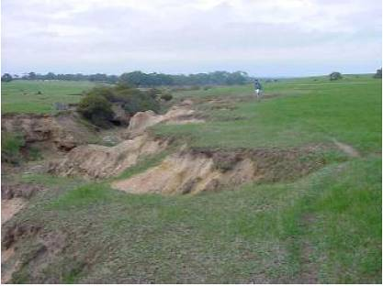
Figure 22: Collapse of gully walls and headward extension of side-gullies.
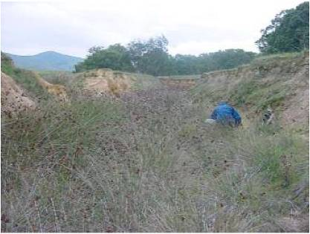
Figure 23: Spiny Rush covering bed of fourth order gully.
6.2 Floodouts and in-gully storages
A proportion of the sediment eroded from the gully network is stored in floodouts and in-gully storages. Floodouts generally occur at breaks of slope. The floodouts that are present on the steep slopes west of Phillips Flat Road do not represent a significant storage for the finer sediments which are eroded from the gullies. Instead, these floodouts are comprised of colluvial boulders and

Ararat geomorphic study final report

clasts which form an armour layer on the surface of the floodout (Figure 24). A small fraction of the finer sediments are stored in a number of larger floodouts that are present further down the hillslope. We also noted armouring of these floodouts by smaller boulders but not to the same extent as the floodouts on the steeper slopes. The largest of these floodouts has a length of 69 m, width 27 m and a maximum depth of 0.7 m. The amount of sediments stored within this surveyed floodout was estimated to be c.403 m³. Based on survey of the cross-sectional area for the first and second gully networks it was determined that 27% of eroded sediments are stored in floodouts.
SINCLAIR KNIGHT MERZ
I:\wcros\Wc02550\REP03_06.23\Final Report\R02 PJS Ararat Final Report.doc PAGE 36
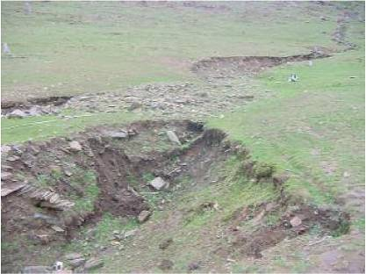
Figure 24: Boulder strewn floodout on steep slopes of Ararat Hills.
The stability of these floodouts was also assessed while in the field. For the most part, the floodouts are grassed but the vegetation cover is lacking on floodouts where boulders form an armour layer at the surface of the floodout. Floodouts may incise when the floodout slope exceeds the slope required for gully incision to occur. The migration of secondary nickpoints up the drainage network can also lead to reworking of the floodout. Two of three large floodouts positioned on the lower slopes were incised by advancing gully heads. The floodout immediately west of Phillips Flat Road is in a stable state. A large tree is present on this floodout, its age (based on its size) would suggest that there has not been erosion for the past c.75 years.
Further downstream there has been some sediment storage in gully-storages in the third and fourth order streams (Figure 23). The deposition and storage of sediments along the channel bed is assisted by the colonisation of the bed by Spiny Rush. Based on work completed on reed beds in Jugiong Creek, New South Wales (Zierholz et al., 2001) it was estimated that an average of 0.7 m depth of sediments has been deposited as in-gully storages. The spiny rush is likely to form a significant trap for sediments moving down the gully network. We estimated that 11.3% of sediments eroded from the gully network are stored in these in-gully storages.

Ararat geomorphic study final report

An area where there may be a large sediment store is between Wills Hills Road and Ararat Road. At this point, there is a notable reduction in channel capacity. It is possible that a large floodout has formed in this section of the gully. We were unable to determine in the field how much sediment, if any, is stored in this section of the drainage network. Based on aerial photographs, it was estimated that this floodout could have dimensions of 1,000 m in length and 50 m in width. If this floodout had a thickness of 50 cm this would represent a storage of 50,000 m³. This would reduce the volume of eroded sediments exported to the Hopkins River from 147,764 m³ to 97,763 m³ (82% to 54%).
SINCLAIR KNIGHT MERZ
I:\wcros\Wc02550\REP03_06.23\Final Report\R02 PJS Ararat Final Report.doc PAGE 37
6.3 Hopkins River
The Hopkins River downstream of Kurrajong Gully shows evidence that there has been a general accretion of the floodplain. Channel banks were documented as stable, with the exception of one localised area where slumping and failure of channel banks has recently occurred. Vertical tension cracks have decreased the stability of the channel bank at this location (Figure 25). The clearing of riparian vegetation from the channel margins would have decreased the strength of the bank materials and would have exacerbated the processes of mass-failure and bank erosion (Abernethy and Rutherfurd, 2000).
We were able to determine the depth of sediments deposited on the floodplain at a number of locations, using the base of older trees as an indicator of the pre-settlement floodplain surface. Scour around the trunk of several trees on the floodplain has exposed the tree roots providing a point to which the thickness of the alluvium could be measured (Figure 26, overleaf).
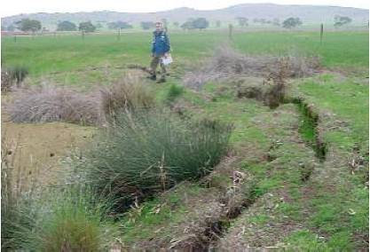
Figure 25: Hopkins River. Note failure of channel bank and tension cracks.
Higher rates of deposition are expected at the channel margins during overbank flood events, due to
the rapid reduction in flow caused by the roughness effects of vegetation. This can lead to the

Ararat geomorphic study final report

formation of natural levee banks. The morphology of the floodplain indicated the presence of a levee style deposition at the channel margins. We determined that 1 m of post settlement alluvium has been deposited at the channel margins. The floodplain extends back 40 m from the channel margins in this section of the river. We were able to provide an assessment of the volume of sediments which have accumulated on the floodplain. For the 5.6 km section of Hopkins River between Kurrajong Gully and Jacksons Creek it was calculated that 223,200 m³ of sediments is stored as PSA on the floodplain. Given that the gully networks eroding Ararat Hills have input 1,171,344 m³ of sediment to the Hopkins River, this would suggest that a large proportion of these sediments have been exported from the upper Hopkins River Catchment study area.
SINCLAIR KNIGHT MERZ
I:\wcros\Wc02550\REP03_06.23\Final Report\R02 PJS Ararat Final Report.doc PAGE 38
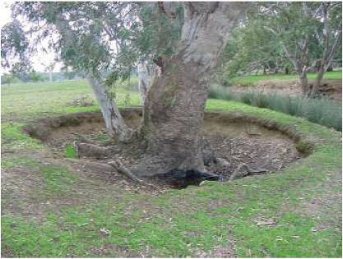
Figure 26: Hopkins River floodplain. Note accretion of floodplain surface as indicated by exposure of tree roots.

Ararat geomorphic study final report

7. Challicum Hills
SINCLAIR KNIGHT MERZ
I:\wcms\Wc02550\REP03_06.23\Final Report\R02 PJS Ararat Final Report.doc PAGE 39
The Challicum Hills physiographic unit has a drainage area of 139 km² or some 32.5 % of the total upper Hopkins River catchment area (Figure 28, overleaf). The unit has a drainage density of 1.9 km/km², which is lower than the drainage density calculated for the entire catchment (2.5 km/km²). Two creeks drain the Challicum Hills unit: Jacksons Creek (101 km²) and Gorrin Creek (38 km²).
Jacksons Creek was selected as the representative drainage network studied in the Challicum Hills unit (Figure 28 and Figure 29, overleaf). The long profile for Jacksons Creek, shows that the creek has a fall in bed elevation of some 82 m over 16,000 m (Figure 9). With such a low rate of fall over a large distance, in comparison to the Ararat and Skeleton Hills drainage networks, it was anticipated that there may be a low rate of transfer of eroded sediments from the gullies dissecting Challicum Hills to the Hopkins River. As catchment area increases there are more opportunities for sediment storage to occur along the drainage network.
Comparison of the drainage network depicted by the 1:25,000 topographic data with aerial photographs showed that there was a lack of a continuous channel network from the gullied areas of Challicum Hills through to Jacksons Creek further downstream. At the base of the steep Challicum Hills, large diffuse floodouts have formed, and the creek only begins to take on a defined form at some distance further downstream away from the eroded areas. In addition, not all of the drainage networks were gullied. Those drainage networks not gullied were omitted from the sediment budget (Figure 27).
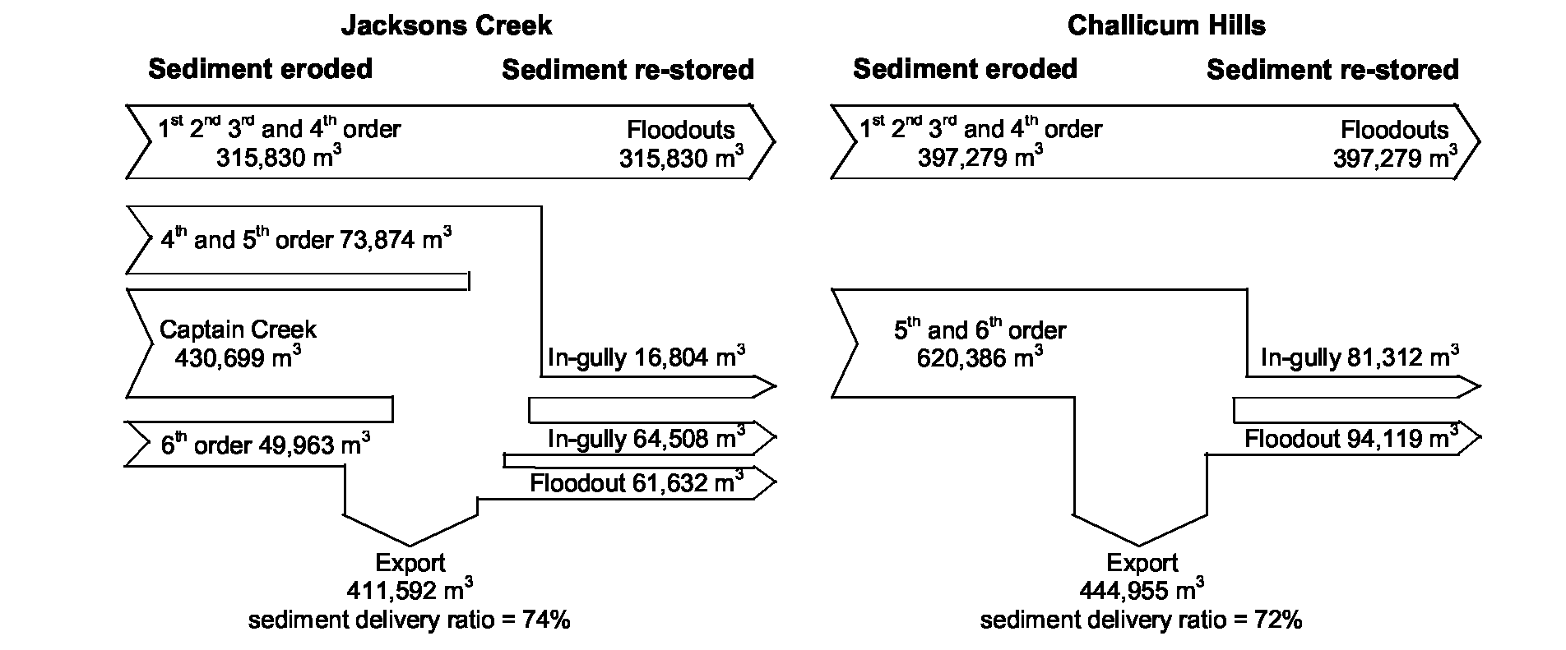
Figure 27: Sediment budgets constructed for Jacksons Creek, and the larger drainage network draining Challicum Hills.
We completed our investigations on the headwaters of the gully networks within the vicinity of Yorks Flat Road, and along Jacksons Creek, characterising the changes in channel geometry and documenting the amount of sediment accumulation/loss. Captains Creek, which drains into Jacksons Creek was also an area of importance because of the channel widening that has occurred in the recent past. Information collected from surveys and aerial photograph analysis was used to construct a sediment budget for Jacksons Creek and the wider Challicum Hills unit (see Figure 27).

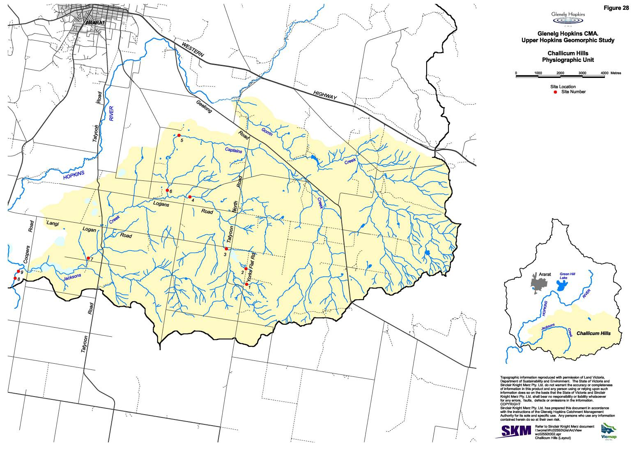
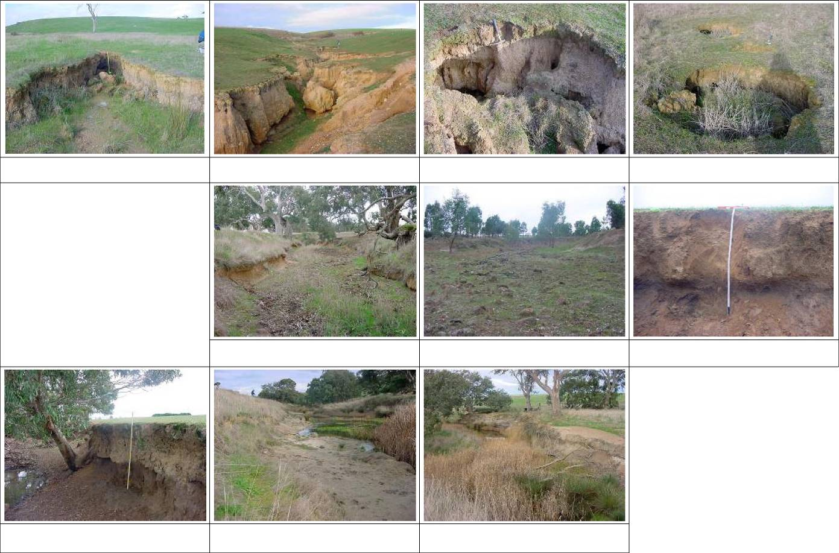
Site 1: Gully head incising floodout east of Yorks Flat
Road.
Site 3: Floodout.
Site 2: Active gullying on steep slopes of Challicum
Hills.
Site 4: Minor undercutting of banks and incised channel
morphology.
Site 2: Pipe outlets in gully head wall.
Site 5: Captains Creek. Massive channel widening has
occurred in this reach. Channel 35m in width.
Site 2: Collapse of A-horizon due to piping above gully
head.
Site 6: Sediment storage on the floodplain of Captains
Creek.
Site 7: Sediment storage on the floodplain of Jacksons
Creek.
Site 8: Hopkins River downstream of Jacksons Creek.
Note indurated clay layer.
Site 9: Hopkins River downstream of Jacksons Creek.
Note undercut banks.
Figure 29: Photographs and descriptions at selected sites in the Challicum Hills physiographic unit (see Figure 28 for site locations).
Ararat geomorphic study final report

7.1 Gully processes
SINCLAIR KNIGHT MERZ
I:\wcros\Wc02550\REP03_06.23\Final Report\R02 PJS Ararat Final Report.doc PAGE 42
The gully network commences on the steep slopes of Challicum Hills. Further upslope from Yorks Flat Road a series of discontinuous gullies are evident which end in small floodouts (Figure 30). No trees are present on these slopes, and the surface is covered is covered by a fine grass. The severely eroded areas on the steeper slopes west of Yorks Flat Road are unfenced and open grazing is permitted.
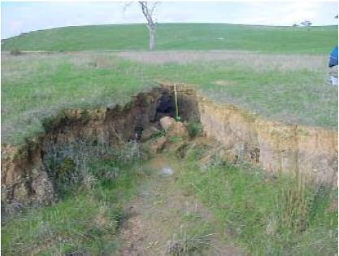
Figure 30: Gully head incising floodout east of Yorks Flat Road.
West of Yorks Flat Road gullies incise and deepen quickly in response to increased slope and drainage area. The soils of the Challicum Hills (hard-setting A horizon and a more clayey dispersive B-horizon) combined with the steep gradients make this area particularly sensitive to erosion. The steep gradient, combined with the high groundwater levels in the area and dispersive characteristics of the B-horizon create conditions ideal for gully extension through the development of subsurface pipes (Figure 31, Figure 32, Table 7).
As water moves in the B-horizon, fine particles are carried in suspension causing piping or seepage erosion (Young and Young, 2001). As subsurface flow emerges at the head or side of the gully, the soil is transported away by channel flow. This allows more soil to move through the pore spaces in the soil, and more erosion to occur. Eventually the A-horizon may become so undercut that it breaks and falls into the pipe as shown in Figure 32 (Young and Young, 2001). Once a pipe is formed, erosion is not limited to simply moving clays and fine silts in suspension through the pores of the soil. The concentrated flow in the pipe exerts shear stress on the walls of the pipe and accelerates the erosion.
We investigated topographic thresholds for gully incision in Challicum Hills (Figure 34, overleaf).
GIS operations were used to determine the contributing area, slope and the distance to divide for
individual gully heads. There were 238 gully heads documented in the Ararat Hills. Study of the

Ararat geomorphic study final report

aerial photographs showed that some of the channel heads depicted by the 1:25,000 topographic data were not gully heads; these were omitted from further analyses.
SINCLAIR KNIGHT MERZ
I:\wcros\Wc02550\REP03_06.23\Final Report\R02 PJS Ararat Final Report.doc PAGE 43
Figure 32: Collapse of A-horizon due to piping above gully head.

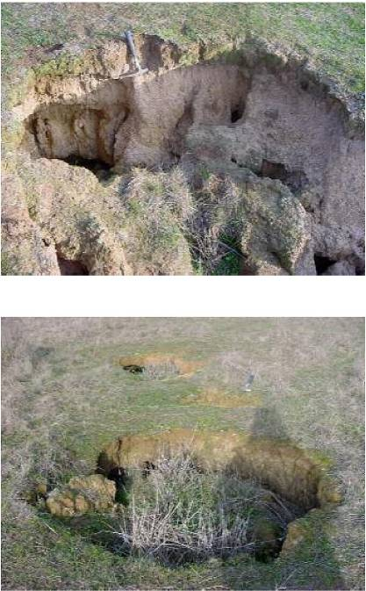
Figure 31: Pipe outlets in gully head wall.
Study of the histogram frequency plots of the topographic parameters for the gully heads (Figure 34, overleaf) indicates that the majority of the gully heads have catchment areas in the range of 5,000-10,000 m². Many of the gully heads are also positioned between 200 and 400m from the drainage divide and are located on slopes >5º. It could be argued that gully heads with larger catchment areas have the potential to continue to erode further upslope towards the drainage divide.

Ararat geomorphic study final report

Table 7: Gully head dimensions and activity for selected channel heads.
SINCLAIR KNIGHT MERZ
I:\wcms\Wc02550\REP03_06.23\Final Report\R02 PJS Ararat Final Report.doc PAGE 44
Site | Grid ref | Area (m2) | Slope  (º) | Distance¹  (m) | Width  (m) | Height  (m) | Status | Description
1 | 0678056  5859215 | 1,117,475 | 1 | 2298 | 0.7 | 0.8 | Active | East of Yorks Flat Road.  Undercut, plunge pool, seepage in subsurface, ponding of water at base of gully, reincised  floodout.
2 | 0678025  5859914 | - | 18 | - | 1.9 | 1.2 | Very  Active | West of Yorks Flat Road. Side gully. Undercut, plunge pool, abrupt sharp edges, pipes feeding gully head (20 cm in diameter).
3 | 0677898  586003 | - | 12 | - | 2.3 | 0.4 | Very  Active | West of Yorks Flat Road. Side gully. Pipes feeding gully head (c.15 cm in diameter.).  Sediments at base of gully head washed away.
¹Distance to drainage divide.
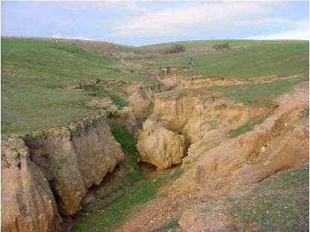
Figure 33: Active gullying on steep slopes of Challicum Hills. Note undercutting of gully sidewalls.
Other factors also need to be considered in evaluating whether gully heads are likely to continue to erode towards the drainage divide. The distribution of erosional pipes will have an influence in channelling sub-surface flow to particular gully heads. Alterations to the contributing area through structural works may also have an influence on whether gully heads continue to erode. Vegetation can play an important role in increasing the resistance of the underlying soils to erosion. Vegetation is also effective in reducing high groundwater levels and reducing the amount of subsurface flow available to erode a gully head.
Sediments which are eroded from the gully networks that have incised the steep slopes of Challicum Hills are deposited at the break of slope as large floodouts. These floodouts are not as clearly defined as the floodouts documented at the base of Ararat Hills. Jeff Smart (landholder, pers. comm.) stated that after a large rainfall event sediments eroded from the gully network are spread out over his paddocks at the base of the hills. This area has naturally poor drainage, and the

Ararat geomorphic study final report

landholder has constructed a shallow drain through his property in an attempt to improve the drainage. The extent of the floodout can be more clearly discerned on the 1948 historical aerial photographs, it extends across the paddocks at the base of the slope.
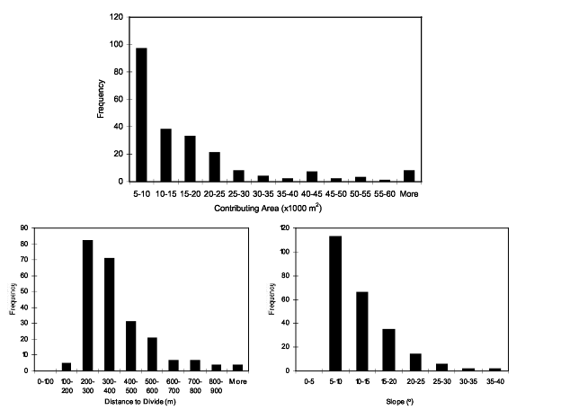
Figure 34: Distribution of topographic parameters for gully heads in the Challicum Hills (all values derived from DTM analysis). .
Results of field surveys and study of aerial photographs indicates that sediments eroded from the steeper slopes of the Challicum Hills are stored in the floodouts which form on the lower gradient slopes; there is no connectivity of sediment transport through to Jacksons Creek. This is important as it means that the erosion of sediments from these areas has no connection with the higher stream orders of Jacksons Creek and the Hopkins River.
Investigation of the remaining drainage network showed that channel widening has been significant further downstream along the course of Jacksons Creek and Captains Creek. Channel widening commences on Jacksons Creek downstream of the point where the creek first crosses Logans Road, c.3 km upstream of the junction with Captains Creek (Figure 35, overleaf). The channel at this point has been fenced-off 15 m from the channel margins. There are no indications of recent channel widening along this section of the creek. There is some minor undercutting of the channel banks (undercut 10 cm in width and 30 cm in height) but, in general, the banks appear to be stable.
SINCLAIR KNIGHT MERZ
I:\wcms\Wc02550\REP03_06.23\Final Report\R02 PJS Ararat Final Report.doc PAGE 45

Ararat geomorphic study final report

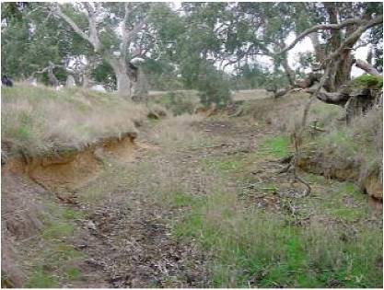
Figure 35: Jacksons Creek, c.3 km upstream of Captains Creek (note minor undercutting of banks and incised morphology of creek).
SINCLAIR KNIGHT MERZ
I:\wcros\Wc02550\REP03_06.23\Final Report\R02 PJS Ararat Final Report.doc PAGE 46
Massive channel widening has occurred along a 3.4 km section of Captains Creek. Survey of the channel in the field showed it to be 35 m wide and 3.2 m deep. It was reported by one local landholder who grew up in the area that the creek in the 1940s was only 2 m wide. It can be clearly seen from the sediment budget (Figure 27), that this area represents a major source of sediment in the Jacksons Creek catchment. Channel widening along Captains Creek alone contributes 78% of the sediment that has been eroded from the drainage network (excluding Challicum Hills). The other 22% is generated by widening along Jacksons Creek and also along a fourth order tributary which joins Jacksons Creek immediately downstream of where the creek crosses Tatyoon Road.
7.2 Floodouts and in-channel storages
The results of field investigations and aerial photograph analysis demonstrated that there is no connection between gullying in the steep Challicum Hills and the supply of sediments to Jacksons Creek further downstream. All of the sediment eroded from these areas are stored in floodouts at the base of the slope. While gully erosion is a serious issue on these steeper slopes, there is a lack of connectivity with the channel network further downstream. Instead, channel widening along the higher order streams, has contributed to the increase in sediment yield from the tributaries draining the Challicum Hills area.
Sediments eroded from in-channel sources are also being deposited on the floodplain of these creeks. This was noted in the lower parts of Captains Creek and also along Jacksons Creek, downstream of Captains Creek. On Captains Creek c.50 cm of PSA could be clearly observed in the stratigraphy of the eroded banks (Figure 36, overleaf). However, only 4% of the 430,699 m³ eroded from Captains Creek has been deposited on the floodplain. The remaining 96% of sediments has been exported to Jacksons Creek. Some of this material eroded from Jacksons and

Ararat geomorphic study final report

Captains Creek (15%) has been deposited along on the floodplain of Jacksons Creek (average of 1 m of PSA measured, Figure 37). A similar proportion of sediments has been stored in a large tributary junction plug/floodout formed upstream of the junction with the Hopkins River.
SINCLAIR KNIGHT MERZ
I:\wcros\Wc02550\REP03_06.23\Final Report\R02 PJS Ararat Final Report.doc PAGE 47
Sediments which are stored on the floodplain of the creeks are not likely to be reworked. In some reaches, there is only a narrow riparian vegetation zone, and there are some indications of channel instability as evident by the scouring and upheaval of trees on the banks. The large tributary junction plug/floodout formed at the junction of Jacksons Creek is densely vegetated with reeds and high grasses. Reworking of these sediment stores, and incision along Jacksons Creek, may

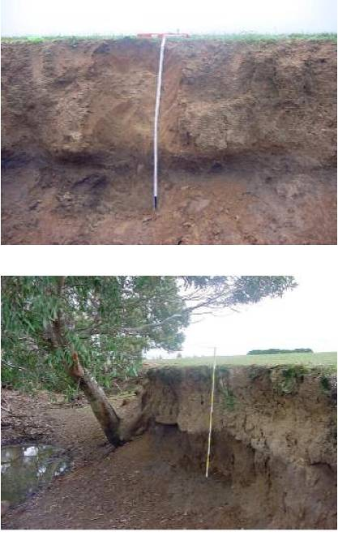
Figure 36: Sediment storage on the floodplain of Captains Creek.
Figure 37: Sediment storage on the floodplain of Jacksons Creek.

Ararat geomorphic study final report

occur if the instability at the junction with Hopkins River continues upstream and begins to cause erosion along the creek (Section 7.3).
SINCLAIR KNIGHT MERZ
I:\wcros\Wc02550\REP03_06.23\Final Report\R02 PJS Ararat Final Report.doc PAGE 48
7.3 Hopkins River
The section of Hopkins River within the vicinity of the junction with Jacksons Creek is an area where there has been significant channel changes. These include channel incision and widening downstream of Jacksons Creek and extensive erosion on the western floodplain. The cause of these channel changes and the present geomorphic stability of this section of the Hopkins River were investigated as part of this study. While, at first instance it appeared that these channel changes may have been linked to an increase in flow and sediments from Jacksons Creek, further investigation of the area showed that a number of other factors need to be considered. An aerial photograph of the area and map highlighting the major features of importance is shown in Figure 38.
No PSA was documented on the floodplain of the Hopkins River downstream of Jacksons Creek. This was contrary to what was expected, as the results of our sediment budget indicate that 411,601 m³ of sediment has been input to the river from Jacksons Creek. The channel is also notably more incised and wider downstream of the junction with Jacksons Creek. The river has incised its bed down to the level of an indurated clay layer, and the bed presently lies at a level 1.7-4.2 m below the adjacent floodplain (Figure 39, overleaf). Channel widths vary markedly ranging from 20 to 30 m (contrary to the 5-10 m channel widths upstream of Jacksons Creek). Evidence of recent channel widening is provided by the undercut vertical banks and tree roots exposed at the channel margins (Figure 40, overleaf). An explanation is required to account for the lack of sediment storage on the floodplain and why channel incision and widening has occurred along this section of the river.
It is well known that changes in channel and floodplain width exert a strong influence on stream power and the potential for sediment transport and storage along a river system (Magilligan, 1992). In unconfined sections where boundary shear stress and unit stream power is reduced there is greater potential for sediment storage to occur. Higher unit stream powers will be anticipated in the more confined sections of the river which will accentuate the movement of sediments through these reaches. The width of the Hopkins River floodplain decreases markedly downstream of Jacksons Creek, in response to the confinement caused by the surrounding granite and basalt terrain. Upstream of Jacksons Creek the floodplain width ranges from 400-600 m, whereas downstream it is only 200-250 m in width. As the channel and floodplain becomes more confined, it is anticipated that unit stream power will increase. A similar increase in the rivers sediment transport capacity may also be expected. These more confined reaches are not conducive for sediment storage and are able to propagate the increased sediment load further downstream. The increased confinement of the channel and floodplain downstream of Jacksons Creek and its effect on sediment transport relationships would explain why no PSA was present in these reaches.

Ararat geomorphic study final report

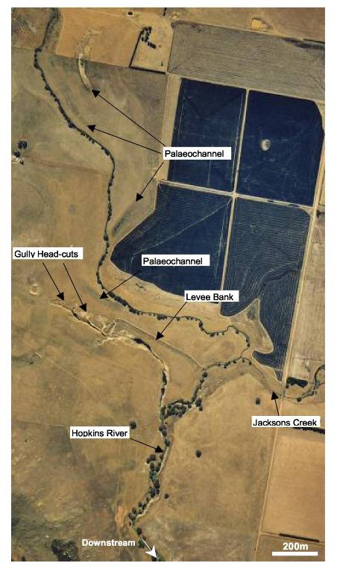
Figure 38: Hopkins River and Jacksons Creek. Note position of palaeochannels, gully headcuts and levee structure.
SINCLAIR KNIGHT MERZ
I:\wcms\Wc02550\REP03_06.23\Final Report\R02 PJS Ararat Final Report.doc PAGE 49

Ararat geomorphic study final report

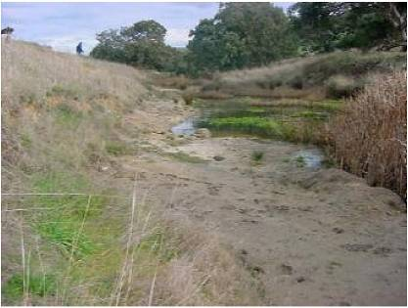
Figure 39: Hopkins River downstream of Jacksons Creek. Note indurated clay layer.
SINCLAIR KNIGHT MERZ
I:\wcros\Wc02550\REP03_06.23\Final Report\R02 PJS Ararat Final Report.doc PAGE 50
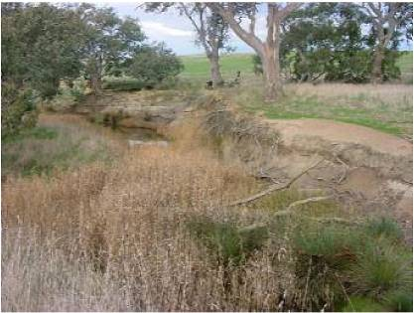
Figure 40: Hopkins River downstream of Jacksons Creek. Note undercut banks.
The term catastrophic widening is used where channel width has changed dramatically during single high magnitude floods or a series of floods (Prosser et al., 2001). Catastrophic widening may be expected to occur along the river where the floodplain is more confined. These represent sites where the erosive power of floods can be expected be at its highest. Increased runoff from cleared catchments contributing to higher magnitude floods, removal of riparian vegetation from channel banks, and changes in the magnitude and frequency of floods through secular climate change have all been cited as possible causes of catastrophic widening (Prosser et al., 2001).

Ararat geomorphic study final report

Extensive clearing of vegetation occurred in the upper Hopkins River catchment and this is likely to have contributed to increased runoff resulting in higher magnitude floods. This combined with the removal of riparian vegetation, may have been the critical factors which have led to the incision and widening that has taken place in the confined section of the river downstream of Jacksons Creek. There is insufficient information available to determine whether these channel changes have been catastrophic or whether they developed more gradually.
SINCLAIR KNIGHT MERZ
I:\wcros\Wc02550\REP03_06.23\Final Report\R02 PJS Ararat Final Report.doc PAGE 51
The effect of the channel incision and widening has not been limited to the confined reaches. As the channel has incised its bed in these confined reaches, effectively steepening the channel bed slope, this has also had an impact on the channel reaches further upstream. The drop in bed level has formed an erosional nickpoint that has continued to migrate up the river. As this nickpoint has migrated upstream it has cut a large channel into the western floodplain. If this nickpoint is allowed to continue its present trajectory, it is likely that this channel will continue to erode further upstream to form a new course for the Hopkins River. The former channel will then be cutoff from flows, and will form part of the floodplain. A nickpoint is also migrating up the present course of the Hopkins River towards the junction with Jacksons Creek. If this nickpoint travels further upstream it may lead to a reworking of sediments stored at the junction of Jacksons Creek.
Levee banks have been constructed in an attempt to confine flood flows to the rivers old course. This has been unsuccessful, and the levee banks have since been breached by advancing erosional gully heads that are deeply incised into the floodplain (individual gully heads 1-2 m in height). Flow during overbank flood events is then diverted along the channel scoured in the floodplain. Over time this channel has incised and widened to form its present dimensions (near its downstream outlet with the Hopkins River the channel is 20 m wide and 2.8 m deep).
It is important to recognise that the erosional processes that control the migration of these nickpoints upstream are fed by both surface and subsurface flows. Study of aerial photographs and assessment of the area in the field shows a series of gully heads incised into the floodplain. Seepage at the face of these gully heads, tension crack development and mass-failure are important processes ensuring their continued extension across the floodplain. Construction of levee banks upstream of these gully headcuts, may be effective in diverting flood flows, however, subsurface flow and extension of the gully network may still continue and undermine the levee bank structure.
The trajectory of the scoured channel that is forming across the floodplain will also provide a straighter path and increased gradient for the Hopkins River than is provided by its present course. Channel migration and avulsion appear to have a longer history along this section of the river. Study of aerial photographs indicates that the channel has shifted dramatically in the past. A number of palaeochannels can be seen at different positions across the floodplain (Figure 38). The Hopkins River in these less confined reaches appears to have a high degree of mobility across the floodplain. Any further consideration to constraining the course of the Hopkins River should be carefully considered in light of dynamic nature of this channel floodplain environment, where channel avulsion and migration across the floodplain can be expected to occur.

Ararat geomorphic study final report

8. Skeleton Hills
SINCLAIR KNIGHT MERZ
I:\wcms\Wc02550\REP03_06.23\Final Report\R02 PJS Ararat Final Report.doc PAGE 52
The Skeleton Hills unit has a drainage area of 24.9 km² which represents 5.84 % of the total upper Hopkins River catchment area (Figure 42, overleaf). The unit has a drainage density of 2.8 km/km², which is comparable to the drainage density calculated for the entire catchment (2.5 km/km²). Buckingham Gully was selected as the representative drainage network studied in the Skeleton Hills unit (Figure 42, overleaf). The long profile for Buckingham Gully, shows that the gully has a fall in bed elevation of some 75 m over 3,680 m (Figure 10).
Comparison of the drainage network depicted in the digital topographic data with that surveyed in the field, along with aerial photograph analysis, indicates that the 1:25,000 stream network provides an accurate representation of the gully network. Study of the aerial photographs of the Skeleton Hills unit confirmed that it was reasonable to extrapolate information collected on sediment loss/storage for Buckingham Gully to other gully networks in the physiographic unit.
Field investigations followed the gully from its headwaters (between Buckingham and Big Hill Road) to where it connects with a larger drainage network and finally joins with the Hopkins River (south of Warrak Road). The various gullies and creeks in Skeleton Hills form the headwaters of the upper Hopkins River catchment. Information collected from surveys and aerial photograph analysis was used to construct a sediment budget for the Skeleton Hills unit (see Figure 41).
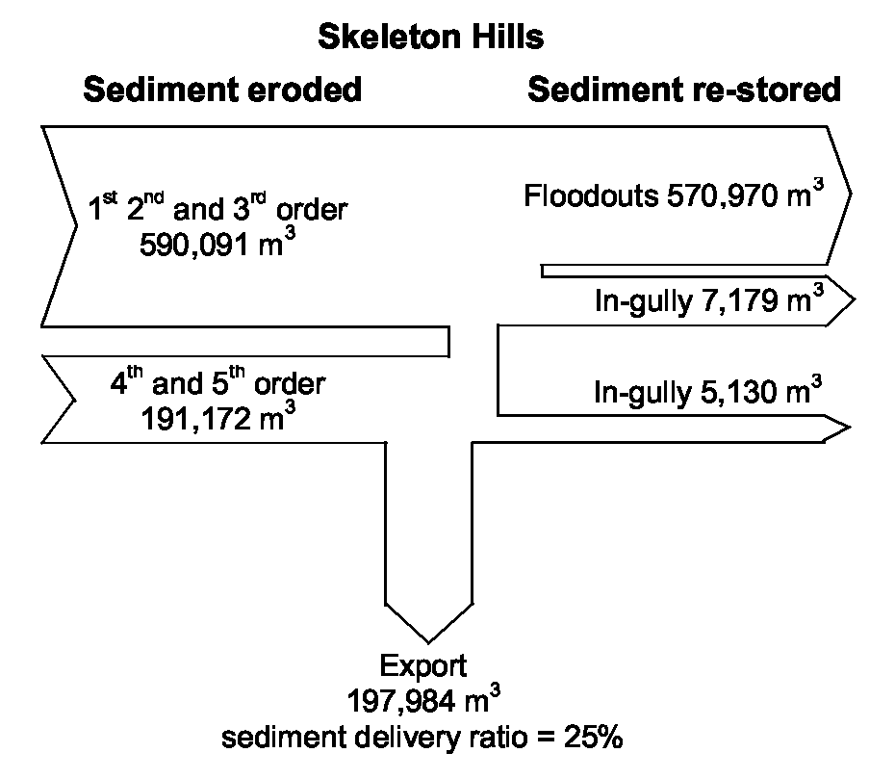
Figure 41: Sediment budget constructed for the larger drainage network draining Skeleton Hills.
8.1 Gully processes
The upper headwaters of Buckingham Gully lie incised within a steep narrow valley. Isolated trees are present in these upper parts, and the surface of the valley is covered by a fine grass. The area is unfenced and open grazing is permitted. The soils in which the gully networks have developed are comprised of an upper organic rich clay porous A-horizon and a lower B-horizon comprised of an impermeable dense clay. The differences in permeability between the A and B-horizon and the highly dispersive characteristics of these soils provide favourable conditions for pipe formation to

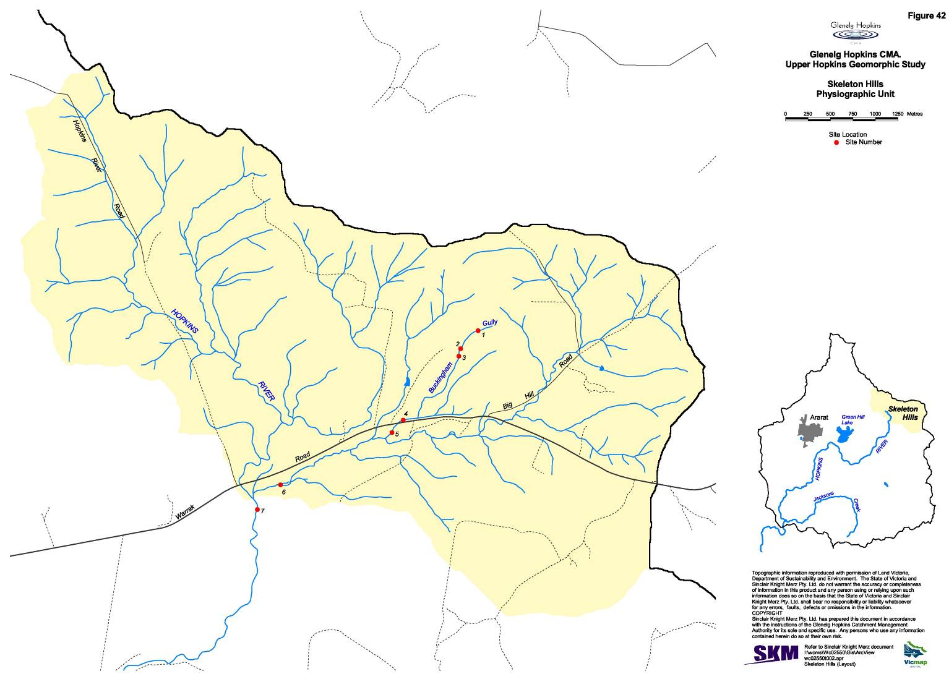
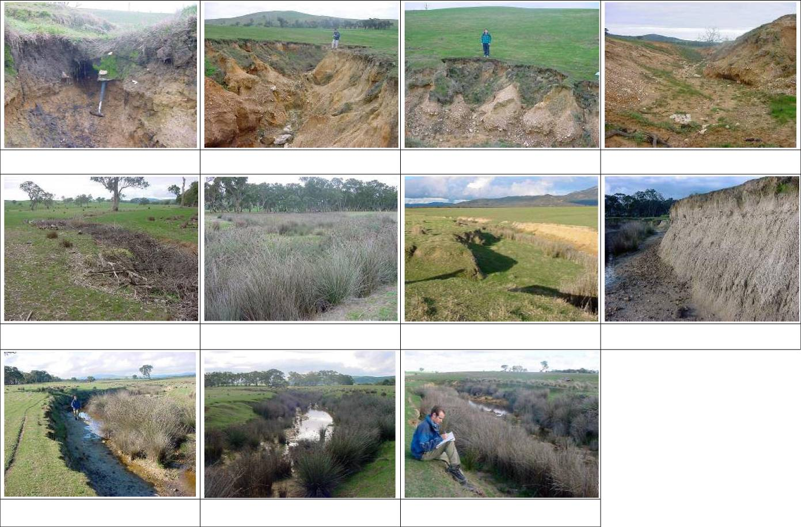
Site 1: Gully head. Note 30 cm diameter pipe at the
boundary between the A and B soil horizons.
Site 2: Buckingham Gully. Note bedrock at base of
gully and erosion of sidewalls.
Site 2: Buckingham Gully. Collapse of gully walls and
headward extension of side-gullies.
Site 3: Buckingham Gully. Note inclined sidewalls.
Site 4: Gully head threatening to rework sediments
stored in floodout.
Site 5: In-gully storage as inset fill between older
terraces.
Site 6: In-gully storage as inset terrace in incised gully.
Site 6: Near vertical gully side-wall. Note lack of Spiny
Rush at toe.
Site 6: In-gully storage as inset terrace in incised gully.
Site 7: Hopkins River downstream of Buckingham Gully.
Spiny Rush stabilising channel margins.
Site 7: Hopkins River downstream of Buckingham Gully.
Incised stable channel.
Figure 43: Photographs and descriptions at selected sites in the Skeleton Hills physiographic unit (see Figure 42 for site locations).
Ararat geomorphic study final report

Site  occur. Underlying these soils, are the coarser gravel colluvial deposits that have formed on the slopes of these hills.  Towards the top of the valley there are three gully heads, spaced c.10 and 20 m apart. The dimensions and activity of these gully heads are shown in Table 8. The duplex structure of the soil, and the formation of an erosional pipe at the boundary between the A and B-horizon is shown in Figure 44. The presence of this pipe in the gully head indicates that subsurface flow is important in driving further headward extension of the gully. A plunge pool was noted in the third gully head, also highlighting the importance of surface flow. The presence of these features in the gully heads indicates that they are still active.  Table 8: Gully head dimensions and activity for selected gully heads.  SINCLAIR KNIGHT MERZ  I:\wcms\Wc02550\REP03_06.23\Final Report\R02 PJS Ararat Final Report.doc PAGE 55  1 | Grid ref  0684067 5874747 | Area  (m²)  77,698 | Slope  (º)  4 | Distance¹  (m)  461 | Width  (m)  0.9 | Height  (m)  0.4 | Status  Inactive | Description  Abrupt gully head, covered with grass.
₂ | 0684067  5874747 | 77,698 | 4 | 471 | 1.0 | 1.1 | Active | Abrupt gully head, no undercut. 30 cm diameter outlet pipe at  boundary between A and B  horizon.
3 | 0684022  5874736 | 104,805 | 6 | 546 | 1.8 | 1.3 | Active | Abrupt gully head, undercut. Plunge pool present. Bedrock crops out at base of gully.
¹Distance to drainage divide.
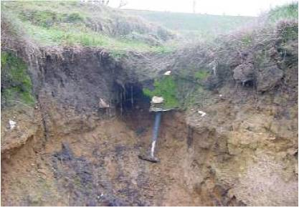
Figure 44: Gully head. Note 30 cm diameter pipe at the boundary between the A and B soil horizons.
We investigated topographic thresholds for gully incision in Skeleton Hills (Figure 45, overleaf). GIS operations were used to determine the contributing area, slope and the distance to divide for individual gully heads. There were 98 gully heads documented in the Ararat Hills. Study of the aerial photographs showed that a small proportion of the channel heads depicted by the 1:25,000 topographic data were not gully heads; these were omitted from further analyses.
The histogram frequency plots of the topographic parameters of the gully heads (Figure 45)
indicate that the majority of the gully heads have catchment areas in the range 5,000-10,000 m².

Ararat geomorphic study final report

Many of the gully heads are also positioned between 300 and 400 m from the drainage divide and are located on slopes >5º. It could be argued that gully heads with larger catchment areas have the potential to continue to erode further upslope towards the drainage divide.
SINCLAIR KNIGHT MERZ
I:\wcms\Wc02550\REP03_06.23\Final Report\R02 PJS Ararat Final Report.doc PAGE 56
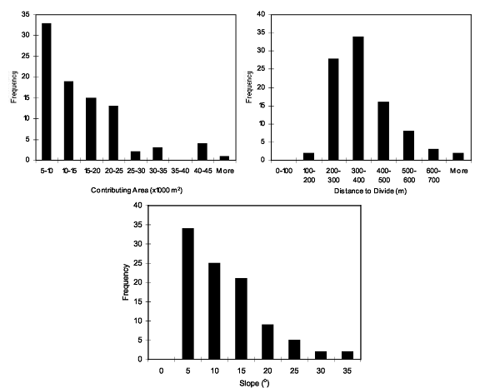
Figure 45: Distribution of topographic parameters for gully heads in the Skeleton Hills (all values derived from DTM analysis).
There are other factors that also need to be considered in evaluating whether gully heads are likely to continue to erode towards the drainage divide. These include soil depth, the presence and distribution of pipes and the density of vegetation cover. Pipes are important in channelling flow to an eroding gully head. Vegetation can also play an important role in increasing the resistance of the underlying soils to erosion, and thereby preventing further headward extension of the gully head.
Immediately down valley from the third gully head the gully rapidly incises through the underlying colluvial sediments and down to bedrock. The depth of these colluvial sediments and bedrock varies along the drainage network. The second and third order gullies have a V-shaped morphology with 1.5 to 2.8 m high sidewalls. These gully sidewalls are typically comprised of a lower gravel/clay colluvial unit, a dense clay B-horizon and organic rich A-horizon. Angular clasts eroded from the colluvial unit are littered along the floor of the gully, except in areas where bedrock crops out in the gully bed. Gully sidewalls are clearly actively eroding through a

Ararat geomorphic study final report

combination of erosion by surface and subsurface flow. As the gully heads become more incised by flows along the base of the gully, seepage along the sidewalls has resulted in the formation of pipes that have developed from the base of the gully sidewalls. These pipes channel subsurface flow, leading to erosion and undercutting of the sidewalls. As the base of the sidewalls are progressively undercut by seepage and piping, mass-failure mechanisms operate along the top of the sidewalls.
SINCLAIR KNIGHT MERZ
I:\wcros\Wc02550\REP03_06.23\Final Report\R02 PJS Ararat Final Report.doc PAGE 57
Investigation along the gully network indicates that the gully will continue to incise its bed down to the underlying bedrock. Processes of gully incision are still active where the gully has not yet reached bedrock. Gully sidewall erosion will also occur in association with processes of incision, and widening will continue after the period of incision is complete. Vertical sidewalls will be eroded away by a combination of surface and sub-surface erosional processes (seepage, piping, mass-failure and rilling). Over time this can transform an incised gully with near-vertical sidewalls which is 7 m in width to a gully which is 15 m wide with inclined sidewalls. Figure 46 shows one section of Buckingham Gully where the gully has incised down to bedrock and the sidewalls are actively eroding. This is compared with Figure 47, which shows a section of the gully where the gully is no longer widening and the sidewalls are inclined on an angle of 30~.
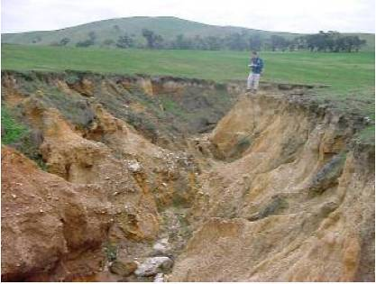
Figure 46: Buckingham Gully. Note bedrock at base of gully and erosion of sidewalls.
The gully network ends at the break of slope in a poorly defined floodout. This floodout has been incised by a gully head positioned immediately north of Warrak Road. An attempt has been made to stabilise this gully head by infilling it with debris (Figure 48, overleaf). There is no indication that this gully head has been active in the recent past. South of Warrak Road there has been another area of sediment storage where the gully has previously held a much wider and incised course. Downstream of this storage area, the gully begins to incise and widen markedly in response to the additional input of flow from a number of tributaries which join the gully network.

Ararat geomorphic study final report

At this point the gully, has the appearance of an incised channel. Large amount of sediments have been eroded from this area through channel incision and widening.
SINCLAIR KNIGHT MERZ
I:\wcros\Wc02550\REP03_06.23\Final Report\R02 PJS Ararat Final Report.doc PAGE 58
Figure 48: Gully head threatening to rework sediments stored in floodout. Note debris dumped in gully.

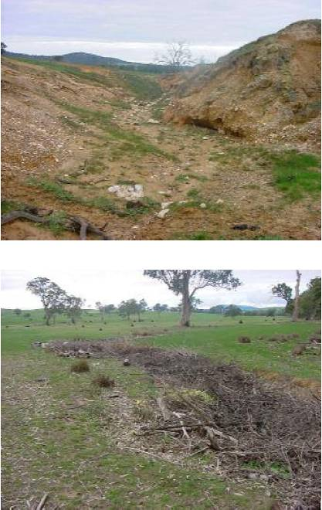
Figure 47: Buckingham Gully. Note inclined sidewalls.
The results of the sediment budget indicate that downstream of the floodout areas, erosion along fourth and fifth order streams has contributed 191,172 m³ of sediments to the Hopkins River. There is an absence of vegetation stabilising the gully sidewalls, however, there are no indications to suggest that these sidewalls are still actively eroding.

Ararat geomorphic study final report

8.2 Floodouts and in-gully storages
SINCLAIR KNIGHT MERZ
I:\wcros\Wc02550\REP03_06.23\Final Report\R02 PJS Ararat Final Report.doc PAGE 59
Results of field investigations and aerial photograph analysis indicate that the majority of sediments which are sourced from the gully networks incised into the steeper slopes of Skeleton Hills have been stored in floodouts at the break of slope (97% of sediments eroded from these areas are stored in floodouts). While gully erosion is a serious issue on these steeper slopes, there has been a lack of connectivity with the channel network further downstream. However, the potential exists for this floodout to be reworked through reincision by advancing gully heads.
There has also been some sediment storage in an area immediately south of Warrak Road. At this point, sediments have been deposited as a broad inset fill that has formed within a series of terraces either side of the gully (Figure 49). This is a relatively small area of deposition extending only c.90 m along the third order streams and accounts for only 7,179 m³ of sediments (1% of the sediments eroded from the gullies incised on the steeper slopes). The remaining area of sediment storage is further downstream along the gully network, towards the confluence with the Hopkins River. Sediments are deposited as lower inset terraces within the incised channel to form in-gully storages (Figure 50, overleaf). These storages represent a total volume of 5,130 m³ of sediments (<1% of that eroded from the gully network). While this represents a comparatively small volume of sediments, the presence of these in-gully storages and Spiny Rush established over the bed of the channel provides further evidence that this section of the gully is no longer actively incising or widening.
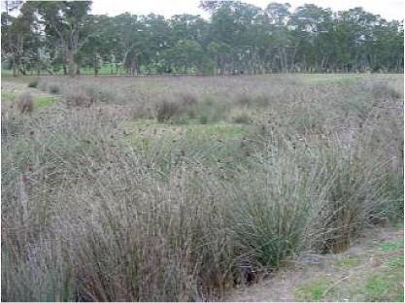
Figure 49: In-gully storage as inset fill between older terraces.

Ararat geomorphic study final report

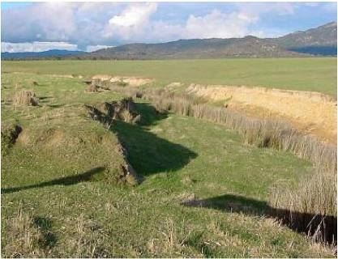
Figure 50: In-gully storage as inset terrace in incised gully.
SINCLAIR KNIGHT MERZ
I:\wcros\Wc02550\REP03_06.23\Final Report\R02 PJS Ararat Final Report.doc PAGE 60
8.3 Hopkins River
Based on the constructed sediment budgets for the drainage networks, 197,984 m³ of sediments have been input into the Hopkins River from the Skeleton Hills area. There was a notable absence of PSA on the floodplain or in-channel sediment storages in this section of the Hopkins River. The Hopkins River downstream of Buckingham Gully has the appearance of an incised channel (Figure 51). Sediments input to the Hopkins River from the Skeleton Hills area have been transported further downstream.
The present status of this section of the Hopkins River can be regarded as stable. The channel can no longer incise its bed in these reaches as it has eroded down to the bedrock. While the banks of the river in parts are characterised by sharp edges, there is no evidence to suggest that they have been recently eroded (Figure 51). The establishment of Spiny Rush at the toe of the banks has probably been an important factor buffering these banks from further erosion.
Based on the surveys completed of this section of the Hopkins River and aerial photograph analysis of the channel reaches further downstream, it was determined that c.9.2 km of river has experienced a similar loss of sediments to that documented in this section of the river. It was calculated that 139,470 m³ of sediments has been eroded from this section of the Hopkins River.

Ararat geomorphic study final report

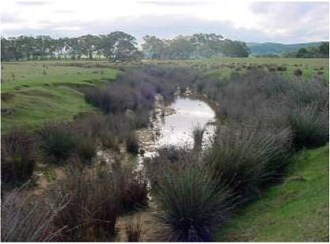
Figure 51: Hopkins River downstream of Buckingham Gully. Note Spiny Rush stabilising channel margins.
SINCLAIR KNIGHT MERZ
I:\wcros\Wc02550\REP03_06.23\Final Report\R02 PJS Ararat Final Report.doc PAGE 61

Ararat geomorphic study final report

9. Rehabilitation options
SINCLAIR KNIGHT MERZ
I:\wcms\Wc02550\REP03_06.23\Final Report\R02 PJS Ararat Final Report.doc PAGE 62
The section begins with a summary of the activity of the gullies in each of the three physiographic units, and the threat that increased erosion from these gullies poses to the upper Hopkins River (Table 9). We consider the stability of in-gully storages, floodouts and floodplains and the potential for these sediments to be reworked. The consequences of doing nothing are outlined, followed by a discussion of the various structural and non-structural erosional control works that may be used to stabilise actively eroding gullies and rehabilitate stable gullies. A number of rehabilitation options are then recommended to stabilise and rehabilitate gullies in the three physiographic units. This is followed by a discussion of other issues that, if left unattended, will result in further deterioration of the upper Hopkins River.
Table 9: Summary of erosion risk and recommendations for the study area.
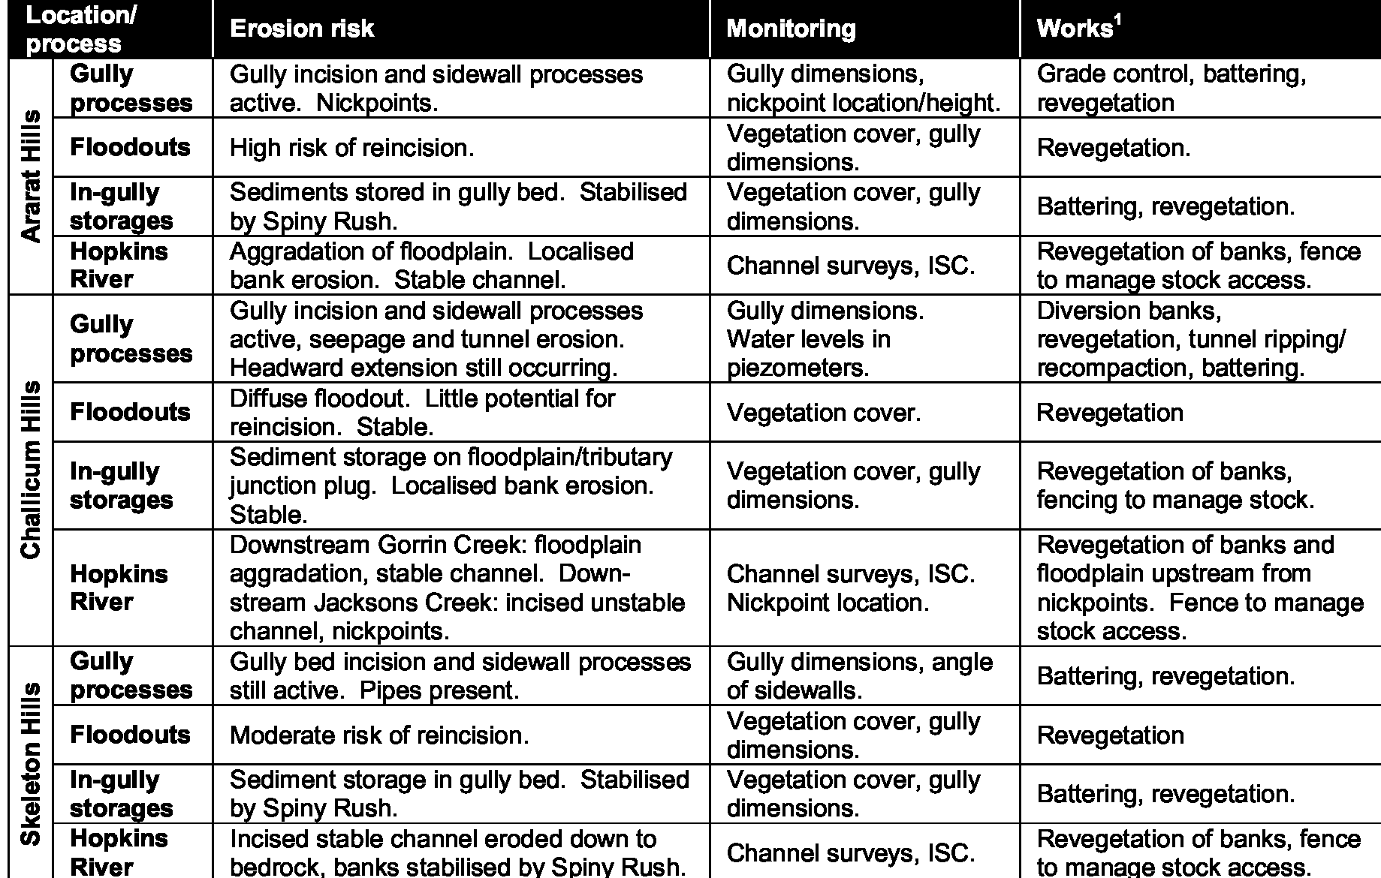
¹See Appendix B for a detailed description of gully control works.
9.1 Erosion risk
Our field investigations identified active gullies in each of the physiographic units. Sharp edges on the gully heads, recent undercutting and slumping of gully sidewalls, erosional pipes and nickpoints along the gully network confirm the comments made by landholders that the gullies are still active (see Appendix A). However, there are notable differences in the nature of the erosional processes that are operating in the three physiographic units, and their potential for further erosion.
Ararat Hills
The majority of the gully networks that drain the Ararat Hills have reached their maximum
headward extent. Consultation with landholders indicates that there has been no major adjustment

Ararat geomorphic study final report

in the extent of the gully network in the past c.60 years (Appendix A) but erosion is still occurring along the gullies. Nickpoints were observed in the upper parts of the gully network (see Table 10). The formation of nickpoints and their migration towards the drainage divide, results in further incision and widening of the gully, releasing more volumes of sediment.
SINCLAIR KNIGHT MERZ
I:\wcros\Wc02550\REP03_06.23\Final Report\R02 PJS Ararat Final Report.doc PAGE 63
Table 10: Location and heights of nickpoints surveyed in Ararat Hills.
Grid reference Height
665472 | 5866612 | 30 cm
665582 | 5866647 | 30 cm
666187 | 5866657 | Three nickpoints spaced c.75 m apart: 20 cm, 30 cm, 30 cm
667077 | 5865527 | 60 cm
667077 | 5865497 | Two nickpoints spaced 3 m apart: combined height 2.4 m.

The Spiny Rush that has established in the lower parts of the gully network now traps sediments eroded from floodouts and the upper gully network. If no action were to be taken to control the processes of erosion in the Ararat Hills, periodic rejuvenation of the upper gully networks and reincision of floodouts may be expected to occur (Figure 19). As eroded sediments are currently being deposited in association with the Spiny Rush in the lower gully network (Figure 23), it is unlikely that there would be significant sediment inputs to the Hopkins River.
The Hopkins River downstream of Ararat Hills does not show any indications of recent channel instability, except at one location where erosion of channel banks is occurring (Figure 25). At this point there is also an absence of bank vegetation. Localised erosion may be expected to occur at the channel margins where there is an absence of bank stabilising vegetation. If no action is taken to maintain the condition of the riparian zone, further bank erosion will probably occur.
Challicum Hills
Gullies in the Challicum Hills have a more recent history than those in the Ararat or Skeleton Hills areas. Indeed, gullies were not present in this area prior to 1940s when gullying commenced after these slopes were cleared of vegetation (see Appendix A). These gullies appear to be active and are a significant concern to local landholders. Well-developed pipes have formed above many of the gully heads in this area (Figure 31 and Figure 32). If no action is taken to control erosion in these areas, the result will be widespread loss of sediments from these hillslopes.
While gullying on these steep slopes is active, sediments eroded from these areas are not transported to the gully network further downstream. Instead, eroded sediments are stored in large floodouts at the base of the slope. These areas form quasi-permanent sediment storages. Further downstream along Jacksons Creek and Captains Creek, there has been significant incision and widening in the past, which has released large volumes of sediment to the Hopkins River. Processes of channel incision and widening in these reaches have now largely stabilised. In some reaches, where riparian vegetation is in a degraded state, there is evidence of recent incision and widening (Figure 35). If no action is taken to improve the condition of vegetation in these sections, there is a risk that continued erosion would occur. The formation of a large vegetated floodout/tributary junction plug at the junction of Jacksons Creek and Gorrin Creek serves as an effective trap for sediments eroded from the gully network. Hence, the volume of sediments input

Ararat geomorphic study final report

to the Hopkins River can be expected to be low, as the majority of sediments are trapped in this large sediment storage.
SINCLAIR KNIGHT MERZ
I:\wcros\Wc02550\REP03_06.23\Final Report\R02 PJS Ararat Final Report.doc PAGE 64
Downstream from Gorrin Creek there are indications that there has been significant aggradation on the floodplain of the Hopkins River. The Hopkins River downstream of Jacksons Creek lies incised within the surrounding floodplain, and a nickpoint is presently migrating upstream. If no action is taken to control the upstream migration of this nickpoint, major adjustments to the Hopkins River may be expected. There is also the possibility that sediments stored in the large tributary junction plug/floodout at the junction of Jackson Creek may be reworked.
Skeleton Hills
The Skeleton Hills area is similar to the Ararat Hills, in that the majority of the gully networks have reached their maximum headward extent. Consultation with landholders as part of this study, suggests that there has been no major adjustment in the extent of the gully network in the past c.60 years (see Appendix A).
While the gully networks have reached their maximum drainage network extent, erosion is still occurring along the gully network. In some parts, the gully has incised its bed down to the underlying bedrock and sidewall processes are active. In time, these erosional processes will transform a gully with vertical sidewalls to one with stable inclined walls (Figure 46 and Figure 47). If no action is taken to rehabilitate these areas, the gully will continue to incise its bed down to bedrock and gully sidewalls will continue to erode.
Sediments eroded from the upper gully networks are stored in floodouts and in-gully storages. No secondary nickpoints were observed along these gully networks. An abrupt gully head has formed at the downstream end of the floodout for the representative gully studied which threatens to rework this large sediment storage (Figure 48). Spiny Rush provides an effective buffer against further erosion lower down in the gully network. Where these plants are established they indicate that the gully is no longer actively incising or widening its dimensions (Figure 49).
The Hopkins River immediately downstream of the gully networks draining the Skeleton Hills area has the appearance of an incised channel. In the past, this section of the Hopkins River has functioned as a significant source of sediments. The channel is no longer actively incising its bed or widening it dimensions. The channel has incised its bed down to resistant bedrock. Spiny Rush have colonised the channel margins and the channel appears to be in a stable state.
9.2 Monitoring
As discussed in Section 2, a sequence of morphological changes occurs within an evolving gully network. Hence, any monitoring program should target those erosion processes that are active in the landscape for the given stage of gully network development. Monitoring is valuable on two counts. Firstly, managers need to know the extent and activity of erosion processes before they commit resources to stabilisation and rehabilitation actions. There is no point, for example, in building expensive control structures in an inactive gully. Secondly, managers need to know the

Ararat geomorphic study final report

efficacy of any works undertaken. Understanding what works and what doesnt allows adaptive management to refine later stabilisation works. A summary of the techniques used to monitor different erosional processes is outlined in Table 11.
SINCLAIR KNIGHT MERZ
I:\wcros\Wc02550\REP03_06.23\Final Report\R02 PJS Ararat Final Report.doc PAGE 65
Table 11: Summary of monitoring techniques.
Process  Gully head/nickpoint migration | Monitoring technique  Map position of gully head from repeat aerial photographs | Monitoring  interval  5-10 years
Process  Gully head/nickpoint migration | Monuments above gully head (repeat measures to gully head) | Annual
Process  Gully head/nickpoint migration | Erosion pins gully headwall | Event based
Gully incision/widening | Monumented cross-sections | 3-5 years
Gully incision/widening | Repeat ground photographs from referenced view stations | 1 year
Gully incision/widening | Erosion pins in gully sidewalls | Event based
Seepage and pipe erosion | Monumented cross-sections (specifically noting undercuts) | 3-5 years
Seepage and pipe erosion | Diameter of erosional pipes | Event based
Seepage and pipe erosion | Piezometer groundwater levels | Monthly
Floodout reincision | Transects of vegetation cover | 3-5 years
Floodout reincision | Erosion pins to mark position of gully head (if present) | Event based
River morphological changes (erosion, aggradation, migration) | Aerial photo analysis | 5-10 years
 | Riparian vegetation survey | 5-10 years
 | Monumented cross-section | 3-5 years
 | Index of Stream Condition (ISC) | 5 years
 | Repeat ground photographs from referenced view stations | 1 year

Where they are active, gully heads will migrate towards the drainage divide over time. The position of gully heads may be mapped for different subcatchment areas using aerial photographs and GIS techniques. The suggested time frame between aerial photo analysis is 5-10 years. Alternatively, the location of these gully heads may be registered in the field using erosion pins to mark their position. Monitoring of gully head position could then be undertaken by the local landholder. Monitoring of gully head position in the field should be event based, as much of the erosion can be expected to occur in response to larger storms.
Headward migration of nickpoints along the bed of the gully network may result in further incision and widening along gully network. Nickpoint migration may also contribute to the reincision of floodouts, undermining of culverts at road crossings and failure of erosional control works (i.e. grade-control structures, flood retention and gully plug dams). To determine whether nickpoints are active requires ongoing monitoring of their location and height over time. Again observations (against some datum) could be recorded by the landholder annually or after specific events.
A repeated study of the morphological features of the gully network will provide an ongoing record of the activity of the gully network. The activity of gully heads and sidewalls can be assessed according to a set of pre-defined criteria (Table 3, Section 5.1). Photographs can be taken of active and inactive gullies, and the different attributes of the gully network. This can then be used to create a photographic guide for local landholders so that they can be responsible for the ongoing assessment of gully stability.
Measuring the rate in which a gully is deepening or widening can be determined using a number of different approaches. Permanently monumented cross-sections at various points along the gully allow comparisons of repeated cross-section surveys and hence assessment of stability. Erosion pins may also be used to monitor gully incision and widening but are less reliable due to the difficulty of accurate repeat measurements, washout (in very active gullies) and loss from animal

Ararat geomorphic study final report

disturbance or vandalism. Repeat ground photographs of gully morphology from referenced viewing points can also be used to provide a qualitative assessment of gully stability.
SINCLAIR KNIGHT MERZ
I:\wcros\Wc02550\REP03_06.23\Final Report\R02 PJS Ararat Final Report.doc PAGE 66
In areas affected by the erosion processes of subsurface flow, groundwater levels may be monitored by establishing a set of piezometers in the upslope contributing area (Higgins et al., 1990). Knowledge of groundwater level fluctuations will help in the design of appropriate structural and non-structural control works to control erosion. Tunnel formation and enlargement also contributes to further gully head and sidewall erosion. Repeated surveys of the gully network recording the position and diameter of tunnels are required to monitor these processes. Undercutting of sidewalls is also a feature of gullies where seepage erosion is active. Repeat surveys of monumented cross-sections, specifically noting the presence or absence of undercuts will also be useful for providing an ongoing assessment of the activity of seepage erosion.
Sediments stored in floodouts may be reworked through reincision contributing increased sediment loads to areas downstream. The stability of these floodouts is sensitive to reductions in vegetation cover, which decrease the resistance of the surface to erosion and increase the potential for reincision. Monitoring of floodout stability should also focus on measuring changes in vegetation cover and the position and dimensions of gully heads that threaten to migrate up from the downstream gully network.
A range of monitoring techniques can be applied to assessing the changing morphology and dynamics of rivers. Sequential analysis of aerial photographs at regular intervals (5-10 years) provides for a general evaluation of channel planform and can be used to determine whether there have been changes in channel position and width. Repeat ground photographs of channel morphology from referenced viewing points provide for a qualitative assessment of channel stability. Monumented cross-sections allow one to quantify the morphology of the channel and evaluate its overall stability. Interpretation of scour and fill occurring over a long period of time allows one to determine trends in aggradation or degradation and thus recovery or decline along the stream reach.
Riparian vegetation provides an important role in river networks by stabilising channel banks (Abernethy and Rutherfurd, 2001). Riparian vegetation surveys in which the width and density of vegetation along the stream banks is recorded are recommended. Where the channel banks and adjacent floodplain have been fenced off and revegetated, regular vegetation surveys are required to monitor the success of these projects. Index of Stream Condition (ISC) surveys provide an overall assessment of stream health at referenced locations. There are two ISC sites within the study area that will be resurveyed every five years (Section 3.2).
Recommendations
We recommend the following monitoring works be undertaken in the three physiographic units.
1) Repeat surveys of gully dimensions at monumented cross-sections located along the length of the gully networks should be undertaken within all three areas. At the very least, gully depth,

Ararat geomorphic study final report

width and the angle of gully sidewalls should be measured at a number of points for each stream order.
SINCLAIR KNIGHT MERZ
I:\wcros\Wc02550\REP03_06.23\Final Report\R02 PJS Ararat Final Report.doc PAGE 67
- The position of erosional nickpoints and their height should be monitored along Kurrajong Creek in the Ararat Hills unit and along the Hopkins River, downstream of Jacksons Creek.
- Piezometers should be installed to monitor groundwater levels in the contributing areas of gullies in the Challicum Hills area. Repeat measurements of the diameter of erosional pipes and the presence/absence of undercuts in gully head and sidewalls should also be undertaken.
- The condition and extent of vegetation cover established on floodouts and along the stream network should be monitored. The position and dimensions of gully heads that threaten to reincise floodouts should also be monitored.
- The environmental condition of the Hopkins River should continue to be monitored to provide information for the Index of Stream Condition (ISC) database.
9.3 Control works
We have completed a review of the various structural and non-structural works that are recommended by various authorities for stabilising active gullies and rehabilitating gullied landscapes (see Appendix B for complete descriptions). The extensive work of Clem Sturmfels (see Sturmfels, 2003) has provided valuable local insight into the rehabilitation problem. A recent assessment of gully control structures in the Eppalock Catchment (SKM, in prep.) also provides a critique of various structural and non-structural works in rehabilitating the gullies in the upper Hopkins River catchment. The geological setting in which these gullies have developed and characteristics of the soils are similar to those documented in the upper Hopkins River catchment (Ordovician interbedded slates and sandstones, sodic and highly dispersive soils). Concrete grade control structures/culverts and diversion banks have been constructed in an attempt to control gully erosion in this area. Structure failure was recorded at a number of sites and at some locations these structures have contributed to further erosion downstream. Our assessment of the Eppalock structures emphasises that efforts to rehabilitate gullied areas have a greater probability of success once the main phase of incision and headward extension has passed.
Concrete grade control structures and diversion banks were established in the Eppalock catchment. The aim of these structures was to arrest further headward erosion of gullies, and trap sediments eroded from areas further upstream. The structures also pond water to control the rate of flow to the watercourse downstream. Areas downstream were then rehabilitated by chisel ploughing and revegetation (DCFL, 1985). Generally, these structures have performed effectively in trapping sediments from upstream areas. However, structure failure has been noted at a number of sites.
Concrete structures established on sodic soils are particularly prone to failure. Expansion and cracking of these soils, which opens up the soil fabric to erosion by subsurface flow, combined with high groundwater levels have led to undermining of these structures. Upgrading of these structures will require chemical amelioration (to reduce the dispersive character of the soils), filter

Ararat geomorphic study final report

cloths (prevent removal of fines) and greater reinforcement of the base and sides of the present structure (using rock and/or concrete). If these grade control structures are to be applied in the upper Hopkins River catchment, careful attention will be required in reinforcing the gully walls.
SINCLAIR KNIGHT MERZ
I:\wcros\Wc02550\REP03_06.23\Final Report\R02 PJS Ararat Final Report.doc PAGE 68
The concentration of flow through a narrow notch and its transfer to the base of the gully, without adequate dissipation at the base of the structure can be expected to result in further scour of the gully downstream. Gully incision and widening was noted downstream of a number of these structures in the Eppalock Catchment. Gully sidewalls can also be easily undercut by shallow flows along the gully bed (the result being mass failure of sidewalls). Continued scour of the bed and sidewalls downstream threatens to undermine the upstream concrete structure. Investigations in the Eppalock Catchment showed that tree planting has been successful in stabilising an incised gully downstream of a culvert.
Ararat Hills
As the gully network in the Ararat Hills is relatively stable, gully battering may be used to rehabilitate gully networks (Appendix B). Prior to battering, areas must be protected from run-off by diversion banks or similar structures. The construction of grade control structures along the gully network, may be effective in stopping the migration of nickpoints. Vegetation should also be established on the battered areas and floodouts. Revegetation of these areas will be more successful if these areas are fenced off from grazing. Edging of sidewalls may be completed in the lower gully network where the gully is no longer actively incising its bed or widening its dimensions.
Challicum Hills
Efforts to rehabilitate gullied areas are less likely to be successful in areas where gullying is a more recent feature in the landscape. This is true of the gullies that have dissected the steep slopes of Challicum Hills. A combination of structural and non-structural options is recommended to control the erosion on the steep slopes of Challicum Hills. While interceptor banks may be effective in diverting overland flow from these gullied areas, the erosional processes contributing to the collapse of gully walls are largely driven by subsurface flow. Hence, surface flow approaches are unlikely to be of benefit in stabilising these gullies. Deep-rooted vegetation with high evapotranspiration rates should be used to reduce seepage at the base of the headwall (see Table 22, Appendix B). Planting of quick growing trees in the gully contributing area will lead to a reduction in ground water levels, but this will not be immediate. If non-native tree species are used, they should be managed to prevent their uncontrolled spread through the environment and should be accompanied by native seedlings. The steep walls of deeper gullies are also prone to mass-failure. Trees planted close to the gully can help prevent this process, but those planted further back will have less effect (Rutherfurd et al., 1999). Undercutting of gully walls can be expected where the height of the gully wall exceeds the depth in which the roots have penetrated the surface.
Native riparian vegetation established along the creek should be maintained; these areas should
also be fenced off. This will provide the opportunity for young seedlings to establish themselves
without the interference of grazing. Localised erosion along Jacksons Creek was noted in some

Ararat geomorphic study final report

areas. Abernethy and Rutherfurd (1999) provide guidelines for stabilising stream banks with riparian vegetation. A minimum riparian width of 5 m measured onto the floodplain from the bank crest plus the height of the bank is recommended.
SINCLAIR KNIGHT MERZ
I:\wcros\Wc02550\REP03_06.23\Final Report\R02 PJS Ararat Final Report.doc PAGE 69
The instability documented on the Hopkins River downstream of Jacksons Creek (see Section 7.3) is unlikely to be effectively controlled by structural works. Previous attempts to prevent an erosional nickpoint from scouring out the floodplain through the construction of levee banks have been unsuccessful. Continued scour of the floodplain and migration of the secondary nickpoint upstream has the potential to result in the formation of a new course for the Hopkins River. The removal of vegetation from the floodplain has been a contributing factor in the nickpoint eroding to its present position. Planting of vegetation on the floodplain upstream of this nickpoint may slow down the rate of erosion.
Skeleton Hills
The gullies in the Skeleton Hills have reached their maximum headward extent but processes of gully bed incision and widening are still active in the upper parts of the gully network. Gully battering may be used to rehabilitate gully networks (Appendix B). Prior to gully battering, areas must be protected from run-off through the construction of diversion banks or similar structure. Vegetation should also be established on the battered areas and floodouts. Revegetation of these areas will be more successful if these areas are fenced off from grazing. Edging of sidewalls may be completed in the lower gully network where the gully is no longer actively incising its bed or widening its dimensions.
Recommendations
We recommend the following control works be undertaken in the three physiographic units.
- Battering of gullies in the Ararat and Skeleton Hills. Diversion banks will be required to divert flow away from gullies that are actively incising their bed and eroding their sidewalls. Revegetation should accompany the works combined with fencing to manage stock access.
- Diversion banks and deep drainage should be constructed to divert surface and subsurface flow away from gully heads in the Challicum Hills area. Ripping of tunnels, battering and recompaction of soils could accompany the drainage works along with revegetation of contributing areas with deep-rooted trees to lower groundwater levels.
- Vegetation cover should be established and maintained on floodouts. Priority revegetation should occur where gully heads are threatening to reincise the floodouts.
- Revegetation should be undertaken along the stream network in areas where banks show signs of recent bank erosion. As a general rule, a minimum width of 5 m measured onto the floodplain from the bank crest plus the height of the bank is recommended (see Abernethy and Rutherfurd, 1999).

Ararat geomorphic study final report

5) The area downstream from Jacksons Creek on the Hopkins River requires special attention. We recommend extensive planting of deep-rooted trees across the floodplain. Selection of native trees to be planted should be based on a survey of remnant riparian vegetation along the Hopkins River (and see Appendix B). The area should also be fenced to exclude stock from grazing in this area.
SINCLAIR KNIGHT MERZ
I:\wcros\Wc02550\REP03_06.23\Final Report\R02 PJS Ararat Final Report.doc PAGE 70

Ararat geomorphic study final report

10. Summary and conclusions
SINCLAIR KNIGHT MERZ
I:\wcros\Wc02550\REP03_06.23\Final Report\R02 PJS Ararat Final Report.doc PAGE 71
The gullies in the upper Hopkins River catchment area are established on soil types that are inherently sensitive to erosion. Clearing, mining and agriculture in the three area led to increased rates of runoff, accelerated erosion and gullying. The gully network developed rapidly in the first few decades following clearing.
Gullies proceed through an identified cycle of development that commences with initial incision of the valley. Gullies will continue to erode upslope until they approach some point where the area contributing runoff to the gully head does not produce flows that will continue to incise the floor of the gully. The transformation from vertical to inclined gully sidewalls represents a later stage of adjustment and indicates that the gully has approached a stable state. Rehabilitation of gullied areas is most successful when gullies have reached their maximum headward extent and are no longer incising their bed.
Our field investigations show that some gullies are still active in each of the studied physiographic units. The presence of sharp edges to the gully heads, recent undercutting and slumping of gully sidewalls, erosional pipes and nickpoints along the gully network confirm the comments made by landholders that the gullies are still active. Sediment storage in floodouts and in-channel storages was also documented in each of the three areas. However, the proportion of sediments stored along the gully network verses the proportion exported to the Hopkins River varies significantly between the three units. While gullying may still be active, further investigation has shown the sediments eroded from the gully network may not be transported through to the Hopkins River.
Only a small proportion of the sediments eroded from the gully networks in the Ararat Hills unit is stored within the gullies themselves (13%). Similarly, a comparatively small proportion of sediments eroded from the Ararat Hills unit is stored on the floodplain of the Hopkins River (16%). Hence, some 71% of sediment eroded from the Ararat Hills gully network is exported, via the river, from the upper Hopkins River catchment study area.
A number of nickpoints were documented along the Ararat Hills gullies. As these nickpoints continue to migrate up the drainage network, further incision and widening of the gully sidewalls can be expected to occur, releasing more sediment. Grade-control structures present where the road crosses a gully tend to limit the migration of these nickpoints throughout the drainage network. The establishment of Spiny Rush on the gully bed in the lower parts of the network is likely to form an erosion buffer that prevents further incision and widening. These vegetation beds are also important in trapping sediments sourced from eroded areas further up the gully network. The current stability of the lower gully network results in sediments being stored within the gullies, rather than being transported to the Hopkins River. Further investigation of the lower network of Denicull Creek would be required to identify whether there are linkages between sediments eroded along the lower creek and the Hopkins River.
While gullying on the steep slopes of Challicum Hills has been intense, sediments eroded from
these gullies have been stored in large floodouts, and there is no connection with the higher order

Ararat geomorphic study final report

streams that connect to the Hopkins River. However, incision and widening along Captains Creek and Jacksons Creek has been an important source of increased sediment supply to the Hopkins River. A proportion of these eroded sediments has been stored along the creek as overbank deposits (15%) and a tributary junction plug/floodout which has formed at the junction of Jacksons Creek with the Hopkins River (11%). Seventy four percent of sediments eroded from Captains and Jacksons Creek have been input into the Hopkins River. The high sediment transport capacity of the Hopkins River downstream of Jacksons Creek has resulted in the export of these sediments from the upper Hopkins Catchment study area. A similar patterning of storage in floodouts, erosion and widening along the higher order stream network is believed to have occurred for Gorrin Creek. However, further investigation of the Hopkins River downstream of Gorrin Creek would be required to determine whether there has been storage in these reaches.
SINCLAIR KNIGHT MERZ
I:\wcros\Wc02550\REP03_06.23\Final Report\R02 PJS Ararat Final Report.doc PAGE 72
The gullies dissecting the steep slopes of Challicum Hills are still actively eroding. Field surveys and aerial photograph analysis along the higher order streams, where channel incision and widening has occurred would suggest that the major period of adjustment has passed, however in some areas, particularly where there is limited riparian vegetation there is evidence of recent channel instability. Sediments eroded along the higher order streams are unlikely to be transported through to the Hopkins River because of the presence of a large tributary junction plug/floodout at the junction with the Hopkins River. This sediment storage is covered with dense grass and Spiny Rush that are likely to form an effective trap for incoming sediments.
The instability documented at the junction of the Jacksons and Hopkins River has been investigated in detail. Channel incision and widening in the confined reaches downstream of Jacksons Creek, has led to the formation of a nickpoint which is migrating upstream. Continued upstream migration of this nickpoint may lead to a reworking of sediments stored in the floodplain and the creation of a new course for the Hopkins River. Sediments stored in the large tributary junction plug/floodout at the confluence of Jacksons Creek with the Hopkins River may also be reworked. The construction of an artificial levee is unlikely to halt the continued erosion of these nickpoints further upstream.
The majority of sediments eroded from the gullies that have incised the steeper slopes of Skeleton Hills are stored as large floodouts (96%). Sediments stored in these floodouts may be reworked through reincision by advancing gully heads. Incision and widening of the higher order channels downstream form these floodouts have contributed the majority of sediments to the Hopkins River. This phase of incision and widening appears to have passed. Colonisation of the bed by Spiny Rush and the deposition of sediments as lower inset terraces within the incised channel, indicates that there is no longer active transport of sediments to the Hopkins River.
The lack of sediment storage along the Hopkins River downstream of the Skeleton Hills drainage area indicates that these sediments have been transported further downstream. The river in this section of the upper Hopkins River catchment has an incised channel morphology. The river has eroded its bed down to bedrock, limiting further incision. The establishment of Spiny Rush along the channel margins indicates that the channel is no longer widening and has reached a relatively

Ararat geomorphic study final report

stable state. Study of aerial photographs indicates that this incised channel form continues over a distance of 9.2 km and represents a sediment loss of some 139,470 m³.
SINCLAIR KNIGHT MERZ
I:\wcros\Wc02550\REP03_06.23\Final Report\R02 PJS Ararat Final Report.doc PAGE 73
It is important to recognise that sediment budgets provide us with an account of past erosion, transport and storage of sediments in a drainage network. However, this may not necessarily elucidate the current, or future, patterns of sediment movement through the system. For instance, our interpretation of the Ararat Hills sediment budget and the contemporary gully network is that the sediment eroded in the past have been efficiently transported through the system to the Hopkins River and exported from the study area. Now, with an increasing density of vegetation on the gully beds, sediment tends to be trapped within in-gully storages and floodouts. A similar interpretation can be made for both the Challicum and Skeleton Hills physiographic units. Across the study area, the direct coupling of source areas with the Hopkins River via the gully network is now, largely, no longer apparent.
Recognising different coupling relationships, how they changed over time and their current status formed the basis for considering management actions in the three physiographic units. Recent investigations of gully control works in the Eppalock catchment provided an insight into those control works that are likely to be effective in rehabilitating the gullies in the upper Hopkins River catchment. The sodic and dispersive nature of the soils which make these areas susceptible to seepage and tunnel erosion, are difficult to stabilise using structural control works. A combination of structural and non-structural works is recommended in areas where seepage erosion and tunnelling are still active.
Battering of gullies may be undertaken in the Ararat and Skeleton Hills area. Diversion banks will be required to divert flow from gullies that are actively incising their bed and eroding their sidewalls. Revegetation of these battered areas and stabilisation of these waterways will have a higher probability of success if these areas are fenced off and stock are excluded. The gullies that have formed on the steep slopes of Challicum Hills are active. We recommend a combination of structural and non-structural works in this area. Construction of diversion banks and deep drainage will be required to divert surface and subsurface flow away from gully heads. Erosional pipes can be ripped up followed by battering and recompaction of soils. Planting of deep rooted trees in the contributory area of the gully network will serve to lower groundwater levels.
Efforts are required to maintain and improve the condition of vegetation cover on floodouts, particularly where gully heads are threatening to reincise the floodout. The process of erosion and channel instability in the area downstream of Jacksons Creek on the Hopkins River if allowed to continue will result in major adjustments of channel form. To arrest this erosion, we recommend extensive planting of deep-rooted trees across the floodplain. Investigations in the Eppalock Catchment, and elsewhere show that vegetation can also be used effectively to stabilise gully sidewalls and streambanks.
Further monitoring of gully dimensions is recommended in each of the three areas based on a series
of monumented cross-sections positioned along the length of the gully network. The position of
nickpoints and their height should also be monitored along Kurrajong Creek. Groundwater levels

Ararat geomorphic study final report

may be monitored by establishing a network of piezometers in the upslope contributing areas of gullies in the Challicum Hills. Knowledge of groundwater levels and the extent of the tunnel network will be useful for designing the structural and non-structural works required to stabilise and rehabilitate the active gullies in Challicum Hills.
SINCLAIR KNIGHT MERZ
I:\wcros\Wc02550\REP03_06.23\Final Report\R02 PJS Ararat Final Report.doc PAGE 74
Knowledge gaps and future work
We have identified three additional areas that require work to complete the study for the entire catchment area. The areas are the Mount Langi Ghiran area, Green Hill Lake drainage area and tributaries east and south of Ararat. These areas are about as large (and diverse) as the areas that we have already analysed. Widening the study to include these additional areas will provide the information required to complete the sediment budget for the entire upper Hopkins River.
This study has not investigated the ecological condition of the upper Hopkins River catchment. Increased sediment loads from the gullied areas has resulted in sedimentation. The ISC 1999 data indicates that there is little in-stream habitat in this section of the river. An additional study that investigates the ecological condition of the river, and the potential for habitat improvement work is recommended.

Ararat geomorphic study final report

11. References
SINCLAIR KNIGHT MERZ
I:\wcros\Wc02550\REP03_06.23\Final Report\R02 PJS Ararat Final Report.doc PAGE 75
Abernethy, B. and I.D. Rutherfurd, 1999. Guidelines for Stabilising Streambanks with Riparian Vegetation. Technical Report 99/10. Cooperative Research Centre for Catchment Hydrology, Melbourne.
Abernethy, B. and I.D. Rutherfurd, 2000. The effect of riparian tree roots on the mass-stability of riverbanks. Earth Surface Processes and Landforms, 25(9): 921-37.
Abernethy, B. and I.D. Rutherfurd, 2001. The distribution and strength of riparian tree roots in relation to riverbank reinforcement. Hydrological Processes, 15(1): 63-79.
Baxter, N. and N.J. Robinson, 2001. A Land Resource Assessment of the Glenelg Hopkins region. Centre for Land Protection Research, Bendigo.
Boucher, S.C., 2003. Gully erosion. Department of Sustainability and Environment. On line: www.dse.vic.gov.au
Bridge, J.S. (ed.), 2003. Rivers and floodplains: forms, processes and sedimentary record. Blackwell Publishing, Oxford, United Kingdom.
Crouch, R.J., 1987. The relationship of gully sidewall shape to sediment production. Australian Journal of Soil Research, 25: 531-9.
Cummings, D., 1999. Trickle flow pipes for gully erosion control, Landcare Notes. Department of Natural Resources and Environment, pp. 4.
DCFL, 1985. Eppalock Catchment Project: a Soil Conservation Success Story. Deptartment of Conservation, Forests and Lands in collaboration with the Soil Conservation Association of Victoria, Melbourne.
Dietrich, W.E., C.J. Wilson, D.R. Montgomery, J. McKean and R. Bauer, 1992. Erosion thresholds and landsurface morphology. Geology, 20: 675-9.
Dollar, E.J.S., 2000. Fluvial Geomorphology. Progress in Physical Geography, 24(3): 385-406. Durham, L.J., 1961. Soil conservation in the Bredbo area. Journal of the Soil Conservation Service of New South Wales, 17(1): 157-87.
GHCMA, 2002. Glenelg Hopkins Regional Catchment Strategy 2003-2007. Glenelg Hopkins Catchment Management Authority, Hamilton.
Graf, W.L., 1977. The rate law in fluvial geomorphology. American Journal of Science, 277: 178- 91.
Graham, O.P., 1984. Gully erosion. Journal of the Soil Conservation Service of N.S. W. , 40: 30-7. Harvey, A.M., 2002. Effective timescales of coupling within fluvial systems. Geomorphology, 44: 175-201.
Higgins, C.G., B.R. Hill and A.K. Lehre, 1990. Gully development, with a case study. In C.G. Higgins and D.R. Coates (eds.), Groundwater geomorphology; the role of subsurface flow in earth-surface processes and landforms. Geological Society of America Special Paper 252, Boulder, Colorado.
Hilborn, D. and R.P. Stone, 1985. Gully erosion control. Ontario Ministry of Agriculture and Food. On line: www.gov.on.ca/OMAFRA/english/crops/facts/88-059.htm
Hooke, J., 2003. Coarse sediment connectivity in river channel systems: a conceptual framework and methodology. Geomorphology, 1337: 1-16.
Horton, R.E., 1945. Erosional development of streams and their drainage basins; hydrophysical
approach to quantitative morphology. Geological Society of America Bulletin, 56: 275-370. King, R.L., 1985. Explanatory Notes on the Ballarat 1:250 000 Geological Map, Geological
Survey Report No. 75.
Kirkby, M.J. and R.P.C. Morgan, 1980. Soil erosion. Wiley-Interscience, London and New York. Knighton, A.D., 1998. Drainage Networks. In A.D. Knighton (ed.) Fluvial forms and processes : a new perspective, London: 9-64.
Krause, F.M. and R.B. Smyth, 1875. Ararat Gold Field. Mining Department, Melbourne. LCC, 1972. Report on the South Western Study Area. Land Conservation Council, Melbourne.
Lewis, D.W. and D. McConchie, 1994. Practical Sedimentology. Chapman and Hall, New York.

Ararat geomorphic study final report

Magilligan, F.J., 1992. Thresholds and the spatial variabiliy of flood power during extreme floods. Geomorphology, 5: 373-90.
SINCLAIR KNIGHT MERZ
I:\wcros\Wc02550\REP03_06.23\Final Report\R02 PJS Ararat Final Report.doc PAGE 76
Milton, L.E., 1971. A review of gully erosion and its control. Soil Conservation Society, Victoria. On line: www.dse.vic.gov.au
Morgan, R.P.C. and D. Mngomezulu, 2003. Threshold conditions for initiation of valley-side gullies in the Middle Veld of Swaziland. Catena, 50: 401-14.
National Land and Water Resources Audit, 2001. Australian Natural Resources Atlas. Commonwealth of Australia. On line: www.audit.ea.gov.au
NLWRA, 2001. Australian Agricultural Assessment 2001. Draft Final Report. Agricultural
Productivity and Sustainability, National Land and Water Resources Audit, Canberra.
Oostwould Wijdeness, D.J., J. Poeson, L. Vandekerckhove and M. Ghesquiere, 2000. Spatial distribution of gully head activity and sediment supply along an ephemeral channel in a Mediterranean environment. Catena, 39: 147-67.
Poesen, J., J. Nachtergaele, G. Verstraeten and C. Valentin, 2003. Gully erosion and environmental change: importance and research needs. Catena, 50: 91-133.
Poeson, J., L. Vandekerckhove, D.J. Oostwould Wijdeness, G. Verstraeten and B.V. Wesemael, 2002. Gully erosion in dryland environments. In L.J. Bull and M.J. Kirkby (eds.), Dryland Rivers: Hydrology and Geomorphology of Semi-arid Channels. John Wiley & Sons, Ltd., New York: 229-61.
Prosser, I.P. and B. Abernethy, 1996. Predicting the topographic limits to a gully network using a
digital terrain model and process thresholds. Water Resources Research, 32(7): 2289-98.
Prosser, I.P. and B. Abernethy, 1999. Increased erosion hazard resulting from log-row construction
during conversion to plantation forest. Forest Ecology and Management, 123: 145-55. Prosser, I.P., I.D. Rutherfurd, J.M. Olley, W.J. Young and P.J. Wallbrink, 2001. Patterns and
processes of erosion and sediment transport in Australian rivers. Marine and Freshwater
Research, 52(1): 81-99.
Prosser, I.P. and C.J. Slade, 1994. Gully formation and the role of valley-floor vegetation, southeastern Australia. Geology, 22: 1127-30.
Reid, L.M. and T. Dunne, 1996. Rapid evaluation of sediment budgets. Catena Verlag GMBH, Germany.
Rosewell, C.J., R.J. Crouch, R.J. Morse, J.F. Leys, R.W. Hicks and R.J. Stanley, 1991. Forms of erosion. In P.E.V. Charman and B.W. Murphy (eds.), Soils: their properties and management. Sydney University Press in association with Oxford University Press Australia, South Melbourne: 12-35.
Rutherfurd, I.D., B. Abernethy and I.P. Prosser, 1999. Stream erosion. In S. Lovett and P. Price (eds.), Riparian Technical Guidelines Volume One: Principles of Sound Management. Land and Water Resources Research and Development Corporation, Canberra: 61-78.
Rutherfurd, I.D. and M. Budahazy, 1996. A sand management strategy for the Glenelg River and its tributaries, western Victoria. Report to the Department of Natural Resources and Environment, Victoria and Southern Water. Report 96/9, Cooperative Research Centre for Catchment Hydrology, Melbourne.
Rutherfurd, I.D. and N. Smith, 1992. Sediment sources and sinks in the catchment of the Avoca River, North Western Victoria. Department of Conservation and Natural Resources, Water Divsion, Melbourne.
Schumm, S.A., M.D. Harvey and C.C. Watson, 1984. Incised Channels: Morphology, Dynamics and Control. Water Resources Publications, Littleton, Colorado.
Schumm, S.A. and D.K. Rea, 1995. Sediment yield from disturbed earth systems. Geology, 23(5): 391-4.
SKM, in prep. Sssessment of Gully Control Structures in the Eppalock Catchment. Report prepared for the North Central Catchment Management Authority, Huntly.
Slaymaker, O., 2003. The sediment budget as a conceptual framework and management tool. Hydrobiologia, In press: 1-12.
Sturmfels, C., 2003. The Soil and Land Portal. On line: www.stumbles.id.au/clem

Ararat geomorphic study final report

Trimble, S.W., 1999. Decreased rates of alluvial sediment storage in the Coon Creek Basin, Wisconsin, 1975-93. Science, 285(5431): 1244-6.
SINCLAIR KNIGHT MERZ
I:\wcros\Wc02550\REP03_06.23\Final Report\R02 PJS Ararat Final Report.doc PAGE 77
Young, A. and R. Young (eds.), 2001. Soils in the Australian Landscape. Oxford University Press, Melbourne.
Zallar, S.A., 1980. Soil Stabilisation and Revegetation Manual. Government Printer (Third Edition, revised). Soil Conservation Authority of Victoria. Melbourne.
Zierholz, C., I.P. Prosser, P.J. Fogarty and P. Rustomji, 2001. In-stream wetlands and their significance for channel filling and the catchment sediment budget, Jugiong Creek, New South Wales. Geomorphology, 38: 221-35.

Ararat geomorphic study final report

Appendix A Consultation with landholders
SINCLAIR KNIGHT MERZ
I:\wcros\Wc02550\REP03_06.23\Final Report\R02 PJS Ararat Final Report.doc PAGE 78
As part of this Background Review we completed a number of informal telephone interviews with landholders to gain an appreciation of their attitudes, issues and priorities with respect to gully erosion and sedimentation. Conversations revolved around a set of loosely defined questions:
~ Are gullies present on your property?
~ What is the extent of the gully network or how many gullies are present on your property?
~ Are gullies a management issue on your property? Stock management? Rabbit harbour? Other?
~ Do you have any knowledge of when gullying commenced?
~ Are the gullies still active? If not, have the gullies been active in the recent past? How active are they?
Nine landholders were interviewed. A summary of the information gathered from these informal interviews is outlined below.
Landholders in the Ararat and Skeleton Hills unit cannot recall there being significant changes in the extent of the gully network in the recent past. The general consensus was that gullies had already reached their current extent prior to the current tenure. While there has not been any notable extension of the gully network in the recent past, a number of landholders were of the opinion that gully bed incision and sidewall erosion was still active. John Stewart, from Kurrajong remarked that gullies may drop as much as a foot after a large rainfall event. A number of landholders in the Ararat and Skeleton Hills unit have in the past completed gully restoration works on their properties. Debbie Shae, a landholder in the Skeleton Hills unit reported that they had completed a number of successful gully restoration works on the property in the early 1980s. Incised gullies are no longer a feature of these units, as they have had their sidewalls battered and trees have been planted on the slopes. Mark Pilgram commented that one of the gullies on his property had eroded two chains in the past two years.
A different picture of the history of gully erosion and activity was provided by the landholders who have properties in the Challicum Hills unit. It was stated by Jeff Smart and Eric Carter that gullies were not present in this unit prior to the 1940s. Clearing of native vegetation off the teep-sided slopes did not occur until the early 1940s. Gullying commenced rapidly after hese lopes were cleared of vegetation. The general consensus provided from landholders in the Challicum Hills unit was that these gullies are still active. Jeff Smart has intentions to stabilise some of the areas where gullying is a problem. He intends to use similar techniques to those employed by the landholders in the Ararat and Challicum Hills area.
Landholder perceptions of the gullies ranged from those who viewed the gullies as a significant erosional problem, to those who viewed the gullies as not posing a significant erosional problem. The latter, were landholders who had successfully stabilised the gullies and revegetated the eroded areas. Landholders also mentioned that while Spring Rush has formed a cover along a number of gullies which has aided to stabilise the gully bed, these areas have also provided habitats for rabbit.

Ararat geomorphic study final report

This has led to a number of landholders spraying areas where Spring Rush has formed a dense cover, in an attempt to reduce the extent of the rabbit problem.
SINCLAIR KNIGHT MERZ
I:\wcros\Wc02550\REP03_06.23\Final Report\R02 PJS Ararat Final Report.doc PAGE 79
Overall, perceptions on whether gullies are a management issue or not, varied, depending on the present condition of gullies on individual properties. A gully on Mark Pilgrams property s advancing towards one of his wool sheds and is seen as a significant problem that requires intervention. Plans are in progress by Jeff Smart to stabilise the eroding gullies on his property.

Ararat geomorphic study final report

Appendix B Gully control works
SINCLAIR KNIGHT MERZ
I:\wcros\Wc02550\REP03_06.23\Final Report\R02 PJS Ararat Final Report.doc PAGE 80
A mixture of surface and subsurface processes may operate to cause gully erosion at any location at any time. In most instances the rehabilitation techniques, described below, will need to be applied together to adequately counter all erosion processes responsible for gully initiation and headward extension. The key is understanding the processes and where in the erosion cycle the gully is. It is then a matter of selecting the technique(s) that will mitigate the erosion processes and restore the gully to a more stable state. Rehabilitation of gullied areas is most successful when gullies have reaches their maximum extent and are no longer actively incising their beds.
B.1 Reclaiming areas affected by surface erosion processes
A combination of diversion/interceptor banks, trickle-flow pipes, flood retention and gully plug dams, grade control structures, battering and vegetation measures are used to decrease overland flow, infill the gully network and increase the resistance of the underlying materials to erosion.
Table 12: Use of diversion/interceptor banks to halt runoff.
Aim | Divert flow away from area where active gully erosion occurs.
Construction | Bank is constructed on the contour using clay from either above or below bank. Overland flow is  diverted across the hillslope to a stream or dam via a grassed waterway. Important that the grade of structures is not too steep and that the bank does not pond water.
Advantages | Banks effectively break up a long slope into a series of shorter slopes. The maximum depth of runoff is therefore reduced, together with its velocity and erosivity. Greater length of overland flow along diverted path increases infiltration and reduces runoff.
Disadvantages | Flow diversion may simply give rise to gullying elsewhere (Prosser and Abernethy, 1999). Only  useful for overland flow. Not suitable for sites prone to tunnel erosion or sites where deep cracking  and sub- surface seepage is occurring. Not suitable for sites with perennial water flow or high salt  levels.
See also | Sturmfels (2003), Milton (1971), Prosser and Abernethy (1999), Boucher (2003)

Table 13: Trickle flow pipes to stabilise gully heads.
Aim | Control headward erosion of the gully network.
Construction | Pipe and diversion bank are used to intercept flows which would otherwise act on the channel head. Pipe runs from a point upslope of the gully head to the floor and the diversion bank diverts flow away from the gully head. Anti-seepage collars should be installed on all pipes to prevent water from channelling around the outside of the pipe (Hilborn and Stone, 1985). Some mechanism is required to dissipate the energy of the water and reduce chances of scour and erosion at the outlet (rocks or small stilling basin). Trickle-flow pipes are often constructed in conjunction with fencing and revegetation works to stabilise eroding gullies.
Advantages | Surface flows are diverted away from the active gully head. Have been successfully used in areas of cracking clay and highly dispersive soils (Cummings, 1999).
Disadvantages | Pipe structures have a limited life due to abrasion, corrosion and exposure to sunlight. Banks, pipes  and outfall structures need to be checked periodically to ensure the works are still structurally intact (no blockage, overflow, scour or seepage). Usually limited to catchments with an area of 40-50 hectares and gully heads less than 3 metres deep.
See also | Cummings (1999), Sturmfels (2003), Boucher (2003), Hilborn and Stone (1985)

Table 14: Runoff storage in flood retention dams.
Aim | Store floodwaters for a short period during storm events, to protect eroding gully heads and facilitate the collection and disposal of water.
Construction | Wide valleys are required to achieve a high storage efficiency.
Advantages | Water stored by flood retention dam may also be used for watering stock. Often combined with drop structures at the head of the gully to dissipate flow energy and limit further headward extension of the gully.
Disadvantages | A high risk of failure exists where these structures are built in areas where the soil is prone to tunnelling.
See also | Sturmfels (2003), Poesen et al. (2003)

Ararat geomorphic study final report

Table 15: Runoff storage in gully plug dams.
SINCLAIR KNIGHT MERZ
I:\wcros\Wc02550\REP03_06.23\Final Report\R02 PJS Ararat Final Report.doc PAGE 81
Aim | Used to collect water off long stretches of battered gullies.
Construction | Comprised of compacted earthen bank built across an eroded channel using a bulldozer, scraper or scoop. Once battering has settled, grassed up gully plug can be replaced with a diversion bank.
Advantages | Water stored by gully plug dam may also be used for watering stock.
Disadvantages | Not suitable in areas where seepage and tunnel erosion are active, as the ponding of surface water may result in an increase in groundwater percolation and flow rates. Increased subsurface flow may accentuate problems of seepage erosion and tunnelling along incised gully networks, and cause failure of dam wall.
See also | Sturmfels (2003)

Table 16: Battering of gullies to form a stable parabolic waterway.
Aim | Lowers the head and sidewalls to a more stable angle which is then revegetated. In time area may  be used for grazing and cropping, therefore, increasing land productivity.
Construction | Involves infilling the gully with soil to form a grassed parabolic waterway. The topsoil is stripped back prior to battering in the gully sides. Topsoil is respread over the finished work. Battered areas must also be protected from run-off using diversion banks or similar structure. Areas should not be grazed until there is a continuous grass cover over the surface.
Advantages | Has been used widely to rehabilitate gullies in the upper Wimmera Catchment and also on some of the gully networks in the Skeleton Hills area.
Disadvantages | It is unusual to fill gullies greater than 3 m in depth owing to the associated cost of earthworks (Graham, 1984). Gully battering in cropping land can increase the area allocated for production,  the costs on grazing land are often difficult to justify (Rosewell et al., 1991).
See also | Graham (1984), Rosewell et al. (1991), Boucher (2003), Sturmfels (2003)

Table 17: Grade-control structures to stabilise nickpoints and halt gully head extension.
Aim | Provide breaks in slope, by creating near-vertical drops at selected locations along the gully.
Construction | Structures may be built with a range of different materials including concrete and rocks. The design of these structures typically incorporates an upstream notch, a chute section and an energy dissipating area. Filter cloths are used in soils that are prone to slaking and dispersion, to prevent soils from washing through and causing failure.
Advantages | Controls active bed erosion in gullies where diversion and gully battering is not feasible. May be used to stop an erosional nickpoint from migrating upstream and rejuvenating a gully network. Concrete gully head structures are also used to stabilise the head.
Disadvantages | Expensive to build. Concrete structures require deep foundations into floor and banks to prevent  failure.
See also | Hilborn and Stone (1985), Sturmfels (2003)

Table 18: Role of vegetation as an alternative to structural works.
Aim | Increase the resistance of the underlying materials to erosion, and lead to a decrease in groundwater levels.
Construction | Typically in conjunction with stock exclusion fencing. A list of trees recommended for use in gully  stabilisation in Victoria is presented by Zallar (1980).
Advantages | Compared to an unvegetated state, slopes covered by a continuous cover of vegetation experience an increase in erosion resistance of between one and two orders of magnitude (Kirkby and Morgan, 1980). Plant roots increase the cohesive strength of the soils. Infiltration rates at the surface of a  vegetated soil are generally much higher than for the unvegetated state. Volume of surface runoff for a precipitation event is therefore reduced, decreasing its effectiveness in generating surface erosion. The establishment of vegetation on the channel beds, forms an important buffer against erosion and increases the stability of the gully. The increased resistance provided by a vegetated gully serves to trap a greater proportion of sediments and also increases the rate in which gullies recover.  Fencing off incised gullies will also prevent stock from disturbing the gully sidewalls and grazing on  any vegetation that has stabilised the gully bed. Grazing management will improve the extent of  vegetation cover in the eroded areas. In time, the resistance of the underlying materials can be  expected to increase, and the potential for erosion to occur will decrease.
Disadvantages | Concentrated runoff downstream of vegetated zones may cause incision because of a clear water effect. Where seepage erosion is a cause of gully development, revegetation techniques which only protect the topsoil and favour infiltration will have little or no effect in controlling erosion (Poesen et al., 2003). Vegetation provides a harbour for rabbits (Durham, 1961).
See also | Durham (1961), Kirkby and Morgan (1980), Zallar (1980), Poesen et al. (2003), Boucher (2003)

Ararat geomorphic study final report

B.2 Reclaiming areas affected by subsurface erosion processes
SINCLAIR KNIGHT MERZ
I:\wcros\Wc02550\REP03_06.23\Final Report\R02 PJS Ararat Final Report.doc PAGE 82
A combination of mechanical, chemical and vegetative measures are used to destroy existing tunnels, limit overland flow, promote relatively even infiltration and increase the polyvalent cation concentration on the clay complex, especially in dispersive subsoils.
Table 19: Mechanical techniques.
Aim | Impede runoff, promote more even infiltration and break up the flow paths formed by deep tunnels.
Construction | Techniques include: the construction of banks to impede runoff, deep ripping, chisel ploughing and other types of cultivation. These promote more even infiltration by rupturing the hard-set A horizon. Deep ripping is used to break up the flow paths where tunnels are of a shallow depth. Where possible deep tunnels should be dug out and the area recompacted.
Advantages | Reduce runoff, promote for more even infiltration. Pipes used by rabbits as burrows, their removal  aids in controlling rabbit populations.
Disadvantages | Enhancement of infiltration and throughflow may aggravate seepage and tunnel erosion (Higgins et al., 1990). Feasibility analysis required to determine whether it is cost-effective to complete works.
See also | Higgins et al. (1990), Boucher (2003)

Table 20: Chemical amelioration of dispersive soils.
Aim | To reduce the dispersive character of the soils by increasing the polyvalent cation concentration on the clay complex.
Construction | Application of gypsum to the soil leads to the replacement of exchangeable sodium (and some magnesium) with calcium to produce an electrolyte effect. The additional use of lime may assist in maintaining the electrolyte effect.
Advantages | Decreases the dispersive characteristics of the soils that contribute to the high sensitivity of these materials to erosion.
Disadvantages | Measures may be beyond the resources of farmers (Higgins et al., 1990).
See also | Higgins et al. (1990), Boucher (2003)

Table 21: Revegetation of contributing area.
Aim | Improvement in soil fertility, increase in the evenness of infiltration and imparting a degree of stability to the soil surface. Establishment of deep-rooted trees will result in a lowering of groundwater levels, this is important in situations where piping and seepage erosion are important.
Construction | Vegetative measures include the planting of tree species (see Table 22) which have been successful in establishing on severely tunnelled soils in Victoria (Zallar, 1980; Boucher, 2003).
Advantages | Vegetative cover can also reducing the drying effects on the soil during summer (desiccation cracks break up soil structure and increase the sensitivity of the soils to erosion). Planting of deep-rooted trees in affected areas will reduce subsurface and groundwater flow which drive processes of seepage erosion and pipe formation.  Planting of vegetation on gully beds buffers the gully from erosion and serves as an effective trap for sediments.  A higher rate of water use by improved pasture species means that the size of earthworks and erosion-control structures can be minimised (as runoff within the affected area is reduced) with a concomitant increase in productivity (Boucher, 2003).
Disadvantages | Concentrated runoff downstream of vegetated zones may cause incision because of a clear water effect. Where seepage erosion is a cause of gully development, revegetation techniques which only protect the topsoil and favour infiltration will have little or no effect in controlling erosion (Poesen et al., 2003). Increased vegetation cover provides habitat for rabbits (Durham, 1961).
See also | Durham (1961), Zallar (1980), Kirkby (1980), Zierholz et al. (2001), Boucher (2003), Poesen et al. (2003)

Table 22: Vegetation species established on eroded areas in Victoria¹.
Common name Black Wattle | Scientific name Acacia decurrens
Grey Box | Eucalyptus hemiphloia
Yellow Gum | Eucalyptus leucoxylon
Red Box | Eucalyptus polyanthemos
Red Iron Bark | Eucalyptus sideroxylon
Golden Western Wreath | Acacia saligna
Sallow Wattles | Acacia longifolia
See also Zallar (1980) and Boucher (2003).

Ararat geomorphic study final report

Appendix C Sediment analysis
SINCLAIR KNIGHT MERZ
I:\wcms\Wc02550\REP03_06.23\Final Report\R02 PJS Ararat Final Report.doc PAGE 83
Particle size analysis was completed on sediments sampled from the different sediment source and storage areas as a possible tracing tool. Comparing the grain size distribution of samples won from gully walls, catchment stores (floodouts and floodplain) and in-channel stores allowed us to assess the travel distance (or export) of sediment fractions of different calibre.
We utilised two different methods to determine the grain size distribution of the sediments. The grain-size distribution of coarser sediments was established by dry sieving the samples through a nest of 13 sieves which ranged in aperture from 8000 pm to 63 pm (see Lewis and McConchie, 1994). Dry samples were mechanically sieved for a period of 30 minutes, with the weight of sample retained from each sieve recorded. The majority of sediment samples had a very high silt/clay content, which meant that their grain size distribution (<63 pm) could not be accurately determined through sieving.
Hydrometer analysis was used as a second method to determine the particle size distribution for those samples with high/silt clay content. In this analysis the density of a sediment-water suspension is measured at time intervals and the progressive decrease in density is correlated with the size fractions that have settled past the measuring depth in the intervening times (see Lewis and McConchie, 1994). This technique provides a detailed break down of the silt/clay fraction. For these samples, the proportion of the sediment sample that has a particle size coarser than 63 pm represents the sand fraction of the sediment sample.
A summary of the grain-size diameter of sediments for the different fine/very fine gravel, sand, silt and clay fractions is outlined in Table 23.
Table 23: Sediment grain size scale.
Sediment | Grain size
Fine/very fine gravel | 8000 pm — 2000 pm
Sand | 2000 pm — 63 pm
Silt | 63 pm — 4 pm
Clay | <4 pm

The very fine grained nature of the sediments sourced from the gully networks and the low settling velocities are characteristics which have contributed to their high rate of delivery to the Hopkins River in the past. The higher settling velocities of coarser grained sediments results in a greater probability of the gravel/sand component being deposited in floodouts and in-gully storages. The roughness effects of vegetation established along the gully network, serves to increase the potential for all size fractions to be trapped along the gully network in floodouts and in-gully storages. The following sections describe the grain-size characteristics of sediments sampled along the gully network (gully heads, floodouts and in-gully storages) and the Hopkins River for each of the three physiographic units.

Ararat geomorphic study final report

Ararat Hills
SINCLAIR KNIGHT MERZ
I:\wcms\Wc02550\REP03_06.23\Final Report\R02 PJS Ararat Final Report.doc PAGE 84
Particle size analysis of the different sediment sources and storages in the Ararat Hills unit indicates that the sand component of the sediments eroded from the gully head and sidewalls is trapped in floodouts and in-gully storages (Table 24). The gravel component stored in the floodouts is eroded from the colluvial deposits, which underlie the finer material in the gully sidewalls. The grain size distribution of these sediments provides a more detailed break down of the different size fractions (Figure 52).
The high silt/clay content of the sediments eroded from the gully walls as sampled from the gully head (64% silt/clay), is not matched in the floodout or in-gully storage (2.6% silt/clay). The fine silt/clay fraction is not stored in floodouts, but instead has been transported further downstream along the gully network.
Table 24: Textural analysis of sediments in Ararat Hills unit.
Feature % Gravel % Sand % Silt % Clay Texture class
Gully head |  | 36.0 | 25.0¹ | 39.0 | Clay loam
Floodout | 55.1 | 42.3 | 12.6¹ | - | Sandy gravel
In-gully storage | 29.6 | 46.8 | 14.9¹ | 18.8 | Gravelly muddy sand
Hopkins River floodplain | - | 52.7 | 29.7¹ | 17.6 | Sandy loam
¹Percent silt/clay.
Spiny Rush is effective in trapping the gravel, sand and silt/clay component of the sediment load. Our field investigations showed 1 m of PSA has been deposited on the Hopkins River floodplain downstream of Kurrajong Gully (Section 6.3). Particle size analysis of these sediments indicates that both the coarser sand component and the finer silt/clay fractions of the sediment load are deposited on the floodplain.
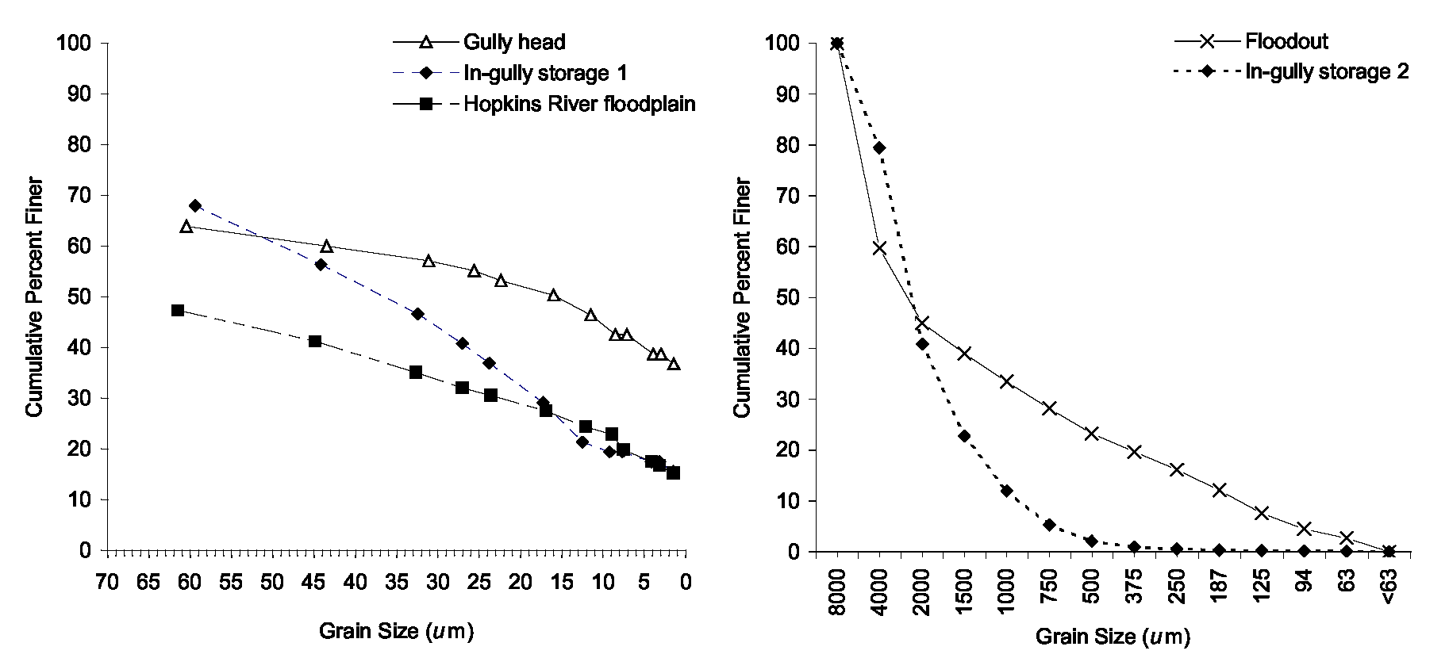
Figure 52: Grain size distributions of the sediments in Ararat Hills.
Challicum Hills
The results of field investigation showed that sediments eroded from the steep slopes of Challicum Hills are stored in floodouts. The material eroded from these gullies is comprised of a very high silt/clay component (78%, Table 25). There is no significant difference between the grain size characteristics of sediments eroded from the bank of Jacksons and Captains Creek (Table 25 and

Ararat geomorphic study final report

Figure 53). The results of the sediment budget for this unit showed that 73% of the sediments sourced from in-channel sources have been input to the Hopkins River (Figure 27). However, no PSA was documented on the Hopkins River downstream from Jacksons Creek. This was attributed to the greater confinement of the channel and floodplain of the Hopkins River downstream from Jacksons Creek and its effect on increasing the conveyance capacity of the channel (see Section 7.3).
SINCLAIR KNIGHT MERZ
I:\wcms\Wc02550\REP03_06.23\Final Report\R02 PJS Ararat Final Report.doc PAGE 85
Table 25: Textural analysis of sediments in Challicum Hills unit.
Feature % Sand % Silt % Clay Texture class
Gully head | 22 | 42 | 36 | Clay loam
Jacksons Creek bank | 27 | 47 | 26 | Loam
Captains Creek bank | 20 | 52 | 28 | Silty clay loam
Hopkins River bed | 69 | 10 | 21 | Sandy loam
Hopkins River floodplain | 36 | 26 | 38 | Clay loam

A coarsening of overall grain size may be anticipated where the river demonstrates a greater capacity to transport its sediment load. The sediments sampled from the bed and floodplain of the Hopkins River have a notably higher percentage of sand than those sampled from the bank of Jacksons Creek and Captains Creek (Table 25). The results of particle size analysis concur with the results of our field investigations and constructed sediment budgets.
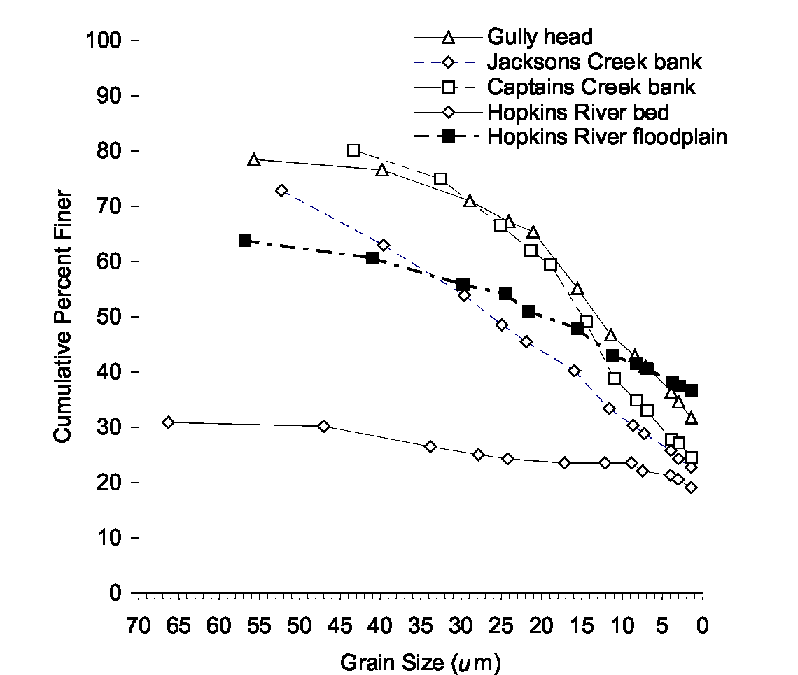
Figure 53: Grain size distributions of the sediments in Ararat Hills.
Skeleton Hills
The results of our field investigations and constructed sediment budgets reveal that the majority of sediments that have been eroded from first, second and third order streams are stored in the floodout (Figure 41). Comparison of particle size analysis for sediments sampled from the gully head and the floodout shows a close match in the grain-size characteristics (Table 26 and Figure 54). There is a notable decrease in the percent clay for the floodout sediments, which suggests that a proportion of the clay fraction is transported further downstream.

Ararat geomorphic study final report

Table 26: Textural analysis of sediments in Skeleton Hills unit.
SINCLAIR KNIGHT MERZ
I:\wcms\Wc02550\REP03_06.23\Final Report\R02 PJS Ararat Final Report.doc PAGE 86
Feature % Sand % Silt % Clay Texture class
Gully head | 24 | 44 | 32 | Clay loam
Floodout | 26 | 58 | 16 | Silt loam
Gully sidewall | 35 | 37 | 28 | Clay loam
In-gully storage | 66 | 24 | 10 | Loamy sand
Hopkins River bench | 64 | 23 | 13 | Sandy loam

Further downstream from these floodouts, the material eroded from the gully sidewalls has a slightly higher sand fraction and lower silt/clay component, than that sampled from the gully head and floodout (Table 26). As with the Ararat Hills area, analysis of the sediments that are deposited as in-gully and in-channel storages in association with Spiny Rush, shows that these plants are effective in trapping both the sand and silt/clay component of the sediment load.
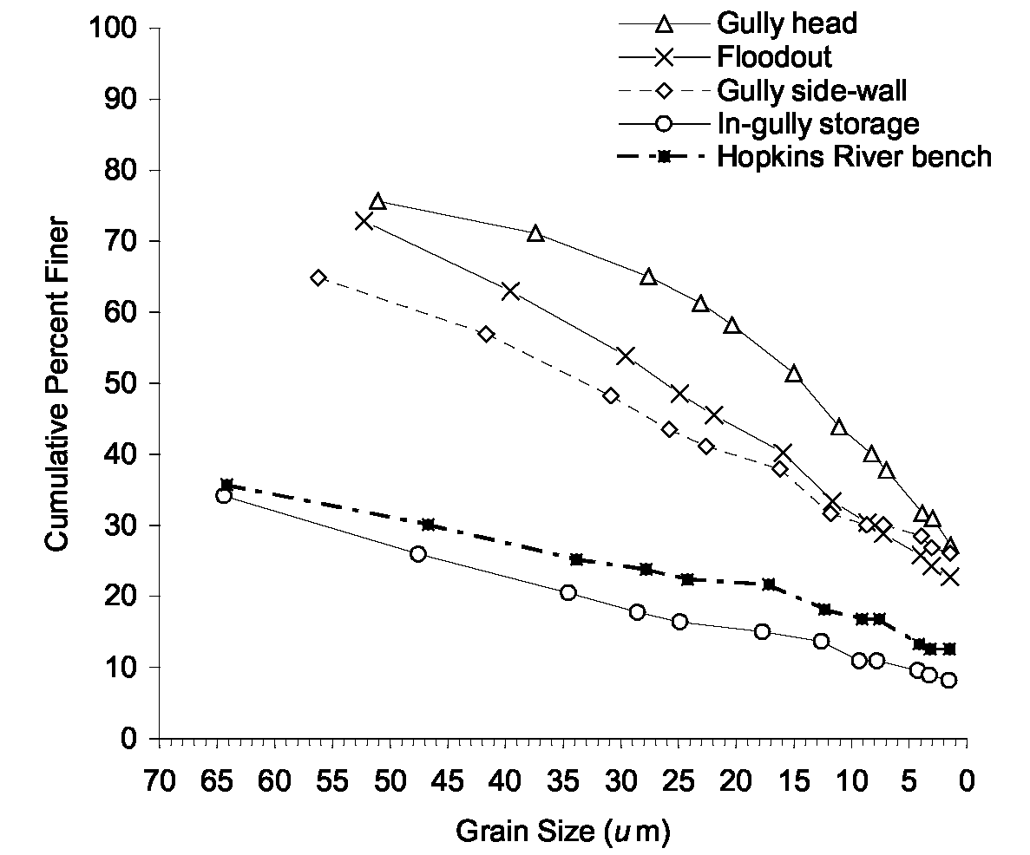
Figure 54: Grain size distributions of the sediments in Ararat Hills.
Summary
The results of particle size analysis of the sediment sources and storages are in general agreement with the findings from our detailed field investigations and sediment budgets. As sediments are eroded from their source, there is a greater probability that the coarser gravel/sand fraction will be deposited in floodouts and in-gully storages. Comparison of the grain size characteristics for the sediments sampled from the gully head, floodout and in-gully storages in the Ararat Hills gully network show that a larger proportion of the gravel/sand fraction is deposited and stored in floodouts and in-gully storages. The coarser grain size distribution of the channel and floodplain sediments downstream from Hopkins River is anticipated, given the increased capacity of the river in this section to convey it sediment load downstream.

