FERGUSONS HILL LAND SYSTEM
Gently dissected hills and ridges developed on outcrops of mainly finer sediments of Paleocene Age have been grouped into the Fergusons Hill land system. The soil and vegetative association have much in common with the Mt. Mackenzie land system but the topography is more subdued, and as a result management of this area presents fewer problems.
The land system is comprised of two major areas – those at Fergusons Hill and along the ridge of Pipeline Road, and several other small areas on ridges through the study area. The geomorphic history of these areas is generally similar in that they are areas of Paleocene marine sands, clays and silts of the Wangerrip Group that have escaped the deep dissection of the Mt. Mackenzie land system. The geological beds are somewhat variable and the coarseness of the material outcropping at the surface is a strong determinant of the soil that has formed on each part of the landscape. The geology has been complicated by various subsequent marine transgressions leaving variable beds of sand and clay in adjacent land systems and also occur occasionally as remnants in this land system. The absence of fossils makes interpretation of exact geological ages somewhat tentative but it is probable that some of the sands of component 3 and the clays of component 1 belong to more recent marine transgressions than the bulk of the material in the land system.
While having landscape and general land capability features in common, the separate mapped areas of the land system do exhibit different combinations and extent of the separate components. At Fergusons Hill itself component 6 dominates the landscape with components 2 and 3 being common and component 1 occupying most of the land around the periphery of the hill. Component 6 soils are members of the group of relict soils belonging to former humid and possibly warmer climates discussed elsewhere. The appearance and properties are similar to the dominant soils of the nearby Simpson land system, but only rarely are they underlain by lateritic ironstone. Thus it appears probable that at one stage these fine structured red and yellow mottled soils covered most of this landscape (except the areas where parent material is mainly sand) and subsequent geological erosion has only left remnants on the gentler parts of the landscape. The indigenous vegetation on these soils is an open forest of messmate and brown stringybark with widespread hybridisation between these two species. Bushy needlewood seems to be a strong indicator species of these soils in the understorey. Similar fertility problems are encountered here as are found in the nearby Simpson land system.
On steeper slopes coming away from these areas of component 6, younger and sandier yellow gradational soils are encountered. These are equivalent to the dominant soils of the Mt. Mackenzie land system but are found on less severe slopes in this land system. Due to the weak structure and light texture they are prone to deterioration by sheet and rill erosion and require more careful management than the previous soils. The vegetation is similar to that found in the often adjacent component 6 but brown stringybark becomes more dominant and there is frequent encroachment of peppermint species into the association.
BLOCK DIAGRAM AND DRAINAGE PATTERN FOR THE FERGUSON HILL LAND SYSTEM
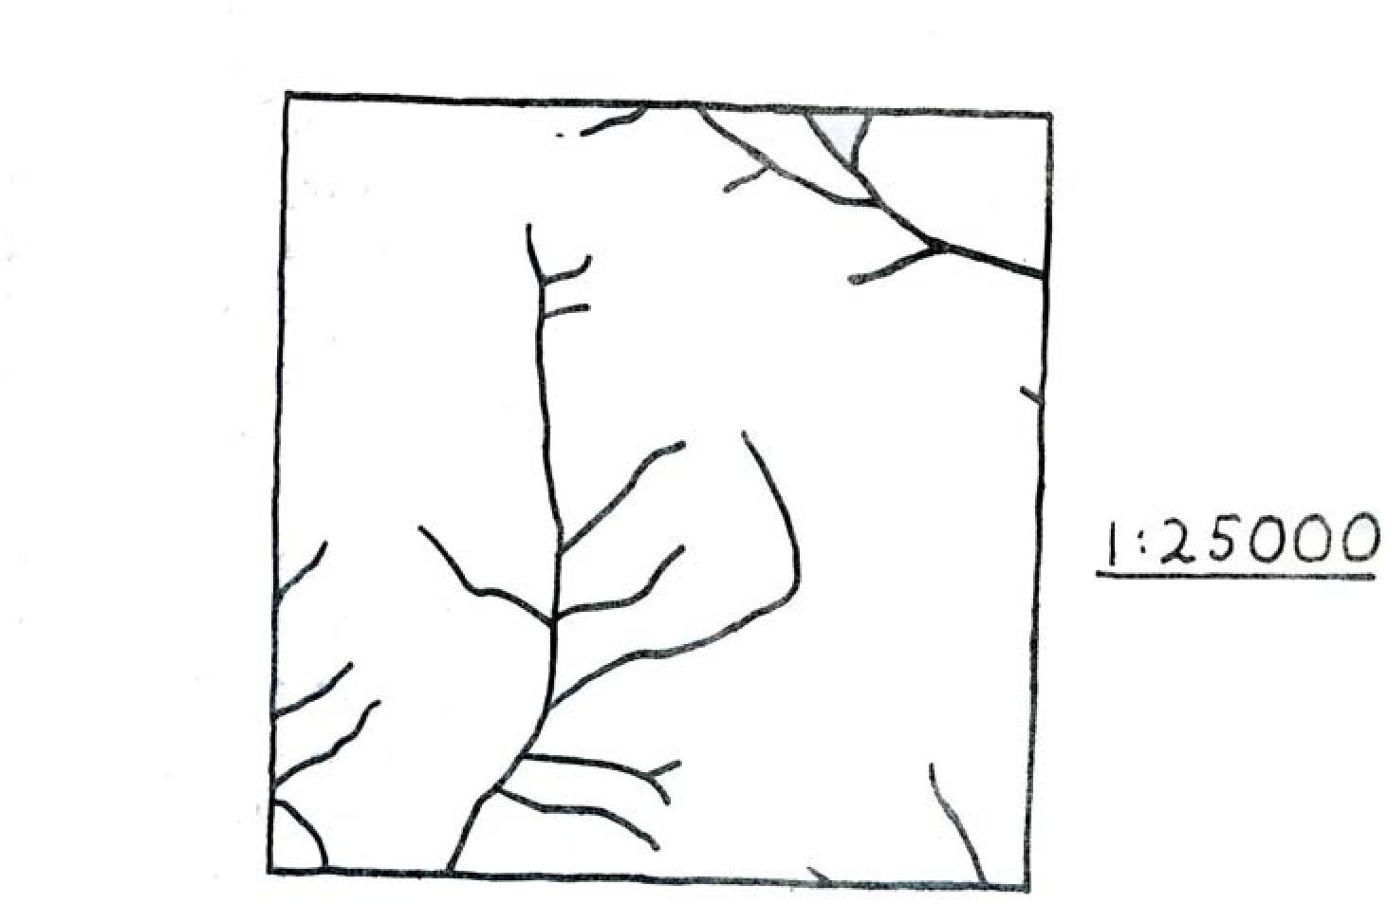
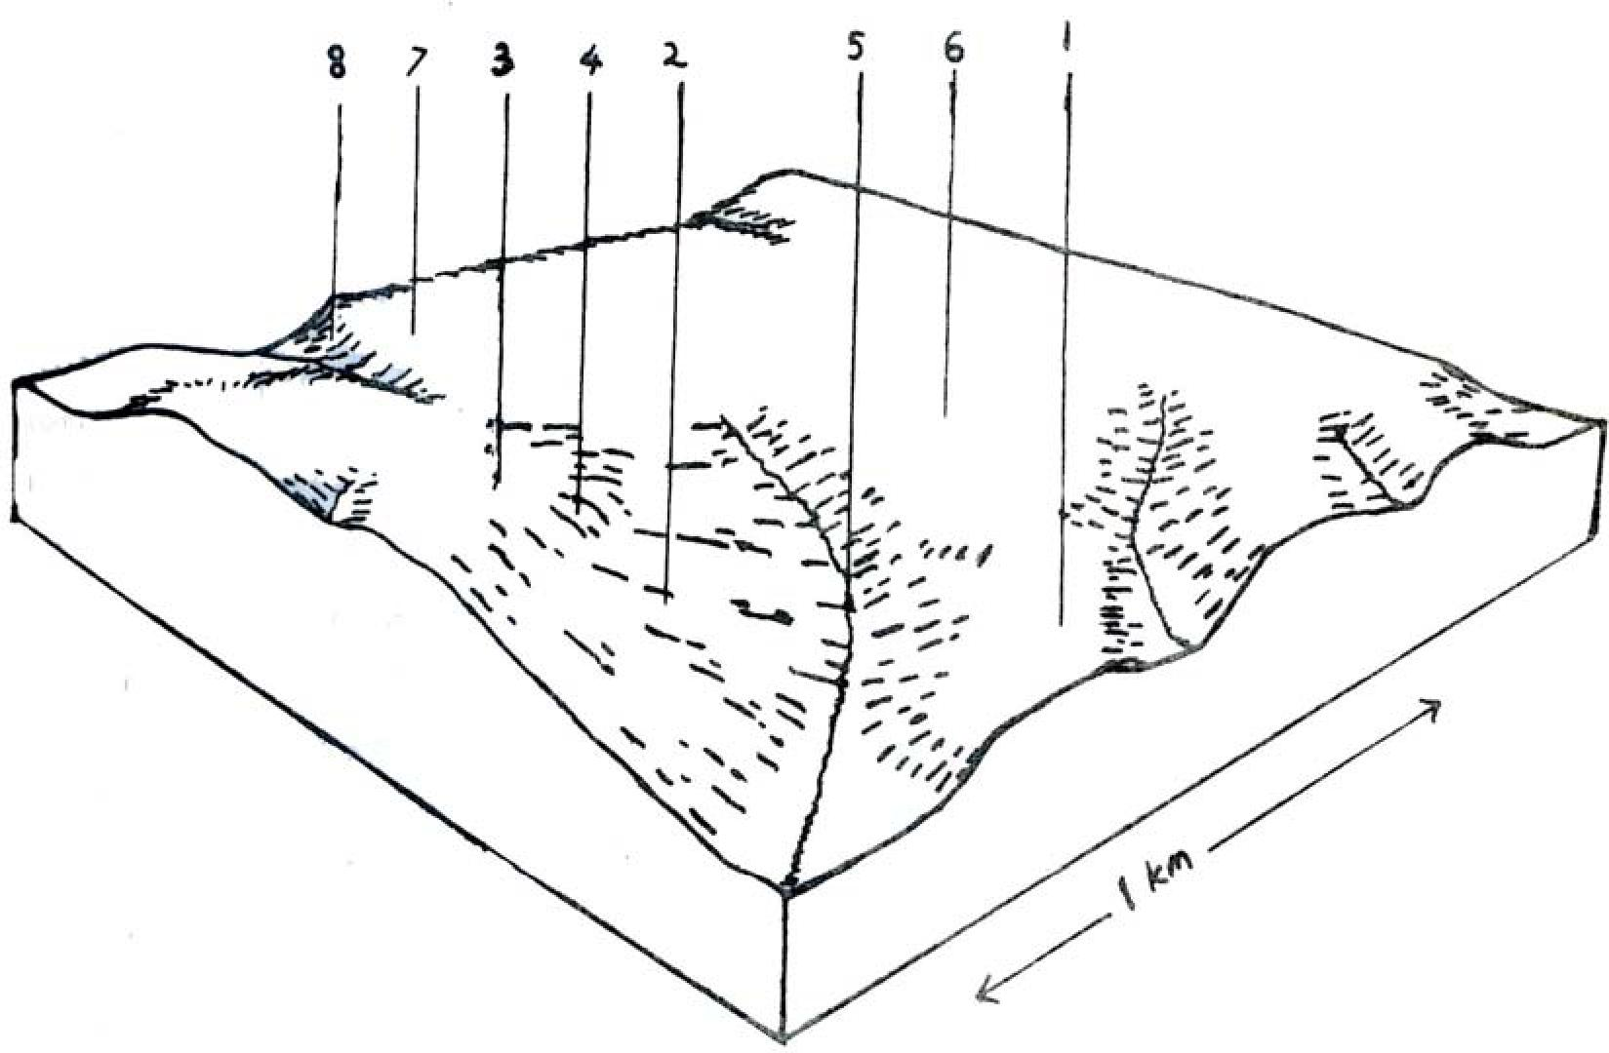

Ferguson’s Hill Land System AREA: 52 Km2
Component |  | 1 | 2 | 3 | 4 |  | 5 | 6 |  | 7 | 8
Proportion % |  | 15 | 20 | 25 | 4 |  | 8 | 15 |  | 10 | 2
Climate | Rainfall mm  Temperature ^{oC}  Seasonal Growth Factors | Annual: 1000 – 1100 mm  Monthly Range: 40 mm (Jan) – 130 mm (Aug)  Annual: 13.0  Monthly Range: 7.5º July – 19º Feb  Period When Average Monthly Temperature < 10ºC June → August  Period When Precipitation < Potential Evapotranspiration: mid November → March
Geology | Age Lithology | Marine sand, clays & silts of Paleocene age. Some small areas of Pleistocene lateritic ironstone.
Topography | Landscape | Undulating hills & ridges
Topography | Elevation M | 30 – 230
Topography | Local Relief M | 40
Topography | Drainage Pattern | Dendritic
Topography | Drainage Density | 2.4 km/km²
Topography | Landform | Undulating hills |  |  |  |  |  |  |  |  | Scarps
Topography | Position | Lower slope | Slopes | Crests | Midslopes |  | Swales | Crest upper slope |  | Crests
Topography | Average Slope (Range) | 4% (1% - 7%) | 14%(5%-37%) | 5% (2% - 9%) | 11% |  | 4% (2%-9%) | 4% (0% - 11%) |  | 4% ( 0% - 7%) | 29% (25- 37%)
Topography | Slope Shape | Straight | Straight | Convex | Straight |  | Concave | Convex |  | Straight | Concave
Native Vegetation | Structure Dominant Stratum | Open forest | Open forest | Low woodland | Open forest |  | Open fore. | Open forest |  | Tall woodland | Open forest
Native Vegetation | Species | Messmate, Swamp Gum | Brown Strin- Gybark Shin-Ing Peppermi-Nt Messmate | Shining Peppermint, Brown Stringybark | Stringybark Narrow Leav-Ed Peppermint Grey Gum Messmate |  | Messmate, Brown Stringy- Bark | Brown Stringybark, Messmate |  | Brown Stringy-  Bark Messmate | Messmate, Stringybark Swamp Gum Blackwood
Native Vegetation | Other Common Species | Red Fruit Saw  Sedge, Prickly Tea Tree, Prickly Moses |  | Scented Paperbark Wiry Bauera Pouched Coral Fern Prickly Tea Tree S Aw Sedge, Heath Bush Pea Blackboy | Narrow Leaved  Wattle, Prickly  Moses, Prickly Tea Tree |  |  | Myrtle Wattle, Banksia, Bushy Needlewood, Prickly Moses, Furze Hakea, Mountain Correa, Tea Tree |  | Myrtle Wattle, Silver Banksia, Dusty Miller Bushy  Needlewood | Prickly Moses, Dogwood, Narrow Leaved Wattle, Blanket Leaf
Soil | Parent Material | Unconsolidated clays & silts | Unconsolidated clays silts & sands | Unconsolidated sand | Unconsolidated sand silt & clay |  | Alluvial sand silt & clay | Unconsolidated clay & soil |  | Unconsolidated clay & silt | Colluvial lateritic ironstone
Soil | Group | Greyish brown grad. Soils | Yellow grad. soils, weak structure | Grey sand soil with hardpan uniform text. | Red sandy loam soils uniform text. |  | Grey  gradational soils | Mottled yellow red grad. Soil fine structure |  | Red grad. soil weak structure | Stony red gradational soils
Soil | Surface Texture | Fine sandy loam | Sandy loam | Loamy sand | Sandy loam |  | Peaty sandy loam | Sandy loam |  | Sandy loam | Gravelly loamy sand
Soil | Permeability | Moderate | Rapid | Very slow | Rapid |  | Slow | Moderate |  | Rapid | Rapid
Soil | Av. Depth M | > 2 | > 2 | > 2 | > 2 |  | > 2 | > 2 |  | 0.9 | > 2
Soil | Northcote Class |  | Gn 4.64 | Uc 3.32 | Uc 5.21 |  |  | Gn 3.84 |  | Gn 2.11 | Gn 2.41
Land Use |  | Uncleared areas: hardwood forestry production, domestic water supply protection, nature conservation, gravel extraction. Cleared areas: beef cattle grazing, dairy farming, domestic water supply protection
Hazards Of Soil Deterioration |  | Low hazard of  erosion | Moderate hazard of sheet erosion |  |  | Low haz. gully erosion soil pugging |  |  | Low hazard of erosion |  | Mod. Hazard of  erosion
Management Practices For Soil Conservation |  | Maintenance of adequate ground cover at all times of the year. Wintering of stock away from badly drained areas when waterlogged. Replacement of surface soil over disused extraction sites & revegetation with indigenous vegetation.

Where the exposed beds contain almost exclusively sand, grey sand soils with a hardpan develop. This hardpan is normally encountered at about 0.9 metres from the surface and is usually between 0.2 metres and 1.5 metres thick. It is also variable in the degree of limitation it imposes on water and root movement into the yellow sand layer below but generally larger roots do seem to penetrate this layer quite well. These soils are generally encountered on ridges and crests in the landscape so that they are mostly well drained by water moving sideways through the bleached horizon above the somewhat impermeable hardpan. Low woodlands of peppermints and brown stringybark have usually developed on these sites despite the extremely low fertility and often excessive drainage. The ridge coming away from Fergusons Hill usually possess these soils and the accompanying vegetative associations but the sand on these sites probably originates from a later deposition than that comprising the bulk of the sediments of Fergusons Hill. The position of some of these deposits seems to suggest that they may be remnants of old beach dunes left behind as the final transgression of the Tertiary sea receded in successive stages (somewhat comparable to the recession ridges in Western Victoria and South Australia). This successive retreat of the Tertiary Sea may have been responsible for determining the NW / SE orientation of drainage line across this coastal plain – the drainage lines developing from the estuarine swamps frequently formed behind coastal dune systems.
On some of the easterly orientated ridges emanating from Fergusons Hill, uniform red sandy soils are often encountered just below the crests of the ridges. These occurrences are minor and the soils have not been studied in detail. However they support open forests of brown stringybark and other species and are probably similar in nutrient status and water holding capacity to the yellow gradational soils, weak structure. Their occurrence probably coincides with a change in the nature of the geological beds.
Around the apron of Fergusons Hill are found heavier textured soils with gradational profiles, yellow, pale red and grey mottles, medium to fine structure, a high porosity in the subsoil and an acid reaction throughout. These soils also are not widespread and this is the only part of the survey area they have been observed. It is possible that they belong to another ancient climatic regime as with the mottled yellow, red gradational soils, fine structure, which occurred somewhere between this latter regime and present time, but their equivalents to other less complicated land systems in the study area have not been correlated. Thus they have been listed as a separate soil group until more detailed surveys may correlate this group with others in nearby land systems. Drainage is moderately good and originally open forests dominated by messmate used to grow on these soils. Saw sedges in the understorey are an indication of their good water holding capacity.
In the drainage lines and on the outwash slopes of Fergusons Hill are found grey gradational soils. These young soils have moderately light textures grading from a sandy loam at the surface to a sandy clay loam at about 1 metre. Vegetation is variable depending on site drainage but generally open forests or messmate and brown stringybark persist on most sites. Soil structure is generally weak, organic matter is abundant in the surface horizons and the soil reaction is acid. The subsoils are generally quite stable so deterioration is uncommon.
Successive geological erosional periods have led to removal of large quantities of poorly structured sand material from Fergusons Hill and deposition of it in neighbouring landscapes over the top of heavier clay soils. If time has permitted sufficient weathering and leaching, hardpan layers have formed between the two different materials as described elsewhere and these soils have impeded drainage with closed scrub vegetation. Thus Fergusons Hill has also played an important part in determining the soils and vegetative association of neighbouring land systems.
The large area along Pipeline Road differs in a number of respects from Fergusons Hill. Lateritisation has taken place across this landscape and several remnants of the surface still exist. In some cases these are overlain by mottled yellow, red gradational soils, fine structured as in the Simpson land system and the adjacent Tomahawk Creek land system but generally weaker structured red gradational soil is found with lateritic ironstone forming an almost penetrable layer at about 1.5 metres below the surface. Water and roots penetrate this ironstone layer only down fissures and other irregularities, and cannot form their own paths through it as with the hardpans discussed above. These soils support quite good stands of native hardwoods which approach 30 metres height. Thus fertility levels must be moderate and drainage good.
In the north eastern part of this ridge, sandy yellow gradational soils are encountered on gentle slopes while elsewhere component 3 is encountered. There are some areas here where these sands possess very thin layers of coffee rock so that the soils are excessively drained. As such, grasstree, prickly tea tree and shining peppermint form the association with a low open woodland or open scrub structure, and these areas have a very low productivity for any form of land use other than nature conservation. Also in some areas the sediments include very coarse sands and gravel and extraction pits in very slow unless the organic surface horizons are replaced over stripped areas to provide a medium for germination. Generally these soils are highly acid, excessively drained, low is almost all plant nutrients, and easily subject to sheet and rill erosion.
On the southern side of this ridge, steep slopes lead away to the Gellibrand River some hundred metres below. Where this has exposed any lateritic ironstone remnants at the top of the hill, red gravelly gradational soils have developed and these areas have been included in this land system as component 8. These soils are equivalent to the red gravelly gradational soils of the Tomahawk Creek land system and similarly possess open forests of messmate, brown stringybark and swamp gum. They have in some areas been developed for gravel extraction and these sites also present some problems for revegetation after the sites are abandoned – topsoil layers are very thin and difficult to replace while subsoil layers provide a poor medium for germination.
Restrictions to plant growth occur during the winter months due to low temperature. Restrictions due to moisture stress vary with the widely varying moisture holding capacities of the different soils. For example the sands of component 3 would have practically no moisture holding capacity except for that water held up above the hardpan layer following rain. Thus growing seasons on these sands are likely to end fairly shortly after mid November when precipitation falls below estimated potential evapotranspiration. On the more porous and heavily textured soils of component 1, however, carryover of soil moisture is likely to extend the growing season to early January.
Some of the areas in this land system have been cleared for agriculture, but generally they are not as suitable as surrounding areas of land for more intensive uses such as dairy farming. As such most of the cleared land is used for grazing of beef cattle and it is likely that the more fertile components of the ridge along Pipeline Road will be converted into pine plantations or maintained for hardwood forestry in the future. As this ridge is within a domestic water supply catchment this is probably a more desirable form of land use than agriculture.
In summary this land is not as potentially useful for highly productive enterprises as neighbouring land systems. The economics of supplying large quantities of fertilisers to soils with low water holding capacities make them less appealing than other areas for agricultural development. The variation in site potential over short distances makes it awkward to manage the areas for forestry production.

