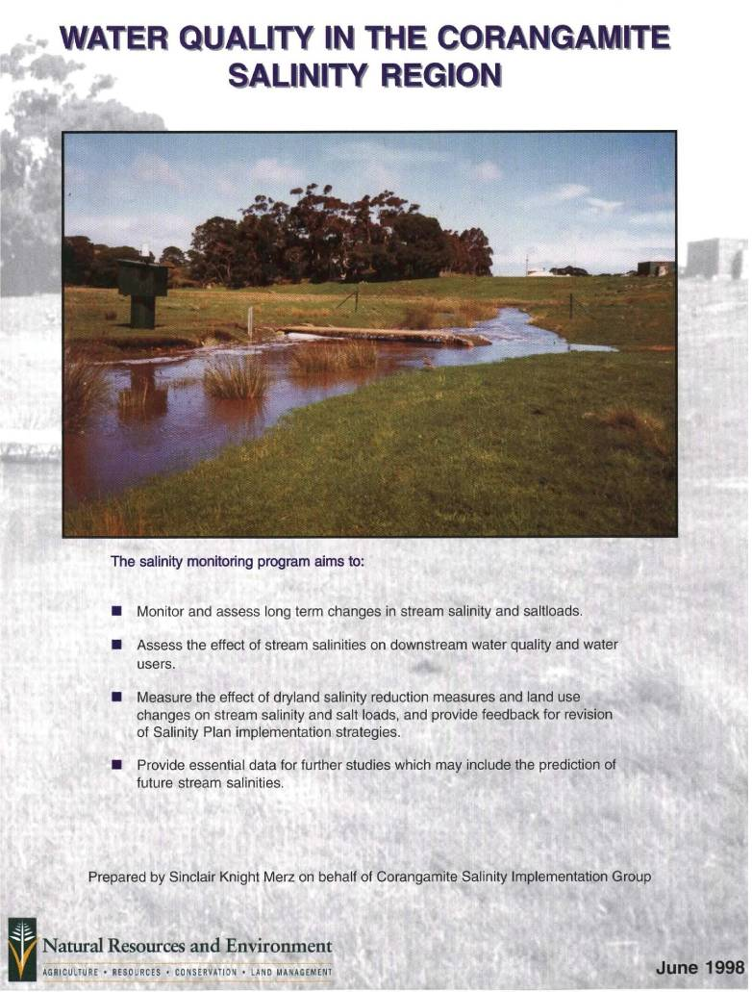
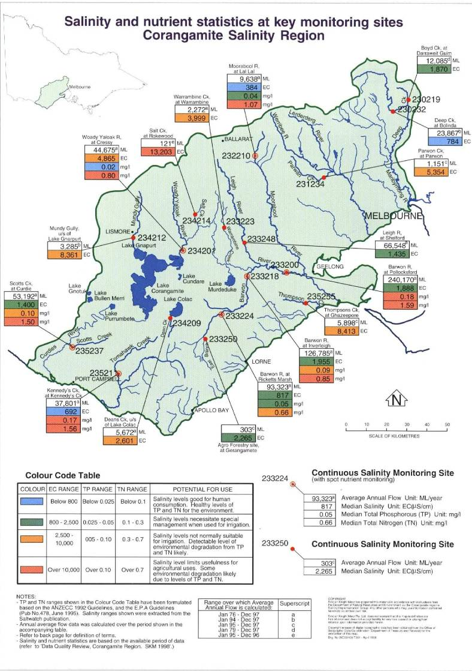
Continuous monitoring of salinity at the sites shown on the map produces important information about salinity in the Corangamite region, particularly concerning catchment processes and trends in salinity, while also providing data for studies into the effectiveness of catchment management activities (eg. impact of changing land use on the water quality of rivers).
The graph below presents key statistics from data recorded at eight of the seventeen continuous salinity monitoring sites in the Corangamite salinity region. The median value is defined as the `middle' value of all the measurements recorded. Streams in south west Victoria are generally characterised by long periods of low flow punctuated by relatively brief high flow events. Given this flow pattern, median salinities generally reflect the salinity of water during low flow periods.
Median Stream Salinity in the Corangamite Region
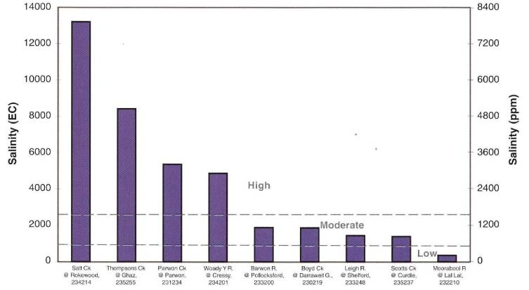
Stream salinity in the region varies from being quite low on the Moorabool River at Lal Lal (median of 364 EC), to being very high on the Salt Creek at Rokewood (median of 13,203 EC).
Ranges of Salinity, Total Phosphorous and Total Nitrogen shown in the colour code table opposite have been broken into four components, from blue (good), to red (bad). The ranges for salinity were determined by their potential for use (eg. drinking, irrigation), whereas the ranges for Total Phosphorous and Total Nitrogen were primarily determined by their effects on the environment. Humans and animals have the ability to consume much higher levels of Total Phosphorous and Total Nitrogen than can be tolerated by the aquatic environment.
Serious algal blooms have occurred across the Corangamite region, caused by the high levels of nutrients present in the surface water. The levels of nutrients present in the surface water reflect the surrounding land use, and provide an indication of the general health of the catchment. The nutrient concentrations presented on the map show that the Total Nitrogen level is over 0.7 milligrams per litre (the 'worst condition' category) at all but one of the seven spot nutrient monitoring sites presented. Total Phosphorous medians range from 0.02 milligrams per litre to 0.18 milligrams per litre, with only two of the seven spot nutrient monitoring sites having a level in the 'worst condition' category. There are many more sites in the Corangamite region where spot nutrient monitoring is performed.


