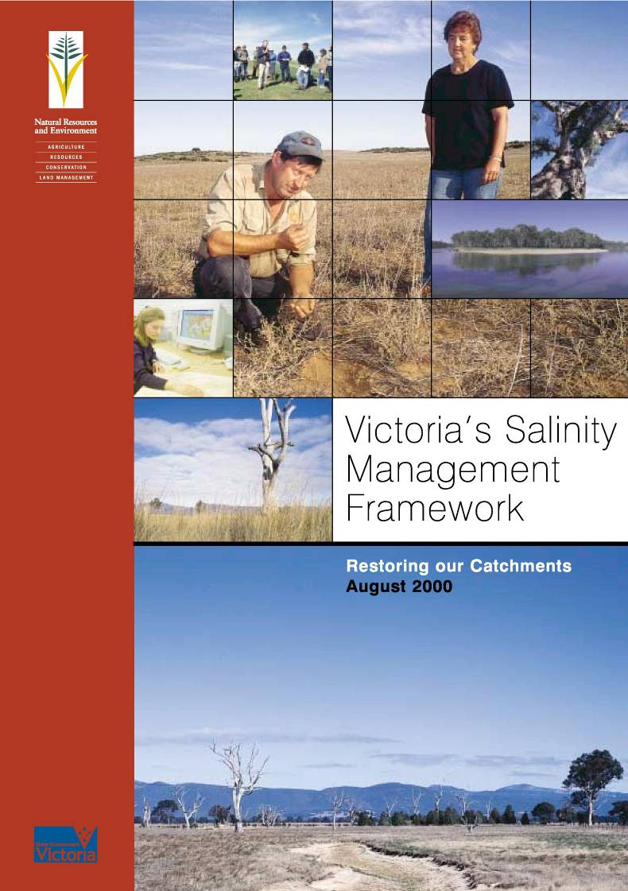
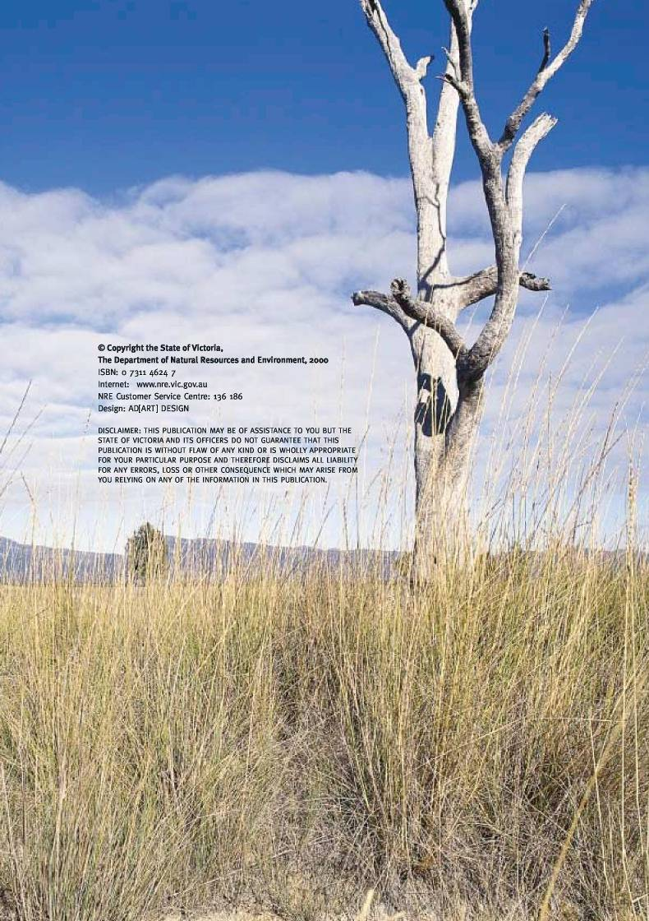
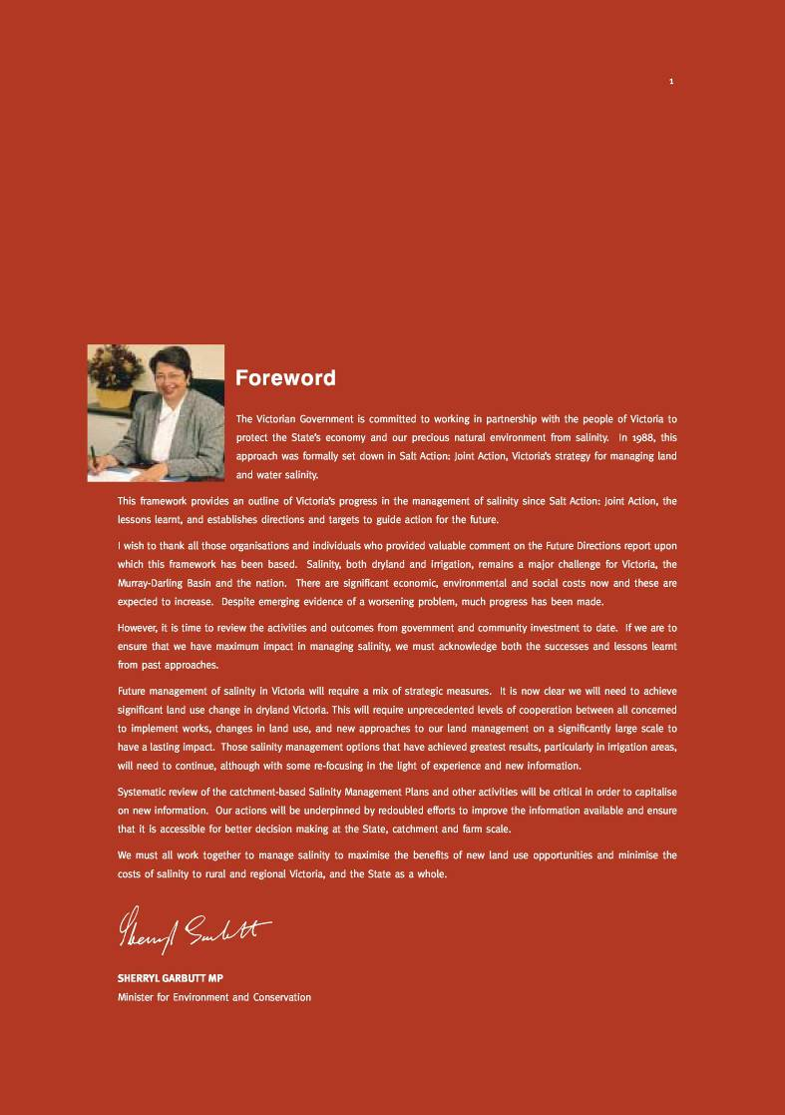
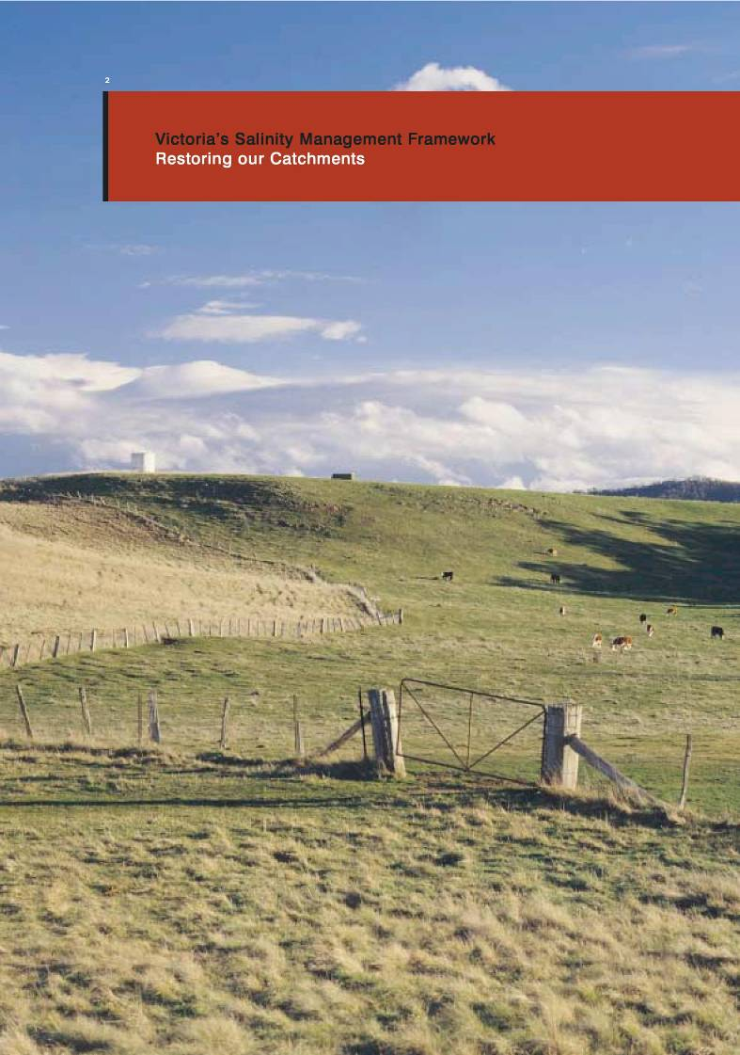

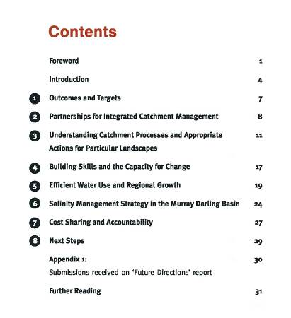

Introduction
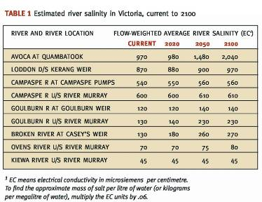
For nearly a decade and a half, the Victorian Government has worked with the community to address salinity. Since the establishment of Salt Action: Joint Action in 1988, communities in salt-affected areas have worked with Government to develop and implement regional Salinity Management Plans. Twenty-one such plans are already in place. Each of these plans aims to
identify and promote sustainable land uses, and each strives to protect environmental values and where possible rehabilitate degraded environments. They also seek to find equitable solutions for all individuals and communities affected by salt, and aim to minimise social hardship while long-term sustainable solutions are being established.
In world terms, Victoria has a unique blend of economic, environmental and social strengths. Our community-driven, wholeof-catchment approach to salinity management has harnessed those strengths and given us a powerful means of dealing with natural resource management issues at a catchment scale. Indeed, the World Bank has recognised Victoria’s approach to water resource management and integrated catchment management as world’s best practice.
The original objectives of Salt Action: Joint Action focussed on the long term commitment required by Government and the community to implementation of integrated land and water management plans over 30 years. Despite progress in implementing these plans, salinity remains a substantial and growing issue. The direct cost of salinity in Victoria is estimated to be $50 million per year, with some 140,000 hectares of irrigated land and 120,000 hectares of dryland significantly affected.
At the time of the original development of Salt Action: Joint Action, dryland salinity was perceived to be an emerging problem. We now have much better information about the extent and severity of dryland salinity. It is now apparent that groundwater levels are rising over large areas of dryland Victoria, and by 2050 a ten-fold increase in the area affected by salt is projected. Maps 1, 2, 3 and 4 illustrate the magnitude of the projected problem for Victoria.
One consequence of the increase in dryland salinity is the rise in river salinity in many of Victoria’s catchments. Estimated increases in river salinity from the present time to 2100 are provided in Table 1. An aid to interpreting salinity levels in rivers is provided in Table 2.
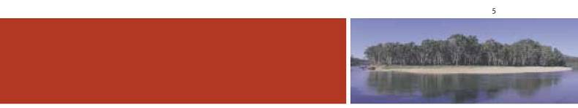
Dryland salinity results in damage to agricultural land, downstream water users, aquatic ecosystems and biodiversity, and to regional and urban infrastructure such as deterioration of road and building foundations from shallow, saline groundwater.
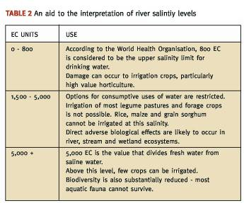
Recent groundwater and catchment modelling
and research indicate that many ‘best practice’
agricultural systems in the grazing and cropping
industries cannot reduce the amount of water leaking into the groundwater system in comparison to native vegetation.
Indeed, large-scale revegetation may represent the only prospect of halting or reversing water table rises in higher rainfall regions.
These findings highlight the need for substantial land use change. This view is confirmed by recent work at the national level, including the Prime Minister’s Science, Engineering and Innovation Council; the discussion paper for natural resource management “Managing Natural Resources in Rural Australia for a Sustainable Future”; the National Land and Water Resources Audit; Stage 2 of the National Dryland Salinity Program; and the Murray Darling Basin Commission Salinity Audit and Draft Salinity Strategy.
The community’s willingness to meet the challenge of fighting salinity in partnership with Government has been impressive. The community has more than matched Government’s investment in this fight and has readily accepted responsibility for implementing salinity plans.
There is still much to do to achieve sustainable irrigation management through:
- Improving water use efficiency
- Adopting best management practices
- Providing appropriate drainage infrastructure
- Matching irrigation practice to land capability.
Equally, we must also redouble our efforts to manage dryland salinity. But in doing so, we must not lose sight of the major opportunities and benefits that our continued fight against salinity can deliver in the long-term.
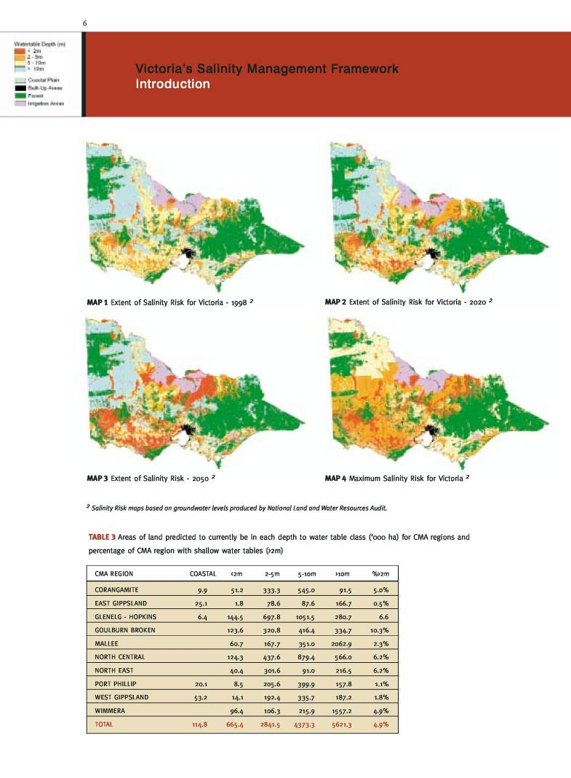

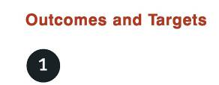
There are no quick fixes for the salinity problems we face in Victoria and Australia. Progress is hard won and depends on concerted effort and investment over the long term. To guide these efforts it is important to focus on realistic outcomes and set medium term targets to measure performance in working towards these outcomes.
The following outcomes and targets are ambitious but achievable in light of our current level of understanding.
Outcome
Communities have improved their prosperity and quality of life through strategies which maximise opportunities for ecologically sustainable land uses and which minimise the social, economic and environmental impacts of salinity.
Targets
In working towards this outcome, the following targets are proposed to measure progress:
- By 2005, there will be representative coverage of monitoring, sufficient to account for the impacts of groundwater rise and river salinity.
- By 2005 critical recharge zones within catchments will be identified with 50% of these critical areas revegetated by 2015.
- By 2005 a quarter of agricultural production will be produced from natural resources that are managed within their capacity. By 2015 this will increase to half of all agricultural production.
- By 2015 there will be a real reduction in the environmental and economic impacts of salinity.
- By 2015 Victoria will have investigated and, where practical, substantially reduced the impact of rising groundwater on the riverine environment and key wetlands.
- By 2015, Victoria will have participated in joint Murray Darling Basin salt interception schemes to earn sufficient salt
credits to provide for future drainage, new irrigation development and to protect important environmental values.
Victoria’s challenge is to build on the achievements and lessons learnt to date through the following strategies:
- Partnerships for integrated catchment management;
- Understanding catchment processes and implementing appropriate management actions for particular landscapes;
- Building skills and the capacity for change;
- Efficient water use and regional growth; and
- Salinity Management in the Murray Darling Basin.
These strategies are spelt out in more detail in the remaining sections of this framework.
While salinity represents one of the greatest natural resource management challenges in Victoria, it is not the only challenge. Moreover, many of the management options for salinity have a direct bearing on other land, water and vegetation outcomes. Accordingly, our efforts in tackling salinity need to be pursued in a framework of integrated catchment management to ensure we can simultaneously generate other environmental and economic benefits.
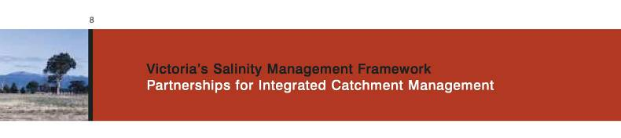

As part of Salt Action: Joint Action, community groups took the lead in preparing each of the 21 Salinity Management Plans. Once plans were completed, community-based Salinity Management Plan Implementation Groups were established to oversee implementation of the Government supported plans.
To successfully tackle salinity we require an understanding of surface and groundwater processes and management intervention at a catchment scale. In Victoria, communities soon recognised that it was not possible to separate salinity management from other natural resource management issues. For example, salinity and nutrients are strongly linked in irrigation areas. We need to address both issues together. Similarly, revegetation strategies for salinity control have an important part to play in managing other land and water degradation problems. Regional Catchment Strategies provide the mechanism to integrate natural resource management activities to deliver these multiple benefits.
In July _{1997,} nine Catchment Management Authorities (CMAs) covering the non-metropolitan regions of the State were established. The CMAs effectively brought together the roles of a large number of single-issue advisory groups (like Salinity Management Plan Implementation Groups and waterway management groups) through the preparation of Regional Catchment Strategies.
The partnership and community leadership approach to salinity management has been an outstanding success. It is important to build on this framework. There is now an opportunity to take the next step based on:
- A better understanding of future risks;
- Learning from the successes that have been achieved to date; and
- Maximising broader natural resource outcomes from implementation.
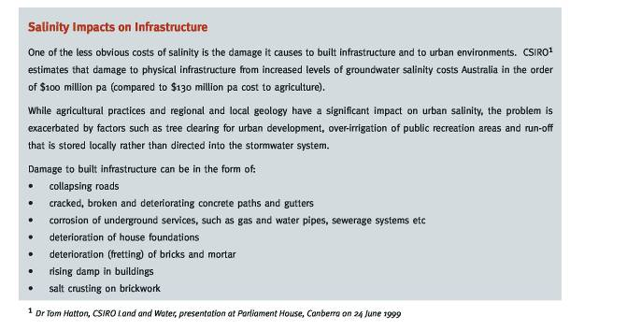
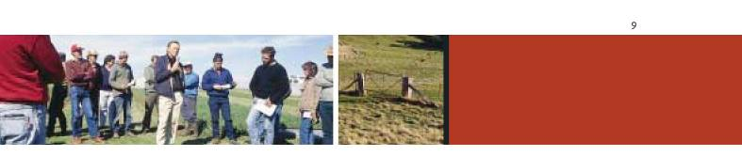
Goals
- To create ecologically sustainable development opportunities for rural and regional communities;
- To strengthen the partnerships between each level of government, CMAs and their Implementation Committees, and the broader community in the fight against salinity; and
- To further encourage industry and landholder involvement in salinity management.
Progress
- Salinity Management Plans having been implemented for about ten years, have been successful in achieving most of the targets set.
- CMAs and their Implementation Committees are continuing to plan and implement broader Regional Catchment Strategies that incorporate Salinity Management Plans.
- A number of partnership programs are in place - for example, Landcare and Natural Heritage Trust projects.
Challenges
- To strengthen integrated catchment management by facilitating the development of detailed action plans consistent with the broad priorities and targets set out in Regional Catchment Strategies.
- To develop greater awareness of, and commitment to, the need to address major land, water and vegetation problems at a landscape scale.
Future Directions
Maintaining and enhancing a partnership approach is critical to ongoing success, as is the need to progressively adjust Regional Catchment Strategies and Salinity Management Plans in view of new information.
- CMAs will work with local communities to review and update Salinity Management Plans by August 2001 with support from Government. The Department of Natural Resources and Environment (NRE) will provide guidelines to assist with the review and preparation of revised plans. It is expected that revised salinity management plans including interim targets will be presented for Government’s consideration by September 2001.
- CMAs will further integrate actions from rural and regional development strategies, vegetation management strategies, greenhouse strategies, Farm$mart and water resources management strategies with Salinity Management Plans through the Regional Catchment Strategies.
- NRE, in conjunction with CMAs, will develop a communication strategy to ensure all parties have up to date information about programs and priorities, and the nature of the salinity threats in their catchments by December 2001.
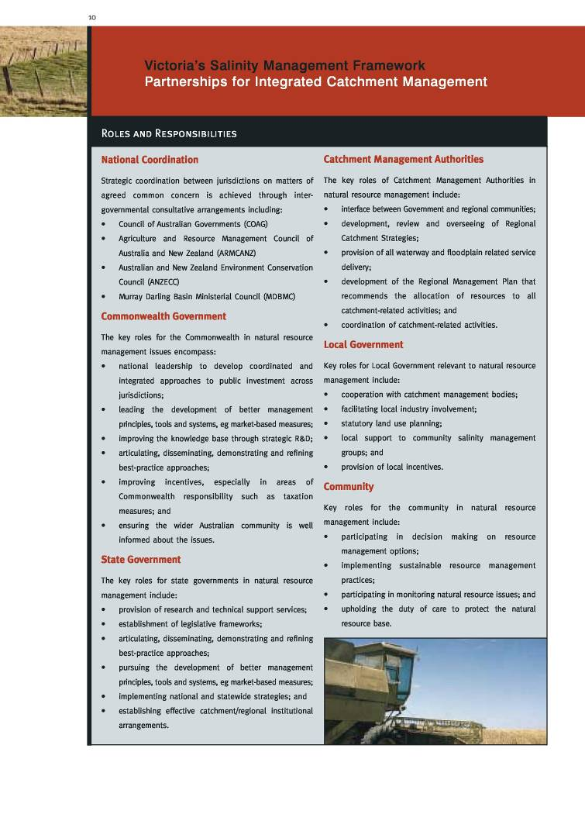

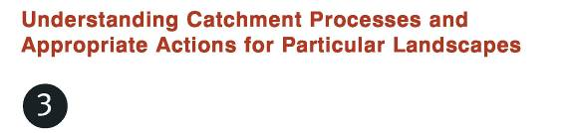
The condition of our catchments underpins the wellbeing of all Victorians. We rely on healthy catchments for
water supply, food, fibre and timber production, the conservation of flora and fauna, tourism and recreation.
Significant wealth is generated from our land and water resources and Victoria’s soil, water, vegetation and
climate provide distinct competitive advantages for a wide range of industries.
In _{1996/97} tourism generated $9.4 billion in Victoria, and provided direct employment to 169,000 people. Studies have shown that over 85% of Japanese visitors and 70% of European and American travellers identify the natural environment as a key element of their travel decisions.
In _{1996/97,} approximately 88,000 Victorians were employed in agriculture and the gross value of the State’s agricultural production was $6.4 billion. This represents about 22% of Australia’s total and, given that Victoria accounts for 3% of the land area, this figure demonstrates the relatively more intensive use of our land and water resources.
Designing Management Responses for Catchments
Effective salinity management requires a fundamental understanding of catchment processes. Salinity management actions must be appropriate for individual catchments. All catchments differ in terms of soil types, rainfall, runoff, recharge rates and the extent of salinisation. Catchments also differ in terms of important environmental features such as wetlands and stands of remnant vegetation and vary according to socio-economic parameters.
Sustainable use and protection of our natural resources requires careful management to maintain the ecological integrity of the resource and to protect Victoria’s reputation as a worthwhile tourist destination and clean, green producer.
Monitoring and assessment programs allow land and catchment managers to see where achievements are being made, and also where further work is required. The monitoring of a range of catchments in Victoria has provided new insights into the effectiveness of dryland salinity control measures.
For example the results of a simulation study of annual leakage amounts under three different farming systems - annual pasture, perennial pasture and trees - at Hamilton in Victoria, indicate that traditional pasture based enterprises may not be sustainable in relatively high rainfall areas (ie >600mm average annual rainfall). The modelling shows (Figure 1) that in this area there is much more leakage to the groundwater under both annual and perennial pasture systems than leakage under the original vegetation.

In these relatively high rainfall areas, carefully targeted private forestry options coupled with properly managed deep-rooted pasture enterprises may be the most effective salinity management regime.
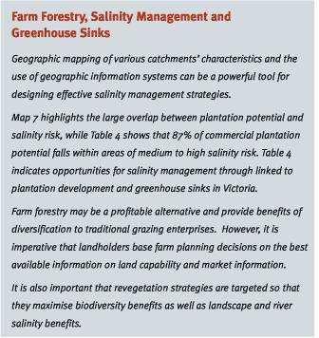
However, in lower rainfall areas, an innovative mix of the following farming practices may be appropriate:
- deep rooted perennial pastures
- commercial farm forestry
- productive use of saline land
- improved cropping practice
- native vegetation management and revegetation
- surface water management
- groundwater pumping
- farm forestry carbon and salinity credits.
An example in irrigation areas of the importance of actions appropriate for different catchments is groundwater pumping. Groundwater pumping may be appropriate where the groundwater is of a standard where it can be safely used for irrigation and disposed of in an ecologically and socially safe manner. In the more salinised irrigation areas where the groundwater is extremely saline, groundwater pumping and disposal would not be appropriate because of adverse downstream impacts.
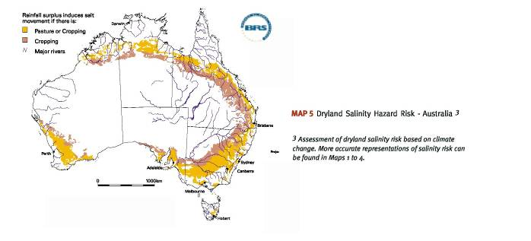

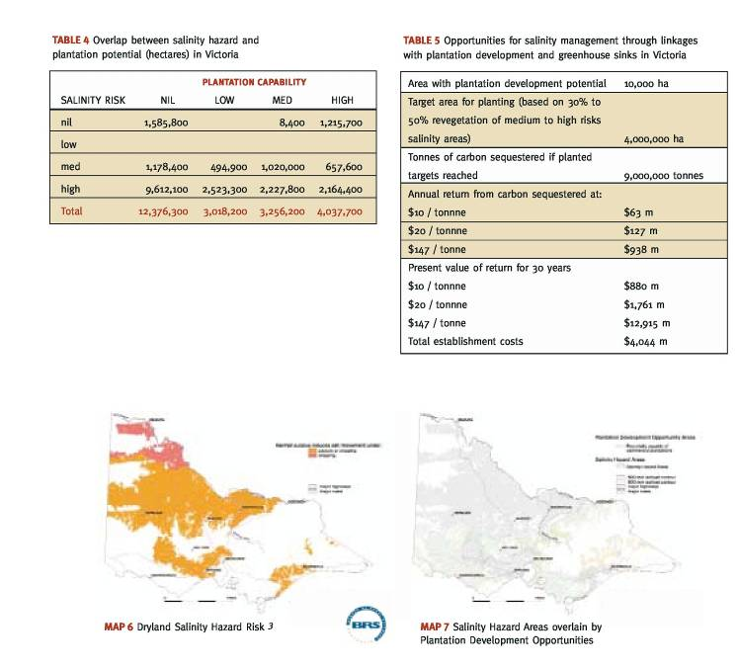
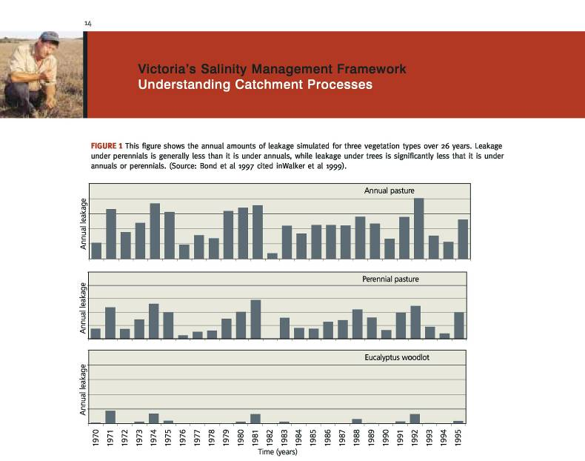
A major challenge in the management of salinity is to target appropriate actions for particular landscapes. A powerful tool for designing strategies to achieve this outcome is the geographic mapping of various catchment characteristics, the use of geographic information systems, and hydrogeological modelling to guide effective land use decisions at a catchment and property level.
Recent developments in airborne geophysics combined with water balance models are providing cost effective tools to predict salinity risks and explore the effectiveness of different land management options.
On the basis of our enhanced understanding of groundwater systems, catchment characteristics and industry development opportunities it is possible to identify a number of different salinity management options. The Prime Minister’s Science, Engineering and Innovation Council (PMSEIC) (1999) have identified the following scenarios for dryland areas.
- Recharge areas causing impacts elsewhere
In some cases salinity management may be achieved by changing farming systems - for example, from wool production to farm forestry in high rainfall areas in Victoria. In other cases salinity management may be achieved by returning the land to native vegetation.
- Hazard land at risk of salinity
On this land it is important to characterise the nature and extent of hazards in each region and identify appropriate responses. Currently we cannot be confident that farming systems such as perennial pasture establishment will achieve bio-physical sustainability in some environments. Combined work to evaluate both the bio-physical and economic impacts of farming systems and revegetation on a landscape scale in different hazard zones is justified.
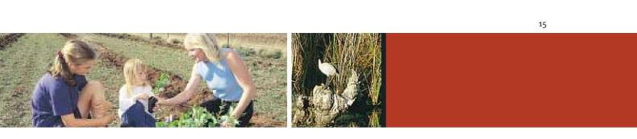
• Degraded land able to be farmed
In these areas the aim is to prevent salinity from becoming worse and to reduce the off-site impacts of farming. This may
require fencing and revegetation with salt tolerant species for opportunistic grazing on limited areas on particular properties.
- Degraded land with limited prospects
In these areas we may need to ensure that measures are taken to facilitate land retirement from agriculture. We also need to ensure that the off-site impacts of these degraded areas are reduced. This normally involves planting with native vegetation, and fencing to protect natural regeneration and ecological succession.
Goals
- To systematically build our knowledge base to enable better decisions for ecologically sustainable development;
- To ensure that strategies and action plans are continually adapted to reflect new knowledge; and
- To match land use with landscape characteristics to maximise ecologically sustainable development opportunities.
Progress
- Over the past 15 years a great deal has been learnt about dryland salinity and its projected extent, mainly in areas of the State within the Murray-Darling Basin. The ability to make these predictions is the ‘pay off’ from years of investment in systematic monitoring programs.
- Victoria has been at the forefront of developments in new predictive modelling techniques and we now have detailed information for many catchments.
- In irrigation areas, soil-salinity surveys have allowed farmers to identify and concentrate water and capital inputs onto their most productive soils. Apart from directly increasing farm productivity, this has allowed the transfer of water to high-value enterprises and contained discharge areas.
- Irrigation Salinity Management Plans have ensured new development occurs in low salinity hazard areas and have led to investor confidence.
- The Nyah to SA Border Salinity Management Plan requires irrigation systems to be designed around land capability. The plan has resulted in 6,000 ha of new, high value development in the Mallee. Estimated benefits include a regional increase in production of about $80 million per annum.
- Surface and sub-surface drainage schemes have been implemented in irrigation areas to maintain water tables below two metres.
- 71,500 ha of high value agriculture has been protected by surface drainage.
- 51,000 ha of high value agriculture receive a high level of salinity protection from groundwater pumps.
- Over 18,000 ha of native vegetation has been planted and 4,700 ha of remnant vegetation fenced in the last decade.
- An additional 12,000 ha of commercial plantations were established in 1999, building on a base of 250,000 ha across the State.
- In 1999 under the Farm Tree Planning Scheme, 90 farms received the services of professional forestry consultants to develop plans for integrating commercial tree production with existing farming systems.

Challenges
- To adapt strategies and action plans to reflect new scientific knowledge.
- To further our understanding of the extent of the existing dryland salinity problem and areas at risk.
- To develop our understanding of land use systems for Victoria that will have environmental benefits in a range of areas, including dryland salinity.
- To ensure that the community has ready access to new knowledge and predictive tools about salinity management.
- Intervention needs to be guided by the latest tools, such as an airborne geophysics and ground-truthing approach integrated with computer modelling at the catchment scale of salt discharge and its effects on vegetation.
- Although the identification of management options based on the degree of salt risk is critical to future land use investment decisions, its practical application is currently hampered by limited information on the socio-economic and environmental impacts of different management options, and the bio-physical characteristics of some environments. For example, plantations may require long rotation periods before they produce sustainable, long-term impacts on water table levels. The level of impact will in turn be influenced by the characteristics of different ecosystems.
Future Directions
- By September 2001, CMAs will have revised their Salinity Management Plans and submitted them for Government’s consideration. The revised plans will include interim targets for key points of key rivers (‘end of valley’ targets). It is expected that within five years the interim stream salinity targets will be reviewed.
- NRE, in conjunction with CMAs, will identify options for the management of salinity based on the socio-economic and environmental characteristics of different catchments (including existing vegetation, water and biodiversity resources) and industry development opportunities (including tourism, mixed farming and plantation development).
- NRE, in conjunction with CMAs, will evaluate the environmental and socio-economic impacts of salinity management options, including broad-scale farm forestry, on a landscape scale in different hazard zones.
- NRE, in conjunction with CMAs, will ensure that options for the management of salinity are implemented within environmental guidelines that protect existing water, vegetation and biodiversity resources.
- NRE will continue monitoring water table levels and the effectiveness of different control options.
- NRE will complete broad-scale mapping of water table levels across Victoria by December 2000.
- NRE will complete detailed modelling of land and water salinity levels for all Victorian catchments by 2005.
- NRE will model projected stream salinities at a catchment scale and review in conjunction with indicators of stream health.
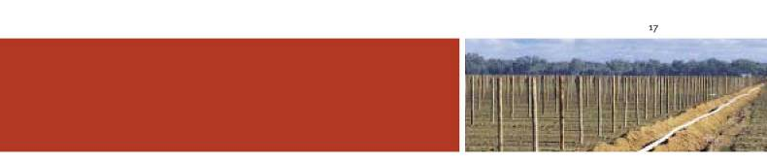

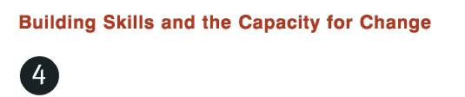
Land managers are central to achieving sound management of our land, water and vegetation resources, and to addressing critical issues such as salinity. In order to make sound decisions about the management of their land, water and vegetation resources they need:
- information about the resource base and links between the resource base and long-term profitability;
- knowledge of the impact of various management practices on long-term profitability;
- information on the economic and environmental costs and benefits of different farm management systems; and
- an understanding of the expectations of the community and the Government in terms of land management responsibilities.
In Victoria a range of programs and activities are in place to develop landholders’ skills and achieve the implementation of sustainable land management practices. These include:
- The community based Victorian Salinity Management Program, delivered through the partnership between NRE and the CMAs, has provided a strong framework for community participation and has built the leadership skills of its participants. The program has a strong focus on community education, ensuring awareness of the issues, building landholder skills and commitment to implementation. Incentives have also been used to achieve on-ground change. In both dryland and irrigation areas, the plans have been successful in meeting many targets.
- Landcare is a major success story for Victoria. Landcare has involved more than half of all rural property owners in a range of group activities to raise awareness and undertake works to address land and water degradation issues.
- Farm$mart, Victoria’s Property Management Planning program, aims to integrate all aspects of farm business planning with natural resource management.
- The activities of local government, including the statutory planning system, provide an additional means of guiding change in land use and management.
- Incentive schemes, such as Second Generation Landcare grants, provide direct funding to individual landholders and groups to undertake land management works.
Goal
To assist land managers to develop their skills and capacity to make effective decisions that address natural resource management issues.

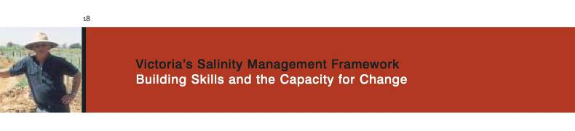
Progress
- A community driven process for salinity management in Victoria that has been in place for more than ten years.
- Increase in community awareness that salinity is a significant issue.
- About 50% of all rural property owners belong to a Landcare group.
- 50% of pumped district irrigators have attended the Irrigation Management Course on issues of improved water management drainage and salinity in Sunraysia.
- Overall, the Irrigation Salinity Management Plans have met the targets they set out to achieve.
- The statutory planning system now provides the framework for a strategic and integrated approach to municipal planning. Salinity overlays are included in local planning schemes and codes of practice also provide a useful means of promoting the adoption of appropriate land management practices.
- Incentives have ensured implementation of on-ground works where this would not otherwise have occurred.
- Landholders have invested an average of $4 for each $1 of Government investment in salinity implementation works and measures.
Challenge
- To ensure effective mechanisms are in place that facilitate community capacity and engagement in natural resource management.
- To ensure continued support for Landcare groups to facilitate the ongoing implementation of works on a catchment scale.
- To encourage market based measures to complement the mix of policy instruments for achieving landscape change and catchment restoration.
Future Directions
- The Second Generation Landcare program will be strengthened to provide support for Landcare groups tackling salinity through strategic land and water management projects.
- NRE, together with industry, community groups and CMAs, will investigate tools such as codes of practice, regulation
and market mechanisms to encourage landholders not currently being reached by traditional extension programs.
- A pilot program to develop a land management agreement system for protection of remnant vegetation and revegetation in priority areas for salinity control will be completed by 2003.
- By 2005 there will be a real increase in capital expenditure by landholders on measures or practices aimed at controlling or preventing salinity degradation.
- By 2005 soil salinity prediction information will be available to all communities for use in developing whole farm plans and regional scale intervention strategies.
- By 2010 the level of participation by landholders in Landcare will increase to 70%.
- By 2010 operations on 70% of farms will be based on whole farm plans that are consistent with Regional Catchment Strategies.
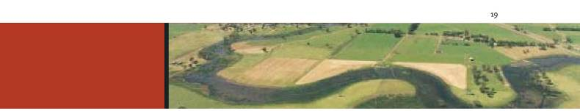

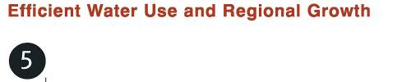
A competitive rural sector underpins the economic wellbeing of regional communities. This requires farming
systems to be profitable and at the same time provide for the sustainable environmental health of catchments.
is imperative that farming systems maximise water use for production with minimal recharge to the water table if the effects of salinity are to be contained.
Sustainable irrigation is among the most profitable farming sectors in Victoria, and is leading in Victoria’s export driven economic recovery. High value new irrigation development is critical to achieving the Victorian Government’s target of increasing the export of rural produce to $12 billion by 2010.
The importance of high value irrigation is demonstrated in the following table that describes the value of produce per 1,000 ML of water use and the employment implications.
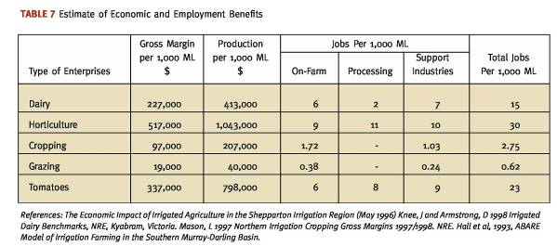
It is also estimated that for every 100,000 ML of water transferred from relatively low value grazing enterprises to high value and water use efficient dairy and horticulture enterprises, there will be a net creation of 1,438 and 2,938 jobs in regional Victoria respectively.
The importance of the dryland sector cannot be underestimated either. It is the predominant land use in Victoria and dominates the landscape. The dryland sector contributes approximately $3.7 billion annually to regional economies in direct gross agricultural production.
There are opportunities to increase production and reduce accessions to watertables by adopting more water efficient farming systems. This will minimise future salinity whilst increasing farm profitability. It is important that all farming systems are compatible with catchment processes and the environmental health of catchments.

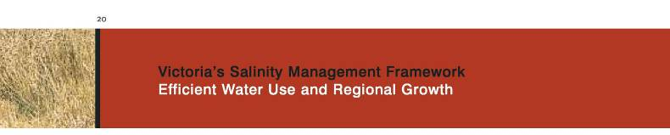
Irrigation Sector
The Victorian Government’s vision for the irrigated sector is a sector which is high value, self-reliant, vibrant and responsive to market opportunities, highly skilled, innovative, quick to adopt world best irrigation management as it develops, and, importantly, one which is environmentally responsible, clean, and sustainable.
Consistent with this vision, Government supports:
- Implementing salinity mitigation works and measures in viable irrigation areas that are economically, socially and environmentally responsible;
- Facilitating the trade of water from marginal to high value use; and
- The adoption of world best irrigation management practice.
The Victorian Government recognises the importance of drainage in irrigation areas to provide for sustainable irrigation development. Government support is provided for drainage where there are overall economic, environmental, and social benefits. However, Government expects drainage programs to maximise environmental outcomes in:
- Restoring the environmental health of catchments;
- Repairing the environmental damage caused by ad hoc drainage and waterlogged catchments; and
- Ensuring nutrient drainage discharge from catchments is reduced.
The Victorian Government acknowledges the extent and importance of new irrigation development and the importance of ensuring that development proceeds with minimal adverse salinity impacts to the River Murray. Government notes also that the substantial new development taking place, by and large, has adopted and in many cases led the world in efficient irrigation practice. The Government expects this effort to continue with a focus also on ensuring that impacts on remnant vegetation and dryland areas are properly managed and accounted for.
A key driver for new irrigation development is the water market. The water market coupled with the availability of salt credits has enabled the transfer of water from marginally viable irrigation enterprises (generally from relatively salinised areas) to high value new irrigation development. This adjustment of the irrigation sector is consistent with the Government’s vision for the sector.
However, the Victorian Government acknowledges the important social issues related to the cessation of irrigation in some areas. Therefore, Government is committed to working closely with local communities through the CMAs, and with rural water authorities and local government, to ensure adjustment proceeds in a socially responsible manner.

Dryland Sector
The importance of the dryland agricultural sector is best illustrated by the following statistics:
- It is the major land use type in Victoria, constituting 54% of the total area of land in Victoria and 95% of agricultural land.
- It has a gross value of annual production of approximately $3.7 billion (measured in _{1995/96),} which represents about 70% of Victoria’s annual agricultural production.
Each dryland catchment is different in terms of physical characteristics and their socio-economic profile.
The Victorian Government’s vision for dryland agriculture is a sector which has the skills base necessary to adopt water efficient farming systems that maximise farm profitability, and is appropriate for the sustainability of the respective catchment. The dryland sector needs the capacity to respond to present and future change in terms of market opportunities and increases in salinity.
NRE will continue to work with the CMAs and industry to develop innovative, profitable, and sustainable agriculture and land management systems. This includes identifying marginal and high hazard areas suitable for alternative management such as revegetation.
NRE will work with the community and industry to develop and promote sustainable farming and land management systems. Specifically, the Department will support measures to assist landholders through:
- Ensuring Farm$mart continues to address natural resource base issues, and improves links to other relevant extension, agriculture and natural resource base programs;
- Strengthen the aspects of landholder extension relating to building motivation, confidence, capacity for change and business planning, as well as risk management;
- Build links and cooperation with industry extension providers and encourage efficient use of the FarmBis program to meet priority learning needs;
- Better understanding the needs of different landholder groups and target these needs more carefully;
- Better understanding the barriers to adoption and ensure strategies are developed to address reasons for non-adoption; and
- Enhancing the capacity of CMAs to support Landcare.

Goals
To enhance Victoria’s social, economic and environmental wellbeing by implementing a water allocation and management system which:
- recognises that water is a finite resource;
- provides for environmental flows that protect down-stream users, river health, biodiversity, tourism and recreational values;
- provides certainty so that water entitlement holders can plan for their future with confidence; and
- encourages efficient irrigation practices and sustainable drainage systems.
To protect Victoria’s extensive dryland agriculture base and biodiversity assets by:
- promoting the protection and expansion of native vegetation;
- improving the water use of dryland farming systems; and
- developing catchment specific farm management systems.
Progress
- Bulk Water Entitlements, the comprehensive assessment and allocation of water entitlements on a regional scale, are in place in a number of systems such as the Goulburn-Murray and the LaTrobe system (approximately 70% of Victoria’s diverted water resources).
- Murray-Darling Basin Ministerial Council (MDBMC) cap sets a limit on water diversions across the whole Murray-Darling Basin, recognising the importance of protecting the future security of existing users and the sustainability of the Murray-Darling Basin river systems.
- Over 18,000 ha of native vegetation has been planted and 4,700 ha of remnant vegetation fenced in the last decade.
- The Victorian Biodiversity Strategy provides a framework for the protection of Victoria’s valuable environmental assets.
- An additional 12,000 ha of commercial plantations were established in 1999, building on a base of 250,000 ha across the State.
Challenges
- To establish water allocation systems that enhance Victoria’s economic and environmental wellbeing.
- To ensure that environmental flows, biodiversity and recreational values are protected in water allocation decisions.
- To build broad community awareness that water is a finite resource.
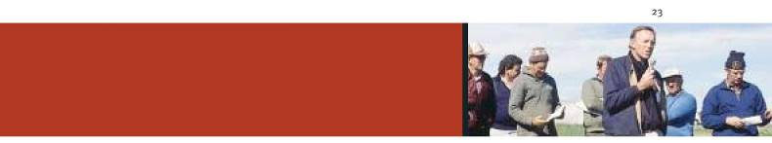
• To reduce the rate of clearing of native vegetation - the major cause of dryland salinity - which continues at a rate of
approximately 2,500 ha per annum. We also need to acknowledge the scale of revegetation required to address the problem - up to 60% to 80% in some catchments. This level of revegetation is unlikely to be feasible in the short to medium term in all catchments. Therefore, the reality is that in some areas we will need to come to terms with ‘living with salt’ - or developing saline agricultural systems. These are two possible management scenarios that could be adopted based on the degree of salinity impact.
Future Directions
- NRE in conjunction with Water Authorities will develop programs aimed at facilitating socially responsible adjustment of marginally viable irrigation areas.
- NRE in conjunction with Water Authorities will develop strategies to ensure that regions have equitable access to the benefits of water trading and new irrigation development.
- Rural Water Authorities will provide farmers with well-defined water entitlements to facilitate investment decisions.
- NRE, in conjunction with CMAs, will identify environmental flows to protect biodiversity and recreational values for stressed rivers by December 2001.
- NRE, through the Water for Growth initiative, will support improvements to irrigation infrastructure to produce water savings.
- NRE will implement a water conservation campaign in conjunction with Water Authorities.
- Rural Water Authorities will be encouraged to improve open channels to reduce evaporation and introduce overflow escape controls.
- NRE will promote drip irrigation systems and farm drainage recycling.
- NRE, in conjunction with CMAs and Water Authorities, will set and enforce environmental guidelines for water and waste water services.
- NRE will establish Groundwater Supply Protection areas to ensure the ecologically sustainable development of our groundwater resources.
- CMAs will coordinate implementation of regional Native Vegetation Plans to reverse the decline in native vegetation in order to achieve a net gain.
- NRE will work with local government to improve the system of native vegetation retention controls.
- NRE, in conjunction with CMAs, will promote revegetation programs to expand the coverage of native vegetation.
- NRE and CMAs will encourage farmers to rehabilitate land by establishing wildlife corridors on private land.
- NRE will develop partnerships with Commonwealth agencies, labour market programs and non-government organisations such as Australian Trust for Conservation Volunteers, Green Corps and Greening Australia to increase the protection, and expand the coverage, of native trees, shrubs and grasses in rural and regional Victoria.
- On degraded land with limited production potential, NRE, in conjunction with CMAs, will explore options to facilitate alternative land stewardship arrangements, coupled with planting native vegetation and fencing to protect natural regeneration and ecological succession.
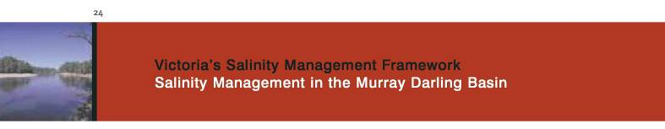
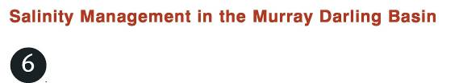
Victoria has played a strong part in implementing the Murray Darling Basin Salinity and Drainage Strategy. The Government is committed to continued support for the completion of the Salinity and Drainage Strategy.
The Victorian Government also supports the need to revise the Salinity and Drainage Strategy to incorporate the knowledge that has been generated over the past ten years and in particular to promote the sustainable management of all catchments of the tributaries of the River Murray to:
- Protect water quality in the River Murray and its tributaries;
- Control existing land and water degradation and prevent further degradation and where possible rehabilitate land and water resources; and
- Conserve the natural environment including aboriginal heritage values and built infrastructure of these catchments, and protect sensitive ecosystems with respect to salinity.
The Government acknowledges a shared responsibility with other jurisdictions to ensure River Murray water quality remains
at a socially acceptable standard in the long term. To contribute to the protection of River Murray water quality, Victoria will:
- Implement catchment Salinity Management Plans to address the emerging salinity problems consistent with the economic, environmental and social objectives of catchment communities.
- Review (and implement) dryland salinity management plans to include interim ‘end of valley’ salinity targets to reduce the projected gradual deterioration in River Murray salinity over the next 15 years from 16.5EC to 6.5EC as measured at Morgan. The interim ‘end of valley’ stream salinity and associated implementation targets will be reviewed every five years.
- Support a new, joint inter-governmental program of salt interception schemes to provide for River Murray water quality benefits at Morgan, to improve the general environmental health of the River Murray and its environs, and to offset the influence of sustainable irrigation development and adjustment including drainage works in Victoria.
The revised Salinity Management Plans, including ‘end of valley’ targets and implementation targets will be developed as a partnership between CMAs and their local community, with NRE support. The plans will be submitted to the Murray Darling Basin Commission for consideration.
Revegetation strategies will be a key mechanism to achieving ‘end of valley’ salinity targets and protection of catchment values. Victoria will implement Native Vegetation Management Plans that will combine landscape, biodiversity and River Murray salinity benefits, while taking into account impacts on water yields.
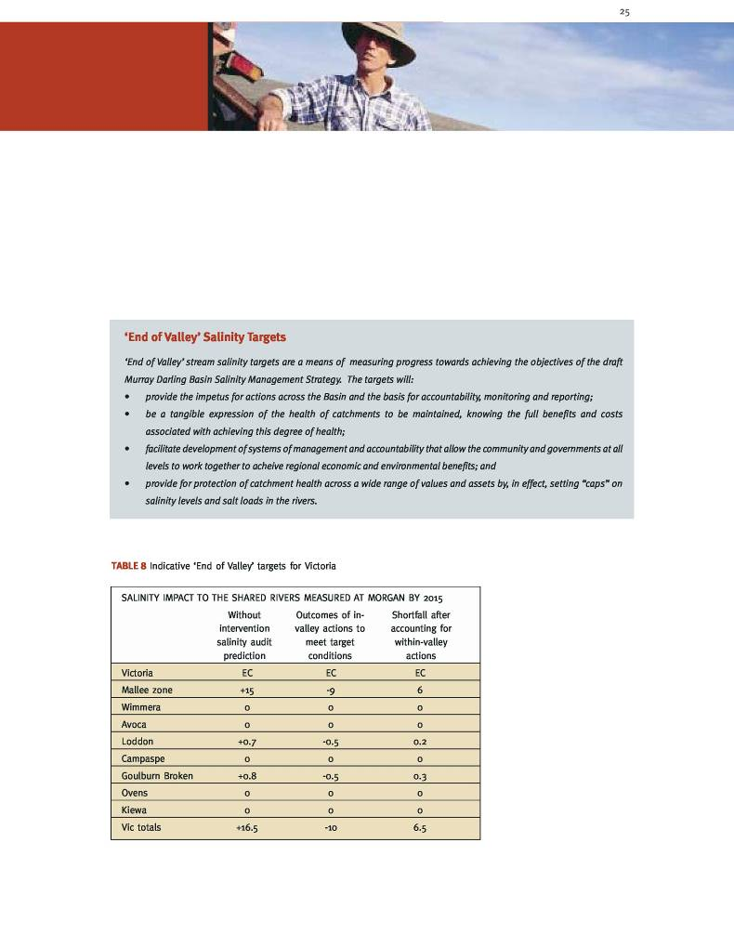

Goal
- To implement the Murray Darling Basin Salinity Management Strategy to achieve the established targets, reduce the predicted salinity increases and promote ecologically sustainable development.
Progress
- Implementation of the Salinity and Drainage Strategy has achieved a 67EC River Murray salinity reduction at Morgan. Victoria has been pro-active in identifying and offering potential salt interception schemes.
- Sustainable and high value new irrigation development and drainage has proceeded at unprecedented rates.
- Water trading has enabled the development to proceed, but has also enabled the retirement of significant areas of relatively highly salinised land from irrigation. This in turn has provided for socially responsible adjustment of the irrigation sector.
- Within the bounds of current scientific knowledge, there has been some success in implementing dryland salinity management measures to reduce recharge to regional watertables. However, these need to be built on to better achieve ‘end of valley’ and ‘within valley’ salinity targets.
- Success in implementing works and measures to protect environmental features include Lake Charm, Dowdles Swamp and Kinnairds Swamp.
Challenges
- Development of realistic and feasible ‘end of valley’ salinity targets.
- Development of ‘living with salt’ options.
- Establishment of and investment in salt interception schemes for the River Murray.
Future Directions
- The Victorian Government in partnership with the community will continue to support joint programs to complete the Salinity and Drainage Strategy to achieve the 80 EC Morgan target as a matter of priority.
- Consistent with community economic, social and environmental objectives, reduce the predicted salinity increases
caused by gradual deterioration in Victoria over the next 15 years from 16.5 EC to 6.5 EC as measured at Morgan.
- NRE, through CMAs, will review interim ‘end of valley’ and ‘within valley’ salinity targets in consultation with regional communities and the Murray Darling Basin Commission by September 2001.
- CMAs, in conjunction with NRE, will develop and promote the implementation of innovative market based dryland farming systems and vegetation management strategies, necessary to achieve the targets.
- Identify and implement cost effective salt interception schemes to earn 15EC of salt credits by the year 2015, to enable future sustainable development of Victoria’s high value irrigation industries.
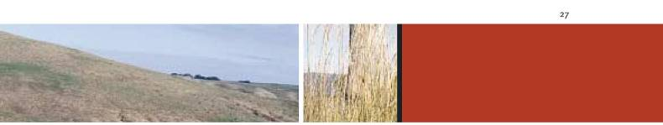

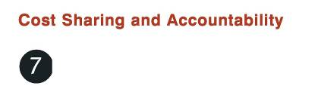
Victoria’s Salinity program is based on transparent cost sharing arrangements between Government and local communities. Investment of public funds has been carefully targeted at activities which are economic, have clear community benefits, and which facilitate and promote coordinated effort of landholders to invest in salinity
management. In irrigation areas alone it is estimated that for every dollar of public investment, the community has invested
four dollars.
In reviewing the salinity management plans CMAs will need to consider whether existing cost sharing arrangements are equitable and efficient.
Cost sharing arrangements will be negotiated on the basis of the following guidelines:
Duty of Care
All natural resource managers and users have a duty of care to ensure that they do not damage the natural resource base. They should be responsible for making good any damage incurred as a result of their actions.
Beneficiary Pays
When it is not possible to attribute damage then prime beneficiaries should pay. Contributions from secondary beneficiaries will, where appropriate, be negotiated with the primary beneficiaries.
Government Contributes for Public Benefit
Government contributes primarily for activities which produce public benefits. Government may agree to contribute towards salinity management activities that provide private benefits, where the cumulative up-take of these activities provides significant public benefit and Government support is required to facilitate this up-take.
Economic Viability
Before Government will contribute to any salinity management activity, the activity must be technically sound and the economic benefits must justify the costs.


Statewide Policy and Monitoring
Government will meet the cost of agreed statewide planning, resource monitoring and assessment, and research and investigation.
Project Evaluation
In setting priority actions and reporting under the Salinity Framework community groups and Government in partnership will need to take into account economic, social and environmental impacts.
Effective consideration of economic, environmental and social impacts will assist in delivering the Government’s commitments to sustainable rural and regional communities, and achieving ecologically sustainable development.
It is important that investment of public funds are for activities in which all the benefits exceed all the costs. The review of the Salinity Management Plans should indicate whether current activities should continue to be supported by Government, and identify new salinity management activities. This will require full and proper project evaluation.
It is imperative that environmental and social benefits and costs are adequately considered. This will require the benefits and costs to be described and compared and a judgement made by the community and Government.
It is expected that all activities will provide net environmental benefits.
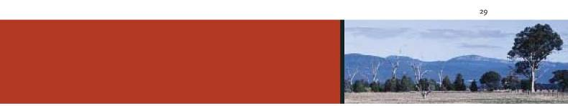

Experience gained over the past decade with salinity management in Victoria and Australia shows that while some important advances have been made, the threat of salinity continues to grow.
n irrigation areas we have seen improvements in water use efficiency. We need to build on this success although with some re-focusing in light of new information.
The growing threat of dryland salinity requires that we overcome several barriers if we are to effectively manage the problem. Firstly, it is now clear that agricultural land use will need to change on a massive scale with revegetation of over 60% of the landscape in many catchments. There will be some difficult trade-offs in striking the balance between the extent of land use change that is feasible and the level of salt affected land we are prepared to live with.
Secondly, much of the land at greatest risk from salinity and requiring greatest change in management is currently in agricultural areas experiencing difficulties such as the wool industry. Many farmers in these industries are unable to invest in enterprise change.
Thirdly, because salinity is a long-term problem, land managers and the general community are likely to under-invest in
control strategies until the damage occurs, at which time, treatment and reversal may become expensive, if not impossible.
However, recent information indicates that new land uses such as farm forestry may offer profitable alternatives to extensive grazing in many areas at risk of salinity. The emerging market in carbon credits also shows promise in improving the commercial options for farm forestry on a large scale. Coupled with mechanisms that increase the protection and coverage of native vegetation there is real scope to substantially reduce the rate of degradation as a consequence of salinity.
The importance of new irrigation development to the State should not be underestimated. This new development is being based on best irrigation practices and the transfer of water to more productive and sustainable farming systems.
In Victoria we now have a strong community infrastructure of CMAs and Landcare groups with the ability to focus community and Government investment in whole-of-catchment approaches to natural resource management.
To effectively target this investment to priority areas and activities, Regional Catchment Strategies and Salinity Management Plans will need to be upgraded in consultation with the community using the latest scientific information about management options and salinity trends.
The future productive capacity and environmental values of our land and water resources depends on doing the right thing at the right time in the right place. Effective partnerships between Government, community and industry will be even more critical for the next phase of salinity management in Victoria.
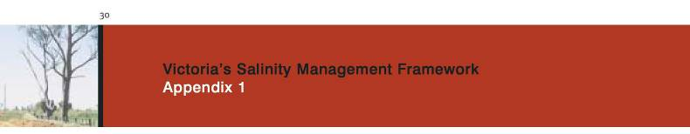
Appendix 1
Submissions received on ‘Future Directions’ report
Terry Simpson
Rod Kirby
Stuart Simms
Lance Lloyd (River Basin Management Society)
Mr. H.P. Abbinga
Chris Norman, NRE
Ken Sampson, Goulburn Broken CMA
Peter Codd, Corangamite CMA
Murray Chapman (Rural Plan)
Loddon Implemenation Committee, North Central CMA
Paul Jerome, Department of Infrastructure
Rod Gowans, Director Parks, Flora and Fauna, NRE
Glenelg Hopkins CMA
Richard McLoughlin, Director Fisheries Victoria, NRE
North East CMA
Port Phillip and Western Port Catchment and Land Protection Board Geoffery Carruthers, West Gippsland CMA
Mark Johnson, Farm Forestry NW, NRE
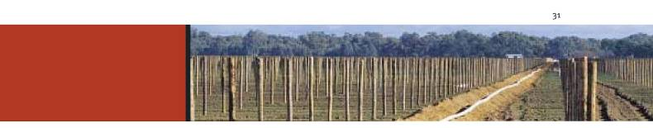
Further Reading
ABARE (1998) Promoting Improved Land Management Practices on Australian Farms. ABARE Research Report 98.4.
Bond, W.J., H.P. Cresswell, R.J. Simpson, Z. Paydar, S.G. Clark, A.D. Moore, D.J. Alcock, J.R. Connelly, M. Freer, B.A. Keating, N.I. Huth, and V.O. Snow ₍₁₉₉₇₎ Meat Research Corporation Sustainable Grazing Systems Key Program Project SGS.130 - Pre-experimentation Water Balance Investigation. Final Report. Consultancy Report 97-31. CSIRO Land and Water.
Charles Sturt University (1999) Landcare in Victoria: Beyond Onground Work.
Department of Natural Resources and Environment ₍₁₉₉₇₎ Managing Victoria’s Catchments - Partnerships in Action. Department of Natural Resources and Environment (1997) Victoria’s Biodiversity - Sustaining Our Living Wealth.
Department of Natural Resources and Environment ₍₁₉₉₉₎ Strategic Review of the Sustainable Dryland Agriculture and Land Management Key Project in Victoria.
Department of Natural Resources and Environment, Victorian Catchment and Land Protection Council, Environment Protection Authority (1998) Know Your Catchments: An Assessment of Catchment Condition Using Interim Indicators.
Murray Darling Basin Commission ₍₁₉₉₉₎ Salinity Audit of the Murray Darling Basin: A Hundred Year Perspective.
Prime Minister’s Science, Engineering and Innovation Council ₍₁₉₉₉₎ Dryland Salinity and its Impacts on Rural Industries and the Landscape.
RIRDC (1998) Improving Farmers’ Management Practices Through Learning and Group Participation. A Report for the Rural
Industries Research and Development Corporation by Mr I.J. Reeve and Professor A.W. Black. RIRDC Publication No. 98/71.
SCARM (1988) Sustainable Agriculture: Assessing Australia’s Recent Performance. A Report to SCARM of the National Collaborative Project on Indicators for Sustainable Agriculture. SCARM Technical Report 70. CSIRO Publishing.
Walker, G., Gilfedder, M. and Williams, J. ₍₁₉₉₉₎ Effectiveness of Current Farming Systems in the Control of Dryland Salinity. CSIRO Land and Water.



