
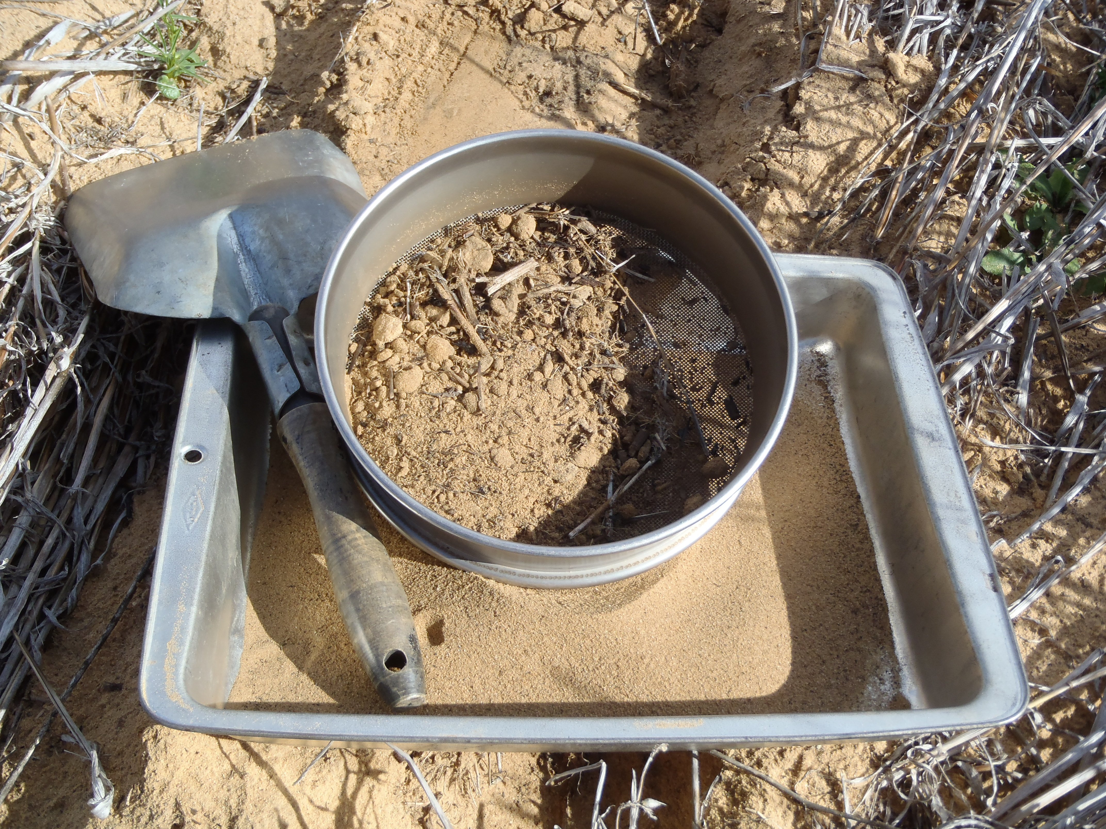
Mallee soil erosion and land management survey

Spring 2012

Mallee soil erosion and land management survey
If you would like to receive this information/publication in an accessible format (such as large print or audio) please call the Customer Service Centre on 136 186, TTY 1800 122 969, or email customer.service@dpi.vic.gov.au.
Published by the Department of Primary Industries
Grains Services, November 2012
© The State of Victoria 2012.
This publication is copyright. No part may be reproduced by any process except in accordance with the provisions of the Copyright Act 1968.
Authorised by the Department of Primary Industries
1 Spring Street, Melbourne 3000.
Disclaimer
This publication may be of assistance to you but the State of Victoria and its employees do not guarantee that the publication is without flaw of any kind or is wholly appropriate for your particular purposes and therefore disclaims all liability for any error, loss or other consequence which may arise from you relying on any information in this publication.
For more information about DPI go to www.dpi.vic.gov.au
or phone the Customer Service Centre on 136 186.
Spring 2012

November 2012

MA 1213.01.164

Prepared for: Mallee Catchment Management Authority
Prepared by:
Heather Drendel
Grains Services
DPI-Hopetoun
T 03 50514500
E heather.drendel@dpi.vic.gov.au

Acknowledgements
This project has been successfully delivered by the Department of Primary Industries (DPI) in partnership with Mallee Catchment Management Authority (CMA), through funding from the State Government.
DPI - Heather Drendel ,Jodie Price, Mark Costello, Robert O’Shannessy, Darryl Pearl, Lara Wakefield, Bernard Noonan
Mallee CMA - Narelle Beattie, Cameron Flowers, Paul Mock, Malcolm Thompson, Derrick Boord, Jessica Cook

Cover image: Tools of the Trade,

Contents

Purpose of Report 4
Trend Summary 4
Background 4
Land management practice and phase 5
Risk of erosion 6
Conclusion 7
Spring 2012 Report 8
Background 8
Objectives 8
Methods 8
Results and discussion 15
Conclusion 20
Recommendations 20
References 20
Appendix 1: Blank field collection form 22
Appendix 2: Data check QA form 24

Purpose of Report
This report provides the results of the ‘Mallee soil erosion and land management survey’. The report is divided into two parts. The first part of the report provides a summary of trends over time in soil erosion risk and land management practices for the Mallee sites surveyed. The second part of the report provides the results from the spring 2012 survey.

Trend Summary

Background

Wind erosion occurs naturally in the landscape and is an important part of soil genesis; many soils in the Mallee have formed by aeolian processes. However wind erosion also causes adverse effects through the removal of large amounts of fine soil particles that result in a direct loss of nutrients from agricultural land as well as sandblasting emerging crops (Armbrust 1984 as cited in Leys et al 2007). Wind erosion also has considerable off-site impact, the airborne particulate matter can cause adverse health effects, and reduced visibility and the deposition of soil can smother native vegetation, bury or undermine infrastructure and increase nutrient loads in waterways (Clune, 2005).

Wind erosion has been a recognised issue in the Mallee since at least 1945 (Thomas as cited in Clune 2005) and as such has been a priority of Natural Resource Management organisations for many years. This has resulted in extensive promotion and research of agricultural practices that minimise the risk of erosion.

In 1978 the Mallee fallow survey commenced after wind erosion became severe and widespread, particularly in areas with light soils (Boucher 2005a). The objective of this original survey was to assess actual erosion and land use practices in the Mallee region of Victoria. The survey has continued using a number of different methods (Wakefield 2008b).

In 2005-2006 the survey underwent a review and redesign. The results reported in the main component of this report are from the current methods which have been implemented since 2007.

The current survey is conducted three times annually, during late summer (February - March), post sowing (June - July) and spring (October). In-paddock assessments are completed at 157 sites, from across six land systems (Central Mallee, Millewa, Tempy, Hopetoun, Culgoa and Boigbeat) within the Mallee region. Refer to methods section in main report.

The Department of Primary Industries (DPI) Farm Services Victoria (FSV) in partnership with the Mallee Catchment Management Authority (Mallee CMA) conducts the Mallee Soil Erosion and Land Management Survey and manages the Soils and Land Management database with funding provided through the Victorian State Government.

The 2005/2006 review determined that the historical data (pre 2007) and the post redesign data can not be directly compared. The historical data has however been included in trend graphs (Refer to Figure 1 & 2) to capture all data collected over the survey’s history, and although not comparable it is a valuable data resource.

The second part of this report documents the methods used in the surveys as well as analyses of the results of the spring 2012 survey. The survey records, soil dry aggregate, vegetation cover and height (risk of wind erosion), land management practices and a centre point photograph.

The following graphs illustrate trends over time for the land management practices and risk of erosion at the sites surveyed.

Land management practice and phase
The data presented in Figure 1 suggests that at the sites surveyed there has been a decrease in long conventional fallow since 1985, this is fallow that is started prior to spring. However, this data needs to be interpreted with caution as the data collected prior to 2007 was collected using different methods compared with the post 2007 data. Since 2007, conventional fallow, at the sites monitored, has remained below 2%.
Historical Data
Post Survey Redesign

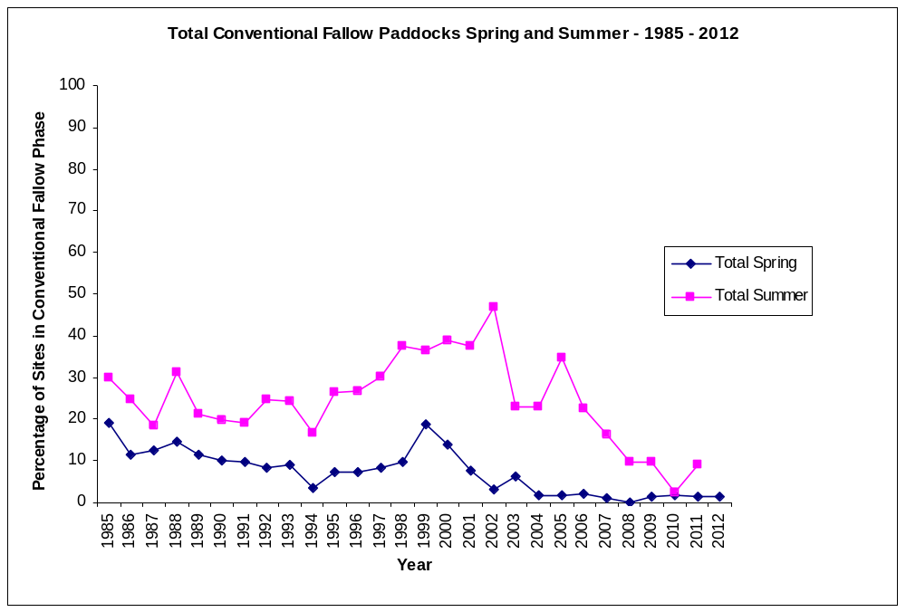 Figure 1: The per cent of sites surveyed in the Mallee under conventional fallow management since 1985. The historical data refers to data collected using the drive by methods from 1985 to 2006 (Wakefield 2008b). Since 2007 the methods were redesigned to include an in-paddock assessment of erosion risk and land management.

Since 2007, for the sites surveyed, there has been a slight decrease in cereal crops. Pasture and other crops have fluctuated depending on the year (Figure 2). Compared with historical data, however, for the sites surveyed, there has been a trend toward more cereal crops with a decline in pasture.

Sites in pasture (volunteer, improved) are still declining in 2012 with an increase in other crops. Cereals still remain the dominate crop. Fallow (all methods) has increased at sites and is recorded at its highest since 2007. Legume and other crops have also recorded an increase at sites. This is most likely attributed to the seasonal conditions following the above average 2011 summer rainfall resulting in favorable sub soil moisture availability.

The reason for a decrease in pasture and an increase in fallow is unknown. There is the possibility that there may be some differences in visual assessments by the different field officers with respect to what is defined as pasture and what is chemical fallow in a no-till/minimum till farming practice.
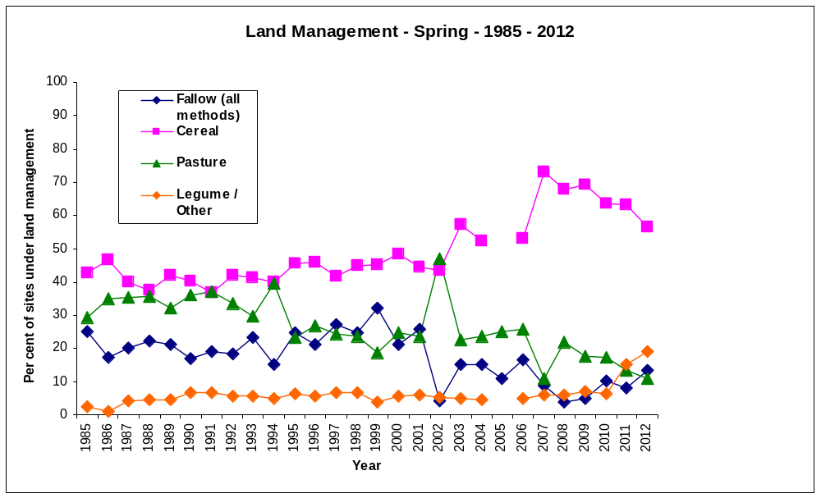
Post Survey Redesign

Historical Data

Figure 2: The per cent of sites surveyed in the Mallee under different management techniques during spring since 1985. The historical data refers to data collected using the drive by methods from 1985 to 2006 (Wakefield 2008b). Since 2007 the methods were redesigned to include an in-paddock assessment of erosion risk and land management.

Risk of erosion
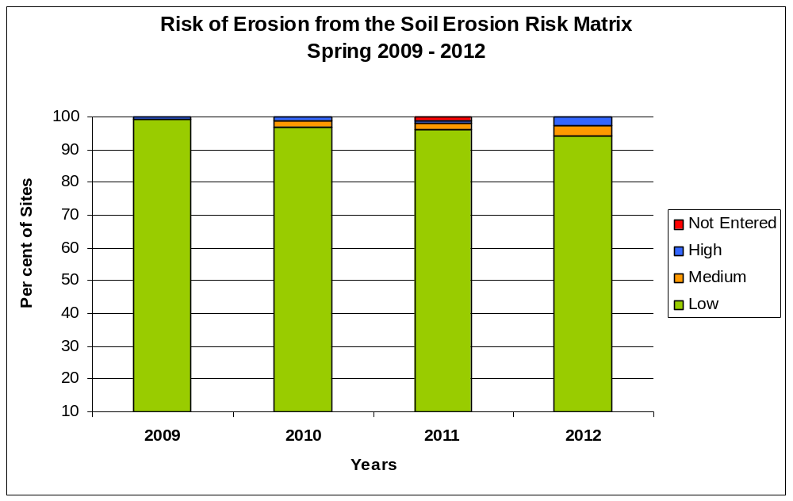
Figure 3: Risk of erosion calculated using the risk matrix for percentage of sites surveyed during the spring survey.

In paddock measurements for risk of erosion at sites surveyed have been recorded in spring since 2009. Greater than 94% of sites have recorded low risk of erosion for spring 2012 (Figure 3) in comparison to previous years recording greater that 96% of sites at a low risk of erosion. 2.54% or four (4) sites recorded as being at a high risk in comparison with 2009-2011 where only one (1) and two (2) sites recorded at being at a high risk of erosion.

Conclusion

The survey of land management phase shows a slight change in trends from 2007 – 2012. Fallow has increased from 9% in 2007 to 13.4% in 2012. At sites the predominate crop remains cereals, with an increase in legumes and other crops being recorded at 6% in 2007 to 19.1% in 2012.

Sites in pasture have been between 11% in 2007 increasing in 2008 to 22% and then decreasing to 10.8% in 2012.

Conventional fallow paddocks, at sites surveyed, have remained below 2%.

A low risk of erosion has been recorded for more than 94% of sites surveyed during spring from 2009 to 2012 using the soil risk matrix method. 2.54% of sites recorded at being at a high risk of erosion during spring 2012.

Spring 2012 Report

Background
The Department of Primary Industries (DPI) Farm Services Victoria (FSV) in partnership with the Mallee Catchment Management Authority (Mallee CMA) conducts the Mallee Soil Erosion and Land Management Survey.

In 1978 the Mallee fallow survey commenced after wind erosion became severe and widespread, particularly in areas with light soils (Boucher 2005a). The objective of this original survey was to assess actual erosion and land use practices in the Mallee region of Victoria.

In 2005-2006 the survey underwent a review (Boucher, 2005a) and was redesigned using recommendations from the review (Wakefield 2008b). The focus of the survey now is on assessing risk of erosion and recording land management practices. The redesigned survey was first trialled in the summer of 2007. The survey is conducted three times annually during late summer, post sowing and spring.

The spring 2012 survey of soil erosion and land management was conducted from October 15th to 19th 2012. This report documents the methods used in the survey as well as analysis of the result of the survey.

Objectives
The objectives of this project (2012/13) were to:
- Undertake, analyse and report on the “Mallee Soil Erosion and Land Management Survey” three times annually (post sowing 2012, spring 2012, and late summer 2013).
- Deliver targeted communication activities to increase landholder awareness of erosion risk and management tools to mitigate both incidence and impact of wind erosion.

Methods
Survey Transects and Sampling Locations
From across six land systems within the Mallee region approximately 160 sites were selected randomly for continuous in-paddock assessments three times a year, late summer (February/March), post sowing (June/July) and spring (October).

Site selection was stratified based on land system. The proportion of sites from each land system was equivalent to the representation of the land system within the major agricultural regions of the Mallee (the area of the survey), for example the Central Mallee land system occupies 50 percent of the survey area (agricultural region of the Mallee), so 50 percent of the 160 sites were located within this land system. Within each land system the sites were also stratified based on land forms (hummock, plain and dune). Again the number of sites on each land form was based on the percent of area covered by that land form within the land system. The data on land systems area and land form area was based on the Rowan & Downes, 1963 report.

Site Locations
The following is a list of the land systems and transects within each land system where the soil erosion monitoring occurs (See figure1).

Central Mallee
- Ouyen to Piangil
- Torrita North to Torrita South
- Tutye North to Tutye South
- Murrayville to Murrayville North
Millewa
- Meringur North to Meringur South
- Bambill North to Bambill South
- Karawinna North to Karawinna South
Tempy
- Gypsum to Gama
Hopetoun
- Hopetoun to Yaapeet
- Gama to Lascelles
- Hopetoun to Woomelang
- Hopetoun to Lascelles
Culgoa
- Swan Hill to Ultima
- Culgoa to Lalbert
Boigbeat
- Ultima to Sea Lake

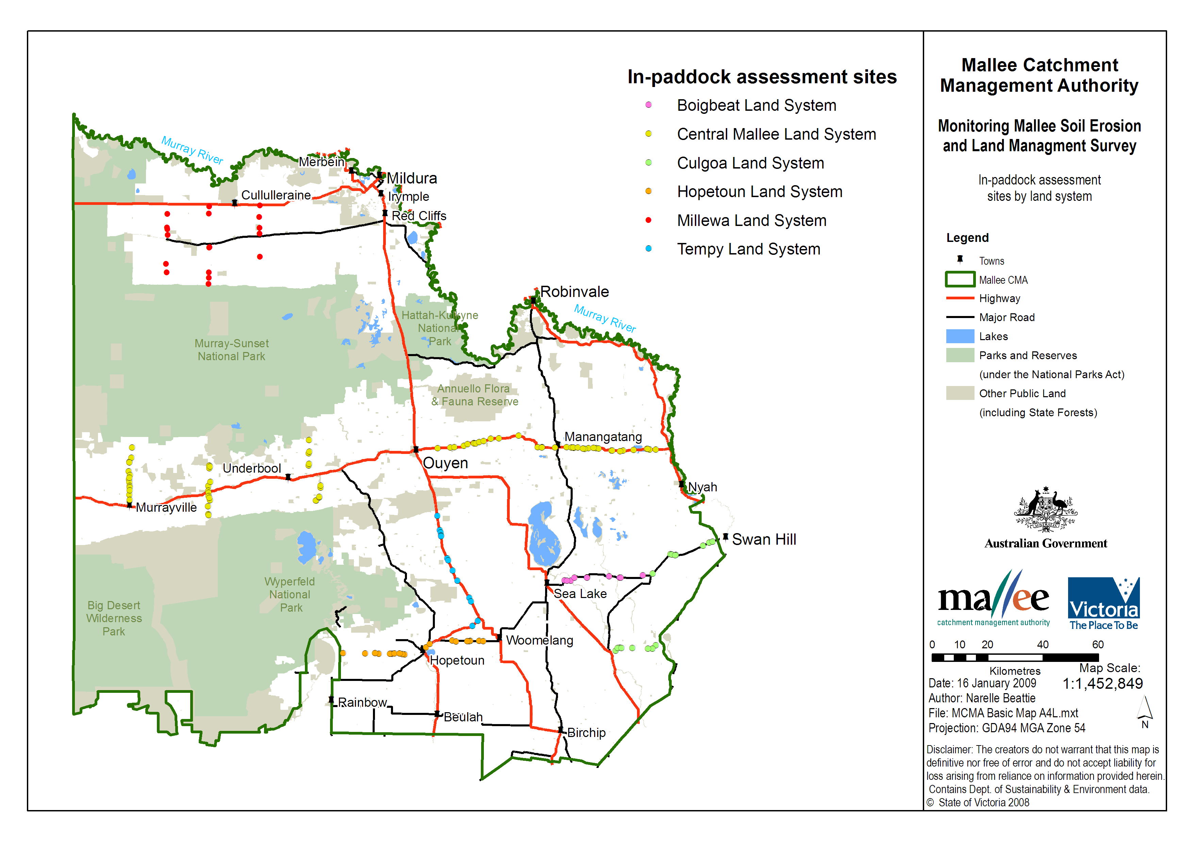

Figure 1: Map of the 157 sites where the soil erosion monitoring is being conducted.

Data Collection
At each site a one hectare area is used for collecting data, this is located 100m along the roadside fence line from the start of the paddock and 50m into the paddock (away from the roadside). At each site the following is recorded:

- Vegetation cover and height measurements.
- Soil dry aggregate measurements.
- The current management phase (i.e. conventional fallow, chemical fallow, crop, pasture).
- The current management practice (i.e. conventional farming or no-till/minimal till).
- The presence/ absence of livestock.
- The presence of standing stubble reported during summer and post sowing surveys.
- Soil detachment rating.

Vegetation Cover and Height Measurements
Vegetation cover was measured using the levy point sampler (Levy & Madden, 1993) (refer to Figure 2). Twenty random sites in the one hectare area were sampled to record vegetation cover and vegetation height (200 points). The sampler was placed on the ground (i.e. without looking) 20 times within the 1 hectare sampling area. Five paces south/north then five paces east/west were taken then recordings taken, and repeated until 20 samples were completed. Vegetation height measurement was recorded by a 40cm ruler attached to the side of the levy point sampler. The height of the closest piece of vegetation (live or dead) to the ruler was measured in centimetres (rounding off to whole number). Vegetation measurements were achieved by counting dead or live vegetation touching the prongs on the levy point sampler.

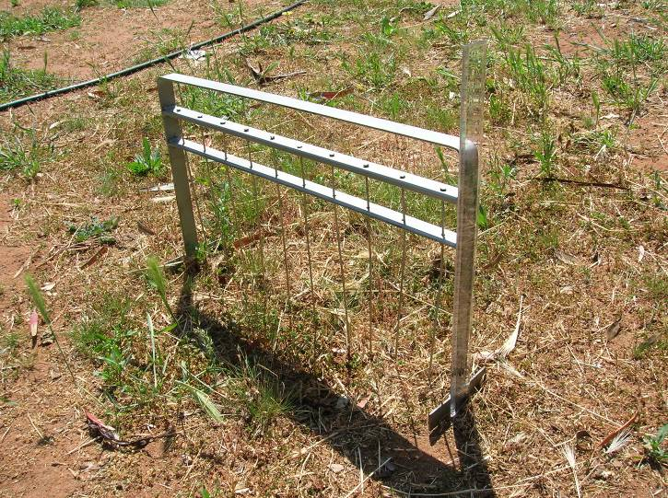

Figure 2: Levy point sampler used for assessing vegetation cover

Dry Aggregation
From within the one hectare sampling area at each site, 3 points were randomly located for collection of soil samples. Each soil sample was collected using a square nosed hand shovel (or hearth shovel). Approximately 2kg of soil was collected down to a depth of 10cm. It was important to ensure that minimal disturbance was made to the soil, and that the soil was dry when sampling. The soil sample was then placed in an 850µm hand sieve and gently shaken over a baking tray. Both the coarse and fine samples were then weighed and the proportion of coarse aggregates was calculated. This provided an indication of the protection dry aggregates provide against wind erosion (Leys et al 2002).

Land Management Phase
Table 1: Management Phase Descriptions
Chemical Fallow | Is referred to where obvious detection of both weed and/or self- sown crop death (due to a chemical application) is observed. This is usually prior to any form of cultivation occurring, (but is not restricted to this) and is in preparation for the next crop.  This "chemical fallow" could be for a relatively short duration (a matter of months) but in some instances may continue for as long as 18 months, i.e. a 2 year rotation where 18 month fallow period is practised.
Conventional Fallow | Land kept free of live vegetation with the use of mechanical cultivation. Visual of up turned earth.
Pasture -Volunteer | Land dominated by random grasses/cereal for grazing
Pasture -  Improved | Land dominated by annual broadleaf and/or legume (i.e. clover/ vetch/ medic) used for grazing or green and brown manuring.
Hay | Pasture that has been prepared for hay by evidence of cutting, windrowing or baling. Obvious cut stems on vegetation or evidence of raked vegetation on ground.
Cereal Crop | Wheat, Barley, Oats, Triticale etc
Legume Crop | Field peas, Vetch, Lupins, Beans etc
Oilseed Crop | Canola, Mustard etc
Other | Saltbush etc

Land Management Practice
Table 2: Management Practice Descriptions
Conventional Farming | A system of multiple cultivation control. Passes before sowing for weed and/or seedbed preparation
No-Till/ Minimal Till | Sowing system aimed at minimising soil disturbance and retaining crop residues

Livestock Present
Livestock including sheep, cattle, horses and goats were recorded as present or absent within the site. They were determined to be present if visual evidence of stock, recent scats or hoof marks could be seen i.e. scats were soft, fresh or dark in colour; stock trails could often be seen throughout the area and around fence lines where stock had walked; and/or evidence of footprints and scats around watering points.

Centre Point Photograph
Paddock management practise and phase is documented by photographic evidence. A centre point photograph is taken at the site by walking twenty five metres into the site from the roadside fence line recording transect, site number, GPS coordinates and survey date.

Soil Stability Assessment
Table 3 was used as a guide to determine soil surface stability. Each site was assigned a detachment rating based on a visual assessment of soil disturbance. This was a method developed by the South Australian Department of Water, Land and Biodiversity Conservation and used as part of their soil erosion monitoring program (McCord 2008).

Table 3: Soil Detachment Rating (McCord, 2008).
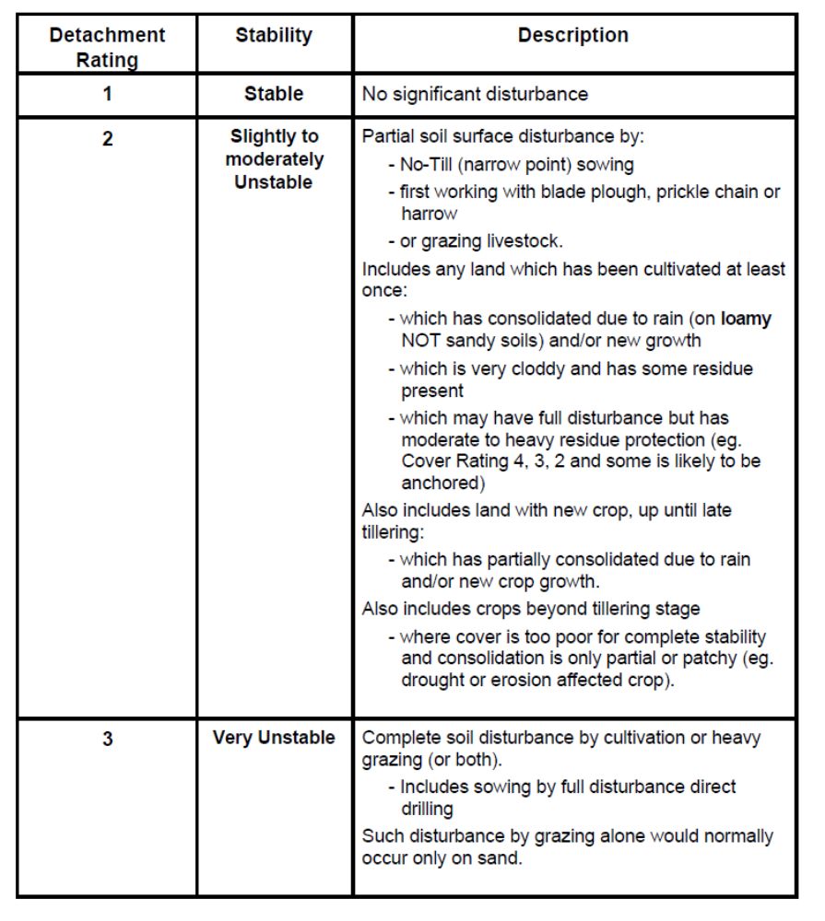
Personnel
To ensure timely completion of the sampling during each survey period a number of teams were setup to complete field work in specified areas. Six teams of two people (Table 4) were assembled and completed all measurements and observations allocated sites. Most teams completed field work in two days.

Table 4: Allocation of transects to teams
Team | Day | Transect | No of sites
1 | 1 | Ouyen Piangil | 12
 | 2 | Ouyen Piangil | 13
2 | 1 | Torrita | 13
 | 2 | Ouyen Piangil | 13
3 | 1 | Tutye | 13
 | 2 | Murrayville | 14
4 | 1 | Millewa | 10
 | 2 | Millewa | 10
5 | 1 | Sea Lake – Ultima – Swan Hill | 15
 | 2 | Sea Lake – Ultima – Swan Hill & Culgoa - Lalbert | 13
6 | 1 | Gama - Yaapeet | 14
 | 2 | Gypsum – Gama & Hopetoun - Woomelang | 19

Data Entry
Field measurements were recorded on hard copy data sheets (Appendix 1) and the data was entered into the database in the office.

A quality control check was completed on the data entered into the database. A 100% check was completed by a staff member not involved in the original entry of the data. A signed quality control form is included as Appendix 2.

Analysis
Erosion risk
For the purpose of comparison three types of assessments of soil erosion risk were completed.
These were:
- Calculation of the ‘Q value’.
- Assessment of soil stability.
- Determination of soil erosion risk using a risk matrix.
Q value
A formula has been derived by Leys (Leys et al 2002) to determine relative wind erosion risk. It uses the direct measurements of vegetation cover and soil dry aggregates to calculate a wind erosion risk for each site. The formula is as follows:

Q = 78.11375017 * exp (-0.05172598 * SC%) * exp (-0.038989759 * DA%)

Where Q is the calculated sediment transport rate (g/m/s) for an equivalent 65km/h wind measured at 10 m height; SC% is the vegetation cover percentage; and DA% is the level of dry aggregation greater than 0.85 mm as determined by gentle hand sieving.

A Q value of less than 5 g/m/s equates to low erosion risk, moderate risk is a Q value greater than 5 but less than 25 g/m/s and a high erosion risk is a Q value greater than 25 g/m/s.

Soil erosion risk matrix
The measurements of vegetation cover and soil dry aggregates were used to estimate a risk of erosion for each site. The rougher the soil surface the more stable the soil is, vegetation contributes to the roughness. It is recommended that vegetation cover remains above 50% cover to adequately protect from wind erosion (Agricultural Bureau of South Australia, 2002). Larger soil aggregates also protect soil from wind erosion. The larger the aggregates the less likely they are to be picked up and carried away by the wind, larger aggregates also contribute to surface roughness. Dry aggregation greater than 40% has been shown to greatly reduce erosion (Leys, Keon & McTanish, 1996). Table 5 is the matrix that was used to determine the erosion risk using the measurements of vegetation cover and soil dry aggregates.

Table 5: Matrix to determine erosion risk for sites where vegetation cover and soil dry aggregates has been measured (McIntosh, Leys & Biesaga, 2006).
dry aggregates | >50% | 30-50% | 10-30% | <10%
groundcover
>70% | low | low | low | low
50-70% | low | low | low | medium
30-50% | low | low | medium | high
10-30% | low | medium | high | high
<10% | medium | high | high | High

Assessment of soil stability.
Completed in the field as described in the data collection.

Results and discussion
Land Management Practice and Phase
Land management practice and phase is recorded during each survey to determine what farming practice and phase is occurring over the year at sites surveyed and also to see whether they have any impact on wind erosion.

The survey of land management phase during the spring sampling period showed 12.1% of the sites were chemical fallowed, 1.3% (2 sites) of the sites were conventionally fallowed, 10.8% of the sites were in pasture and 75.80% of the sites were in crop (Table 6 and Figure 3). Conventional fallow was recorded in one of the six land systems and chemical fallow was recorded in all six land systems.

The 75.80% of the sites in crop consisted of 56.7% cereal, 8.3% legume and 10.8% oil seed. This showed a decrease in cereal from 2011. Legumes remain consistent from the previous years but there was an increase in oil seed crops. This is most probably attributed to the above average summer rainfall in 2011 contributing to adequate sub soil moisture availability for the commencement of the sowing season in 2012.
Table 6: Sites surveyed of land management phase during the spring 2012 survey sampling period.
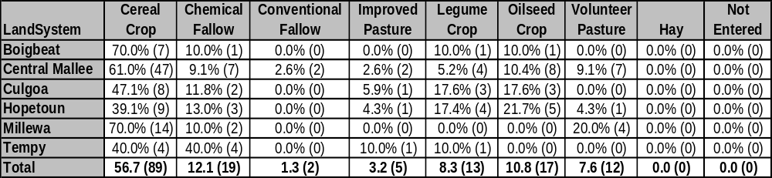

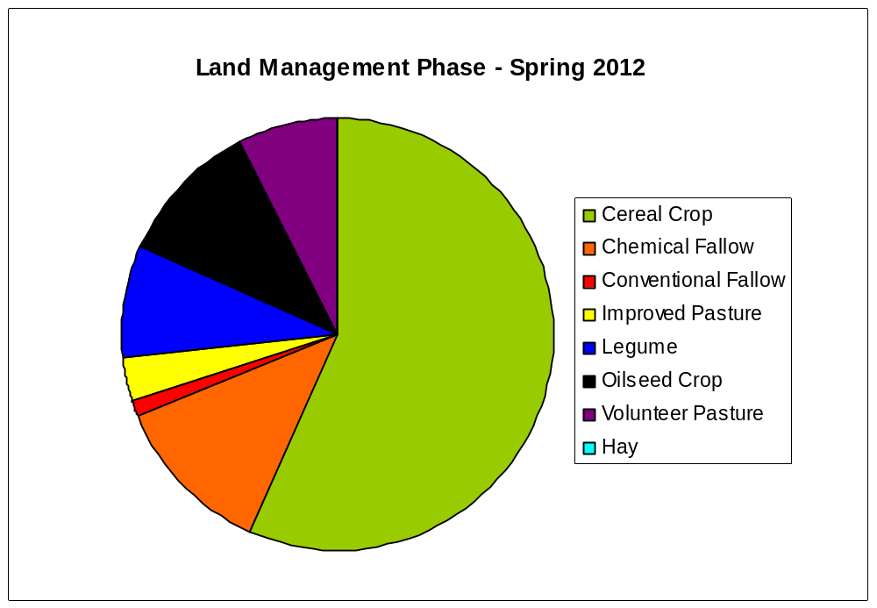
Figure 3: Per cent of the sites under different land management phase, observed during the spring 2012 survey.

Both conventional and no till/minimal till farming practices were observed, at sites surveyed during the spring 2012 survey. One land system observed 100% of sites using no-till/minimal till sowing as their management practice with the remaining five land systems observing both practices across sites surveyed. All sites in the six land systems observed greater numbers of no-till/minimal till than conventional farming as the current management practice (Table 7 and Figure 4). Overall, 25% of the sites sown to crop were managed by conventional farming whereas 75% of the sites were managed by no-till/minimal till farming.

Table 7: Per cent and number of cropped sites observed in conventional and no-till/minimal till farming land management practice spring 2012.
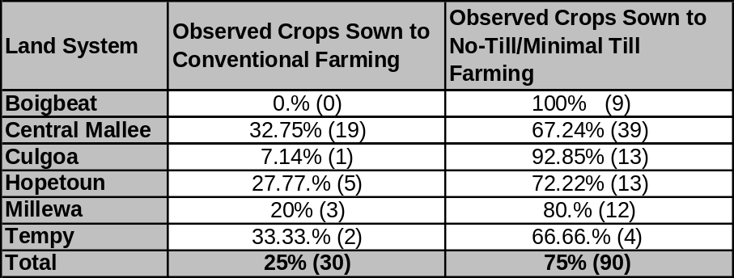

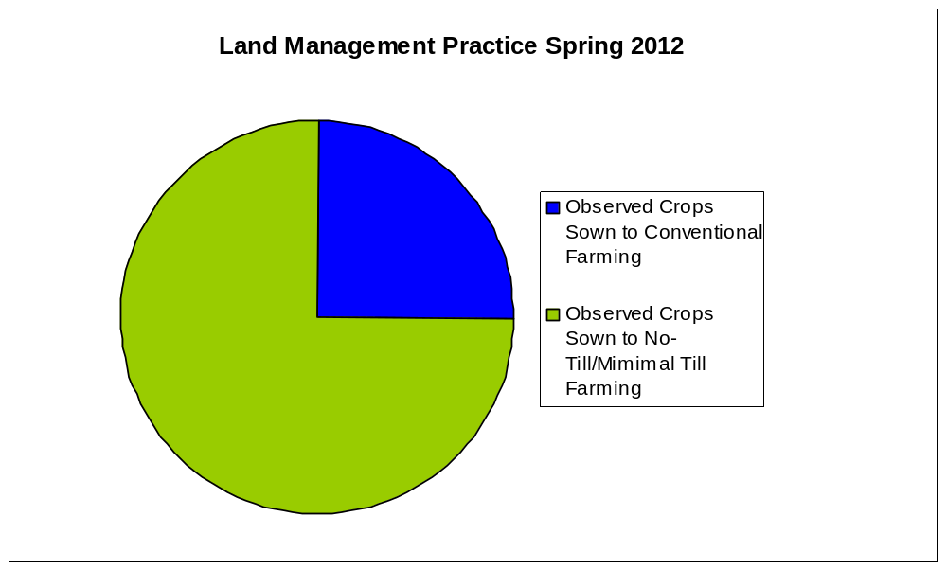
Figure 4: Per cent of cropped sites observed with conventional and no-till/minimal till farm practices during the spring 2012 survey.

Sheep and cattle were observed at 10.8% of sites surveyed during the spring 2012 survey. Cattle were present at three sites and sheep present at seventeen sites. One hundred and thirty seven (87.3%) of sites recorded an absence of stock (Figure 5).

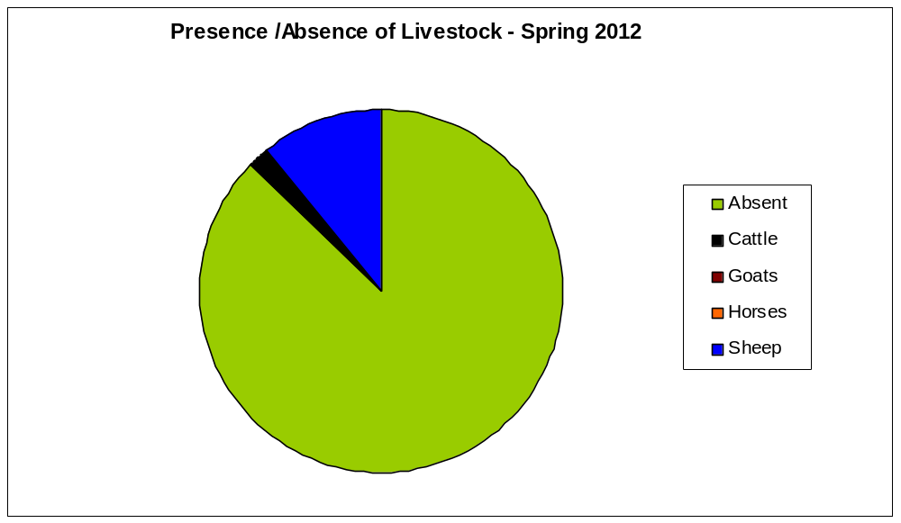
Figure 5: Per cent of sites with livestock absent/present, observed during the spring 2012 survey.

Vegetation Measurements

Spring 2012 survey reported that 69.4% of survey sites recorded greater than 50% of vegetation cover, indicating that these sites are at a low risk of wind erosion. Forty eight or 30.6% of sites had greater than 10% to 50% cover. Nil sites recorded less than 10% vegetation cover (Figure 6 and Table 8).

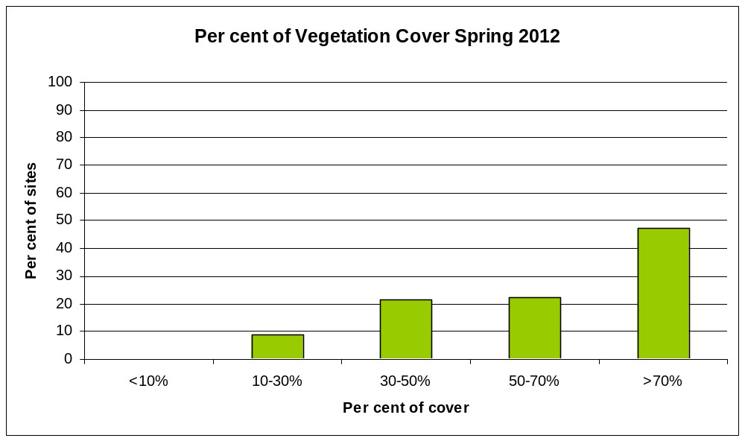Figure 6: Per cent of vegetation cover at sites surveyed for spring 2012 Mallee Soil Erosion and Land Management survey.

Spring 2012 survey recorded that all sites had greater than 10-30% coverage. Two of the six land systems recorded greater than 62% vegetation cover.

Table 8: The per cent (and number) of sites by land system recorded vegetation cover during the spring 2012 survey.
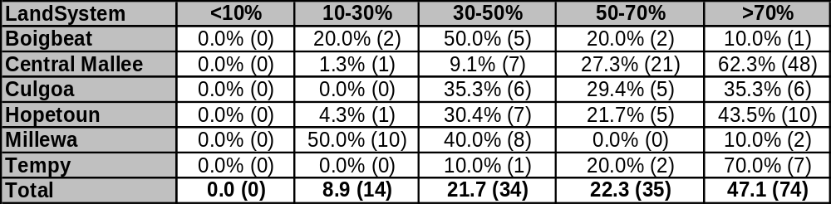

Erosion Risk
Q Value

Table 9: The per cent (and number) of sites with low, medium and high erosion risk calculated using the formula derived by Leys (Leys et al, 2002)
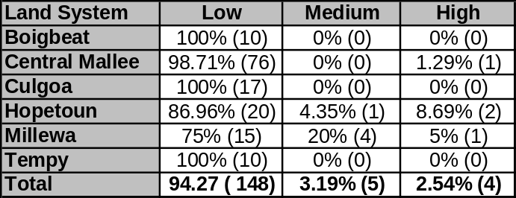
Soil erosion risk matrix

Table 10: The per cent (and number) of sites with low, medium and high erosion risk estimated using the soil erosion risk matrix (Table 4).

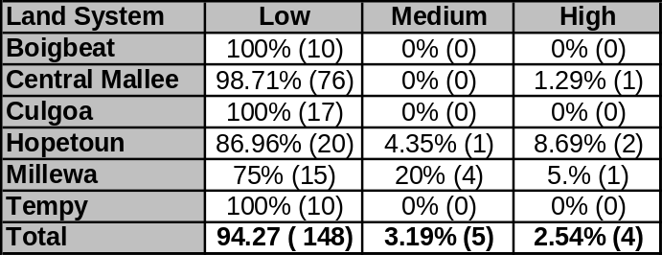
Assessment of soil stability

Table 11: The per cent (and number) of sites with a detachment rating of 1, 2 or 3.
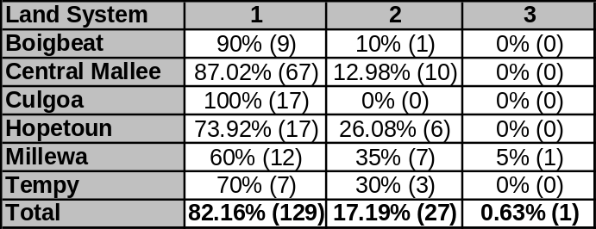

From the different wind erosion risk methods utilised for the spring 2012 survey, consistent results were shown for two of the methods (Q value and soil erosion risk matrix). The Q value (Table 9) and the soil erosion risk matrix (Table 10) indicate that 94.27% of sites were in the low risk category. The Q value method and soil erosion risk matrix recorded four sites (2.54%) with high risk of wind erosion. However the assessment of stability only recorded one site (0.63%) at a high risk of wind erosion. The visual assessment of soil stability must be viewed with caution due to a number of officers making this observation.

Conclusion
During the spring 2012 survey:-
- Soil erosion matrix resulted in 94.27% of sites recording a low risk of erosion
- 69.4% of sites had greater than 50% vegetation coverage rating these sites as a low risk of erosion
- 75.80% of the sites were sown to crop including cereal, legumes and oil seeds.
- 12.1% of sites were in a chemical fallow phase and 1.3% in a conventional fallow phase.
- 10.8% of the sites were recorded under a pasture management phase
- 25% of the cropped sites surveyed were being managed with conventional farming practices and 75% of the cropped sites surveyed were being managed with no-till/ minimal till

Recommendations
- Continue collaborating with NSW, SA and WA to continue to develop soil erosion monitoring protocols, in particular to develop methods to measure risk of erosion.

- Refining definitions of pasture and chemical fallow.

References
Agricultural Bureau of South Australia. (2002). Better Soils: Module 1 How healthy is your soils? http://bettersoils.soilwater.com.au/

Boucher, S. (2005a). Recommendations for benchmarking and monitoring soil erosion by wind. In. Department of Primary Industries.

Boucher, S. (2005b). Review of the DPI (CAS) Annual Mallee Wind Erosion Survey. In. Department of Primary Industries, Werribee.

Erlandsen, S. & Sonogan, R. (1987). Assessment of wind erosion on crop land. Report dated 23 September 1987. In. Department of Conservation, Forests and Lands, Mildura.

Clune, T. (2005). Wind erosion in the Mallee. A milestone report for CMA project 04/133. PIRVic, Department of Primary Industries Victoria.

Grant, R. (1978). Report on the Mallee fallow condition and cultivation practices survey, 1978. In. Soil Conservation Authority, Mildura.

Grant, R. (1979). Report on the Mallee fallow condition and cultivation practices survey, 1979. In. Soil Conservation Authority, Mildura

Levy, E.B. & Madden, E.A. (1933) A point method of pasture analysis. NZ Journal of Agriculture, 20, 267-79.

Leys, J., Heidenreich, S., Murphy, S., Koen, T. & Biesaga, K. (2007). Lower Murray Darling CMA Catchment Health Report Card - Wind Erosion. In. Department of Environment and Climate Change, NSW.

Leys, J., Koen, T. & McTanish, G.H. (1996) The effect of dry aggregation and percentage of clay on sediment flux as measured by a portable field wind tunnel. Aust. J. Soil. Res.(34), 849-61.

Leys, J., Semple, W.S., Raupach, M.R., Findlater, P. & Hamilton, G.J. (2002). Measurement of Size Distributions of Dry Soil Aggregates. In Soil physical Measurement and Interpretation for Land Evaluation (eds N. McKenzie, K. Coughlan & H. Cresswell). CSIRO Publishing, Collingwood

MacEwan, R. (2005). Recommendations for integration of Wind Erosion Monitoring in the Mallee Soil Conservation Strategy. In. Primary Industries Research Victoria.
McCord, A. (no date). State Survey Monitoring Manual Cropping. In (ed P.L.I. Land Resource Unit), Vol. 2006. PIRSA.

McIntosh, G., Leys, J. & Biesaga, K. (2006). Estimating groundcover and soil aggregation for wind erosion control on cropping land. In Farmtalk fact sheet. Mallee Sustainable Farming.

Rowan, J.N. & Downes, R.G. (1963) A study of the land of north-western Victoria Soil Conservation Authority, Victoria

Wakefield, L. (2007a). Monitoring Mallee Soil Erosion Photo Standards. In. Department of Primary Industries, Walpeup

Wakefield, L. (2007b). Monitoring Mallee Soil Erosion Summer Survey Final Report 2007. In. Department of Primary Industries Victoria

Wakefield, L. (2008a). Mallee soil erosion and land management survey - Late summer 2008 report - Draft. In. Department of Primary Industries

Wakefield, L. (2008b). Mallee soil erosion and land management survey - Post cropping and spring 2007 report. In. Department of Primary Industries

