ARARAT LANDCARE GROUP Inc.
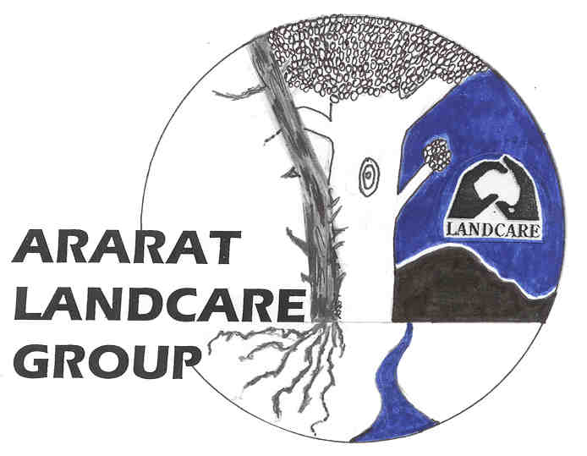
Inc. No. A00119363 VFF Membership No. 992505

Presidents Report 2006/07

As 2007 draws to a close, marking our 8 years as an active urban Group, this report will cover some of our main activities since November 2006.

Weed Control

As one of our main projects – to eradicate weeds, especially gorse, from all public land in the Town – the spray team has continued its efforts throughout the year. On behalf of Council we have extended the areas sprayed to include some roadsides especially Bryant, Burke and Chalambar Roads past Montara Winery. There are now some impressive stretches of dead gorse hedges along all those roadsides.

Additionally a large block of privately owned land adjoining a section of Cemetery Creek and amply covered with gorse has been effectively sprayed. Permission for this was given by the owner who now lives in W.A. and an appropriate invoice will be sent, with photographs, in due course. There is a need to re-spray gorse re-growth along extensive areas of Cemetery Creek.

Indigenous Tree Planting

Although we were all hopeful about resuming our native tree and shrub planting program early in 2007 the winter and spring months have largely thwarted our optimism. However we have conducted a couple of plantouts, one on National Tree Day and the other as an on-going program at the Ararat Hospital. The Car Park area at the Hospital has been very colourful as many of the native flowering plants have been in bloom during spring. We hope that members of the public have noticed and appreciated the qualities of native vegetation including hardiness and beauty! Members of our Group also assisted the Ararat Regional Biolinks Group with a School planting along Cemetery Creek.

Cemetery Creek Walking Track

The section of walking track around the velodrome was upgraded in June when the Langi Kal Kal prison gang spread gravel supplied by Council along its length. Cement dust was then added, a rotary hoe mixed it together and the result was compacted to form a reasonably solid path. Our thanks go to Daryl Scherger who organised the Council supplied materials and equipment. A small section through the pines has yet to be done.

Geoff Ryan has continued to place more nest boxes in trees bordering the walking track. We hope a new and lighter ladder will be helpful from now on. The nest boxes now number over 40 and are designed to cater for parrots, ducks, kookaburras and sugar gliders. All but the Kookaburras have used the nest boxes. European bees have been removed from several boxes.

The footbridge between Acacia Avenue and Beveridge Street was dismantled recently by DSE as the main bearers were beginning to rot. Large pipes topped with gravel replaced the bridge. Thanks to Aileen Banfield (Biolinks Group) for organising the change.

So that some walkers needing a rest can be catered to, Council has supplied and installed two seats near the track, one of them close to our landcare bridge built over the Creek and opened at a ceremony last October. It should be a good viewing spot with a nest box in a nearby eucalypt.

The Mountain Bike Problem

Significant numbers of young mountain bike riders seeking challenging terrain invaded several sections of tributaries leading to Cemetery Creek. This action has given us a challenge too as their fun is causing damage and parents do not seem to regard the practice as harmful in the same way as we do.

There has been much discussion in landcare meetings during the year, letters have been written to Council and the local newspaper, the young people have been spoken to but no positive outcome has resulted so far.

We have suggested to Council that if a suitable area of public land was chosen on which a challenging course could be built it might divert the attention of the young people away from the Creek. If they were consulted about the design of the Course it might have a positive result. Council has been told about a well designed Course which has been built at Anglesea and Council Officers may inspect this site.

Meetings, Guest Speakers and Visitors

We continue to meet on a monthly basis and have welcomed a number of Guest Speakers during the past year. Speakers topics have been wide ranging: Simon Martin from DPI talked about Weed Spotting of State Prohibited Weeds, Ray Draper – Chytried Fungus surveys of frogs in SW Victoria, Russell Pearse – Greenhouse Action Group formed in Ararat, Jo Robinson, DPI, Agriculture and Veterinary Chemical Regulations and Peter Forster on landscape and farming impressions of Jiangxi Province, China. Other visitors have included Mary Johnson, NRM Regional Co-ordinator and Peter Butcher the new CEO from Glenelg Hopkins CMA who was in Ararat to meet Community Leaders and familiarise himself with the area.

Meetings are usually well attended except when a flurry of travelling has affected members. Some have wintered in the Kimberleys whilst others have visited foreign parts such as China and New Zealand. All have interesting tales to tell.

Some of us have been able to attend farm visits – John and Lyn Anderson’s property near Willaura, a workshop on farm biodiversity at Concongella and the Glenelg Hopkins CMA Landcare Awards at Hamilton. I was personally delighted to meet up again with Bill Golding who won a major award as the initiator of the 250 km SW Coast walk to and from Portland. Bill and I had attended Melbourne University together back in 1950!

Conclusion

In review it has been another full and active year. My thanks again go to my colleagues and fellow officials, to Ararat Rural City Council personnel and to members of GHCMA, DPI and DSE who help in a variety of ways.

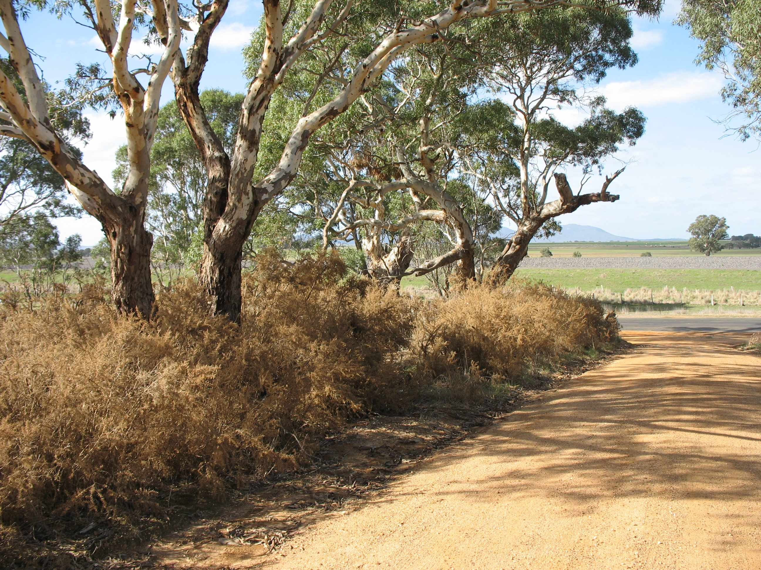

Secretary:
Peter Forster, 655 Jackson’s Creek Rd, Ararat, 3377
Tel: 5352 1530 Fax: 5352 3363
Email: forster@netconnect.com.au

