A REPORT ON THE
SEVEN CREEKS AND MOUNTAIN HUT CREEK
CATCHMENT AREA
(EUROA WATER SUPPLY)
A Proposal for Proclamation
Prepared for Consideration by the
Land Conservation Council
By
J F Wood
&
D M McKinnon
March 1984
SOIL CONSERVATION AUTHORITY
378 COTHAM ROAD, KEW, 3101
INTRODUCTION
The streams from which the township of Euroa (population 3000) derives its water supply, drain the upper reaches of the Seven Creeks catchment and the Mountain Hut Creek catchment. The Euroa Waterworks Trust is responsible for the supply.
Interest in the water resources of the Seven Creeks catchment for irrigation and for additional water for urban and industrial use was brought before the Parliamentary Public Works Committee of Enquiry on Water Resource of Victoria in 1961. The lack of an adequate water supply of suitable quality had, in the opinion of the local community, been a major factor in the town failing to attract industrial development. After considering evidence the Committee reported" in 1964. Three main proposals were considered. None were proceeded with; although site investigations were carried out at the Currie McMasters site on Seven Creeks, but were terminated when suitable foundations could not be found.
The Trust continued to seek alternatives for augmenting township supply and adopted the proposal to have a second storage on Mountain Hut Creek. Construction was completed in 1979. This became the GA Waterhouse Reservoir.
A small section of the Seven Creeks catchment, at its north east extremity, falls within the Shire of Violet Town (refer Figure 2). The remaining catchment areas are within the Shire of Euroa. Portions of the parishes of Boho, Borodomanin, Lima, Marraweeny, Strathbogie, Too-Rour and Wondoomarook cover the areas.

∗ Progress Report No. 4 The Parliamentary Public Works Committee on Water Resources of Victoria Enquiry - Seven Creeks Basin

CATCHMENT FEATURES 1. General
The Seven Creeks is one of numerous streams within the Goulburn Basin emanating within the ranges south of the Hume Highway between Seymour and Benalla. These streams carry large quantities of sediment onto the plains north of the highway and beyond.
Mountain Hut Creek is a tributary of Seven Creeks. The streams rise in the Strathbogie Ranges south east of Euroa and join some 8 km upstream on Mountain Hut Creek, make up respectively 94% and 6% of the total catchment area of 191 km².
The catchments are predominantly closely settled, cleared grazing lands. Holdings range in size from small residential blocks to grazing properties up to 400 ha.
There are several small rural localities in the area; but, Strathbogie, at the junction of Spring and Seven Creeks, is the only township within the catchment. It has a population of about 70.
Figure 1 - Catchment Locality Plan
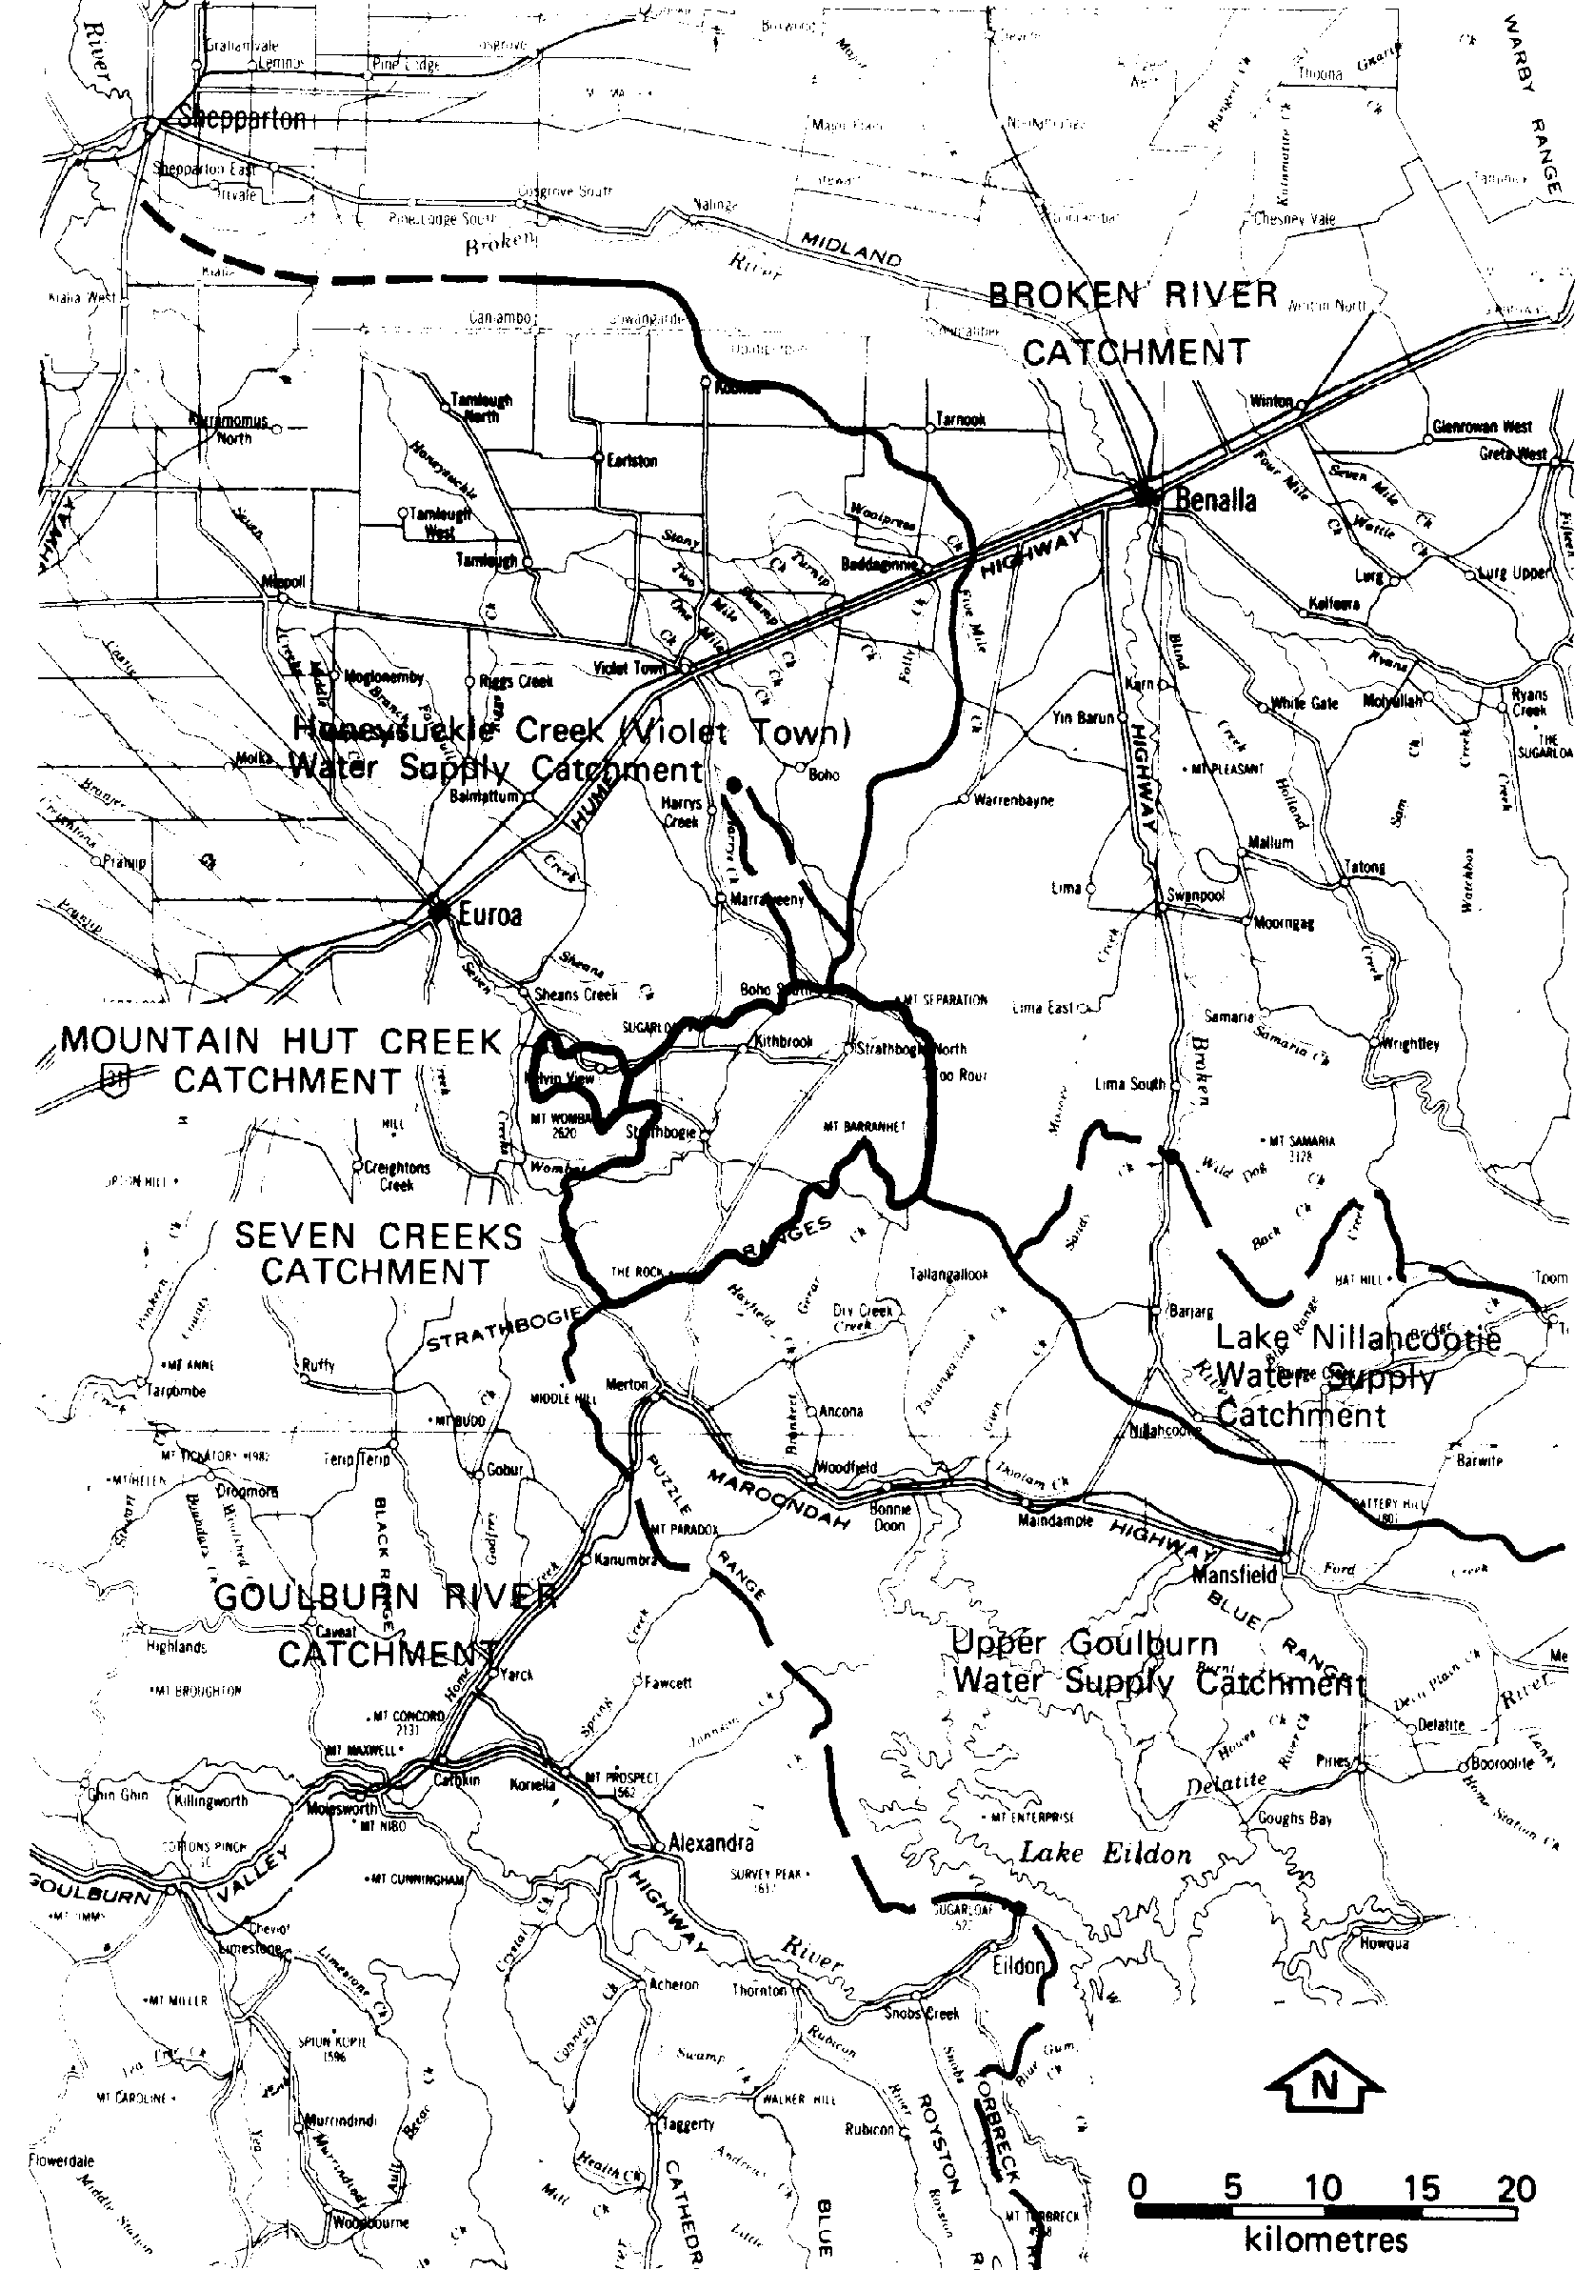
2. Geology, topography, soils
The whole of the catchments are situated within the area of the Strathbogie Plateau, an elevated area formed on the Strathbogie pluton (granite). The emplacement of granite was associated with major volcanic activity (Violet Town volcanics) during the Upper Devonian periods.
The plateau has a gently rolling land form on which a characteristic rectangular drainage pattern has developed. Land dips from the east (average elevation 650 m), to the west (average elevation 500 m) where both creeks outfall via an escarpment to the plains, some 200 m lower. Surface rock is present in many areas with granite tops prominent on the rises. Features of the landscape are two prominent peaks: Mt Barranhet (823 m) on the southern boundary in the east and Mt Wombat (799 m) on the north western extremity of the plateau on the Mountain Hut Creek catchment boundary.
Soils formed on the granite are sandy in nature and mainly reddish duplex types, weakly bleached friable gradational types or friable reddish gradational types. All have weakly structured subsoils often sandy in nature.
Figure 2 - Municipal Boundaries
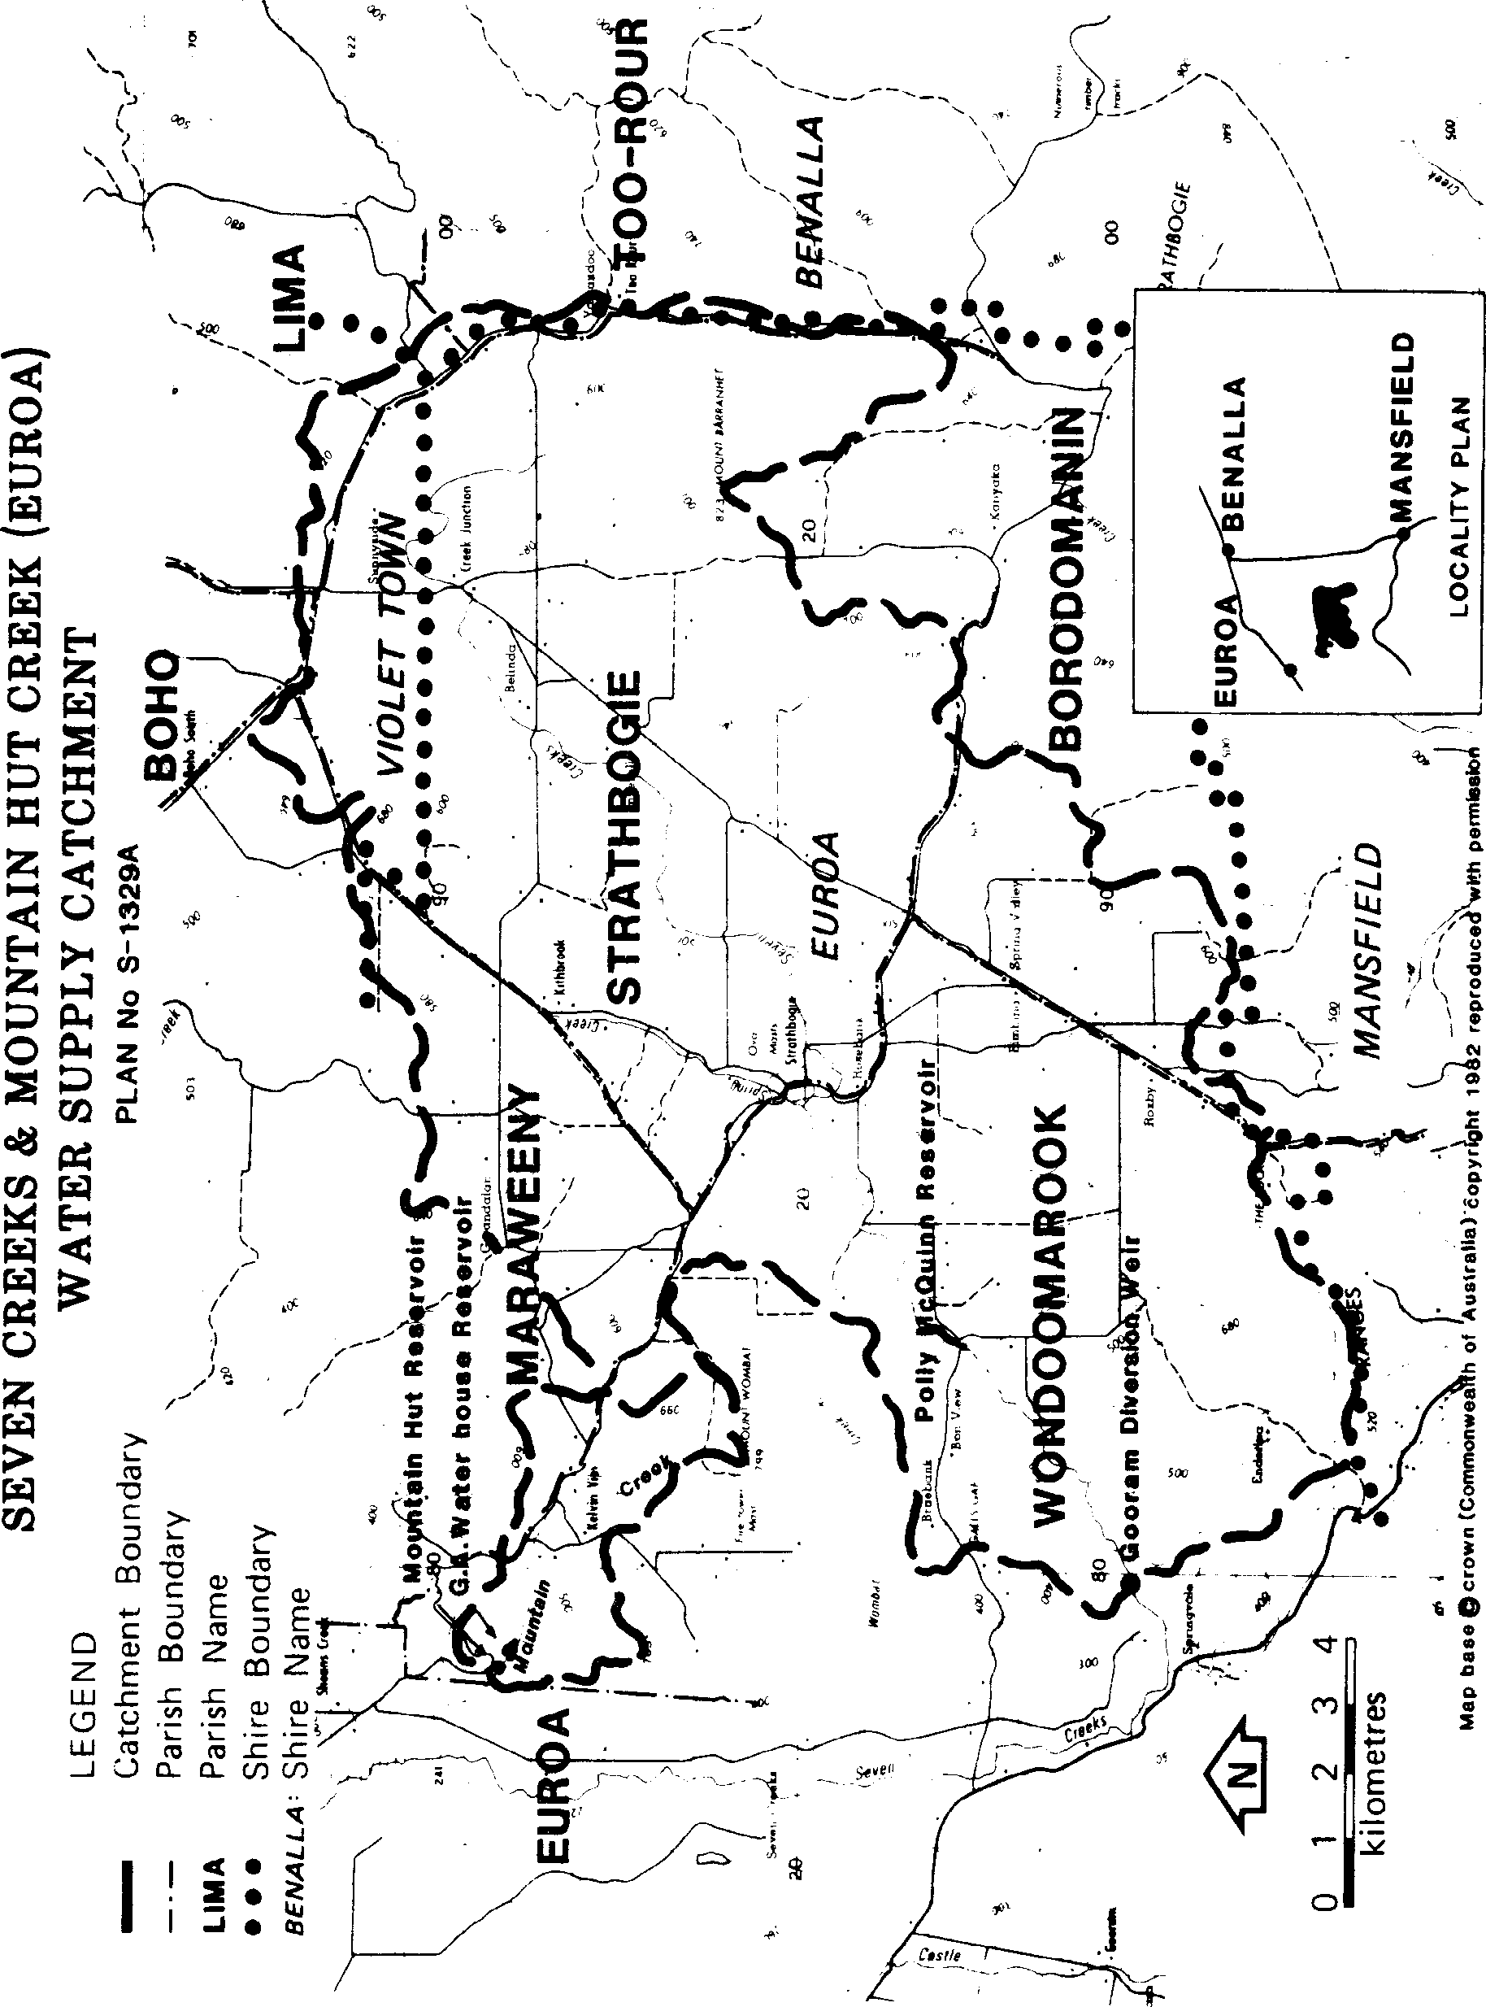
- Climate
The northern, eastern and southern ridge of the catchment and adjacent hills form a slightly elevate rim surrounding the central valley of Sevens Creeks, thereby creating a moderate rain shadow along the valley. Annual average rainfall varies from 1200 mm at the head of the valley to 900 mm on the lower country. Light snowfalls occur regularly on the plateau.
No temperature records are available from stations within the catchment. Euroa, located on the adjacent lowlands, is the nearest recording station. Here the average daily maximum temperature is highest in February (28.9ºC) and lowest in July (11.9ºC). The average daily minimum temperatures also are highest in February (16.2ºC) and lowest in July 7.7ºC).
On the plateau temperatures would be noticeably lower than those recorded at Euroa. Climatic conditions on the plateau would have the effect of significantly suppressing growth during winter (but of extending the growing period to late spring). It is estimated that the first severe frost may occur in April and frosts could be expected to continue until early November.
- Vegetation
The original vegetation of the plateau comprised on open forest with heaths and moss beds scattered throughout. Predominant timber species were messmate stringybark, narrow leaf peppermint and broad leaf peppermint associated with red box, long leaf box and mountain swamp gum. Numerous understory species were present but most significant were the wetland species sch as tea tree.
Land development since occupation has resulted in clearing a major part of the native vegetation. Continued clearing or the natural decline of native species under a grazing regime has reduced further the number of native species generally retained about watercourse depressions and wet area. Tea tree, a natural and prolific coloniser in the wetter area, is still preferentially removed.
Public lands are now the only significant areas of forest cover. Softwoods account for some 120 ha.
Figure 3 - LCC Recommendations
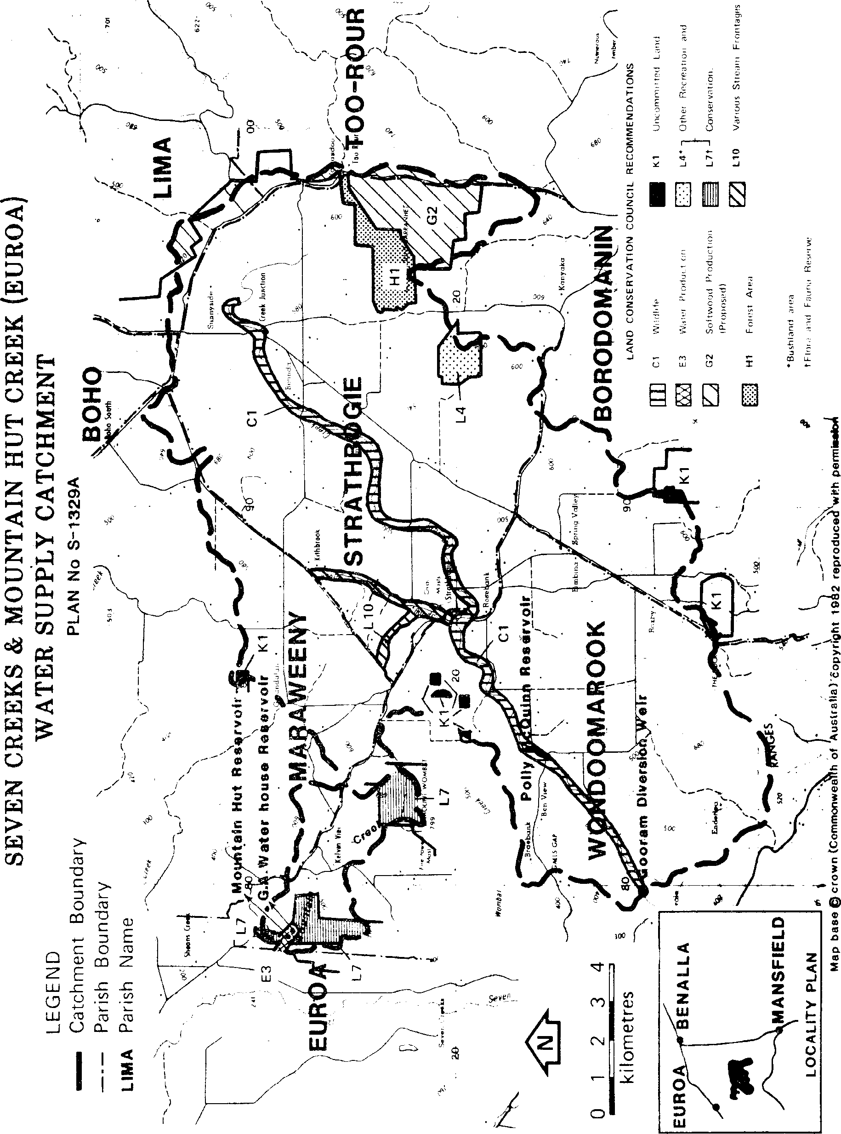
LAND TENURE AND LAND USE
- Freehold land
Approximately 1860 km², or 97% of the total catchment area, is freehold land. The most common land use is sheep grazing for wool and meat production: although, over more recent years cattle numbers have increased significantly. Stock generally have unrestricted access to streams, watercourses and the soak areas throughout the catchment. Stocking rates are relatively high and the surface horizons of soils are light. The combination of these factors places considerable pressure on the drainage system and its environs due to the level of activity and the resulting disturbance.
Cropping is only rarely practices throughout the area, the most intensive use of land being a small area of grass seed production (phalaris and cocksfoot) for which the plateau is noted; also, there are several small orchards.
Much of the low lying land that remains perennially wet is considered by landholders to be a problem because of the rapid tea tree growth. The tendency is to convert these boggy areas to grassland by drainage, grubbing of the tea tree and the sowing of pasture.
- Public Lands
There are various parcels of public land (Figure 3) distributed throughout the catchments approximating 3% of the total area. Mountain Hut Creek catchment contains approximately 25% public land.
In terms of area and location the most significant areas of public land are those adjacent to streams. There is an excess of 25 km of streams where this occurs as frontages (reserved or unreserved). Most of these frontages are leased to adjacent landholders; few are fenced and native vegetation has been cleared from a high proportion where they abut freehold land, allowing unrestricted access of stock to the streams.
Reserved Forest is situated at the headwaters of both Seven Creeks and Mountain Hut Creek, within the more rugged sections of the catchment.
Recommendations" for public land in the catchment have been made. These are shown on Figure 3. An edited extract from these recommendations is given below. These have been approved by Government and the relevant bodies have been directed to implement them.
C1 (Seven Creeks wildlife Reserve)
- That the Seven Creeks above Halls Gap road, including Gooram off-take and indicated on Figure 3, be used for the conservation of the trout, cod, and other native fish.
- That the stream frontages on the Seven Creeks from allotment 11A, Section A, Parish of Wondoomarook (Halls Gap Road) upstream to allotment 6, section D, Parish of Strathbogie, including that section above the Gooram off-take and indicated on Figure 3, be used for the
conservation of wildlife and for water supply purposes. At present it is anticipated that proper management for thee uses will not require closure of any further section of Seven Creeks to angling.
∗ "Final Recommendations. North Eastern Study Area - District 2" Land Conservation Council, Victoria Melbourne, July 1974.
(c) That adjacent landowners should be permitted to obtain water for their stock and that the area
designated in C1 (b) be permanently reserved under section 4 of the Crown Land Reserves Act 1978 as a wildlife reserve to be managed by the Fisheries and Wildlife Division in consultation with the Euroa Waterworks Trust.
E3 That the area of 8 ha indicated on the map and shown on Figure 3 be used to protect the lower water
storage on Mountain Hut Creek and that it be reserved for water supply purposed under section 4 of the Crown Land Reserves Act 1978 and be under the control of the Euroa Waterworks Trust as a committee of management.
G2 (Toorour-Boho)
That the area indicated on the map and shown on Figure 3 be used for softwood production and that it be reserved forest.
H1 That the area indicated on the map and shown on Figure 3 be used for:
- conservation of fauna and flora, and preservation of scenic values;
- protection of the adjacent area recommended for softwood production;
- low-intensity hardwood production, recreation, forest grazing, honey production, and mining where these activities do not conflict with (a) above; and that it be reserved forest.
Council also recommends that the fundamental importance of the Mount Barranhet area as a source of domestic water be recognized in its management.
K1 That the land indicated on Map A and shown on Figure 3 be used to:
- achieve or maintain stability of the land and maintain its usefulness for all possible future used;
- protect water catchments;
- conserve native fauna and flora;
- provide other activities and products that are necessary to achieving, or do not conflict with, the uses above;
and that it be uncommitted land and become unoccupied Crown land proclaimed as protected forest.
L4 (Bald Hill bushland reserve)
That the area indicated on the map and shown on Figure 3 be used to maintain the local character and quality of the landscape and that it be permanently reserved under section 4 of the Crown Land (Reserves) Act 1978 for the purposes stated above.
L7 (Mount Wombat-Garden Range flora and fauna reserve)
That the area indicated on the map and shown on Figure 3 be used to:
- provide a source of water for domestic use in Euroa (Mountain Hut Creek watershed);
- protect and conserve the flora and fauna;
- provide recreational and educational experiences related to an appreciation of natural environments;
- provide for firewood and posts where intensity, locality and method of use do not conflict with the primary uses (a) and (b);
and that it be permanently reserved under section 3 of the Crown Land (Reserves) Act 1978and managed by the Forests Commission.
L9 (i) That the road reserved in rural landscapes be used to help maintain the local character and
quality of the landscape and that their uses in reducing the hazard of fire to and arising from road-users should be consistent with maintaining these values.
- That the road authorities institute more effective control over removal of road-making material and the rehabilitation of such sites on road reserves.
- That, because of the importance of indigenous vegetation and fauna habitat on some of these reserves, the relevant management authorities should adequately assess the environmental consequences of any management practices.
L10 (a) That all reserved stream frontages including those shown on Figure 3 be used to conserve
native flora and fauna, to provide opportunities for outdoor recreation where appropriate and to maintain the local character and quality of the landscape, and that these frontage remain or be permanently reserved.
(b) That, where these frontages are subject to water frontage licences, the relevant legislation and
regulations should be amended so as to clearly provide for public access to and use of these lands for recreation, such as fishing, picnicking and walking.
- Trust Land The amount of land over which the Trust has control around its storages or headworks differs as set out below.
Polly McOuinn Reservoir Little of the land above FSL is controlled by the Trust. Freehold land extends
almost to the waters edge making fencing impractical for the greater part of the boundary. The public and stock have virtually free access to the water.
Gooram Diversion Weir The weir is set within a broad section of public land frontage, remote from public
access and difficult for stock access. Informal control on entry is exercised by the Trust.
G A Waterhouse Reservoir A total area of about 13.5 ha including the storage and surrounds is fenced and
managed by the Trust. Entry of the public or stock is prohibited.
Mountain Hut Reservoir Public land surrounds the storage. The site is unfenced, but agreement with the
relevant authority has been reached for the erection of a fence to discourage vehicular access to the reservoir.
- Roading
Road reserves account for 2% of the catchment area. Many are unused and a proportion of these are leased for grazing. More than 70% of constructed roads are unsealed.
- General
The provision of extensive vehicular access and of public access to the streams make the area popular for day touring. In addition, camping, fishing and swimming are also popular activities within the area.
- Future Trends and Planning
The Strathbogie Plateau with its mild summer climate and picturesque landscape has, over recent years, attracted a number of hobby farmers and rural residents to the smaller holdings or allotments. If this trend continues increasing pressures will be present for development of the area. The additional roads and additional drainage of the wet areas will result in a greater amount of "hard surfacing" that will contribute to greater and more rapid run-off to the drainage system.
The Shire of Euroa is currently preparing a planning scheme that will require a more comprehensive evaluation of land to be made for subdivision purposes. Cental to that evaluation procedure is information provided by the Soil Conservation Authority in the form of erosion risk ratings, for land throughout the Shire. A significant point about these ratings for land within the catchment areas is that the majority of the plateau falls within a moderate erosion risk category. That is to say, the majority of land is suitable for further development but requires careful planning to prevent land deterioration. A strong recommendation has also been made for the Planning Scheme to recognise the water production role of land within the catchment areas.
Figure 4 - Water Supply Headworks
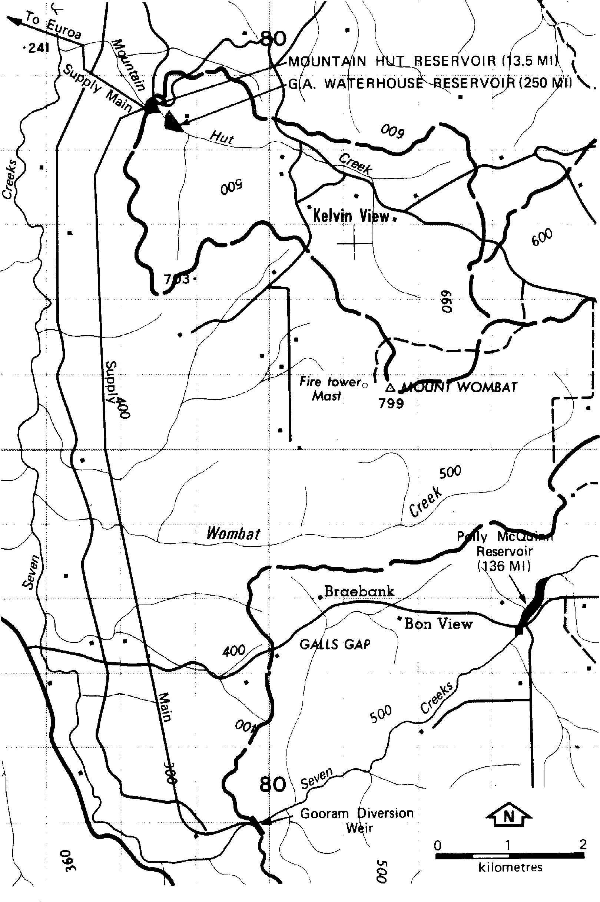
WATER SUPPLY
- Water Supply Systems
The Euroa Waterworks Trust supplies domestic water to the township of Euroa and to 70 private services, between Gooram offtake and the town, from headworks on both Seven Creeks and Mountain Hut Creeks (refer Figure 4). The Trust relies on Seven Creeks as the major source of supply.
The Trust supplies about 1000 services in the urban area that produce a maximum demand of about 5.4 ML per day during January and February. During these months a further demand of 0.5 ML per day can be attributed to the rural and farm services supplied along the route of the pipeline.
Seven Creeks
Water from the Seven Creeks is diverted at the Gooram offtake weir for gravity feed directly to the town service basin or alternatively to the Mountain Hut reservoir in the adjacent catchment. The weir has not significant capacity so that when base flow is insufficient both for the Trust's requirements and the maintenance of low in Seven Creeks, flow to the weir is regulated by released from Polly McQuinn reservoir, some 5 km upstream of the weir.
Polly McQuinn is an on-stream storage, situated some 6 km downstream of Strathbogie. The present capacity is not known, but due to sedimentation is thought to be some 60% les than the design capacity of 136 ML. The Trust is currently investigating means for removing plant growth (Cumbungi) and silt from the storage to improve its effectiveness.
Mountain Hut Creek
The main storage on Mountain Hut Creek is the GA Waterhouse reservoir of 250 ML capacity. A second storage, the Mount Hut reservoir, of 13.5 ML capacity is located about 500 m downstream. It receives throughflow and regulated output from the upper storage or may receive water from the Seven Creeks pipeline. From the Mountain Hut reservoir water is gravity fed to an open service tank (2.2 ML) before distribution to the town system. Chlorination of the supply is carried out at the service tank.
- Water Quality
Water samples are taken monthly from various points in the system for bacteriological and physical analysis. Results from these tests show that turbidity, colour and E. coli levels of the supply are frequently above desirable levels. Of particular concern are the high turbidity levels experienced in early autumn. These levels frequently interfere with the normal method for bacteriological analysis.
Although supply is chlorinated, E. coli numbers are repeatedly detected in the "treated supply". Conditions contributing to this may be the lack of detention period following chlorination, high turbidity or re-infection due to the open service tank.
Higher E. coli counts are generally detected in samples taken from Mountain Hut reservoir rather than from Gooram offtake. The reason for this is not known.
HAZARDS TO WATER SUPPLY
- Grazing
The greatest single factor thought to be affecting water quality is the general effect on the relatively high grazing pressure in the area. With few exceptions stock have unrestricted access to the extensive spring areas and to water courses throughout the plateau. During periods of low stream flows problems with faecal contamination are accentuated.
Of major concern is the condition of many of the stream environs particularly along Seven Creeks where public land frontages are present. Natural vegetation is absent or diminishing under present management, reducing the protection which areas such as these could be expected to provide for the stream.
- Intensive Agriculture
During heavy rains sheet erosion of cultivated areas does take place. At present it is not considered to be a significant problem due to the limited area involved; but an increase in cultivated area, particularly for orchards or grass seed production, may lead to greater hazards if suitable conservation measures are not observed.
The possibility of contamination from indiscrete use of sprays, particularly on land close to streams is also a potential risk.
- Forestry
Forestry operations are not expected to have a marked effect on the water quality. Increases are expected in runoff and turbidity during rainfall could be expected with the construction of roads and tracks. However, with the use of appropriate conservation measures during operations and with adequate maintenance of tracks and roads, the deterioration in water quality should be minimised.
- Siltation
Erosion and siltation are still actively occurring within the catchment although probably at reduced rates. The greatest contribution is thought to be coming from the stream zone but a significant amount may be coming from the cumulative effect of roads, tracks, etc.
- Other Hazards
- Strathbogie Township. There is a potential risk that street run-off, contamination from old and
ineffective septic effluent drain fields and the disposal of materials from commercial premises could adversely affect the water quality, particularly as the town is located on the banks of Spring and Seven Creeks.
- Mountain Hut Creek Camp. The camp is located at the head of Mountain Hut Creek and has a
capacity to house some 300 people. Although some basic safeguards have been implemented by the camp
organisation, primary contact, contaminated run-off, and other sources of contamination pose a significant potential risk to pollution of the headwaters stream.
(c) Public access to streams. Seven Creeks and several other main tributary streams are easily accessible
at a number of points where formal and informal recreational developments have evolved over the years. Ponds at Strathbogie and immediately below Polly McQuinn reservoir are two examples where the stream is used extensively for swimming, thereby imposing potential risks to the water quality from primary contact.
Figure 5 - Proclamation Plan
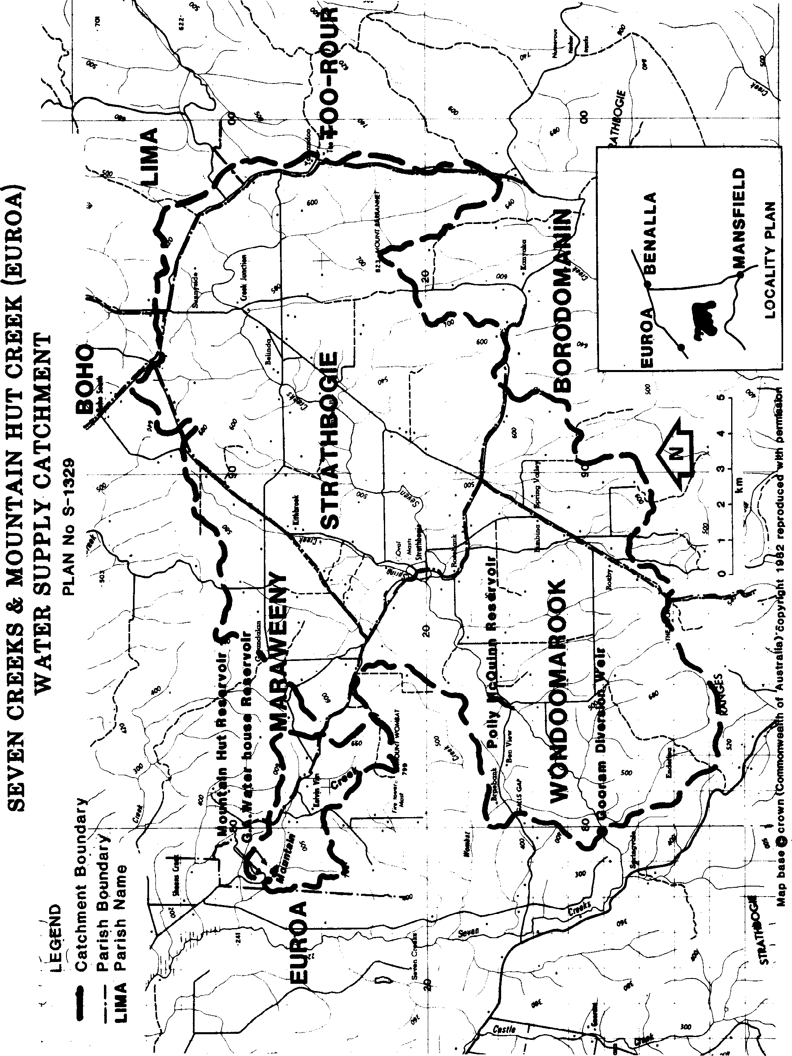
RECOMMENDATIONS
That the Land Conservation Council recommends to the Governor-in-Council that the catchments to the Gooram Diversion weir on Seven Creeks and to the Mountain Hut reservoir on Mountain Hut Creek as shown on Plan No. S-1329 (Figure 5) be proclaimed under the provisions of Section 22(1) of the Soil Conservation and Land Utilisation Act (1958).

