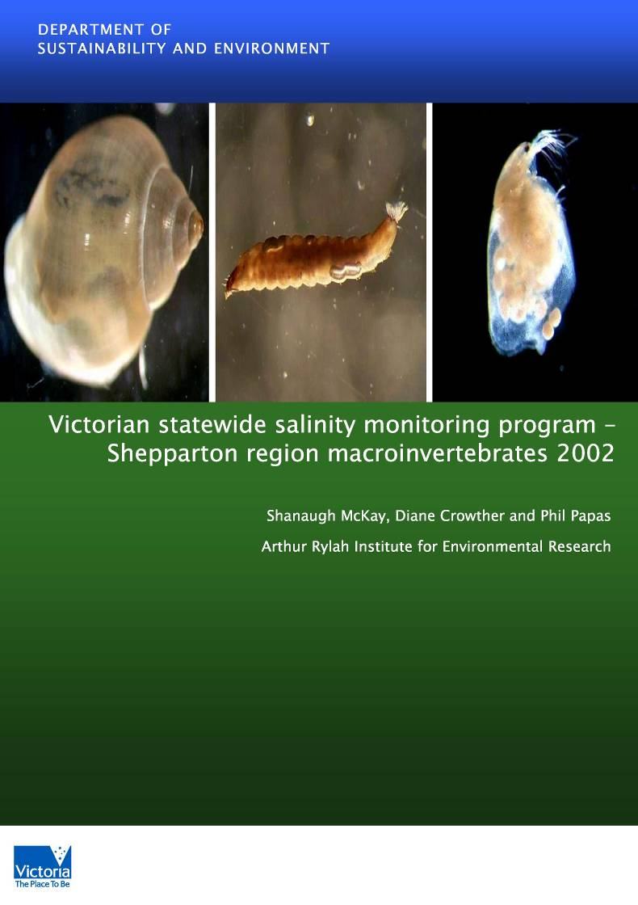
© Freshwater Ecology, Department of Sustainability and
Environment
Title Victorian Statewide Salinity Monitoring Program:
Shepparton Region Macroinvertebrates 2002
Produced by Shanaugh McKay, Diane Crowther and Phil Papas
Arthur Rylah Institute for Environmental Research, Department of Sustainability and Environment, 123 Brown Street, Heidelberg, VIC, 3084
Produced for Department of Primary Industries - Tatura
Date April 2003
Acknowledgments

Thanks are due to Grey Day (DPI- Tatura) for field sampling and Paula Ward for preliminary sorting of macroinvertebrates. Greg Day provided water quality data.
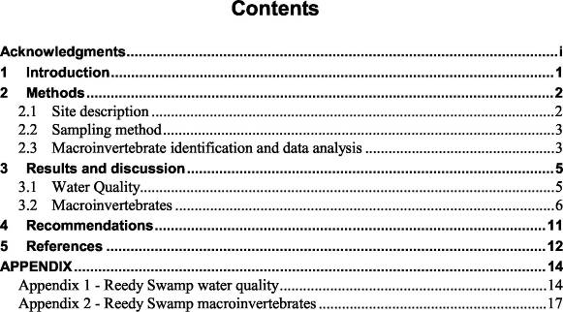
1 Introduction

Rising saline groundwater is one of the most serious environmental problems in rural Victoria. The principal causes for the rise in groundwater tables are the clearing and replacement of deep-rooted native perennial vegetation with shallow rooted annual pastures or crops, and broad-scale irrigation. Remnant vegetation and the aquatic environment are adversely affected by saline groundwater close to the surface. Groundwater movement and runoff draining into wetlands and streams from other saline affected areas can also have an adverse impact. Measures to control the rising saline groundwater table, such as groundwater pumping and sub-surface draining may have additional impacts on the terrestrial and aquatic environment. The Victorian Government Salinity Program through the Victorian Statewide Salinity Monitoring Strategy (VSSMS) aims to minimise the impact of rising groundwater tables on the natural environment and to prevent any further impacts arising from salinity control measures.
The VSSMS is designed to report on all aspects of the Salinity Program (Vic. Gov. undated). One component of assessing the effects of this program on the environment is the monitoring of aquatic macroinvertebrates in wetlands. This is mandatory in most of the Salinity Management Plans (SMP). Macroinvertebrates were chosen because they are the most commonly used group in Australia for biological monitoring of water quality and sampling is easy and cost efficient. Life histories ranging from weeks to years allow impacts to be detected over the short and long term. In addition macroinvertebrates are a diverse group and show a range of sensitivities and tolerances to various pollutants, including salinity. A number of reviews and studies of sensitivities of macroinvertebrates to salinity have been undertaken including the salt sensitivity of Australian freshwater biota by Hart et. al. (1991), macroinvertebrate stream communities at different salinities (Metzeling 1993), and impacts of saline water disposal on macroinvertebrates (Kefford 1997).
The present design of the monitoring program is such that it will be able to be used in later years of the study to assess long term changes to the health of each wetland. The design does not allow for formal comparisons of the biological health between wetlands or regions, only subjective determinations of the biological health of a single wetland at a given point in time. However, as data is gathered over a number of years the benefits of the monitoring program will be in the determination of whether the biological health of the wetlands is improving or degrading in relation to water quality.
This report presents results of the fourth annual monitoring conducted at Reedy Swamp in November 2002.
Victorian State-wide Salinity Monitoring Program: Shepparton Region 2002
Freshwater Ecology, Arthur Rylah Institute for Environmental Research, DSE 2
2 Methods
2.1 Site description
Reedy Creek is located approximately 3 kilometres north west of the Shepparton, in a predominantly agricultural area. The swamp is in close proximity to the Goulburn River with the western side located approximately 100 m from the river at the closest point. The area is of low relief with elevation at 109 m ASL. Minor roads are present on the eastern side of the swamp. Access tracks, used for recreational purposes, are located in amongst remnant vegetation on the northern, western and southern boundaries. Residential properties are located mainly on the southeastern boundary.
Site selection and sampling was undertaken by the Department of primary Industries (DPI), Tatura. The sampling protocol was based on the ‘Mandatory Environmental Monitoring Program Monitoring Guidelines: Macroinvertebrate Monitoring in Wetlands’ and is outlined in section 2.2. Five permanent macroinvertebrate monitoring sites and two water quality monitoring sites are located in shallow water environments most representative of the wetland (Figure 1).
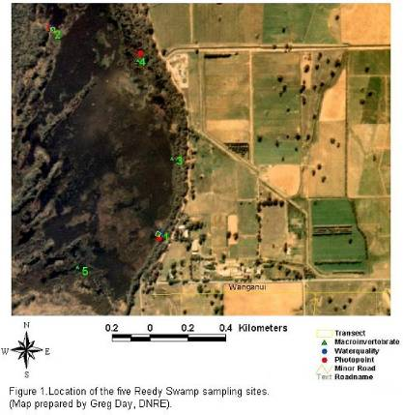
Victorian State-wide Salinity Monitoring Program: Shepparton Region 2002
Freshwater Ecology, Arthur Rylah Institute for Environmental Research, DSE 3
2.2 Sampling method 2.2.1 Macroinvertebrates
Macroinvertebrate samples were taken from five permanent sampling sites using the methods described in (Anon 1996) by a regional DPI staff member. Each site consisted of a permanent marked sampling area of approximately 20 m². From each permanent sampling site, five individual sweep samples were collected using a net size of 500 µm. Each sweep sample within a site was collected from an area approximately 1 m x 1 m and these are referred to as collection points. The five collection points within each permanent sampling site were chosen at random, but each was free from disturbance from the previous collection point(s). Sweep sampling at each 1 m² collection point was conducted for approximately 15 seconds and the samples from all five collection points were combined into one sample. This gives a total of one sample per site.
Samples were taken from collection points by sweeping the net horizontally through emergent or submerged vegetation and around submerged organic debris. The net was swept backwards and forwards, then sideways. The opening of the net was always kept at the front of the direction of the sweep to prevent sample loss. In cases where the water level was much higher than the height of the net, the net was swept through the top strata first and then the deeper strata. After removing any large organic material (twigs, whole plants), the sample was put in a jar and preserved in ethanol.
2.2.2 Water quality
Electrical conductivity and turbidity measurements were taken and water samples collected and analysed for total and soluble nutrients at Sites 1 and 2 (total phosphorus and total nitrogen). Water quality data was compared to that of previous years. Water quality data collected from the two sites was averaged to give an overall figure for the wetland.
2.3 Macroinvertebrate identification and data analysis 2.3.1 Macroinvertebrate identification
In previous years macroinvertebrates collected as part of the salinity monitoring have only been identified to family level. As macroinvertebrates representative of one family can show a wide range of salinity/pollution tolerance/sensitivity it was considered that current and future monitoring should incorporate macroinvertebrate identification to the lowest taxonomic level where possible.
In the laboratory, all macroinvertebrates were removed from each sample, with the aid of a stereo microscope and preserved in 70% ethanol. Macroinvertebrates were then identified to lowest taxonomic level using the latest taxonomic keys. Keys used were Bradbury and Williams (1996), EPA (unpubl.), Govedich (2001), Harvey and Growns (1998), Hawking and Theischinger (1999),
Victorian State-wide Salinity Monitoring Program: Shepparton Region 2002
Freshwater Ecology, Arthur Rylah Institute for Environmental Research, DSE 4
Horwitz et. al. (1995), Pinder and Brinkhurst (1994), Shiel (1995), Smith (1996), St Clair (2000), Watts (2002) and Williams (1980). Taxa that required micro-dissection or where keys were not available were identified to lowest practical level, usually family. A quality control process was used to ensure accurate identification of all macroinvertebrates. The quality control consisted of cross-checking the identification of macroinvertebrates between experienced macroinvertebrate biologists, random checking of taxa identified by an external consultant, the keeping of a voucher collection of all taxa identified and checking the identification of the entire voucher collection by an external consultant.
2.3.2 Data analysis
The percentage abundance of each taxon and taxonomic richness was calculated for each site in the wetland. Macroinvertebrate data from the five sites was combined for analysis, to allow for an overall assessment of macroinvertebrate biodiversity. Sampling during 2002 is the first year that macroinvertebrates have been identified to the lowest taxonomic level possible, therefore data was compared to other years at the family level to identify differences in the macroinvertebrate community composition between years. The multivariate analysis package PRIMER (Plymouth Routines in Multivariate Ecological Research; Clarke & Warwick 1994) was used to perform multivariate analyses of the macroinvertebrate data in order to discern any changes in the macroinvertebrate community composition over time. Similarity Percentages (SIMPER) of species composition and abundances for individual species causing similarity or dissimilarity were determined from the SIMPER output to highlight the taxa that were responsible for the distinction between macroinvertebrate communities observed.
Victorian State-wide Salinity Monitoring Program: Shepparton Region 2002
Freshwater Ecology, Arthur Rylah Institute for Environmental Research, DSE 5
3 Results and discussion
Water quality and macroinvertebrate results for the Shepparton region wetland are presented in the following tables. All raw data is provided in Appendix I.
3.1 Water Quality
Caution must be taken in the interpretation of water quality as results represent a single sample point and may not accurately reflect the background water quality levels. Water quality data from 1997 – 2002 is shown below in Table 1.
Table 1. Water quality data for Reedy Swamp in 1997, 1999, 2001 and 2002

Reedy Swamp | 1997 | 1999 | 2001* | 2002*
Water temperature (ºC) | 28.9 | 22.0 | 24.8 | ns
Conductivity (µS/cm) | 210 | 298 | 231.5 | 395
Turbidity (NTU) | 320 | 24 | 47.5 | 34
pH | 6.0 | ns | ns | ns
Dissolved Oxygen (mg/L) | 9.0 | ns | ns | ns
Total nitrogen (mg/L) | ns | ns | 4.5 | 20.3
Total phosphorous (mg/L) | ns | ns | 0.8 | 3.4

ns = not sampled
Note all values rounded to one decimal place
* Figures derived as an average for sites 1 and 2
Comparisons of turbidity readings at Reedy Swamp across the four years of sampling (Table 1) show turbidity at low to moderate levels in 2002 (20-75 NTU), compared to the somewhat elevated turbidity of 320 NTU found in 1997. Turbidity levels may be higher in spring due to rainfall and therefore the associated run-off from surrounding areas which may contain organic material, nutrients, sediment and other pollutants which impact water quality. Turbidity can also be affected by the presence of algae in the water column.
Electrical conductivity was highest in 2002 with a reading of 395 µS/cm, compared to electrical conductivity levels recorded in previous years of between 210 to 298µS/cm. The values are low and pose no threat to aquatic biota. Total nitrogen and total phosphorus concentrations are higher in 2002 than those recorded in 2001. Nutrient concentrations were not measured in conjunction with macroinvertebrate sampling prior to 2001.
Victorian State-wide Salinity Monitoring Program: Shepparton Region 2002
Freshwater Ecology, Arthur Rylah Institute for Environmental Research, DSE 6
Additional water quality measurements are included in Appendix 1 and indicate total phosphorus and total nitrogen concentrations have increased from June 2002 onwards at both sites in Reedy Swamp and have reached very high levels, particularly at Site 1.
The trophic status of a waterbody can be assessed using nutrient concentrations. Total nitrogen and total phosphorus concentrations at Reedy Swamp are well above guidelines developed by the Advisory Group for the State of the Environment Report (Office of the Commissioner for the Environment: OCE 1988). The high nutrient concentrations recorded in Reedy Swamp, particularly at Site 1 may be due to the inflow of water through the Goulburn Murray Water (GMW) rejected irrigation water channel. High nutrient levels cannot be attributed directly to the channel water until testing for nutrient levels is conducted on this source of water. Another potential source of high nutrient levels in the wetland is from internal loadings, whereby nutrients stored in the sediment are resuspended into the water column. Certain environmental conditions enhance nutrient release from the sediments, including increases in pH and temperature and decreases in oxygen levels at the sediment-water interface. Internal nutrient sources have the potential to cause nutrient problems for many years, even if external diffuse and point sources are controlled (State Government of Victoria 1995).
3.2 Macro i nve rte brates
3.2.1 Macroinvertebrate composition
The beetle families Curculionidae (Adults), Staphylinidae (Adults), and the water spider group Aranae are excluded from taxa lists for analysis as they are predominantly found in the littoral zone and are usually incidentally collected in the samples. Chironomidae pupae and unidentified dipteran pupae and are also excluded from the taxa lists as they don’t contribute to the overall number of taxa. Macroinvertebrate results from current sampling and comparisons of macroinvertebrate composition from all years of sampling at Reedy Swamp are presented below in Figure 2, Table 2 and Table 3.
A total of 39 taxa from 10 orders and 26 families were recorded at Reedy Swamp in November 2002. The most numerically dominant order was Hemiptera (water bugs) accounting for 80% of macroinvertebrate abundances (Figure 2, Table 2). The four most taxonomically rich groups were Diptera (true flies - 10 taxa), Coleoptera (beetles – 10 taxa), Hemiptera (true bugs – 6 taxa) and Odonata (dragonflies and damselflies – 4 taxa).
Victorian State-wide Salinity Monitoring Program: Shepparton Region 2002

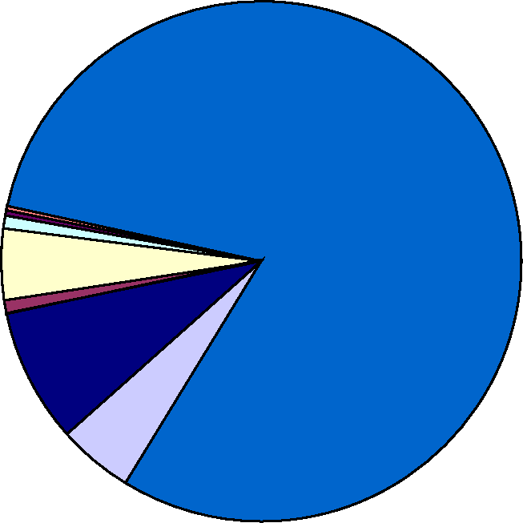

Hirudinea (2) Oligochaeta (2) Mollusca (2) Cladocera (1) Ostracoda (1) Odonata (4) Hemiptera (6) Coleoptera (10) Diptera (10) Trichoptera (1)

Figure 2. Percentage abundance of macroinvertebrate taxa at Reedy Swamp during 2002 monitoring. Number of taxa are indicated in brackets
Freshwater Ecology, Arthur Rylah Institute for Environmental Research, DSE 7
Table 2 summarises the most numerically dominant species recorded in 2002. The numerically dominant Hemipteran order comprised mostly of the Notonectid genus Anisops (a backswimmer) and two Corixid genera Micronecta and Agraptocorixa (water boatmen) The gastropod snail Physa acuta and the Dipteran midge larvae Chironominae were also numerically dominant in Reedy Swamp.
The dipteran families Ephydridae and Stratiomyidae, maggot like fly larvae, have been recorded for the first time in Reedy Swamp. Ephydrids and stratiomyids graze on microalgae and are typical of still waters and often occur in highly polluted or low oxygen environments such as stagnant, nutrient-rich puddles. (Gooderham and Tsyrlin 2002). The presence of these taxa in 2002 are consistent with the increase in nutrients.
Table 2. Summary of the most common macroinvertebrate taxa found at Reedy Swamp, November 2002 (full taxonomic list in Appendix 2). L = larvae.
Order | Family | Subfamily#/Genus | No. of individuals
Oligochaeta | Tubificidae | (Unident.) | 15
Mollusca | Physidae | Physa acuta | 92
Cladocera | Daphniidae | Simocephalus | 20
Hemiptera | Corixidae | Micronecta | 212
 | Corixidae | Sigara | 18
 | Corixidae | Agraptocorixa | 100
 | Notonectidae | Anisops | 1000
Coleoptera | Hydrophilidae | Berosus (L) | 17
 | Hydrophilidae | Helochares (L) | 35
Diptera | Chironomidae | Orthocladiinae # | 37
 | Chironomidae | Chironominae # | 130

Victorian State-wide Salinity Monitoring Program: Shepparton Region 2002
Freshwater Ecology, Arthur Rylah Institute for Environmental Research, DSE 8
The percentage composition of macroinvertebrate taxa in Reedy Swamp in 1997, 1999, 2001 and 2002 is shown in Table 2. Hemipterans (true bugs) numerically dominated the taxa encountered at Reedy Swamp with Notonectidae (backswimmers) and Corixidae (water boatmen) accounting for 45% and 34% of overall composition respectively. Chironomidae (midge larvae), Physidae (snails) and Hydrophilidae (beetles) accounted for 15% of overall composition. The number of macroinvertebrate families at Reedy Swamp has increased from 6 families recorded in 2001 to 26 families recorded in 2002. Muscidae, Stratiomyidae, Ephydridae (Diptera), Veliidae (Hemiptera), Glossophonidae and Richardsonianidae (Hirudinea), Tubificidae (Oligochaeta), Corbiculidae (Mollusca), Carabidae (Coleoptera), Lestidae (Odonata) and Leptoceridae (Trichoptera) were recorded for the first time in 2002.
The higher diversity of species recorded in 2002 may be a result of allowing fluctuations in the water level to persist. Temporary wetland sites, upon drying, become part of a fertilised terrestrial habitat due to excrement and other materials left by aquatic organisms (Cameron 1992). This can support a high biomass of land plants during the terrestrial phase. The terrestrial community in turn leaves organic debris (detritus), which can be used by the aquatic community (Williams 1987). Other factors that would also encourage the high diversity of fauna in a temporary wetland are: the high percentage of aquatic plant cover that supplies the aquatic macroinvertebrates with shelter from potential predators, the low salt concentrations which would not interfere with osmoregularity, and the low turbidity of water that would allow higher rates of primary production (Cameron 1992). Temporary aquatic environments may be no less difficult to adapt to than permanent aquatic environments, as species from most animal orders inhabit temporary waters (Cameron 1992).
Victorian State-wide Salinity Monitoring Program: Shepparton Region 2002
Freshwater Ecology, Arthur Rylah Institute for Environmental Research, DSE 9
Table 3. Percentage composition of taxa at Reedy Swamp in 1997, 1999, 2001 and 2002. Each year represents combined percentage abundances for all sites sampled.
CLASS/ORDER | FAMILY | 1997 | 1999 | 2001 | 2002
Hemiptera | Notonectidae | 6.49 | 0.62 | 0.00 | 45.66
Hemiptera | Corixidae | 74.54 | 6.70 | 2.01 | 34.29
Diptera | Chironomidae | 6.94 | 87.38 | 93.67 | 7.48
Mollusca | Physidae # | 0.37 | 0.78 | 0.00 | 4.07
Coleoptera | Hydrophilidae | 1.03♦ | 0.00 | 0.00 | 3.45♦
Cladocera | Daphniidae | 1.11 | 2.65 | 0.00 | 0.88
Coleoptera | Hydraenidae | 0.15 ♣ | 0.00 | 0.00 | 0.71♦
Oligochaeta | Tubificidae | 0.00 | 0.00 | 0.00 | 0.66
Mollusca | Corbiculidae | 0.00 | 0.00 | 0.00 | 0.40
Coleoptera | Carabidae | 0.00 | 0.00 | 0.00 | 0.31 ♠
Diptera | Stratiomyidae | 0.00 | 0.00 | 0.00 | 0.27
Coleoptera | Dytiscidae | 0.00 | 0.47♠ | 0.00 | 0.27 ♦
Diptera | Ephydridae | 0.00 | 0.00 | 0.00 | 0.22
Odonata | Aeshnidae | 0.37 | 0.62 | 0.00 | 0.22
Hemiptera | Belostomatidae | 1.70 | 0.00 | 0.00 | 0.18
Diptera | Muscidae | 0.00 | 0.00 | 0.00 | 0.18
Ostracoda | Cyprididae | 0.00 | 0.00 | 0.00 | 0.13
Hemiptera | Veliidae | 0.00 | 0.00 | 0.00 | 0.13
Hirudinea | Glossophonidae | 0.00 | 0.00 | 0.00 | 0.09
Odonata | Lestidae | 0.00 | 0.00 | 0.00 | 0.09
Trichoptera | Leptoceridae | 0.00 | 0.00 | 0.00 | 0.09
Hirudinea | Richardsonianidae | 0.00 | 0.00 | 0.00 | 0.04
Oligochaeta | Naididae | 0.00 | 0.16 | 0.86 | 0.04
Odonata | Coenagrionidae | 0.44 | 0.00 | 0.00 | 0.04
Diptera | Ceratopogonidae | 0.00 | 0.00 | 0.58 | 0.04
Diptera | Dolichopodidae | 0.00 | 0.00 | 1.15 | 0.04
Acarina | * | 0.07 | 0.00 | 0.00 | 0.00
Calanoida | Centropagidae | 3.17 | 0.00 | 0.00 | 0.00
Ostracoda | * | 0.59 | 0.00 | 1.73 | 0.00
Odonata | Hemicorduliidae | 0.00 | 0.16 | 0.00 | 0.00
Ephemeroptera | Baetidae | 0.00 | 0.16 | 0.00 | 0.00
Hemiptera | Mesovelidae | 0.07 | 0.00 | 0.00 | 0.00
Hemiptera | Naucoridae | 2.80 | 0.16 | 0.00 | 0.00
Pyralidae | Sciomyzidae | 0.00 | 0.16 | 0.00 | 0.00
Lepidoptera | * | 0.15 | 0.00 | 0.00 | 0.00
Total Taxa |  | 16 | 12 | 6 | 26
Total % |  | 100 | 100 | 100 | 100

Notes:
*Not identified further
# Identified as Planorbidae/Physidae in 1997 samples.
♦ = Larvae and Adult ♣ = Adult
♠ = Larvae
Victorian State-wide Salinity Monitoring Program: Shepparton Region 2002
Freshwater Ecology, Arthur Rylah Institute for Environmental Research, DSE 10
3.2.2 Multivariate analysis
Average dissimilarity percentages for species composition and abundance for each year of sampling were calculated using SIMPER in the PRIMER package. Data showed high dissimilarities in the macroinvertebrate community composition between the following years: 2001 and 1997, 2001 and 2002, 1999 and 2002 and 1999 and 1997. The main taxa that accounted for the dissimilarity between 1997 and 1999 and 2001 were the hemipterans Corixidae and Notonectidae which were numerically dominant in 1997 samples and the dipteran Chironomidae which was numerically dominant in 1999 and 2001 samples. The main taxa that accounted for dissimilarity between 2002 and 1999 and 2001 were the hemipterans Corixidae and Notonectidae and the snail Physidae which were numerically dominant in the sample year 2002 and the dipteran Chironomidae which was numerically dominant in 1999 and 2001 samples. The lowest average dissimilarity occurred between the sample years 1999 and 2001 with and average dissimilarity of 13.8 per cent as Chironomidae and the hemipteran Corixidae were abundant in both years. This analysis showed that all of these taxa are opportunistic in their behaviour and are known to exhibit dramatic population changes as conditions, such as water quality, change.
Victorian State-wide Salinity Monitoring Program: Shepparton Region 2002
Freshwater Ecology, Arthur Rylah Institute for Environmental Research, DSE 11
4 Recommendations
A number of monitoring and management recommendations have been made for Reedy Swamp and are as follows:
- Macroinvertebrates should be sampled on at least a twice-yearly basis, preferably in autumn and spring to provide a more comprehensive and accurate representation of the community.
- Macroinvertebrates should continue be identified to at least genus to allow determination of taxa that are pollution tolerant/sensitive.
- Further training in sampling techniques and data recording should be undertaken to ensure adequate and consistent sampling.
- For future sampling, water quality parameters need to be taken at the time of macroinvertebrate sampling and should include pH, water temperature, dissolved oxygen and nutrients.
- Water quality parameters including nutrient levels need to be monitored for the rejected irrigation water that flows into the wetland via the Goulburn Murray Water (GMW) channel to detect any influence this inflow of water may have on the water quality of the wetland.
- Water quality should continue to be monitored on a regular basis to give an accurate indication of background levels within the wetland.
- Other general environmental conditions such as surrounding land use and habitat condition including macrophytes and disturbances at the site at the time of sampling should be noted at the time of sampling, as these may be important in the consideration and interpretation of results.
- A continuation of the more natural wetting and drying cycle of the wetland is recommended to allow for increased habitat diversity for macroinvertebrates.
Victorian State-wide Salinity Monitoring Program: Shepparton Region 2002
Freshwater Ecology, Arthur Rylah Institute for Environmental Research, DSE 12
5 References
Anon. (1996). Mandatory Environmental Monitoring Program, Monitoring Guidelines: Macroinvertebrate Monitoring in Wetlands. Department of Natural Resources and Environment, Victoria.
Bradbury, J.H. and Williams, W.D. (1996). Key to and checklist of inland aquatic amphipods of Australia. Technical Reports of the Australian Museum 14: 1-21
Cameron, A.J.H. (1992). A survey of aquatic macroinvertebrates in the western wetlands region of Melbourne, Western Wetlands: Report Number 3. Department of Conservation and Environment, Museum of Victoria, Abbotsford.
Clarke, K.R., and Warwick, R.M. (1994) Change in marine communities. An approach to statistical analysis and interpretation. Natural Environment Research Council, UK.
Crowther, D. and Papas, P. (2003). Glenelg Salinity Management Plan Region - Macroinvertebrate Monitoring 2002. Produced for the Department of Sustainability and Environment, Hamilton. Freshwater Ecology, Department of Natural Resources and Environment, Heidelberg.
EPA (unpubl.). Diptera larvae of Victorian inland waters - keys for Identification. April 2000. Environment Protection Authority, Melbourne.
Gooderham, J. and Tsyrlin, E.(2002) The waterbug book: a guide to the freshwater
macroinvertebrates of temperate Australia. CSIRO Publishing, Collingwood, Australia.
Govedich, F.R. (2001). A reference guide to the ecology and taxonomy of freshwater and terrestrial leeches (Euhirudinea) of Australasia and Oceania. Identification Guide No.35. Cooperative Research Centre for Freshwater Ecology: Albury.
Hart, B., Bailey, P., Edwards, P., Hortle, K., James, K., McMahon, A., Meredith, C. and Swadling, K. (1991). A review of the sensitivity of the Australian freshwater biota. Hydrobiologia 210: 105-144.
Harvey, M.S. & Growns, J.E. (1998) Preliminary guide to the identification of families of Australian water mites (Arachnida: Acarina). Identification Guide No. 18. Cooperative Research Centre for Freshwater Ecology: Albury.
Hawking, J.H. & Theischinger, G. (1999) Dragonfly larvae (Odonata). A guide to the identification of larvae of Australian families and identification and ecology of larvae from New South Wales. CRCFE Identification Guide No.24. and AWT Identification Guide No.3. Cooperative Research Centre for Freshwater Ecology: Albury.
Victorian State-wide Salinity Monitoring Program: Shepparton Region 2002
Horwitz, P., Knott, B. & Williams, W.D. (1995). A Preliminary key to the malacostracan families (Crustacea) found in Australian inland waters. Identification Guide No. 4. Cooperative Research Centre for Freshwater Ecology: Albury.
Kefford, B.J. (1997). The effects of saline water disposal on the aquatic environment using macroinvertebrates as indicators: final report. Marine and Freshwater Resources Institute, Department of Natural Resources and Environment, Victoria.
Metzeling, L. (1993). Benthic macroinvertebrate community structure in streams of different salinities. Australian Journal of Marine and Freshwater Research. 44: 335-351.
Office of the Commissioner for the Environment (OCE). (1988). State of the Environment Report 1988: Victoria’s Inland Waters, Office of the Commissioner for the Environment, Melbourne.
Pinder, A.M. and Brinkhurst, R.O. (1994). A preliminary guide to the identification of microdrile Oligochaeta of Australian inland waters. Identification Guide No. 1. Cooperative Research Centre for Freshwater Ecology: Albury.
Shiel, R.J. (1995). A guide to the identification of rotifers, cladocerans and copepods from Australian inland waters. Identification Guide No.3. Cooperative Research Centre for Freshwater Ecology: Albury.
Smith, B.J. (1996) Identification keys to the families and genera of bivalve and gastropod molluscs found in Australian inland waters. Identification Guide No.6. Cooperative Research Centre for Freshwater Ecology: Albury.
State Government of Victoria (1995). Nutrient management strategy for Victorian inland waters, March, 1995, Sate of Victoria.
St Clair, R. (2000). Preliminary keys for the identification of Australian caddisfly larvae of the family Leptoceridae. Identification guide No. 27. Cooperative Research Centre for Freshwater Ecology: Albury, NSW.
Watts, C.H.S. (2002). Checklists and guides to the identification, to genus, of adult and larvae of Australian water beetles of the families Dytiscidae, Noteridae, hygobiidae, Hliplidae, Gyrinidae, Hydraenidae and the superfamily Hydrophiloidea (Insecta: Coleoptera). Identification guide No. 43. Cooperative Research Centre for Freshwater Ecology: Albury, NSW.
Williams, W.D. (1980). Australian Freshwater Life. Second Edition. Macmillan: Melbourne.
Williams, D.D. (1987). The ecology of temporary waters. Timber Press, Portland, Oregon.
Freshwater Ecology, Arthur Rylah Institute for Environmental Research, DSE 13
Victorian State-wide Salinity Monitoring Program: Shepparton Region 2002
Freshwater Ecology, Arthur Rylah Institute for Environmental Research, DSE 14
APPENDIX
mg/I
mg/I
Mar-96 Jun-96 Sep-96 Dec-96 Mar-97 Jun-97 Sep-97 Dec-97 Mar-98 Jun-98 Sep-98 Dec-98 Mar-99 Jun-99 Sep-99 Dec-99 Mar-00 Jun-00 Sep-00 Dec-00 Mar-01 Jun-01 Sep-01 Dec-01 Mar-02 Jun-02 Sep-02
Dec-99
Feb-00
Apr-00
Jun-00
Aug-00
Oct-00
Dec-00
Feb-01
Apr-01
Jun-01
Aug-01
Oct-01
Dec-01
Feb-02
Apr-02
Jun-02
Aug-02
Oct-02
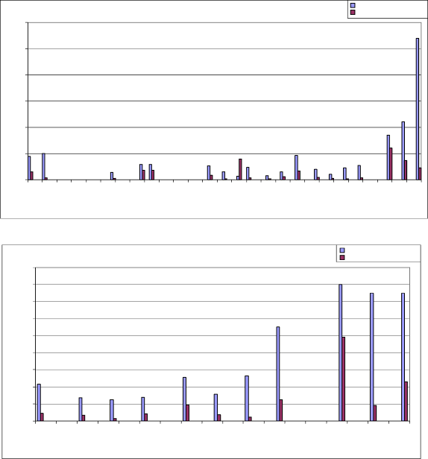
4
6
5
3
2
0
1
0.8
0.6
0.4
0.2
1.8
1.6
1.4
1.2
0
1
Figure 11. Reedy Swamp Site 1 - P levels
Figure 12. Reedy Swamp Site 2 - P levels
Total Phosphorus Reactive Phosphorus
Total Phosphorus Reactive Phosphorus
Appendix 1 - Reedy Swamp water quality
Victorian State-wide Salinity Monitoring Program: Shepparton Region 2002
Total N (mg/I)
Nitrate & Nitrite (mg/I)
Mar-96 Jun-96 Sep-96 Dec-96 Mar-97 Jun-97 Sep-97 Dec-97 Mar-98 Jun-98 Sep-98 Dec-98 Mar-99 Jun-99 Sep-99 Dec-99 Mar-00 Jun-00 Sep-00 Dec-00 Mar-01 Jun-01 Sep-01 Dec-01 Mar-02 Jun-02 Sep-02
Feb-00
Feb-01
Feb-02
Oct-02
Dec-99
Jun-00
Oct-00
Dec-00
Jun-01
Oct-01
Dec-01
Jun-02
Apr-00
Apr-01
Apr-02
Aug-01
Aug-02
Aug-00
Total N (mg/I)
Nitrate & Nitrite (mg/I)

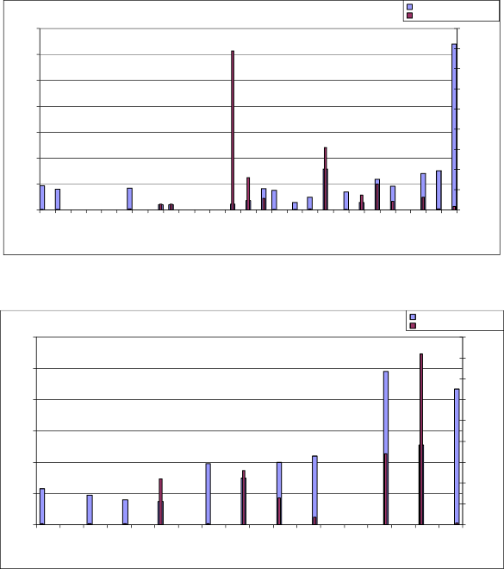
35
0.9
0.8
30
0.7
25
0.6
20
0.5
0.4
15
0.3
10
0.2
5
0.1
0
0
Figure 13. Reedy Swamp Site 1 - N levels
Total Nitrogen (TKN) Nitrate & Nitrite
12
0.45
0.4
10
0.35
0.3
8
0.25
6
0.2
4
0.15
0.1
2
0.05
0
0
Figure 14. Reedy Swamp Site 2 - N levels
Total Nitrogen (TKN) Nitrate & Nitrite
Freshwater Ecology, Arthur Rylah Institute for Environmental Research, DSE 15
Victorian State-wide Salinity Monitoring Program: Shepparton Region 2002
Mar-96 Jun-96 Sep-96 Dec-96 Mar-97 Jun-97 Sep-97 Dec-97 Mar-98 Jun-98 Sep-98 Dec-98 Mar-99 Jun-99 Sep-99 Dec-99 Mar-00 Jun-00 Sep-00 Dec-00 Mar-01 Jun-01 Sep-01 Dec-01 Mar-02 Jun-02 Sep-02
us/cm2
NTU
Mar-96 Jun-96 Sep-96 Dec-96 Mar-97 Jun-97 Sep-97 Dec-97 Mar-98 Jun-98 Sep-98 Dec-98 Mar-99 Jun-99 Sep-99 Dec-99 Mar-00 Jun-00 Sep-00 Dec-00 Mar-01 Jun-01 Sep-01 Dec-01 Mar-02 Jun-02 Sep-02

Figure 15. Reedy Swamp Site 1 & 2 - EC levels | EC - Site 1  EC - Site 2

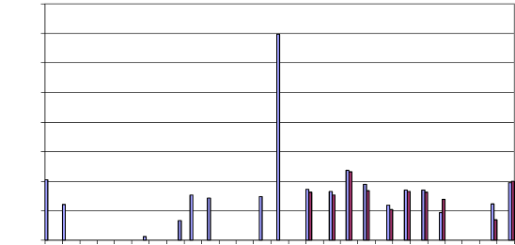
1600
1400
1200
1000
800
600
400
200
0
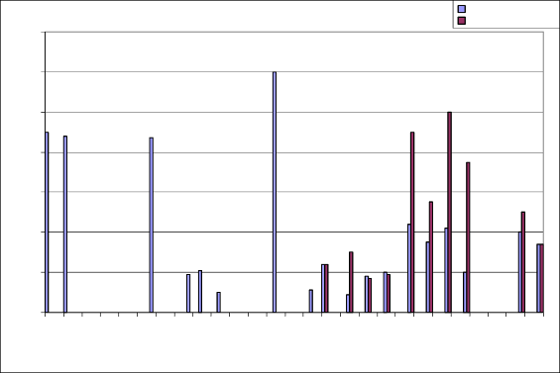
140
120
100
80
60
40
20
0
Figure 17. Reedy Swamp Site 1 & 2 - Turbidity levels
Turbidity - Site 1 turbidity - Site 2
Freshwater Ecology, Arthur Rylah Institute for Environmental Research, DSE 16
Appendix 2 - Reedy Swamp macroinvertebrates

Collector: Greg Day
Sorted by: Paula Ward
Date Collected: 21 November, 2002
ORDER | FAMILY | GENUS | Site 1 | Site 2 | Site 3 | Site 4 | Site 5
Hirudinea | Glossophonidae | (Unident.) | 1 | 0 | 0 | 0 | 1
 | Richardsonianidae | (Unident.) | 0 | 0 | 0 | 0 | 1
Oligochaeta | Naididae | (Unident.) | 0 | 0 | 1 | 0 | 0
 | Tubificidae | (Unident.) | 15 | 0 | 0 | 0 | 0
Mollusca | Corbiculidae | Corbicula | 0 | 1 | 0 | 8 | 0
 | Physidae | Physa acuta | 20 | 63 | 6 | 0 | 3
Cladocera | Daphniidae | Simocephalus | 2 | 0 | 0 | 0 | 18
Ostracoda | Cyprididae | (Unident.) | 1 | 0 | 0 | 0 | 2
Odonata | Coenagrionidae | Ischnura aurora | 0 | 1 | 0 | 0 | 0
 | Lestidae | Austrolestes analis | 0 | 1 | 0 | 0 | 0
 | Lestidae | Austrolestes | 0 | 1 | 0 | 0 | 0
 | Aeshnidae | Hemianax | 0 | 1 | 0 | 0 | 0
 | Aeshnidae | (Unident.) | 0 | 3 | 0 | 0 | 1
 | Zygoptera | (Unident.) | 0 | 1 | 0 | 0 | 0
Hemiptera | Corixidae | Micronecta | 3 | 84 | 69 | 1 | 55
 | Corixidae | Sigara | 10 | 6 | 2 | 0 | 0
 | Corixidae | Agraptocorixa | 17 | 21 | 57 | 0 | 5
 | Corixidae | immature | 8 | 251 | 105 | 2 | 79
 | Notonectidae | Anisops | 55 | 749 | 103 | 1 | 92
 | Notonectidae | immature | 0 | 32 | 0 | 0 | 0
 | Belostomatidae | (Unident.) | 2 | 0 | 2 | 0 | 0
 | Veliidae | Microvelia | 0 | 3 | 0 | 0 | 0
Coleoptera | Dytiscidae | Liodessus (A) | 4 | 1 | 0 | 0 | 0
 | Dytiscidae | Hyphydrus (L) | 0 | 1 | 0 | 0 | 0
 | Carabidae | (Unident.) (L) | 0 | 0 | 0 | 7 | 0
 | Hydraenidae | Ochthebius (A) | 0 | 0 | 0 | 8 | 0
 | Hydraenidae | Hydraena (A) | 0 | 0 | 0 | 1 | 1
 | Hydraenidae | (Unident.) (L) | 0 | 1 | 0 | 5 | 0
 | Hydrophilidae | Berosus (A) | 0 | 0 | 2 | 0 | 0
 | Hydrophilidae | Berosus (L) | 1 | 13 | 0 | 0 | 3
 | Hydrophilidae | Limnoxenus (L) | 2 | 0 | 1 | 0 | 0
 | Hydrophilidae | Paracymus (A) | 0 | 1 | 0 | 0 | 0
 | Hydrophilidae | Helochares (A) | 7 | 1 | 0 | 4 | 0
 | Hydrophilidae | Helochares (L) | 8 | 3 | 14 | 9 | 1
 | Hydrophilidae | Enochrus (L) | 1 | 0 | 3 | 0 | 0
 | Hydrophilidae | (Unident.) (L) | 0 | 0 | 2 | 2 | 0
 | Staphylinidae | (Unident.) (A) | 0 | 2 | 0 | 8 | 0
Diptera | Chironomidae | Tanypodinae # | 0 | 1 | 0 | 0 | 1
 | Chironomidae | Orthocladiinae # | 18 | 2 | 12 | 2 | 3
 | Chironomidae | Chironominae # | 41 | 3 | 24 | 2 | 60
 | Ceratopogonidae | EPA sp.17 | 1 | 0 | 0 | 0 | 0
 | Muscidae | (Unident.) | 1 | 2 | 0 | 0 | 1
 | Ephydridae | (Unident.) | 0 | 0 | 5 | 0 | 0
 | Dolichopodidae | (Unident.) | 0 | 0 | 0 | 1 | 0
 | Stratiomyidae | EPA sp.9 | 1 | 0 | 0 | 0 | 0
 | Stratiomyidae | EPA sp.6 | 1 | 0 | 0 | 0 | 0
 | Stratiomyidae | EPA sp.4 | 2 | 0 | 0 | 0 | 1
 | Stratiomyidae | (Unident.) | 1 | 0 | 0 | 0 | 0
Trichoptera | Leptoceridae | Triplectides australis | 0 | 2 | 0 | 0 | 0
 |  | TOTAL | 223 | 1251 | 408 | 61 | 328

Notes: A = Adult, L = Larvae, # = Subfamily level identification

