A REPORT ON
THREE WATER SUPPLY CATCHMENTS
IN EAST GIPPSLAND
A proposal for Proclamation
prepared for consideration by the
Land Conservation Council
By
L D Russell
Catchment Investigation Officer
November 1983
Soil Conservation Authority
378 Cotham Road. KEW 3101
TABLE OF CONTENTS
SUMMARY 4
INTRODUCTION 6
- THE BOGGY CREEK (NOWA NOWA) CATCHMENT 6
THE CATCHMENT AND WATER RESOURCE 6
2.2 CLIMATE 8
2.3 PHYSIOGRAPHY AND NATIVE VEGETATION 8
2.4 LAND TENURE, USE AND MANAGEMENT. 8
2.4 WATER QUALITY HAZARDS 11
- THE BUCHAN RIVER (BUCHAN) CATCHMENT 14
3.1 THE CATCHMENT AND WATER RESOURCE 14
3.2 CLIMATE 14
3.3 PHYSIOGRAPHY AND NATIVE VEGETATION 14
3.4 LAND TENURE, USE AND MANAGEMENT. 18
3.5 WATER QUALITY HAZARDS 18
- THE TAMBO RIVER CATCHMENT 21
4.1 THE CATCHMENT AND WATER RESOURCE 21
4.1.1 The catchment to the Swifts Creek offtake . 21
4.1.2 The remainder of the catchment. 21
4.2 CLIMATE 21
4.3 PHYSIOGRAPHY AND NATIVE VEGETATION 23
4.4 LAND TENURE, USE MANAGEMENT 23
4.5 WATER QUALITY HAZARDS. 25
4.5.1 The catchment to the Swifts Creek offtake . 25
4.5.2 The remainder of the catchment. 27
SOURCES OF INFORMATION 34
LIST OF FIGURES
FIGURE 1.1 - LOCALITY PLAN OF CATCHMENTS 5
FIGURE 2.1 - (BOGGY CREEK (NOWA NOWA) WATER SUPPLY CATCHMENT 7
FIGURE 2.2 - BOGGY CREEK (NOWA NOWA) WATER SUPPLY CATCHMENT 9
FIGURE 2.3 - TERRAIN TYPES OF THE BOGGY CREEK CATCHMENT 10
FIGURE 2.4 - BOGGY CREEK (NOWA NOWA) WATER SUPPLY CATCHMENT - LAND TENURE AND MANAGEMENT 12
KEY TO FIGURE 2.4 13
FIGURE 3.1 - BUCHAN RIVER (BUCHAN) WATER SUPPLY CATCHMENT 15
FIGURE 3.2 - BUCHAN RIVER (BUCHAN) WATER SUPPLY CATCHMENT 16
FIGURE 3.3 - TERRAIN TYPES IN THE BUCHAN RIVER CATCHMENT 17
FIGURE 3.4 - LAND TENURE AND MANAGEMENT 19
KEY TO FIGURE 3.4 20
FIGURE 4.1 - TAMBO RIVER WATER SUPPLY CATCHMENT 22
FIGURE 4.2 - TAMBO RIVER WATER SUPPLY CATCHMENT 24
FIGURE 4.3 - TERRAIN TYPES OF THE TAMBO RIVER CATCHMENT 26
FIGURE 4.4 - LAND TENURE AND MANAGEMENT 28
KEY TO FIGURE 4.4 29
FIGURE 6.1 - BOGGY CREEK (NOWA NOWA) WATER SUPPLY CATCHMENT - PLAN NO. S-1234A 31
FIGURE 6.2 - BUCHAN RIVER (BUCHAN) WATER SUPPLY CATCHMENT - PLAN NO. S-1235A 32
FIGURE 6.3 - TAMBO RIVER WATER SUPPLY CATCHMENT - PLAN NO. S 1236A 33
FIGURE A.1 - BOGGY CREEK (NOWA NOWA) WATER SUPPLY CATCHMENT - LAND SYSTEMS 36
FIGURE A.2 - BUCHAN RIVER (BUCHAN) WATER SUPPLY CATCHMENT - LAND SYSTEMS 37
FIGURE A.3 - TAMBO RIVER WATER SUPPLY CATCHMENT - LAND SYSTEMS 38
APPENDIX
APPENDIX A - LAND SYSTEMS OF THE CATCHMENTS 35
APPENDIX B - PLANNING SCHEME INTERIM DEVELOPMENT ORDERS. 43
SUMMARY
This report recommends the Proclamation of the catchments to the Tambo and Buchan Rivers and the catchment to the Boggy Creek as Water Supply Catchments under the Land Conservation Act 1970 and the Soil Conservation and Land Utilization Act 1958. Proclamation is the initial stage in the process by which the Soil Conservation Authority discharges its statutory responsibility of determining appropriate land use and management in such catchments.
These streams drain more than 3 700 square km of the southerly slopes of the Great Dividing Range and supply water for domestic and industrial use to a number of townships in East Gippsland.
One-quarter of the land in these catchments is freehold, where the major land use is grazing.
The Land Conservation Council has made recommendations for the use of public land in the catchments. The major uses recommended are conservation (parks and reserves) and hardwood timber production, with substantial areas recommended for ‘uncommitted’ status.
The possibility of significant mining activity of public land is foreshadowed.
The major hazard to water quality in each catchment is the disturbance of soil in or close to streams and continued stock access to streams. These are generally part of normal land use practices in the catchment; an improved level of land management is required to maintain acceptable water quality, rather than radical changes to land use.
Figure 1.1 - Locality Plan of Catchments
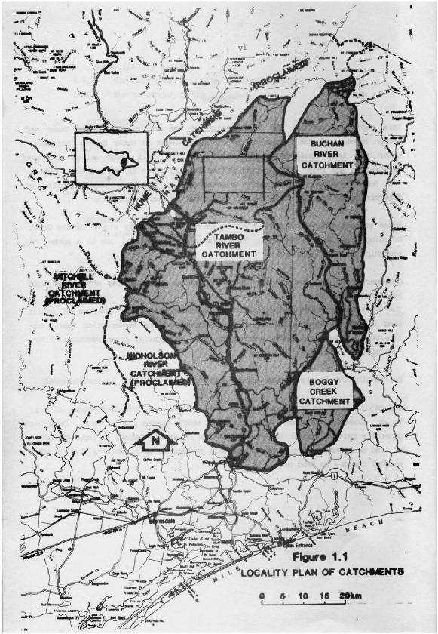
INTRODUCTION
This report summaries results of preliminary investigations by the Soil Conservation Authority in the catchments of the Tambo and Buchan Rivers and the Boggy Creek in East Gippsland (Figure 1.1).
These catchments are part of land which has been the subject of studies by the Land Conservation Council, the Alpine Study Area and the Gippsland Lakes Hinterland Study Area. Final Recommendations for both areas have been published (Land Conservation Council 1979, 1983). A review of the Alpine Area is currently being undertaken with Final Recommendations due in December 1983.
It is Council’s policy that
“(where) multiple use is required of a catchment supplying water for domestic, industrial, or irrigation
purposes, the catchment should be proclaimed under section 5(1) of the Land Conservation Act 1970 and section 22(1) of the Soil Conservation and Land Utilization Act 1958.”
(Land Conservation Council 1979, 1983)
The three catchments which are the subject of this report supply water for domestic and industrial use to a number of small townships in East Gippsland and to private divertors along the streams. Land in these catchments is managed for a variety of uses.
The Tambo River provides water to two Waterworks Trusts with offtakes at Swifts Creek and at Bruthen. However, the catchment should be proclaimed as a single entity.
The Soil Conservation Authority has a statutory responsibility to determine suitable land use in catchment areas and, as a first step in the process, proclamation is made under the provisions of the Land Conservation Act 1970 and the Soil Conservation and Land Utilization Act 1958. Progression to a Land Use Determination under the Soil Conservation and Land Utilization Act 1958 may be made if further investigation indicates the need.
This report has been prepared to facilitate the proclamation of these catchments. It is recommended that Proclamation be made under the appropriate Acts.
2. THE BOGGY CREEK (NOWA NOWA) CATCHMENT The Catchment and Water Resource
The catchment, of some 340 square km, lies on the southern foot slopes of the Great Dividing Range, between Mt. Victoria and the township of Nowa Nowa (Figure 2.1).
The main streams are the Boggy Creek and the Yellow Waterholes Creek. Neither stream is gauged on a regular basis, however spot checks have indicated that summer flows are, at times, unlikely to be sufficient to meet seasonal demand.
Water is diverted for domestic (Nowa Nowa township, population: 265) and industrial (three sawmills) purposes from Boggy Creek, some 6 km upstream of Nowa Nowa.
There is one licensed private diversion (industrial, 39 ML) in the catchment.
Water is pumped from a natural on-stream storage (of approximately 45 ML) to storage basins and then reticulated. There are plans to construct a low wall across the stream to increase the storage to 75 ML.
The water is tested monthly for bacterial levels. The raw river water is frequently unsuitable for domestic consumption because bacteria counts and turbidity are recognised locally as problems. The water is chlorinated on a routine basis.
Diversion, treatment and reticulation are managed by the Lakes Entrance Waterworks Trust.
Figure 2.1 - (Boggy Creek (Nowa Nowa) Water Supply Catchment
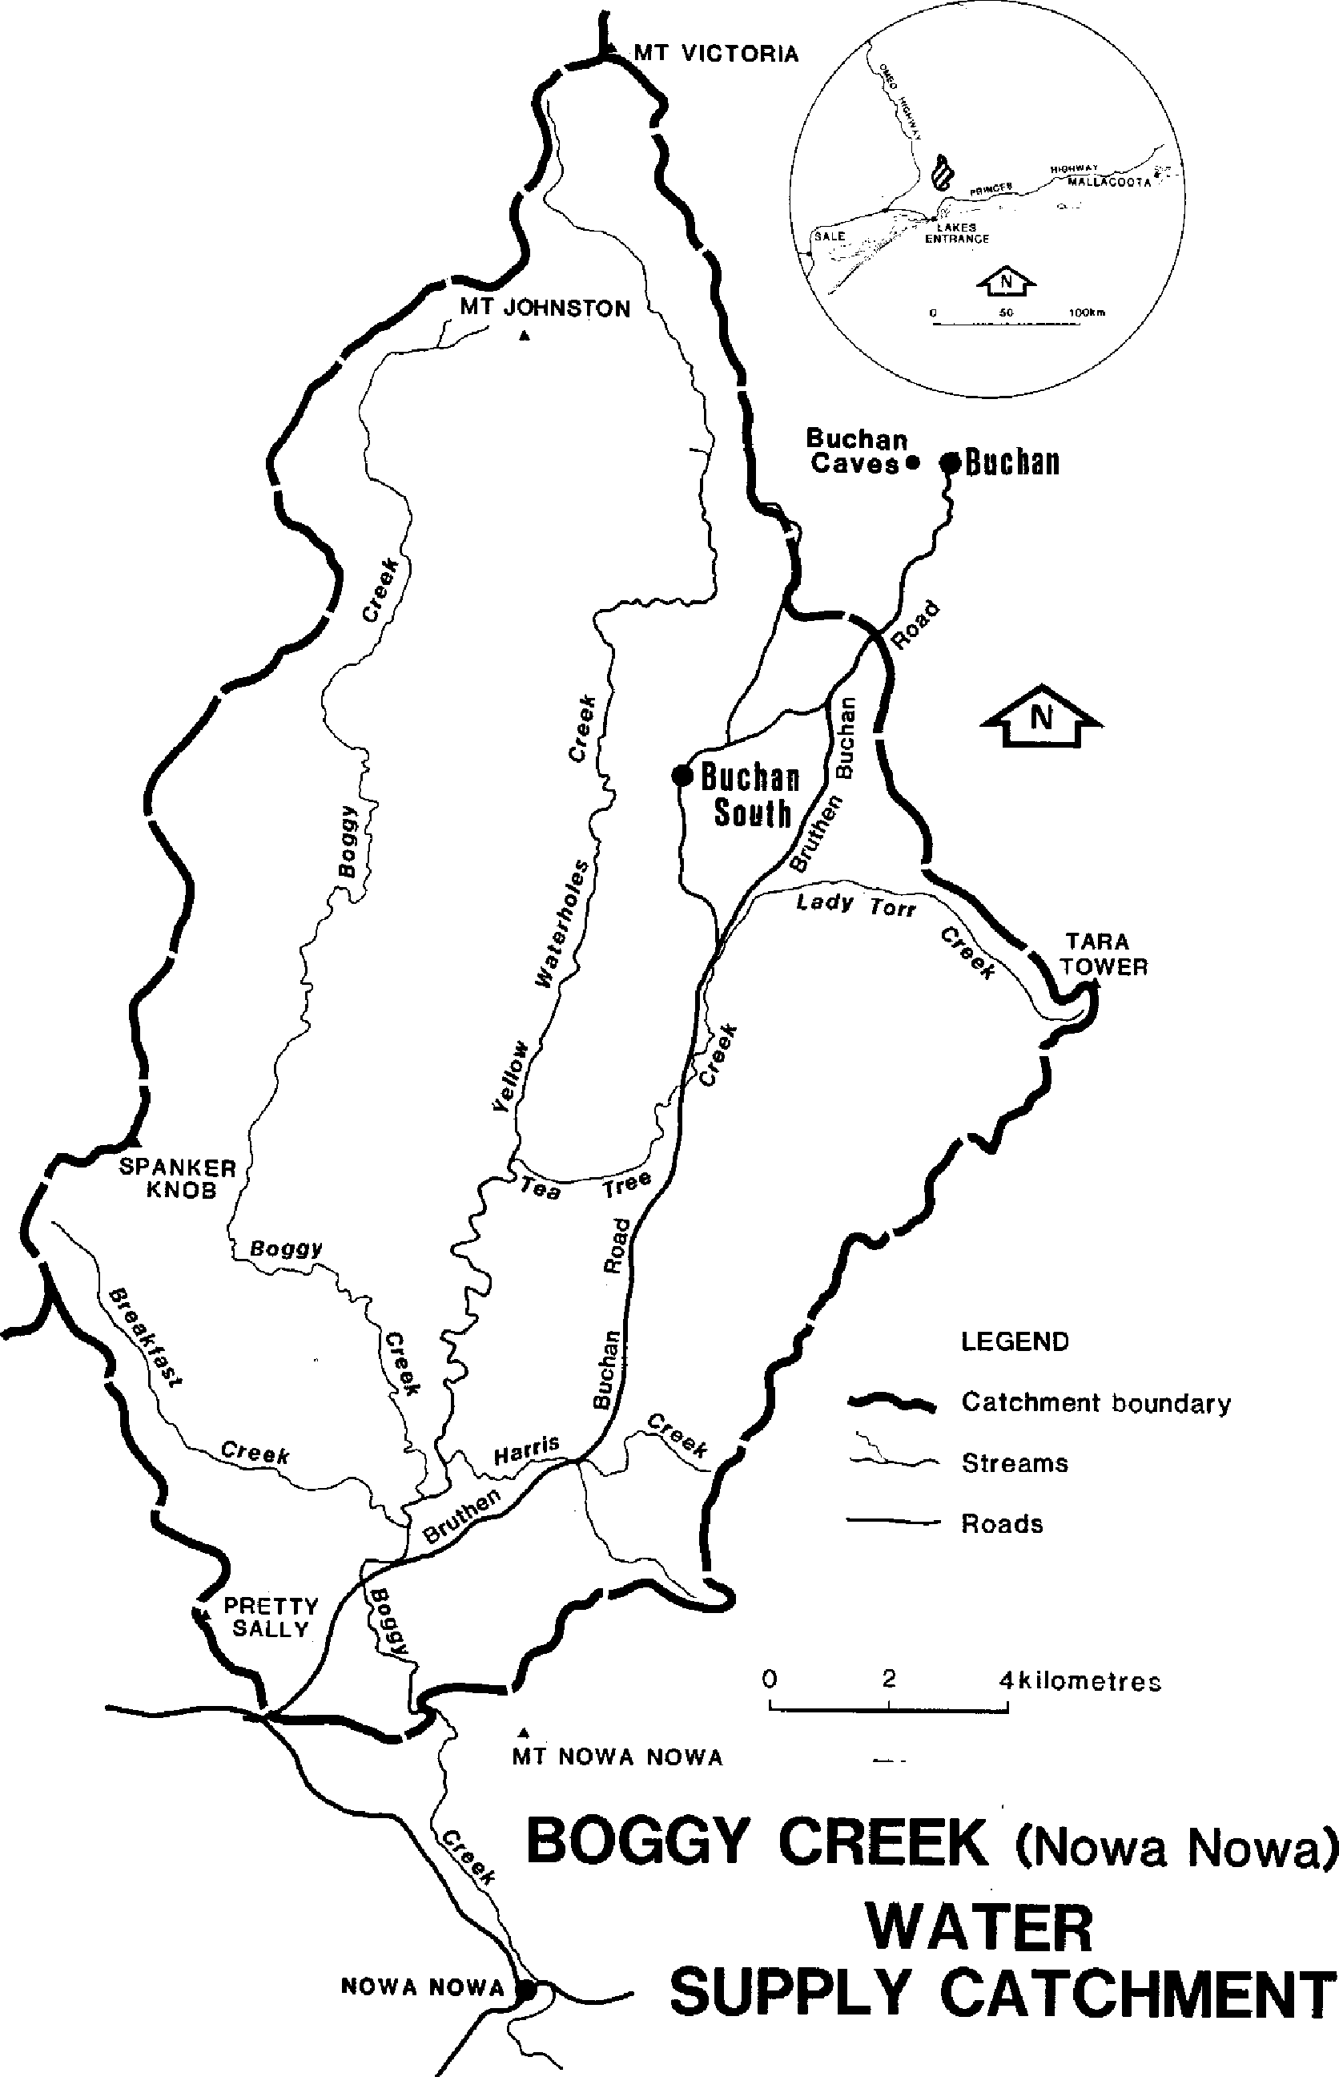
2.2 Climate
The catchment is within the Land Conservation Council’s Gippsland Lakes Hinterland Area. Final Recommendations for the use of public land have recently been published and are summarised in Figure 2.4.
The catchment is subject to a cool temperate climate. Relevant climatic details from Nowa Nowa, which is the meteorological station closest to the catchment, are summarised in Table 2.1 (see also Figure 2.2).
Table 2.1 Climatic Data.
STATION: Nowa Nowa
Mean annual rainfall: 900 mm
Elevation above sea level: 61 m
 | February | July
Mean daily maximum temperature | 28.6⁰C | 14.6⁰C
Mean daily minimum temperature | 13.4⁰C | 1.4⁰C

(Bureau of Meteorology, 1975)
The higher elevations of the northern portion of the catchment are likely to be moister (Figure 2.2) and cooler than conditions experienced at Nowa Nowa. The growing period may be restricted by occasional drought conditions over the summer period.
2.3 Physiography and Native Vegetation
The catchment lies between 100 and 680 metres above sea level, with Mt. Victoria, Mt. Johnston, Spanker Knob and Mt. Tara being the dominant peaks. The terrain is dominated by large tracts of both dissected highlands and foothills, with significant areas of older alluvial plains (Figure 2.3).
The landscape has developed on a variety of rock types, including siliceous and calcareous sedimentary rocks, volcanic rocks, and alluvium.
Native vegetation varies from the moist messmate forest to the drier silvertop, stringybark forest. (Descriptions of the land systems which characterise the various terrain types are contained in Appendix A).
2.4 Land Tenure, Use and Management.
Approximately 25 per cent of the catchment is freehold land (Figure 2.4) and predominantly cleared of native vegetation. The major land use is grazing, primarily for beef production, with some residential use (the township of Buchan South). The freehold land encompasses all land types, however it is the gentler slopes which are the most intensively developed.
The public land carries native forest which is managed by the Forests Commission primarily as protection forest with small quantities of timber products being extracted.
The Forests Commission has prepared detailed prescriptions for the management of harvesting and regeneration operations; adherence to these is necessary to minimise adverse effects on water supply. Current forest operations are limited to minor post and sleeper cutting (approximately 20 ha for the 1982/83 season and a similar area projected for 1983/84). Some 50 ha of clear felling for saw log harvesting is planned for 1983/84.
A total of approximately 8150 ha was burnt by wildfire in the 1982/83 summer.
Deposits of iron ore have been mined in the past and are currently being further prospected. Quarrying of marble has also taken place in the past for building purposes.
Current water frontage licenses cover less than 1 km of land fronting the Boggy Creek, accounting for only a small portion of such frontages in the catchment. Other frontages may be either unused or subject to illegal occupation.
Figure 2.2 - Boggy Creek (Nowa Nowa) Water Supply Catchment
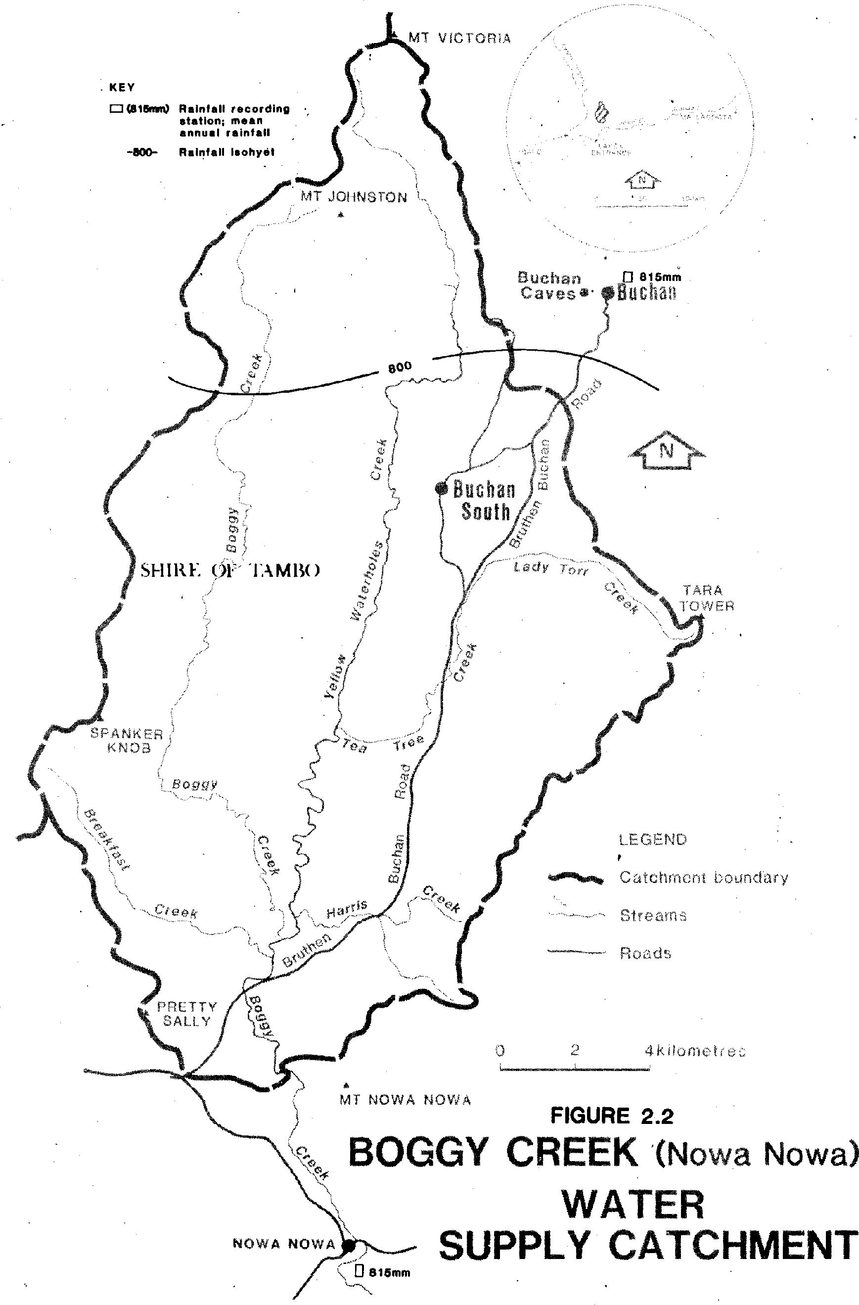
Figure 2.3 - Terrain Types of the Boggy Creek Catchment
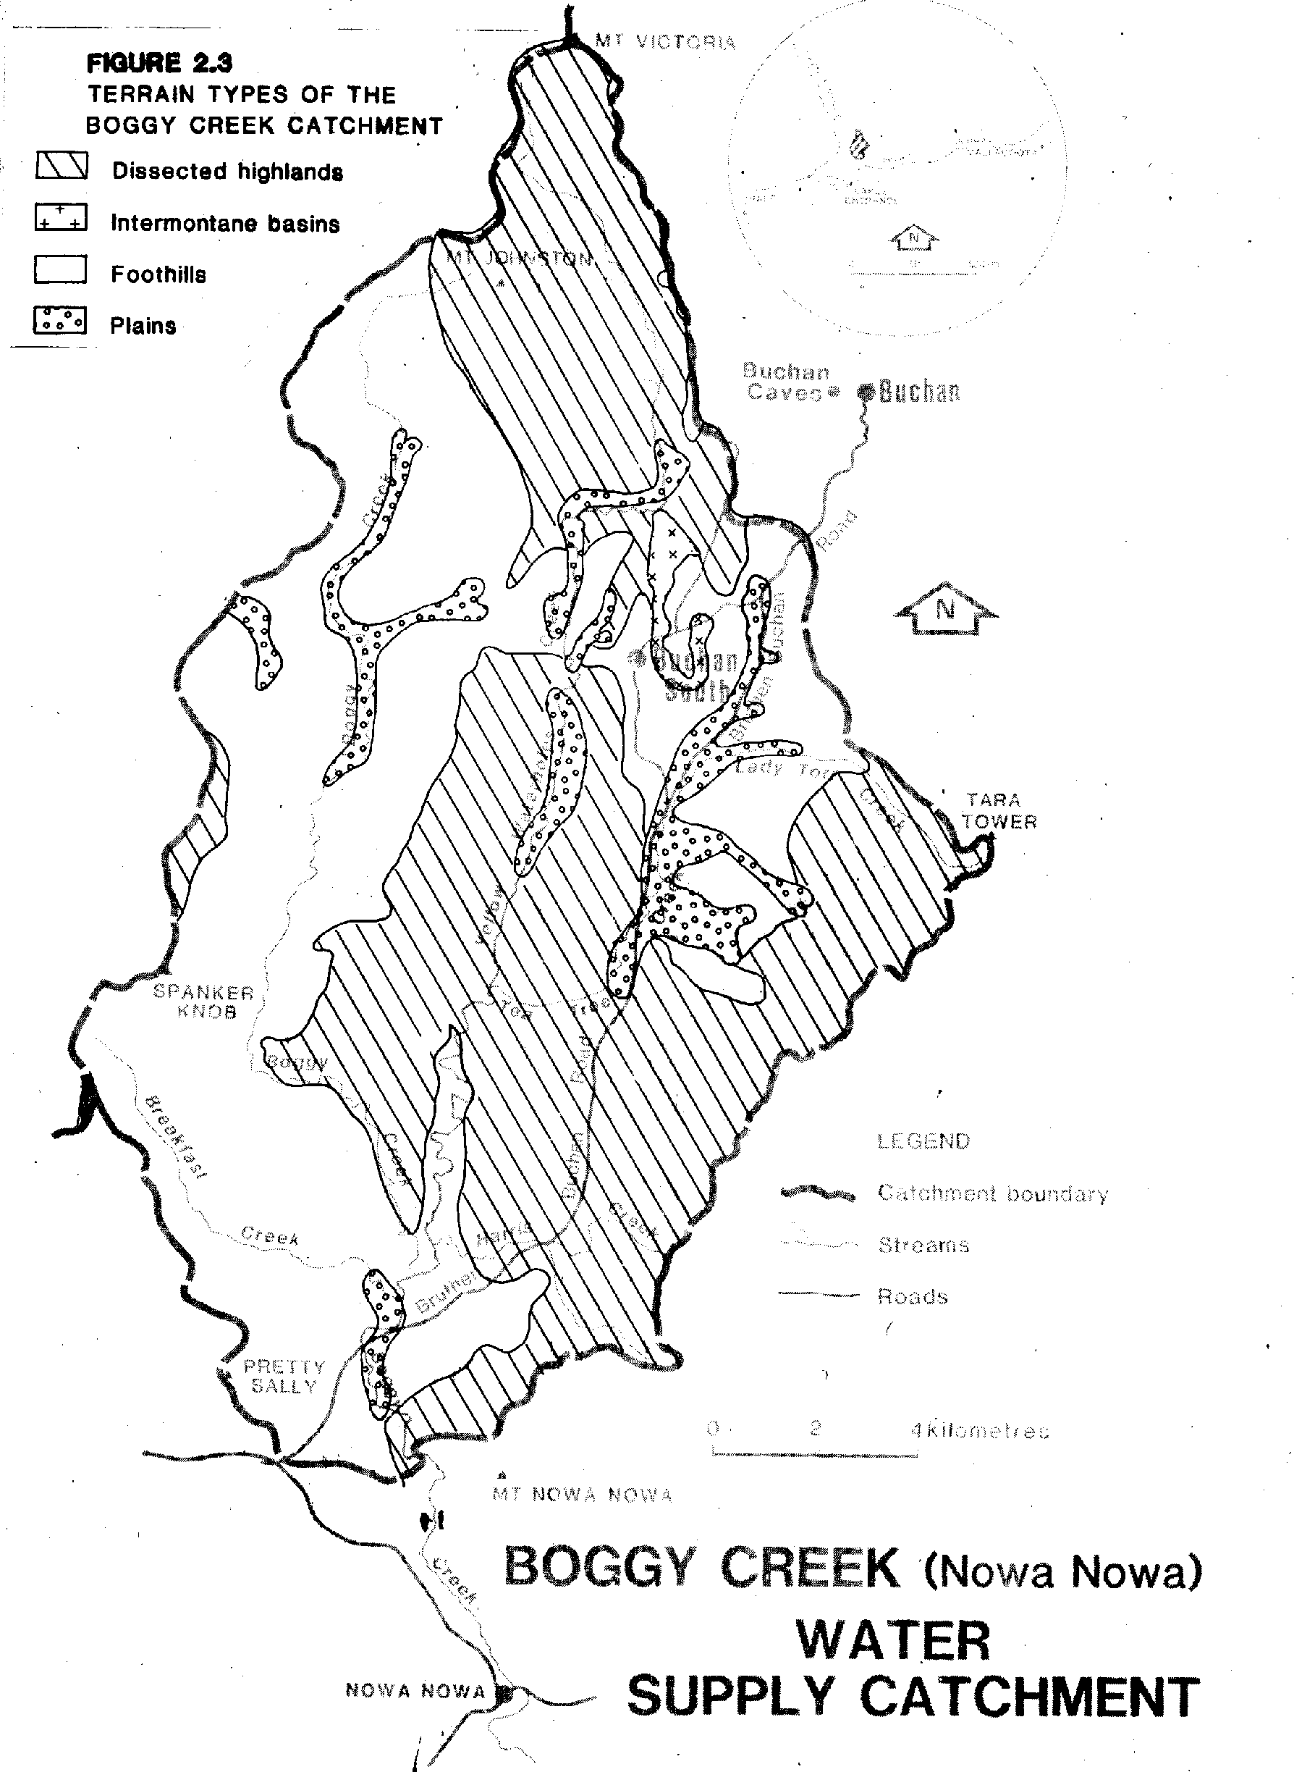
The entire catchment is within the Shire of Tambo. Development in the shire is regulated by an Interim Development Order. Freehold land in the catchment is zoned Rural A (general farming); the relevant provisions of this zone relate to minimum subdivision allotment size and density, and the erection of buildings within 250 m of Boggy Creek requires a permit (Appendix B). State Forest is exempted from the Ordinance.
2.4 Water Quality Hazards
Erosion from disturbed sites in or close to streams is the greatest hazard to water quality. Disturbance may arise through forest operations (logging, roading), mining (open cut, roading) or agriculture. Turbidity and sedimentation problems are of most concern. Iron ore bodies in the southern part of the catchment are being prospected and, if payable, may be mined using open-cut techniques. Stock have access to substantial sections of the major streams passing through freehold areas; such access frequently results in faceal contamination and stream bank erosion. This hazard will continue while this access remains.
Aldrick, et al. (in preparation) have identified the Carrabungla, Collins, Wonnangatta, Colquhoun and Westbury land systems (see Figure A.1 and Table A.1) as being erosion prone and extensive land disturbance could be expected to be reflected in poor quality runoff water until stabilisation of the disturbed areas has been achieved.
Figure 2.4 - Boggy Creek (Nowa Nowa) Water Supply Catchment - Land Tenure and Management
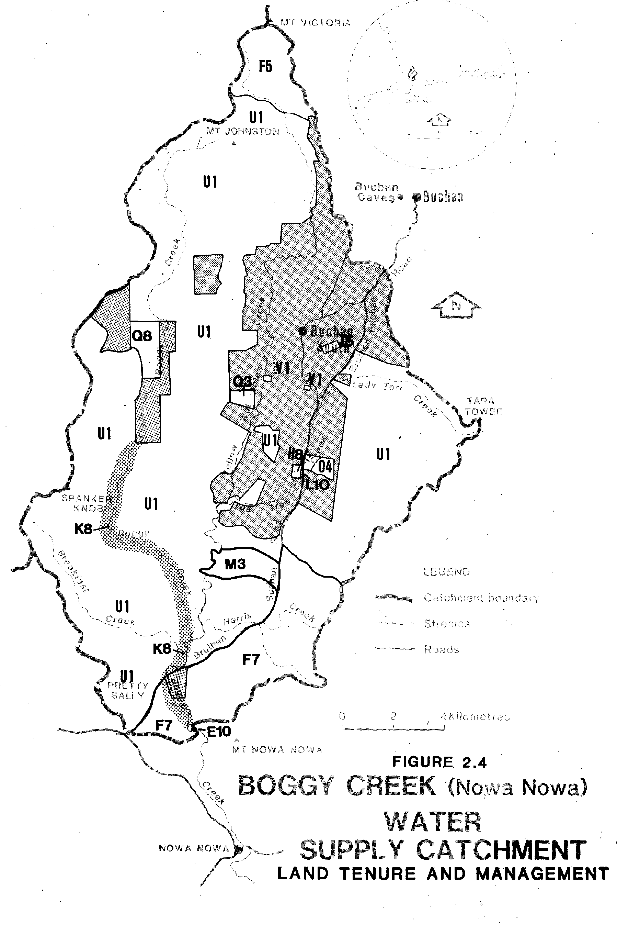
Key to Figure 2.4
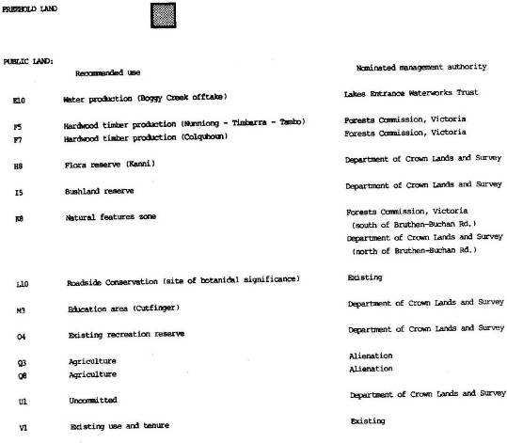
3. THE BUCHAN RIVER (BUCHAN) CATCHMENT 3.1 The Catchment and Water Resource.
The catchment, of some 780 square km, lies on the southerly slopes of the Great Dividing Range, between Mt. Cobberas No. 1 and the township of Buchan (Figure 3.1).
The main stream is the Buchan River, with the Reedy, Mellick Munjie and Frying Pan Creeks being major tributaries.
The Buchan River has a mean annual flow of greater than 150 000 Ml (Bibra and Riggs, 1971), far in excess of likely requirements. Water is diverted for domestic (Buchan township, population: 230) and industrial (sawmill) use, from the Buchan River upstream of Buchan. The estimated annual consumption is 40 ML. There are four private deviators in the catchment, two domestic (4.4 ML) and two irrigation (321 ML).
Water is pumped directly from the river to a service basin where only limited detention occurs before chlorination and reticulation. There is no on-stream storage. Chlorination is necessary due to persistently high bacteria levels. The diversion, treatment and chlorination is managed by the Buchan Waterworks Trust.
3.2 Climate
The majority of the catchment is subject to a cool temperate climate. Sub-alpine conditions and intermittent snow-cover prevail at higher altitudes.
Limited meteorological data are available for areas within the catchment. There are a number of rainfall recording stations throughout the catchment but no temperature recording stations. However reference is made to recordings from Omeo and Nowa Nowa which are the closest such stations.
The mean annual rainfall recorded at Buchan is 815 mm, with 903 mm recorded at Gillingall (Bureau of Meteorology, 1975). Total precipitation at higher altitudes is substantially greater (in excess of 1600 mm at Mt. Nunniong – Figure 3.2).
The pattern and extent of seasonal changes in temperature are likely to be similar to those experienced at Omeo and in the Upper Tambo River catchment (section 4.2) for the northerly portion of the catchment. Southerly areas are likely to experience a temperature regime closer to that of Nowa Nowa (see section 2.2).
The growing period is likely to be significantly restricted by low temperatures, intermittent snow cover and frost heave over the winter period and, in the lower portions of the catchment, to lesser extent by occasional summer drought.
3.3 Physiography and Native Vegetation
The catchment lies between 80 and 1800 metres above sea level, with Mt. Cobberas No. 1, Mt. Deception, Mt. Wombargo and the Nunnett Plains being the dominant topographic features. There are substantial areas at greater than 1220 m above sea level (Figure 3.2).
Two terrain types dominate the landscape – dissected highlands and plateau remnants, with minor areas of other terrain types (Figure 3.3). The landscape has developed on a variety of rock types, including volcanic, siliceous and calcareous sedimentary and metamorphosed rocks. Native vegetation varies from sub-alpine woodland and grassland, through moister ash, messmate and mountain grey gum forest, to the drier stringybark, silvertop and peppermint forests.
(Descriptions of the land systems which characterise the various terrain types of the lower portion of the catchment land are contained in Appendix A. Those which characterise the upper and mid portions of the catchment are described in the Land Conservation Council’s Alpine Study Area Report, 1977. It should be noted that the latter descriptions are considered to be less accurate than the descriptions in Appendix A, which are based on extensive fieldwork).
Figure 3.1 - Buchan River (Buchan) Water Supply Catchment
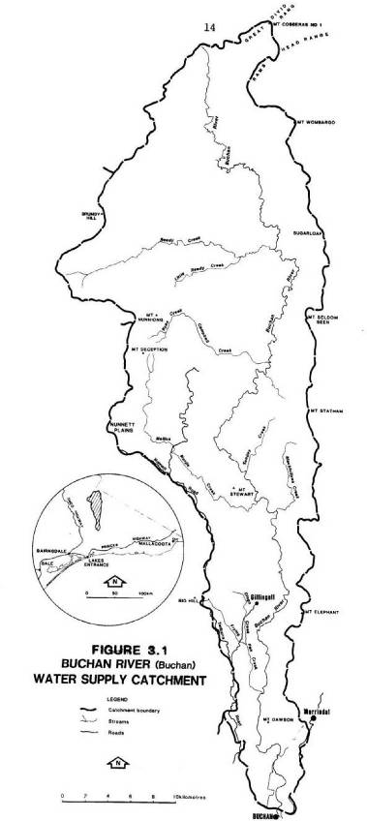
Figure 3.2 - Buchan River (Buchan) Water Supply Catchment
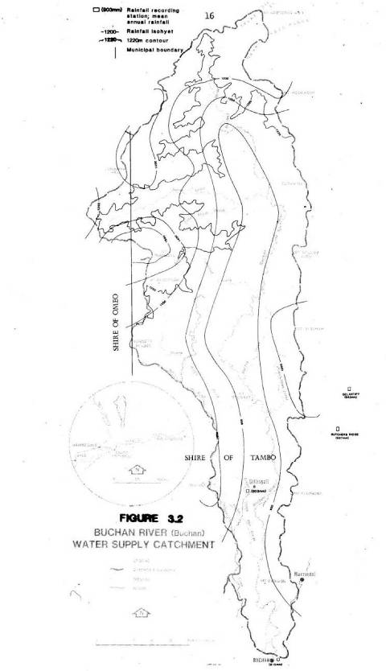
Figure 3.3 - Terrain types in the Buchan River Catchment
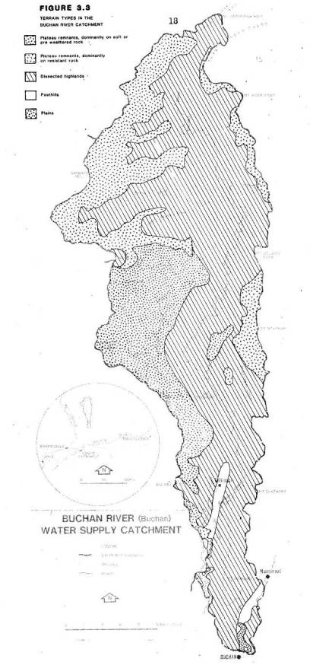
3.4 Land Tenure, Use and Management.
Approximately 10 per cent of the catchment is freehold land (Figure 3.4) and predominantly cleared native vegetation. Small areas of dissected highlands, foothills and plains, have been developed for pastoral purposes (mainly beef production).
Public land in the catchment is covered by Final Recommendations made by the Land Conservation Council (Alpine: 1979, Gippsland Lakes Hinterland: 1983). The Recommendations for the Alpine Area within this catchment were accepted by the government of the day and are in the process of being implemented. A review of these Recommendations is currently in progress. Final Recommendations for the Gippsland Lakes Hinterland Area have only recently been published. The current approved land use for the alpine areas and the Final Recommendations for the Gippsland Lakes Hinterland Area are summarized in Figure 3.4.
Some 330 ha of clear felling for saw log harvesting was undertaken during the 1982/83 season, with a similar amount scheduled for next season. Operations are centered in the central portion of the catchment. The Forests Commission has prepared detailed prescriptions for the harvesting and regeneration of hardwood forests; adherence to these is required to minimise adverse effects on the water supply.
Wildfires burnt some 3400 ha of forested land during the 1982/83 summer.
Mineral exploration is active in the area. Limestone is being quarried for lime and paper manufacture.
There are a number of grazing licenses held for public land in the catchment; grazing is usually limited to the summer months. There are two water frontage licenses held for 2 km of land fronting the Buchan River, only a small portion of such frontages in the catchment. Remaining frontages may be either unused or subject to illegal occupation.
The majority of the catchment is within the Shire of Tambo, with a small portion of the public land in the Shire of Omeo (Figure 3.2). Development in the Shire of Tambo is regulated by an Interim Development Order. Freehold land of the catchment is zoned Rural A (general farming). Relevant provisions relate to minimum subdivision allotment size and to the erection of buildings within 250 m of the Buchan River which requires a permit (Appendix B). State Forest is exempted from the Ordinance.
The Soil Conservation Authority, by direction from the Premier, has supervisory control over earthworks and grazing on land above 1220 m sea level. Substantial areas of the Cobberas – Tingaringy National Park (including the ‘once-only logging’ areas) and some of the Hardwood Timber Production areas (around Mt. Deception ) are above the 1220 m contour.
3.5 Water Quality Hazards
River water quality is currently unsatisfactory for domestic use due to bacterial contamination and periodic turbidity.
The source of the bacterial contamination has not been identified, however, stock which have free access to streams above the offtake, are thought to be the major source. The turbidity is associated with periods of heavy rainfall.
Grazing on alpine land higher in the catchment is unlikely to have a direct effect on water quality at the offtake, but long term effects on the hydrologically sensitive bogs and springs could adversely affect their regulatory function on stream flows.
Road drainage entering the streams at stream crossings is likely to be the major source of turbidity. Extension of the road network associated with forest operations and tourist activities may exacerbate the problem.
Aldrick, et al. (in preparation) have identified the Carrabungla and Collins land systems (see Figure A.2 and Table A.1) as being erosion prone and extensive land disturbance could be expected to be reflected in poor quality run-off water until the disturbed areas are stabilised. The alpine land systems of Jamieson and Bulltown Spur, whilst not as directly erosion prone, are difficult to stabilise once disturbed because of the harsh climate.
Figure 3.4 - Land Tenure and Management
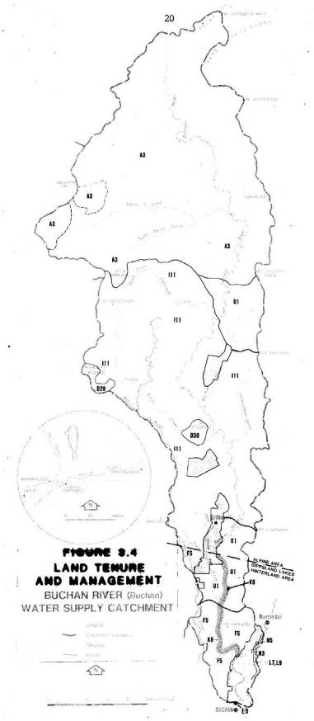
Key to Figure 3.4

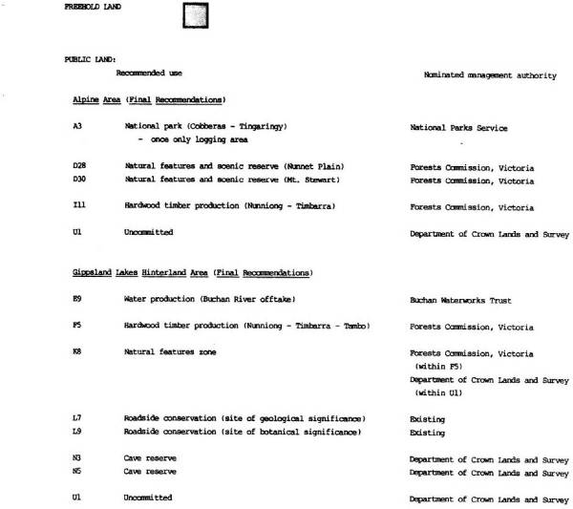

4. THE TAMBO RIVER CATCHMENT 4.1 The Catchment and Water Resource.
The catchment, of some 2650 square km, lies on the southerly slopes of the Great Dividing Range, between Mt. Leinster and Bruthen (Figure 4.1). The catchment can be considered in two parts, the catchment to the Swifts Creek offtake and the remainder of the catchment to the Bruthen offtake.
4.1.1 The catchment to the Swifts Creek offtake.
This sub-catchment, of some 690 square km, lies on the southerly face of the Bowen Mountains, between Mt. Leinster and the Swifts Creek township (Figure 4.1). The mean annual flow at Swifts Creek is far in excess of likely requirements. (The mean annual flow gauged at Bindi, 5 km upstream, is 46 000 ML, (Bibra and Riggs, 1971). However low flows during a dry summer are unlikely to meet the seasonal demand.
Water is diverted from the river immediately upstream of the townships of Swifts Creek for domestic (Swifts Creek, population: 350) and industrial (sawmill) use. The estimated annual consumption is 90 ML. Water is diverted privately under three domestic (6.6 ML) and seven irrigation (334 ML) Permits.
Water is pumped from a sump in the river to storage basins, chlorinated and reticulated. There is no on-stream storage. There are some problems with taste, algal growth and copper contamination and the water is routinely chlorinated prior to reticulation because of bacterial contamination, attributed to water fowl on the storage basins.
Diversion, treatment and reticulation is managed by the Swifts Creek Waterworks Trust. 4.1.2 The remainder of the catchment.
The remainder of the catchment, of some 1960 square km, lies between the townships of Swifts Creek and Bruthen (Figure 4.1).
The Tambo and the Timbarra Rivers are the main streams, with Haunted Stream, Wilkinson Creek and Swifts Creek being major tributaries. The mean annual flow of the Tambo River, gauged at Bruthen, is greater than 172 000 Ml (Bibra and Riggs, 1971) which is far in excess of likely requirements.
Water is diverted for domestic (townships of Bruthen, Wiseleigh and Mossiface, combined population: 800) and industrial (sawmill) use. The estimated annual consumption is 106 Ml. Private divertors in the remainder of the catchment are subject to seventeen irrigation (607 Ml), one industrial (50 Ml) and 26 domestic (57.2 Ml) Permits.
Water is pumped from sand spears in the bed of the Tambo River to service basins and then reticulated. There is no on-stream storage. Diversion, treatment and reticulation are managed by the Lakes Entrance Waterworks Trust.
Bacterial contamination is an intermittent problem and the water has a high iron content. The water is aerated to remove iron and detention at the service basins is the only other treatment applied.
The Trust is also concerned about intermittent extreme turbidity and attributes the problem to the combination of heavy rain and unprotected riverbanks in the Swifts Creek/Ensay area.
4.2 Climate
Much of the catchment is subject to a cool temperate climate, with sub-alpine conditions prevailing at higher altitudes in the north.
Recorded mean annual rainfall ranges from 612 mm at Swifts Creek and 668 mm at Tongio, to in excess of 700 mm at Bruthen, Tambo Crossing and Reedy Flat (Bureau of Meteorology, 1975). Total annual precipitation is however much greater at higher altitudes being in excess of 1600 mm at Mt. Leinster and Mt. Tambo, and in excess of 1200 mm at Mt. Bindi, Mt. Nugong, Mt. Deception and Mt. Baldhead (Figure 4.2).
Figure 4.1 - Tambo River Water Supply Catchment
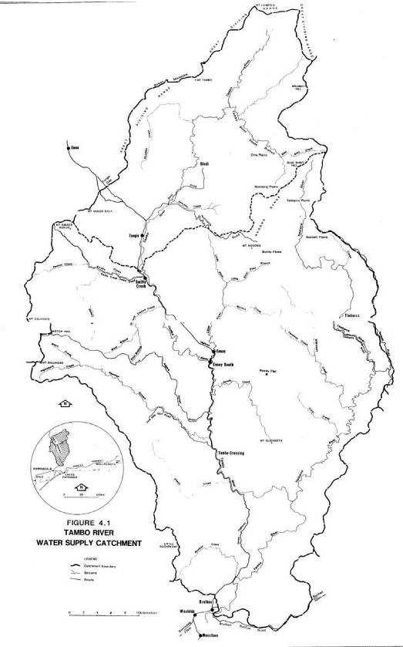
Official temperature records are limited to three nearby stations – Omeo, Bairnsdale and Nowa Nowa. The temperature regime in the northern part of the catchment is likely to be similar to that experienced at Omeo (Table 4.1) while at lower altitudes in the southern part of the catchment, a regime similar to that of Bairnsdale (Table 4.2) or that of Nowa Nowa (Table 2.1) is likely to be experienced.
Table 4.1 Climate Data.
STATION: Omeo
Mean annual rainfall: 676 mm
Elevation above sea level: 649 m
 | January | July
Mean daily maximum temperature | 25.0⁰C | 10.2⁰C
Mean daily minimum temperature | 10.2⁰C | -0.4⁰C

(Bureau of Meteorology, 1975)
The growing period in these more northerly parts of the catchment is likely to be severely restricted by low temperatures, intermittent snow cover and frost heave in winter and by occasional summer drought.
Table 4.2 Climate Data.
STATION: Bairnsdale Post Office
Mean annual rainfall: 696 mm
Elevation above sea level: 14 m
 | February | July
Mean daily maximum temperature | 25.4⁰C | 14.3⁰C
Mean daily minimum temperature | 13.2⁰C | 4.3⁰C

(Bureau of Meteorology, 1975)
In the Swifts Creek area, which suffers from a rain shadow associated with the adjacent mountain ranges, and the southern portion of the catchment, the growing period is more likely to be restricted by summer drought than by low temperatures.
4.3 Physiography and Native Vegetation
The catchment lies between 20 and 1560 metres above sea level, the Swifts Creek offtake being located 350 metres above sea level. There are numerous peaks and some high level plains which dominate the landscape (Figure 4.2), with substantial areas at elevation greater than 1220 m above sea level.
The terrain is dominated by dissected highlands, with significant areas of intermontane basins, plateau remnants and foothills (Figure 4.3). The landscape has developed on a variety of rock types, including siliceous and calcareous sedimentary rocks; basaltic and acid volcanic rocks and associated metamorphosed sediments; and recent alluvium.
Native vegetation varies from sub-alpine woodland and grassland, through moist ash, messmate and mountain grey gum forest, to drier silvertop, stringybark and yertchuk forest types.
(Descriptions of the land systems which characterise the landscape are contained in Appendix A).
4.4 Land Tenure, Use Management.
Approximately 40 per cent of the catchment is freehold land (Figure 4.4) and predominantly cleared of native vegetation. Relatively large areas of dissected highlands, foothills and intermontane basins have been developed for pastoral purposes (mainly sheep and cattle production with limited cultivation for fodder crops and pasture renovation. There is also limited residential development (Swifts Creek and Ensay townships).
Figure 4.2 - Tambo River Water Supply Catchment
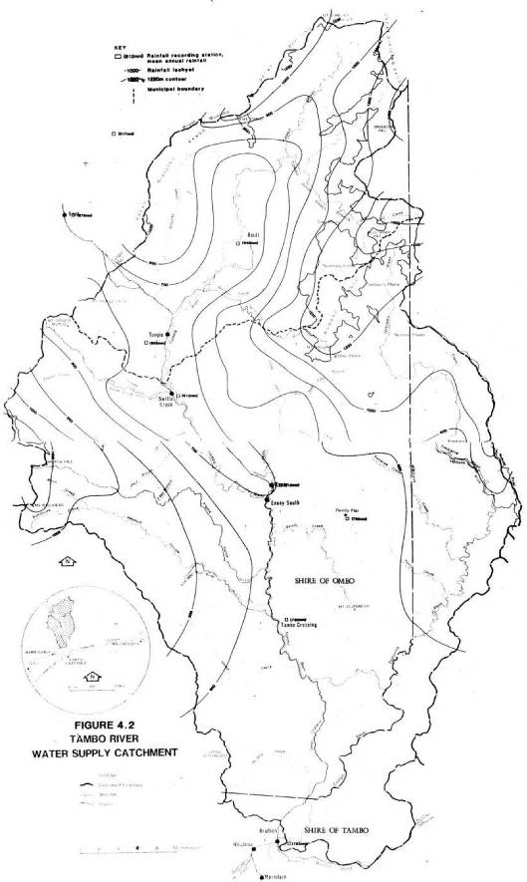
The public land of the catchment is covered by Final Recommendations made by the Land Conservation Council. The Recommendations for the Alpine Study Area affecting the catchment were accepted by the government of the day and are in the process of being implemented. A review of the alpine area is currently in progress. The Final Recommendations for the Gippsland Lakes Hinterland Area have only recently been published. The current approved land use for the Alpine Area and the Final Recommendations for the Gippsland Lakes Hinterland Area are summarised in Figure 4.4.
Current forest operations involve some 480 ha of clear felling for saw log harvesting, distributed throughout the central regions of the catchment, and some 150 ha of selective logging for posts and sleepers in the southern portion of the catchment. Planned operations for the coming season include 540 ha of clear felling for saw log harvesting and 200 ha of selective logging. The Forests Commission has prepared detailed prescriptions for hardwood harvesting and regeneration operations; adherence to these is required to minimise adverse effects on water supply.
Wildfires burnt some 22 500 ha of forested land in the catchment during the 1982/83 summer.
There are several grazing licenses held for various areas of public land in the catchment. There are also five water frontage licenses held for some 16 km land fronting the Tambo River above the Swifts Creek offtake, and 37 licenses for 30 km of land fronting the Tambo River below the offtake, the Timbarra and Little Rivers, and Riley, Swifts and Sandy Creeks. These are only a small portion of such frontages in the catchment; other frontages may be either unused or illegally occupied.
A number of ore bodies in the catchment are being prospected and evaluated, particularly deposits of copper and allied metals in the upper reaches of the Tambo River sub-catchment. This find has encouraged further exploration over much wider areas of the catchment.
The catchment spans two municipalities – the Shire of Omeo and the Shire of Tambo.
Development in the Shire of Omeo is regulated by an Interim Development Order: all development requires a permit (Appendix B). Development in the Shire of Tambo is also regulated by an Interim Development Order. Freehold catchment land in the Shire is zoned Rural A (general farming). Relevant provisions relate to minimum allotment size and density (Appendix B) and to the erection of buildings within 250 m of Wilkinson Creek and the Tambo and Timbarra Rivers which requires a permit. State Forest is exempted from the Ordinance.
The Soil Conservation Authority, by direction from the Premier, has supervisory control over grazing and earthworks on land greater than 1220 m above sea level. The majority of this land is within the recommended Hardwood Timber Production areas (Figure 4.4).
4.5 Water Quality Hazards.
4.5.1 The catchment to the Swifts Creek offtake.
The main water quality problem is bacterial contamination, attributed to water fowl on the storage basins. There appears to be little which can be done to prevent this contamination.
Road drainage entering the streams at stream crossings is the most likely source of potential sediment turbidity problems. Extension of the road network associated with access, mining, forest operations and tourist activities would result in deterioration of water quality, particularly if the design and maintenance of road drains are inadequate.
There are no extensive areas of active sheet or gully erosion in the catchment. Many drainage lines on freehold land have eroded in the past, however these have generally stabilised and are not of immediate concern.
Continued access to streams by stock in the lower reaches of the catchment may result in minor but continuing stream bank erosion and faecal contamination of the stream. Grazing on alpine land higher in the catchment is unlikely to have a direct effect on water quality at the offtake, but long term effects on the hydrologically sensitive bogs and springs could adversely affect their regulatory function on stream flow.
Figure 4.3 - Terrain types of the Tambo River Catchment
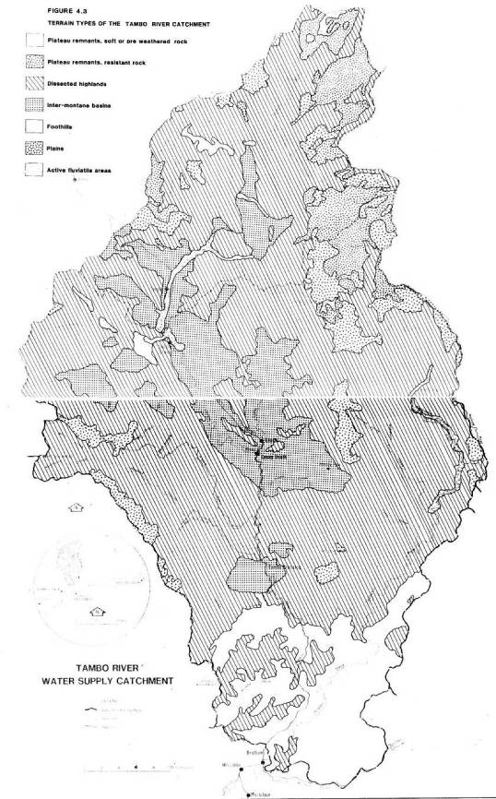
4.5.2 The remainder of the catchment.
In view of the size of the catchment, significant attention of the effect of local deterioration of water quality is likely to occur before water reaches the present offtake. Consequently, land uses close to the offtake are likely to have the greatest effect on water quality and are therefore of the greatest concern. However sound land management practices should be encouraged throughout the catchment.
There have been problems with turbid water, presumed to be the result of stream bank erosion (see section 4.1.2) entering the supply system during periods of high river flow. Inadequate disposal of road drainage water and continued free stock access to streams represent the most significant potential sources of water quality deterioration at the offtake (turbidity and bacterial contamination).
Possible effects of grazing on alpine land are as described above (section 4.5.1).
The old King Cassilis mining area is close to the Swifts and Power Creeks and a number of the sludge dams remain. These presumably contain a high concentration of toxic substances and as they are beginning to erode, the possibility of these substances being carried into the water supply is grounds for considerable concern. Consideration should be given to the stabilisation of these old dams in the interests of water supply.
There has been concern expressed over the possible impact on water quality of the mining of ore bodies which are now being prospected. It is likely that the mining techniques used, if mining proceeds, will be modified to minimise the risk of contamination of the water supply.
Part of the mineral exploration program in the northern part of the catchment has been the monitoring of water quality to determine natural base metal concentrations in the catchment water. Initial results indicate a high natural level of base level concentrations of base metals in the catchment waters during low stream flows, reflecting the outcropping of mineralized rocks in the stream bed.
Aldrick, et al. (in preparation) have identified the Blomford, Carrabungla, Collins, Wonnangatta, Dargo and Colquhoun land systems (see Figure A.3 and Table A.1) as being erosion prone and extensive land disturbance in these areas can be expected to be reflected in poor quality run-off water until the disturbed areas stabilise. The alpine land systems of Wellington, Jamieson, Bulltown Spur, Bennison, Nunniong, Hotham and Moroka, whilst not as directly erosion prone, are difficult to stabilise once disturbed because of the harsh climate.
Figure 4.4 - Land Tenure and Management
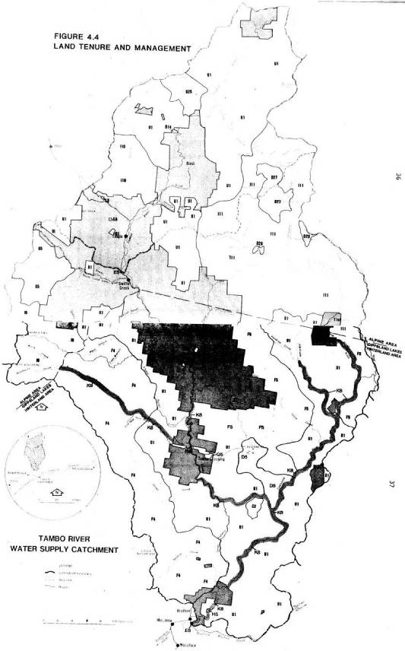
Key to Figure 4.4
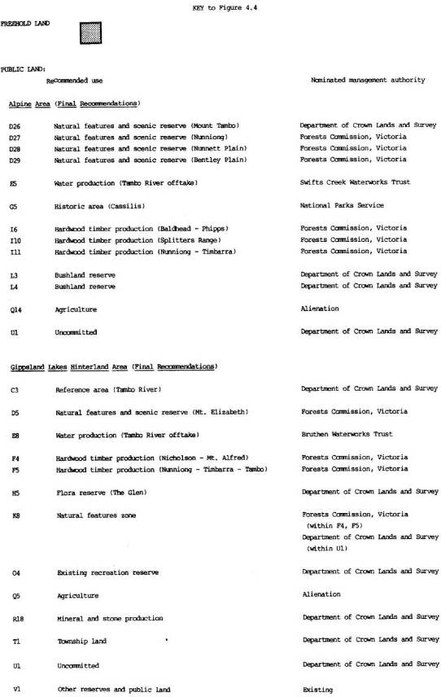
RECOMMENDATIONS
As a result of these investigations, it is recommended that:
the Land Conservation Council recommend to the Governor-in-Council that the following catchments be proclaimed under section 5(1)(b) of the Land Conservation Act 1970 and section 22(1) of the Soil Conservation and Land Utilization Act 1958:
- the Boggy Creek (Nowa Nowa) Catchment, as shown on Plan No. S-1234A (Figure 6.1);
- the Buchan River (Buchan) Catchment, as shown on Plan No. S-1235A (Figure 6.2); and
- the Tambo River Catchment, as shown on Plan No. S-1236A (Figure 6.3).
Figure 6.1 - Boggy Creek (Nowa Nowa) Water Supply Catchment - Plan No. S-1234A
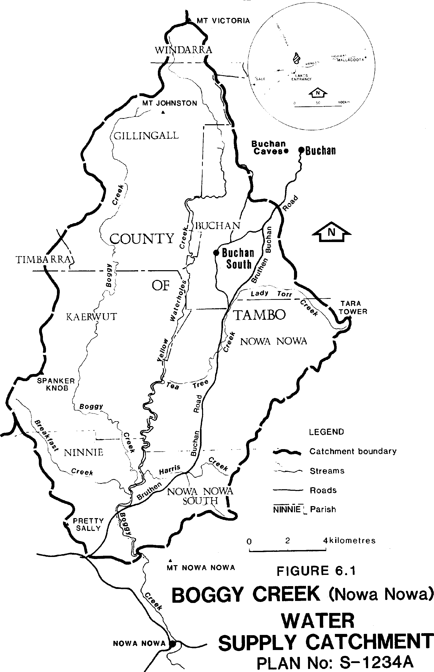
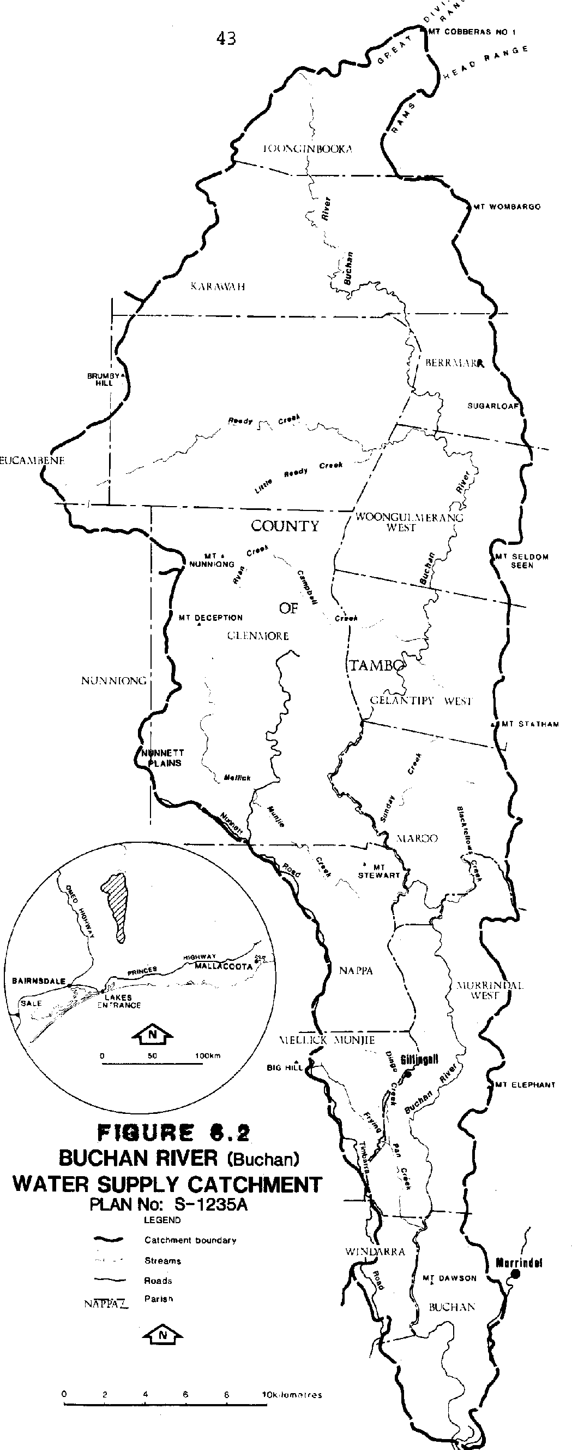
Figure 6.3 - Tambo River Water Supply Catchment - Plan No. S1236A
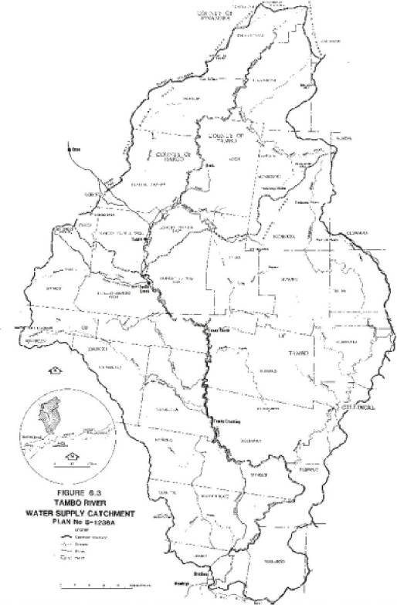
SOURCES OF INFORMATION
ALDRICK, J. M., R. H. M. van de GRAFF, B. M. NICHOLSON, D. O’BEIRNE, R. HOOK and N. L. SCHOKNECHT. (In preparation). A Study of the Land of the Catchments of the Gippsland Lakes.
BIBRA E. E., and H. C. W. RIGGS. 1971. Victorian River Gaugings to 1969. State Rivers and Water Supply Commission.
BUREAU OF METEOROLOGY. 1975. Climatic Averages, Australia. Metric Edition. Australian Government Publishing Service.
HOLZER, E. E. (Ed.) 1980. Victorian Municipal Directory 1980. Arnall and Jackson Pty. Ltd. LAND CONSERVATION COUNCIL. 1977. Report on the Alpine Study Area.
LAND CONSERVATION COUNCIL. 1979 Final Recommendations - Alpine Area.
LAND CONSERVATION COUNCIL. 1982. Report on the Gippsland Lakes Hinterland Area.
LAND CONSERVATION COUNCIL. 1983. Final Recommendations - Gippsland Lakes Hinterland Area.
Discussions with officers of the Buchan, the Lakes Entrance and the Swifts Creek Waterworks Trusts. Discussions with officers of the Forests Commission, Victoria, and the Department of Crown Lands and Survey.
APPENDIX A - LAND SYSTEMS OF THE CATCHMENTS.
The following maps and tables describe the land of the catchments in terms of land systems (areas of land in which recognisable patterns of topography, soils and vegetation occur).
The tables are based on data presented by Aldrick, et al. (in preparation) in an early draft. Subsequent revisions of the data may have resulted in reclassification of some small areas of land in these catchments. However any changes are of a minor nature and do not materially affect this report.
Figure A.1 - Boggy Creek (Nowa Nowa) Water Supply Catchment - Land Systems
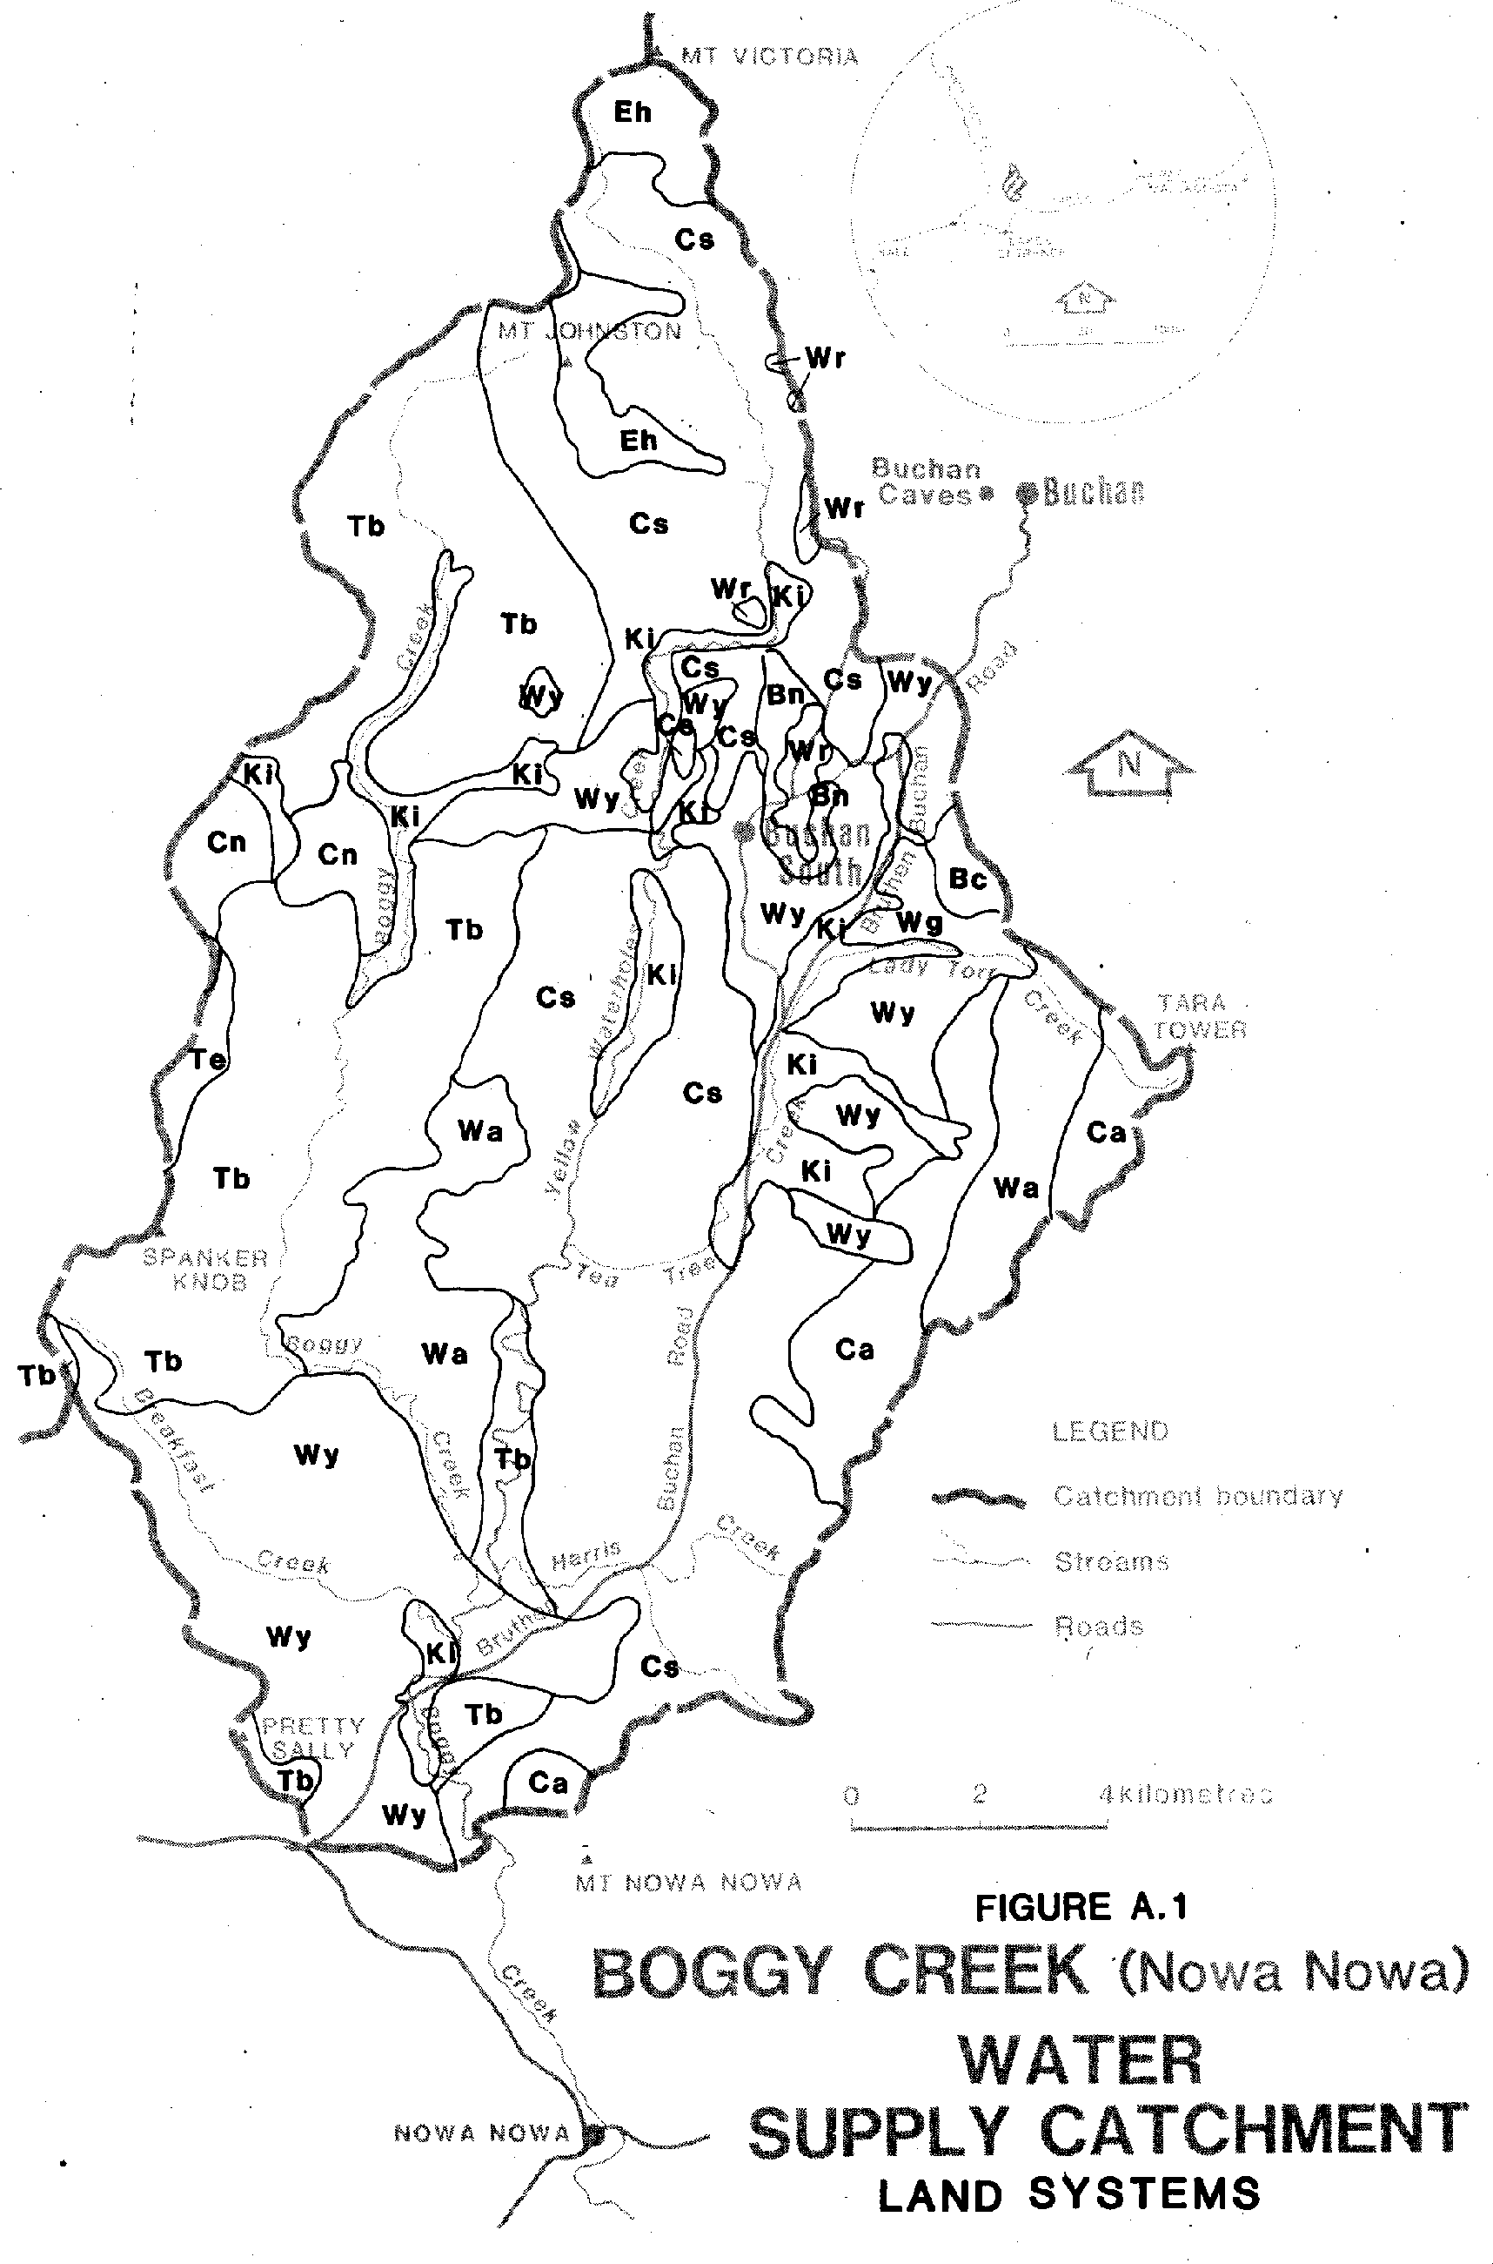
Figure A.2 - Buchan River (Buchan) Water Supply Catchment - Land Systems
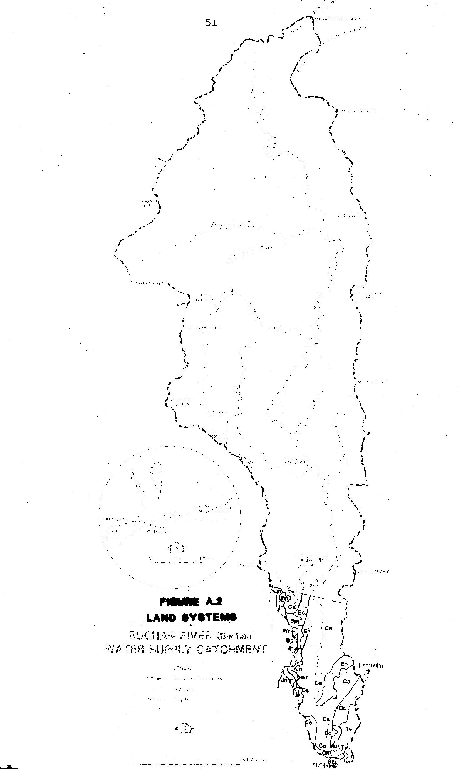
Figure A.3 - Tambo River Water Supply Catchment - Land Systems
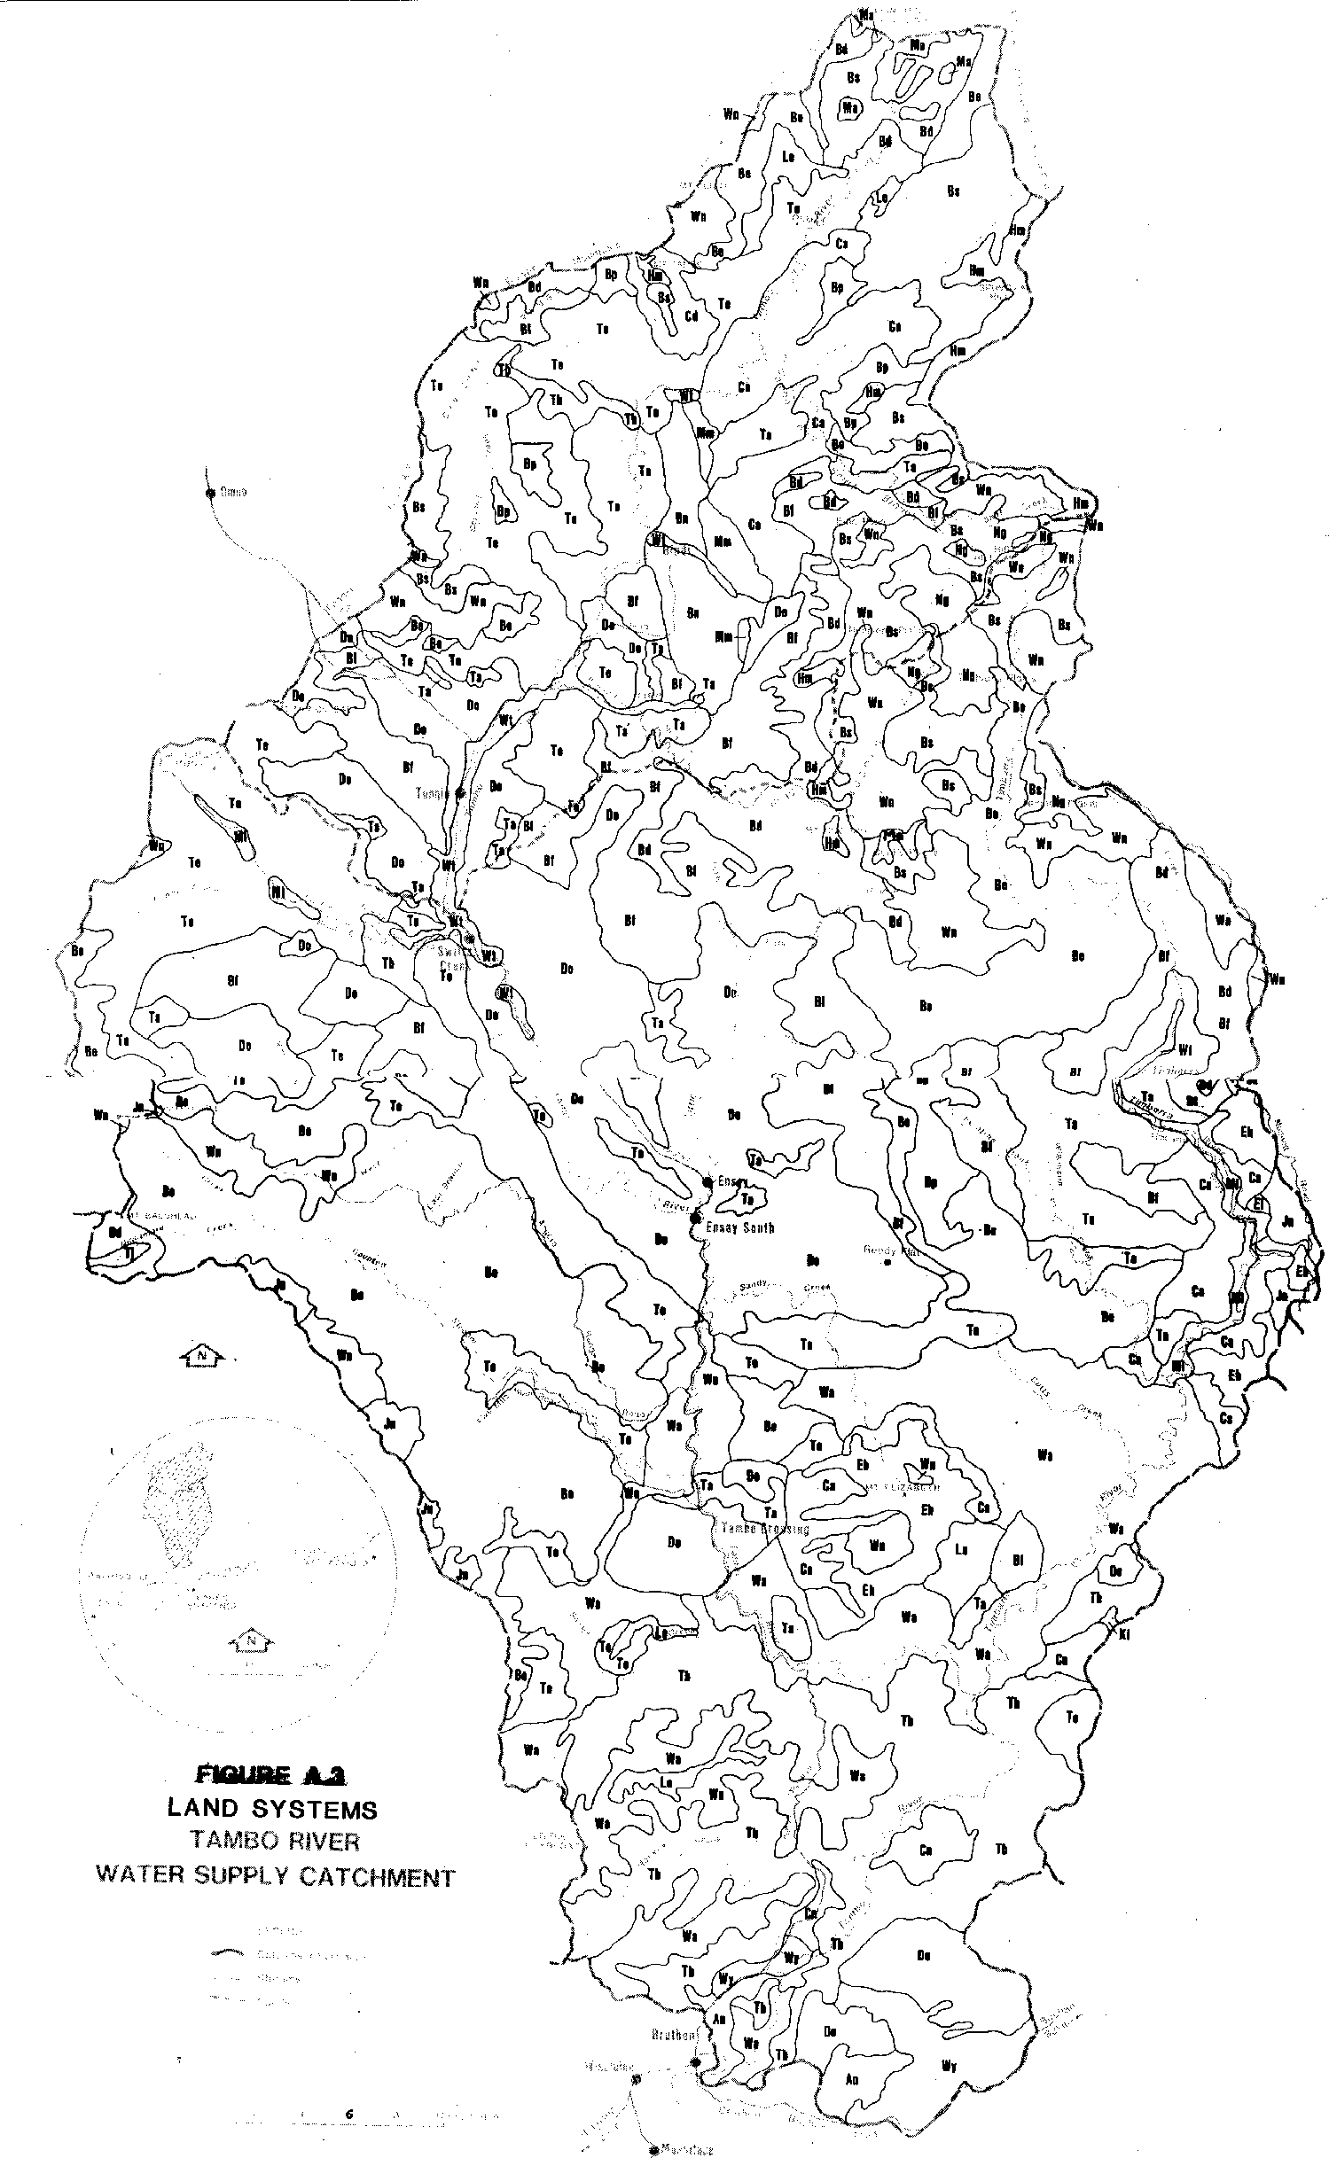
TABLE A.1 Land Systems of the Catchments.
LAND TYPE | DISTINGUISHING  CHARACTERISTICS | LAND SYSTEM |  | GEOLOGY | SOILS | NATIVE VEGETATION TYPES
Plateau remnants on soft or pre- weathered rock | Dense humid forest | Wn | Wellington | Various, often acid volcanic, plutonic & metamorphic  rock | Red earths; brown earths; lithosols; humic gley soils | Alpine ash, peppermint, candlebark Open Forest II, III; alpine ash, mountain grey gum, peppermint, messmate, manna gum Open Forest III, IV
Plateau remnants on soft or pre- weathered rock | Less dense humid | Jn  Bp | Jamieson  Bulltown Spur | Various – mainly Ordovician  sediments  Various | Red earths; brown earths; alluvial soils; lithosols  Red earths; lithosols | Snowgum, peppermint, candlebark, Open Forest II, ash Open Forest III, messmate, brown stringybark, peppermint, candlebark Open forest II, III  Peppermint, mountain ash, snow gum, peppermint, or mountain grey gum, messmate, silvertop, red stringybark, long-leaved box Woodland I, II, Open Forest II, III
Plateau remnants on resistant rock | Lower sub-alpine areas | Bs | Bennison | Palaeozoic  sediments and associated metamorphic rocks | Red earths; brown earths, alpine humus soils | Snowgum Woodland I, II; alpine ash Open Forest III, IV; candlebark, peppermint Open Forest II
Plateau remnants on resistant rock | Alpine to sub-alpine areas | Ng | Nunniong | Tertiary basalts | Lithosols; brown earths; alpine humus soil | Snowgum Woodland I; alpine Grassland
Dissected  highlands | Mountains in alpine and sub- alpine areas | Hm | Hotham | Various | Lithosols; alpine humus soils | Snowgum Woodland I, alpine Grassland and Heathland
Dissected  highlands | Mountains with humid forests | Bd  Be  Eh | Baldhead  Birregun  Elizabeth | Palaeozoic granitics, gneissic metamorphics Palaeozoic sediments  Palaeozoic acid volcanics | Brown earths; red earths; lithosols  Lithosols; brown earths  Red earths; brown earths | Peppermint Open Forest II, III; mountain grey gum, messmate, manna gum Open forest III  Mountain grey gum, peppermint, messmate candlebark Open Forest II, III; ash Open Forest III, peppermint Open Forest I, II  Messmate or silvertop Open Forest II, III; alpine ash, candlebark Open Forest III
Dissected highlands (continued) | Hills with humid forests | Tj | Tanjil | Palaeozoic  plutonics; gneissic metamorphics | Brown earths; red earths; yellow earths | Ash, peppermint Open Forest III;  silvertop, messmate, mountain grey gum Open Forest II
Dissected highlands (continued) | Hills with humid forests | Le | Latrobe | Palaeozoic sediments | Red and yellow podzolics; lithosols | Silvertop messmate Open Forest II, messmate, manna gum Open Forest III

LAND TYPE | DISTINGUISHING  CHARACTERISTICS | LAND SYSTEM |  | GEOLOGY | SOILS | NATIVE VEGETATION TYPES
 | Mountains with drier forests | Bf Ca Cd Te Mm | Blomford  Carrabungla  Clifford  Talbotville  McAdam | Palaeozoic  granitics, gneissic metamorphics Palaeozoic acid volcanics  Various  Palaeozoic sediments  Palaeozoic calcareous sediments | Lithosols; brown earths Lithosols; brown earths Lithosols  Lithosols; red and brown earths  Red and brown earths; lithosols | Red stringybark or silvertop Open Forest I, II; peppermint, messmate Open Forest II  Mixed Open Forest II of peppermint, silvertop, yertchuk, long-leaved box, red box and others.  Snowgum Woodland I, II; peppermint, candlebark or red stringybark, long-leaved box Open forest I, Open Woodland I, II.
 |  |  |  |  |  | Mixed Woodland I to Open forest II of apple box, peppermint, long-leaved box, yellow box.
 |  |  |  |  |  | Snowgum, manna gum grassy woodlands I
 | Hills with drier forests | Cs | Collins | Palaeozoic acid volcanics and | Lithosols; brown and yellow earths; yellow podzolics | Mixed Open Forest II, III of yertchuk, red stringybark, red box, mixed Open Forest II, III of mountain grey gum, white and yellow stringybark, red box, red  stringybark
 |  | Tv | Taravale | Palaeozic calcareous sediments | Structured red earths | Yellow box Open Forest II, Woodland II
 |  | Ta | Timbarra | Palaeozic granitics, gneissic  metamorphics | Red earths; yellow podzolic, solodic soils; alluvial soils | Mixed Open Forest I, II, III of white box, long-leaved box, blue gum, white stringybark
 |  | Wa | Wonnangatta | Palaeozic sediments | Lithosols; brown earths; red podzolics; alluvial soils | Mixed Open Forest II, III of silvertop, red stringybark, peppermint, messmate, mountain grey gum
Intermontane basins | Lower elevation areas with drier forests | Bn | Bindi | Palaeozoic calcareous sediments | Euchrozems, solodic soils | Snowgum, manna gum grassy Woodland II; long-leaved box, red box Open Forest II

LAND TYPE | DISTINGUISHING  CHARACTERISTICS | LAND SYSTEM |  | GEOLOGY | SOILS | NATIVE VEGETATION TYPES
 |  | Do | Dargo | Palaeozic pre- weathered granitics, gneissic  metamorphics | Red, yellow and brown podzolics; weisenbodens | Mixed Open Forest II of white box, but-but, peppermint, white stringybark, long-leaved box, blue gum, candlebark, red stringybark; manna gum grassy Open Forest II
Foothills | Areas of base volcanic rock | Wr | Wheeler | Cainozoic basalt | Prairie soils | Red box, but-but Open Forest II
Foothills | Various parent lithologies | An  Bc  Cn De Tb Wy | Anderson Buchan  Colquhoun Deadhorse Tambo  Westbury | Mesozoic fan deposits  Palaeozoic calcareous sediments Cainozoic fan deposits, plateau remnants, small spurs  Palaeozoic plutonics  Palaeozoic sediments  Cainozoic  sediments | Yellow podzolic soils; solodics; yellow earths Structured red earths  Siliceous sands; yellow podzolics; podzols  Earthy sands; yellow podzolics  Yellow podzolic soils; brown earths; red podzolic soils  Yellow podzolic soils; yellow solodic soils | White stringybark, silvertop, red box Open Forest II, III; lilly pilly Closed Forest II
 |  |  |  |  |  | Yellow box Open forest II, Woodland II
Mixed Open Forests II of silvertop, white stringybark, mountain grey gum, red box, swamp gum, manna gum, but-but
White stringybark or red stringybark or silvertop Open Forest II, but-but or swamp gum or peppermint Open Forest II
White stringybark, mountain grey gum Open Forest III; red stringybark, red box Open Forest II; lilly pilly Closed Forest II White stringybark, silvertop, Forest red gum, brown stringybark Open Forest III, red ironbark, blue gum, swamp gum Open Forest II, III
Plains | Duplex soils | Ki  Mu | Kinni  Murrindal | Cainozoic  sediments  Cainozoic alluvium and colluvium | Yellow podzolic soils; soloths  Soloths; yellow podzolic soils; alluvial soils; chernozems | Silver-leaf stringybark Woodland I; manna gum, narrow-leaf peppermint, but-but Open Forest II  Manna gum, red box Open Forest II
Active fluviatile areas | Well drained, soils | M1  Wt | Maffra 1 Walnut | Cainozoic clays, silts, sands Cainozoic alluvium, colluvium | Minimal prairie soils; red earths; alluvial soils  Alluvial soils; earthy sands; solodic soils | Forest red gum, red box Open Forest II  Yellow box or manna gum Open Forest II; Closed Sedgeland

LAND TYPE | DISTINGUISHING  CHARACTERISTICS | LAND SYSTEM |  | GEOLOGY | SOILS | NATIVE VEGETATION TYPES
 | Poorly drained, non-arable areas | Ma | Moroka | Palaeozoic  sediments, Recent alluvium, colluvium | Yellow earths; humic gley soils; acid peat soils | Black sallee, snowgum shrubby Woodland I, II; Open Heathland

APPENDIX B - PLANNING SCHEME INTERIM DEVELOPMENT ORDERS.
The following are relevant extracts from the Interim Development Orders for the Shire of Omeo and the Shire of Tambo.
- Shire of Omeo Planning Scheme Interim Development Order
“Clause 3. (1)
Subject to this Order, a person shall not use, develop or subdivide any land within the Shire of Omeo, except in accordance with the consent of the responsible authority.”
- Shire of Tambo Planning Scheme Interim Development Order “Part II – GENERAL
4. USE AND DEVELOPMENT OF LAND
4.1 Use and Development of Land in Zones. Subject to this Order, land in a zone specified in Table of Uses to any Clause:
- may be used for a purpose specified in column 2 of the table;
- may be used or developed for a purpose specified in column 3 of the table if the conditions indicated or set forth opposite are complied with, but shall not be used or developed for such purpose unless those conditions are complied with;
- may, with consent, be used or developed for a purpose specified in column 4 of the table; and
- shall not be used for a purpose specified in column 5 of the table.”
“Part III – ZONE PROVISIONS
6. RURAL ‘A’ ZONE
6.1 Purpose of the Zone. The purpose of the Rural “A” Zone is:-
- to promote the use of the land for essentially farming activities
- to limit unnecessary fragmentation of farming lands;
- to permit limited expansion of the saw milling industry and other related industries;
- to preserve the physical environment and retain the rural amenity of land within the zone;
- to regulate use, development and subdivision which may limit the range of practicable future use of land within the zone.
6.2 Subdivision
(a) Land within the Rural “A” Zone shall not be subdivided except with the consent of the Responsible Authority and provided that:-
(i) in any parcel of land being subdivided each separate allotment to be created shall have an area of not less than 2.0 hectares and the overall density of allotments shall not exceed one allotment for every 30.0 hectares of land within the parcel exclusive of any reservations and road areas: .....”
“Part IV – SPECIAL CONTROLS
9. CONTROL OF DEVELOPMENT ALONG STREAMS
9.1 The area of land within 250 metres of the following waterways are specified as being areas of natural beauty and interest within the meaning of Clause 8A of the Third Schedule to the Town and Country Planning Act:
Boggy Creek Nicholson River
Buchan River Snowy River
Lake Tyers Suggan Buggan River
Little River Tambo River
Livingston River Timbarra River
Murrindal River Wilkinson River”
TABLE B.1 Table of uses to clause 6.
COLUMN 1 | COLUMN 2 | COLUMN 3 |  | COLUMN 4 | COLUMN 5
Zone | Purposes for which land may be used or  developed. | Purposes for which land may be used or developed subject to conditions. |  | Purposes for which land may, with consent be used or developed. | Purposes for which land shall not be used or developed.
Zone | Purposes for which land may be used or  developed. | Purpose | Conditions |  | Purposes for which land shall not be used or developed.
Rural A | Farming Forestry Home occupation  Minor road  Passive recreation | Advertising sign House | Subject to Clause 6.7  On an allotment of not less than 30 ha or on an allotment created pursuant to Clause 6.2. | Any purpose other than those referred to in Columns 2,3, or 5. | Bank  Bulk Store (other than  the bulk storage of  agricultural produce) Bus Depot  Flat  Hotel  Machinery Showroom Motel  Motor Showroom  Place of assembly Residential Building Restaurant (other than  ancillary to a Service  Station)  Shop  Trade Storage Building Warehouse

