[Extract from the Victoria Government Gazette, No. 66, dated 22nd July, 1964]
Soil Conservation and Land Utilization Act 1958
LORNE WATER SUPPLY CATCHMENTS
PROCLAMATION
By His Excellency the Governor of the State of Victoria, and its Dependencies in the
Commonwealth of Australia, &c., &c., &c.
I, THE Governor of the State of Victoria in the Commonwealth of Australia, by and with the advice of the Executive Council of the said State and in pursuance of the provisions contained in section 22 of the Soil Conservation and Land Utilization Act 1958 (No. 6372), do by this proclamation define the three water supply catchment areas to be known collectively as the Lorne Water Supply Catchments.
The areas to be proclaimed are more specifically defined as follows:
- That part of the Catchment of the St George River and its tributaries upstream of the Allen Reservoir situated in State Forest in the Parish of Lorne.
- That part of the Catchment of the Erskine River and its tributaries upstream of an offtake weir situated on the Erskine River north-east of Crown allotment 26A in the Parish of Lorne, and
- That part of the Catchment to the Cherry Tree Creek upstream of the Rough and Tumble Reservoir situated in the State Forest in the Parish of Lorne.
The use of land within these catchments is subject to determination by the Soil Conservation Authority, acting under the provisions of section 23 (1) (a) of the Soil Conservation and Land Utilisation Act 1958 (No. 6372).
The areas described are indicted on plan no. 1432 hereunder, the original of which is lodged at the Head Office of the Soil Conservation Authority, 378 Cotham Road Kew. E.4.
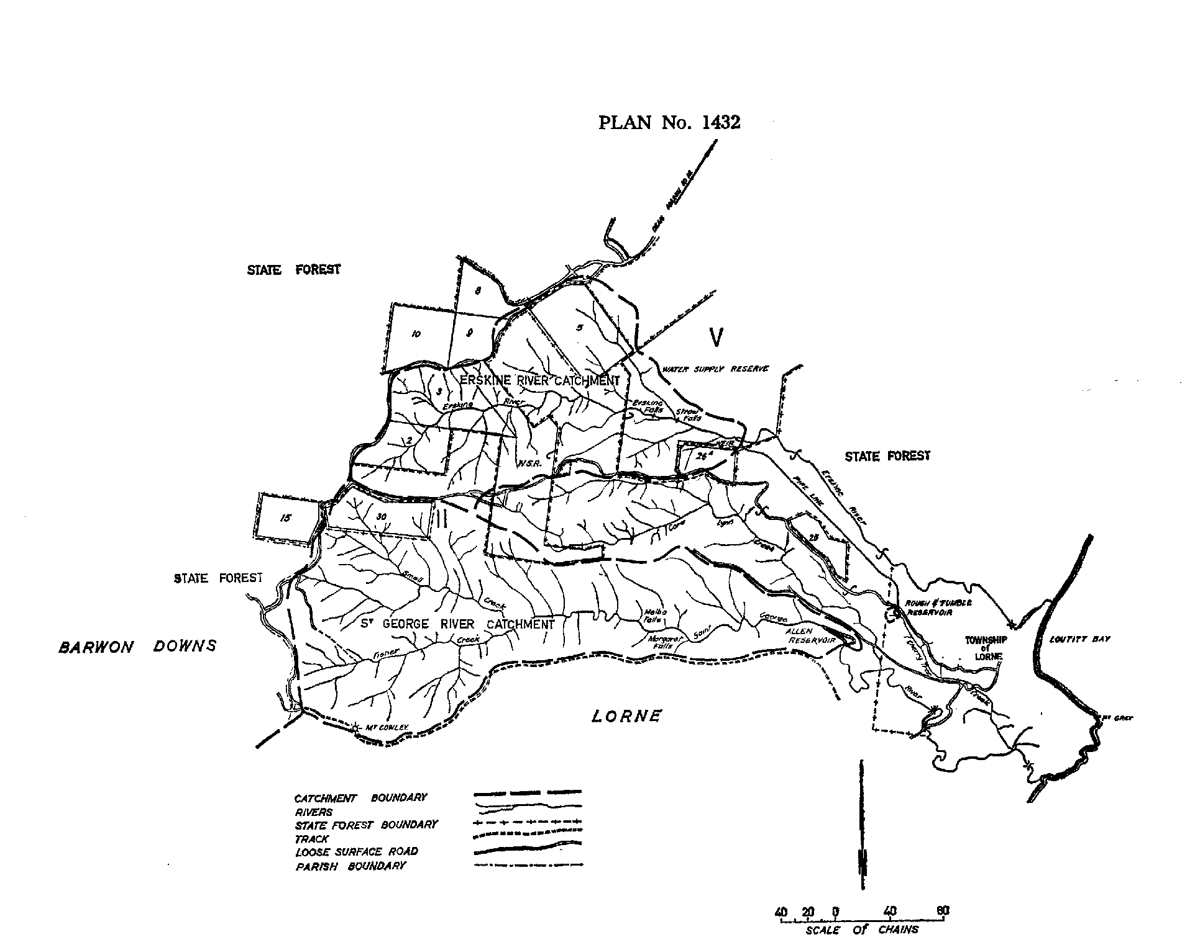
Given under my Hand and the Seal of the State of Victoria aforesaid, at Melbourne, this fifteenth day of July, in the year of our Lord One thousand nine hundred and sixty-four, and in the thirteenth year of the reign of Her Majesty Queen Elizabeth II.
(L.S.) ROHAN DELACOMBE
By His Excellency's Command
JIM BALFOUR
Minister for Conservation
GOD SAVE THE QUEEN!
By Authority: A. C. Brookes, Government Printer, Melbourne

