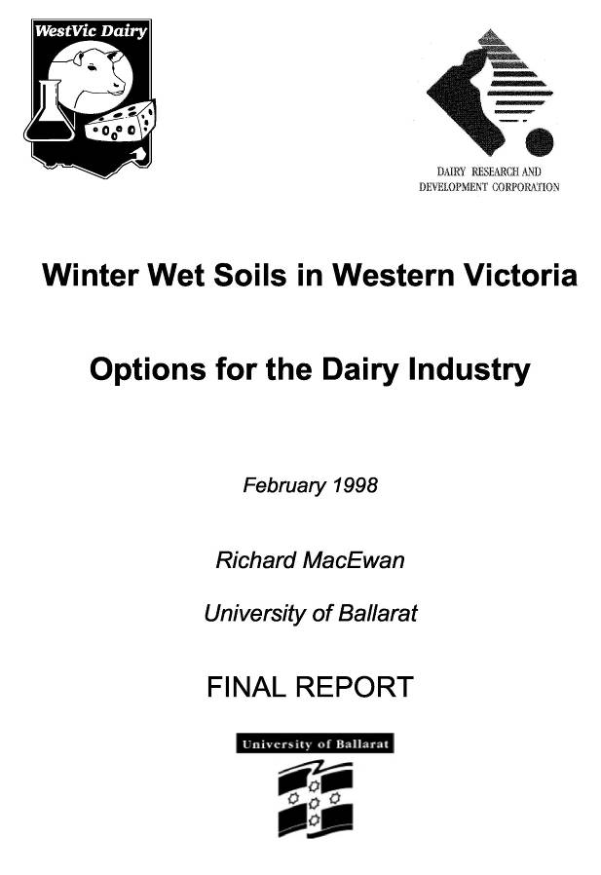
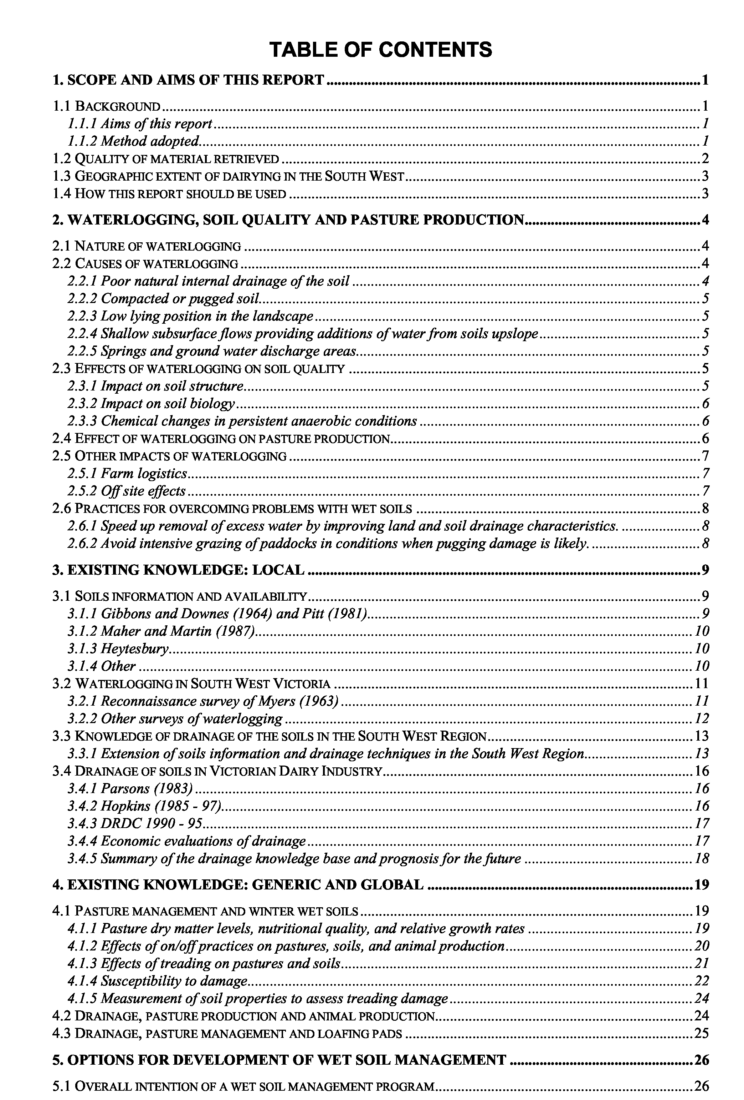
11
111
Acknowledgments
iv
Many people assisted through the provision of advice, comments, copies of papers, and unpublished or scarce material during the course of this consultancy. I particularly acknowledge the help given by Joe Jacobs, Graeme Ward, David Hopkins and Brendan Christy in the Department of Natural Resources and Environment at Warrnambool, Colac and Rutherglen respectively. Dr David Horne at Massey University, New Zealand, helped by giving copies of papers and comments on research directions and experiences in New Zealand. Richard Gloyne, Timboon, was helpful in discussions on drainage feasibility and adoption. Library research staff at the University of Ballarat, particularly Leeanne Pitman, Sue Taylor and Rose Counsel gave invaluable assistance in database searches and document acquisition. Claire Twite assisted with database entry, photocopying and document sorting. Dairy farmers encountered at field days across the South West have provided me with a better understanding of the constraints of the industry and consequently steered my thinking on this topic to their real world. However, the opinions and conclusions expressed in this report, unless specifically cited with respect to source, are mine, and none of those who assisted can be blamed for errors or biases expressed here.
Prologue
v
A sense of history or, not quite a circle, almost a spiral
The following extracts from the archives are presented to show that, although the waterlogging or ‘wet soil’ problem is still with us and has been known about for a long time, there has been progress, albeit slow. We are therefore not going round in circles but gently spiralling, the author trusts upwards out of the mire, in a progressively improving approach to dairy pasture management in the South West of Victoria.
David Myers (1963)
‘ This survey revealed that seasonal waterlogging was an extensive and intensive problem with a very real and adverse effect on the livelihood of farmers in many areas in Southern Victoria. It will not be anything new to the people living in badly drained areas to tell them that a serious drainage problem exists on their farms. They know this. But it was not known that similar problems existed in almost all of the main dairying districts in the State. The same high rainfall that makes these areas so well suited to high production likewise induces drainage problems, wherever soil and topography are such that surplus water accumulates in the soil during winter. It was obvious in the field that soil waterlogging in southern Victoria resulted from a combination of high rainfall, soil types and topography. ‘
‘ The value of drainage is clearly greater than the bare economics of the matter... There is no question of these farms ever being abandoned. Even without further research, known techniques could do much to alleviate these winter conditions. all possible resources should be applied in a unified attempt to resolve these drainage problems.’
Ian Parsons (1983)
‘ In South West Victoria there are 2,128 dairy farms and probably more than 60% of these farmers are faced with some drainage problem and consequently a loss in pasture production. ... Following this drainage project, I now feel competent at handling most drainage enquiries confronting this office. .... Designing and planning drainage systems can be undertaken with reasonable confidence.’
Warren Mason and Caroline Lemerle (1994)
‘ Waterlogging of soils in winter is seen as possibly the greatest limitation for dairying in Western Victoria. Not only is grazing difficult and damaging to the pastures, but utilisation is reduced, and farmers are inhibited from increasing stocking rates to levels that most profitably match total pasture production. It is argued in Western Victoria that there has been sufficient work carried out to demonstrate drainage systems on dairy farms.
Conversely we need to determine what can be achieved without drainage. Although drainage is often considered as a potential cure-all ... most soils are not and will not be drained. We need to develop strategies for these ‘undrained’ soils. Management of drained and undrained soils needs to be investigatedjointly.’
1. Scope and aims of this report
1.1 Background
This report has been prepared under a consultancy agreement between WestVic Dairy Research and Development Committee and the University of Ballarat. The project was instigated under the general topic of ‘wet soil management options for dairy farms in South West Victoria’ which is defined as a priority in the Western Victorian Dairy Industry Development Program (Mason & Lemerle, 1994). The scope of this report is to review existing information and develop a number of possible options for the WestVic Dairy R & D committee to consider. One or a number of options will then be developed into a full proposal for submission to Dairy Research and Development Corporation (DRDC) for funding.
1.1.1 Aims of this report
- Review available literature, from within Australia and overseas, relating to management of wet soils used for pasture production, particularly in the dairy industry.
- Identify knowledge gaps and possible barriers to improving wet soil management and indicate the areas of research and extension required in the Western Victorian dairy industry.
1.1.2 Method adopted
- A literature search of selected databases was carried out by the University of Ballarat, Information Services Branch (details of the search and search terms are included as appendix 2). Papers that appeared at first sight to be relevant were obtained as copies through inter-library document delivery services.
- Specialised or local information, in the form of unpublished notes or internal reports, was obtained by making telephone or email contact with scientific staff known to have worked, or be working on this topic either in Australia or New Zealand.
- Further published sources of information, that did not turn up in the database searches, were added to the literature for review by searching recent copies of industry journals (particularly N.Z. Dairy Exporter) and following through cited sources in published refereed papers.
- All the literature obtained was studied for relevance to the topic and details of each source were entered into a referencing database along with comments and notes that seemed pertinent to the project development (an annotated bibliography containing reference details and including notes made during the course of this work is included as appendix C).
- The effect of wet soils on the dairy farming system, research results, knowledge gaps and potential areas for research or extension were identified through literature review, discussions with a number of individuals (named in the acknowledgments) and two meetings with the WestVic Dairy R & D committee. At these latter meetings project options were presented and these have been modified and detailed in this report.
- In writing this report it is assumed that the audience will have a level of technical knowledge or access to specialist advice for clarification of any unfamiliar concepts or terms.
1
1.2 Quality of material retrieved
Documents retrieved and studied were not all equal in the quality or reliability of information contained in them. Six levels of publication were recognised, the distribution of these is shown in the following figure.
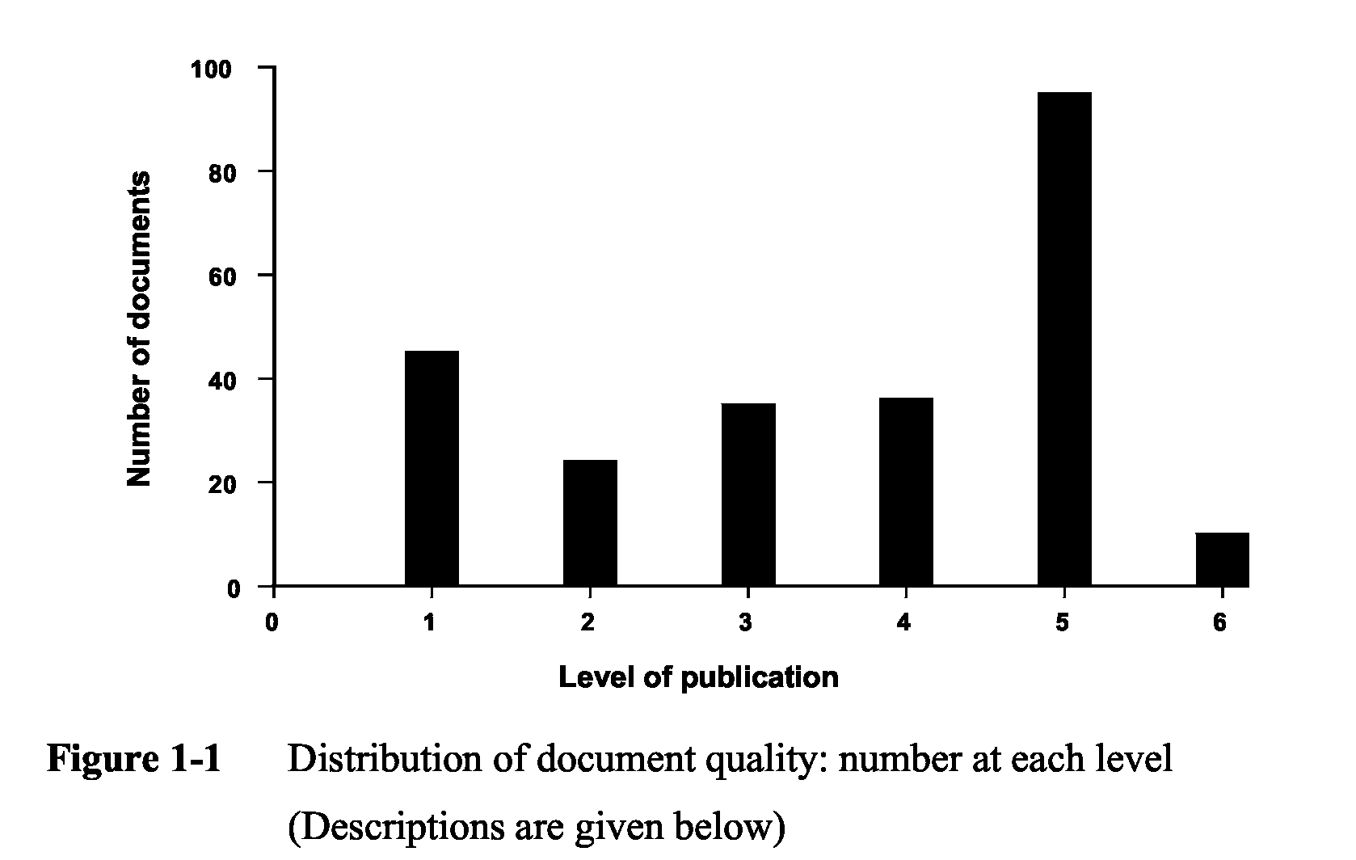
- News articles and other secondhand reporting of information. Variable quality some very good others ‘preachy’ or based on subjective experience. Some lower level extension material and Dairy Exporter articles are included in this level.
- Field day notes, providing some details of research project aims or details of research results. These are also of variable quality and may fall towards level 1. However they usually represent the first appearance of data and methods. Research proposals, reviews and study tour reports would be included at this level.
- Internal or limited issue reports and technical bulletins. These often have good value information in them especially when based on review, interpretation and practical application of advice. Some extension material is included at this level. Government reports such as the State of the Environment Report are included at this level, not at level 6. as they are of uncertain quality with respect to peer review.
- Papers published in conference proceedings. Often these are the only place that results appear to be written up although they are usually an early run up to publishing the content in a refereed journal.
- Fully refereed scientific publications. These are the Rolls Royce documents. They have been through a process of peer review and mostly contain statistically analysed results of research projects. PhD and Master of Science research results are included at this level.
- Standard recognised textbooks and book chapters. By the time information is published at this level it has already been through levels 4 or 5. If it is here then it should be tried and true; the proven and accepted conventional wisdom on the topic. The limitation is that by the time information is published at this level it has usually been around for a long time and may be over-generalised or out of date.
2
1.3 Geographic extent of dairying in the South West
There are approximately 2000 dairy farms in the region stretching from Heywood in the west to Geelong in the east. Dairying is scattered around the Ballarat district and there are still a few dairy farms on the coastal fringe around Apollo Bay. Irrigation is carried out on only a few farms, particularly those on the better drained volcanic soils around Alvie but is being extended to other parts of the region. Figure 1-2 shows the distribution of milking cows on a parish basis (map courtesy of David Buntine via David Hopkins, Department of Natural Resources and Environment, DNRE, Colac).
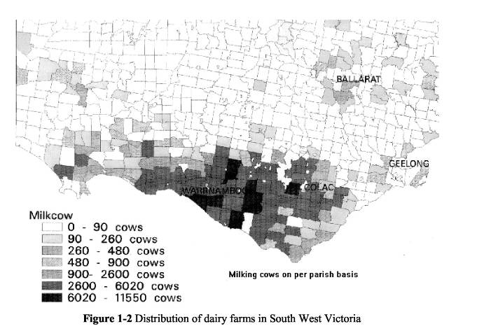
1.4 How this report should be used
This report is not the final word on wet soil management. The issue is diverse and a full review and discussion of different aspects such as waterlogging, drainage, grazing strategies and pasture management, and methods for soil assessment could fill several books. This report should be used as a ‘first base’ resource document to find published material relevant to wet soil management, particularly in South West Victoria. Appropriate references can be found here to support or justify funding applications for soils or pasture research, including environmental aspects. The body of the text in sections 2 to 6 provides an overview of the information gleaned from the literature; it is not a fully blown literature review but provides pointers to the best sources available. Often fuller notes can be found in the annotated bibliography, appendix C, along with references that are pertinent to the general topic but which are not cited in the main text. Recommendations in section 7 are regarded by the author as ‘mandatory’.
3
2. Waterlogging, soil quality and pasture production
The general issue of waterlogging and specific effects of wet conditions on soil properties and plant growth has been addressed by many authors (e.g. Adams & Akhtar, 1994; Tregaskis & Prathapar, 1994) and can be found in standard texts (e.g. Wild, 1988; Marshall, Holmes & Rose, 1996) so only needs summarising in this report in order to set the context. While some examples are given in this section more detailed data is cited in other sections of the report or can be found in the sources listed in appendix C, the annotated bibliography.
2.1 Nature of waterlogging
A waterlogged soil is one that is saturated or nearly saturated with water. This condition can occur briefly in all soils during and immediately after heavy rain. Saturation of the pore space within the root zone limits air supply, inhibits respiration and consequently depresses plant growth unless the plants are adapted to living in wet conditions (e.g. having either aerenchyma or aerial roots). Saturated conditions can easily be recognised in the field by extracting a spade full of soil from the layer of interest and observing water flowing out of the soil mass.
A critical volume fraction of gas filled porosity (g.f.p.) in the soil is generally accepted in the literature as lying between 0.08 and 0.12 for diffusion rates of oxygen and carbon dioxide to maintain a satisfactory soil atmosphere for growth. Oxygen diffusion rates are ten thousand times faster through gas filled pores than through water filled pores. There is no absolute threshold fraction for gas filled porosity as actual rates of respiration are temperature dependent, and gas diffusion depends on continuity, tortuosity and connectivity of the pore space, not just volume. A smeared subsurface layer only millimetres thick could be sufficient to create locally anaerobic (no molecular oxygen) conditions on and below that layer.
2.2 Causes of waterlogging
Waterlogging only becomes a problem when the conditions persist for more than several days and is usually due to one or more of the following factors:
2.2.1 Poor natural internal drainage of the soil
Inherent soil properties, texture and structure, control the drainable porosity and hydraulic conductivity of the soil. Drainable porosity is equivalent to gas filled porosity at field capacity and should constitute at least 0.2 (20%) of the soil volume to avoid waterlogging problems. Hydraulic conductivity is a measure of how quickly water can move through soil if unimpeded. Internal drainage characteristics can only be interpreted from a knowledge of the whole soil profile and, in some cases, the underlying regolith (sediments or weathered rock). If impeding layers or features exist then water will not move readily out of layers above even though they may be intrinsically quite permeable (drainable porosity >20% of soil volume).
A history of waterlogging in a soil can be recognised from soil colour, especially through the evidence of gleying (blue-grey colours, mottled yellow-grey subsoils, rusty coatings in root channels, blackish or rusty mottles in paler sandy or loamy A2 horizons).
4
2.2.2 Compacted or pugged soil
Shallow compaction of the soil resulting from treading pressures can restrict downward movement of water and encourage shallow perching of water within the top few centimetres of soil. We have witnessed this at a sandy loam site near Nullawarre where a spade depth of soil was excavated and water was seen to ooze out of the top few centimetres but not from the lower depths. Using a pocket penetrometer, soil strength was found to be almost three times higher in a thin compacted layer compared to the soil above and below this layer.
Pugging and puddling seals the soil surface and exacerbates waterlogging of the topsoil by impeding infiltration and providing surface indentations for water storage, thereby reducing the efficiency of surface drainage from the paddock.
2.2.3 Low lying position in the landscape
Low lying positions inevitably receive any runoff from upslope positions and if they also have imperfect surface drainage then the soils have to cope with multiples of the annual rainfall. Soils in these sites are frequently fine-textured (clays) and therefore remain waterlogged for long periods.
2.2.4 Shallow subsurface flows providing additions of water from soils upslope
Sloping sites often become wetter downslope not because of any major change in soil type, groundwater hydrology or accumulation of runoff, but simply due to slow throughflow of water downslope and within the soil profile. Consequently these soils remain wetter longer and effectively have to handle more than the annual rainfall as with low lying positions in the landscape.
2.2.5 Springs and ground water discharge areas
These features are an expression of the groundwater hydrology and underlying geology. Whereas most waterlogging in the South West Region is associated with rainfall excess over soil water storage capacity and therefore associated with freshwater, springs, seeps and groundwater may in many instances be saline.
2.3 Effects of waterlogging on soil quality
General decline in soil quality for pasture production lessens potential for sustainable farming. Soil physical, chemical and biological properties can all be affected in deleterious ways by waterlogging.
2.3.1 Impact on soil structure
- Breaking, churning and roughening of soil surface by hooves when the soil is wet and weak destroys soil aggregates, decreases their wet stability and modifies macroporosity. The process is self-perpetuating due to ponding of water in hoof marks, reduced infiltration and poorer surface drainage. Consequently the soil remains wetter longer than in the undamaged state.
- Soil compaction within topsoil causes a loss in porosity of the soil with the larger macro-pores or pores that would be gas filled at field capacity the first to be lost. Compaction usually occurs just below the pugged soil in waterlogged conditions and restricts downward percolation of water and root penetration.
5
- In the deteriorated condition created in (i) and (ii) above the soil remains wet for long periods and dries slowly. This is not ideal for soil structure regeneration which occurs more effectively with frequent wetting and drying cycles. Consequently the surface soil tends to exhibit more cracking and more hard setting behaviour (Reid & Parkinson, 1984).
- Soil loss by water erosion, or potential for water erosion is increased with decreased infiltration, surface ponding and increased runoff.
2.3.2 Impact on soil biology
- Decreased biological activity occurs in waterlogged, and especially in pugged, conditions. This limits nutrient cycling, and also has physical implications as fewer drainage pores are created by earthworms. Effects on dung beetles (mostly active in spring and early summer) and on beneficial micro-organisms or pathogens are unknown.
- Lower annual organic matter additions from plant roots occur if dry matter production is depressed. Also the depth of root zone is limited so root residues are confined to the upper part of the soil profile. A thatch of unutilised grass may build up on the soil surface.
2.3.3 Chemical changes in persistent anaerobic conditions
- Reduction occurs of nitrate-nitrogen, NO3-, to nitrite, NO2- , to nitric oxide, NO, to nitrous oxide, N2O, and nitrogen gas, N2. Total nitrogen is depleted.
- Iron and manganese compounds are readily reduced and become soluble releasing Fe and Mn into soil solution. Mn toxicity can limit plant growth.
- Ethylene production begins when soil oxygen concentration drops below one percent in waterlogged conditions and will inhibit root growth. It is probably more serious than lack of oxygen.
2.4 Effect of waterlogging on pasture production
The effect of waterlogging on pasture production can be described functionally, but there are also quantitative studies that have been carried out either as greenhouse and pot studies where water and aeration have been controlled, or as field studies where areas have been drained and compared with an undrained equivalent. The following generalisations are made onthe basis of existing data in relation to pastures on waterlogged as opposed to non-waterlogged areas.
- Pasture dry matter production is lower and this effect is greatest in the winter. Some data show no, or only small, annual differences in production, however, winter growth is more valuable.
- Utilisation of dry matter as a percentage of available pasture utilisation is lower due to treading and muddying of sward. Losses may be as high as 80%.
- Nutritional value of pasture is lower so supplements are needed to maintain milk production levels.
- Pasture composition is poorer, due both to decline of species intolerant of wetter conditions (e.g. Clovers) and colonisation of pugs and bared soil by weeds (e.g. Ragwort), and more frequent renovation is therefore needed.
- Pasture regrowth is slower, therefore longer rotations, or larger grazing area allocations are needed.
6
- There is less root penetration into the subsoil and consequently lower water use and less drought resistance in spring and early summer as the soil dries.
- Denitrification in waterlogging conditions (see 2.3.3) and consequently a loss of available nitrogen means that higher fertiliser applications are needed to maintain production.
2.5 Other impacts of waterlogging
Apart from the direct effects of wet soils on soil and plant there are a number of indirect negative effects on farm management (labour, costs and hazards), and off site effects on the environment and the public perception of the industry.
2.5.1 Farm logistics
- Access for vehicles and stock is severely restricted when paddocks are wet, especially in gate areas. This can lead to time wasted in rescuing bogged vehicles and repairing damage. Additionally timing of operations such as feeding out, cutting hay or silage and optimal grazing rotation, is at the mercy of weather and soil. Difficulties arise in selecting paddocks for “safe” grazing.
- Rough surface conditions of pugged paddocks when dry are a potential source of injury for staff and stock. Rolling or some degree of renovation may be necessary as soon as possible after grazing and pugging damage has been incurred.
- Muddiness of animals involves extra cleaning costs at milking.
- Animal health hazards are higher in wet conditions, leading to time wasted, low condition scores, and higher veterinary bills.
- Extra supplementary feeding to make up rations for milk production may be required as animals fail to fully utilise available pasture.
- Overall the stress (financial and health) on the farm manager and staff is increased. 2.5.2 Off site effects
- The most topical environmental impact of dairy farms generally is that of nutrient loads in run off leading to eutrophication of creeks. (e.g. Hazell, 1991; Ledgard et al., 1996; Sandercock et al., 1996). Additional problems of erosion and siltation of creeks may be aggravated by any land management in high rainfall areas and, in some cases, a badly organised cure (e.g. poorly planned drainage) can be worse than the disease.
- Wet soil problems therefore impact on the public image of the dairy industry and dairy farmers as potential polluters. The appearance of the farm and stock in muddied condition does not provide a positive image for the industry either and there have been instances of complaint from members of the public on seeing the ‘poor cows standing out in the mud and rain’!
- Interactions between waterlogging and salinity are also regionally important. Dryland salinity is perceived to be increasing in South West Victoria. The conventional wisdom is to advocate returning a proportion of the landscape to tree cover in order to prevent recharge to regional and local saline groundwater. The sacrifice of valuable pasture to trees is an unattractive option for dairy farms and in fact may not solve either the problems associated with salinity or with waterlogging. Recent work (MacEwan et al., 1996; Dahlhaus & MacEwan, 1996, Clifton & Taylor, 1996) has highlighted the need to develop more realistic approaches to both of these problems.
7
iv. The dairy industry as a major user of land in the region cannot avoid being closely scrutinised with respect to nutrient and salt issues.
2.6 Practices for overcoming problems with wet soils
There are two groups of practical measures that can be taken to overcome the problems associated with wet soils:
- Speed up removal of excess water by improving land and soil drainage characteristics.
- Avoid intensive grazing of paddocks in conditions when pugging damage is likely.
Strategies adopted under either of these headings are not entirely independent. More speedy removal of excess water will increase “safe” grazing intervals but there will still be times when the paddock is vulnerable to damage so grazing will need to be restricted. On the other hand, in the high rainfall environment of southern Victoria, there will always be winters where the “safe” grazing periods do not coincide with optimum grazing time and grazing rotation plans. Any option successfully implemented by the dairy industry is likely to be a combination of measures from both categories. Strategies available under the two categories are summarised below. These are discussed in relation to published work in sections 3 to 5 of this report.
2.6.1 Speed up removal of excess water by improving land and soil drainage characteristics.
- Intercept all surface runoff from areas extraneous to the grazing area (roads, land higher in catchment).
- Improve surface drainage of surrounding paddocks.
- Improve surface drainage of paddocks (more surface drains, land forming, removal of surface roughness).
- Improve soil internal drainage characteristics by removing any compact or impeding layers (surface loosening, shallow chisel ploughing or ripping to relieve cow-induced soil compaction, deep ripping to loosen compact soil zones which are inherent to the soil type).
- Encourage more open soil structure by appropriate pasture management (good root development, choice of species).
- Install subsurface drainage systems (e.g. pipes, pipes + moles, pipes + ripping, pipes + gravel moles, tube wells).
2.6.2 Avoid intensive grazing of paddocks in conditions when pugging damage is likely.
- Change land use (dedicate as a hay or silage paddock and graze only in summer, or remove from the grazing rotation).
- Remove stock as soon as pugging is imminent.
- Allocate short grazing periods on restricted area to allow optimal feed intake prior to onset of pasture damage.
- Designate “sacrifice area” to which cows are moved in any wet weather.
- Construct or designate “loafing area” (pad, laneway, barn or woodlot) to which stock can be moved in wet conditions.
- Construct feed pad for all supplementary feeding in wet weather. 8
3. Existing knowledge: local
In this section the available information on the region’s soils, associated waterlogging, and pasture response to drainage is summarised.
3.1 Soils information and availability
Soil survey information in the South West Region is confined to three major published reports:
- Gibbons, F.R. and Downes, R.G. 1964 “A study of the land in south-western Victoria.”
- Pitt, A.J. 1981 “A study of the land in the catchments of the Otway Range and adjacent plain.”
- Maher, J.M. and Martin, J.J. 1987 “Soils and landforms of south-western Victoria. Part 1. Inventory of soils and their associated landscapes.”
The associated maps are at a resource inventory scale useful for determining project locations (Dent & Young 1981) but not useful for providing farm or catchment scale management advice. Mapping units at this scale contain high variability of soils, which are incompletely documented and of unpredictable distribution. The approximate coverage and overlap of these reports is shown in figure 1., more detailed maps of the study areas are included in appendix 1.
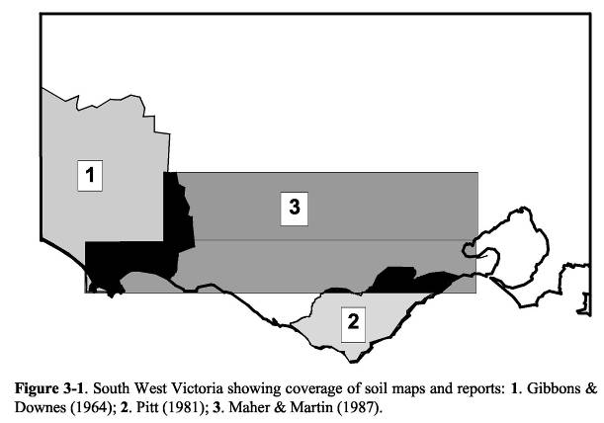
3.1.1 Gibbons and Downes (1964) and Pitt (1981)
The studies by Gibbons and Downes (1964) and Pitt (1981) are similar in approach, scale
and detail supplied. The mapping has been accomplished by adopting a land systems
approach which is based on physiographic divisions visible on air photographs. Within each
9
land system, land components are identified but are not mapped. Principal soils found in the study area are described and some analyses provided. Maps showing the land systems are published at a scale of 1:250 000. The original survey mapping would have been carried out at 1:100 000. Unpublished field notes and maps are not available for the Gibbons and Downes (1964) survey, but some of the old field notebooks, air photographs and analyses are available for the Pitt (1981) study (Martin Bluml, Centre for Land Protection Research, CLPR, Bendigo, pers. comm.April 1997).
3.1.2 Maher and Martin (1987)
The study by Maher and Martin (1987) adopted a different approach but comes up with similar boundaries for mapping units (published at 1:250 000) to those in the Statewide land systems coverage of Rowan (1993) and the published geological survey maps. In this study, soils were grouped according to features important for management with soils clustered after a basic classification according to Northcote (1979). The survey involved over 3000 soil profiles (auger or road cutting) and samples are currently being analysed. Original survey notes and air photographs use to map boundaries are still accessible for this study (Mark Imhof, pers. comm.April 1997). Some of the mapping units and unit descriptions may be revised in the near future (John Martin, pers. comm. April 1997). The original intention was that this study would be followed with two further reports; one on the chemical and physical properties of the soils, and one with management recommendations.
3.1.3 Heytesbury
The Heytesbury area, important to the dairy industry is not covered by the three studies, however some relevant soils information can be found in Pitt et al. (1977) but this has been largely included in Pitt (1981) with the exception of the Swan Marsh land system. This land system is a flat, poorly drained area of land to the north of Simpson with alluvial soils largely derived from basalt to the north (black cracking clays) or from the coastal sediments (Hanson Plain Sand) to the south (yellow-grey gradational soils often with ironstone present in the profile).
Recent studies in the Heytesbury (Dahlhaus et al., 1996; MacEwan et al., 1996; MacEwan, 1994) have focussed on waterlogging, landslides and salinity at the farm and sub-catchment scale. MacEwan (1994) gives an overview of the geology and geomorphology of the region and discussion of principal soils of the area in relation to soil structure and drainage characteristics. Fifteen 0.1 m by 0.9 m deep cores preserved from sites referred to are housed (five boxes of three cores each) at DNRE in Gellibrand Street, Colac and can be accessed by contacting David Hopkins at that office. Some physical analyses (particle size) were completed for these cores and are available from Richard MacEwan, University of Ballarat. MacEwan et al. (1996) mapped soils and salinity at Newtons’ farm, Gallum Road, Simpson (R364 drainage research site) and described soils and geomorphology of the Heytesbury area. Five soil types were mapped at the R364 site.
3.1.4 Other
The most recent work in the South West dairy region has entailed detailed documentation and analysis of 12 soil profiles associated with the South West Dairy Irrigation Project (DNRE dairy research staff, Warrnambool). Besides soil profile descriptions and chemical analyses, some physical properties have been measured, in particular bulk density and soil moisture characteristics for different horizons. These data are unpublished but available
10
within DNRE via Graeme Ward, Warrnambool; Mark Imhof, Melbourne; and Austin Brown, State Chemistry Laboratory, Werribee.
3.2 Waterlogging in South West Victoria
Winter waterlogging of soil is an extensive problem in South West Victoria for cropping and pasture industries. The, recently established, ‘Southern Farming Systems’ group has been set up with support from DNRE staff in Ballarat and Geelong to trial potential improvements in crop production in the high rainfall areas south of the Dividing Range. Some of these options are based on improving soil physical conditions through use of gypsum, deep ripping and drainage, while others are based on new crops or crop varieties. Waterlogging is recognised in the dairy industry as a major limitation to pasture management, and also, even if it is not a limit to pasture production, it certainly limits milk production from grass fed cows due to inferior pasture utilisation.
3.2.1 Reconnaissance survey of Myers (1963)
Undoubtedly, still the most significant survey of this problem was that carried out from 1960 to 1961 by David Myers, a dairy husbandry officer with the Department of Agriculture (Myers, 1963). It is worth noting some of the rationale of the time in the following passages taken from the foreword to that survey report:
“Drainage of soils is widely recognised as important in obtaining high production from agricultural lands in overseas area similar to southern Victoria’s dairying areas. In these parts of Victoria drainage is generally a neglected subject. It appears that in the absence of a unified body to take responsibility for the design and evaluation of the different types of systems available, there has been no accumulation of knowledge of the subject of drainage. the drainage project was initiated (by the Dairy Husbandry Branch) in 1959. ”
The aim of the drainage project was “to encourage and organise the orderly development of drainage on dairy farms in Victoria...” and consisted of three phases:
- A descriptive survey of existing drainage problems and practices in Victoria
- Demonstration and further development of drainage techniques
- Extension in the form of a drainage advisory service.
Myers’ (1963) report comprises the first phase of this project, although demonstration sites were set up at Seville and Launching Place in 1959. Stage 3 was seen as depending on validated “demonstration, a drainage service staffed by full-time specialists and adequately equipped with machinery”. As far as I know this did not develop, although activities in the early 1980’s by Bram Bakker revived the efforts towards developing drainage expertise in the Department of Agriculture. The statement on requirements for successful extension reflects the attitudes of the time with respect to responsibilities of government departments (this was also the time of the rise of Soil Conservation Authority). While we might agree with the three pre-requisites of demonstrated technique, drainage design competence, and suitable machinery, there are other ways of satisfying these outside of the government departments.
Myers set out to complete phase 1 and visited districts from Heywood to Traralgon and northwards to Kyneton, observing soil conditions in July and August 1960 and interviewing farmers and department district staff. Areas in the South West were: Heywood, Macarthur, Warrnambool, Colac, The Otways, Ballarat and Geelong.
11
A simple classification was made of areas either in need, or not in need, of drainage. Soils were classified as waterlogged if the ground surface was covered with water or pugged mud and water for periods of 3 to 4 days, or a watertable existed at 12 inch depth or shallower for prolonged periods. Areas in need of drainage (waterlogged areas) were subdivided into five land units each having similar waterlogging problems, and therefore, presumably, having similar drainage solutions, plus two further miscellaneous complex units. Further sub-divisions were made on the basis of location. Myers used observations of surface wetness conditions, pugging, vegetation associations and yabbie activity, plus a four inch auger for confirming soil types and depths to shallow watertables. Boundaries were drawn onto a 1:250 000 scale map (one inch to four miles). The availability of Myers’ original maps is unknown; one very small scale map is included in his report (Myers, 1963). The originals would be worth finding. Because of the importance and scarcity of this report a summary of Myers’ land units and soils is presented in table 3-1.
Myers said of the Western Miscellaneous Unit (Camperdown, Terang, Timboon,
Heytesbury area): “ In this area, a rainfall of 30 to 40 inches per year combines with sharp
changes in topography and soils to form a complex of drainage problems. Waterlogging is
a major problem on an estimated 50% of the area The need for drainage was fairly
commonly recognised by farmers, but few knew how to tackle it The complexity of
problems make this a difficult area in which to start drainage trials. Furthermore tree roots and disturbances to the soil profile on recently cleared forest land will hamper drainage work. Thus drainage problems could best be organised from GlenOrmiston Research Station. When successful techniques are found these could be extended further into this Miscellaneous Unit as required.” (Myers, 1963).
It is interesting to reflect on this now. GlenOrmiston, on the edge of Mount Noorat, has naturally well structured freely draining soils so the necessity to develop drainage did not exist at the station. Subsequently, drainage within the Heytesbury has been developed and demonstration of the techniques to drain the soils of the district has been achieved through the not insignificant efforts of one dairy extension officer and the services of drainage contractors, and without a major departmental research program or advisory service.
3.2.2 Other surveys of waterlogging
No other actual on ground surveys of waterlogging have been carried out in the region. The problem has been mapped by interpreting existing land systems data at a scale of 1:250 000. The 1991 State of the Environment Report (Office of the Commissioner for the Environment, OCE, 1991) reviews the impact of agriculture in Victoria and includes an assessment of waterlogging. The South West is shown as having moderate to high inherent susceptibility to soil structure decline (map 18.1 facing p.386) but insignificant to low inherent susceptibility to waterlogging (map 18.2). The maps were prepared by Jim Rowan for the OCE report and are derived from the State's land system database. Waterlogging is quite evidently a serious problem in the South West and its under-representation in this report is an issue that needs to be acknowledged in development of any future policies relating to land degradation and land management in the region.
The only specific study that has attempted to define the area prone to waterlogging in South West Victoria since Myers is an RMIT student project by Nicholls (1995). The study employed Arc/Info as a GIS to manipulate existing data files provided by DNRE. Data input were: land systems (1:250 000), surface hydrology, contours (1:100 000), roads and tree cover. Output shows five classes of waterlogging and relates this to land use. Waterlogging appears to have been underestimated in this study, which is limited by the
12
level, quality and scope of the data used but provides a first go at using GIS to investigate this issue. If climatic data, more sophisticated use of digital elevation modelling, geology or regolith, and a more appropriate soils database were included, then this would provide a realistic evaluation of waterlogging in the region.
3.3 Knowledge of drainage of the soils in the South West Region
This resides in the experiences of farmers and drainage contractors and is virtually undocumented. It is not the place of this review to produce that documentation, nevertheless a broad summary is useful and is therefore attempted here (see also table 3-1).
Soils in the region reflect regional geology, geomorphology and topography and so their variety and variability is much greater than the surface geology. However geological survey at 1:250 000 (Ballarat, Colac, Hamilton and Portland sheets) provides a good context for understanding the parent materials, soils and drainage problems. Experience is principally confined to the area between Colac and Warrnambool and table 3-2 provides my general observations on drainage experience or potential of some of the major soils used for dairying in that part of the region.
A number of significant dairy areas are not included in table 3-2, because either they are not in need of drainage, e.g. the red soils around the scoria cones of Mt Leura and Red Rock, or because nothing is really known about the success of drainage. The additional areas which need to be taken into consideration are:
- The ‘lake and dune system’ to the east of Lake Corangamite (Nicholson et al. 1992). The soil materials here are recent alluvial and lacustrine deposits with more recent lunettes and are derived from the surrounding basalt. These would have some soils in common with the group described in table 3-2 as ‘Volcanic, basalt flows and lacustrine or alluvial material derived from basalt’.
- Otway group (Cretaceous) which makes up the Otway Range. These sediments are sandstones and mudstones with little or no quartz, the mineralogy is micaceous and weathers rapidly to clay soil. The land is highly susceptible to landslips. Rainfall is high and waterlogging common. There are many dairy farms on this unit to the north of the Otway Range and along the coast, for instance at Apollo Bay.
- Murray Basin sediments (Quaternary) which occur to the north of Portland to the west of the Glenelg river. These comprise dune limestones. minor siliceous sands, swamps, lake margin and lagoon sand sheets.
3.3.1 Extension of soils information and drainage techniques in the South West Region
Drainage has been a topic for discussion groups and has also been the subject for two major seminars and field days in the Simpson area which have hosted talks on this topic by specialists from the United Kingdom, New Zealand and Australia (Department of Agriculture, 1993, 1994). Recent meetings, field days and discussion groups have centred on other aspects of wet soil management such as on/off grazing, use of pads, and managing pugging. Awareness of the issues and some of the options must therefore be high across the region. The quality of practical knowledge and support is high but it is not known what is preventing wider or more rapid adoption of drainage techniques. A survey of 76 farmers who had installed drainage revealed that 96.6% believed subsurface drainage was effective in overcoming waterlogging, and 88.7% saw it as an economically justifiable option (Christy, 1995). More than 90% of the installations had been carried out in the previous four years which demonstrates the growing interest in drainage.
13
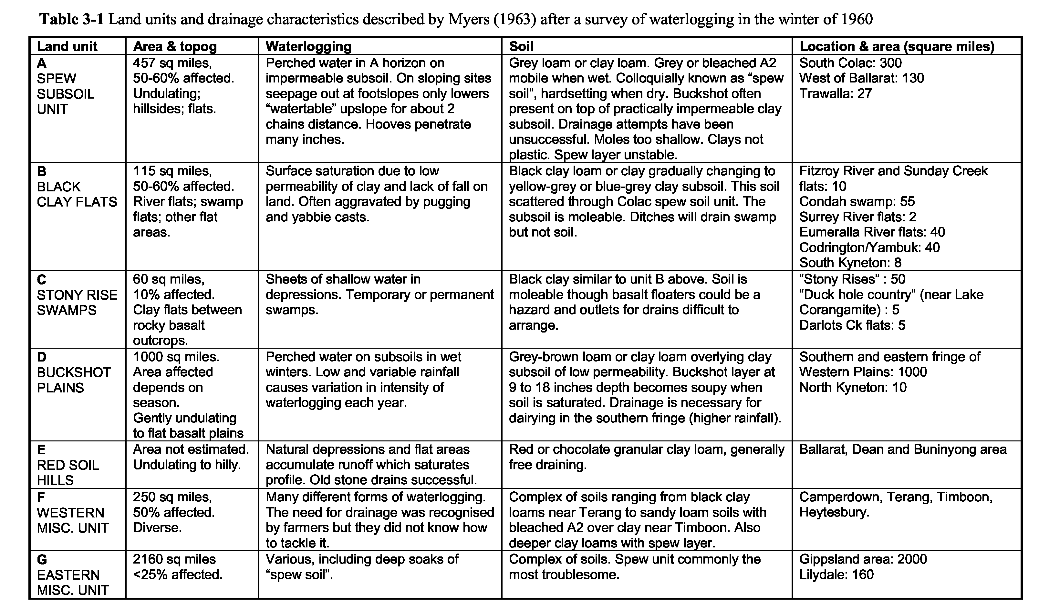
14
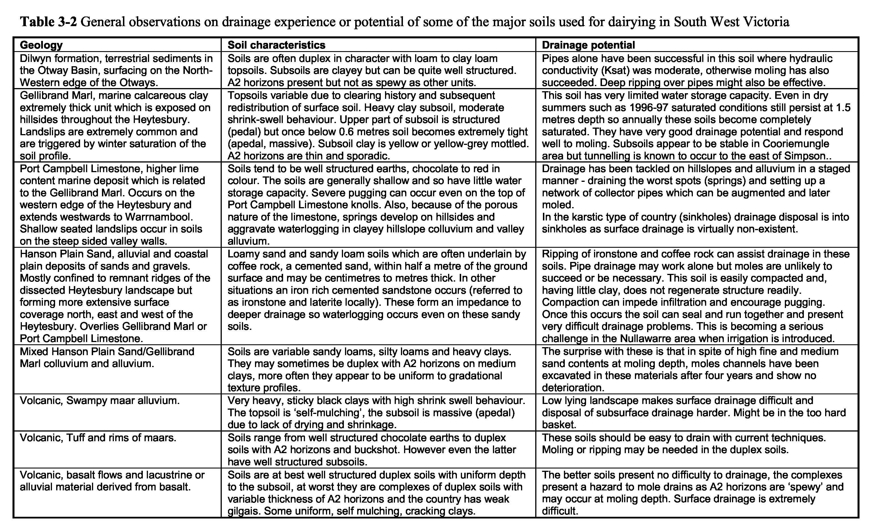
15
Winter Wet Soils in Western Victoria Options for the Dairy Industry, Richard MacEwan, February 1998
3.4 Drainage of soils in Victorian Dairy Industry
Drainage of soils has been carried out but documentation has been sparse. One of Myers’ principal tasks was to survey existing drainage systems but he reported that, “virtually no worthwhile underground drainage systems were discovered, and the conclusion was reached that very few drainage systems existed. Those that were found proved unrewarding subjects for further study ”(Myers, 1963). The drainage project of the Dairy Husbandry Group set up trials at Seville and Launching Place in 1959, but I have not found any records of the achievements of these trials.
3.4.1 Parsons (1983)
Ian Parsons reported specifically on drainage systems for use in South West Victorian dairy farms. Installations were carried out under the supervision of Bram Bakker from Department of Agriculture at Werribee. Agflow pipe (80 mm slotted PVC) was laid by hand in the base of a trench cut by Ditch Witch and was backfilled with scoria. Mole drainage was installed using a very large mole plough built at Werribee (100 mm diameter foot) pulled by a D4 60 HP bulldozer and 45 HP tractor in series. Some moles were installed with a smaller 3-point linkage mole plough. Drainage was carried out in 1980 at the Woolsthorpe State School oval and in two paddocks on a property of John Dwyer near Timboon. Moling took approximately one hour per hectare. Observation was made that moles were pulled in deeper by travelling downslope rather than upslope.
Pasture measurements were made using pasture cages on an undrained ‘control’ site and two mole drained paddocks (one drained with large foot, the other drained with the smaller foot), but results need to be interpreted carefully due to differences in cage size, clipping practice, interference by cows, and insufficient replication. Additional measurements were carried out at Ross Powell’s property in Cooriemungle. Species composition was also recorded (visual estimate). Drainage improved pasture production by 1695 kg DM ha⁻¹ yr- 1 (control = 14 137; drained = 15 832 kg DM ha⁻¹ yr⁻ ¹), representing a relative increase of 12%. A calculation based on feed DM conversion to kg of butterfat showed that the costs of drainage would have been covered in one year. Utilisation of the pasture was not measured. Herbage quality was analysed and found to be better on the drained sites.
3.4.2 Hopkins (1985 - 97)
David Hopkins working primarily in the Colac and Heytesbury area facilitated the installation of pipe and mole drainage on a number of dairy farms in the region. Contractors Bill Boersma (Aussie Drain) and Richard Gloyne (Drain Tech) have been responsible for carrying out the pipe installations while farmers have carried out moling with a variety of mole ploughs. Pasture measurements were made, and water levels in shallow dip wells were monitored, at a number of farms. These measurements were not carried out as part of a funded research project but have nevertheless given useful indications of the performance of the drainage systems and response of the pasture to drainage. Some of the results were reported in MacEwan et al. (1992) and are repeated here because of their regional importance.
At Barongarook, moles were installed at 40-50 cm depth and 3-4 metre spacing in a well structured Dy4.1 soil with a moderate _{Ksat} of 0.25 m _{d}- 1 (Hopkins, personal communication June 1991). Three years results showed that initially pasture production was improved during winter and spring; 72% increase in dry matter in the first year, 17% in the second,
16
Winter Wet Soils in Western Victoria Options for the Dairy Industry, Richard MacEwan, February 1998
and 13% in the third year, the moles gradually failing over the three winters. It is thought that the demise of the channels was largely due to moling in low moisture conditions (December) and using too large a mole foot and expander (100 mm). The paddock was subsequently re-moled, with a smaller expander (70 mm diameter), in mid-summer after 200 mm rain had rewetted the profile. No further pasture measurements were made at this site but the improved drainage allowed vehicles to be driven across this paddock with no ill effects in one of the wettest winters on record (1991).
At Barongarook West a Dy3.41 soil in which the A2 horizon often extended to a depth of 50 cm (spew soil unit of Myers, 1963) was successfully drained with pipes at 20 metre spacing and a pasture yield increase of 67% was achieved in the first year (Hopkins and Bakker, 1986). Differences in pasture utilisation were not measured but it would be fair to assume that this would increase on the drained areas. Subsequent deep ripping across the pipes at this site has apparently increased the benefits (Hopkins, personal communication).
3.4.3 DRDC 1990 - 95
Major research into drainage and pasture production has been carried out on dairy farms in North East Victoria under the DRDC funded projects DAV 166 and DAV 258 (Christy, 1996). Under the second of these projects drainage was funded in Gippsland and a survey of farmer attitudes to drainage carried out in the South West.
Soils drained in the North East were at three sites with yellow duplex soils and at one site with a complex of uniform cracking clay and duplex soils. Moles (in some cases gravel filled moles) were used at all of these sites. The duplex soils would correspond to Myers’ ‘spew soils’ in physical behaviour. The subsoils appear to be less stable than those found in the South West. The cracking clay would be comparable to some of the heavier basalt derived soils in the South West. Drainage was effective at all sites in increasing annual dry matter production and utilisation of pasture. The simplest summary of the results averaged across the sites would be to suggest that ‘every hectare drained equals half a hectare gained’. In this respect results are comparable or better than those reported from either New Zealand or the UK.
In Gippsland gravel moles were specifically tested. Winter pasture production increased by 15 to 30% depending on mole spacing but some sites were much more successful than others.
3.4.4 Economic evaluations of drainage
The DRDC funded research has established that there are large pasture production benefits due to drainage. The replicated nature and time period of the experimental work leaves this fact in no doubt. Economic benefits have been estimated and, conservatively, show that drainage payback can be within three years of the initial investment. However, confidence in these evaluations does not seem to be ‘out there’ in the dairy community. There could be a number of reasons for this:
- In spite of ‘awareness raising’ field days and seminars there is no follow up with farmers who might need to know more. The initiative is theirs to take or not. Some may contact the local drainage contractor but the department take no (designated) active role in facilitating project development.
- There is no departmental extension material on drainage that is up to date or regionally relevant.
- There is no departmental or industry ‘policy’ on drainage of waterlogged soils. 17
Winter Wet Soils in Western Victoria Options for the Dairy Industry, Richard MacEwan, February 1998
- When drainage is discussed it is sometimes treated apologetically rather than enthusiastically. The hope is for some other, as yet undemonstrated and cheaper, solution.
- There is a lack of confidence in the unknown. Even though there is ample demonstration that drainage does work it is treated with some scepticism until seen to work on familiar territory.
- There are other priorities for the home farm dollar, e.g. fencing, dairy modernisation, herd improvement, pasture renovation.
3.4.5 Summary of the drainage knowledge base and prognosis for the future
Drainage techniques are now well established in Victoria with contractors equipped, experienced and able to do the necessary work. The question of drainage on difficult clay (duplex) soils in South East Australia was addressed in the review by MacEwan et al. (1992) and consultants such as Professors Gordon Spoor and Richard Godwin have visited sites in the South West and advised on improved methods of mole drainage.
Lack of documentation is cause for concern. In 1960 Myers surveyed the area and found no drainage worth recording. In 1997 there were dozens of installations working successfully in the region. There are also some failures and difficult soils. Unless the systems are documented we may never reach a position of being able to offer sound drainage advice. While the individual farmers concerned and the contractor, who has carried out drainage work, have first hand knowledge of the systems, that knowledge is not readily available to others and is incomplete with respect to descriptions of soils or analyses of their physical properties. The documentation that is needed could be provided retrospectively, in the first instance by augmenting the data collected by Christy (1995) and secondly by visiting selected sites (successes and failures) to record the drainage system and performance, and to describe and sample soils. Details are outlined in section 5 of this report.
In discussion the drainage question is often raised with three impediments:
- Too expensive.
Drainage will always be an expensive investment, however whether it is too expensive is entirely dependent on net benefits. All the research and investigation up to now appears to indicate a fairly swift payback period and therefore more than marginal benefit.
- Too hard to do.
Whether drainage is too hard to do or not is a function of the soils and landscapes exhibiting the problem. The technology exists so the ‘too hard’ factors can be problems with finding an outlet suitable for gravity disposal of water (low gradient, no regional drainage system, water quality issues), soils have not responded to drainage in the past or are proving difficult now, or, complex landform involves complex and therefore expensive design.
- It has caused problems in the past.
Drainage has certainly caused problems in the past with manifestions such as flooding, erosion or environmental conflicts (e.g. Woady Yaloak diversion scheme). However, there is little doubt that in the wetter areas drainage is an essential component of sustainable land management. The association of drainage with salinity, and more recently nutrient issues keeps it as a sensitive issue. The Scoping Study for Rural Drainage in Victoria (Argent and Ewing, 1996) addresses this issue which will undoubtedly be taken up by the new Catchment Management Authorities appointed in July 1997.
18
Winter Wet Soils in Western Victoria Options for the Dairy Industry, Richard MacEwan, February 1998
4. Existing knowledge: generic and global
While there are many principles that are understood in relation to wet soil problems generally, prescriptions for solutions must always be tailored to local physical and economic conditions. Technology transfer is always possible by adopting lessons learned elsewhere, so a summary of generic knowledge is appropriate here as well as a review of research results from elsewhere in Australia and from overseas. However, the following quote should serve as a sobering introduction of the topic to those who believe that there is little need for research in the South West Region.
"The subject of herd and pasture management during the cool season has probably generated more paper and heat than almost any other topic in New Zealand grassland farming. The merits of slow and fast rotations, loafing platforms, tight and lax grazing, and block and on/off grazing, etc., have been exhaustively debated without any real national consensus or recipe emerging. However, this is not really surprising when variations in pasture density, structure, composition and species, their interaction with grazing and treading in different regions and seasons, are taken into account." (Lancashire, 1982)
4.1 Pasture management and winter wet soils
Pasture management practice is really no different on wet soils than it is on other soils. The only difference in management is in removing stock when the ground is wet, otherwise suffering the consequences of pugging damage to soil and pasture. In the latter case, more effort then needs to be put into pasture renovation strategies or selection of species tolerant of abuse. In coventional block grazing or in on/off grazing strategies, the same principles apply with respect to pasture dry matter available at grazing, residual cover left after grazing and subsequent regrowth of pasture, so there are studies of pasture growth not directly associated with wet conditions that are relevant here and can be included under the following headings:
- Pasture dry matter levels, nutritional quality, and relative growth rates.
- Effects of on/off practices on pastures, soils, and animal production.
- Effects of treading on pastures and soils.
4.1.1 Pasture dry matter levels, nutritional quality, and relative growth rates
Principles of pasture management to maximise dry matter production and herbage quality are well set out for the southern Victorian dairy industry in the extension material produced for Target 10 (Curtis and O'Brien, 1994). Published research experiments often have a mix of concurrence and divergence of results. For instance there is agreement that the amount of residual pasture after grazing directly affects regrowth, but there is no consistency in terms of annual effects. Hoogendoorn (1986), working at Massey, NZ, compared intensive grazing or topping of pasture with lenient grazing and showed that seasonal effects were great with season interacting with grazing regime. The greatest effects were seen in spring. Swards grazed intensively and frequently had the lowest percentages of senescent matter and highest values for herbage quality. Santamaria and McGowan (1982) working at Ellinbank, Victoria, reported on the effects of amount of pasture present on current growth rate, amount of pasture present before grazing on subsequent pasture growth rate, and the amount of pasture present after grazing on subsequent pasture growth rate. Plots were grazed to give residual pasture levels of 900, 1200, and 1500 kg DM ha⁻¹. The amount of pasture positively affected the current growth rate during winter and early spring. Their
19
Winter Wet Soils in Western Victoria Options for the Dairy Industry, Richard MacEwan, February 1998
results suggested that longer rotations or more lenient grazing in winter substantially increase winter growth with only a small decline in pasture quality. There were no effects of winter grazing management on regrowth in spring.
This last result is supported by earlier New Zealand work (Anon., 1974) in which no consistent regrowth differences could be demonstrated for the September to December period in intensively grazed or laxly grazed (on/off) pasture, although winter effects were most positive in the on/off system. The general impression is that pastures catch up and that net differences in annual production are small or negligible. The issue important to the industry is to maximise winter pasture intake and maintain pasture nutritional quality.
4.1.2 Effects of on/off practices on pastures, soils, and animal production
Grazing systems using on/off practices are popular in New Zealand. They basically combine an appreciation of optimisation of pasture dry matter offered to the cows, the nutritional quality of that pasture, and utilisation penalties resulting from grazing too long and too intensively in wet conditions. There are a few quantitative studies on this topic, notably those by Anon (1974), Christy (1996), McQueen, (1970), and Thomson and Laurence (1992), and many anecdotal accounts (e.g. Bradshaw et al., 1996; Mountfort, 1996). Analysis of the types of publications retrieved on this topic, as per section 1.2 reveals a paucity of published refereed material and a dominance of either newsy articles (predominantly Dairy Exporter), or conference papers (figure 4-1). Extension, advisory material is also limited.
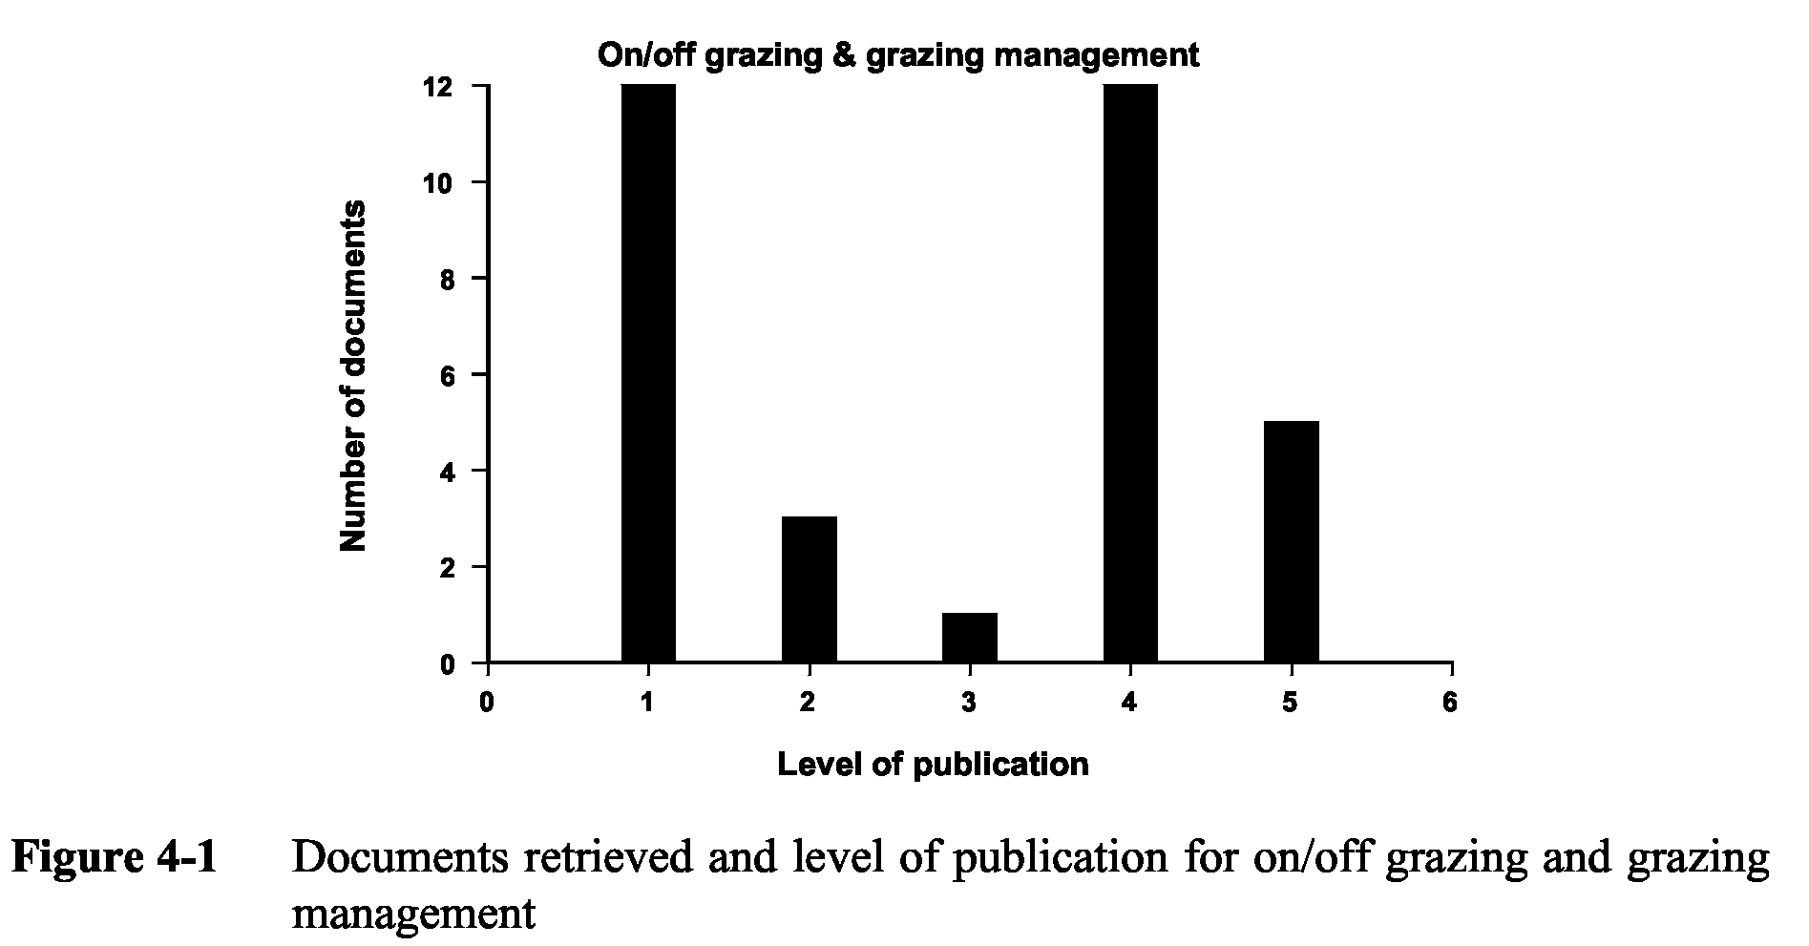
Blackwell (1993) argues that there is no detrimental effect on cow condition through on/off grazing, when cows are off pasture provided certain conditions are met. There is no clear evidence that milk production is increased by on/off grazing or that the economics of constructing special loafing and feed pads are justified. Recent debate in New Zealand (Hockings, 1995, 1996a; Holmes, 1995a, 1995b) has been concerned with this question although it does appear that a stand off facility may need to be considered a normal capital cost for farms with heavy soils. Pasture dry matter is judged to manage on/off systems but Hoogendorn (1966) showed that leaf allowance rather than DM allowance was the best predictor of dry matter intake and milk and milk protein yield over three grazing trials in early summer. It is clear that more research is needed in this area.
20
Winter Wet Soils in Western Victoria Options for the Dairy Industry, Richard MacEwan, February 1998
21
4.1.3 Effects of treading on pastures and soils
The effects of treading on pasture and soils have been substantially researched and reported on and analysis of the level of publications in these topics reveals a subject that is much loved by researchers but has little output at the extension level and is not often considered newsworthy. The marked difference between this and the on/off grazing topic is that the latter is one which can be taken up practically by farmers, whereas this is a complex topic which entails a high level of technical appreciation. Nevertheless the impact of treading on soils and pasture and consequent effect on the production system is profound and so efforts to transfer information on this topic should be made. The on/off grazing system can be regarded as a response to knowledge of the damage caused by treading in wet conditions so the topics are strongly linked. However, the responsiveness of the farmer to wet conditions would be increased if monitoring techniques were introduced to help in making decisions in on/off systems and to enable assessment of soil condition under different grazing regimes.
Treading damage to pasture has been studied in dry and wet conditions. Bruising and tearing of foliage dominate in dry conditions, while muddying or burial of foliage and shearing of roots occurs in wet conditions. Damage to the soil has been itemised in section 2.3.1 and some of the topics are only briefly considered here in relation to published research.
Compaction in relation to animal treading has been addressed by a number of authors (Abdel-Magid et al., 1987; Brown & Evans, 1973; Gifford & Hawkins, 1978; Krenzer et al., 1989; Mulholland & Fullen, 1991; Proffitt et al., 1995a, 1995b, 1995c; Taboada & Lavado, 1993; Tanner & Mamaril, 1959; Warren et al., 1986), but only a few have considered treading and compaction in combination with waterlogging or drainage (Gradwell, 1968; Hamilton & Horne, 1988; Horne, 1992; Proffitt et al., 1995c; Taboada & Lavado, 1993). Compaction is common within the top 12 centimetres of soil but can occur to depths that are beyond the reach of normal tillage equipment available on dairy farms on South West Victoria. Mullins and Fraser (19 80) proposed a mechanism for pugging which would entail development of compaction below the pugged soil. The distribution of documents retrieved on treading and pasture and on treading and soil physical properties are shown in figures 4-2 and 4-3.
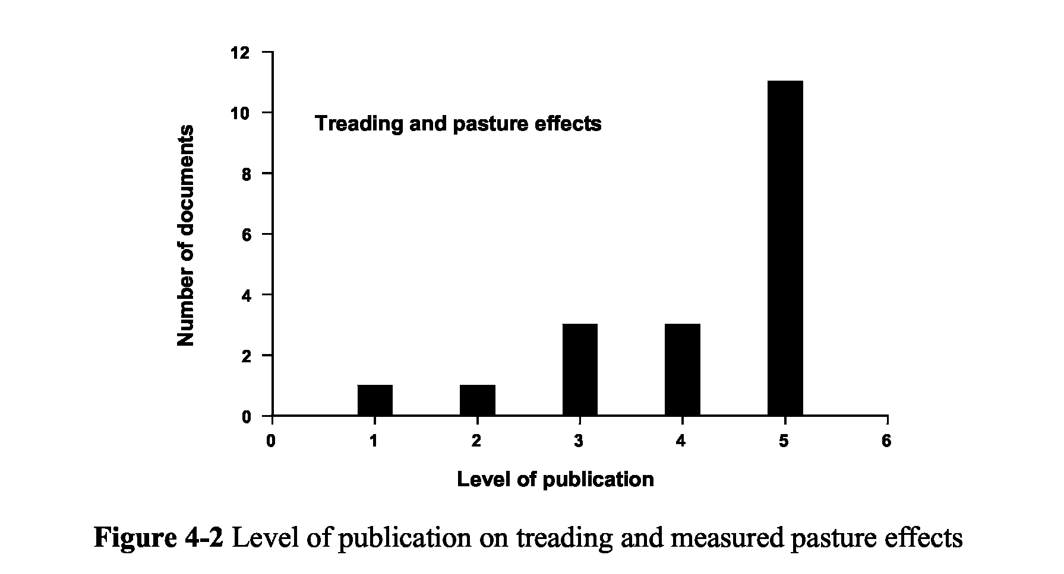
Winter Wet Soils in Western Victoria Options for the Dairy Industry, Richard MacEwan, February 1998
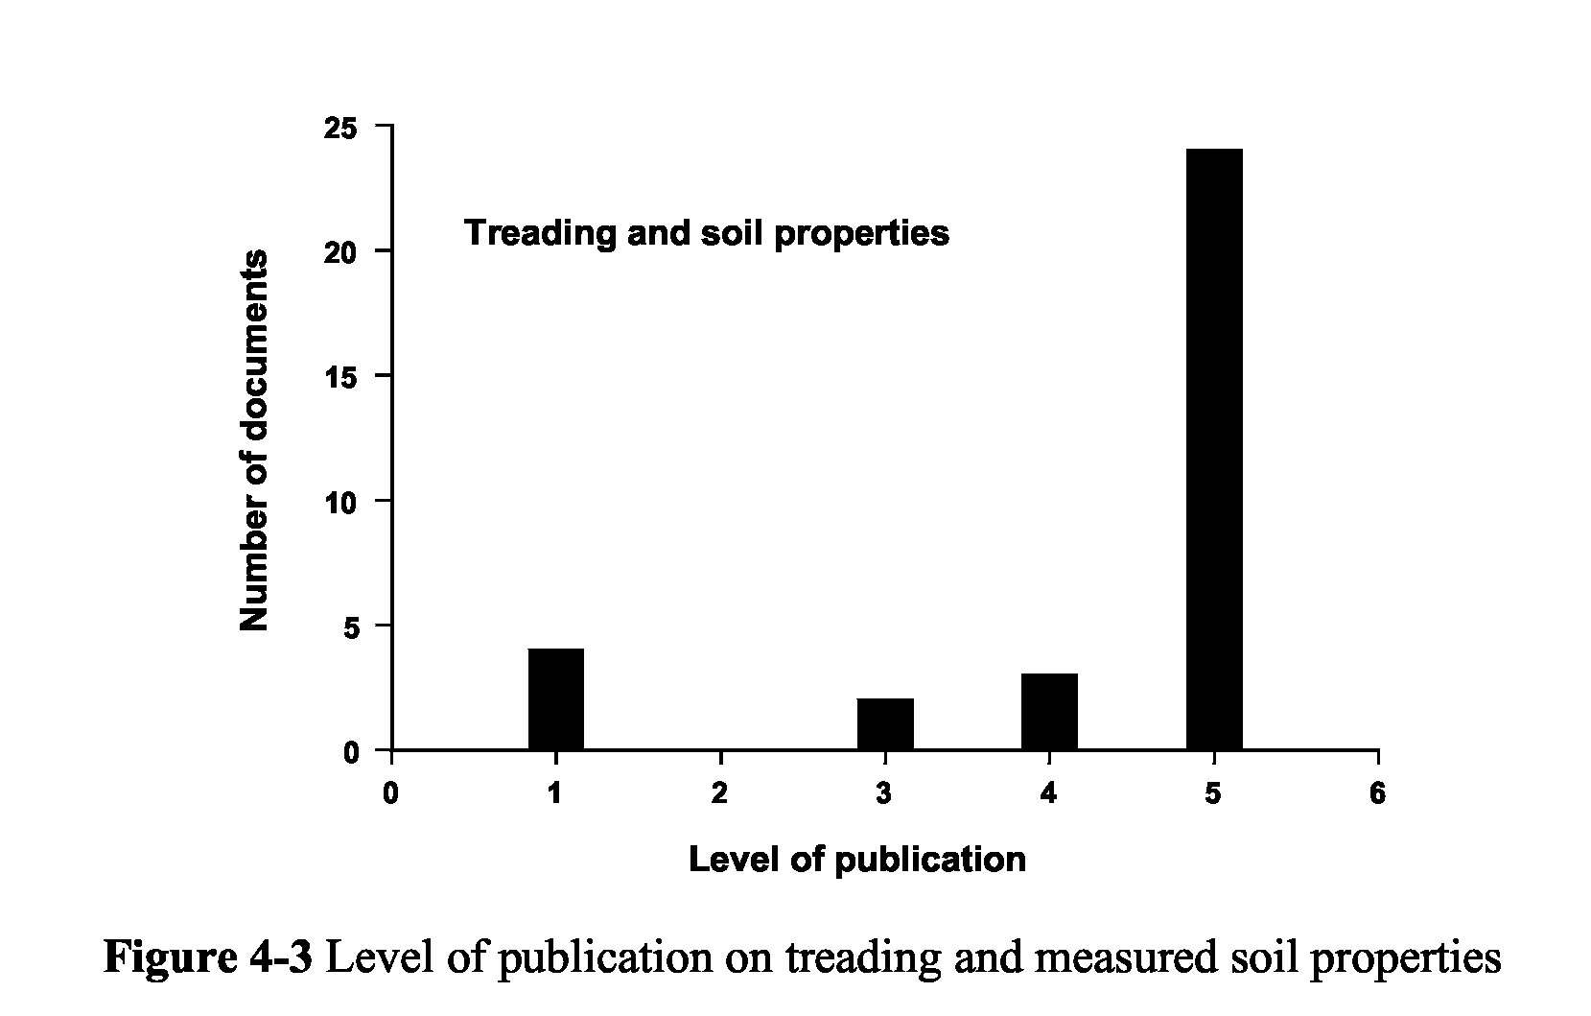
4.1.4 Susceptibility to damage
Soil damage is not equal on all soils subjected to the same sorts of pressures and depends on soil structural characteristics (aggregation, organic matter levels, texture, soil plasticity and shrink-swell). Differences in susceptibility to treading damage have been demonstrated (Climo & Richardson, 1984; Proffitt et al., 1995c; Scholefield et al., 1985). Soil becomes progressively weaker at moisture conditions wetter than plastic limit. Soil compactability is greatest at around the plastic limit and decreases as the soil becomes saturated and pore spaces fill with water. At these higher moisture contents shearing and destruction of aggregates increase under treading. It is the latter damage that is recognised as pugging. However, compaction and pugging can occur together, in fact, Scholefield (1986) showed that even saturated soils may be compressed under hoof pressures.
Pasture and crop losses due to waterlogging (McFarlane et al., 1992) and pugging susceptibility (Horne & Stewart, 1986) have been related to watertables or saturated conditions occurring within 20 centimetres of the ground surface. The latter approach has been used to assess drain performance in relation to ‘safe grazing days’ (Horne, 1987). Bowler (197 1) proposed a reckoning system for protection of paddocks from damage which used antecedent rainfall to predict how much rain would produce vulnerable soil conditions.
Soil does not need to be saturated or have a watertable within the profile in order to be damaged. Potential soil damage in different seasons depending on the soil moisture profile at the time is presented in table 4-1.. Three soil layers are proposed for the purpose of this exercise; 0-10 cm, 10-20 cm, and deeper than 20 centimetres, and three soil moisture conditions: dry, moist, and wet. Thus, for example, heavy rain in the autumn break coupled with slow infiltration can induce weak wet conditions in the topsoil; or, in duplex soils (especially ‘spew’ type) saturated conditions can exist in the A2 horizon while moist, apparently ‘safe’, conditions persist at the surface but this layer could be broken by hoof or wheel and induce pugging. Techniques to assess likelihood of pugging damage and to score ground condition in relation to drainage performance or degree of waterlogging and pugging (e.g. Galvin, 1983) are readily adaptable for monitoring by farmers.
22
Winter Wet Soils in Western Victoria Options for the Dairy Industry, Richard MacEwan, February 1998
23
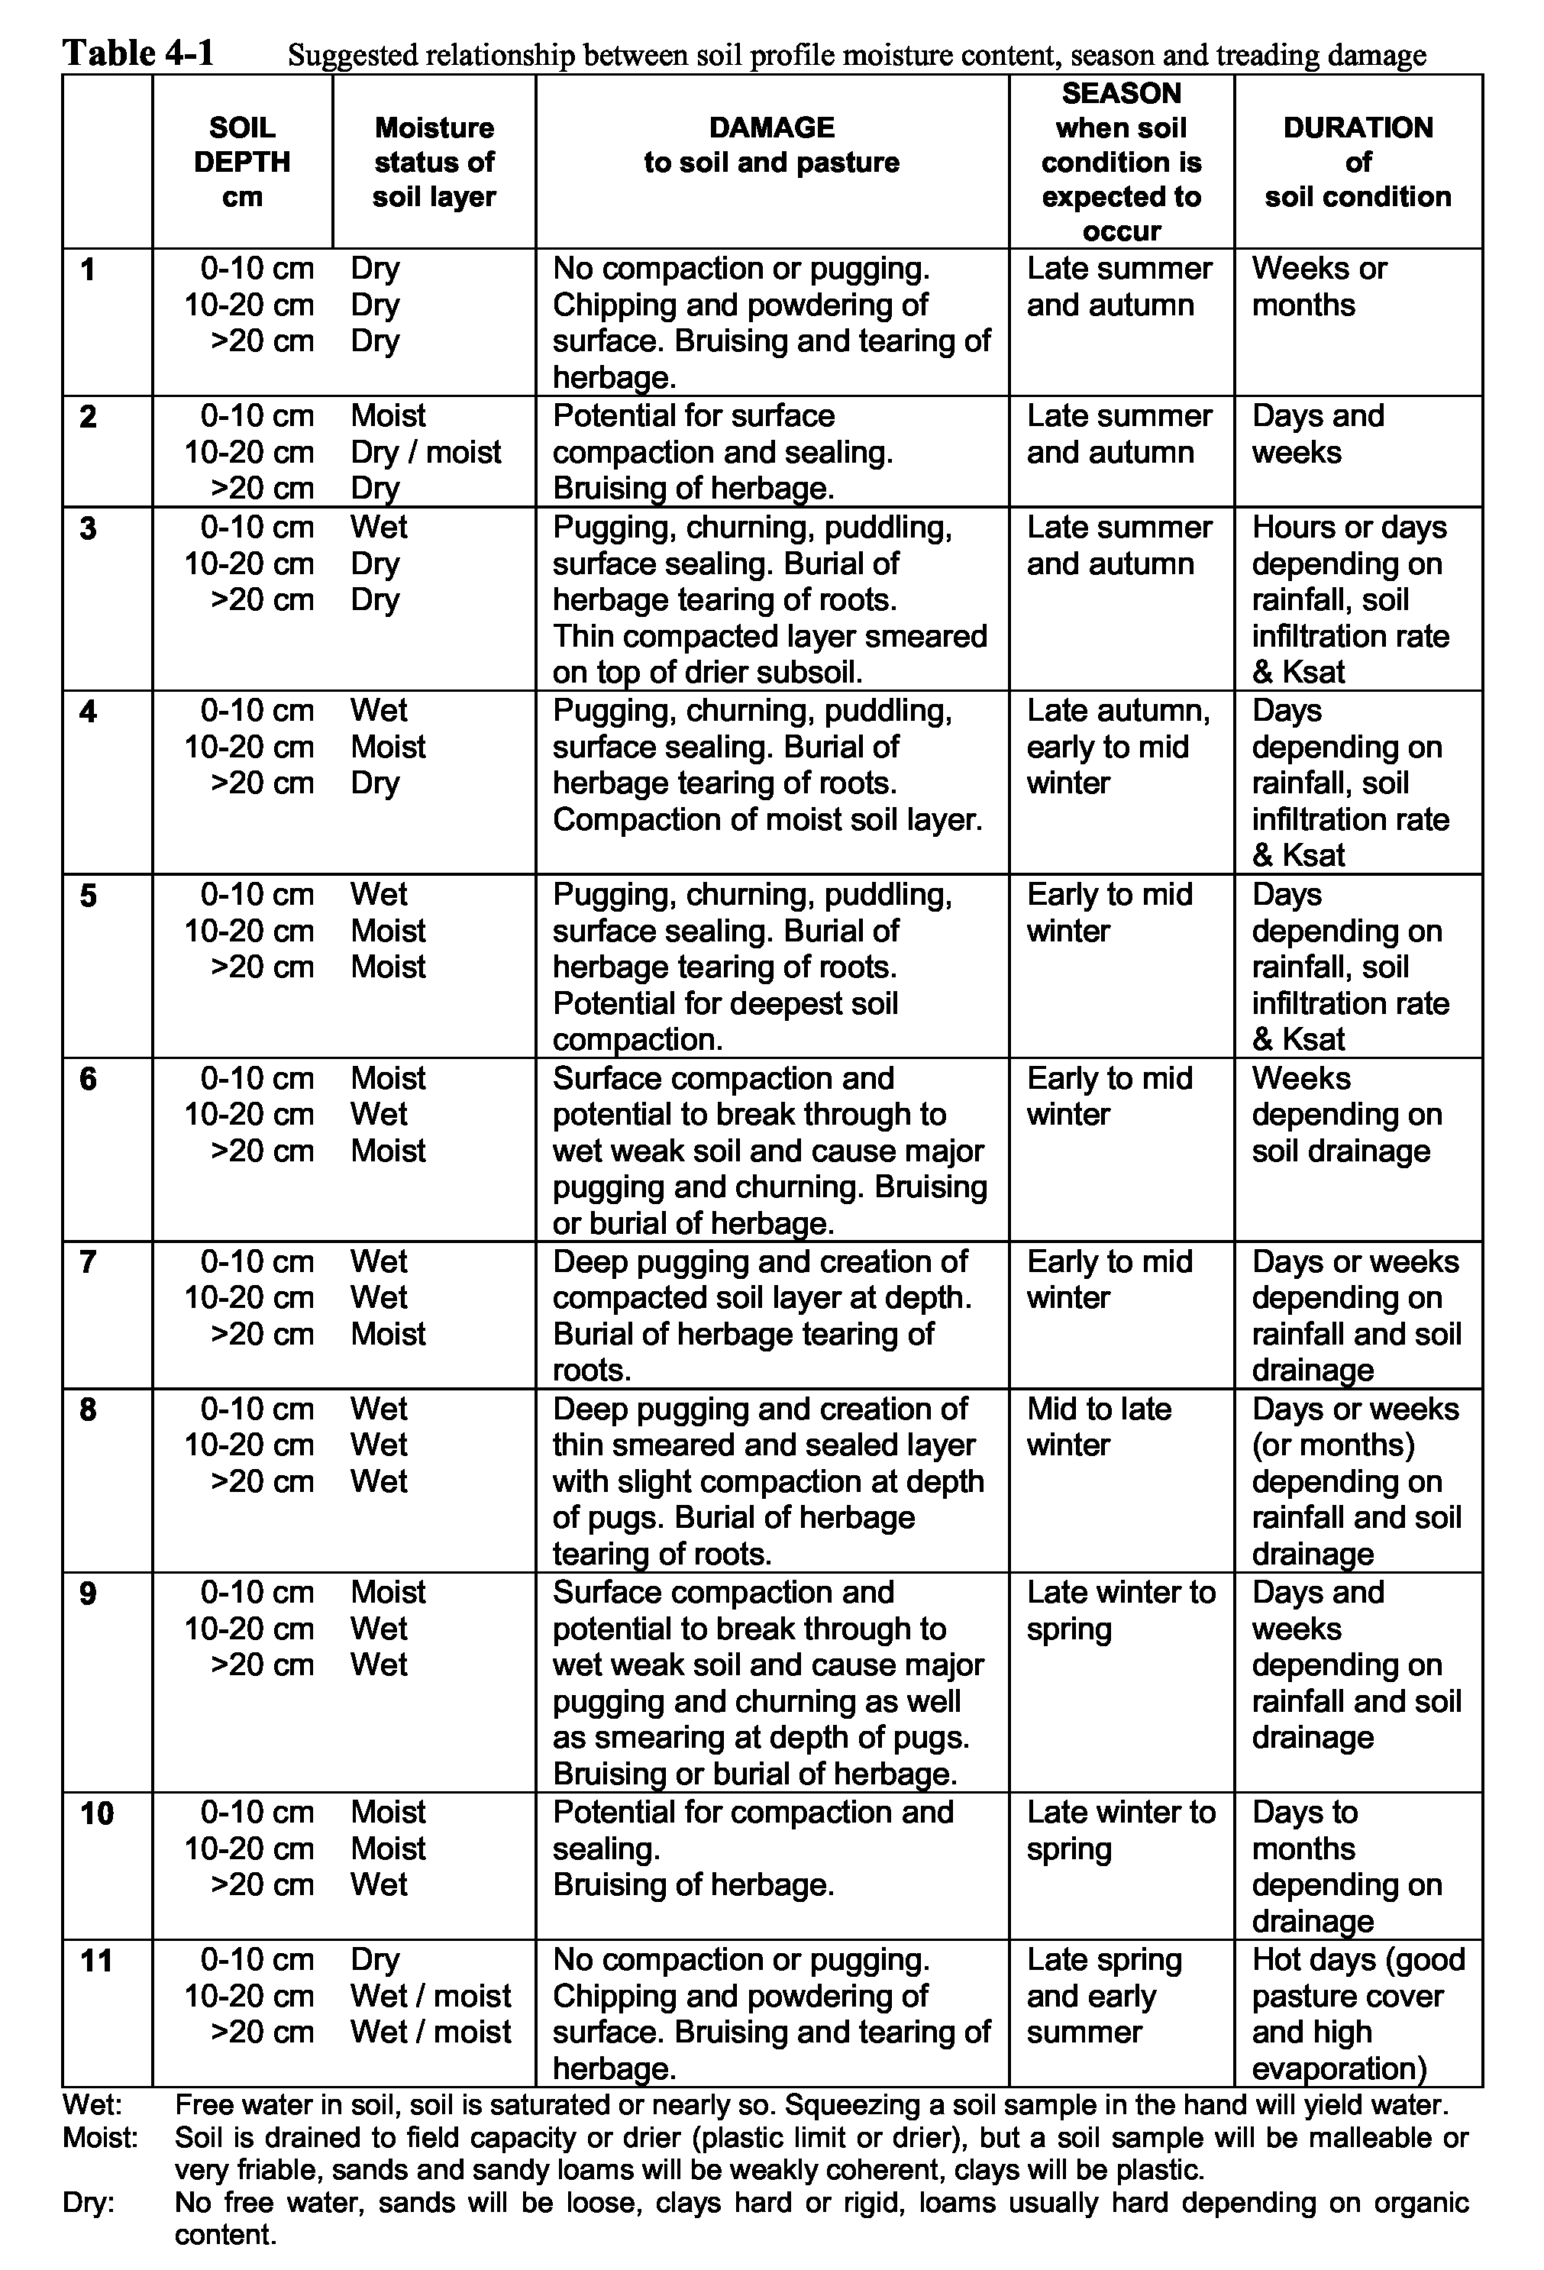
Winter Wet Soils in Western Victoria Options for the Dairy Industry, Richard MacEwan, February 1998
24
4.1.5 Measurement of soil properties to assess treading damage
Physical properties of soils are commonly measured with respect to treading damage, although chemical and biological properties are also affected. Tanner and Mameril (1959) sampled 20 pasture soils and compared these with untrodden areas (e.g. under fencelines), using bulk density, air permeability, penetration resistance, and infiltration as indicators of compaction. Total and air filled porosity were calculated from bulk density cores sampled at field capacity. Air permeability and resistance to penetration (moist soil at field capacity) were found to be the most consistent parameters. Infiltration rate was stated by the authors to be labourious to measure and highly variable. Although disc permeameters would be an improvement on their techniques there would be difficulties in pugged soil. More elaborate techniques involving dyes to investigate preferential paths for water movement (Dreccer & Lavado, 1993), or resin impregnated soil blocks to examine macroporosity (Kemp et al., 1994; Lytton-Hitchins et al., 1994) have also been used to good effect on dairy soils.
Assessment of pugging damage has been loosely quantified in terms of ground condition (Gleeson, 1966; Horne and Stewart, 1986) or described in terms of a quantifiable index of poaching (or pugging) severity (Wilkins and Garwood, 1986), as follows:
Poaching severity = [Percentage area poached X mean depth (cm) of depressions]/100
The limitation of this index is the assumption that depressions twice as deep are twice as bad so the same index will be derived for a paddock with 50% of the area damaged by hoofprints 4 cm deep as a paddock with 25% of the area damaged with hoofprints 8 cm deep. This is unrealistic as the paddocks are not equal in terms of their renovation requirements.
Briggs (1978) proposed a framework for quantifying processes under the general consideration of poaching (pugging) that included physical, chemical and biologicial soil properties. AgResearch (NZ) in have a current project on this question (Anon., 1996d).
4.2 Drainage, pasture production and animal production
While good publications were retrieved on the effects of drainage on pasture production (figure 4-4), the only publication quantifying animal production in relation to drainage is that of Tyson (1992) who reports an increase of 8% in beef production over a ten year period attributable to drainage of unimproved pasture, and 20% increase on drained compared with undrained re-seeded pastures. The shape of the bar chart in figure 4-4 illustrates a topic that has been well researched and for which there is a good balance of information available.
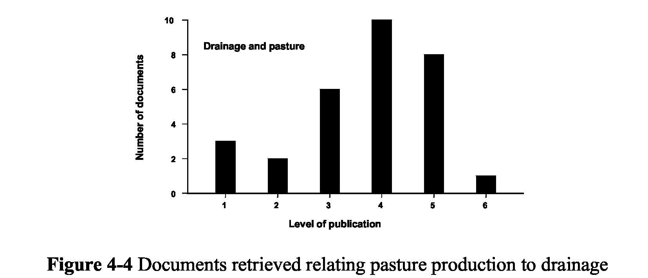
Winter Wet Soils in Western Victoria Options for the Dairy Industry, Richard MacEwan, February 1998
25
4.3 Drainage, pasture management and loafing pads
Evidence from observations on ground conditions, watertable levels and modelling of weather conditions and soil moisture, all seems to indicate that drainage, at the intensity affordable on a dairy farm, is insufficient to allow indiscriminate access to pasture. The notion of ‘safe grazing days’ has been introduced above (4.1.4) and estimates in New Zealand and the UK have shown that while drainage will extend the grazing season, there will still be times when grazing is ‘unsafe’ on drained paddocks. Horne and Stewart’s model predicted safe grazing days for a Tokomaru silt loam when the watertable was deeper than 200 mm from soil surface. It was noted that a daily rainfall of 10 mm in spring would make the soil unsafe for grazing regardless of watertable depth. In a year of average rainfall unsafe grazing days were 10 (drained) and 69 (undrained); in a wet year 33 (drained) and 119 (undrained).
This situation therefore requires that animals be taken off the paddock onto a laneway or to a specially constructed pad and an on/off grazing management system employed. Of the publications retrieved on loafing pads and feed pads (figure 4-5) only two fell in to categories 5 and 6, showing a topic that is highly popular at the working end of dairy farming but is backed by very little research.
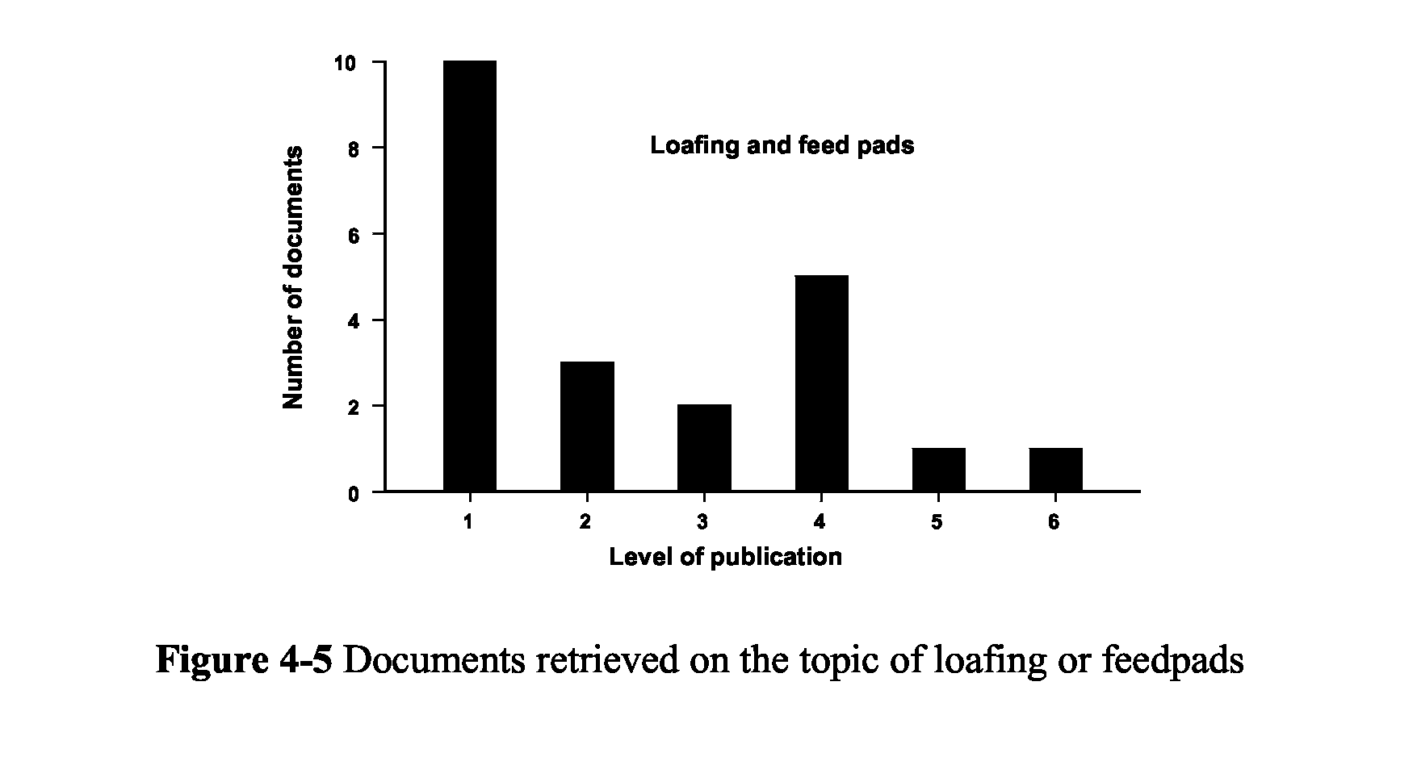
Winter Wet Soils in Western Victoria Options for the Dairy Industry, Richard MacEwan, February 1998
5. Options for development of wet soil management
Previous presentation has been made to WestVic Dairy on options for wet soil management research and development (papers tabled on 15/1/97 and 6/2/97). Because of the complex nature of the wet soil problem it is necessary to recognise that any aspect has ramifications for other aspects of the problem. Perhaps rather than considering these aspects as options, which implies choice of direction and manner of operation, it should be recognised that these ‘options’ are needs which operate in partnership to deliver solutions. The task for the WestVic group is to decide where the limited R&D dollar is concentrated initially and anticipate where external support may allow the development of other components of an R&D program. The recommendation of this report is that a program of integrated and parallel projects should be designed to achieve the outcomes.
5.1 Overall intention of a wet soil management program
To develop clear guidelines for improving pasture management and productivity on dairy farms having moderate to severe winter waterlogging in South West Victoria and to encourage the implementation of solutions such as subsurface drainage and on/off grazing systems.
5.1.1 Desired outcomes
It is too simplistic to say that the desired outcome is more milk production per hectare per year. In dealing with wet soil it is recognised that it is a limitation to productivity but is also leading to degradation of soil and environment under current management trends. It therefore requires addressing as a sustainable farming issue for the long term. Desired outcomes include enabling the industry to reach the production goals in the context of a sustainable system. Many of these outcomes are knowledge or resource (service infrastructure) based and can be considered means to ends. They are regarded here from the point of view of three groups: the farmers, the government staff and consultants, and the dairy industry in total. Suggestions about the necessary character of the outcomes for these three groups are given below.
5.1.2 Outcomes needed for the dairy farmers
- Links with active wet soil management discussion/action groups.
- Knowledge of the limitations that wet soils present to productivity.
- An appreciation of the strategies available to improve management of wet soils.
- Access to technical support and advice to develop appropriate solutions on their own farms.
- The ability to assess the problem on their own farms.
- An appreciation of how their farm affects, and is affected by, the surrounding catchment.
- The ability to apply on/off grazing systems and monitor soil and pasture quality. 5.1.3 Outcomes needed for departmental staff and private consultants
- First hand knowledge of the soils and landscapes in the region, and of the impact of waterlogging.
- The ability to interpret site-specific wet soil problems. 26
Winter Wet Soils in Western Victoria Options for the Dairy Industry, Richard MacEwan, February 1998
- A sound knowledge of paddock drainage techniques, or access to specialist advice.
- A sound knowledge of rehabilitation techniques for pugged pastures.
- The ability to advise on technical issues associated with on/off grazing, pasture production, pasture quality, and subsurface drainage.
- Access to economic evaluations of subsurface drainage, on/off grazing systems and loafing areas.
- Access to a GIS database with geology, soils, hydrology, climate and drainage data.
- Procedures for central record keeping of site visits, advice given, on ground works, etc.
- An appreciation of the environmental context of the wet soil management problem and proposed solutions, including issues such as nutrient enrichment of waterways, erosion, and salinity.
- Expert technical support for assessment of catchment hydrology and impact of changed management on waterway flow regimes and nutrient loads.
5.1.4 Outcomes needed for the dairy industry (all partners)
- A more productive farming system encompassed by a long term strategy for protection and improvement of land and soil resources used for dairy pastures in the region which optimises resource use and milk production.
- An effective extension network providing high quality technical and economic advice and support to dairy farmers committed to better soil and pasture management on farms prone to periodic waterlogging.
- A cooperative understanding with other agencies such as Catchment Management Authorities, Salinity Implementation Groups, Shire Councils, any waterway management authorities, and other environmental interest groups.
5.2 Components for a wet soil management program
The overall farming system aims at maximising or optimising animal production through manipulation of soils and pasture. This management is carried out within an environment that determines the nature and severity of the problem, but which is affected by the farming system (nutrients, water use, drainage). In some cases adaptation to that environment through adjusting pressures on the land, selecting species tolerant of the conditions, or changing the land use may all serve to produce a farming system that is sustainable and productive. Invariably, engineering solutions will be married with these other biological strategies. Engineering solutions include; modifications to surface drainage, installation of sub surface drains, construction of stand-off and feeding areas, effluent handling systems, irrigation, fertilisers, and tillage.
The inter-relationships between the farming system, soil and pasture management, engineering aspects, environmental constraints and effects, and the goal of animal production are illustrated diagrammatically in figure 5-1. Inevitably, all these aspects are involved regardless of the focus of activity.
Not illustrated in the figure but of equal importance with the farming system are the economic aspects or business considerations, and the educational and extension process which flow to and from the farm.
27
Winter Wet Soils in Western Victoria Options for the Dairy Industry, Richard MacEwan, February 1998
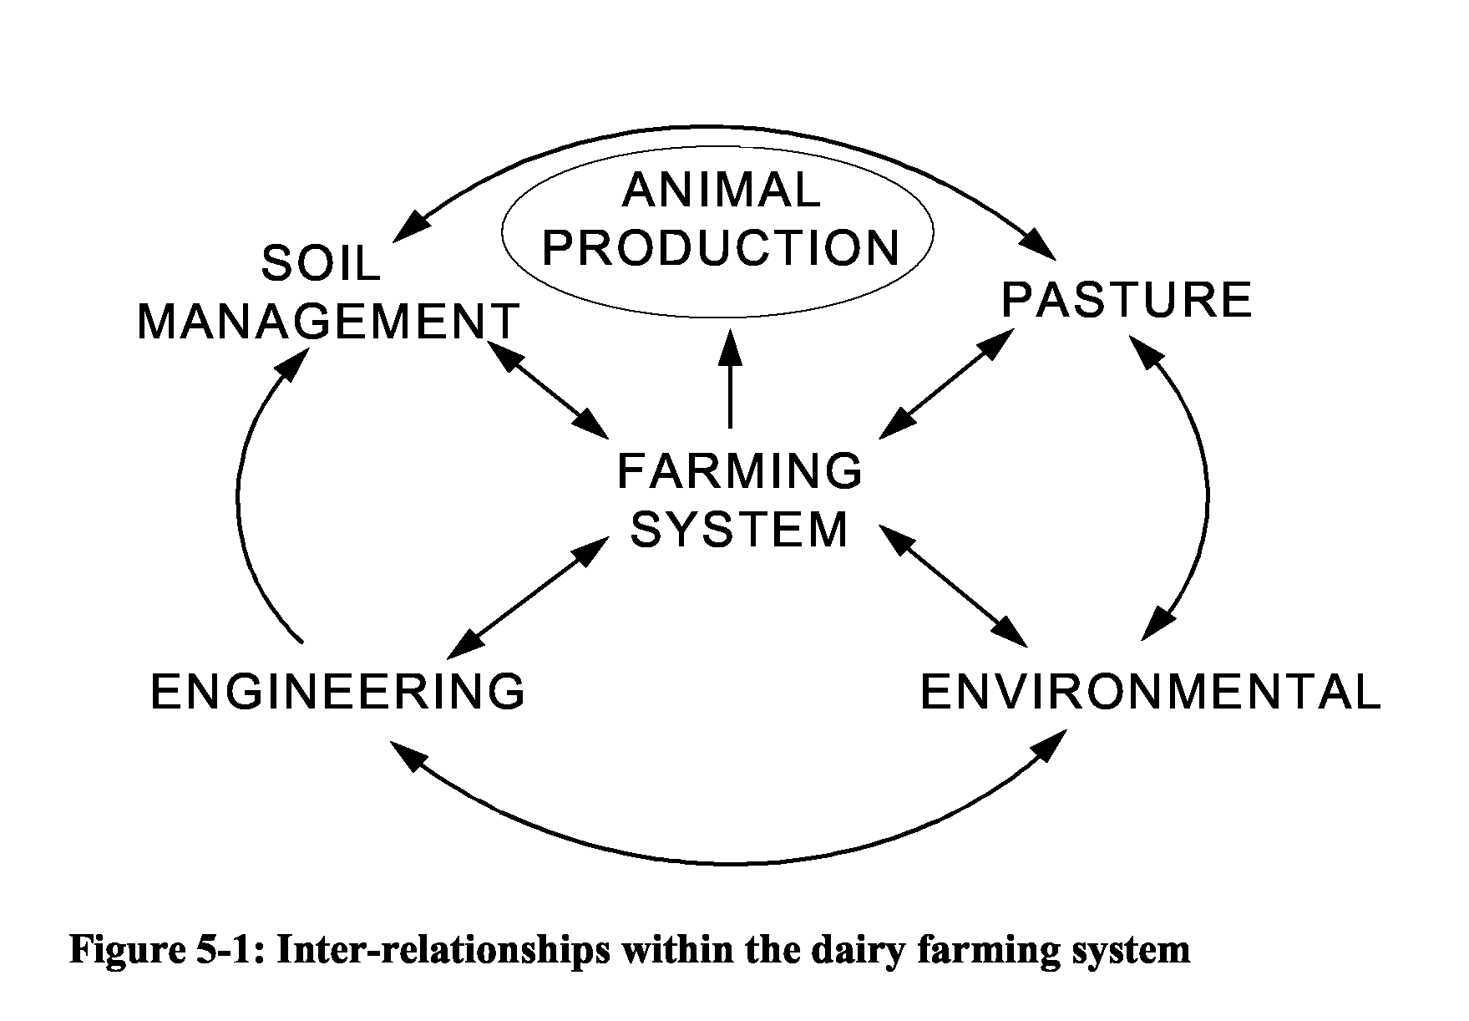
A well balanced program would therefore include the following components:
Basic soils research. Inventory, properties affecting drainage, soil structure and qualities affecting pugging susceptibility, renovation and soil structure management, soil fertility including biological aspects.
Pasture studies related to on/off grazing. Pasture utilisation, optimal cover before and after grazing for minimisation of damage in wet conditions, duration and intensity of grazing, economics of supplementary feeding, economics of pad construction.
Engineering solutions. Drainage design and maintenance, construction of pads, effluent handling.
Development of indicators for soil and pasture monitoring/management. Deriving from basic soils research and being driven through an R&D and extension partnership to enable farmers to improve soil management.
Environment and catchment protection issues. Acknowledgement of the role that the farming system plays in affecting hydrology, erosion, water quality (turbidity, salinity, nutrients), and wetlands.
Demonstration and extension. Discussion groups, field days, economic justification of changes to management systems. Incorporation of wet soil management into business plans. Production of regionally relevant bulletins on: soil differences, pasture management incorporating on/off grazing, design and economics of loafing pads, design and economics of drainage. Identification of barriers to current adoption of wet soil management strategies.
28
Winter Wet Soils in Western Victoria Options for the Dairy Industry, Richard MacEwan, February 1998
5.3 Strategies for wet soil management
For simplicity three strategies are proposed for the South West: Drainage strategy
Drainage is seen as important enough to warrant separation from the soil management strategy below.
Grazing management strategy
Such a strategy is a response to the need to protect both pasture and soils from damage when wet. However, the focus here is on pasture quality, dry matter production and utilisation. This will probably be perceived by the industry as the most important and easily implemented program component.
Soil management strategy
Baseline soils data collection is essential to a program aimed at improving soil management. It will probably seen as the most esoteric aspect of the program. Its importance should not be under-estimated. Extension in this component will be challenging.
5.4 Improving knowledge of drainage in the region
A major limitation to progressing drainage in the region is the lack of documentation of activity undertaken previously. Sufficient installations exist to allow evaluation of the effectiveness of drainage systems but the basic data are unavailable at present. Pipes alone are unlikely to be effective in most of the clay soils and moles are needed. Efforts should be made to categorise the region’s soils in relation to their capacity for successful mole drainage.
A number of physical and chemical properties, as well as implement geometry and soil moisture conditions, are known to control the success of mole drainage (Spoor & Ford, 1987; Spoor et al., 1982a, 1982b). If these are recorded at sites where moling is carried out then we will have a better basis for judging the relevance of any of these factors in our region. The results of such review and research would be important enough to warrant publication in an internationally refereed journal.
Important issues for investigation in this area are the longevity of moles in the regions subsoils; relations between slope, length and erodibility of moles; and drainage of ‘difficult soils. A recent field day at the Weels’ farm on Gallum Road involved excavation of a soil pit in the Gellibrand Marl. This opportunistically intersected a seven year old mole channel in perfect condition. At a field day at Powell’s in 1993 a moling demonstration inadvertently ruptured a water pipe which discharged water directly into the newly formed mole channel on an approximately 5% grade and there was no evidence of channel instability (discharge was clear) even after half an hour of this treatment. A mole in a fine sandy to silty loam at Powell’s was excavated after two years and the channel wall found to be coated with iron oxides, and lined with roots and earthworm castings (evidence of stabilisation in inherently ‘unsuitable’ material). However other soils which appear to be appropriate for drainage are presenting severe problems, especially those with high sand contents.
A database for storage of information collected about drainage installation should include
the following fields. Some of the data are collectable by non-specialists and could be
29
Winter Wet Soils in Western Victoria Options for the Dairy Industry, Richard MacEwan, February 1998
provided by the landholder or contractor, other items comprise soils and hydrological data that would require specialist knowledge.
General information
Location (farm and paddock/s).
Area drained.
Year of installation.
Rating of success (subjective, e.g. no better, effects short-lived, worth doing more). Economics (cost of installation, measured or estimated benefits).
Landscape and soil properties
Geomorphology, hydrology including hydrogeology.
Soil profile description, including saturated hydraulic conductivity. Texture and bulk density of principal horizons within the drained profile.
Drainage design
Pipe depth, gradient, length, diameter and spacing.
Secondary treatment, i.e. deep ripping, moling, gypsum. Space and depth of moles.
If mole drained:
Method (implement design) and month of installation.
Length and gradient of mole channels.
Soil moisture conditions at time of installation (profile assessment or measured). Weather in the few days after installation.
Visual assessment of mole channel (excavation: condition of channel, roof, legslot). Subjective appraisal of mole performance.
Soil properties for moling
Particle size analysis at moling depth.
Likely variability of subsoil at moling depth at the site.
Soil plasticity and shrinkage (Atterberg limits)
Clay mineralogy and dispersive properties (Emerson test, wet sieving, sodicity)
Environmental aspects:
Destination of drainage water (e.g. creek, wetland).
Quality and quantity of drainage water leaving site.
30
Winter Wet Soils in Western Victoria Options for the Dairy Industry, Richard MacEwan, February 1998
6. Discussion
6.1 Complexity of the wet soil problem
In spite of the ubiquity of the problems with wet soils and wet soil management there is disappointingly little in the literature that is the result of statistically reliable research. The problem is large and complex and consideration of the scope for research in this area reveals a wide range of topics:
- soil physical properties (soil strength, hydrology, drainability);
- soil physical and chemical interactions and relationship to plant growth;
- impact of treading on soil physical properties, pasture composition and yield;
- impact of wet soil damage on soil biological functions relating to structure and fertility;
- grazing management strategies for maintenance of maximum quality and quantity of pasture (paddock size, duration and intensity of grazing, on/off systems);
- climate-soil relations and performance of drainage systems (effectiveness, safe grazing days and relative costs for more intensive-higher performance drainage systems);
- physical organisation of dairy farm (infrastructure: roads, stand-off areas, drainage);
- pasture renovation and soil rehabilitation strategies and costs;
- farm labour organisation (moving, feeding, cleaning, milking, renovating, harvesting);
- animal health;
- animal production and milk production.
6.2 Milk production as a parameter in pasture research
The dairy industry’s interest in wet soil management is primarily in the economics of increasing milk production. Extension of advice to dairy farmers on management changes to cope with wet soils also has a ‘bottom line’ - what is it going to cost to implement and what difference will it make to profitability and productivity? The answers given to the latter questions are usually generalised and often just reasonable guesses. This situation is unlikely to change without additional research to support economic analyses of wet soil management in the South West Region.
6.2.1 Existing data and the role of models
The published literature reviewed during the course of this project focuses on aspects of the total system, never on the complete system, and rarely on milk production. The reasons for this lie in the complex nature of the topic and the requirements of a reductionist scientific approach. While modellers may be able to piece together the system from these separate studies, the incorporation of features such as pugging and subsequent changes in pasture utilisation has not yet been achieved. In fact if it was to be done, the output of such models would be highly sensitive to chosen numerical inputs relating to pasture production or utilisation in wet grazed environments. Existing datasets are few, findings are not always consistent, and relative increases in production quoted by various workers have high variance. We are therefore a long way from being able to judge with any confidence the economic benefits of wet soil management strategies.
31
Winter Wet Soils in Western Victoria Options for the Dairy Industry, Richard MacEwan, February 1998
There have been studies in which milk production from controlled groups of cows, subjected to different treatments, has been measured. These experiments have been focussed on the nutrition of the animal (Meijs, 1981), grazing strategies (e.g. Da Silva, 1994; Hoogendoorn, 1986), and physical stresses associated with walking (Pratumsuwan, 1994). They have all involved procedures for monitoring intake that are elaborate and expensive to implement. It is understandable why there are few datasets that include milk production as a measured output of an experimentally controlled system.
6.2.2 Economics of pasture production vs. milk production
There is a fairly well established relationship between dry matter consumption and butterfat and milk production, and therefore potential milk production is estimated from measures of feed availability. This is an acceptable approach provided that other factors are taken into consideration; however in the papers studied the analysis has always been simplistic and therefore the results of such analyses are questionable.
A well managed dairy herd will be given the feed that it needs to maintain maximum milk production. The practice is to use grass pasture wherever possible, estimate any shortfall in potential intake, and make good the difference with supplemental rations of silage, hay or grain. It is therefore a totally false assumption that an increase in pasture production will result in “more milk in the vat”, however it is fair to equate improvement in pasture production, utilisation, and therefore intake, with a saving in supplemental feed costs.
To increase milk production it is more likely that an increase in herd size would have to follow any increase in pasture production. This would therefore entail other costs in buying in or breeding additional milkers and increasing all other overheads associated with milking extra animals. There is also an interaction between the herd and the land which would create greater pressure on the land through higher stocking rates, increased grazing intensity and shorter rotations. An overall increase in level of management must go hand in hand with the improved system and this too has costs in training and adjustment of management practices.
6.3 WestVic Dairy R&D
WestVic Dairy must decide whether the measurement of milk and milk solids in any R&D in the region is an essential element to produce economic evaluations of measures to manage pastures on wet soils. If they decide that it is essential, then a major long term funded project will have to be developed. Without an existing dairy research station in the region any projects will have to run from the regional DNRE offices, perhaps in conjunction with Melbourne University (GlenOrmiston). To be successful there would have to be a clear separation of staff involved in the research project from those involved in other routine dairy extension activities. Research will only be successful if specifically dedicated scientific and technical support staff are funded within such a program which would have to be spread across existing dairy farms with willing cooperators.
32
Winter Wet Soils in Western Victoria Options for the Dairy Industry, Richard MacEwan, February 1998
7. Recommendations
The information available on wet soil management has been reviewed and knowledge gaps identified. Potential project areas have been discussed in section 5 of this report. The following recommendations are made as essential components for long term wet soil management in the South West Region. These recommendations are not regarded as options.
Recommendation 1: Face facts
The dairy industry in South West Victoria must recognise that:
- The only way to protect soil structure and pasture in a wet environment is to not graze pastures intensively, or for extended periods, when the soil is wet.
- Soil strength depends on water content and even with drainage there will be ‘unsafe’ grazing days.
- Increasing production trends entailing higher treading densities and shorter rotations are going to make wet soil management more difficult than at present.
7.1 Drainage strategy
Sufficient drainage is installed in the region to provide the basis for evaluation on a range of soils and extension to the rest of the industry. The following recommendations 2 to 5 are envisaged as elements for a strategy and require a degree of integration. Some aspects of these are proceeding in part anyway but the effort needs to be coordinated and long term. Recommendation 5 is likely to occur in some form anyway, so it is to the industry’s advantage to be pro-active and take the initiative with the Catchment Management Authorities.
Recommendation 2: Extend drainage
Existing information on the need for drainage, the costs of drainage, and the potential benefits should be put into a package that can be extended to the dairy community. Extension staff should be trained in the principles of drainage, the basic physical properties of the soils of the region, and the recognition of different waterlogging situations. An initial regional survey of all dairy farmers should assist in identifying the current barriers to adoption of drainage and assist with an extension program.
Recommendation 3: Establish a drainage database
Farms with existing drainage, or planned installation of drainage, should be identified and data stored in a database accessible to GIS (starting with data of Christy, 1995). This will assist in monitoring of progress and will provide a basis for regional planning and collaboration suggested in recommendation 5.
Recommendation 4: Select dairy paddock drainage demonstration and monitoring areas
Economic evaluation of drainage needs to be soundly based. Negotiation should be carried out with potential collaborating farmers to take on a role as monitors and demonstrators of drainage performance, pasture management, and animal performance. Farms should be selected to represent differences in regional characteristics. Assistance could be given with
33
Winter Wet Soils in Western Victoria Options for the Dairy Industry, Richard MacEwan, February 1998
management of drained areas on farms so that more effective demonstration would result. This could become a respectable research project if it were given funding. Demo Dairy could be one of the sites to represent duplex soils on the basalt.
Recommendation 5: Inform and involve Catchment Management Authorities
A working relationship should be established with the Catchment Management Authorities (CMA’s) taking over from the Corangamite and Glenelg Catchment and Land Protection Boards, so that any future drainage work is conducted in an orderly manner with the support of the community at large. A small working group comprising representatives from DNRE, the dairy industry, the drainage industry, and the CMA’s should be convened this year so that all parties can be brought up to date on the problem to the industry and the context for rural drainage in Victoria (scoping study of Argent & Ewing, 1996).
7.2 Wet soil grazing management strategy Recommendation 6: Conduct trials using on/off grazing systems
Research is needed in order to determine whether there are any economic benefits in the application of on/off grazing systems. Trials could be carried out on existing farms. Two approaches are possible:
- Determination of pasture response and soil quality changes under conventional rotational grazing and under more controlled on/off systems where stock are removed from paddocks at risk of damage. Management would require fencing to split areas for comparison of the two treatments. Pasture dry matter production, utilisation and feed quality should be monitored throughout the whole grazing season in order to assess annual production in the two systems.
- Determination as above with additional monitoring of milk production and animal condition. This would entail splitting herds from late autumn to early spring and maintaining the two herds on separate management regimes.
There would need to be at least four participating farms to allow statistical analysis of the trial results.
Recommendation 7: Develop existing pasture advice to include wet conditions
It is necessary to develop decision rules for optimal management of pasture production, quality and utilisation in combination with strategies for protecting soils from damage when wet. This is a logical development from existing guidelines on pasture management such as Curtis and O’Brien (1994).
Recommendation 8: Evaluate loafing pad and feeding pad options
The investment in pads needs to be evaluated. Many questions revolve around this topic. As a strategy for protecting soil and pasture what is the cost/benefit? What are the best construction options? Will using laneways, dairy or sheltered area be a more economic option?
7.3 Soil management strategy
Existing soils information is either incomplete, uninformative or unavailable. This situation
is not unique to the region nor to the industry. Improved soil management can only be
implemented if there is a better basic appreciation of local soil differences and qualities.
34
Winter Wet Soils in Western Victoria Options for the Dairy Industry, Richard MacEwan, February 1998
Soil management may be associated with drainage, pasture renovation after pugging, relieving compaction, identifying the most vulnerable areas on the farm, or implementing an on/off grazing management strategy.
Recommendation 9: Improve availability of basic soils information in the region
Encourage and support soil data collection, analysis and interpretation to the end that regionally relevant extension material is produced for the dairy industry. While wet soil management is the focus of this report, the interpretation of soil chemical fertility and lime and fertiliser advice would necessarily be included for completeness.
Recommendation 10: Develop soil monitoring skills in the dairy industry
Dairy farmers are the managers of the soil through grazing practice, farm layout and choice of pasture management. Interpretive skills relating to soil types and soil conditions must be developed within the farming community. Existing discussion groups can be used for this process.
Recommendation 11: Develop soil rehabilitation and pasture renovation techniques
Pugging damage and compaction is inevitable in the dairy industry, but tillage or soil treatment to remedy damage and renovate pastures has not been developed in the region. Some of the equipment used can do more harm than good if used in inappropriate moisture conditions. Existing available techniques should be reviewed and evaluated for the suitability for use in different soils and should give consideration to timing of operations and soil conditions.
35
8. Appendix A. Maps of South West Victoria Soil Studies 8.1 Extent of survey coverage by Maher and Martin (1987)
36
8.2 Extent of survey coverage by Gibbons and Downes (1964)
37
8.3 Extent of survey coverage by Pitt (1981)
38
Library database searches, Wet Soil Management. Leeanne Pitman, University of Ballarat, June 1997
39
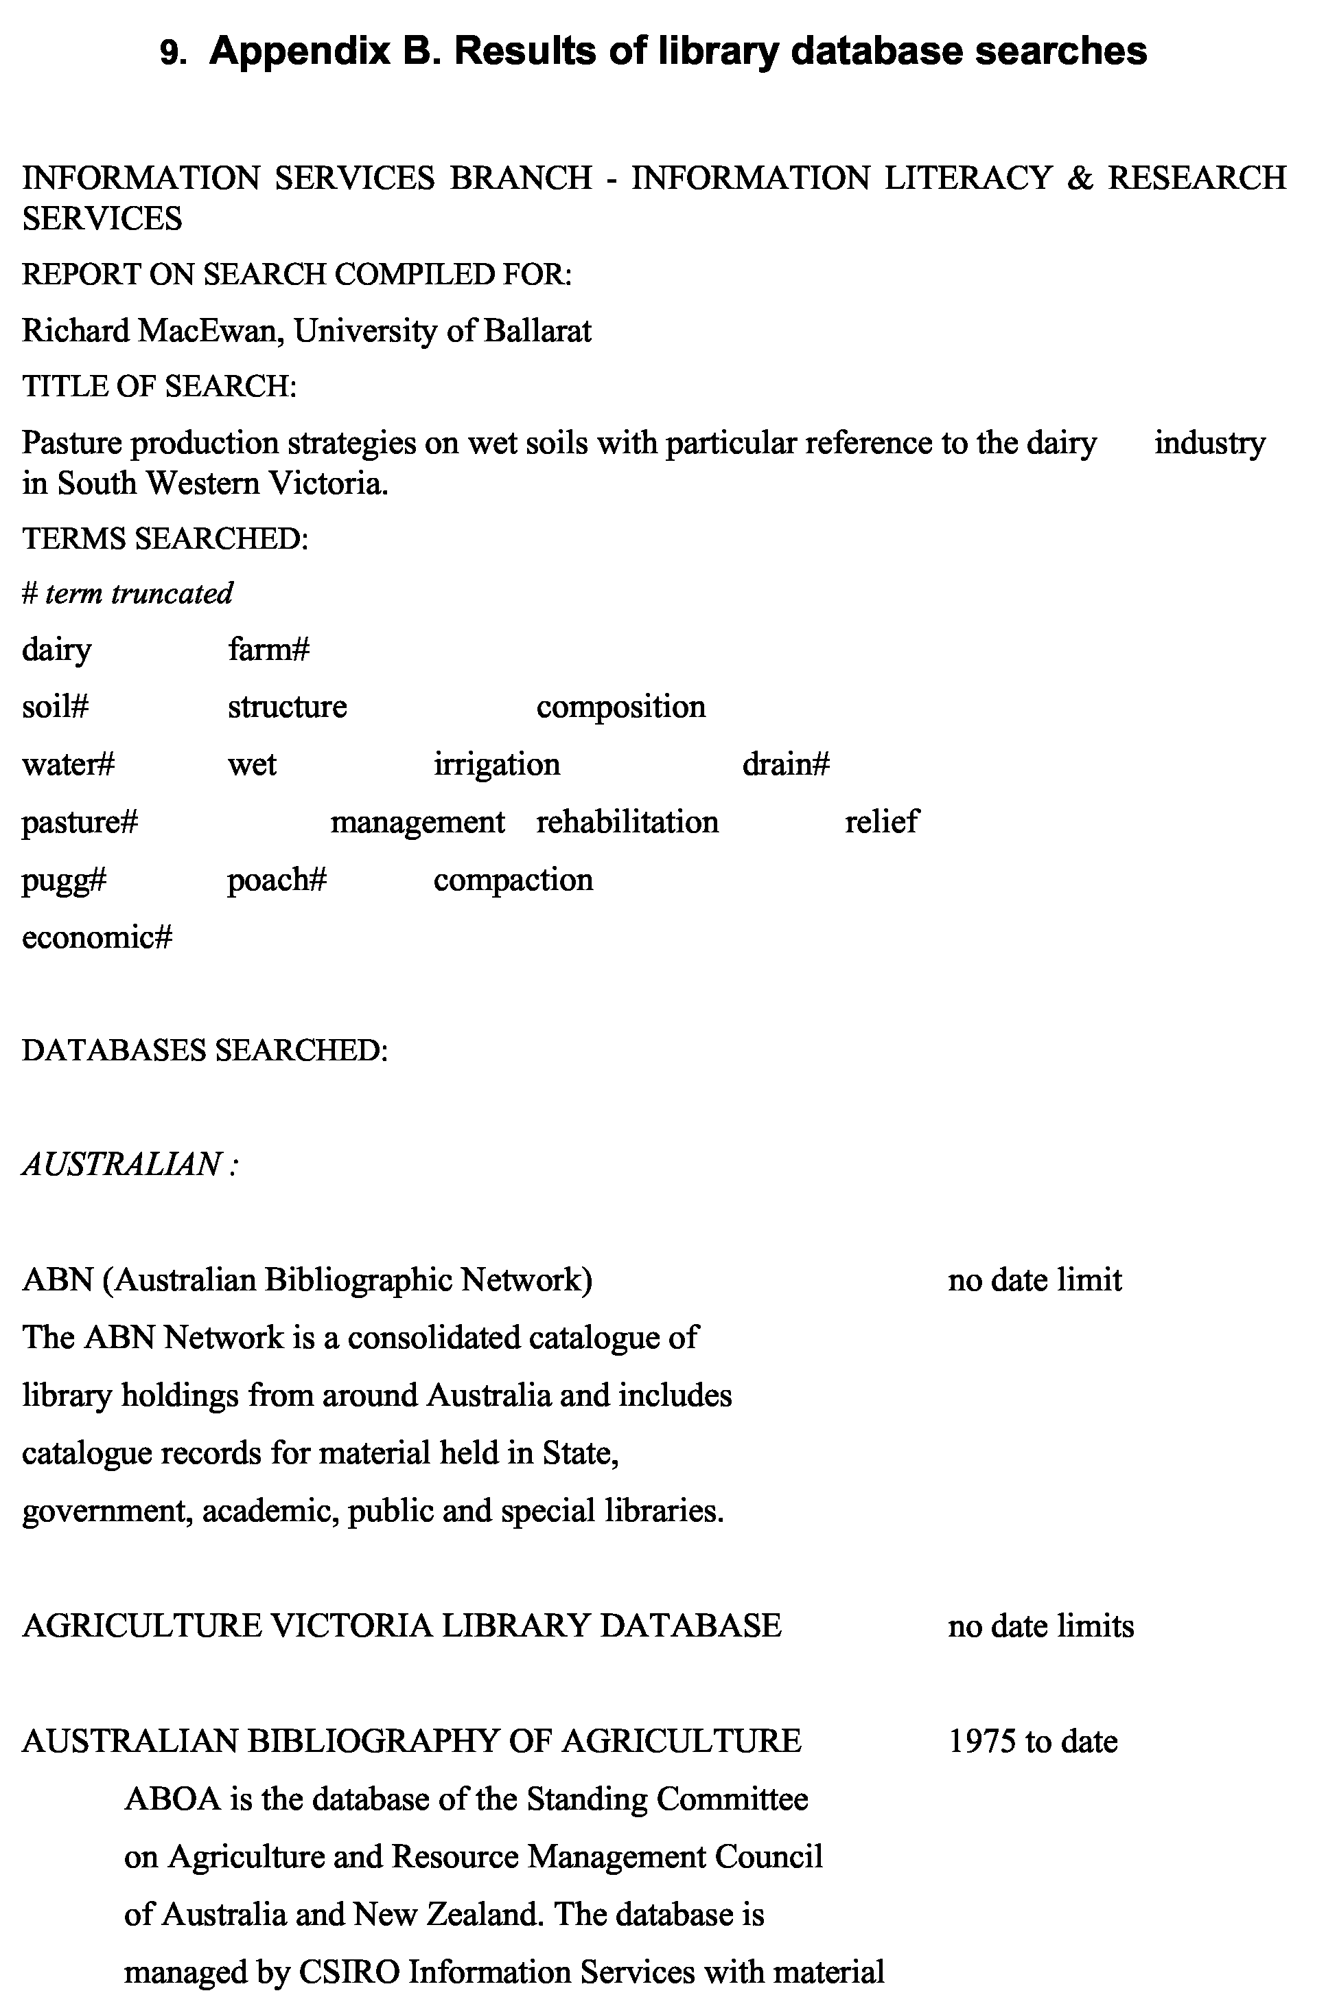
Library database searches, Wet Soil Management. Leeanne Pitman, University of Ballarat, June 1997
40
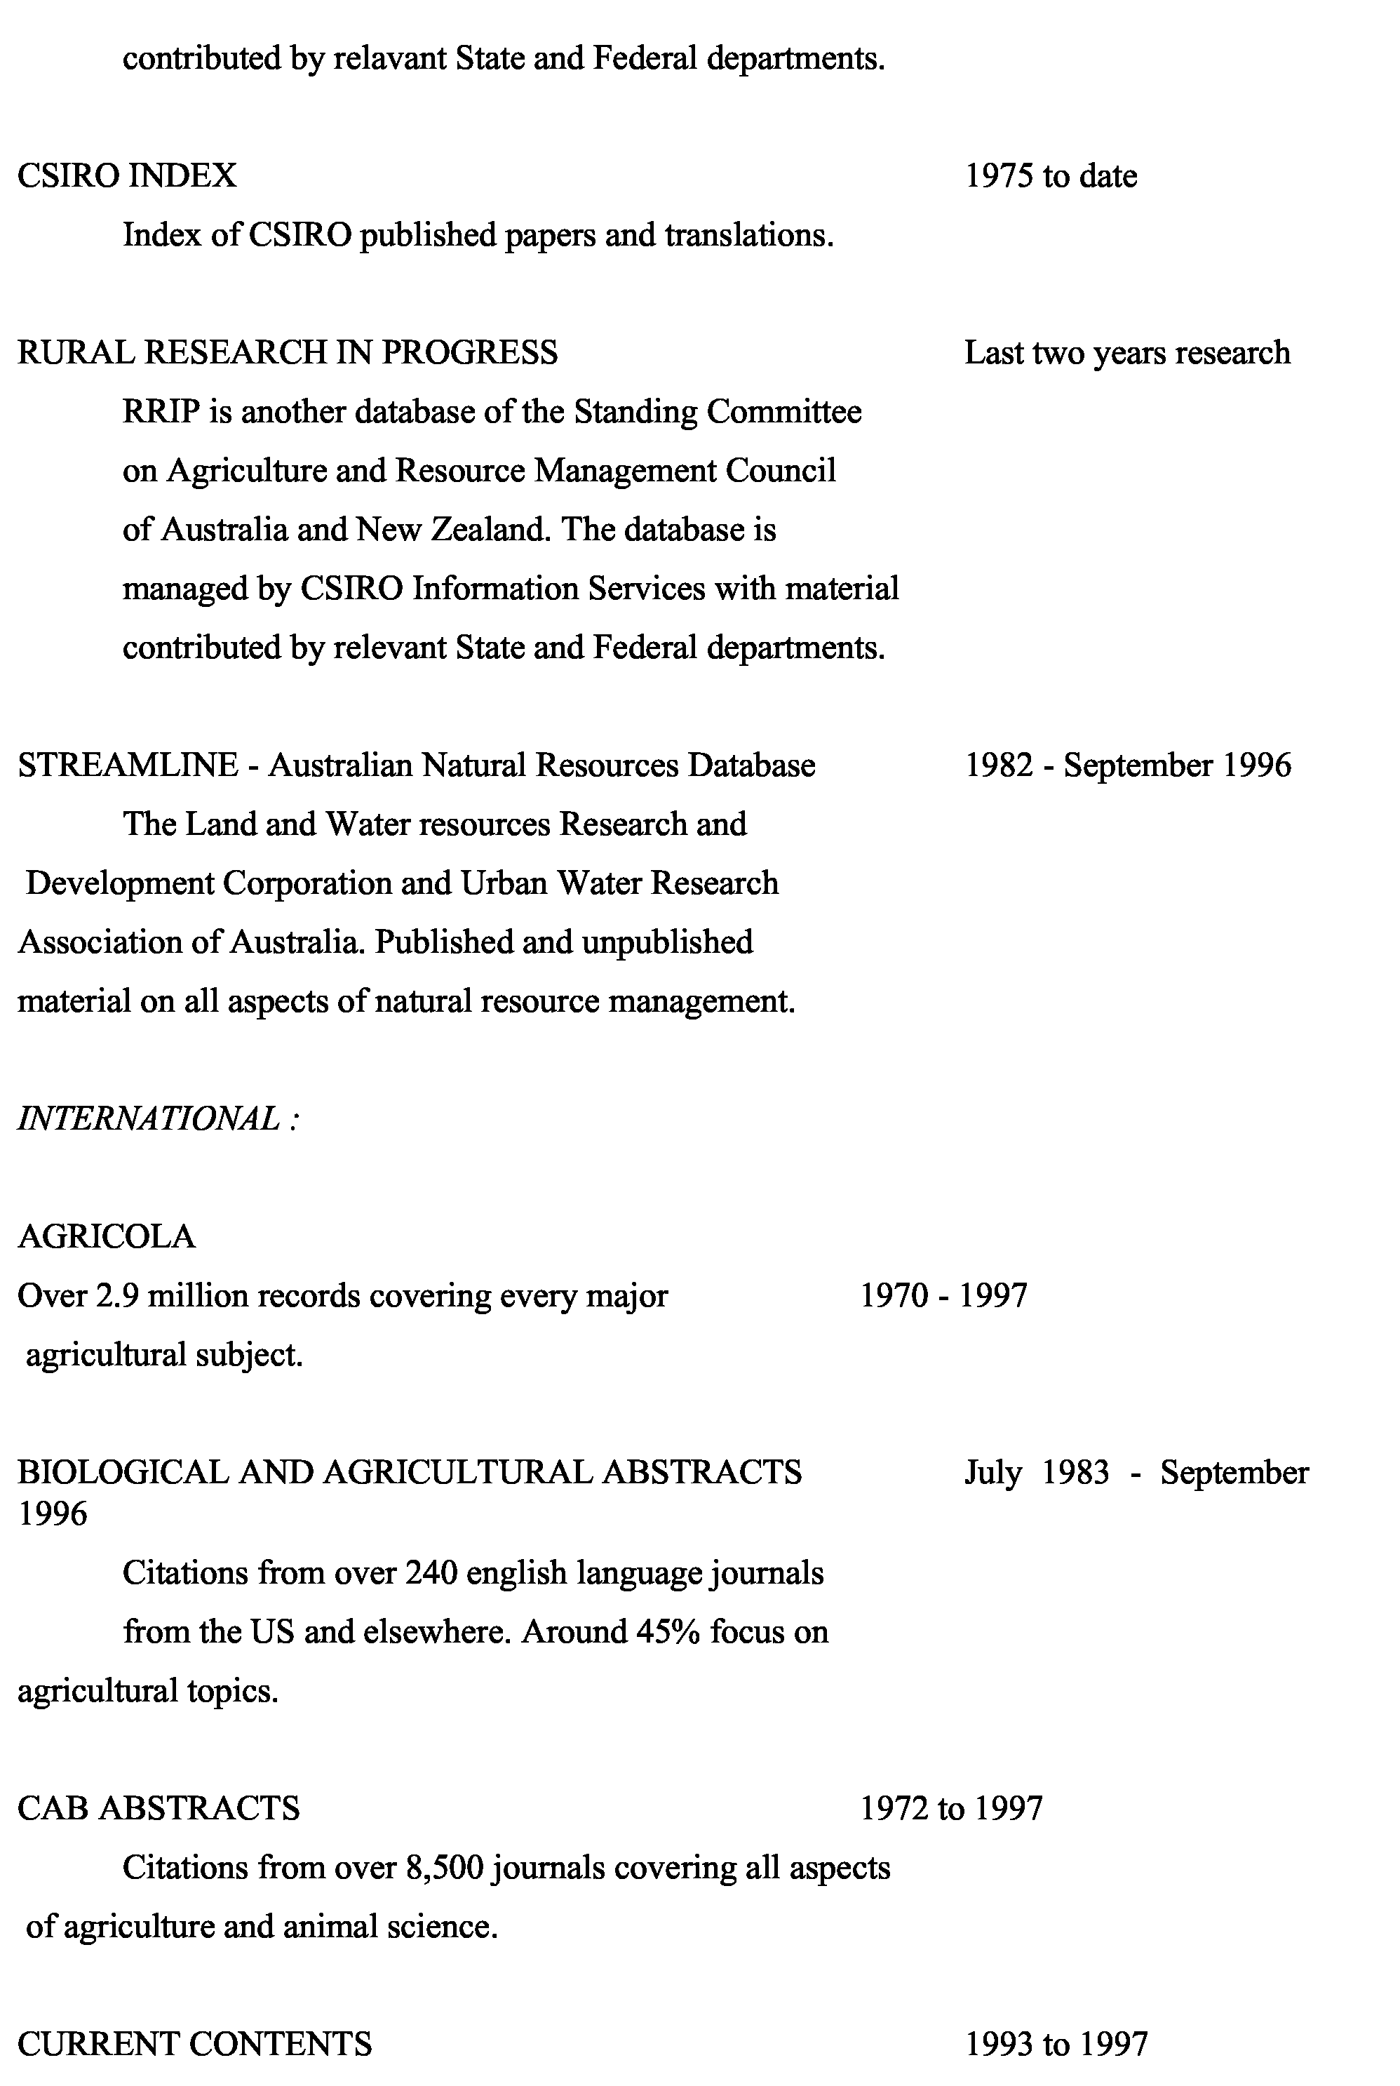
Library database searches, Wet Soil Management. Leeanne Pitman, University of Ballarat, June 1997
41
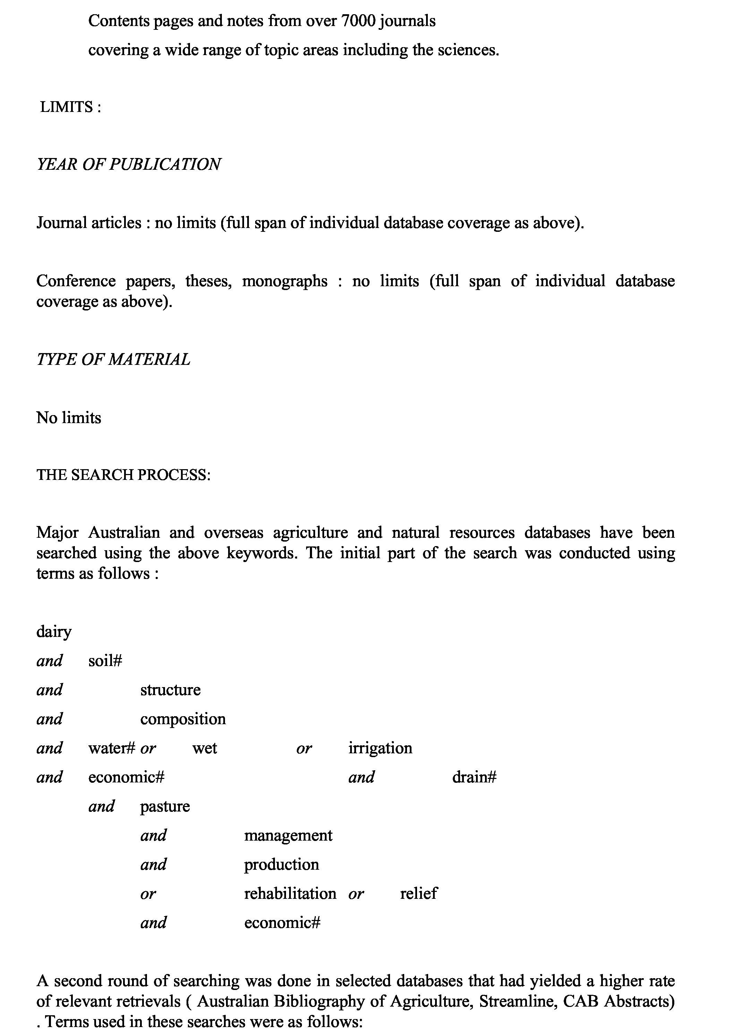
Library database searches, Wet Soil Management. Leeanne Pitman, University of Ballarat, June 1997
42
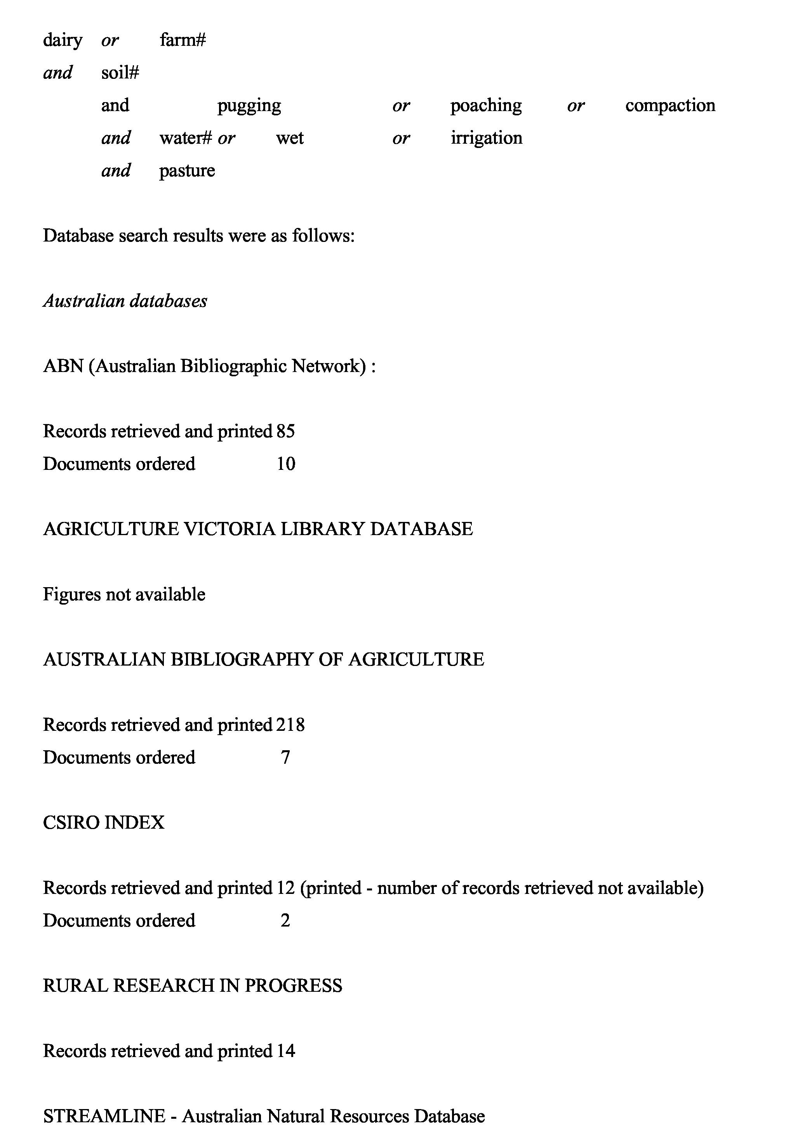
Library database searches, Wet Soil Management. Leeanne Pitman, University of Ballarat, June 1997
43
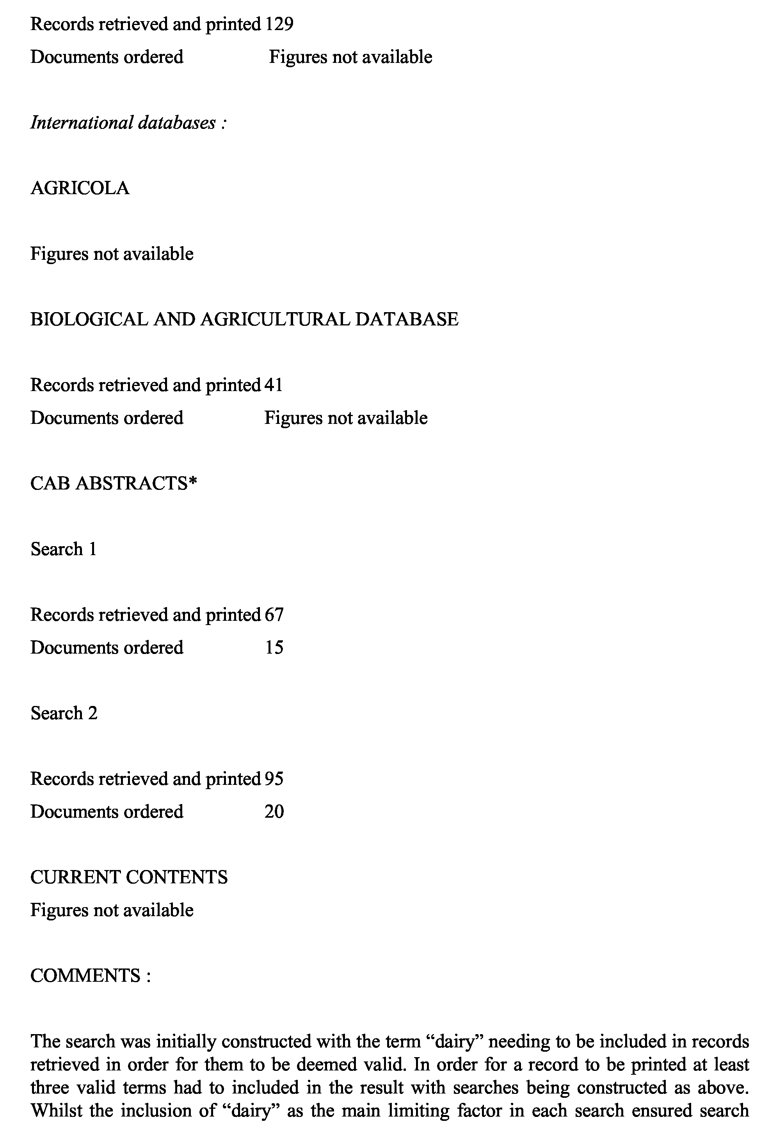
Library database searches, Wet Soil Management. Leeanne Pitman, University of Ballarat, June 1997
results that were specifically related to the main search focus, it is likely that a large amount of potentially useful material related to the management of wet soils in other environments was overlooked.
The second round of searching, whilst similarly constructed to the first, broadened the search from results specifically related to dairy to the more general farm environment. A valid search result in this round included either of the terms “pugging”, “poaching” or “compaction”, together with at least one other relevant term from the search group as indicated above.
Duplication
A duplication rate of approximately 10% was recorded between search results from Australian databases with the rate slightly lower for international databases.
Database limitations
No one database is completely comprehensive, thus the need to search multiple databases in the same subject area to ensure the highest possible retrieval of material reflecting a broad scope and publication type. This particular search highlighted the limitations of many of the chosen databases, and confirmed the need to search in a less formal environment to ensure the greatest possible retrieval of relevant material from all possible sources.
Unpublished material: a large amount of unpublished material exists that can only be retrieved through local knowledge and previous experience. Personal contact is an important factor in retrieving this material and this was evidenced by the success in locating private and departmental research papers that would otherwise have not been located. The culture of information exchange that exists between those researching and working in similar areas appears to also play an important part in ensuring the breadth of material located.
Interdepartmental, industry specific and small run publications: this type of publication is often not included in published indexes and electronic databases. Publications such as Dairy Exporter are a good example of an industry specific publication that does not appear in any database search results. Useful material was located from these sources as a result again of local knowledge, previous experience and industry expertise.
REFERENCE AND RESEARCH TEAM CONTACT :
Leeanne Pitman
Information Literacy & Research Services Manager
44
Library database searches, Wet Soil Management. Leeanne Pitman, University of Ballarat, June 1997
45
Information Services Branch University of Ballarat
email: l.pitman@ballarat.edu.au
WestVic Dairy, Wet Soil Management: Annotated Bibliography. R.J. MacEwan.
10. APPENDIX C: Annotated Bibliography 10.1 Advice to readers
The bibliography has been prepared during the course of a consultancy on wet soil management for the dairy industry. During this project databases were fairly exhaustively searched for relevant material and any papers with apparent relevance to the project were obtained. Other references and reports were added from other sources. References cited in the body of the report to WestVic Dairy R & D Committee can be found here. Not all of the references listed here are cited in the report. Notes are appended to most of the references and were made by R.MacEwan. They should not be regarded as ‘abstracts’, often only brief mention is made of the relevance, or otherwise, of the paper in question. Data referred to in the notes should always be checked with the original paper as published if they are to be cited. The bibliography should serve as a guide to any future researchers undertaking work in this topic area and will save the effort of searching for publications prior to January 1997.
10.2 Bibliography
- Abdel-Magid, A.H., Trlica, M.J. and Hart, R.H. (1987). Soil and vegetation responses to simulated trampling. Journal of Range Management 40,303-306. Notes: Trampling effects were simulated in greenhouse experiments. Cores 14 cm diameter and 15 cm deep were taken (sod intact) using a hydraulic soil sampler. Cores were kept at field capacity or near for four weeks prior to trampling to allow initial grass growth. Soil cores were then set up to represent three different moisture regimes (all either field capacity or drier so wet soils were not investigated in this research). An artificial, bronze hoof was used to simulate footfalls onto the sods. Five levels of trampling were used (32, 16, 8, 4, 0 footfalls) during a 32 day period to simulate continuous grazing. A short duration grazing system was simulated by "trampling" the soils only during the last 4 days of the period to give the same no. of footfalls in each system. Bulk density increased at the 2 higher levels of trampling and was greater for the continuous system. Infiltration rates in the higher trampling regimes were reduced to less than half the untrampled soils
- Adams, W.A. and Akhtar, N. (1994). The possible consequences for herbage growth of waterlogging compacted pasture soils. Plant and Soil 162, 1-17. Notes: Soil compaction through intensive stocking with cattle has been found to cause a reduction in herbage production which could be ameliorated by soil aeration. Topsoil passed through a 5 mm mesh sieve and intact soil cores with surface vegetation were incubated anaerobically with or without added mineral-N. Perennial ryegrass and white clover were grown hydroponically to examine their sensitivity to high concentrations of manganese. Depletion of available nitrate through denitrification appeared to be the main reason for a decrease in growth of grass on waterlogged intact cores, but in field conditions where anaerobiosis is probably more severe there may be an additional effect of manganese toxicity to clover. Good introductory summary of effects of waterlogging. Good explanation of experimental method. Small cores were used (80 mm deep 53 mm diameter). Redox potential measured with platinum electrodes
46
WestVic Dairy, Wet Soil Management: Annotated Bibliography. R.J. MacEwan.
- Anon., (1974). "A comparison of two systems of winter grazing management and effects on subsequent pasture growth rates. No.3 Dairy unit: 1974." (UnPub) Notes: This document from an unknown source summarises the ON/OFF grazing experiment carried out at Massey, New Zealand in 1974. Figures for kg DM/ha on the pastures are given. Treatments involved two groups of 16 cows each, these grazed for 2 or 24 hours and were given hay supplement (9% of diet for the ON group, 22% for the ON/OFF group). Faster regrowth of pasture following short duration grazing due to higher residual stubble (aimed for 850 kg/ha). Shorter rotations possible with ON/OFF system would enable more even pasture quality across the farm and better utilisation. Mean values of regrowth were: 20.4(ON) and 29.3(ON/OFF) kg DM/ha/day. Pasture before grazing ranged between 1770 and 3140 kg DM/ha, and after grazing: 644- 1186(ON/OFF)and 310-640(ON). No consistent effect on growth rates was shown in the September-December period although the winter effect was consistent (faster regrowth for ON/OFF system). Larger area of pasture is required each day for ON/OFF system. Good table presented relating area required per day by herd and rotation length (total area/area needed per day). and
- Anon., (1993a). Beetles' beneficial toil in burying dung pats. Dairy Exporter October,30,32. Notes: Reports on research project being carried out in New Zealand by Jenny Dymock and Shaun Forgie on dung beetles. Up to 75% of grass tillers and clover stolons may die if under manure pats for a fortnight or more. Depending on weather, pats may persist for 6 months. Researchers hope to enhance manure degradation by introducing new dung beetle species (NZ has no native pastoral species). In the 1960's Australia started importing species from Africa and 25 out 45 introduced became established. Australian programme reduced free-living animal gastro-intestinal nematodes on pasture by up to 80%. Bush fly numbers were also reduced. "Beetle activity aerates the soil, reduces erosion, enhances water and root penetration, and lessens the amount of dung available as a breeding ground for flies." Dung beetles come in three broad types: one lives in the manure and makes balls of dung to hold its eggs, another makes balls and rolls them away from the pat for burial underground, the third tunnels under the pat and takes its dung balls deep into the soil. They may go as deep as a metre but 15-30cm is normal. Beetles in Africa can bury 1.5kg of elephant dung in 2 hours
- Anon., (1993b). Feeding and loafing pads: build now for savings. Dairy Exporter January, Notes: Reports on experience of Kevin O'Connor on Tokomaru silt loam. 300 cows on 100 ha. Loafing pad was built in 1984: one metre of sawdust over washed metal and novaflo (subsurface drainage). Cost was 18,515 NZ$. Maintenance averaged 2440 over past 3 winters (sawdust removal and replacement). Feed area with concrete pad and bunkers cost 19,857. Benefits of the system: no pasture damage, ability to maintain rotation length, low supplement wastage, maintain cow condition, calving on pad reduced losses, no need to graze off the farm, drainage works protected. Herd has up to 4 hours on pasture. If pugging is likely herd stays on pad. Problems: continuing maintenance, shortage of sawdust supply. Also reports on Caroline Whitelock's farms - two sets of feeding areas and loafing pads. Feeding bins and standing area cost $20000 or $133/cow. Larger farm loafing pad and feeding area cost $40000 or $114/cow.
47
WestVic Dairy, Wet Soil Management: Annotated Bibliography. R.J. MacEwan.
Sawdust replaced every year ($1000-1500 per pad per year). Weed and rodent control $300/yr. Smaller farm's pad was used 81 days in 1992. Neil and Julie Candy's loafing pad cost $26/cow. Pad is wood shavings over rotten rock with no additional drainage
- Anon., (1993c). Minimise pugging on soggy soils. Dairy Exporter April,9-12. Notes: Four west Taranaki dairy farms are discussed. Soils are on volcanic land with freely draining topsoils but impeded drainage through ironstone or mudstone pans. Three hours grazing is reckoned to provide maintenance. In exceptionally wet weather cows are stood off. Temperament of Jerseys against Friesians is discussed. Paddock grazing system outlined in Mountfort 1993 is employed
- Anon., (1994a). Prepare for autumn sowing. Dairy Exporter September,20. Notes: Reports on Simon Moloney's advice on pasture renovation: Soil test, drainage, weed elimination, lime if needed (shallow cultivation), sowing date and moisture levels (Autumn sowing), roller drill or crop drill with downtubes off, fine weed free consolidated seedbed, N based fertiliser before drilling, DD paddocks use MAP at 200kg/ha, post grazing herbicide. No hay or silage from early autumn pastures in first year of production
- Anon., (1994b). Grass to grass pasture renovation, fallow to follow ploughing. Dairy Exporter September,22,24. Notes: Report refers to book on pasture renovation written by Simon Moloney and John-Paul Praat from Lincoln Ventures, Hamilton, NZ (no publication details given). Discussion on minimum tillage - limited effectiveness due to poor weed control, less opportunity for soil smoothing, accurate seed depth placement is difficult (particularly important for small seeds). Mouldboard plough has been favoured in NZ because of problems in trying to use implements where surface residues or partly buried residues are present. Seed depth, fertiliser, weed and pest control must all be right. Massey University studies of direct drilling equipment over 22 years have shown up problems in lack of expertise in the equipment and some effects of the equipment (esp. shape of groove into which seed is sown)
- Anon., (1994c). Respect for soil crucial with effluent disposal. Dairy Exporter January,27. Notes: Reports on warnings by Max Turner and Warren Woodgyer (Massey University) that soils should not be indiscriminately used for effluent disposal on dairy farms. Some recommendations have proposed that effluent be disposed on wet or imperfectly drained soils as a preferred method for preventing nitrate leaching into groundwater. Report refers to 1970's research at Massey (but no references given) where dairy shed effluent disposed onto artificially drained soil was the most satisfactory method. "Effluent disposal requires the best drainage". Disposal on imperfectly drained soils will lead to anaerobic conditions and soil degradation
- Anon., (1994d). Utilising underground waterway for reverse flow irrigation. Dairy Exporter January,42-43. Notes: Wayne Skaggs, North Carolina State University visited NZ as the D.G.Bowler memorial lecturer. He discussed principles of utilising drainage systems to provide sub irrigation. Success depends on soil properties and
48
WestVic Dairy, Wet Soil Management: Annotated Bibliography. R.J. MacEwan.
would need to be trialed in the field in NZ. System is used in the US mid west. Should work in coarser textured soils. Blocking main drain in dry spells holds water closer to root zone. Fine textured soils especially if mole drained would run into trouble with such a system
- Anon., (1994e). March sowing advised. Dairy Exporter September,25-26. Notes: Describes optimum timing for NZ dairy pasture establishment
- Anon., (1995a). Quad depugger. Dairy Exporter July, 126. Notes: Describes a device built by NZ farmer Peter Anich costing $1400. Hauled behind a quad bike (therefore traffics conditions too wet for at tractor). System is basically a tyre roller fitted with rear quad bike tyres. The frame allows additional weights (e.g. concrete fence posts)
- Anon., (1995b). Paddock pugging test. Dairy Exporter November,34,36. Notes: Describes how to use a rising plate pasture metre to estimate susceptibility of paddock to treading damage by pushing down on the shaft and recording depth of penetration. A table is provided giving six classes of soil strength related to six penetration depth ranges. Susceptibility to damage is related in each class. Depth classes: 0-2.5, 3-5.5, 6- 8.5, 9-11.5, 12-14.5, 15-20.5 cm; Soil strength: very good, good, fair, poor, very poor, nil; Susceptibility to damage: pugging unlikely, pugging unlikely be careful if it rains, pugging likely so restrict grazing duration, easily pugged don't graze, almost a swamp. This was developed by the Northland advisory team looking for ways to evaluate drainage and on/off grazing systems
- Anon., (1996a). "Study Tour of New Zealand Dairy Farms to Investigate Strategies for Managing Wet Soils." (DNRE, Victoria: Notes: Final report to DRDC of a tour carried out in 1995 by Brendan Christy, David Hopkins, Frank Mickan, and Nabil Badawy (all from Agriculture Victoria), Cathy Joiner (dairy farmer), and Richard Gloyne (Drain Tech, and chair of SW Vic.Wet Soil Management Steering Committee). General observations on NZ dairy pasture management with emphasis on off-paddock wintering systems. 18 pages. 12 plates
- Anon., (1996b). Up to 9 months recovery time for pugged pasture. Dairy Exporter June,46. Notes: Report of a meeting with dairy farmers and Mike O'Connor (AgResearch Ruakura, Soils and Fertiliser group). Hauraki Plains dairy pasture pugged in a farm trial suffered an initial 75% decline in production and took 9 months to recover. Other soils showed 45% decline and 8 months recovery (Te Kowhai soils), and 25% decline with 3 months recovery (Horotiu soils). Clays most susceptible to pugging, then silts, then sands. Mark Carlyon (dairy farmer) reported on his experiences with on-off grazing. His perception was that timing of stock removal in wet was critical, with 15 minutes making a big difference. His strategy for stock removal is based on: rainfall, water levels (drains and groundwater), whether pugging is commencing, wind direction and chill factor, colour of the grazing break (what does this mean?). Cows were moved as soon as treading damage was observed. Management options to reduce pugging: minimise cow walking on fresh break, stand cows off (at dairy, on races, on sacrifice
49
WestVic Dairy, Wet Soil Management: Annotated Bibliography. R.J. MacEwan.
area, in woodlot). No effect on cow condition. Less topsoil and fertiliser loss into drains and creeks. Duncan Smeaton (AgResearch) reported on UDDER, a farm simulation model. Programmable pugging damage and relative costs of taking animals off wet paddocks or not
- Anon., (1996c). Kaitaia farm. Dairy Exporter June, 107-108. Notes: Page 108 only in file. Steve Nightingale (ag engineering consultant, Whangarei) commenting on subsurface drainage as an integral part of lowland management. General comments on soil structure and drainage. Trial work on Kiapara clay soils showed increases in pasture production and utilisation after moling. Farm stocking increased from 2.5 to 3.1 cows/ha. Milk solids increased by 175 kg/ha giving increased revenue of $600 /ha/yr. Drainage cost $1960/ha. A system using Novaflo (proprietary product I know nothing about) was outlined. It is laid at 250m/ha and topped with metal to assist water movement. Unless provision is made for lateral flow they will do 20% of required drainage; mole drains at 2m, giving 5000m/ha, will carry 80% of drainage water to complement Novaflo. It is stressed that on/off grazing must be used too and that drainage is not an excuse to leave cows on paddocks in the wet. On/off grazing is vital to the survival of mole drains which may last up to 30years. Note: if Novaflo is a pipe drain (probably is) it is being laid at 40 metre spacing in the example above
- Anon., (1996d). Soils research project. Dairy Exporter September,?. Notes: Reports on Ruakura project led by Doug Edmeades. Project is looking at methods of routinely measuring soil physical quality in the lab and on the farm. Peter Singleton looking at pugging, others at soil biology (microbial indicators for soil quality). Lab studies may include artificially compacting cores (hydraulic rams) to assess pasture growth in compact conditions
- Anon., (1996e). Water quality study. Dairy Exporter October,65. Notes: Catchment based study linked to NZ Sustainable land management strategy
- Anon., (1996f). Special demands when wet. Dairy Exporter October,38. Notes: Brief news article on Neil and Glenda Gray (Hauraki Plains, New Zealand). 600 m² sawdust loafing pad plus feeding barn each with a holding capacity of 100 cows. Annual maintenance $1400. ON/OFF system with cows having 3 hours a day on grass and the rest housed or on concrete or sawdust from early July
- Anon., (1996g). 'Sustainable' is never sufficient. Dairy Exporter October, 128. Notes: Reports on speech by Sir Colin Spedding, also on NZ context and their strategic group on sustainable land management research
- Anon., (1996h). On the DPB at 12 months. Dairy Exporter October, 129.
- Anon., (1996i). Marine clay soils absorb water. Dairy Exporter September,41. Notes: Reports on work by Peter Singleton. The marine clay is largely montmorillonitic,
50
WestVic Dairy, Wet Soil Management: Annotated Bibliography. R.J. MacEwan.
therefore high shrink swell behaviour and develops cracks in summer (cricket habitat). This soil would compare with the soils on the maars in south Victoria and the Gellibrand Marl soil in the Heytesbury. On the Hauraki plains farmers work proactively to prevent pugging as once it has occurred several months are needed for recovery. Cattle are moved at night if it rains. Pugging damage examined showed soil had not recovered after 14 months, pasture recovered after 4-8 months. Penetrometer is used to assess soil strength with the threshold value of 350 kPa marking risk of pugging. If the penetrometer moves through 5cm with less than 350 kPa then there is considerable pasture damage and puddling if grazed. Current trials by AgResearch Grasslands based at Ruakura have 2 aims: determine which soil properties are useful to measure for assessment of pugging damage, and secondly determine the extent to which farmers are affected. A second set of grazing trials is being run to determine the most useful grazing practices to prevent pugging damage and soil deterioration (nil grazing, grazing for a maximum of 3 hours, shallow ripping effects). Preliminary data showed different degree and amount of degradation across 3 soil types (Horotiu soil, Te Kowhai silt loam, and Hauraki plains soil)
- Anon., (1996j). Degradation of soil after compaction not always obvious from grass growth. Dairy Exporter October,40,42. Notes: Report on work by Peter Singleton's group at AgResearch Ruakura. Research addresses concerns about slow long term degradation as these effects may not be immediately evident in grass growth, although in one study soil pugging and compaction damage following a single pugging event depressed pasture production by 20-80% depending on soil type. In Te Kowhai soil, soil structure had not recovered fully after 14 months, infiltration was 10 times slower, and although pore volumes were similar, pores were not well connected and aeration and water storage were reduced. Similar effects were noted in the Hauraki soil but the Horotiu soil appeared to have returned to normal within 14 months. It is possible that the so called 'normal' condition is in fact a compacted soil condition. Comments are made on de-nitrification, emission of greenhouse gases, and pollutants in run off, all of which can occur as a result of soil compaction
- Anon., (1996k). Barn, 15m*30m, and feedpad play key roles at calving. Dairy Exporter September,42,44. Notes: Intro reference to compaction: hoof pressure of a standing cow 345 kilopascals. Trials 40 years ago (??whose) established that between 17 kPa and 1400 kPa soil was compacted but without any significant effect on perennial and short rotation ryegrass. But when pugging occurred in wet soil ryegrass growth was drastically reduced. Reference made to advice at that time which was to graze only when the top 25-50 mm of soil was clear of free draining water. Even in the 1950's L.R.Wallace advocated more trial work on ON/OFF grazing systems. Article then reports on wintering barn of Lawrie and Fay Jones. Barn and feed pad accommodates 150 cows. Farm is humped and hollowed and Drainflow is installed at the end of each hollow. Waterlogging is still a problem although flooding is not
- Anon., (1996l). Cows choosy about pasture according to Massey trials. Dairy Exporter January,20-21. Notes: Reports on sward preference trials being carried out at Massey. Preliminary results suggest that cows prefer tall sparse swards over short dense swards.
51
WestVic Dairy, Wet Soil Management: Annotated Bibliography. R.J. MacEwan.
PhD research of Wendy Griffiths. Paper was to be presented at Animal Production Society Conference in February 1996
- Anon., (1996m). Study seeks facts on environment. Dairy Exporter January,37,39. Notes: Water quality impacts of dairy farming studied in 1800 hectare catchment of a tributary of the Waikato. Stocking rates, fertiliser programmes, crops, pastures, land applications of effluent, winter farm management and water quality. Computer model developed by Harvey Rodda (National Institute of Water and Atmospheric Research, NIWA). Preliminary report outlines some of the model's outputs. Drainage would reduce surface runoff and P accessions to the waterway
- Anon., (1996n). Environmental challenges facing systems. Dairy Exporter September,51. Notes: Report on seminar 'Towards Greener Pastures' (Denise Church, NZ Ministry of Environment). Environment 2010 and Sustainable land management strategy contain priorities set by NZ government for environment. Environment 2010 strategy identified key issues which crucially affect the environment and economy. Primary production pressures included soil compaction, soil structure deterioration through cultivation or stock on wet soils. Through the Green Package NZ government will spend $100m a year on land management research (1997)
- Anon., (1996o). 'Humping and hollowing' as done by the book. Dairy Exporter June,45. Notes: Press announcement of a booklet produced by Westland Co-op Dairy Company which explains do's and don'ts but is no a 'do it yourself book'
- Argent, R.M. and Ewing, S.A. (1996). "Rural drainage in Victoria. Scoping Study. CEAH Report 1/96." (Centre for Applied Hydrology, University of Melbourne: Melbourne.)
- Armstrong, A.C. (1986). Mole drainage of a Hallsworth Series soil. Soil Use and Management 2,54-58. Notes: Measurements of poaching using the method of Davies and Armstrong (1986) consistently showed that greatest degree of poaching is on undrained controls and that the mole-drained plots suffered significantly less damage. Emphasis is laid on the importance of timing of moling operations to coincide with the spring drying out phase of the soil
- Armstrong, A.C., Rycroft, D.W. and Welch, D.J. (1980). Modelling watertable response to climatic inputs - its use in evaluating drainage designs in Britain. Journal of Agricultural Engineering Research 25,311-323. Notes: Adopts a water balance approach and model incorporating the van Schilfgarde non-steady state drainage equation. Real watertable depths were compared with those predicted by the model. Modelling of the watertable required a reliable estimate of saturated hydraulic conductivity. Assumption in the model was that infiltration always exceeded rainfall (unlikely in South West Victoria especially in paddocks with surface soil damage).
52
WestVic Dairy, Wet Soil Management: Annotated Bibliography. R.J. MacEwan.
Model gave realistic prediction of watertable depth and demonstrated the superiority of moled systems against pipes alone in the clay soils
- Baker, A-M., Younger, A. and King, J.A. (1988). The effect of drainage on herbage growth and soil development. Grass and Forage Science 43,319-336. Notes: Effects of drainage on perennial rye grass (Lolium perenne) swards. Over 4yrs mean increase of 1.5t/ha/annum, 16% increase on undrained site. N content of herbage was also increased which led to an increase in total Nitrogen recovery of 24.8kg/ha (15%). Drainage led to increased root efficiency and N availability due to lower watertable, this resulted in greater tillering and earlier leaf extension in spring. A number of measurements were made on herbage growth (and components) leaf extension rates and root measurements
- Bakker, A.C. (1981). Drainage in southern Victoria. In "Better drainage of farmland. Speaker notes from one day seminar, Glenormiston Agricultural College, 28 April, 1981." pp. 1 -10. (Agricultural Engineering Society (Australia) Victorian branch: Notes: Good overview of effects of waterlogging, benefits of drainage, soils in the area (from David Myers 1963 report), and drainage design (including bedding system)
- Bezkorowajnyi, P.G., Gordon, A.M. and McBride, R.A. (1993). The effect of cattle foot traffic on soil compaction in a silvo- pastoral system. Agroforestry Systems 21, 1-10. Notes: Study focussed on the effect of grazing and therefore compaction around hardwood and softwood tree seedlings. Bulk density increases were attributable to cattle grazing. A pot experiment showed that water infiltration and nitrogen uptake decreased with increasing compaction and adversely affected seedling growth. The addition of nitrogen fertiliser improved seedling growth in the compacted soils
- Bidwell, V.J. (1978). "Field drainage guide. Project Report P/16." (New Zealand Agricultural Engineering Institute: Notes: A good practical guide to drainage techniques, layout and design (pipe spacing). Much of the generic information here is applicable to Australia. The book fulfils a purpose in bridging the gap between a farmer with a waterlogging problem and a contractor able to install drains. The only attempt in Australia to satisfy this need would be Frank Mickan's 1993 publication "Improving Waterlogged Paddocks"
- Blackwell, M.B. (1993). Experiences with on-off grazing in early lactation on dairy farms in Northland. Proceedings of the New Zealand Society of Animal Production 53,37-39. Notes: No detrimental effects on cow condition or daily production by standing cows off pasture provided certain conditions are met: 1. On/off grazing of lactating cows is done while feed cover is plentiful, to extend the length of the first (and second) milking rotations, to avoid getting into feed shortage. 2. Pasture must have good length and density (around 2500 kg DM/ha) to allow high levels of DM intake in restricted time period. 3. Cows must be in good health. 4. Magnesium supplementation was reported as essential. 5. First calving heifers must be well grown and cows must be in good condition. Negative aspects of on/off grazing: Extra time to move cows on and off yard, wash down yard and extra loading on effluent system
53
WestVic Dairy, Wet Soil Management: Annotated Bibliography. R.J. MacEwan.
- Boomsma, J. (1980). The place of silage in spring grazing management. Agricultural note series No 80 1-3. Notes: Discusses the role that silage plays in maintaining pasture quality in Gippsland
- Bowler, D.G. (1971). Cattlepad drainage and some aspects of their use on heavy soils. In "Sheepfarming annual." (Ed. Barton, R.A.) pp.75-80.(Massey University: Notes: Bowler deals briefly with definition and construction of cattlepad: soil is not removed (topsoil left in place too), conditions should be dry, site should be moled or subsoiled, pipes at 3 metre spacing with minimum grade 0.4%, pipes should be bedded in gravel with trench filled to surface, retaining walls for sawdust fill and 12 inch hardwood sawdust topped with 6 inch of post peelings, average of 50sqft per animal. He gives an outline of the reason for using cattlepads - soil structure protection (static loads: sheep 30lb/sqin, cattle 50lb, crawler tractors 3-8lb/sqin, wheeled tractors 20-30lb). When cattlepads are necessary: low permeability soils even when efficiently underdrained. He gives a three level formula for calculating when pad should be used to spare the pasture soil. K1; when rainfall <50pts in last 7 days, about 250pts will be needed before saturation occurs. K2; if rainfall is 50-150pts in previous 7 days, 50 points in 24 hours will give saturation. K3; if rainfall exceeds 150pts in previous 7 days, about 10pts will be required to give saturation. He then suggests allowing 24 hours per 25pts or rainfall after the conditions for saturation have been satisfied (counting after the first day of rainfall). A table illustrating his method is offered for a six week period in 1968 using DSIR rainfall records. Using this approach he shows no. of days that cattlepad would have been beneficial from 1966 to 1970 (12,21, 17,nil,29). The point is made that where there is no underdrainage in heavy soils there would be weeks at a time where the animals would have to be kept off the paddock
- Bowler, D.G. (1980). "The drainage of wet soils." (Hodder and Stoughton: Auckland.) Notes: An excellent text on wet soil problems and drainage techniques. It includes brief discussion on particular applications such as dairy pastures and orchards. There is a short section (in Ch13: Some important management and maintenance practices 231- 243) on cattlepads. Cattlepad = specially built free-draining area simply to provide a loafing space. Feeding platform = a hard surface area used for animals feeding on hay or other supplements from racks Loafing barn = a roofed over cattlepad. Cattlepad floor is usually made from sawdust, post peelings, or woodchip and since it is usually uncovered it should be underdrained. In wet conditions cattle can be shifted onto the pad and held there "on the basis of one day per 6 mm of rain occurring in the previous 24 hours". More detail can be found in Bowler (1971). One practice is to intensively drain paddocks close to the pad. These then allow early release of animals from the pad. Bowler,D.G.(1971) Cattlepad drainage and some aspects of their use on heavy soils. Massey University Sheep Farming Annual. 75-80
- Bowler, D.G. (1981). The pugging of grasslands. Proceedings of the New Zealand Grassland Association 42,217-218. Notes: Brief article summarising effects of grazing in wet conditions on pasture productivity: herbage pressed into mud and wasted, surface compaction increases ponding, pasture recovery is delayed, animal health is affected in extreme conditions. Hoof pressures: 0.8kg/sq.m for sheep, 2.5 kg/m² for heavy cattle at
54
WestVic Dairy, Wet Soil Management: Annotated Bibliography. R.J. MacEwan.
rest. Pressures double with movement. Reports that Edmond (1962) found a fourfold yield reduction as a result of threefold increase in sheep stocking rate. Minimisation of pugging is by: reserving best drained paddocks for grazing during wettest period of year, spreading the herd thinly over as many fields as possible. Most positive method is to install efficient sub surface drains at least in areas most convenient to use in winter and spring but preferably over all of wet area. Construction of a dry-standing structure (sawdust pad) see Bowler 1980 chapt. 13
- Bradshaw, C., Christy, B., Watson, D., Horne, D.J., Mickan, F., Notman, P., Paynter, R. and McNamara, T.A. (1996). "Management Options on Wet Soils." (Target 10: Notes: Information sessions at Warragul and Glen Alvie, Thursday April 11th 1996. Papers by Carol Bradshaw, Brendan Christy and Dennis Watson, David Horne, Frank Mickan, Peter Notman, Ron Paynter, and Tom and Anne Mette McNamara. Good practical information on drainage options, off paddock wintering systems, grazing management and nitrogen, and some examples given by dairy farmers of their own approaches and experiences in these topics
- Briggs, D.J. (1978). Edaphic effects of soil poaching by cattle. North of England Soils Discussion Group 14,51-62. Notes: Increase in soil bulk density when the soil is close to field capacity and trampled by hoofed animals. Briggs refers to a figure which did not appear in the publication - very frustrating as the figure purportedly provides a framework towards a quantitative model of soil processes under considerations of poaching. The diagram showed the dual aspects of poaching: the direct structural consequences of trampling and the more indirect changed due to resulting differences in the rates of nutrient cycling by plants and animals. Briggs uses data from papers by Edmond, Gradwell, and Campbell to illustrate depression in grass growth and increase in bulk density. Consequences of structural alteration are seen as: lowering infiltration, increasing runoff and possibly erosion; reduction of nitrates, sulphates; lower leaching losses though with slow drainage. Uptake of nutrients is reduced but dung and fodder residues are concentrated (pugging is uneven within paddocks and concentrates around feed areas, gates, water troughs, shelter). Decline in numbers of soil macro-organisms slows rate of nutrient cycling therefore although nutrients may be higher in poached areas the availability will not be higher. Plots were set up to look at the effects of stocking and test the model and physical and chemical properties of the soil were measured. Situation is complex and the results needed much discussion and explanation (high variance, 'unexpected' results). Bulk density changes were most consistent with an increase with stocking density. Earthworms also decreased substantially with increase in stocking density as did infiltration capacity. Organic matter changes in the top 15 cm were seen to be the result of churning and mixing of surface soil layers with deeper material resulting in an even distribution of OM but relative loss from the top 9 cm compared to lightly grazed plots. In general Briggs suggests that the model is supported by the data. One implication of the observations is that recovery of poached (pugged) areas is not possible simply be removing the trampling pressure for short periods. Restoration may require deep ploughing, fertilising and re-seeding.
- Brown, K.R. and Evans, P. S. (1973). Animal treading - a review of the work of the late D.B.Edmond. New Zealand Journal of Experimental Agriculture 1,217-226. Notes:
55
WestVic Dairy, Wet Soil Management: Annotated Bibliography. R.J. MacEwan.
Experiments were conducted using sheep at intensities from 0 to 50/ha and on a range of soils, at three controlled moisture contents (equivalent to dry, moist and wet), and using a range of pasture species and mixes. Experiments took place in New Zealand between 1955 and 1972. Additional experiments were carried out using artificially compacted soils, and artificially puddled soils, and studying the plant response to these changed soil physical conditions
- Bryant, A.M. (1979). Effect of frequency of grazing during autumn-winter on dairy farm productivity. NZ Ministry of Ag. & Fish.Ag.Res.Div.Annual Report 5 1.(Abstract) Notes: 3 grazing frequencies applied between May and August. 46, 70 and 92 days were the average intervals with the largest intervals 65, 104 and 117 days. Days in milk were; 212, 214 and 226 respectively; milkfat per cow; 125, 129, 138 kg: milkfat per hectare; 539, 556, and 597 kg: Pasture growth kg DM/ha may - February; 14400, 12100, and 13300: pasture present 1.8.78; 1630, 1800 and 2020 kg DM/ha
- Campbell, A.G. (1966). Effects of treading by dairy cows on pasture production and botanical structure on a Te Kowhai soil. New Zealand Journal of Agricultural Research 9, 1009-1024. Notes: Introduction refers to other studies: Tanner & Mamaril 1959 reported 20% decline in pasture yield due to treading, Federer et al 1961 found the opposite on the same soil in a subsequent year. Scott 1963 found significantly higher pasture production on drained soils than on undrained soils when both were trodden by sheep. The experiment reported in this paper used two treading intensities (60 & 120cows/acre) for two durations (one and two days). DM production over following 12 months was measured. Cumulative effect of one annual pugging was studied over three years. Fifteen plots were used for the 3 treatments (2 intensities for one day and control) in year 1. The two day duration of grazing was not introduced until year 2 when the plots were split to allow a repeat of the year 1 treatments as well as the additional duration. Year 3 was a repeat of the 6 treatments used in year 2 (the control plot was split to allow mowing with removal of grass, or mowing with return of grass). Figure 2 in the paper shows plates of the pasture damage during treading for the 60cows*1day and 120cows*2days treatments, and for which there is a gross difference with the more intensively trodden pasture showing severe damage. RESULTS showed little difference in DM production. Zero grazing without return of nutrients gave the lowest production. In year one the 120 cows/acre plot gave a reduction of 7% but the difference was not statistically significant. In year two the mown control with removal of grass produced DM yield similar to the 120 cows/acre * 2days treatment. In autumn and winter the stocked/trodden treatments produced significantly less than the controls but the differences over the year were only around 2%. Weeds increased on trodden plots throughout the course of the experiment but were never proportionally important. The authors comment that other factors could account for DM production differences in the three years of the experiment (wetness, rank pasture, DM at grazing). There was no evidence that a single treading in late winter had any cumulative effect when repeated in subsequent years. Gradwell 1966 (N.Z.J.Agric.Res.9:127-36) reported that changes in water retention characteristics due to severe treading had almost disappeared in 6 months and completely disappeared in 10. McQueen 1965 (Proc.Ruakura Fmrs.Conf. Week: 204-10)could not show any benefit from prevention of treading by the use of a feeding platform when animal production was used as the criterion (the converse of this is of course that production did not suffer by taking cows off pasture and feeding
56
WestVic Dairy, Wet Soil Management: Annotated Bibliography. R.J. MacEwan.
supplements). The soil was a Te Kowhai silty clay with a low bulk density and high macroporosity (18-30% air filled at 4 kPa)
- Cavelaars, J.C. (1974). Subsurface field drainage systems. In "Drainage Principles and Applications. Vol IV." pp.1-65.(ILRI: Wageningen)
- Chan, K.Y. (1989). Friability of a hardsetting soil under different tillage and land use practices. Soil and Tillage Research 13,287-298. Notes: Study showed decrease in friability in conventionally tilled alfisol compared to friability of permanent pasture. Direct drilling increased friability
- Chapman, R. (1990). Changes in soil structure and texture after subsoiling soils under permanent pasture. In "Proceedings of the Fifth National Land Drainage Seminar." (Eds. Horne, D.J. and Furkert, I.F.H.) pp.71-78.(Massey University: Palmerston North, New Zealand.) Notes: A comparative study on the effects of a vibrating and non- vibrating subsoiler on soil physical properties. Subsoiling was carried out in dry conditions and resulted in some soil mixing. The surface texture of the soil affected by the vibrating subsoiler was reclassified from a clay loam, to a clay. Subsoil aggregates were brought up into the to 0-20cm layer and 'A' horizon aggregates were incorporated into the deeper 20-45cm depth subsoil layer
- Chiew, F.H.S., Kamaladasa, N.N., Malano, H.M. and McMahon, T.A. (1995). Penman-Monteith, FAO-24 reference crop evapotranspiration and class-A pan data in Australia. Agricultural Water Management 28,9-21. Notes: Technical consideration of different estimates of Et
- Christy, B. (1995). "Survey of dairy farmers attitude to drainage in South West Victoria." (UnPub) Notes: Survey of 76 farmers who had installed drainage was carried out with the intention of evaluating the relative success of the technique and identify future research/extension needs. Findings were that 96.6% believed subsurface drainage was effective in overcoming waterlogging, and 88.7% saw it as an economically justifiable option. >90% of the installations had been carried out in the previous 4 years. 31% recognised deterioration in performance of some of their drainage systems. Recommendations were: 1. investigate reasons for deterioration of some pipe systems and devise remedies. 2. investigate failed mole systems. 3. devise "best bet" drainage methodology for soil types in the Heytesbury region (why only Heytesbury??). 4. investigate approaches for decreasing horse power requirements of moling. 5. initiate an educational program for drainage users that will: ensure an annual maintenance check of outlets and surface drains; provide an appreciation of the critical conditions controlling mole channel life expectancy; encourage protection of drained areas from damage during wettest periods. 6. extend advice and encouragement to the regional dairy farmers that waterlogging can be alleviated by cost effective methods
57
WestVic Dairy, Wet Soil Management: Annotated Bibliography. R.J. MacEwan.
- Christy, B. (1996). "Soil management strategies for increased autumn-winter milk production. Final report to DRDC. Project number DAV258." (pp. 1- 147. (Department of Agriculture: Melbourne.) Notes: Comprehensive report of six years work, primarily in NE Victoria where a combination of nitrogen and drainage was used to improve phalaris/sub clover based dairy pastures. Improved DM production and utilisation were equivalent to at least a 50% increase in DM intake per hectare. The greatest increases were achieved at the wettest site (Crookes) which had DM production 25-30% higher than at the other sites when drained, yet was only slightly above average production (across the 4 sites) when undrained. Results showing increases in utilisation were consistent across all sites over four years of measurement. Drainage/nitrogen interaction was not significant. N application gave significant benefit on undrained and drained sites. Three sites were reseeded (Wallace site undersown) an weediness was higher on undrained plots. Based on the cost/benefit analysis the payback period for three possible drainage systems was estimated as less than 2 years. There are some difficulties with the analysis in that real benefits (increased milk production) were not measured but are assumed to flow on from increased DM production. In reality there would be other costs incurred in gaining the milk production. The DM increase could most realistically be compared to the equivalent cost of buying in feed. Work in South West Victoria involved a survey of farmers experiences with drainage and an experiment in on/off grazing. The survey results are discussed in Christy, 1995. The on/off grazing trial was carried out at two properties. Soil properties were not described or measured, nor was pugging damage. However the briefer grazing periods resulted in more rapid regrowth of pasture and amounted to consumption of 70-80% of potential 12 hour intake in four hours at Gloyne's property. At Capizzi's there was no difference in pasture performance between a 4 and 12 hour grazing period in 1994. In 1995 significant differences were found between all grazing treatments at both sites. These results confirm other studies on regrowth of swards of different densities but overall the analysis is incomplete (what are the annual benefits?)
- Christy, B., Raisin, G., Mitchell, D., Trapnell, L. and Drysdale, G. (1994). "Field day notes. Dealing with Wet Pastures. Agronomic, Environmental and Economic Issues." (Unpublished AgVic handout: Notes: Contents are unedited notes for participants in a field day at Sarah and Stephen Crooke's property at Gundowring, 27 July 1994. 1. Wet soil management, farmers' perspectives 2. Wet soil management. Brendan Christy (RRI) 3. Water quality and quantity issues in rural catchments. Greg Raisin & David Mitchell (MDFWRC) 4. Economic and financial analysis of the Kiewa valley pasture improvement program. Lindsay Trapnell (AgVic, Benalla) 5. Dealing with wet pastures. Geoff Drysdale (AgVic, Wodonga) Section 1 comprises a couple of sentences from each of the four participating farming families. Section 2 outlines the NEBDIG/AgVic/DRDC Kiewa valley drainage project and some figures on pasture production and utilisation averaged over 2 years, ambiguous (poorly expressed) explanation of results due to unedited nature of the document. Rationale for the project is presented and some generic information on drainage planning. Section 3 reports the findings from some nutrient and runoff studies conducted at the site. Nitrogen load (kg/ha) was higher from the mole drained site than the surrounding catchment in 5 of 6 events (exception was a large storm). Total P load over all events was the same from the mole drained site and surrounding catchment although 4/6 events delivered higher P from the mole drained area. The study showed a seasonal impact on nutrient regulation by the small artificial wetland (most effective in Spring with less export of N and P than
58
WestVic Dairy, Wet Soil Management: Annotated Bibliography. R.J. MacEwan.
import). Section 4 presents a partial budget analysis and demonstrates a payback period for mole drainage or gravel mole drainage of between 1.4 and 2.4 years
- Clements, R.O., Henderson, I.F. and Bentley, B.R. (1982). The effects of pesticide application on upland permanent pasture. Grass and Forage Science 37, 123-128. Notes: Reports an increase in soil compaction with application of pesticides (insecticides applied to pasture. It is suggested that the pesticide has suppressed earthworm populations
- Climo, W.J. (1985). Winter management: importance of drainage. In "Massey University Dairy Farming Annual." pp.77-83.(Massey University: Palmerston) Notes: When soil is wet, stock treading damage can seriously reduce Pasture utilisation, regrowth, and cause a long-term deterioration of soil properties. Contrary to Ridler paper (this vol) Climo asserts that high stocking rates are used to trample out undesirable species like Browntop, and that Ryegrass and white clover pastures are more resistant to treading than many other species. However, prolonged treading in WET conditions causes deterioration in soil physical properties which restrict growth. Good section on changes to soil properties, reproduced here: Static loads exerted by a cow estimated as 340-390 kPa, sheep 200 kPa (Bowler 1980, Wind & Schothorst 1964). Moist soils are compacted, wet soils are remoulded (Wind & Schothorst 1964; Gradwell 1968). Changes in bulk density have been widely reported (Edmond 1974, Gradwell 1966, 1968, Federer et al 1961, Tanner & Mamaril 1959) with increases occurring up to 200 mm deep. Duration of change not reported. Consequences are restricted root penetration, lower infiltration, increased runoff, more difficult to cultivate. Remoulding is considered to be most serious (Kellett 1978). Macropores are lost, (esp continuity ?). Sharpley & Syers (1979) attributed a 17% reduction in subsurface drain flows to treading damage. Impeded surface drainage and waterlogging results in low oxygen movement through the soil and this may restrict plant growth (Gradwell 1965). Water and nutrient uptake is also limited and loss of nitrate by denitrification can occur (Russell 1974). Low pasture utilisation: Kellett(1978) reports reductions of 20% in wet conditions. Horne & Tillman (1984) showed lower utilisation by sheep on wet areas (soiled pasture?). They also showed 29% greater regrowth in drained soil. Animal health may be affected through favourable conditions for parasitic worms, flukes(and hoof disorders?). Management difficulties are alteration of grazing rotation to allow longer recovery period, extra supplements, extra fertiliser, resowing. Factors involved in occurrence of stock treading damage: Size of animals, vegetative cover (e.g. turf mats, but these are a feature of poor fertility). High production pastures tend to be more open and allow direct hoof/soil contact, also higher stocking rates and increased treading intensities. Grazing intensity and duration can be altered. High intensity grazing gives more potential for damage in wet, longer grazing allows more time for damage to occur. At commencement of grazing damage is slight because of protective attribute of bulky pasture cover, as bulk is removed damage increases especially as stock wander for shelter, feed or water. Options are therefore: on/off grazing, quick rotations, set stocking to reduce intensity. Soil properties: See Marshall & Holmes 1988. Climo & Richardson (1984) showed that three different soils had different reactions to stock treading depending on structure and drainage characteristics. This knowledge allows adoption of different management strategies for the three soils. Scotter & Horne (19 84) developed a model to compare unsuitable grazing days in different years (shown in table 1.)
59
WestVic Dairy, Wet Soil Management: Annotated Bibliography. R.J. MacEwan.
Unsuitable grazing can be related to watertable depth if there is a good relation between this and rainfall. Sometimes watertable depth can be 'safe' but rainfall will be sufficient to weaken topsoil and make 'unsafe'
- Climo, W.J. and Richardson, M.A. (1984). Factors affecting the susceptibility of 3 soils in the Manawatu to stock treading. New Zealand Journal of Agricultural Research 27,247-253. Notes: Good review of soil properties affecting susceptibility to treading damage. Bulk density, macroporosity 50cm suction, penetrometer resistance at 0, -15, - 30 and -60cm suction were all measured. Total porosity was estimated using a particle density of 2.6 (which could well have led to errors of overestimation since the soils contain high OM and also amorphous clays {allophane?}). Results showed clear differences between the 3 soils (see Climo, 1985). Results did not indicate a relationship between bulk density and observed soil responses to stock grazing. The work of Burke et al(1964) and Gradwell (1974) is cited as demonstrating that a number of soil with high susceptibility to treading damage had marked differences in bulk density. Burke,W., Galvin,J., Galvin,L. (1964) Measurements of structural stability of pasture soils. in Transactions of the 8th International Congress of Soil II:581-5 Gradwell,M.W. (1974) Laboratory test methods for comparing structural stabilities of soils under winter grazing. NZ Soil Bureau scientific report 18. 19p
- Colbourn, P. and Harper, I.W. (1987). Denitrification in drained and undrained arable clay soil. Journal of Soil Science 38,531-540.
- Collas, P. (1987). A cone penetrometer method for studying trafficability for farming operations. In "Drainage design and management. Proceedings of the fifth national drainage symposium." pp.293-301.(Chicago) Notes: Considers physical properties of soil affecting workability through two characterisations of two soil types ( a clay and a silt loam). Moisture content and adherence, and moisture content and penetration resistance were determined. Threshold values for working days (tillage and trafficability) were determined from these relationships. Farmer perception of workability was tested against these technical determinations. Better agreement existed for the clay soil than for the silt loam soil. A resistance to penetration threshold of 0.2MPa for the clay and 0.3MPa for the loam were determined by the technicians as the levels at which farmers recognised a change of state. Comparisons of penetration resistance on drained and undrained soils showed the positive effects of drainage. A comparison of a gypsum ameliorated and drained sodic soil is made with an unmodified field and a large increase in working days is demonstrated
- Collins, J. (1988). Pasture Utilisation. In "Bridging the gap: theory into practice." (Ed. Teese, I.) pp.1-6.(ACIL Australia Pty Ltd: Leongatha, Victoria) Notes: Demonstrates use of a megajoule budgeting process similar to cash flow planning but for feed management
- Collis-George, N. (1991). Drainage and soil structure: a review. Australian Journal of Soil Research 29(6),923-934. Notes: Review of drainage theory in relation to soil
60
WestVic Dairy, Wet Soil Management: Annotated Bibliography. R.J. MacEwan.
porosity. Some discussion of field descriptions of soil structure and the potential for these to be improved. However there is no need for major improvement of drainage formulae
- Coomber, R. (1994). Loafing pads for dairy cattle. Agfacts A1.7.3, 1-3. Notes: New South Wales advisory leaflet (3 pages) on construction of loafing pads. Porous material 600-900 mm deep retained by low wall. Each cow allowed 9 m² (this is 1.5 times greater than Bowler 1971). Minimum slope recommended for good surface drainage from the pad is 1:20 (steep?!). Basic principles of construction and advice with respect to drainage water is offered
- Cowan, R.T., Davison, T.M., Lowe, K.F., Reason, G.K. and Chopping, G.D. (1993). Integrating pasture technology research with farm management. In "Proceedings of the XVII International Grassland Congress." pp.1286-1288.( Notes: In developing productivity of these low producing systems a number of key requirements were identified for the Queensland industry: a) a response in terms of milk yield and economics was needed, b) the technology had to be shown to be widely applicable, c) farmers needed to be involved in the evaluation process. Programme consisted of a series of experiments on 37 farms and 2 research stations
- Creagh, C. (1993). Dung Beetles. Trees and Natural Resources December, 16-19. Notes: Describes introduction of 55 species of dung beetles from Africa, Europe and Asia between 1968 and 1982. Four species became established in Victoria. DRDC have funded further dispersal. Research by Dr Marina Tyndale-Biscoe is briefly described, esp. with respect to bush fly counts. Reference is also made to BIOSCAN a CSIROWADA collaboration involving 300 primary and secondary schools in SW WA, this is a survey of populations of both dung beetles and bushflies
- Crompton, C. (1997). Drainage investment recouped in 3 seasons. Dairy Exporter April,46-47. Notes: Refers to a Massey University study which measured pasture production and soil properties on drained and undrained paddocks. Composition of pasture and composition of soil atmosphere (oxygen and carbon dioxide concentrations) were all improved by drainage. Treading effects on soil physical properties and pasture were not measured in this study.
- Curll, M.L. and Wilkins, R.J. (1983). The comparative effects of defoliation, treading and excreta on a Lolium perenne-Trifolium repens pasture grazed by sheep. Journal of Agricultural Science, Cambridge 100,451-460. Notes: Pasture was set stock at two stocking rates. Treatments were: treading + excreta return, treading no excreta return, no treading + no excreta (graze through cages allowing defoliation). Return of excreta increased soil N, rye tillering but decreased clover; overall DM increased by 26%. Doubling stocking rate increased herbage growth by 53%. Sheep live weight change benefited at the higher stocking rate (excreta returned) but not at the lower rate. Treading increased compaction but had no overall effect on herbage growth and botanical composition at the low stocking rates. At the high stocking rate treading
61
WestVic Dairy, Wet Soil Management: Annotated Bibliography. R.J. MacEwan.
reduced herbage growth by 10% and plant root weight by 47%. Differences in sward performance between stocking rates were due more to the difference in defoliation intensity than either treading or excreta. Clover decline was more substantial at higher stocking rates
- Currie, J.A. (1984). Gas diffusion through soil crumbs: the effects of compaction and wetting. Journal of Soil Science 35, 1-10. Notes: Describes experimental work on a silty clay loam having been 100 years under grass and therefore with high water stability. Gas diffusion coefficients were measured on wetted (-5 kPa to -1 kPa and -5 to -12.5 kPa), and compacted 1-2 mm soil crumbs. Results showed an interaction between compaction and wetting. Paper is significant in consideration of aeration especially in soil wetter than field capacity
- Curtis, A. and O'Brien, G. (1994). "Pasture management for dairy farmers." (2nd Edn. Department of Agriculture: Melbourne, Victoria.) Notes: Published as part of Target 10, a dairy industry project for dairy farmers. This edition for Gippsland and Western Victoria. The booklet is clearly written and contains good background information on pasture plants, their growth requirements and management. There are no references cited, nor is there a bibliography. It is suggested that 70-80% of pasture produced is eaten on the most profitable farms, whereas generally 50% or more may be going to waste. Estimated production is 5-14 t DM/ha/yr. Good colour pictures of swards in different condition (after milker grazing, a few days after grazing, ready to graze. long pasture). A good model to extend into wet pasture with treading damage. Altogether a good booklet on pasture management but no reference to the pasture losses associated with grazing wet soils or what to do about it
- Clifton, C. and Taylor, J. (eds) (1996). "South West Research and Investigation Strategy Review. Workshop proceedings. Ballarat March 14-15, 1996." (Department of Natural Resources and Environment: Melbourne.) Notes: Addresses research needs in the management of dryland salinity. Papers concentrate on management of recharge or deep drainage component of the water balance. Out of the five project areas proposed by the workshop participants, two are relevant to wet soil management in the dairy industry. Project 3. Conceptual models for hydrogeological systems; this will address gaps in understanding of the hydrological controls and pathways in the landscapes of the South West Region and aid in developing sound approaches to water balance studies. Project 4. Waterlogging and discharge interaction; this will evaluate the role of runoff and soil waterlogging in aggravation of salinity in discharge sites
- Da Silva, S.C. (1994). "A study of spring grazing management effect on Summer-Autumn pasture and milk production of perennial ryegrass x White Clover dairy swards." (Unpublished PhD thesis: Massey University, New Zealand.) Notes: Describes experimental work on "late control" of pastures. These are laxly grazed in spring then grazed hard at time of anthesis. This management can result in enhanced summer-autumn herbage production of higher digestibility than pasture allowed to progress normally to its reproductive phase
62
WestVic Dairy, Wet Soil Management: Annotated Bibliography. R.J. MacEwan.
- Dahlhaus, P.G., Buenen, B.J. and MacEwan, R.J. (1996). Landslide studies in the Heytesbury region, South West Victoria. Soil Science-Raising the Profile. ASSSI & NZ National Soils Conference, 1996. 3,55-56. Notes: Reports on a study using air photos and GIS which showed that landslides were dominant on particular aspect and slope land units in the area. Proposition is that landslide frequency has increased since clearing but landslides are smaller than in the past
- Dahlhaus, P.G. and MacEwan, R.J. (1996). Dryland salinity in South West Victoria - questioning the myth. Soil Science-Raising the Profile. ASSSI & NZ National Soils Conference, 1996. 2,57-58. Notes: Three case studies (Heytesbury, Pittong, and Dundas Tablelands) are presented to provoke a more comprehensive approach to appreciation of hydrology and salinity in South West Victoria. For each district a different water balance model is needed and all are more complex than a simple recharge-discharge model
- Davies, A., Adams, W.A. and Wilman, D. (1989). Soil compaction in permanent pasture and its amelioration by slitting. Journal of Agricultural Science, Cambridge 113, 189-197. Notes: A field grazed by dairy cows for 26 years had bulk density which increased steadily down to 10-12 cm depth but decreased below this. Bulk density at 10- 12 cm was approx twice that of 2-4 cm with a total porosity only 22%. Slitting the soil to penetrate the compacted layer approximately doubled net herbage accumulation and uptake of N,P and K. Slitting also increased roots below 12 cm depth. Work was carried out at Aberystwyth, Wales. Study was carried out to determine the nature of the compaction and the extent of improvement that could be attained in pasture growth following slitting. Surface soil was visibly compact and soil plus root matter sheared off easily at a depth of 10cm; rusty mottles and iron stained root runs were visible near the soil surface. Slitter has a working width of 2.1m with 36 slit tines able to penetrate to 15cm depth. Experiment consisted of slit and no slit in a randomised block design, two plots per block, 15 blocks. Block size was 12.3 by 57.8 metres. In the second year the plots were split to allow study of two N fertilisers. Soil was sampled intact and impregnated with resin an UV dye in order to photograph macro pores to a depth of 16 cm. Two passes of the slitter produce slits at 20 cm spacing. The slitter is regarded as a more favourable method for ameliorating compaction than ploughing
- Davies, P.A. and Armstrong, A.C. (1986). Field measurements of grassland poaching. Journal of Agricultural Science, Cambridge 106,67-73. Notes: Field measurements of grassland poaching were made using a profile meter comprising steel pins (1.5 mm diameter, 30cm long) placed vertically through guide holes at 1cm horizontal spacing. Graph paper 1metre by 0.2m protected behind perspex was mounted behind the pins and used to record the height of each pin to the nearest 1 mm. One metre transects were marked out permanently in the field so that they could be relocated for subsequent measurements. Four transects per plot, each measured every 3-4 months, data recorded manually. Soil surface rugosity was characterised by using the standard deviation of data about a mean (untransformed data - contrast with Kuipers[1957] who used 100 times the logarithm of the standard deviation to enhance the differences in tilled soils). Data plotted as pin height against transect length (corresponds to each pin) showed little change in shape between Nov'81 and Aug'84 showing that the belief in surface recovery
63
WestVic Dairy, Wet Soil Management: Annotated Bibliography. R.J. MacEwan.
during the winter removal of stock was perhaps a myth. During summer the visual observations did not confirm that the undrained area was poached, this was due to the thick sward disguising the surface features. The study showed clear differences between three treatments: undrained, tile drained (12m spacing)and mole drained (worst to best). By 1984 the standard deviations (s.d.) of all three treatments were similar; the authors explain this as poaching recovery from initial damage after 3 years. However, the mole drainage s.d. has increased, whereas the undrained has decreased. Another explanation could be that the moles have deteriorated and that the undrained has become more compact (the treatments were new pastures sown after an arable period). The poaching damage is in fact, according to the s.d. assessment, similar in all three treatments which confounds the theory that drainage will reduce poaching. Perhaps this soil has reached its maximum surface damage in all 3 treatments? This would be a balance between compaction (surface strength to support grazing animals) and pugging/smearing as a result of hoof traffic of the wetter, weaker soil above a compact pan. Compaction was not measured in this study. [Kuipers,H.(1957) A relief meter for soil cultivation studies. Neth.J.Ag. Sci.5:255-262]
- Dent, D. and Young, A. (1981). "Soil survey and land evaluation." (George Allen & Unwin: London.)
- Department of Agriculture, (1993). "Overcoming Waterlogged Soils. Field day notes. Simpson, 2 September 1993." (Department of Agriculture: Colac.)
- Department of Agriculture, (1994). "Is Pugging Bugging You? Target 10 Seminar Notes. Simpson, 10 August 1994." (Department of Agriculture: Colac.)
- Dodd, M.B., Chu, A.C. and Matthews, P.N.P. (1990). Can we reverse the process of deterioration in a run down prairie grass pasture? Proceedings of the New Zealand Grassland Association 51, 123-126. Notes: Abstract: In a trial at Palmerston North in 1988, a deteriorating Bromus willdenowii (Bromus catharticus) cv. Grasslands Matua pasture was aerated with a seed drill coulter to 2-3 cm depth and given 0 or 50 kg N/ha. A simple model outlining the changes in yield components characteristic of pasture deterioration is proposed, against which the effects of treatments were compared. Aeration accelerated deterioration, probably because the technique caused plant damage and/or soil compaction. However, autumn applied N reversed the early stages of pasture deterioration by improving plant size through increased tiller size
- Donohue, G. (1994). Winter grazing - is there a better way? In "Is pugging bugging you? Seminar Notes, Simpson, 10 August 1994." pp. 19-27. (Department of Agriculture: Colac) Notes: Analysis of feed requirements of milking cows and the use of a feed plan in conjunction with practices aimed at minimising pugging damage in dairy pastures
- Douglas, J.T., Crawford, C.E. and Campbell, D.J. (1995). Traffic systems and soil aerator effects on grassland for silage production. Journal of Agricultural Engineering
64
WestVic Dairy, Wet Soil Management: Annotated Bibliography. R.J. MacEwan.
Research 60,261-270. Notes: Contrast this work with that of Davies,A. et al. 1989. Biggest effect on herbage yield was in the reduced traffic of the novel compared to the conventional systems. Aeration had little effect and was attributed to: additional pore space did not significantly improve aeration or nutrient uptake, form location and quantity of slot pore space did not compensate for porosity lost due to compaction. Visual assessment suggested slots were closed by subsequent traffic. Natural biopores may have been displaced or damaged in slotting. Slot blades damaged grass in spring. Over compaction may exist to depths greater than the slotting depth. Wheel induced traffic reduced grass yields by about 13% and N-offtake by 18%. Experimental work was carried out at Mains Farm, Penicuik, Scotland
- Dreccer, M.F. and Lavado, R.S. (1993). Influence of cattle trampling on preferential flow paths in alkaline soils. Soil Use and Management 9(4), 143-148. Notes: Macroporosity as preferential flow paths (PFP's) was investigated using a potassium iodide solution. The technique involves ten 20 mm irrigations of potassium iodide (7.5g/l) applied to the surface of six 1 metre square plots over 2-3 days. The soil is covered to prevent evaporation. Cores taken from depths or horizons are sampled. Starch powder is spread on the under side of the core, percolating iodide is oxidised with a spray of chlorine solution. the core areas are mapped according to intensity of colouration (4 classes: 1, 0.5, 0.25 and 0.0) and the sum of the products of area and colour coefficient used to provide a %PFP. The technique was first reported by Van Ommen et al (1988) and is suitable for soils that are not strongly structured (e.g. topsoils of the Hanson Plain Sand?). The technique showed differences between soils and between compacted and non compacted soils. Van Ommen,H., Dekker,L.W., Dijksma,R., et al. (1988) A new technique for evaluating the presence of preferential flow paths in nonstructured soils. Soil Sci.Soc.Am.J. 52:1192-1193 (see also Van Ommen et al. J.Hydrol.105:253-262(1989))
- Drysdale, G., Bartram, D. and MacEwan, R.J. (1990). "Investigating the benefits of subsurface drainage on dairy pasture. The Drainage Project, Kiewa Valley, November 1990." (Department of Agriculture: Wodonga.) Notes: Short introduction to DAV 166. Notes provided during field days demonstrating mole drainage in the Kiewa Valley. Nothing much here. A map of the moling layout at Wallace's farm and some drawings of mole plough and gravel mole plough are provided
- Drysdale, G., Crooke, S., Avery, A., Ridley, A. and MacEwan, R.J. (1991). "Drainage for dairy pastures: Soil and pasture management research in north east Victoria. Field day Gundowring 5 February 1991." (Department of Agriculture: Wodonga.) Notes: Collection of short papers introducing dairy research project funded by DRDC (DAV 166). Describes 4 farms where experimental work is being set up. Coincided with a field day demonstrating pipe drainage (W.Boersma: Aussie Drain) at the farm of Sara and Stephen Crooke
- Drysdale, G., MacEwan, R.J. and Avery, A. (1991). "Drainage: Dairy pastures. Bus tour of experimental sites in the Kiewa Valley 14th August 1991." (Department of Agriculture: Wodonga.) Notes: Collection of short papers related to DAV166 project
65
WestVic Dairy, Wet Soil Management: Annotated Bibliography. R.J. MacEwan.
funded by DRDC. Soils and site characteristics are described for the four drainage experimental areas, and issues such as groundwater monitoring and water quality are addressed. A wetness/pugging map is presented for the Muller site, and maps of the contours and drain layouts are provided for all four sites
- Earl, R. (1996). Prediction of trafficability and workability using tensiometers. Journal of Agricultural Engineering Research 63,27-34. Notes: Relationship between soil strength and soil water suction was measured over 18 months on six UK soils. The relationship was found to depend on soil type, soil bulk density and type of vegetative cover. Critical soil water suction limits for predicting trafficability and workability are presented in the paper. The suggestion is made that these could be used in conjunction with data from tensiometers to assess the status of field soils at fixed points within fields (repeatedly and non destructively). The paper is concerned with cropping situations (trafficable is defined as able to support, without undue sinkage, a 70kW tractor. Some useful comments are made with respect to farmers's assessments; amount of sinkage experienced while walking, ease with which a walking stick can be pushed into the soil, tendency of soil to stick to boots, mode of failure of clods (plastic, brittle), visual appearance of soil surface (wet or dry), and knowledge of antecedent conditions (how wet is profile likely to be). Bush recording penetrometer was used to measure soil strength, tensiometers were installed at 5 and 15cm depth. Measurements were made fortnightly. Results were significant (p0.05-0.1) but the r-squared values were unimpressive. Table 3 of this paper presents critical soil water suction limits for trafficability and workability under grass and under wheat. Results are reported as cm of water suction at 5 and 15cm depth. Generally these are 20-40 for trafficability and 30- 100 for workability, with some extreme values. For one soil series (Cuckney, a slightly pebbly loamy sand) values as small as 5cm (0.5 kPa) are suggested. Highest suctions are demanded for the Denchworth series, a swelling clay with properties in common with some of our Basaltic subsoils and also the Gellibrand Marl, and the Evesham series (clay). These required suctions of 25-50cm (2- 3 kPa) for trafficability, and 40-140 (4- 14 kPa) for workability. There was no soil of texture equivalent to the Hanson Plain Sand (sandy loam - silty loam) in this study
- Edmond, D.B. (1958a). The influence of treading on pasture - a preliminary study. New Zealand Journal of Agricultural Research 1,319-328. Notes: Reports on technique used to study sheep treading effects on pasture. Long narrow plots (1.7 miles by 4ft 10in). Foliage removed by mowing prior to treading. Sheep underfed for 12-24 hours prior to treading (to minimise excreta). Mobs of 30 sheep were walked up and down plots to simulate treading at different grazing intensity. Stocking rates from 0-20 sheep/acre. Herbage progressively decreased with treading intensity increase. Most effect was produced by first treading. In dry conditions the untrodden plots contained more soil moisture than the trodden plots (1/2 to 2inch depth). Bulk density increased with treading intensity (measured in 4 depth intervals to 6.0 cm) significant in upper 3 sample depths. Some problems arose with "fast sheep" running, slipping and sliding on the plots. A soil pan was identified at 4-6cm. Gleying (bluish soil colour) was observed in the 1.5-4.5 cm soil depth. Earthworm activity, drying of soil, and plant growth, appeared to counteract in part the effects of treading
66
WestVic Dairy, Wet Soil Management: Annotated Bibliography. R.J. MacEwan.
- Edmond, D.B. (1958b). Some effects of soil physical condition on ryegrass growth. New Zealand Journal of Agricultural Research 1,652-659. Notes: Two soil treatments were applied: 1. compaction; 1. compaction plus puddling. 1. Soil was passed through 1/4in sieve and compacted in a moist state in 6in by 6in cylinders using progressively increasing pressures of 25, 50, 100 and 200 lb/sqin until compaction was complete in each case (using a hydraulic press). Bulk densities lay between 1.58 and 1.68 at the end of the trial. A single seedling was planted in each cylinder of compacted soil and all were left outside with sub irrigation at 5 and half inches depth plus natural rainfall. Trial ran for 65 days. Herbage and whole plant yield were not significantly affected by treatment. Soil surface did get puddled by rain and permeability was restricted. Plant morphology was affected with leaf width and area being greatest under the 50lb/sqin treatment. 2. Soil compaction and puddling involved four treatments: untreated; soil puddled; soil puddled then compacted, soil compacted (50lb/sqin). Soil was rotary hoed. Puddling was effected by saturating soil and stirring with a rake. Three weeks later plots were compacted using treading equipment fastened to boots of operator (photo in figure 1. is a classic). The treading equipment exerted a pressure of 50lb/sqin. Puddling significantly reduced herbage weight, compaction increased it significantly. There was no puddling X compaction interaction. There were no significant treatment differences in root yield, but this may have been due to small numbers of samples and sampling method. Compaction or puddling alone were both effective in increasing soil bulk density and resistance to penetration
- Edmond, D.B. (1962). Effects of treading pasture in summer under different moisture levels. New Zealand Journal of Agricultural Research 5,389-395. Notes: Investigates effect of treading under summer irrigation. Different soil moisture contents were achieved with spray irrigation. Treading reduced herbage yield particularly in moist conditions. Soil was already compact before summer study so treading effects on soil structure were not observed
- Edmond, D.B. (1964). Some effects of sheep treading on the growth of 10 pasture species. New Zealand Journal of Agricultural Research 7, 1-16. Notes: Pasture plots were sown with pure single species composition. Yields of all species decreased progressively with treading rate. Treading effect was greatest in Autumn and least in summer. Perennial ryegrass was tolerant of treading
- Edmond, D.B. (1974). Effects of sheep treading on measured pasture yield and physical conditions of four soils. New Zealand Journal of Experimental Agriculture 2,39-43. Notes: Four soils were used in the study. Subsoils and topsoils were collected and laid into plots approx. 4 square metres area and 0.45 metres deep, then trodden by foot pressure. Final bulk densities exceeded that found in the natural condition but reached original values in the top 6 cm by the end of the first experiment. As structure would obviously have been grossly altered in this project, I doubt the value of such a study. There are laboratory engineering tests that could be conducted more meaningfully than embarking in this kind of elaborate artefact of an experiment.
67
WestVic Dairy, Wet Soil Management: Annotated Bibliography. R.J. MacEwan.
- Eggelsmann, R. (1987). "Subsurface drainage instructions. DVWK Bulletin no.6." (Springer: Berlin.) Notes: Excellent standard text on drainage (German origins but published in English)
- Federer, C.A., Tenpas, G.H., Schmidt, D. and Tanner, C.B. (1961). Pasture compaction by animal traffic. Agronomy Journal 53,53-54.
- Foster, L. (1996). Disillusioned USA industry 'strangling in mechanised noose of overcapitalisation'. Dairy Exporter October, 50,52,5 5. Notes: An interesting article on the US dairy industry. If there is a moral here, it is fairly clear - grass pastures are a safer economic option than heavy capital investment in feeding barns and reliance on bought in (or home produced) feed. Over capitalisation is leading to bankruptcy, costs of milk production are higher
- Francis, P. (1993). Vegetation beats poor drainage. Australian Farm Journal 3(7),78- 81. Notes: Primarily concerned with sowing salt resistant pasture grasses and direct seeding trees and tagasaste
- Galvin, L.F. (1983). The drainage of impermeable soils in high rainfall areas. Irish Journal of Agricultural Research 22, 161-187. Notes: Classic paper evaluating the performance of moles, gravel moles and ripping in which the superiority of gravel moles is clearly demonstrated. This attributable to collapse of mole channels and settling of rip lines in the wet environment. Ripped and moled sites suffered severe pugging. Soil properties (psa, bulk density and plastic limits) are provided. Moles, gravel moles and rips were all at 1.3m spacing. Ground condition was scored as follows: 1,Baked hard & dry; 2,Dry on top; 3,Damp but firm; 4,Damp and firm with occasional wet patches; 5,Damp and soft; 6,Squelchy or ponded patches on 20% of plot; 7,Squelchy or ponded patches on 20- 50% of plot; 8,Squelchy or ponded patches on more than 50% of plot; 9,Very soft and waterlogged; 10,Hard frost and snow. Scores were given at weekly intervals. Effectiveness of the drainage ranged from poor at Ballinamore to very good at Kanturk. The differences are due to soils and soil moisture condition at time of moling (inadequate crack generation during moling)
- Gardner, W.K., Fulton, M.C. and Flood, R.G. (1991). Reclamation of a failed subsurface drainage system on an unstable clay soil. Australian Journal of Experimental Agriculture 31,93-97. Notes: Reports on the use of gypsum to increase soil stability and hydraulic conductivity on a soil where subsoil drainage installation had been unsuccessful in solving waterlogging
- Gaskin, G.J. and Miller, J.D. (1996). Measurement of soil water content using a simplified impedance measuring technique. Journal of Agricultural Engineering Research 63, 153-160. Notes: Describes a new probe for moisture measurement in soil. Results are compared to TDR and Neutron Probe. The sensitivity to soil volume is suggested to be less than 50 mm radius. Probe is still being developed
68
WestVic Dairy, Wet Soil Management: Annotated Bibliography. R.J. MacEwan.
- Gibbons, F.R. and Downes, R.G. (1964). "A study of the land in the south-western Victoria." (Soil Conservation Authority: Kew, Victoria.) Notes: Land systems approach applied to soil survey in the Western District. Useful for preliminary identification of soil/landscape differences in that part of the South West but there is minimal soil data. Original field notes from this survey are untraceable (confirmed by DNRE/CLPR Bendigo April 1997)
- Gifford, G.F. and Hawkins, R.H. (1978). Hydrologic impact of grazing and infiltration: a critical review. Water Resources Research 14,303-313. Notes: Largely focuses on infiltration measurements made in a number of USA studies relating to grazing intensity (none, light, moderate, heavy). While concerned with rangeland rather than intensive dairy pastures the paper provides useful discussion on relative merits of measurement and also raises a number of relevant questions, e.g. with respect to recovery. Implication of data is that recovery is a very long process
- Gleeson, T. (1966). Experiments on poaching of pasture. In "An Foras Taluntais Research Report (Soils)." pp. 19-22.( Notes: Effect of length of grazing season and mole drainage at Ballinamore: 8 paddocks grazed at high stocking and fertiliser rates. Poaching damage was severe until July (mid Summer in Ireland). Poaching became serious again after mid October. Most damage occurred at initial grazing but did increase with subsequent grazings due to water ponding in hoof marks and further weakening the soil. Mole drains had little or no effect on either poaching or grass production, nor did poaching affect the survival of mole channels which was 100% on all plots. However, treading did seal off fissures to the mole channels after 2 years. Poaching and state of ground records on different soils: an arbitrary scale of 4 categories was used to describe surface conditions (wetness) = no surface water, slight, some, much; score was summed as days per month. Poaching readings were percent area damaged, this increased with stocking rate (5.6% and 9.5% with 1 cow per 2 and 1.5 acres respectively at the Ballinamore site). Effects of lime, fertiliser and management on the susceptibility of different soil types to poaching: proposal was to 'test poach' these soils in late 1967 after rain. At time of this report tests of sod strength were being made. Overwintering trials: only observations that drastic but short lived reduction in infiltration occurred. Pilot study on methods to reduce poaching damage: remedial effects of rolling, surface drains and controlled grazing were being investigated on a severely poached farm. No results reported
- Gloyne, R. (1993). Protecting your investment in mole drainage. In "Overcoming waterlogged soils. Field Day Notes, Simpson 2 September 1993." pp. 13 -18. (Department of Agriculture: Colac, Victoria)
- Godwin, R.J. (1993). Subsoiling and moling. In "Overcoming waterlogged soils. Field Day Notes, Simpson 2 September 1993." pp. 19-27. (Department of Agriculture: Colac, Victoria) Notes: Summarises principles involved in subsoil modification with mole plough or deep ripper. Emphasis on soil conditions, working depth and machinery design
69
WestVic Dairy, Wet Soil Management: Annotated Bibliography. R.J. MacEwan.
- Godwin, R.J., Warner, N.L. and Smith, D.L.O. (1991). The development of a dynamic drop-cone device for the assessment of soil strength and the effects of machinery traffic. Journal of Agricultural Engineering Research 48, 123-131. Notes: Describes the use of a large drop cone of very simple construction for field use. Apparatus consists of 1 metre of stormwater pipe, a 2kg, 30degree apex cone, and tape measure. The authors achieved a good correlation between soil surface strength, as measured by cone penetration, and vehicle wheel sinkage. We (MacEwan & Sharkey 1996) have used the same apparatus and found a good correlation between this and hand held shear vane, and effectively demonstrated differences between drained and undrained areas. However, the interpretation in relation to susceptibility to pugging is likely to be more complex (see Mullins & Fraser 1980) as pugging involves progressive weakening of the soil by reworking
- Gourley, C.J.P., Crawford, A.E., Laidlaw, S.J. and Hopwood, K. (1996). Modifying the root zone of a high rainfall pasture. Soil Science-Raising the Profile. ASSSI & NZ National Soils Conference 1996 3,85-86. Notes: Experimental work at Ellinbank involved removal, amelioration and replacement of soil layers (5cm increments for 0- 25cm treatment and 10cm increments for 0-50cm treatment). P, K, Lime and OM (as chopped silage) formed the ameliorants. Zn, Cu, Mo and Co were also applied to the whole profile to remove effects due to trace element deficiencies. Pasture dry matter yields were only different significantly from normal practice where OM was deep placed in association with fertilisers and where five times the rate of fertilisers and twice the rate of OM were deep placed. The difference is probably attributable to N release from the decaying silage. Root distribution and depth were not affected by any treatment. Experiment showed that there were no gains to be made by deep placement or structural disturbance of this soil. The soil was a krasonozem which is inherently well structured. It is quite unlike the major soils used for dairying in West Victoria except for some around Alvie and Camperdown
- Gradwell, M.W. (1960). Changes in the pore space of a pasture topsoil under animal treading. New Zealand Journal of Agricultural Research 3,663-674.
- Gradwell, M.W. (1965). Soil physical conditions of winter and the growth of ryegrass plants. New Zealand Journal of Agricultural Research 8,238-269. Notes: Reports the results of pot experiments in which soil was packed to different densities and subjected to different degrees of puddling. Biggest (negative) effect was high density with high water content/low aeration
- Gradwell, M.W. (1968). Compaction of pasture topsoils under winter grazing. In "Transactions 9th International Congress Soil Science. Adelaide 1968. Vol III." pp.429- 434.(International Society of Soil Science: Notes: Reports on treading damage due to sheep grazing in New Zealand. Trend towards increasing stocking rates as pastures are improved through species change and use of fertilisers. This puts increasing pressure on the soil, especially in winter. Macroporosity decreased from 13 to 7 per cent of the soil volume as stocking rates were increased from 3.6 to 21.5 ewes/acre. Closer grazing of
70
WestVic Dairy, Wet Soil Management: Annotated Bibliography. R.J. MacEwan.
the sward led to removal of soil's protective vegetative cover. It was noted that soils varied in their compactability, with the young basaltic and andesitic soils being the most resistant to compaction in a standardised lab test. Damage due to remolding by puddling results in shrinkage of the soil mass in spring. Gradwell refers to a number of other publications of his(NZ.J.Ag.Res.:3(663-74);8(238-67);9(127-36) & NZ.J.Sci.:4(250- 70)) which should be followed up. Recommendation is made for controlled grazing using a yard with feeding racks to stand the animals on during wetter weather, or using barns to house the animals during winter. He stresses (1) the cumulative nature of pasture pugging, and (2) the appreciable benefit gained by removing stock when soils are saturated and wetter than field capacity. Partially pugged soil will be softer and wetter thereafter due to water ponding in hoof prints. Safe grazing time is therefore more restricted. The prevention of initial damage by careful grazing control from the beginning of winter is doubly important
- Hainsworth, R.J., McCallum, D.A. and Thomson, N.A. (1992). Pasture renewal following winter treading damage. In "1992 Massey University Dairy Farming Annual." pp. 134-137.(Massey University: Palmerston) Notes: Reports 1990 experiments at Taranaki (NZ) Ag Research Station, to evaluate pasture treatment following pugging damage. Treatments were: control (no pasture renewal) harrow only roll only drill ryegrass seed + harrow broadcast ryegrass seed + harrow broadcast ryegrass seed + roll Paddock was grazed over the duration of the trial. There was no difference between the control or rolling or harrowing alone. Drilling ryegrass seed, followed by harrowing, gave significantly higher plant numbers than control and harrowing alone. Main advantage was in 12 months following renewal with significantly higher component of ryegrass in the reseeds. Results from a one year trial showed that reseed is worthwhile
- Hamilton, D.T. and Horne, D.J. (1988). The effect of treading damage on pasture utilisation and topsoil structure. In "Proceedings of the Fourth National Land Drainage Seminar." (Eds. Horne, D.J. and Furkert, I.F.H.) pp.133-141.(Massey University: Palmerston North, New Zealand) Notes: Sheep were grazed on drained and undrained soil, soil saturation was monitored with shallow dip wells. Undisturbed cores 20 mm deep and 48 mm diameter were taken (6 per plot). Cores were flooded in Haines apparatus and drained to 0.5m suction. Macroporosity was determined from the volume of water drained divided by volume of the core. Cores 50 mm by 48 mm were taken for bulk density determination. Soil infiltration rates were measured with a double ring infiltrometer. Pasture utilisation was calculated by measuring pasture before and after grazing. Pasture was cut with electric shears. In pugged soil the pasture was stood up and washed prior to cutting. Pasture meter was also used but this under estimated DM in pugged plots. Changes in macroporosity after grazing were undetectable but infiltration rates were reduced to virtually zero (sealing by puddling of soil surface). Study showed that sheep could not be forced to eat the pasture present on undrained plots. Increasing stocking increased treading damage and further decreased utilisation of pasture. Confirms earlier assumptions that sheep preferentially graze drained plots. Calculations on moisture content, watertable depth and soil strength confirm that the Tokomaru silt loam mus be drained. Emphasis is made that these findings are for sheep grazing and findings would be different for heavier stock
71
WestVic Dairy, Wet Soil Management: Annotated Bibliography. R.J. MacEwan.
- Hansen, S. (1996). Effects of manure treatment and soil compaction on plant production of a dairy farm system converting to organic farming practice. Agriculture, Ecosystem and Environment 56, 173-186. Notes: Pasture DM, botanical composition, earthworm activity and soil bulk density were measured in 3 manure application treatments. Compaction was created by tractor during harvesting operations. Soil compaction decreased yields significantly (soils were well drained sandy loams) by 27% (34% in wet year). Soil compaction decreased the no of earthworms from 800 to 210 per square metre. A positive effect of manure was found on earthworms in the non compacted soil but not in the compacted soil. Heavy dressings of slurry resulted in appearance of dead earthworms immediately after application, esp. in compacted soil. Air filled porosity of compacted soil was as low as 3% in Autumn 1987. Author concludes that on this soil it is more important to avoid soil compaction than increase manure rate or use on specific manure treatment of those trialed in this experiment
- Harris, C.A., Blumenthal, M.J. and Scott, J.M. (1993). Survey of use and management of Lotus pedunculatus cv. Grasslands Maku in eastern Australia. Australian Journal of Experimental Agriculture 33,41-47. Notes: Telephone survey of district agronomists and postal survey of farmers known to have had experience with Lotus pedunculatus cv. Grasslands Maku were carried out in 1990. Maku is used over a wide range of soil conditions. In the dairy sector it is being used on poorly drained, waterlogged soils. 75% of the dairy farmers reported that they believed its feed value to be equal to or better than white clover. This variety was bred in New Zealand and released in 1975. It has a known tolerance of waterlogging and can outyield white clover on acid soils. Paper establishes some research needs related to Maku. Some dairy farmers have reported poor performance of cows grazing Maku-based pastures and there is some record of poor persistence under dairy cattle grazing. Milk production from Maku-based pastures should be monitored and investigations into grazing techniques that encourage persistence under intensive grazing should be carried out. Maku has been used in New Zealand and Scotland and so should tolerate the climate of South West Victoria - has it been used?
- Harris, W.G., Wang, H.D. and Reddy, K.R. (1994). Dairy manure influence on soil and sediment composition: implications for phosphorus retention. Journal of Environmental Quality 23, 1071-1081. Notes: Particular concerns exist with respect to sandier soils due to their low ability to retain P. Investigation was into inorganic components that influence the stability of P in surface soil horizons and in some neighbouring stream sediments. Non- crystalline Si (probably phytoliths) was thought to inhibit Ca-P crystallisation in the soil where it had probably also accumulated through manure additions
- Hazell, P. (1991). "Mt Lofty Ranges dairy farm water quality monitoring programme 1987-89. Draft report." (UnPub) Notes: A substantial report on an intensive monitoring program. An important finding relevant to wet soil management is that paddocks which are used continuously for holding and grazing by milking dairy cows at night can have a detrimental impact on stream water quality. The principle manageable component was washdown water (milking sheds)
72
WestVic Dairy, Wet Soil Management: Annotated Bibliography. R.J. MacEwan.
- Hely, F.W. and Zorin, M. (1977). Tolerance of eight Lucerne populations to wet conditions on tablelands colluvium. Aust. CSIRO Div.Plant Ind.Field Stn Rec. 16, 15-24. Notes: Reports that a high proportion of the plants were resistant to pressures associated with acid wet conditions and suggests that selection for tolerance to specific soil conditions may be possible in lucerne populations climatically adapted to the Southern Tableland Environment
- Helyar, K.R. (1994). Edaphic constraints to perennial grasses: change the plant to suit the soil or vice versa? New Zealand Journal of Agricultural Research 37,391-397. Notes: Discusses overcoming edaphic constraints to growth of perennial grasses by either treating the soil to reduce or eliminate the problem or by breeding cultivars with tolerance to the soil limitation. With respect to waterlogging there is a need for fundamental work at the physiological level to determine whether suitable sources of tolerance are available within species
- Herrick, J.E. and Lal, R. (1995). Soil physical property changes during dung decomposition in a tropical pasture. Soil Science Society of America Journal 59,908- 912. Notes: Pasture degradation due to overgrazing is a major problem in Central and South America. Traditional (tillage) methods for relief of compaction are unavailable. Dung was collected from stabled steers and dropped from a height of 1.5 metres in 1500kg portions to ensure normal soil-dung contact. Study showed reduction in bulk density, increase in infiltration rates, increased macroporosity (air filled at 0.006 MPa) below dung patches. Paper describes a transferable methodology for this type of study which would be appropriate for SW Victoria
- Hockings, B. (1995). Padding or Paddock: 'Second opinion' on winter stand-off. Dairy Exporter July, 104-105. Notes: Emphasises the current relevance of 1960's NZ work. Some graphic description of Tokomaru silt loam souped into porridge in wet conditions and hard set like brick when dry. Comments with surprise on Holmes (1995) that the wintering experiment showed the use of a sawdust pad to be marginal even after 7 years observations. Considered opinion is that pad is not worth the investment
- Hockings, B. (1996a). Intangibles of wintering-off cows. Dairy Exporter July, 154. Notes: Stratford farm trial did not show high economic benefit from wintering off cows over a 3 year trial period. Study showed that because of high costs, a loss was possible. Long term average profit is so marginal that the whole operation has to be questioned. Intangibles were decreased pugging damage but increased cow stress which was attributed to transport (contrast this with Mark Carlyon's comments in DE June 1996, p46). Brian comments on findings by Norm Thomson (Taranaki agricultural research station) that 80% of pasture considered available could be trodden into the ground in wet conditions and that even under minor pugging conditions 10-20% of the feed would be trampled in (the same would apply to feed fed out to the cows)
- Hockings, B. (1996b). Budget thoroughly if taking on extra land. Dairy Exporter October,48-49.
73
WestVic Dairy, Wet Soil Management: Annotated Bibliography. R.J. MacEwan.
- Holmes, C. (1995a). Wintering pads relieve heavy soils. Dairy Exporter May, 106. Notes: See also the notes on Hockings 1995 article. Advocates more on farm research "before the benefits of wintering pads are written off". Point is made that heavier soils may show more benefit (traditionally the dairy research has been centralised on freely draining soils). Taranaki and Waikato have lighter soils than Tokomaru silt loams of Manawatu. Massey University dairy cattle research unit is convinced that heavy grazing pressures and all pasture damage must be minimised during winter if productivity is to maximised on Tokamaru silt loam
- Holmes, C. (1995b). Vulnerability of heavy soils in wet winters. Dairy Exporter September, 119. Notes: Letter to the Dairy Exporter. Response to Hocking 1995. Agrees that costs of production will be increased. Does not agree that significant benefits will occur in only one in twenty years. Emphasises experience on Tokamaru silt loam during wet winters: 3 very wet during last 10 years, only 2 dry. Calls for more research particularly on heavy soils. What are long term effects on pastures and soils? What are the effects on cows of standing off on races and concrete? How are farmers affected? Are races and concrete damaged by cows? Can we design simple, low cost, easy to maintain stand-off facilities? Should we regard cost of stand-off facility as a normal capital cost for farms with heavy soils?
- Hoogendoorn, C.J. (1986). "Studies on the effects of grazing regime on sward and dairy cow performance." (Unpublished PhD thesis: Massey University, New Zealand.) Notes: Intensive grazing or topping of pasture was compared with lenient grazing. The seasonal effects were great with season interacting with grazing regime. The greatest effects were seen in spring. Swards grazed intensively and frequently had the lowest percentages of senescent matter and highest values for herbage quality (DMD & N%). Spring: high % of grass leaf and clover, low % grass stem and senescent matter; high herbage quality into summer. Discussion suggests that leaf allowance rather than DM allowance was the best predictor of dry matter intake and milk and milk protein yield over 3 grazing trials in early summer
- Hopkins, D. (1993). Farm Drainage. In "Overcoming waterlogged soils. Field Day Notes, Simpson 2 September 1993." Department of Agriculture: Colac)
- Hopkins, D.G. and Bakker, A.C. (1986). Subsurface drainage, what is the real potential? In "Pasture Productivity - looking for a lot. Proceedings of the Grassland Society of Victoria 27th annual conference, Melbourne." (Ed. Chonley, D.) pp.54- 57.(Grasslands Society of Victoria: Melbourne)
- Horne, D.J. (1987). Soil water and unsafe grazing days on the Tokomaru silt loam in the Winter of 1986. In "Massey University Dairyfarming Annual 1987." pp.131- 133.(Massey University: Notes: Using a threshold value of 200 mm for watertable depth on Tokomaru silt loam research showed that pasture utilisation was 35% lower and regrowth 30% lower when sheep grazing was carried out in wet conditions. Unsafe
74
WestVic Dairy, Wet Soil Management: Annotated Bibliography. R.J. MacEwan.
grazing days for cows were predicted using water table shallower than 300 mm and rainfall more than 2 mm as two criteria which needed to be satisfied. In 1986 there were 41 days between June and mid-September when grazing dairy cows would have damaged Tokomaru silt loam. Drainage is advocated to deal with excess water and increase soil bearing strength but days will still occur when soils are too wet and on/off grazing or feed pads will be needed
- Horne, D.J. (1992). Some effects of treading damage by dairy cows. In "Proceedings of the 6th National Land Drainage Seminar." (Eds. Horne, D.J. and Furket, I.F.) pp.55- 64.(Massey University: New Zealand) Notes: Introduction is on soil strength and moisture content in pasture. The paper reports results from a study of different types of treading damage and the relationship between severity of treading damage and some soil parameters and pasture utilisation parameters. Soil measurements included bulk density, penetrometer resistance and infiltration rate. Pasture was measured using a "quadrant cut" procedure to allow determination of pasture utilisation. Good discussion on the meaning of pasture utilisation. Calculation of total porosity was made from bulk density measurements assuming a particle density of 2.6g/cc, this is likely to have overestimated pore space as the Tokomaru silt loam may have a particle density less than this (the bulk density values were low if the soil was considered to be compact - email sent to David on this question,26/12/96). Total porosity may not be the best indicator of structural change due to compaction as macropores are the most affected, the pore space was not characterised with respect to pore size distribution in this study. Bulk density was 25% greater under hoofprints. Compaction damage is contrasted with an earlier study on sheep grazing (Hamilton & Horne 1988) where damage was less and confined to surface 2cm. Infiltration measurements showed evidence of surface sealing. Three types of treading damage were identified: pugging, pressing, and churning. Author suggests that puddling and smearing (not observed here be noted in the Hamilton and Horne 1988 sheep paper) should be included for completeness. David also comments that pressing (causing unseen compaction) may be more significant that pugging in reducing pasture production, and suggests measures may be needed to overcome soil compaction
- Horne, D.J. (1994a). The effects of grazing on wet soils: why drainage is a necessity. In "Is pugging bugging you? Seminar Notes, Simpson, 10 August 1994." pp. 9-12. (Department of Agriculture: Colac) Notes: Outlines New Zealand work on pasture production and economics of drainage in dairy pastures
- Horne, D.J. (1994b). Improved soil management: why 'drainage' is insufficient. In "Is pugging bugging you? Seminar Notes, Simpson, 10 August 1994." pp.13- 17.(Department of Agriculture': Colac) Notes: Stresses need to protect soil structure from compaction, pugging and puddling. Outlines strategies such as on/off grazing and use of loafing pads in New Zealand
- Horne, D.J. and Hooper, M. (1990). Some aspects of winter management of "wet" soils. In "Massey University Dairy Farming Annual." pp.90-94.(Massey University: Palmerston) Notes: Cites Ridler(1985)with respect to objectives of winter management:
75
WestVic Dairy, Wet Soil Management: Annotated Bibliography. R.J. MacEwan.
cows in good condition at calving (condition score 5), adequate pasture at calving (2000 kg DM/ha), pasture capable of rapid growth from calving onwards, and max. utilisation of supplements. Grazing wet soils is likely to: reduce pasture utilisation by 20-40%, reduce regrowth rates by 20-30%. Repeated grazing in successive wet winter is likely to: cause soil structural damage, reduce infiltration, restrict root depth, reduce pasture quality (increase bare ground and weed invasion), encourage conditions for poor animal health (fluke and lameness)
- Horne, D.J., Reyland, A.B., Palmer, A.S. and Macgregor, A.N. (1996). Soil quality under dairy pastures. In "Soil quality is in the hands of the land manager. Proceedings of an international symposium: Advances in soil quality for land management: Science, practice and policy. 17-19 April, Ballarat." (Eds. MacEwan, R.J. and Carter, M.R.) pp. 81-85.(Centre for Environmental Management, UB: Ballarat) Notes: Stresses the need to match soil type and intensity of dairying. Damage to surface soil and pasture during wet periods must be minimised through installation and maintenance of artificial drainage and/or the adoption of strategies for removing cows from paddocks in wet conditions
- Horne, D.J. and Stewart, D.K. (1986). "The benefits of drainage under pasture. Publication No.4. Massey Farms Series." (Massey University: Massey, N.Z..) Notes: This represents a summary of research conducted on a mole drained Tokomaru silt loam (PhD thesis of David Horne). Drainage lowered watertables and lowered water content of topsoils but there was no effect on soil temperature. Utilisation of available pasture was 25% higher on drained plots (mob grazed with sheep). In winter 1984 utilisation was 83% on drained plots compared with 48% on undrained plots. Water tables closer to the surface than 100 mm (measured with shallow dip wells) resulted in severe pugging damage and poor utilisation, whereas watertables below 300 mm resulted in good utilisation and minimal pugging damage. Areas were visually assessed and ranked (1=full utilisation with remaining grass about 10 mm high; 5=virtually no pasture utilised but trodden into the mud). In the dry year mole drainage had no effect on pasture production whereas in a year of average rainfall (1983) the positive effect was significant. Regrowth was 74% higher on drained plots for Aug-Sept and 49% higher for Oct- Nov. Between July and January differences amounted to a 30% increase on the drained plots. Weeds tolerant of waterlogging increased on undrained plots. Root activity was investigated using isotopes of P and S. Most of the uptake was from the 0- 80 mm soil depth, especially in cold weather. Drainage did encourage a deeper root system. In spring the relative root activity in 0- 80 mm was similar in both drained and undrained treatments but was significantly greater in the 80-200 mm depth in the drained plots. The root system of clover seemed to be more greatly affected by drainage than the root system of the grass, perhaps because grass recovers more quickly after waterlogging or damage. A safe grazing day model is discussed where safe grazing days can be predicted for a Tokomaru silt loam (watertable deeper than 200 mm from soil surface). It was noted that a daily rainfall of 10 mm in spring would make the soil unsafe for grazing regardless of watertable depth. In a year of average rainfall unsafe grazing days were 10 (drained) and 69 (undrained); in a wet year 33 (drained) 119 (undrained)
76
WestVic Dairy, Wet Soil Management: Annotated Bibliography. R.J. MacEwan.
- IILRI, (1974). "Drainage principles and applications (4 vols)." (International Institute for Land Reclamation and Improvement: Wageningen, Netherlands.)
- Jannot, P. (1988). Drainage and crop production system on intensive dairy farms in western France. Agricultural Water Management 14,61-68. Notes: Increased intensity of dairying in Western France has led to an increase in the area used to grow maize and silage and a decrease in the area used for permanent pasture. This intensification is hampered by increased waterlogging problems on many soils. Observations were made on a range of farms. 1.Some installed drainage without changing the intensity of production but gained in working days. 2. Some combined drainage with an intensification of production. 3.Most installed drainage after intensifying production. The waterlogged area is 40000 ha. Most of the soils need to be drained, approx 10% have been drained. One to two hundred hectares were drained every year 1975-81, increased to 700ha in 1983 and dropped to 500ha per annum since 1983 (paper published 1988). Before 1981 drainage was on farms of type 2 above; the number of cattle had increased steadily in the years before drainage but has stayed constant since. Farms of type 3 have been drained since 1982 with permanent pasture being ploughed and extra animals bought in
- Johnson, R.J., McCallum, D.A. and Thomson, N.A. (1993). Pasture renovation after winter pugging damage. Proceedings of the New Zealand Grassland Association 55, 143-146. Notes: Experimental area was severely pugged when 13.2 mm of rain fell on already saturated soil (Egmont Brown Loam at Taranaki Agricultural Research Station). Block grazing (250-500 cows/ha/day). Cows hooves broke through 4-8 cm which resulted in burial of herbage and exposure of roots. Pasture renovation was subsequently investigated using a randomised block design with 4 replicates of six treatments. Analyses 3 reseeding treatments: broadcast ryegrass seed followed by rolling or harrowing; drilled ryegrass seed followed by harrowing; and 3 non-seeded treatments: rolling, harrowing and untreated control. Average DM was higher in the 3 seeded treatments than the non-seeded treatments. Differences were greatest in Spring and 27 months after treatment. The differences in the production of the reseeds persisted for the two years of the experimental work showing that "undersowing" had a long-term beneficial effect on pugged pastures.
- Kellett, A.J. (1978). "Poaching of grassland and the role of drainage. Field Drainage Experimental Unit Technical Bulletin No.78/1." (MAFF: UK.) Notes: Describes the poaching process in relation to elastic, compressive and plastic deformation of soil in response to an applied load. Consideration of modifying effects of sward and interactions between soil and climate. A graph of probability of poaching during the grazing season in relation to the potential evaporation curve is presented. Geology (drift) maps at a scale of 1:63,360 (1 inch per mile) were used to supplement soil maps where these did not exist. Soil texture, hydraulic conductivity, rainfall, evaporation but not topography were used to delineate classes. Three classes of susceptibility to poaching are distinguished. Map was not produced by a survey of poaching incidence but is interpretive of existing physical data above.
77
WestVic Dairy, Wet Soil Management: Annotated Bibliography. R.J. MacEwan.
- Kellett, A.J. (1980). "Gravel filled mole channels. Field Drainage Experimental Unit Bulletin 79/2. ADAS Reference Book 388." (MAFF: London.) Notes: Reports that gravel moles were twice as expensive as moles and that flow through a gravel filled mole is about 1.5% that through a conventional mole. Suggests that 60 metre channels on slopes 2% and above would provide equivalent water removal to conventional moles. Field experiments showed that gravel filled moles perform in a similar way to normal mole drainage in removing rainfall and controlling the water table. Surface ground condition scoring showed that good drainage achieved by both sorts of moles reduced the risk of poaching and on average allowed a total of six weeks extra grazing per year. Watertable below 30cm was regarded as suitable for light stock and below 40cm normal grazing was possible. Grass pasture yields increased substantially with drainage. Spring grass before grazing was as follows (t DM/ha): Gravel moles 2.44; moles 1.86, pipes 1.81, undrained 0.79; All at 18 May 1976. In the following year the equivalent areas at 10 May 1977 carried 2.14, 1.86, 1.63 and 0.61 respectively. Discussion on hydraulics is good. Graph is presented showing gradient versus max length of gravel mole channels for two design coefficients (15 and 25 mm per day). Costs of different systems are also presented graphically for gravel moles and normal moles at 2 or 1.5 metre spacing and for different collector drain spacing from 20 to 125 metres.
- Kemp, R.A., Lee, J.A., Thompson, D.A. and Prince, A. (1994). Biological and physical amelioration of poached soils. In "Soil Micromorphology: studies in management and genesis. Proceedings of the Ninth International Working Meeting on Soil Micromorphology, Townsville, Australia, July 1992. (Developments in Soil Science; 22)." (Eds. Ringrose-Voase, A.J. and Humphreys, G.S.) pp. 697-706. (Elsevier: Amsterdam; New York) Notes: Soil structural changes over a one year period were observed in a poached area of land in Berkshire using resin-impregnated blocks following removal of trampling pressures. A more continuous macropore network was produced by biological activity and led to an improvement in infiltration rate. Further time is needed for complete structural regeneration. The area studied was a gate area - the farmer did not regard poaching as a general problem but periodically moved gates to reduce trampling pressures and allow natural recovery of the damaged soil. Two areas were marked out, each 15 by 15m; one area in the field well away from the damaged area, and one at the gate site. Infiltration measurements were measured at 5 random locations within the area using double ring infiltrometers (290 and 450mm). Up to eight 38 and 100 mm diameter cores were taken at each site for oedometer tests. Undisturbed 70 by 60 by 40 mm samples were taken in Kubiena tins from 3 random samples within each site. Two vertical and three horizontal blocks were taken from each location. Paper provides a good model study using this approach (UV dye and resin impregnated blocks)
- Kiely, J. (1995). Grazing dairy cows in wet spring conditions. In "Moorepark Dairy Exhibition- April 1995." pp.51-53.( Notes: Simple description of experiences on the impermeable soils of the Kilmaley and Ballinamore stations and the heavy limestone soils of the Irish midlands where wetness is due to springs and seeps. Grazing limitations in the wet, soil bearing capacity, herbage quality and yield, animal treading damage, and the need for drainage are all briefly discussed. Some attention is given to
78
WestVic Dairy, Wet Soil Management: Annotated Bibliography. R.J. MacEwan.
the need to use low ground pressure (<12psi) tyres for machinery in silage harvest for instance
- Kiely, J. and Galvin, L. (1989). Grazing season constraints on wet land. In "Unknown source." pp.4-6.(Unknown: Notes: I obtained this copy from David Hopkins at Colac office (DNRE) and do not have complete reference details. Treading damage was assessed in conjunction with a ground scoring chart as part of a study of poaching. The sward bearing strength was scored into one of 10 categories. The ground scoring system was correlated with rainfall, watertable height, and general drainage conditions. Poaching was associated with scores of 5 and above. Ground scoring chart: 2. Dry on top 3. Damp but firm 4. Damp and firm with some wet patches 5. Damp and soft 6. Ponded patches on 20% 7. Ponded patches on 20-50% 8. Ponded patches on more than 80%. Drained areas were 1 to 2 scores lower than undrained and therefore not so liable to poaching. A successful grazing management system must include these rules: i) monitor periods of heavy rainfall, ii) record ground conditions, iii) prevent severe poaching by housing cows, iv) anticipate a long winter and provide adequate silage. The study was at Kilmaley, Co. Clare, Ireland
- Kooistra, M.J. and Boersma, O.H. (1994). Subsoil compaction in Dutch marine sandy loams: loosening practices and effects. Soil and Tillage Research 29,237-247. Notes: This paper reports compaction and tillage studies largely on arable land. Pasture on similar soil was used as reference to contrast with well developed soil structure. Deep tillage to remove compaction resulted in worse recompaction if management practices were not modified. Because of high faunal activity the most favourable soil physical properties and related land qualities occurred in permanent pasture land. Three land qualities were considered: moisture deficit, workability and air filled porosity. Good examination of soil structural features, especially voids. Some thin section work
- Krenzer, E.G.J., Chee, C.F. and Stone, J.F. (1989). Effects of animal traffic on soil compaction in wheat pastures. Journal of Production Agriculture 2,246-249. Notes: In the US southern Great Plains wheat is grazed in the autumn and early winter and cattle are removed to allow development of a grain crop. In a replicated study of the impact of grazing on bulk density and soil strength it was shown that compactive effects could occur to a depth of 30cm which would be too deep to be removed by moldboard plow. Bulk density increased by as much as 16%. The depth of compaction varied with grazing intensity and with soil type. The sandy loam showed the deepest effects, the silt loam soils were affected to 12.5 cm depth
- Lancashire, J.A. (1982). Plant growth in dairy pastures in winter. In "Dairy production from pasture. Conference proceedings, New Zealand and Australian societies of animal production. February 2- 5, 1982. Ruakura Animal Research Station, Hamilton,NZ." (Eds. Macmillan, K.L. and Taufa, V.K.) pp.347-358.(NZ Society of Animal Production: Hamilton) Notes: Quote from p352: "The subject of herd and pasture management during the cool season has probably generated more paper and heat than almost any other topic in New Zealand grassland farming. The merits of slow and fast rotations, loafing platforms, tight and lax grazing, and block and on/off grazing,
79
WestVic Dairy, Wet Soil Management: Annotated Bibliography. R.J. MacEwan.
etc., have been exhaustively debated without any real national consensus or recipe emerging. However, this is not really surprising when variations in pasture density, structure, composition and species, their interaction with grazing and treading in different regions and seasons, are taken into account." Point is made that winter production is strongly influenced by previous summer and autumn management. NZ situation, summer rainfall is important: pasture species can be badly affected by overgrazing in summer (affects tillering), effects can carry over to following spring. Treading damage: reference made to 'classical' studies of Edmond (Brown & Evans, 1973; Edmond, 1962, 1963: latter in NZ J.Ag.Res., former in NZ J.exp.ag.). These showed that damage was more severe on heavy soils than on light soils, immediately after heavy rain rather than when soil moisture had fallen to field capacity. These findings were confirmed by Brougham et al (1975) in proceedings of the Ruakura Farmers' Conference 27:75. who found no advantage from the use of loafing pads for beef bulls when the soils were above field capacity, on a recently drained silt loam. Kirton (1967) reviewed the effects of different methods of winter grazing on treading damage and feed utilisation, and many articles (Gilbert, 1981) have described the excellent financial returns from drainage and off paddock grazing systems on wet country. Avoidance of excessive treading damage and poor feed utilisation is a key part of any winter grazing programme on all but the lightest country with country races, barns, pads and sacrifice areas being used to minimise the effects (Mitchell & Glenday 1958)
- Lawes, J. (1981). Doing your own surveying for drainage. In "Better drainage of farmland. Speakers notes from seminar held at Glenormiston Agricultural College 28th April 1981." pp. 1 -9. (Agricultural Engineering Society: Victoria)
- Lean, G. (1995). Is pugging bugging you? Mackinnon Project Newsletter. 1-2. Notes: Newsy article with warnings and advice on pugging and avoidance. Suggests that sub-surface drainage is not an attractive economic option for dairy farmers. Suggest moving animals onto laneways, higher ground etc. Title was derived from Seminar title at Simpson
- Ledgard, S.F., Thom, E.R., Singleton, P.L., Thorrold, B.S. and Edmeades, D.C. (1996). Environmental impacts of dairy systems. In "Proceedings of 48th Ruakura Farmers' Conference, Ruakura 11 June 1996." pp.26-28+.( Notes: Soil compaction is identified as a significant environmental impact of dairying, N levels in surface and groundwater are also hi-lighted. Table 2 (p.28 shows bulk density profiles at three sites, all seem very low, c.f. the Horne 1992 paper on treading, which is probably due to the nature of the soils. All have highest bulk density at 7-10.5 cm depth. For me, this paper further confirms that we must characterise the local properties of soils with respect to compaction (ie. use a relative compaction index related to Proctor maximum compaction) as it is not reasonable to compare bulk densities of soils at different sites without some way of standardising the relative damage
- Lee, K.E. and Foster, R.C. (1991). Soil fauna and soil structure. Australian Journal of Soil Research 29,745-775. Notes: Review paper presented to the 'Advances in soil
80
WestVic Dairy, Wet Soil Management: Annotated Bibliography. R.J. MacEwan.
structure" symposium in Shepparton. Emphasis is on earthworms and effects on aeration and infiltration which is 2 to 10 times higher in soils with earthworms compared to soils without earthworms
- Lewis, D., Temple-Smith, M., Noble, C. and Ellington, A. (1990). Chapter 3. Soils. The soils resource for the Australian dairy industry. In "Feedbase 2000: a workshop to determine the priorities for research into soils, pastures and fodder crops." (Eds. Bartsch, B. and Mason, W.) pp. 13-18.(CSIRO and DRDC: Melbourne) Notes: A review paper emphasising the need to relate soil properties to plant growth. Biological processes involving nutrient supply, and degradation processes (acidification, compaction, impeded drainage, salinity) are briefly considered. Gaps in knowledge in relation to management of soil macrofauna to increase pasture production (annual increases of 15-20% cited for NZ). Research needed on earthworms and dung beetles for dairy pasture soils. Simple monitoring systems needed to allow diagnosis of unhealthy roots (soil borne plant root pathogens). Need to progress salinity research and management (probably more applicable to irrigated dairy in drier parts of the state). Drainage cited as a priority for R&D which had been neglected
- Lytton-Hitchins, J.A., Koppi, A.J. and McBratney, A.B. (1994). The soil condition of adjacent bio-dynamic and conventionally managed dairy pastures in Victoria, Australia. Soil Use and Management 10,79-87. Notes: Authors comparison revealed greater macroporosity and lower bulk density of the biodynamically farmed soil. The upper 50 mm of soil also had higher organic matter on the biodynamic farm. After heavy rain the conventional farm had unfavourable soil aeration for root growth at 200 mm whereas the biodynamic farm was only marginally unfavourable (2% versus 7% air filled porosity). More favourable physical and chemical conditions were attributed to management differences which included: less grazing pressure, longer irrigation cycle, use of bio-dynamic horn manure preparation, intermittent compost applications, less tractor traffic and taller pasture growth. In discussion the authors point out that grazing management on the biodynamic farm was not optimal for milk production (pasture height exceeding 150mm, grass allowed to grow tall) but that the management encouraged deeper root development. There were no differences in pasture composition (Wimmera ryegrass, perennial ryegrass, paspalum and white clover)
- MacEwan, R.J. (1993). Soils and subsoil drainage-applications for agriculture in South West Victoria. In "Overcoming waterlogged soils. Field Day Notes, Simpson, 2 September 1993." Department of Agriculture: Colac, Victoria)
- MacEwan, R.J. (1994). Soils and hydrology in the Heytesbury environs. In "Is pugging bugging you? Seminar Notes, Simpson, 10 August, 1994." pp. 1-8.(Department of Agriculture: Colac) Notes: Overview of the geological and geomorphology of the region and discussion of principle soils in the area. Discussion focuses on soil structure and drainage characteristics. Field day talk at the Simpson Hall included 0.1m by 0.9m deep cores preserved from different local sites and samples of soil from different horizons for texture comparison. Soil cores are housed (five boxes of three cores each) at DNRE in Gellibrand Street, Colac
81
WestNic Dairy, Wet Soil Management: Annotated Bibliography. R.J. MacEwan.
- MacEwan, R.J. and Dahlhaus, P.G. (1996a). Hydrology, pedology and dryland salinity in the granitic landscape of the Upper Woady Yaloak catchment: implications for management. Soil Science-Raising the Profile. ASSSI & NZ National Soils Conference. 1996 2, 155-156. Notes: The role of waterlogging and throughflow is emphasised in a conceptual model for the granitic landscape suffering from salinity. Interception of water from upslope waterlogged soils and the installation of drainage is proposed as a rational management practice
- MacEwan, R.J. and Dahlhaus, P.G. (1996b). Raising the profile with Western District farmers - soils training for the landholder. Soil Science-Raising the Profile. ASSSI & NZ National Soils Conference. 1996 2, 157-158. Notes: Reports on a survey of attitudes to soil science and geology and a resulting soils training course run over four days in 1995
- MacEwan, R.J., Dahlhaus, P.G., Robertson, E.H. and Eldridge, R.E. (1996c). Waterlogging and dryland salinity as influenced by pedogeomorphic history in the Simpson area. Soil Science-Raising the Profile. ASSSI & NZ National Soils Conference. 1996 3, 145-146. Notes: Proposes a model for present day hydrology in the dissected coastal sediments of the Heytesbury settlement, based on an understanding of the geology, geomorphology and contemporary soil distribution
- MacEwan, R.J., Gardner, W.K., Ellington, A., Hopkins, D.G. and Bakker, A.C. (1992). Tile and mole drainage for control of waterlogging in duplex soils of southeastern Australia. Australian Journal of Experimental Agriculture 32,865-878. Notes: Reviews waterlogging as a general feature of soils, especially duplex and yellow duplex soils in Australia. Considers the problems of drainage associated with these soils and the limitations of moling. An extensive review of mole drainage is a major feature of this paper. Some results for pasture and crop responses to drainage are given for Victorian sites
- MacEwan, R.J. and Sharkey, B.A. (1996). Application of a field drop cone penetrometer in investigating winter waterlogging, subsurface drainage, and soil strength in dairy pastures. Soil Science-Raising the Profile. ASSSI & NZ National Soils Conference. 1996 3, 143-144. Notes: Demonstrates the value of a drop cone penetrometer compared to shear vane for use in the field for rapid collection of soil strength data. Sites were dairy farms in South West Victoria
- Macmillan, S. (1995). Mild but wet climate brings longer grazing benefits. Dairy Farmer 42(4),56. Notes: Reports on farming experience near Stranraer, SW Scotland. Mostly about feed management not on wet soil management
82
WestVic Dairy, Wet Soil Management: Annotated Bibliography. R.J. MacEwan.
- Maher, J.M. and Martin, J.J. (1987). "Soils and landforms of south-western Victoria. Part 1. Inventory of soils and their associated landscapes." (Department of Agriculture and Rural Affairs: Melbourne.)
- Marshall, T.J., Holmes, J.W. and Rose, C.W. (1996). "Soil Physics." (3rd Edn. Cambridge University Press: Cambridge, New York, Melbourne.) Notes: Excellent 'standard' text on this topic by Australian authors and with Australian examples
- Mason, W. and Lemerle, C. (1994). "Western Victorian Dairy Industry: Regional development program. Final Report." (NSW Agriculture, Science Leaders Group: Notes: Recommendations 12 and 16 are pertinent to this consultancy. 12: Research Human Resource Development 16: The P fertiliser and wet soils projects have our highest priority (essential)
- McColl, R.H.S., McQueen, D.J., Gibson, A.R. and Heine, J.C. (1985). Source areas of storm runoff in a pasture catchment. Journal of Hydrology 24, 1-19.
- McFarlane, D.J., Wheaton, G.A., Negus, T.R. and Wallace, M.J. (1992). "Effects of waterlogging on crop and pasture production in the Upper Great Southern, Western Australia. Technical Bulletin No.86." (Department of Agriculture: Western Australia.) Notes: Reports on quantification of waterlogging and effects through a combination of detailed on ground monitoring, remote sensing, meteorological statistics and industry survey. Intensity of waterlogging was described using the SEW30 index. The index is calculated by summing all daily values (in cm) of saturated conditions within 30cm of the soil surface. Therefore two days with the water level at 20 cm below the surface (i.e. 10cm above the 30cm threshold) represents a waterlogging intensity of 20cm.days. This is the same as one day with the water level at 10cm below the soil surface (i.e. 20cm above the 30cm threshold). Once soils had become saturated in July, rainfall as little as 5 mm was sufficient to induce waterlogging. 209 shallow (70cm) wells were installed to monitor water levels. Intense grid of wells revealed that waterlogging was very variable over short distances but showed a consistent pattern from year to year. Implications are that crop or pasture performance due to wet conditions can only be associated with monitoring stations close by (within a few metres). No field measurements of the effect of waterlogging on pasture growth in Australia have been published (1992). In this study the effect of waterlogging on pastures depended on site, time of year and intensity of waterlogging. Other factors such as soil type and pasture management also had effects. At one site slight waterlogging reduced pasture growth relative to non-waterlogged areas until September. In spring the wet areas produced greater growth which more than compensated for the reduced winter growth. (However timing of the growth is important - winter growth is more valuable feed??). At other sites, spring growth was insufficient to compensate for waterlogging depression of growth in winter. Pasture quality as indicated by lack of clover seed reserves was poorer compared with waterlogged areas. Seasonal production was generally about 10% lower on waterlogged areas. Good section on spectroradiometry. Near infra-red between 0.8 and 1.08 um gave good separation for wheat crops suffering from waterlogging. Best separation for oat crops was 0.7 - 1.08; 1.2 - 1.38; 1.46 -1.82, and 1.9 - 2.5. In general pasture spectra
83
WestVic Dairy, Wet Soil Management: Annotated Bibliography. R.J. MacEwan.
were more variable than crop spectra - no separation ranges are indicated in the paper, though graphs are provided. It is clear from the graphs that the differences in reflectance between waterlogged and non- waterlogged plants are clearest in wheat and least clear in pastures (Figs 20-22, pp 28-29). Author advocate urgency in investigations into the effect of waterlogging on pasture production
- McKenzie, N.J. and Jacquier, D.W. (1996). Improving the field estimation of hydraulic conductivity in soil survey. Soil Science-Raising the Profile. ASSSI & NZ National Soils Conference. 1996 3, 165-166. Notes: Field texture (estimated clay content), clay dispersion, macroporosity, and bulk density were used to estimate saturated hydraulic conductivity (Ks)on 99 different soil horizons from 36 sites. Estimates were compared with field and laboratory measures of Ks. The authors concluded that coarse level prediction of Ks should be possible in routine land resource survey but that accurate prediction would not be possible in most landscapes. However they doubt that this would restrict any practical conclusions with respect to land management
- McPhillips, M. (1981). "Feeding platforms and loafing pads for cattle: Types and construction." (aglink 1/3000/2/81, Ministry of Agriculture and Fisheries: Wellington, New Zealand.) Notes: New Zealand advisory leaflet (4 pages). More detailed than NSW version but there is much common content
- McQueen, I.P.M. (1970). The effects of winter management on farm production. An assessment of the wintering trial on No.3 dairy unit, Massey University. In "Dairy Farming Annual." pp.169-180.(Massey University: Palmerston) Notes: Refers to a trial set up in 1962 with the objective of assessing the value of removing stock from pasture during wet weather in the winter. Soil is Tokomaru Silt Loam intensively drained with mole drains, the soil tends to become impervious at the surface following pugging damage and structural damage. Two 26 acre farmlets, one with a loafing barn and feeding platform. Eight years work is summarised. Stocking rates were increased to a level where production could not be increased per acre. Data show a dip in 1965/6 which was attributed to: poor grass growth associated with weather conditions, insufficient top dressing, set stocking rather than block grazing (especially significant on the wintering farm which suffered pugging damage). Butterfat per acre steadily increased with stocking rate to a peak then declined (peak approx 3.5cows/ha). Analysis of four years data 1966-70 showed a net increase in 2.6% butterfat for the farm with off paddock wintering. Poaching occurred in each year and was severe in 1968. The areas observed as damaged were seen to have poorer pasture production which was affected for some months after (no measurements). The observation is made that the damage is transitory or compensated for by other effects as the impact on butterfat yield differences is small. The conclusion is that there are short term effects on cow production following treading damage but there are no substantial gains attributable to using yards or feeding platforms. The 2.6% increase could be accounted for as experimental error (the trial is unreplicated). The comment is made that there is potential for serious poaching damage to pasture and that techniques for controlled grazing exist. The management involved demands extra skill, judgement and worry
84
WestVic Dairy, Wet Soil Management: Annotated Bibliography. R.J. MacEwan.
- Mead, J.A. and Chan, K.Y. (1992). Cultivation techniques and grazing affect surface structure of an Australian hardsetting soil. Soil and Tillage Research 25,217- 230. Notes: Further develops the work of Chan (1989) on hardsetting behaviour. Evaluates a range of tillage practices. Grazing of all seedbeds with sheep during winter compacted the soil and offset any soil benefits achieved through cultivation. Greatest compaction occurred on the disced seedbed to a depth of 140 mm following grazing for 22 days. The least compaction occurred on the chisel ploughed seedbed
- Meijs, J.A.C. (1981). "Herbage intake by grazing dairy cows." (pp. 1-264.(Pudoc: Wageningen.) Notes: This book is the edited doctoral thesis of J.Meijs. It would be an excellent source for the nutritional aspects of grazing and milk production. Good content on daily grazing allowance and pasture regrowth. There is NO INDEX. In browsing time available, I could find no reference to wet soils or effects of pugging in this book, although there is reference (p.68-9) to herbage contamination in pastures by dung, urine, and application of slurries. Extensive review of literature is given of: - nine possible methods for estimating herbage intake by grazing ruminants, with special attention given to the sward cutting and indirect animal methods, - the factors determining herbage intake by grazing ruminants. 151 trials between 1976 & 1979
- Mickan, F. (1993). "Improving Waterlogged Paddocks." (Department of Agriculture, Victoria: Melbourne.) Notes: A Target 10 project involving field days to coincide with a visit by Prof Dick Godwin from Silsoe was supplemented by this publication of Frank's. 53 pages with 23 figures illustrating waterlogging problems and drainage layouts. Good extension material outlining the problems associated with waterlogging and the use of drainage to solve those problems. The target audience was in Gippsland but much of the material is generic. Style is instructional/selling and there are no references. Chapter 4. has some research results comparing drained and undrained pasture production, and Chapter 5 has an economic evaluation. Pasture growth was compared during winter period and showed substantial, but declining yield differences between '87 and '89 (72%, 17%, 13% increases) for mole drained plots. Results reported are David Hopkins Barongarook site near Colac
- Mielke, L.N., Swanson, N.P. and McCalla, T.M. (1974). Soil profile conditions in cattle feedlots. Journal of Environmental Quality 3, 14-17. Notes: Paper addresses concerns about pollution of surface water via run off or of groundwater by infiltration or nutrients accumulating in the feedlot profile. Three USA feedlots were examined and data are presented for some physical and chemical properties of soil profiles under these lots. The soil profile is unique in that there is no water extraction by plants, and the surface can be divided into three layers unique to the feedlots: 1. Manure layer, 2. Interface layer of mixed (churned) mineral and manure, 3. Compacted soil surface. Layer 3 has been affected physically by trampling and chemically through dung and urine. The high sodium and potassium content in the animal faeces modifies the clays and increases their dispersive properties. A platy structure develops in some soils and others become massive. Observations suggest that after dispersion and compaction the original texture has little effect on water infiltration. Organic gels formed by microbial action clog pores and the hydrophilic substances in the manure swell and reduce infiltration when wet. However when dry they crack. Movement of nitrate-N to
85
WestVic Dairy, Wet Soil Management: Annotated Bibliography. R.J. MacEwan.
groundwater can be minimised by keeping the surface layers moist. Bulk densities of the top 7.6cm of a silt loam were 0.4g/cc lower outside the feedlot, and 0.2g/cc lower for a silty clay loam. These soils had bulk densities of 1.6 an 1.7 respectively inside the feedlot. Infiltration was not large enough to be measured over a 20 day period. Conclusions are the where an interface layer exists and the surface is covered in manure nitrate-N is less likely to accumulate in the profile than in a pasture soil
- Mitchell, G.J., Chinner, S.R., Colman, P.V. and Heinjus, D.L. (1994). "High Rainfall Pasture Research. Final report. Cattle Compensation Fund: Project 12-88. Technical Bulletin 6." (SARDI & PISA: Adelaide.) Notes: Evaluation of several pasture species in the central high rainfall zone of South Australia (mean annual rainfall >500mm). Dairy production in this area estimated as $64million in 90/91. Cites Cocks (19 80) as estimating dryland pastures based on annual ryegrass and subterranean clover having a potential production of 28 tonnes DM/ha/yr. However measured yields are 12 t.DM/ha/yr. 30 commercially available (mostly) perennial pasture grass cultivars were evaluated under dryland, and summer irrigated regimes. 20 pasture legumes were evaluated in dryland regimes. 10 white clover cultivars were evaluated under dryland and irrigated regimes. Field trials were carried out on acidic and neutral duplex, lateritic, heavy clay and deep acidic sandy soils. This report would be extremely useful comparative material for anyone undertaking evaluation of pasture varieties for the West Victorian Dairy industry. Contains good data for 3 yrs plus observations on persistence or decline under grazing (plot assessments were by mowing ungrazed pasture varieties)
- Moloney, S. (1994). Soil compaction is a compelling factor favouring full cultivation. Dairy Exporter September, 16-18. Notes: Soil compaction is given as the reason that direct drilled rye grass pastures last only 3-4 years on average in main NZ dairying areas, particularly Waikato (low bulk density volcanic soils). Compaction layer exists between 7.5 and 18 cm depth. Moldboard ploughing to 15 to 20 cm depth will disrupt the compact soil. Chisel ploughs will work too but are often used too deeply and bring up too much subsoil. Discs and chisel ploughs don't turn or bury soil like the moldboard plough. Brief mention of subsoilers and aerators and the need to identify where compaction is occurring (what depth). Some discussion follows on procedure for pasture renovation and seed bed preparation
- Moore, I. (1969). Protecting the soil against poaching. Country Life 145,373-374. Notes: Ian Moore was the principal of Seale Hayne Agricultural College, Newton Abbott, Devon he published this article in Country Life at a time when awareness of soil structural problems was growing. (In 1971 MAFF published "Modern Farming and the Soil" a publication which went in detail into the compaction problems that were limiting production)The article is written in a popular rather than scientific style but some worthy points are made. Excessive poaching occurs particularly when cattle are folded (grazed) on kale in wet weather, ploughing does not fix up the problem but leaves a cloddy surface, only winter frost could regenerate an acceptable tilth. "To advise that stock should only graze when the soil is fit enough to carry them is counsel of perfection, so the question arises: can anything be done to improve the structure of soil
86
WestVic Dairy, Wet Soil Management: Annotated Bibliography. R.J. MacEwan.
so that more latitude is possible?". In answer Ian Moore proposes that the key is organic matter to increase soil resilience
- Morton, J.D. and Francis, G.S. (1990). The effect of gravel mole and hump and hollow drainage on pasture production on a West Coast gley recent soil. In "Proceedings of the Fifth National Land Drainage Seminar." (Eds. Horne, D.J. and Furkert, I.F.H.) pp.83-101.(Massey University: Palmerston North, New Zealand.) Notes: Effects of gravel mole and hump and hollow drainage on dairy pasture production in high rainfall conditions (4000 mm MAR) were investigated. Pasture response to gravel mole was not economic, though hump and hollow drainage could be justified. Humps were 1- 2m high and 10-15m apart with a gradient of less than 5%. They were constructed by ploughing and use of a back blade. Soils were too low in clay to permit mole drainage without gravel. Hump and hollow costs were $800/ha, gravel mole costs were $2910/ha
- Mountfort, M. (1993). Progressive paddock grazing a way to manage winter. Dairy Exporter April,6-7,9. Notes: Reports on practices by Taranaki farmers. Whole herd is grazed in a paddock for 2-4 days before moving to the next. They will not return to strip grazing with electric fence. Paddock grazing system aims to keep stocking density low, minimise use of heavy machinery and avoid pugging. Supplements are all placed before the cows arrive (allows choice of timing in use of tractor). Hay is used (preferred) as the supplement. Variations in practice could be leaving the cows for a fifth day in fine weather, or pulling them off the paddock in the wet. "Keep stock density down, leave 5cm of pasture." Mob size 250, paddock size average 2.1ha. (Ray and Anne Barron). One farmer comments on relation between ragwort and pugging
- Mountfort, M. (1994). Minimum mud on boots of Woodville winners. Dairy Exporter May,6-7. Notes: Describes the farm of Gerrit and Lyn Arends in NZ. Concrete feed pad was used to replace original sawdust feedpad as maintenance of the latter was too costly. Farm is drained with Novaflo and surface drains. If necessary cows will be stood on the feeding platform for a week Gerrit has tried on/off grazing but said that it created almost as much mud as normal grazing
- Mountfort, M. (1996). Hauraki Plains farmers keep on top of pugging. Dairy Exporter 34-35;38-42;4. Notes: Yet another article praising the virtues of feeding barns, sawdust loafing pads, concrete feeding pads and stand off areas. Account of the Siddins' farm and management in the Hauraki Plains. On/off grazing is used to minimise but not eliminate damage. At one stage cows were off pasture for 3 weeks, at other times they were out for 1.5 to 5 hours a day. Concrete pad preferred to sawdust pad because of ease of cleaning and maintenance. Stanfords' farm nearby has 30 by 20 metre concrete feedpad and two sawdust loafing pads. Sawdust pads cost $3-4000 a year to maintain and sawdust is becoming scarce. Post peelings and bark are now being used and seen as standing up better than sawdust. Even these are becoming scarce as there are other markets such as fuel and garden supplies. Most of the farm is humped and hollowed. Soil compaction studies were carried out on this farm in 1994 by Brett Addison of AgResearch Ruakura. Area was deliberately pugged and pasture regrowth, change of species and soil structure were monitored
87
WestVic Dairy, Wet Soil Management: Annotated Bibliography. R.J. MacEwan.
- Mulholland, G. and Fullen, M.A. (1991). Cattle trampling and compaction on loamy sands. Soil Use and Management 7, 189-193. Notes: Cattle trampling increased soil bulk density and penetrometer resistance. Trampling produced very dense zones at depths of 1- 10.5cm. Simulation experiments showed that the most severe structural changes occurred on initial compaction
- Mullen, G.J., Jelley, R.M. and McAleese, D.M. (1974). A method for measuring soil compactability in grazed pastures. Irish Journal of Agricultural Research 14,43-48. Notes: Paper describes apparatus used in the field to measure compactability and recovery of soils from compaction (or loading). Apparatus is suspended from a tripod and can be fitted with a variety of "feet" which can be progressively loaded while the sinkage into the soil is measured. Recovery was measured by unloading the foot and recording the relief of compaction from the relative "sinkage" after loading and unloading. Compaction was measured in terms of mm reduction from initial surface level. However, reference is made to an earlier paper by these authors in 1973(?); I.J.Agric.Res.13, 171-., and in which bulk densities and "poachability index" are recorded as part of the same experiment. Three rates of treading were compared and cultivation preparations were also compared. percentage recovery = 100*(recovery after 3min/soil compactability). Units were mm depth. Values for percentage recovery lay between 33 and 45%. Treatments were applied to saturated soil in situ. The technique was chosen as traditional penetrometers with small cones are regarded as unsuitable in stony soils. The feet used in this apparatus had flat bottoms and diameters of 2.54, 4.45 and 7.62cm. Pressures ranged from near zero to 9.22, 3.02 and 1.06 kg/cm² respectively for the three feet using weights up to 45kg total. A 2.5cm head of water was maintained on the soil during the measuring procedure
- Mullins, C.E. and Fraser, A. (1980). Use of a drop-cone penetrometer on undisturbed and remoulded soils at a range of soil-water tensions. Journal of Soil Science 31,25-32. Notes: Relevant to poaching susceptibility as undisturbed and disturbed topsoils and subsoils were investigated. Discussion on use of consistency index as an indicator of soil strength for undisturbed soil suggests that structure, especially of topsoils, would confound the use of this index. Coherent soils lose strength on remoulding; the ration of their shear strength when undisturbed to that when disturbed is known as sensitivity. The ratio may vary across soils from 1 to 100 or even 1000. In a compactable soil (e.g. unsaturated topsoil) shearing may take place between rather than within aggregates and the soil becomes stronger. These facts considered make the use of consistency index inappropriate for undisturbed soils. The soils in this study regained their undisturbed values of cone penetration after a few days. A process for poaching is suggested whereby saturated soil being incompressible is not capable of compaction to accommodate the applied load of an animal's hoof. The soil may fail and a zone of shear or soil remoulding is created around the hoof. In the presence of free water (surface water or that expelled from larger pores under stress) the remoulding encourages water uptake and swelling of the soil. With repeats of this process (e.g. gateway, fenceline, water trough) the surface of the soil can be brought to its liquid limit, each tread remoulding and hence wetting up and weakening a greater depth of soil. In this context drainage, by removing surface water and water which might
88
WestVic Dairy, Wet Soil Management: Annotated Bibliography. R.J. MacEwan.
otherwise be released from the collapse of large pores, will limit the progressive weakening of the soil and therefore limit the depth of damage
- Mulqueen, J. (1985). The development of gravel mole drainage. Journal of Agricultural Engineering 32(2), 143-151.
- Mulqueen, J., Hayes, E. and Finnerty, P. (1987). Topsoil compaction causes ponding in pastures. unknown 164-166. Notes: Reports on degradation of previously trouble free soil during 1986 in the west and south of Ireland. Ponding developed in hollows as a result of topsoil compaction and runoff from slopes throughout the field. Farms mostly had high stocking rates. Test pits revealed that root were confined to the top 7 cm of topsoil which peeled easily from the topsoil below (7-17cm). Soil was anaerobic and smelled bad. Bottom topsoil layer was very dense and broke into slabs. Problem occurred in various soils ranging in texture from sandy loams to silty clay loams. Soils with high quantities of fine sand and silt seemed to be more affected. Grass growth was poor and bare patches occurred throughout the fields. Some numbers relating to treading pressures by cows and how compaction is caused. Compacted soils do not recover readily and should be loosened mechanically. Paraplow is recommended
- Murtagh, G.J., Colman, R.L., Drane, F.H. and Standen, B.J. (1975). "Feed-year development for dairy farms on alluvial soils in northern New South Wales. Technical Report no.227. AGDEX 130/34." (Department of Agriculture, NSW.: Notes: While some reference is made to the need for surface drainage of the gilgai soils, the experiment was carried out on farms which satisfied the following criteria: freedom from long term inundation during floods, no major drainage problems or use of irrigation on a large scale. The bulletin provides a detailed production and economic analysis in different seasons and might be useful to someone analysing the business aspects of dairy pasture production and management
- Myers, D.J. (1963). "A reconnaissance survey of soil waterlogging in Southern Victoria." (Victorian Department of Agriculture: Melbourne)
- Nash, D. and Murdoch, C. (1996). Phosphorus in runoff from a highly fertile dairy pasture. Soil Science-Raising the Profile. ASSSI & NZ National Soils Conf.1996 3, 189- 190. Notes: Experimental work on a krasnozem at Ellinbank showed high P content of surface runoff. As this occurred when soil was saturated it was not expected that buffer strips would remove this P. During storm events the transport capacity of the runoff water would be higher than the retarding effects of vegetation
- Nicholls, V. (1995). "Determination of waterlogging in South West Victoria." Fourth year student project, RMIT. (UnPub) Notes: The only study that has attempted to define the area prone to waterlogging in South West Victoria since Myers. The study employed Arc/Info as a GIS to manipulate existing data files provided by DCNR. Data input were: land systems (1:250 000), surface hydrology, contours (1:100 000), roads
89
WestVic Dairy, Wet Soil Management: Annotated Bibliography. R.J. MacEwan.
and tree cover. Output shows 5 classes of waterlogging and relates this to land use. The study is limited by the level, quality and scope of the data used but provides a first go at using GIS to investigate this issue. Include: climatic data, more sophisticated use of digital elevation modelling (possible with contour data), geology or regolith, and a more appropriate soils database, and this would provide a realistic evaluation of waterlogging in the region
- Nicholson, C., Straw, W., Conroy, F. and MacEwan, R.J. eds. (1992). "Restoring the balance: a strategy for managing salinity in the Corangamite Region." (Salt Action: Victoria.) Notes: Defines region in terms of land management units based on geomorphology and describes salinity problems occurring in each unit and measures to control it.
- O'Brien, G. and Hepworth, G. (1994). "Evaluation of a pasture management extension program for dairy farmers in West and South Gippsland." (Department of Agriculture: Melbourne.)
- O'Connor, K.B. (1985). Winter management: construction of a wintering pad. In "Massey University Dairy Farming Annual." pp.83-85.(Massey University: Palmerston) Notes: Report by a dairy farmer on management experiences. Stock rate: wintering 270 head on 80 hectares which is 3.4cows/ha. During drier winters cows were successfully stood for short wet periods, on races, under trees and in cow yards. 7000 metres of Novaflo had been laid and these areas were regarded as needing protection, therefore the decision was made to put in a loafing pad. Loafing pad. Refers to difficulties with recommendations in MAF Ag.Link "Feeding platforms and Loafing Pads for Cattle, Types and Construction". This recommends falls of 1:10 to 1:20, the fall used in the end was 1:200. Excavator formed humps and hollows at 2 metre intervals, a drain one spade width and depth was dug in each hollow, 50 mm of pea gravel then a length of novaflow covered in pea gravel mounded. O.5 and o.75 stone (??) was laid over the whole area until tops of humps were covered. A thin layer of pea gravel was laid over the stone. One metre coverage of sawdust (this cost ~$9000 in cartage). Pad was 28 metres wide and 53 metres long (I interpret this from other figures in the paper). A concrete feed area of 80 by 7 metres was also laid ($8500). The total cost of feed pad and feeding area was close to $40000, original estimate was $28000. Labour, estimated as 100 man days was not included. Details of costings are in the paper
- O'Loughlin, E.M. (1992). Manipulating the water balance to reduce waterlogging. In "Catchments of Green. A National Conference on Vegetation and Water Management. Proceedings (Adelaide, SA: March 23-26, 1992)." pp.77-81.( Notes: Basically 'selling' TOPOG, the computer model developed by the Division of Water Resources for assessing waterlogging (wetness index) and the impact of various catchment changes in land use on the long term incidence of waterlogging. Engineering and biological approaches can be used in the model, which is basically a complex 3 dimensional water balance. At the time of presentation of this paper, commercialisation of TOPOG was anticipated. However, I am not sure that this ever happened
90
WestVic Dairy, Wet Soil Management: Annotated Bibliography. R.J. MacEwan.
- Office of the Commissioner for the Environment, (1991). "1991 State of the Environment Report. Agriculture and Victoria's Environment." (OCE, Government of Victoria: Melbourne.) Notes: Chapter 18 gives an overview of soil structure decline in Victoria. The South West is shown as having moderate to high inherent susceptibility to soil structure decline (Map 18.1 facing p.386) but insignificant to low inherent susceptibility to waterlogging (Map 18.2). The maps are based on a report prepared by Jim Rowan for the OCE during preparation of the State of the Environment report and are derived from the State's land system database. Waterlogging is quite evidently a serious problem in the South West and its under-representation in this report is an issue that needs to be acknowledged in development of any future policies relating to land degradation problems
- Olney, G.R. (1989). "Development of a Multi-Period Dairy Farm Model: Final Report." (Dept. of Agriculture: Perth, WA..)
- Olney, G.R. and Falconer, D.A. (1986). The use of a model to assess the financial benefit of a drainage system for irrigated dairy farms in Western Australia. Proceedings of Australian Society of Animal Production 16,291-294. Notes: Mathematical model used predicted pasture DM production with drainage, optimum number of cows milked, and proportion of cows calving in January-February to take advantage of bonus prices for milk (Feb-May in WA). The expected financial benefits to the dairy farmers was similar to the expected costs of the drainage system. Drainage is beneficial and is simply a question of engineering feasibility.
- Parsons, I. (1983). "Appendix A: Report on project evaluation of drainage systems for use on dairy farms in South-West Victoria. (Source not known for this document: possible Department of Agriculture internal report, June 1983)." (UnPub)
- Patto, P.M., Clement, C.R. and Forbes, J.J. (1978). "Grassland poaching in England and Wales. Permanent Grassland Studies 2." (Permanent Pasture Group. Grassland Research Institute: Hurley.)
- Peel, S. (1985). Efficient use of grassland on dairy farms: how much room for improvement is left? Agricultural Progress 32-38. Notes: While it is acknowledged that more grass could be produced with additional N fertilisers, the main comments are on the need to increase utilisation. Estimates (UK) are that apparent efficiency of utilisation over the full year is only 59% (target = 80-85%). Key factors in increasing utilisation efficiency are: attention to detail in conservation (better silage practice), maintain high grazing pressure (most profitable grazing pressure is almost always one at which individual animal performance is somewhat below the maximum), minimise the impact of wet soil by drainage, lengthening stand off period, integrating sheep with cattle
- Peel, S. and Matkin, E.A. (1984). Herbage yield and animal production from grassland on three commercial dairy farms in South-East England. Grass and Forage
91
WestVic Dairy, Wet Soil Management: Annotated Bibliography. R.J. MacEwan.
Science 39, 177-185. Notes: Yields of grass measured on 3 dairy farms in 1981. Yields were close to expectation even in spite of considerable poaching of some swards. Utilisation by grazing was greatly reduced under very wet soil conditions. Major losses occurred in the conservation of grass. Efficiencies of utilisation of grass on the 3 farms were: 70%, 44%, and 58%. Farm 2 was the wettest, farm 1 the most freely draining. DM yields and N levels for the three farms were, respectively: 10.3t/ha using 336kg N/ha; 12.8 t/ha using 354 kg N/ha; and 9.5t/ha using 169kg N/ha
- Piearce, T.G. (1984). Earthworm populations in soil disturbed by trampling. Biological Conservation. 29,241-252. Notes: Heavy trampling by livestock considerably reduced earthworm populations. Surface species and juveniles were most affected. Allolobophora was most effective in ameliorating soil compaction
- Pitt, A.J. (1977). Soils of the Otway Ranges and surrounding coastal plain. Proceedings of the Royal Society of Victoria 89,69-76.
- Pitt, A.J. (1981). "A study of the land in the catchments of the Otway Range and adjacent plains." (Soil Conservation Authority: Kew, Victoria, Australia.)
- Pitt, A.J., Jakimoff, A.W. and Evans, B.J. (1977). "An interim report on the land in the Heytesbury settlement scheme." (Soil Conservation Authority: Victoria.)
- Pratumsuwan, S. (1994). "Effect of walking extra distances on the performance of grazing cows in early lactation." (Unpublished PhD thesis: Massey University, New Zealand.) Notes: The study concluded that high producing cows in early lactation can walk on a relatively flat farm up to 7.5km/day at a comfortable speed with no significant effects on lactation. Reservation was expressed that there might be an effect in hilly terrain. Useful review of literature on energy cost of walking, feed intake, metabolic effects and lactational effects. In his review of the energy cost of walking he proposed that data could be interpreted as follows: 1 km of horizontal walking = 0.1 kg DM or 0.25 kg milk; and 1 km of vertical walking = 1.1 kg DM or 2.6 kg milk. This leads to an assumption that more feed dry matter must be consumed to maintain milk production. Other studies showed variously; decreased feed intake with exercise, no change, or increased intake. Voluntary intake would be restricted mostly by rumen fill, especially with low digestibility straw. Generally the evidence from other studies appears to be conflicting and is therefore inconclusive with other factors needing to be taken into consideration. Exercise consistently decreased body weight. Very little evidence of the effect of exercise on lactation. No significant drop in milk yield from animals exercised as long as they were fed adequately. Recent NZ work demonstrated drop in milk yield, protein yield, increase in somatic cell counts, and no effect on fat yield when cows were walked an extra 8 km daily. therefore inconclusive
- Proffitt, A.P.B., Bendotti, S., Howell, M.R. and Eastham, J. (1993). The effect of sheep trampling and grazing on soil physical properties and pasture growth for a red-
92
WestVic Dairy, Wet Soil Management: Annotated Bibliography. R.J. MacEwan.
brown earth. Australian Journal of Agricultural Research 44,317-331. Notes: Investigation was carried out in W.A. and in wet conditions. Infiltration rates were reduced but there were no measurable changes in bulk density. Bulk densities were between 1.38 and 1.47 g/cc (watch this paper it gives the units as mg per cubic metre! Must be Mg or tonnes) in the 0-40 mm depth
- Proffitt, A.P.B., Bendotti, S. and McGarry, D. (1995a). A comparison between continuous and controlled grazing on a red duplex soil. I. The effects on soil physical characteristics. Soil and Tillage Research Notes: Treatments were: continuous grazing (set stocked for 17 weeks following winter rains; controlled grazing (stock removed when soil was close to plastic limit); and zero grazing (grass removed by mowing). Topsoil structural characteristics measured were: bulk density, infiltration rates, tensile strength, and pores as seen in resin-impregnated soil blocks. Controlled grazing resulted in structure that was little different to the zero grazing treatment, continuous grazing resulted in deterioration (higher bulk density than other treatments, lower macropores, remolding of soil, higher tensile strength). Plastic limit is regarded by the authors as a useful indicator in relation to soil management with soil's being protected from damage when stock are removed if soil is as wet as or wetter than PL
- Proffitt, A.P.B., Bendotti, S. and Riethmuller, G.P. (1995b). A comparison between continuous and controlled grazing on a red duplex soil. II. Subsequent effects on seedbed conditions and crop establishment and growth. Soil and Tillage Research Notes: Following earlier study by same authors (this journal 199-210) it was shown that pre-sowing tillage was needed in the set stocked treatment whereas the controlled and zero grazing treatment areas were suitable for direct drilling without prior tillage
- Proffitt, A.P.B., Jarvis, R.J. and Bendotti, S. (1995). The impact of sheep trampling and stocking rate on the physical properties of a red duplex soil with two initially different structures. Australian Journal of Agricultural Research 46,733-747. Notes: A long term tillage and gypsum trial at Merredin, W.A., had resulted in two different topsoil structures (as measured by water stability of aggregates, infiltration and soil strength). This site was used to study the impact of trampling in wet conditions. All measures showed that topsoil structure deteriorated under trampling, the degree of deterioration depended on initial soil conditions, with the least damage caused on the better structured soil
- Ramirez, J.A. and Finnerty, B. (1996). Precipitation and water-table effects on agricultural production and economics. Journal of Irrigation and Drainage Engineering 122(3), 164-171. Notes: Hydrological model applied to an economic assessment of irrigated agriculture and climatic variability. Parameters used were watertable depth and soil matric potential in relation to root zone moisture availability and irrigation requirements. Agricultural benefits were found to be highly sensitive to production cost variations, crop market prices and available irrigation water supply
93
WestVic Dairy, Wet Soil Management: Annotated Bibliography. R.J. MacEwan.
- Reed, K.F.M. and Flinn, P.C. (1994). Assessment of perennial legumes for acid soils in South Western Victoria. In "Alternative Pasture Legumes 1993." 2nd National Alternative Pasture Legumes Workshop, 25-28 July 1993. (Eds. Michalk, D.L, Craig, A.D. and Collins, W.J.) pp. 152-154.(South Australian Research and Development Institute: Kybybolite, SA) Notes: In South Western Victoria most soils are too waterlogged in winter for lucerne, and too dry in summer to maintain white clover. Trials were carried out at Hamilton on a basaltic gravelly loam and silty loam, and at Greenwald on a deep sand. A number of species were evaluated primarily to improve summer- autumn feed and facilitate spring lambing rather than autumn- winter lambing. This would enable higher stocking rates of ewes through the winter. Tables are presented for t/DM/ha of species at each site and for predicted digestibility of dry matter
- Reid, I. and Parkinson, R.J. (1984). The wetting and drying of a grazed and ungrazed soil. Journal of Soil Science 35,607-614. Notes: A 4 year field experiment showed that topsoil damage by trampling caused prominent development of shrinkage (desiccation) cracks. Autumn rewetting of the soils by rainfall was different in the grazed and ungrazed soil. Where topsoil structure was damaged a proportion of the rainfall was diverted down the cracks, by passing the topsoil. Redistribution of water took place from two centres: the bottoms of the cracks and the soil surface. In soil unaffected by trampling the soil accommodates seasonal shrinkage without surface cracking and water redistribution is via infiltration and diffusion from the surface only. Polygonal cracks are common after summer drying of clay soils damaged by trampling of grazing animals
- Ridler, B. (1985). Winter management: effects on pasture, soils and cows. In "Massey University Dairy Farming Annual." pp.73-77.(Massey University: Palmerston) Notes: Most potential for soil damage during block grazing (300-500 cows/ha/24hr). Even moderate (apparent) damage can have an effect on pasture production that extends into the spring. However, there may be little measurable effect on milkfat production through the year because of other compensating effects (of soils, pastures, management - unspecified tho'. Has anyone actually defined these compensatory mechanisms?). Cumulative effect may result from repeated annual damage (refers to K.Kelly in Kyabram 1984 Research Report, p24). Grazing duration reduction has more benefit in wet weather than reducing stock density/24hr (Mathews, P.N.P. unpub 1971 Masters thesis). Best practice is to graze paddocks not growing and leave those that are - don't base rotation on a time interval. Pasture composition may affect resilience to hard block grazing (Browntop dominant more resilient than ryegrass, Prairie grass does not stand block grazing in wet at all. N.B. NZ examples). Refers to McQueen (1970) paper re. platform
- Riffkin, P., Quigley, P. and Cameron, F. (1995). "DAV 313: Improving the white clover feedbase by optimising nitrogen fixation. Survey report. Agriculture Victoria." (UnPub)
94
WestVic Dairy, Wet Soil Management: Annotated Bibliography. R.J. MacEwan.
- Rolfe, C. (1989). Drains for rains. Richmond-Tweed Dairy News Aug No.3, 1-5. Notes: Simple description of surface and sub-surface drains. Context is New South Wales but information is generic
- Rounsevell, M.D.A. (1993). A review of soil workability models and their limitations in temperate regions. Soil Use and Management 9, 15-21. Notes: Soil workability is a concept relevant to tillage and traffic particularly in cropping systems but can also be applied to soil conditions that are critical for soil damage if trampled by stock. The paper reviews models that are principally based on climatic data interpreted in relation to the soil moisture content of the soil. Critical values such as plastic limit and field capacity must be known for the soils, as well as other profile drainage characteristics based on texture. The models discussed were effective in predicting actual number of working (or safe days) in the longer term (e.g. monthly) but were not sensitive enough to reliably predict the precise days largely because of patterns of rainfall within a 24hour period. Some models have used soil moisture zones (equivalent to depth slices of soil) and based working days on a specified maximum moisture content (e.g. as a percent of field capacity moisture content) for a minimum number of specified layers. This kind of soil water balance approach is appropriate but requires good basic data to use in a believable model. The modelling results can be used in farm planning - perhaps they would be applicable to analysing the likely use of a feed pad and loafing area on wet dairy farms. This review paper is an excellent starting point for such an approach in the dairy industry of southern Victoria. There is some evidence that soil moisture deficit is more reliable as a predictor of soil strength than soil matric potential (perhaps because of soil hysteresis effects)
- Sandercock, C., O'Shanassy, K. and Loone, J. (1996). "Hopkins water quality management strategy: Review of primary evidence. DRAFT. Water Ecoscience #96." (Water Ecoscience: Melbourne.)
- Santamaria, A. and McGowan, A.A. (1982). The effect of contrasting winter grazing management on current and subsequent pasture production and quality. In "Dairy production from pasture. Conference proceedings of the New Zealand and Australian societies of animal production. February 2- 5, 1982, Ruakura Animal Research Station, Hamilton, NZ." (Eds. Macmillan, K.L. and Taufa, V.K.) pp.359-360.(NZ Society of Animal Production: Hamilton, NZ) Notes: Reports on the effects of: 1. The amount of pasture present on current growth rate. 2. The amount of pasture present before grazing on subsequent pasture growth rate. 3. The amount of pasture present after grazing on subsequent pasture growth rate. Work was carried out at Ellinbank with 42 plots, 100m-square. Plots were successively closed over a period of 16 weeks commencing 2nd June. Plots were grazed to give residual levels of 900, 1200, and 1500 kg DM/ha. Pasture was measured with rising plate meter at fortnight intervals. The amount of pasture positively affected the current growth rate during winter and early spring. There were no significant effects of grazing intensity on growth rate, thus the way in which the pasture reached a particular height, e.g. by more lenient grazing or a longer closure period, did not affect growth rate. In October and November, all plots were uniformly grazed every 10-20 days. The growth rates in spring were not related to pasture present either before or after grazing at the end of winter. The results suggested that longer
95
WestVic Dairy, Wet Soil Management: Annotated Bibliography. R.J. MacEwan.
rotations or more lenient grazing in winter substantially increase winter growth with only a small decline in pasture quality. There were no effects of winter grazing management or regrowth in spring. This paper does not refer to treading damage or wet soils - was the experimental work on the red soil at Ellinbank? There is no mention of the grazing intensity or duration for the experimental work in this paper. Is there an internal report from Ellinbank on this work which gives more detail?
- Schilfgarde, J.. (1974). "Drainage for Agriculture. Monograph 17." (American Society of Agronomy:
- Scholefield, D. (1986). The fast consolidation of grassland topsoil. Soil and Tillage Research 6,203-210. Notes: Experimental work which showed that macropores can be collapsed by transient pressure, e.g. cow hoof, even when they are water- filled. Definition of processes of deformation given as soil compression: either 'compaction' = expression of pore gases, or 'consolidation' = expression of pore water. Experiment measured consolidation produced by simulated hoof pressure in two soils of contrasting texture. Sandy loam and clay were used both from Hurley, Berkshire. Conclusions: large pores undergo rapid collapse when subjected to hoof pressure irrespective of whether they are filled with air or water. The extent of soil deformation due to fast consolidation may be as large as that due to compaction and in sandy soils may be a high proportion of the maximum deformation possible for a given pressure. In order to reduce the structural damage caused to wet soils by hoof and wheel pressure it would be necessary to reduce the contact time to below that for fast deformation. This is feasible for wheeled vehicles but not for animals which presumably use the abrupt end of the fast deformation phase in order to obtain grip in wet conditions. The fast deformation time will thus affect the walking behaviour of livestock
- Scholefield, D. and Hall, D.M. (1985). A method to measure the susceptibility of pasture soils to poaching by cattle. Soil Use and Management 1, 134-138. Notes: Research is outlined which tested the hypothesis that poaching is caused by a progressive loss of soil strength during repeated treading in wet weather. Four soil types were investigated. Results showed that susceptibility to poaching was not only dependent on clay content of the soil and suggestion is that soil bulk density and strength of the sward also influence poaching susceptibility. Rate of loss of soil strength during treading in wet weather is regarded as a measure of susceptibility to poaching. Experiment used penetrometer described in Scholefield & Hall 1986. on a sandy loam, loam, clay loam and clay. A 0.5m by 0.5m steel frame was sunk into the soil which was irrigated and trodden. Comparison was made with one treatment: 5 treads/hour and 10 mm water/hour. A further treatment of 3 treads and 5mm/hr was added later. Experiment was also repeated with turf cut away. Susceptibility to poaching (relative to each other) was taken as the time or number of treads to produce a particular depth of hoof print. Authors add two other factors to initial soil water content for consideration: the rate at which accumulated water can be incorporated by treading; and the effect of this water at a given degree of remoulding (tread number) on soil strength. The interaction of these three in a self-accelerating mechanism is given
96
WestVic Dairy, Wet Soil Management: Annotated Bibliography. R.J. MacEwan.
- Scholefield, D. and Hall, D.M. (1986). A recording penetrometer to measure the strength of soil in relation to the stresses exerted by a walking cow. Journal of Soil Science 37, 165-176. Notes: Paper describes an elaborate contraption designed to simulate a cows hoof in motion and measure the soil strength in response to the stresses produced. The extent of soil deformation produced by the penetrometer on two pasture soils (in situ) was small and was independent of soil moisture content. However the cone penetrometer and hand held shear vane used for comparison gave significant correlations between soil strength and water content. The results of the experimental work were interpreted as follows: deep hoofprints associated with poached pasture are not produced immediately on treading wet soil, but only after a progressive loss of soil strength due to repeated treading. The rate of loss of soil strength cannot be estimated from a single measure (e.g. one drop cone)
- Scholefield, D., Patto, P.M. and Hall, D.M. (1985). Laboratory research on the compressibility of four topsoils from grassland. Soil and Tillage Research 6, 1-16. Notes: Four soils were used: sandy clay, sandy clay loam, silty loam and clay loam. 150 by 150 mm cores were taken and equilibrated at 0, 5 and 10 kPa suction. Particle size distribution, organic carbon, plastic and liquid limits were determined for the 0-75 and 76-150 mm depths using additional soil samples. Using a modified oedometer, the soils were deformed by a 70 mm disc for 3 seconds and a pressure of 300 kPa. The weights were removed after 3s and rapid elastic recovery of the soil measured over the next 3s. Each core was sampled to give a 50 mm diameter soil core from the deformed soil. Water release characteristic was determined for deformed and undeformed soils between 0 and 103 kPa. Change in the total and air filled porosity was determined for the four soils at four depths and the three tensions used during deformation. Rapid elastic recovery ranged from 32 to 56% and was highest at zero tension. Volume changes due to soil shrinkage during determination of water release characteristic were in the order of 3-6% in uncompressed soils (1-103 kPa). The maximum reduction in porosity due to the transient compression was generally less than that due to shrinkage for the upper layers, but greater for the deeper samples. The interactive effect of soil type and water tension on deformation was highly significant (P<0.001) but the effect of pressure at different tensions for a given soil was not significant. Rapid elastic recovery of all soils increased with increasing water content. Impetus behind this paper was the recognition that while farmers are advised to avoid stocking land in conditions when damage is likely, it is not yet possible to define those conditions for different types of soil. One reason is the lack of detailed knowledge about the nature of mechanical processes occurring in the soil during treading by cattle. Compression of soil beneath the hoof dominates at low to medium water content whereas plastic flow around the hoof dominates at high water content. Severe disruption of ground surface (grassland poaching) can occur through plastic flow. Treading in wet weather can conceivably produce both poaching of the soil surface and compression of deeper layers
- Scott, R.S. (1963). The effect of mole drainage and winter pugging on grassland production. In "Proceedings of the Twenty-fifth Conference, New Zealand Grassland Association." pp.119-127.(New Zealand Grassland Association: Notes: Describes grazing experiments using sheep on drained and undrained plots from 1957-61. Pugging is defined as hoofprint of the animal. There is some discussion of puddling (surface slurry production) and compaction. Undrained plots showed pugging and puddling,
97
WestVic Dairy, Wet Soil Management: Annotated Bibliography. R.J. MacEwan.
drained plots showed pugging only (shallow). Grazing periods were restricted to durations sufficient for the sheep to utilise the grass available. Winter growth differences between drained and undrained were greatest if the plots were grazed rather than ungrazed. Bulk density measurements showed compaction in the top 1.5 inches of the soil and no accumulative effect of compaction over 4 years of the experiment. There was never any significant compaction at 3in depth. Author expressed reservations about generalising from this single soil type but was confident with two conclusions: where winter grazing is not practised drainage is of doubtful benefit in increasing pasture production; where winter grazing is practised the evidence shows that pasture production will suffer appreciably and that drainage will alleviate this damage, to some extent
- Sharpley, A.N. and Syers, J.K. (1979). Loss of nitrogen and phosphorus in tile drainage as influenced by urea application and grazing animals. Journal of Agricultural Research 22, 127-131.
- Smedema, L.K. and Rycroft, D.W. (1983). "Land drainage." (Batsford: London.)
- Soane, B.D. and van Ouwerkerk, C. (1995). Implications of soil compaction in crop production for the quality of the environment. Soil and Tillage Research 35,5-22. Notes: Good brief review with plenty of refs. ABSTRACT Evidence is presented to indicate the possible serious, widespread and long- term implications of soil compaction for the quality of the environment. soil compaction enhances harmful physical, chemical and biological processes which, in the context of inappropriate soil management, lead to soil degradation. Soil compaction is shown to result in changes in soil properties which control the emission of greenhouse gases, the runoff of water and pollutants into surface waters, and the movement of nitrate into ground waters. Soil compaction will also affect the amounts of fertiliser and energy used in crop production, which may have additional adverse environmental consequences
- Sparling, G.P., Shepherd, T.G. and Kettles, H.A. (1992). Changes in soil organic C, microbial C and aggregate stability under continuous maize and cereal cropping and after restoration to pasture in soils from the Manawatu region, New Zealand. Soil and Tillage Research 24,255-241.
- Spoor, G. (1993). Traction and compaction. In "Overcoming waterlogged soils. Field Day Notes, Simpson 2 September 1993." pp.28-3 3. (Department of Agriculture: Colac, Victoria)
- Spoor, G. and Ford, R.A. (1987). Mechanics of mole drainage channel deterioration. Journal of Soil Science 38,369-382.
- Spoor, G., Leeds-Harrison, P.B. and Godwin, R.J. (1982a). Potential role of soil density and clay mineralogy in assessing the suitability of soils for mole drainage.
98
WestVic Dairy, Wet Soil Management: Annotated Bibliography. R.J. MacEwan.
Journal of Soil Science 33,427-441. Notes: Analysis of fundamental physical properties in relation to supporting mole channels. Properties quantified were: clay mineralogy, plastic and liquid limit, bulk density, unconfined swelling, shear strength. The relationship between soil density, mineralogy and aggregate stability are discussed in relation to different failure mechanisms occurring in mole channels (see Spoor et al.,. 1982 Journal of Soil Science.,33:411-425)
- Spoor, G., Leeds-Harrison, P.B. and Godwin, R.J. (1982b). Some fundamental aspects of the formation, stability and failure of mole drainage channels. Journal of Soil Science 33,411-425. Notes: Seminal paper on stresses on the soil during and after mole channel formation. See also later paper by Spoor et al.,. 1987.J. Soil Sci
- Stafford, J.V. and Geikie, A.A. (1987). An implement configuration to loosen soil by inducing tensile failure. Soil and Tillage Research 9,363-376. Notes: Discusses the measured performance of a twin disc rig in 3 soil types: sandy clay loam in dry cemented state, sandy clay loam in moist state with fresh grass cover, clay soil in dry cemented state. Soil is loosened without inversion or mixing. Success depended on disc separation distance and soil condition (moisture status). Discs were not successful in wetter conditions. Disc penetration depth is a limitation but would be appropriate for loosening or aeration of pasture with minimal surface disruption in conditions where poaching damage has occurred
- Steinhardt, R. and Trafford, B.D. (1974). Some effects of sub-surface drainage and ploughing on the structure and compactability of a clay soil. Journal of Soil Science 25, 138-152. Notes: Reports on a full replicated investigation into direct and indirect effect of drainage on soil structure in ploughed and unploughed soil. Soil strength was linearly related to matric suction with the range of -3 to 20cm of water. Compaction data for the unploughed soil suggested relationships between matric suction, tractor wheel sinkage, and wet density but complex interactions prevented any general conclusion. It was concluded that for clay soils the watertable should be drained to below 50- 60 cm depth as a precautionary measure to minimise structural damage. This would maintain a matric suction of 25-30 cm at plough sole depth. A significant conclusion of the authors is that reducing tractor wheel loads is not likely to be an economic alternative to subsurface drainage
- Stuart Merrill, L. (1111). Southern dairies roll out the "cow carpet". unknown Notes: Article written in popular style. Unknown source or year (Dave Hopkins?). Reports the use of geotextiles under crushed stone to use in laneways, feed barns etc. to combat muddiness. US price is 75 cents a square yard. This is compared with concrete at $5.75 a square yard for a four inch thick slab. Two to four inches of cover material is recommended - Florida dairies have used 4-6 in of sand or lime rock. Lots constructed in this way should be scraped to remove manure
- Taboada, M.A. and Lavado, R.S. (1993). Influence of cattle trampling on soil porosity under alternate dry and ponded conditions. Soil Use and Management 9, 139-
99
WestVic Dairy, Wet Soil Management: Annotated Bibliography. R.J. MacEwan.
143. Notes: Argentinian study which revealed a degree of structural regeneration which occurred due to shrink-swell activity of the clay. The authors reported that there was no poaching of this soil. Main emphasis is on soil porosity in the >60micron sizes. Measurements included: total porosity, macroporosity >30um, mean weight diameter of water stable aggregates
- Tanner, C.B. and Mamaril, C.P. (1959). Pasture soil compaction by animal traffic. Agronomy Journal 51,329-331. Notes: Reference is made to the ASAE-SSSA Soil Compaction Committee review of measurements used to determine the degree of soil compaction (Ag.Eng. 39:173-176. Concepts, terms, definitions, and methods of measurement for soil compaction). Air permeability and penetrability were found to be very sensitive to changes in compaction. Infiltration was found to be sensitive but arduous to measure and difficult to interpret. Aeration porosity and either bulk density or total porosity, which are commonly used, were found to be less sensitive to changes in compaction than either air permeability, penetrability or infiltration. Compaction measurements were made on 20 pastures and compared to adjacent hay fields (no animal traffic) or adjacent fence lines which were grazed but which the animals could not tread. Animal traffic caused serious compaction of fine textured pasture soils, severely decreased pore-space open to aeration, and caused a 20% decrease in alfalfabrome-Ladino yields during the first pasture year on one loam soil. Experimental procedure involved wetting up soil to field capacity using an infiltration ring and preventing modification of soil structure by earthworms (1% vol/vol chloroform in water used for wetting up the soil). Penetrometer resistance and infiltration were measured in situ then cores were extracted (3.75 inches in diameter) for measurement of bulk density, air porosity, and air permeability. Method would be appropriate for South West assessments. Tanner and Mamaril's work showed that animal compaction occurred at least to a depth of 8 inches (0.2m).
- Thomas, R.F., Mew, G. and Barker, P.R. (1990). Effect of different drainage systems on bearing resistance of some West Coast, South Island soils. New Zealand Journal of Agricultural Research 33,479-488. Notes: Soils studied were very high in organic matter (peaty) so relevance to soils in South West Victoria is remote. Method used a 100 mm diameter plate which was loaded and forced into the soil at a rate of 1.25mm/min. Load was measured at 30-s intervals or until a maximum was reached or penetration was >75 mm. Loads were applied by hydraulic jack. None of the drainage treatments applied were effective in increasing plate bearing strength. A critical value of 500 kPa is regarded as the threshold below which pugging becomes a problem. Above 700 kPa there is no pugging. Below 200 kPa pugging is severe. The measurements did show differences between the soils in bearing strength and the prognosis was that productivity would be improved by detailed survey and subsequent fencing to isolate areas with low bearing resistance
- Thomson, N.A. and Laurence, M.R. (1992). The effect of duration of winter grazing on subsequent pasture growth. In "Massey Dairy Farming Annual." pp. 132-134.(Massey University: Notes: Reports effects of three different winter management systems: on/off grazing (4hrs on, 20hrs off), block grazing (24hrs), strip grazing (24hrs/strip with no back fence), and a mown control. Trial was at Taranaki Ag Res. Stn., winter/spring
100
WestVic Dairy, Wet Soil Management: Annotated Bibliography. R.J. MacEwan.
1984. Pasture production from on/off was similar to mown control; block and strip produced 17% and 29% less over following four months. Winter grazing at a cow density of 440 cows/ha/day resulted in consumption of all available pasture in 4hrs. Leaving cows longer than 4hrs on the winter break detrimentally affected subsequent pasture growth
- Thomson, R.J. (1983). "Report on a study tour to Victoria. Irrigated pasture and forage crop utilisation for dairy production." (NSW Dept. Agriculture: New England.) Notes: Mostly about supplementary feeding esp. related to Hunter Valley. No reference to wet conditions
- Tregaskis, K.L. and Prathapar, S.A. (1994). "Selected papers researching the effects of salinity and waterlogging on crops within the Murray Basin. Technical Memorandum 94/11." (pp. 1-61.(CSIRO Division of Water Resources: Canberra.) Notes: Excellent review, but pasture section is entirely on waterlogging in irrigated conditions and effects on plant growth, nevertheless a good source
- Twomlow, S.J., Parkinson, R.J. and Reid, I. (1990). Soil loosening and drainage of structurally unstable silty soils. Journal of Hydrology 121,63-83. Notes: Indicates that problems in silty soils can develop when upper part of the profile is loosened over a drainage system. Loosened soil holds more water and is more susceptible to poaching by animals and machinery. This could be relevant to some of the soils in the South West (Richard Gloyne has shown me a site at Nullawarre which has been drained but where water is ponding on the surface close to the drain. The soil is a silt loam with a high percentage of sand)
- Tyndall, F. (1987). "DAIRY MANAGEMENT: Pasture management: Soils and pastures." (Victorian College of Agriculture and Horticulture: McMillan Campus, Victoria.)
- Tyson, K.C. (1992). "Report on AFRC-ADAS Drainage Experiment 1982-1992." (2nd Edn.pp. 1-2 8. (Agriculture and Food Research Council. Inst. Grassland and Env. Res. IGER.: Devon.) Notes: Substantial long term research in the UK over a ten year period evaluated the effects of drainage on pasture production, animal production (beef steers) and nitrogen fertiliser and cycling. Seasonal increases in grass production were attributable to drainage but annual differences between drained and undrained areas were nil on the permanent pasture and 6% on the ryegrass reseeds. Digestibility was highest on a reseed receiving high N (400 kg N/ha) but differences between drained and undrained equivalents was small. Animal production was 8% higher on the drained permanent pasture compared to the undrained even though there were no difference in annual DM production. Animal production was 20% higher on the drained ryegrass reseed compared to production from the undrained ryegrass reseed. Drainage increased the length of the grazing season by a few days in spring and autumn.
101
WestVic Dairy, Wet Soil Management: Annotated Bibliography. R.J. MacEwan.
- Volesky, J.D. (1987). A comparison of high-performance short-duration and repeated- seasonal grazing systems. Diss.Abst.Int.B.Sci & Engng. 48,319B-320B.
- Walsh, J. (1986). Milk production on medium wet soils at Solohead, Co. Tipperary. In "Moorepark 25th anniversary publication." pp.213-276.(An Foras Taluntais: Dublin, Irish Republic)
- Wardaugh, K. and Beckmann, R. (1996). Chemicals affect soil animals. Rural Research 173,7-10. Notes: Reports on effects of drugs used to treat internal parasites of sheep and cattle - persistent effects in dung result in impact on soil organisms. e.g. ivermectin or abamectin injected in to cattle resulted in dung that was toxic to dung beetles for 2-4 weeks and dung breeding flies for 4-5 weeks. Earthworms are not killed but their reproductive capacity may be affected. Milbemycin had no effect on dung beetles. Deltamethrin resulted in short lived effects 1-2 weeks but was sufficient to kill 100% of adult beetles in the first week. Research into timing of animal treatments to minimise impact on soil fauna is being carried out by Keith Wardhaugh and Barry Longstaff (CSIRO). The research will be particularly relevant to the dairy industry which has recently committed substantial funds to the redistribution of dung beetles in dairying areas to ensure effective nutrient cycling. Good picture of "ring of repugnance" (rank pasture associated with unburied dung)
- Warren, S.D., Nevill, M.B., Blackburn, W.H. and Garza, N.E. (1986). Soil response to trampling under intensive rotation grazing. Soil Science Society of America Journal 50, 1336-1340. Notes: Research was carried out to determine whether short-term, intensive rotational grazing had a detrimental effect on soil structure (references are cited which state the opposite - that such practice can improve the characteristics of rangeland soils by chipping and churning, breaking up crusts, improving surface infiltration, and without causing any compaction). Study showed that aggregate stability decreased, bulk density increased and that trampling led to a flat comparatively impermeable layer. Surface relief was measured but no relationship found with level of trampling. Four rates of trampling intensity were used. A comparison between moist and dry conditions was made by irrigating with a sprinkler 10 mm of water on half of each plot. Treatments were replicated three times in a split plot design. Paddocks / plots were 110 sq.metres
- Watkin, B.R. and Clements, R.J. (1978). The effects of grazing animals on pastures. In "Plant relations in pastures." (Ed. Wilson, J.R.) pp.273-289.(CSIRO: Melbourne) Notes: Productivity and composition of pastures can be rapidly and substantially altered by grazing animals in harmful or beneficial ways. Defoliation, selective grazing, trampling, dung and urine deposition, seed dispersal. Chapter focuses on improved pastures in temperate or Mediterranean climates. Each of the effects listed above is examined in turn. Notes here will concentrate on treading section. Reference is made to earlier recognition of treading (Levy,E.B.1926.N.Z.J.Agric.32,291.) and to studies relating treading to soil erosion, grazing behaviour and "hoof cultivation" (refs given all 1950 or earlier). Direct effects of treading are related to work of Edmond in New Zealand, Brown and Evans 1973 review of Edmond's work, and three other sources not
102
WestVic Dairy, Wet Soil Management: Annotated Bibliography. R.J. MacEwan.
sighted or cited during the course of this wet soils project (Brown, K.R.1968. N.Z.J.Agric.Res.11, 131; Bryant, H.T. et al.,.1972.Agron.J. 64,331; and Harris, A.J et al.,.1973. N.Z.J.Exp.Agric.1, 139). Myers, D.J.'s M.Agr.Sc. thesis from Massey University (1956) is given as the source for data on static loads of cattle (is this the same Myers who did the reconnaissance survey of waterlogging in Victoria?). Static load of cattle given as 112-165 kN/m². The dynamic load is about twice the static load. Assumption that a beast makes 8-10K treads/day, each 90 cm², total area trodden per beast per day is nearly 0.01ha. Plant numbers may decline immediately after treading and tiller density is reduced but recovery and reappearance of buried tillers can be rapid. Indirect effects of treading are through effects on the soil by compaction and puddling. Definition of compaction is given as increase in density due to an applied pressure. Definition of puddling is given as a reduction in apparent specific volume (voids ratio) of a soil caused by mechanical work (Bodman, G.B. & Rubin, J. 1948. Proc.Soil Sci.Soc.Am.13,27). Reviews of effects of compaction and puddling on soil physical properties and plant growth are cited: Rosenberg,N.J.1964. Adv.Agron.16, 181; Barley, K.P. & Greacen, E.L. 1967. Adv. Agron.19.1; Eavis, B.W. & Payne, D. 1969. in .Root Growth. ed.W. J.Whittington.Butterworth. 315; Taylor, H.M. et al.,.1972.in.Optimizing the soil physical environment towards greater crop yields. ed. D.Hillel. Academic press.NY.p57. Soils with low bulk density can be greatly deformed. A surface mat of organic matter, leaf litter or vegetation can reduce treading damage. In wet conditions, direct root damage, plant displacement and burial in mud are more extensive than crushing or bruising of leaves. Losses can be reduced by drainage. Recovery of soils after treading has not been well studied (1978). Recovery can depend on type of plant and root growth. Adequate fertility and earthworm activity are important in biological recovery of soil structure. Shrink swell and temperature changes (e.g. frost) are also important. Early work by Low,A.J.1956.J.Soil Sci.6, 179 showed that aggregate stability in old cultivation paddocks recovered more slowly in closely grazed pastures than in laxly grazed or hay pastures. Discussion section of this chapter refers to general principles of management choices available which can affect degree of damage. Appropriate management can minimise pugging damage. It is noted that although pugging damage can be severe appearances can deceptive as a muddied or dirtied pasture may not lose much in production
- Whalley, W.R., Dumitru, E. and Dexter, A.R. (1995). Biological effects of soil compaction. Soil and Tillage Research 35,53-68. Notes: (most soil compaction occurs at field capacity) The paper concentrates on root growth restrictions due to compaction and explores the numerical relationship between root elongation, penetrometer resistance, and matric potential. Effect of compaction on macro and micro soil fauna is also reviewed. Biotic activity is reduced by compaction (roots, earthworms, other fauna)
- Wild, A. (1988). "Russell's soil conditions and plant growth." (11th Edn.Longman: Harlow, Essex.)
- Wilkins, R.J. and Garwood, E.A. (1986). Effects of treading, poaching and fouling on grassland production and utilisation. In "Grazing. Occasional Symposium No.19." (Ed. Frame, J.) pp.19-31.(Hurley: Notes: Review paper with some previously unpublished data on: 1. Effect of grazing intensity in wet conditions on poaching and
103
WestVic Dairy, Wet Soil Management: Annotated Bibliography. R.J. MacEwan.
subsequent herbage accumulation and sward composition (J.Driesen and C.S.Mayne) and 2. Effect of rotational grazing or continuous stocking on poaching, animal performance and herbage growth (T.C.Reid, E.A.Garwood, and A.C.Stone). Although this is a 1986 paper, I have not been able to find, so far, any publications outlining this work in more detail. In study 1. two stocking rates were used (220 & 94 cows/ha) for one day to reduce pasture height to 5 and 8 cm respectively. Poaching was scored on a scale of 0-10 (method not defined and I have not found any other reference in which poaching is 'measured' on a scale of 0-10). Poaching at the higher stocking rate was severe (9) and at the lower was slight (2). Herbage accumulation over the next two grazing cycles was 1.7 & 2.9 t/DM/ha. Ground cover 43 days after initial grazing was 31 and 89% perennial rye, 15 and 5% poa++, and 54 and 6% bare ground. In study 2. continuous grazing was compared with rotational grazing at the same stocking rate (7cows/ha). Soil contamination of herbage, faecal ash and poaching were greater in the rotational treatment. Yield of silage was 12% less after rotational grazing, but both treatments were some 30% less than from strips which had been grazed but were untrodden. Poaching severity was calculated by (%area poached X mean depth in cm)100. [This is not a good index, e.g. 40% area damaged to a mean depth of 10 cm is equal severity to 80% area damaged to a mean depth of 5 cm]. Review section on fouling is good
- Willat, S.T. and Pullar, D.M. (1984). Changes in soil physical properties under grazed pastures. Australian Journal of Soil Research 22,343-348. Notes: Reports on an experiment conducted at Hamilton involving treading by sheep at different stocking rates (0, 10, 15, 19 and 22 per hectare). Bulk density increased, and hydraulic conductivity decreased, with increase in stocking rate. Soil moisture contents between - 2 and -30 kPa water potential are regarded as critical for soil moisture strength and compaction
- Williams, L.A., Rowlands, G.J. and Russell, A.M. (1986). Effect of wet weather on lameness in dairy cattle. The Veterinary Record 118,259-261. Notes: Analysis of potential soil moisture deficit and incidence of treatments of cattle lameness showed that there was a relationship between them. The extent of increase in lameness incidence in autumn appeared to be associated with the amount of rainfall
- Wind, G.P. and Schothorst, C.J. (1964). The influence of soil properties on suitability for grazing and of grazing on soil properties. In "Transactions of the Eighth International Congress of Soil Science, Bucharest." pp.571-580.(International Society of Soil Science: Notes: Frequently cited whenever papers are encountered on soil strength and treading
- Woodd, R. (1987). Wintering stand-off pad worth every cent. New Zealand Farmer September, 11-12. Notes: Reports on wintering stand off pad of farmer Kevin O'Connor (see also O'Connor 1985). Article includes plan drawing and cross section of design used. Kevin claimed investment paid for itself in milkfat earned from undamaged pasture. In winter 1986 the herd lived on the pad for 18 days straight. Pad is used whenever there is a risk of pugging. Kevin emphasises the role that the pad plays
104
WestVic Dairy, Wet Soil Management: Annotated Bibliography. R.J. MacEwan.
105
in protecting the drainage investment (6500 metres laid in 1982-3). "Once you pug this Tokomaru silt loam the paddock is effectively out of production for 12 months"
- Woodward, S.J.R., Wake, G.C. and McCall, D.G. (1995). Optimal grazing of a multi-paddock system using a Discrete Time Model. Agricultural Systems 48(2), 119- 139. Notes: This model of rotational grazing compared four strategies: continuous grazing, strict cyclic rotation, greedy rotation and optimal rotation. Conclusion (4) was that subdivision of land would only increase productivity if pasture trampling in wet conditions would disadvantage long grazing durations. Model in fact showed that increasing the no. of paddocks reduces herbage intake. A small number of paddocks is sufficient in order to maximise intake. Rotational grazing management is best used to take advantage of inhomogeneous distribution of pasture within the grazing system. Subdivision is most useful to separate areas of different productivity. In the model, losses of herbage due to treading and fouling were ignored
- Wrigley, R.J., Chapman, N. and Brodie, G. (1994). Design, construction, operation and maintenance of feed pads and ancillary structures. In "Is pugging bugging you? Seminar Notes, Simpson, 10 August 1994." pp.29-3 9. (Department of Agriculture: Colac) Notes: Stresses need for integrated planning of feed pads with regard to siting and whole farm planning, as well as environmental impact. Includes design criteria (e.g. a 600 kg animal requires a minimum of 9 m² and a recommended area of 15 m²). Includes references

